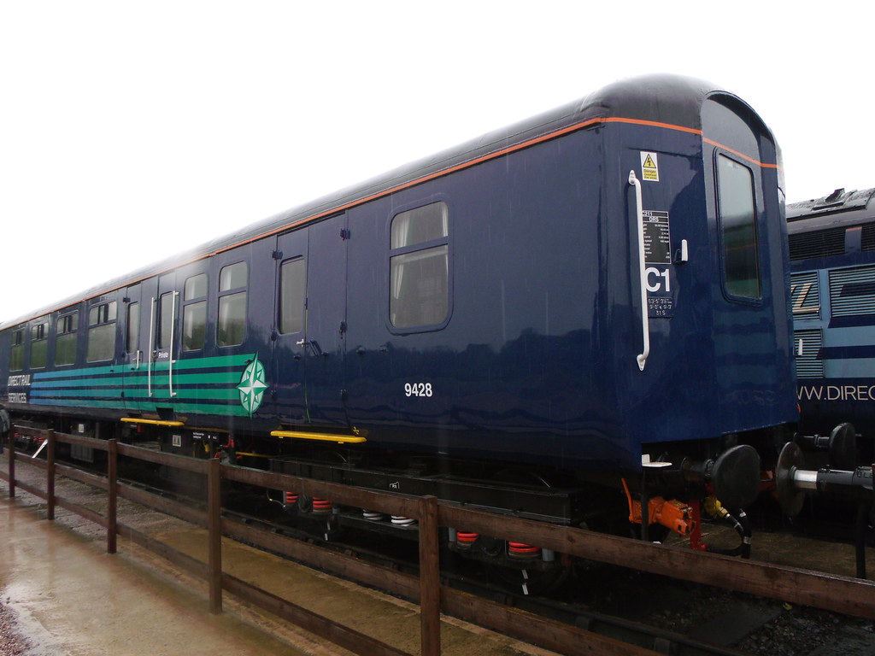

To Provide expert services required to C4 services and refurbishment of two (2) MK2 ABSO Coaches.

Prior Information Notice (PIN)

**Supplier Event Invitation**

**Ref: NTS DRS 0007**

Date: 27th October 2021

Service: Escort Coach Maintenance

Dear Sirs,

**Invitation to attend a Supplier event**

This Supplier Invitation has been published on behalf of Direct Rail Services.

Following on from our previous RFI which was published on the 5th May 2021 We would like to invite interested Bidders to a Supplier event day on the 23rd November or the 24th November 2021 in support of the requirement to carry out C4, C6 and modification on 2 x MK2 BSO vehicles.

Interested Bidders will have the option of specifying one of the two dates stated above

The purpose is to provide interested Bidders the opportunity to physically inspect the Coaches in question and to understand the current characteristics of the said coaches to enable a more informed understanding of the amount work involved to deliver the scope and provide an understanding of the overall requirement and ask any questions which may be included in the published Invitation to tender (ITT).

The General scope as stated in the previous RFI.

Activities include Design and removal & installation of major equipment, corrosion repairs and repaint, full supply chain and materials management, internal modifications to the passenger environment and provision of additional work based on C4 specifications to the expert services required for the C4 and C6 services and refurbishment of two (2) MK2A BSO Coaches. There will be an element of free issues materials as identified in the ITT.

Supplier event Details

Date 23rd and 24th November

The venue.

Direct Rail Services

Etterby Rd,

Kingmoor Depot,

Carlisle

CA3 9NZ

Max number of persons per Organisation will be restricted to 3 representatives

2 hours will be allocated to each organisation. There will be attendees from DRS in attendance to answer any questions that you may have.

Please note the timings will be allocated on a first acceptance first served basis.

Timings.

10:00 – 12.00

12:30 – 14:30

15:00 – 17:00

You will be required to provide the following PPE

DRS Site Induction will be provided at time of arrival.

A form of Identification will be required and presented when arriving on site to the security officer at the security gate.

Photography of the relevant coaches in the company of a DRS representative will be allowed but permission must be sought in the first instance.

Covid Safeguards

You will be provided with a DRS covid form/declaration to be completed 24 hours prior to attending site (laura.brown@ntsglobal.uk)

An appropriate face mask must be worn at all times while on site hand sanitisers are available and we would ask that the 2-metre distance rule is observed

We would be grateful if you could provide your responses by **16:00hrs GMT on the 6th November 2021**

We look forward to meeting up with you.

Kind regards,

Leslie Hopcroft.

1. About Direct Rail Services Limited (DRS)

Background to NTS and DRS

1. The Nuclear Decommissioning Authority (NDA) is bringing together International Nuclear Services (INS), Direct Rail Services (DRS), and the INS subsidiary Pacific Nuclear Transport Ltd (PNTL) to create a single nuclear transport division, Nuclear Transport Solutions (NTS).
   1. DRS is a wholly owned subsidiary of the Nuclear Decommissioning Authority (NDA). The company was established in 1995 as a lynch pin supplier of transport and associated services to the nuclear industry.
   2. Today DRS is dynamic business that is achieving sustained growth with current turnover levels running at around £80 million a year and employing more than 450 staff.
   3. Further information can be found on our website here [**https://www.directrailservices.com/**](https://www.directrailservices.com/)
   4. Invitation Process
   5. This Invitation has been issued on the 26th of October 2021
   6. The deadline for responses will be 6th November 2021 at 16:00pm
   7. You should return your responses Via [Procurement@ntsglobal.uk](mailto:Procurement@ntsglobal.uk)
   8. If you have any queries relating to this Invitation, please email Leslie.hopcroft@nts.global.uk.
   9. Please note: Participation in this invitation exercise is not a pre-requisite for the future procurement process nor does it guarantee selection in a future procurement process.
   10. Questionnaire

All participants are asked to complete Company information and Table 1.

Table 1: Questionnaire

|  |
| --- |
| Please provide Company name and full address |

Table 1

|  |  |  |
| --- | --- | --- |
| Name off attendee(s) | Job Title | Primary contact details |
|  |  |  |
|  |  |  |
|  |  |  |

|  |  |  |  |
| --- | --- | --- | --- |
| Please tick appropriate box | 10:00 –1 2.00 | 12:30 – 14:30 | 15:00 – 17:00 |
| 23rd November 2021 |  |  |  |
| 24th November 2021 |  |  |  |

Please note that the dates and time will be awarded on a first response come first served basis