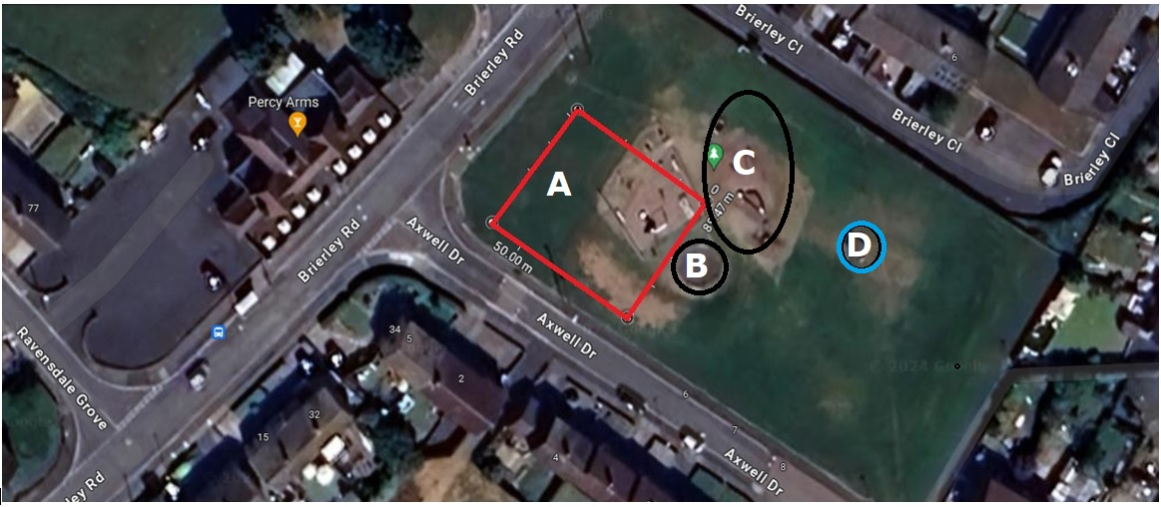



A – New park area.

B -C – Remaining

D – Removed.