


NHS North East Hampshire & Farnham Clinical Commissioning Group
NHS Surrey Heath Clinical Commissioning Group

Integrated Community Services
Lot 1: Shared services across both CCGs
Lot 2: North East Hampshire & Farnham CCG specific services
Lot 3: Surrey Heath CCG specific services

MEMORANDUM OF INFORMATION (MoI)

September 2018

Contents
1 EXECUTIVE SUMMARY 4
2 PURPOSE, STRUCTURE & NEXT STEPS FOR BIDDERS 6
2.1 Purpose of this document 6
3 COMMISSIONING 6
3.1 Commissioning organisations 6
4 INTRODUCTION AND OVERVIEW 6
4.1 Background to the proposed community services across North East Hampshire & Farnham and Surrey Heath Clinical Commissioning Groups 6
4.2 Overview of North East Hampshire & Farnham Clinical Commissioning Group 8
4.3 Overview of Surrey Heath Clinical Commissioning Group 11
4.4 Critical success factors 13
4.5 Key outcomes of the procurement and subsequently delivered service 15
4.6 Scope of the procurement 15
5 PROCUREMENT PROCESS – OVERVIEW 18
5.1 Procurement timeline 18
5.2 Advert 18
5.3 Memorandum of Information (MoI) 18
6 COMMERCIAL FRAMEWORK 19
6.1 Contract 19
6.2 Contract duration 19
6.3 Currency 19
6.4 Service 19
6.5 Workforce 19
6.6 Premises, facilities management & equipment 20
6.7 Information management & technology (IM&T) 20
6.8 Financial envelope 20
6.9 Insurance 21
7 GOVERNANCE & ADMINISTRATION 21
7.1 Procurement costs 21
7.2 Consultation 21
7.3 The Public Contract Regulations 2015 22
7.4 Conflicts of interest 22
7.5 Non-collusion & canvassing 23
7.6 Freedom of Information 23
7.7 Disclaimer 24

1 EXECUTIVE SUMMARY

- The purpose of this Memorandum of Information (MOI) is to provide an overview of the vision for the strategic delivery of Integrated Community Services across North East Hampshire and Farnham Clinical Commissioning Group and Surrey Heath Clinical Commissioning Group. It should be noted that the EU Prior Information Notice (PIN) accompanying this MOI is NOT a call for competition.

- The services detailed in this document are healthcare services for the NHS falling within Schedule 3 to the Public Contracts Regulations 2015 (the Regulations) which are not subject to the full regime of the Regulations, but is instead governed by the Light Touch Regime contained within Chapter 3, Section 7 of the Regulations (Regulations 74 to 76).

- A Selection Questionnaire (SQ) will be issued following the Market Warming Engagement. The Invitation To Tender (ITT) documentation is scheduled to be issued in March 2019.

- This MOI describes the national and local contexts and their impact on the commissioners’ vision for the future of community services. It also provides a description of the population and the range current services.

- Both CCG populations are part of the Frimley Health and Care Integrated Care System (ICS) which covered a population of 800,000 across Hampshire, Surrey and Berkshire. The two CCGs have a track record of successfully commissioning services together and both have patient flows that use Frimley Hospital as their main location for acute services.

- This proposed procurement strategy is designed to achieve a transformational approach to the provision and delivery of community health services, primarily to adults and older people, within the Frimley South area over the duration of the contracts. We intend to realise the vision of true person centred care delivered closer to home, built on the principles of collaboration and collective accountability for agreed outcomes.

- The CCGs’ strategic intentions require the delivery of an integrated solution which accompanies individuals along their journey through health and care services. Seamless transitions between and across these interfaces are essential if the high-level outcome that is ‘to ensure people receive the right care in the right place at the right time’ is to be met.

- There are a number of important NHS policy directions that run alongside this procurement including:
- Integrating care across organisational and functional boundaries
- Sustainability of general practice
- Parity for people with mental health conditions and a holistic approach to care
- Getting serious about prevention
- Community engagement and individual empowerment to self- manage
- Joint commissioning between health and social care
- Meaningful local flexibility within cohesive system wide strategies

- There is continued pressure on our finances, particularly in light of the growing older population – despite this we feel that this is an exciting time to deliver effective services through opportunities for innovation as a result of collaborative working between commissioning organisations, providers, the voluntary sector and our communities.
- Both CCGs have a continued focus on reducing health inequalities, and recognise the benefits of understanding and building on community strengths, working with public health and communities to develop projects of importance to them which can be sustained in the longer term.
- The CCGs plan to offer this tender in three lots (the scope of these are described in more detail later in the MOI):
  - Services whose specifications in terms functions and/or operating approach are shared across both CCGs
  - Services whose specifications in terms functions and/or operating approach have requirements specific to the North East Hampshire & Farnham CCG area
  - Services whose specifications in terms functions and/or operating approach have requirements specific to the Surrey Heath CCG area

- Bidders will be able to apply to participate in the forthcoming procurement for a single lot or multiple lots. The Selection Questionnaire will be issued to accompany the official Contract Notice/Call for Competition which will be issued to commence the competitive procurement process.

- The CCGs wish to support transformation and strategic change through long-term relationships, within the wider system, and therefore the contracts will be offered for duration of five years with the possibility to extend for a further two years.

- Commencement date for the new service is planned for 01 April 2020.

2 PURPOSE, STRUCTURE & NEXT STEPS FOR BIDDERS

2.1 Purpose of this document
2.1.1 This Memorandum of Information (MOI) provides an overview of the:
- Procurement and its objectives
- The CCGs’ service requirements
- Procurement process
- Procurement commercial framework, and
- Procurement governance and administration requirements
2.1.2 The purpose of this MOI is to provide Potential Bidders with sufficient information on the Services being procured to enable them to make an informed decision about whether they wish to participate and attend the Market Engagement Event on 11th October by submitting a registration form, which can be found on the In-tend portal Project Reference number F12026.

3 COMMISSIONING

3.1 Commissioning organisations
3.1.1 The Commissioning Organisations and Contracting Authorities for this procurement are:
- NHS North East Hampshire and Farnham Clinical Commissioning Group
- NHS Surrey Heath Clinical Commissioning Group
3.1.2 The Commissioning Organisations will be referred to as ‘The Commissioners’.

4 INTRODUCTION AND OVERVIEW

4.1 Background to the proposed community services across North East Hampshire & Farnham and Surrey Heath Clinical Commissioning Groups
4.1.1 North East Hampshire and Farnham CCG and Surrey Heath CCG closely partner with regard to work to support shared clinical flows across the community and into Frimley Park Hospital. Together, the CCGs, in conjunction with partners, form the Frimley South Local Delivery System, which enables focused work on areas such as delayed transfers of care (DTOC) and continuing healthcare (CHC).
4.1.2 System relationships between The Commissioners and providers are strong with a high degree of trust and common purpose. The wider Frimley system has a reputation for clinical excellence and sound financial management and this has been reflected in its recognition as a first wave Integrated Care System.
4.1.3 In addition there are currently a number of contracts which the two CCGs commission together, these ranging from local adult community provision, adult mental health and out-of-hours provision.
4.1.4 The Commissioners both recognise the significance of Primary Care as a focus for the delivery of out of hospital services, and as such, will require all potential Bidders who progress past the SQ phase to demonstrate how they have engaged with local primary care services. The Commissioners will ensure that the local providers of Primary Care are available for such engagement at the appropriate time.

North East Hampshire and Farnham CCG
4.1.5 Between April 2015 and March 2018, North East Hampshire and Farnham CCG was selected to be part of the national Vanguard programme, where areas were chosen to lead on the development, testing and implementation of new models of care to support local populations.
4.1.6 The Happy, Healthy, at Home programme has enabled us to transform areas of primary and community care. Each of our five localities (Aldershot, Farnborough, Farnham, Fleet and Yateley) has been supported to create its own integrated care teams – incorporating GP services, community services, mental health, social care, physiotherapy and the voluntary sector – to care for the needs of those members of their communities with the most chronic and complex needs.
4.1.7 In Farnham the programme has helped us to support GP practices to create an Integrated Care Centre, at Farnham Hospital, to enable patients to access urgent same-day GP appointments, reducing the need for people to attend A&E. In Yateley the Urgent Care Centre fulfils the same objective.
4.1.8 April 2018 marked the end of the formal end of the national vanguard programme. We are now incorporating our innovative new services into ‘business as usual’.

Surrey Heath CCG
4.1.9 Surrey Heath has a track record of delivering innovative change at pace and in partnership.
4.1.10 The locality is at the forefront of health and social care integration nationally. It has legally binding joint commissioning arrangements in place with Surrey County Council for adult community services using a commissioning Section 75 and a shared leadership team.
4.1.11 The CCG has had Integrated Care Teams in place since 2015 and the learning from Surrey Heath and North East Hampshire and Farnham CCGs have shaped the rollout of the integrated care concept nationally and across the Frimley ICS.
4.1.12 Since 2017 a systematic approach to anticipatory rather than the traditional proactive/reactive care model has been used within the integrated teams with early identification, through population segmentation of people living with frailty. Interventions are provided that prevent and reduce the impact of a crisis on both the individual and on health and care services
4.3.12 The systems and processes that support provider and commissioner integration are well established and embedded and will need to be adopted by the successful bidder. Staff work as a single team irrespective of organisational boundaries and this is supported by a shared operational leadership structure across the integrated commissioner and provider organisations

4.2 Overview of North East Hampshire & Farnham Clinical Commissioning Group
4.2.1 North East Hampshire and Farnham has a registered population of circa 220,250 residents who are registered with the 21 practices, in 22 locations throughout its geographical area. The CCG has five Primary Care Networks (localities) and two GP Federations:
Primary Care Networks:
- Aldershot
- Farnborough
- Farnham
- Fleet
- Yateley
Federations:
- Salus Medical Services
- Farnham Integrated Care Services
4.2.2 Secondary care flows are predominately to Frimley Health NHS Foundation Trust (Frimley Health NHS FT) with additional specialist cancer services provided by the Royal Surrey County Hospital.
4.2.3 Surrey and Borders Partnership NHS Foundation Trust (SABP), deliver services for adult, and some childrens’/adolescents’ mental health services; Sussex Partnership NHS Foundation Trust for Children and Adolescent Mental Health Services, and TalkPlus for Improving Access to Psychological Therapies Services.
4.2.4 Social care services are provided by Hampshire and Surrey Councils with members of both teams hosted within a hospital team in Frimley Park Hospital.
4.2.5 Out of hours care is provided by North Hampshire Urgent Care Ltd.
4.2.6 There is a network of voluntary and not for profit providers who have and has strong links to local communities and localities.
4.2.7 Map showing locations of GP practices within the CCG
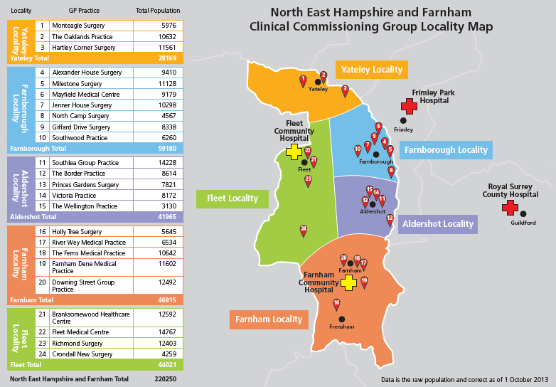
4.2.8 The geographical area of the CCG has both rural and urban areas, with the main towns being favoured locations for commuters from London to live due to the strong rail and road provision.
4.2.9 Key population headlines from the North East Hampshire and Farnham CCG Joint Strategic Needs Assessment (2017) include:
- 24.7% of the population is 19yrs or under, with 19.3% aged 65yrs and over. The predicted demographic growth indicates that by 2023 this older age group will increase by 22.3% - higher than the average national projection.
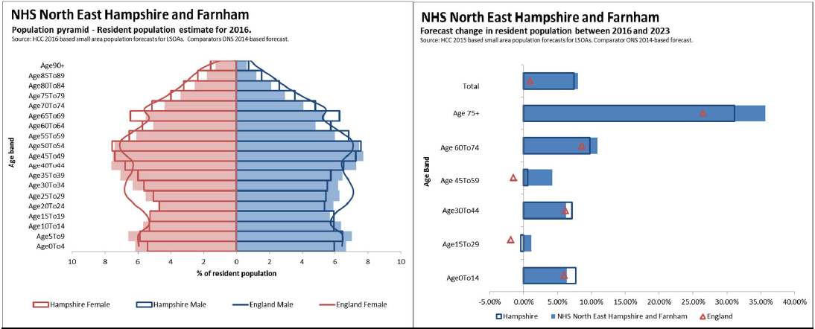
- There is an increasing prevalence in long-term conditions/multi-morbidity, with significant growth of clinical care provision needing to be focused on diabetes, cardiovascular disease, chronic obstructive pulmonary disease, cancer, mental health and musculo-skeletal conditions.
- The range of health and social inequalities can be seen when reviewing the deprivation index for individual wards – the map below shows this clearly.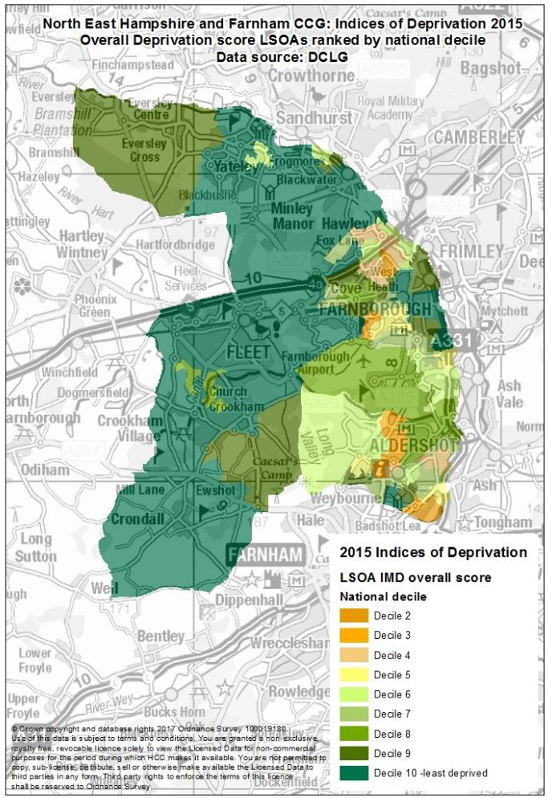

- Within North East Hampshire and Farnham CCG, there are a number of specific population groups with particular needs and whose care is tailored to meet this in a way that recognises and respects these requirements. In particular there are focused populations of military staff and their families, and people from a Nepalese background.
- It is predicted that by 2025, for every two people of working age, there will be one person of pensionable age in Waverley council ward. This has implications in that the proportion of the working-age population is reducing, increasing pressures on services and caring.

4.3 Overview of Surrey Heath Clinical Commissioning Group
4.3.1 Surrey Heath has a registered population of circa 96,700 residents who are registered with the 7 GP practices, in 10 locations, throughout Surrey Heath and Ash Vale. The locality has one Primary Care Network and one GP Federation, Surrey Heath Community Providers Ltd.
4.3.2 Secondary care flows are predominately to Frimley Health NHS Foundation Trust (Frimley Health NHS FT) with more specialist cancer services provided by the Royal Surrey County Hospital.
4.3.3 Mental health services for adults and children are delivered by Surrey and Borders Partnership NHS Foundation Trust (SABP). Choice is offered from a range of providers for people requiring access to Talking Therapies (IAPTS: Improving Access to Psychological therapies)
4.3.4 Social care services are provided by Surrey Council with a locality office in Surrey Heath Borough Council and a hospital team in Frimley Park Hospital.
4.3.5 Our population is supported by a network of voluntary and not for profit providers and has strong local communities.
4.3.6 A map showing locations of GP surgeries within Surrey Heath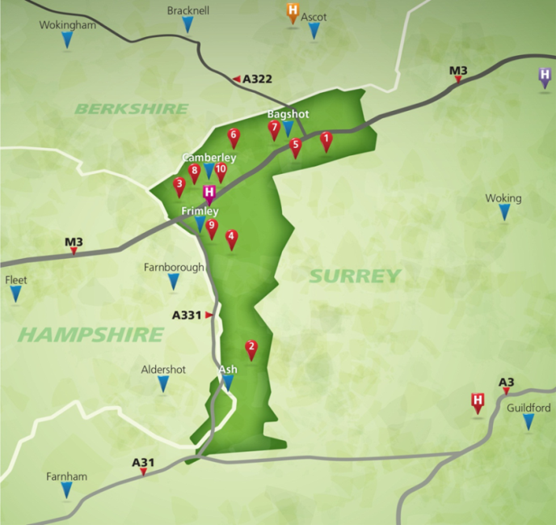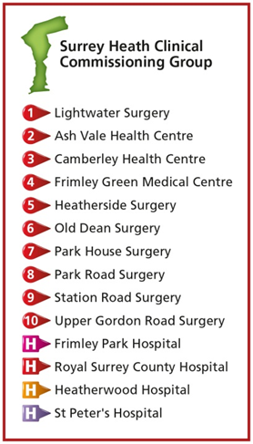
4.3.7 The health of people in Surrey Heath is generally better than the England average. Surrey Heath is one of the 20% least deprived districts/unitary authorities in England, however about 9% (1,400) of children live in low income families. Life expectancy for both men and women is higher than the England average although there is significant variation between the most and least deprived areas of the borough (6.7 year difference for men and 4.1 year difference for women).
4.3.8 The majority of the people in Surrey Heath are of working age and integrated services in the community, including general practice, now operate between 8am to 8pm Monday to Friday and provide a service 365 days of the year.
4.3.9 However, the dominant feature of the population of Surrey Heath is the increase in the number of people aged over 65. The major implications of this are the increase in long term conditions (often with co-morbidities), depression, falls, social care needs and loneliness. The growth in the number of people over 85 is higher than the national and Surrey projections.
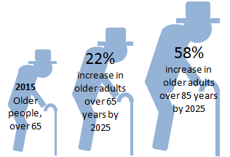
4.3.10 In terms of the make-up of the population there are several key groups for whom there are particular health and care implications:
- People with physical disabilities – estimate 5.9 thousand
- People with Learning disabilities – estimate 1.8 thousand
- People providing more than 50 hours of unpaid care per week – estimate 1.5 thousand
- People receiving adult social care services – estimate 1.4 thousand
- Households experiencing fuel poverty – estimate 2 thousand
4.3.11 There are significant numbers of people who have unhealthy lifestyles including:
- Adults who drink at higher risk levels – estimate 4.7 thousand
- Adults who smoke – estimate 10 thousand
- Adults who are obese – estimate 18 thousand
- Adults who are physically inactive – estimate 20 thousand
4.3.12 Those who exhibit the lifestyle factors above will tend to live in the more deprived areas of Surrey Heath and for each factor there will be a proportion of children and young people who have already fallen into these poor lifestyle patterns.
4.3.13 Of the main long term conditions there are several that stand out in terms of large numbers:
- People with hypertension – 12.2 thousand
- People with respiratory disease – 6.5 thousand
- People with diabetes – 3.9 thousand
- People with depression – 3.4 thousand

4.4 Critical success factors
4.4.1 The assessment of options for service delivery and funding, the assessment of bids which may be received as part of the procurement process and also the longer term evaluation of the programme is driven by the clarification regarding how the success of the programme will be measured.
4.4.2 The CCGs will be looking to understand the extent to which the option or proposal will:
- Deliver integrated care services which can be described as continuous throughout a person’s care journey and where necessarily seamlessly crossing over from one traditional “sector” to another – such as from general practice and social care; and where a person is receiving care they will not be aware that it is being provided by different elements or organisations working together;
- Deliver services that support the user, at the right time, with the right level of intervention, with a shift in focus to proactive care rather than reaction;
- Support people to self-care and maximise their independence as far as possible in order to reduce their reliance on direct care;
- Demonstrate how the services will be provided in a manner that is sensitive to local health and service needs, addresses health inequalities, focuses on our local primary care networks, and wraps those services around the patient;
- Contribute to the delivery of a more efficient and effective urgent care system. This will result in the creation of, and participation in, approaches to alternative care for clinical conditions (particularly focusing on care of the elderly) that enable improved support for self-care and referral to community/out-of-hospital care as well as a reduction in hospital attendance/admission. The service will be required to develop effective working links with the local Integrated Urgent Care system particularly the Clinical Advice Service (CAS);
- Ensure there is a focus on a supported and enhanced primary and community care system led and delivery by primary and community care in partnership sharing knowledge and skills;
- Provide assessment and direct access to appropriate diagnostics, including tools and skills to support improved patient care both in the community and home environments;
- Enhanced proactive care through the use of risk stratification tools, shared governance, agreed risk thresholds and tested assessments;
- Focus on minimal transfers between teams and agencies which will result in better use of resources across the economy;
- Recognise the need for Technology innovations and developments which support patients at all levels of complexity to remain at the highest level of independence they can achieve. Technology considerations to include interoperability with partners for the sharing of records.
- Provide a culture and strategy which includes a career framework that works to attract potential new recruits into the workforce, that ensures people are provided opportunities for development and career/role progression wherever they enter the caring professions, and that supports development enabling individuals to work the fullest of the scope of their role or professional registration licences;
- Ensure that access arrangements must facilitate a positive patient experience, support access for our must vulnerable groups (e.g. those with mental health and learning disabilities, individuals with physical and/or psychological disabilities etc.). Reflect local population demography (working age adults) and patient demand for extended hours appointments;
- Develops partnership working to deliver a smooth and timely transition for people moving into the service from 0-19 services (where provided outside the contracts) and people in need of specialist end of life care.

4.4.3 We are looking a like-minded partner(s) who
- Can deliver an organisational solution which demonstrates strong leadership, sound governance, resilience and gain the confidence of system partners;
- Shares The Commissioners’ vision for change, understands the need for whole system transformational change and will work with The Commissioners to drive this change;
- Can demonstrate how to deliver a service within and across a system that includes:
  - Working as a key partner in a connected system, with a ‘can do’ and ‘its my job’ approach
  - Changing culture beliefs and behaviours across organisational boundaries and throughout the system at all levels
  - Influencing partner organisations to deliver better outcomes for patients
  - Mobilising the third sector and wider community assets including working with housing partners and local community groups
  - Demonstrating sufficient multi-disciplinary capacity and operational ability to deliver services required within defined time scales. Capacity must be flexible enough to meet demand variation
  - Delivering financial balance within the agreed financial envelope across the life of the contracts with demonstrable value for money
  - Active engagement with a wide range of people, their carers, the local community and other stakeholders (in partnership with CCGs) on an on-going basis across the life of the contracts to ensure the changing needs outcome and preferences are met
  - Demonstrating a commitment to provide innovation and implementation of best practice across all areas of the business

4.5 Key outcomes of the procurement and subsequently delivered service
4.5.1 North East Hampshire and Farnham CCG and Surrey Heath CCG would expect to have the following as a result of this procurement:
- A contractor(s) commissioned over a 5 year period (with a 2 year extension option) to deliver against a contract where outcome based measures are prioritised.
- A confirmed set of outcome measures with which to commence the management and delivery of the programme
- A service which addresses the five key NHS domains of care:
  - Preventing people from dying prematurely
  - Enhancing the quality of life for people with long-term conditions
  - Helping people to recover from episodes of ill health or following injury
  - Ensuring that people have a positive experience of care
  - Treating and caring for people in a safe environment and protecting them from avoidable harm
- A contractor/contractors who are committed to being a partner in an integrated health and care systems including those operating at a county level as part of the Frimley Health & Care ICS.

4.6 Scope of the procurement
4.6.1 The scope of this procurement is to include the following services in three lots
LOT 1: Shared services across both CCGs
This lot is focussed on the delivery of services where specifications regarding the functional aspects and operational model are the same across both CCGs. The services in this lot cover both place-based services, as well as others which it is felt would better benefit from a shared operational approach.

The scope of this lot is expected to include the services listed below
Community beds | To support step up, step down and discharge to assess
Diagnostic & Treatment Centre | This is a location which provides assessment functions to support local decision making, and also provides treatment facilities and clinics, many of which are focused on supporting older patients with more complex needs
Out of hours nursing and support services | Working evenings Mon-Fri and all day Saturday and Sunday  Across the wider Hampshire and Surrey Heath area work is progressing to co-design an Integrated Urgent Care solution ahead of a formal procurement. It is therefore expected that the successful bidder will need to commit to working with the wider system to support this work, including evolving this service to integrate with these developments
Hospital Interface Team | A multi-disciplinary team working across both CCGs, and embedded within Frimley Park Hospital, with the intention to support patient flow – particularly proactive discharge and ensuring appropriate referrals to community hospitals

To note: The financial envelope for this lot only includes community beds and the Diagnostic and Treatment Centre, the rest is included in Lots two and three.

LOT 2: North East Hampshire & Farnham CCG specific services
This lot is focussed on the delivery of services where the specifications regarding the functional aspects and operational model are different between the CCGs, with a particular focus of those services to be commissioned by North East Hampshire and Farnham CCG.

The scope of this lot is expected to include the services listed below.
Nursing & Specialist Practitioners | - District nursing (domiciliary & clinic based)  - Community Matrons  - Specialist Practitioner – Diabetes  - Specialist Practitioner – Respiratory  - Specialist Practitioner – Care Homes  - Specialist Practitioner – Parkinsons  - Specialist Practitioner – Tissue Viability  - Specialist Practitioner – Multiple Sclerosis  - Specialist Practitioner – Lymphoedema  - Specialist Practitioner – Heart Failure  - Specialist Practitioner – Epilepsy  To include capacity for rotational nursing night service and nursing admission avoidance and supported discharge service
Therapies & Rehabilitation | - Physiotherapy (neuro-rehabilitation)  - Physiotherapy (other)  - Podiatry  - Speech & Language Therapy – SALT  - Respiratory and oxygen service  - Occupational Therapy

LOT 3: Surrey Heath CCG specific services
This lot is focussed on the delivery of services where the specifications regarding the functional aspects and operational model are different between the CCGs, with a particular focus of those services to be commissioned by Surrey Heath CCG.

The scope of this lot is expected to include the services listed below.
Nursing & Specialist Practitioners | - District nursing (domiciliary & clinic based)  - Community Matrons  - Specialist Practitioner – Diabetes  - Specialist Practitioner – Respiratory  - Specialist Practitioner – Care Homes  - Specialist Practitioner – Parkinsons  - Specialist Practitioner – Tissue Viability  - Specialist Practitioner – Multiple Sclerosis  - Specialist Practitioner – Lymphoedema  - Specialist Practitioner – Heart Failure  - Specialist Practitioner – Epilepsy  To include capacity for rotational nursing night service and nursing admission avoidance and supported discharge service
Therapies & Rehabilitation | - Physiotherapy (neuro-rehabilitation)  - Physiotherapy (other)  - Podiatry  - Speech & Language Therapy – SALT  - Respiratory and oxygen service  - Occupational Therapy

4.6.2 Potential Bidders will be able to apply for one or multiple lots – and these will be evaluated independently. To be clear, Bidders tendering for multiple lots must not combine the bids but will be required to submit standalone bids – one for each lot.
4.6.3 If a Bidder were to achieve number one ranking in more than one lot, this would trigger a second phase in the evaluation process requiring assessment of:
- The economies of scale to be achieved through the delivery of multiple lots
- The organisational capacity to deliver the multiple lots

All information in the second phase will be pre-determined and published with the invitation to tender (ITT) pack, with responses required by the specified deadline for the ITT submission. In order to ensure a fair a transparent process, it should be noted that all information provided for the second phase evaluation will remain unopened until phase one is complete.
4.6.4 The Commissioners have not included community or secondary care mental health services in this procurement but will require the community service provider(s) to work very closely with incumbent providers.
4.6.5 A small element of childrens’ services will be included on this procurement – the details of these will be provided in the specifications. These services must integrate with other community services to ensure organised transition of patients from adolescence to adulthood.

5 PROCUREMENT PROCESS – OVERVIEW

5.1 Procurement timeline
5.1.1 The indicative timelines for the procurement process is set out in the table below. It should be noted that the dates shown are anticipated dates at the time of issuing this MOI and may be subject to change.
Event | Indicative date
OJEU Notice - call for competition and publish Selection Questionnaire (SQ) | W/C 12th November 2018
Deadline for the receipt of the SQ (12:00) | W/C 17th December 2018
SQ evaluation stage completed / Sign off | W/C 4th March 2019
Issue invitation to tender | W/C 11th March 2019
Deadline for receipt of ITT Submissions | June 2019
Award of contract decision notified to Bidders | September 2019
Mobilisation Period | September 2019 to March 2020
Service commencement | 01 April 2020

5.2 Advert
5.2.1 An Advertisement /Call for Competition will be placed at national and local level including on the Contracts Finder portal and the Official Journal European Union (OJEU). This will be as per the Light Touch Regime contained within Chapter 3, Section 7 of the Regulations (Regulations 74 to 76).
5.2.2 All queries relating to the process, the contents of published documentation or general enquiries must be channelled through the Intend portal managed by South of England Procurement Services.

5.3 Memorandum of Information (MoI)
5.3.1 This MOI provides details of the Services to be procured. .
5.3.2 This MOI provides potential Bidders with sufficient information to enable them to make an informed decision about whether they wish to register their interest in the Market Engagement Event for this procurement.

COMMERCIAL FRAMEWORK

Contract
    - The contracts to be entered into by The Commissioners and the selected Provider(s) for the Services will be the NHS Standard Contract for 2017/19, a copy of which will be found at the NHS England website (and may be subject to updates).
    - The Contracts will be separate to and independent of any existing contract currently in place between the Provider(s) and The Commissioners.

Contract duration
    - It is expected that the contract will be awarded for a total of five (5) years with the possibility to extend for up to a further two (2) years

Currency
    - Bids at the Invitation to Submit Final Tender (ISFT) stage will only be accepted in pounds sterling.

Service
    - The Commissioners are looking for Bidders with the necessary financial standing, experience, capacity and capability (or a demonstrable ability to provide the necessary capacity and capability) to deliver progressive and significant improvement to the specified outcomes through the delivery of high quality, patient-centred, integrated and value for money services, which are outcome focused and are delivered in a safe and effective manner.

Workforce
    - Staff transfers (TUPE)
      - Staff who are employed by the current provider(s) may be subject to the Transfer of Undertakings (Protection of Employment) Regulations 2006 (amended 2014) "TUPE". Therefore, potential Bidders must consider whether or not TUPE would apply to any such staff and are recommended to seek appropriate independent legal advice about this.
      - Potential Bidders will be required to provide evidence that they are able to meet the requirements of the new Fair Deal Policy published by HM Government in October 2013.

Premises, facilities management & equipment
    - Premises
      - The Commissioners shall make known to Bidders availability of space in primary and community health premises around the Frimley South Area and whether any of these premises will be mandated for service delivery.
      - Clarification regarding the rental associated with these premises will be included in the financial tender documentation.
      - Where premises are owned and managed by NHS Property Services it is required that facilities management is provided through them. Figures for facilities management will be provided as part of the financial tender documentation.
    - Equipment
      - The Service Provider(s) shall be responsible for the provision and cost of equipment where this is not already in place.

Information management & technology (IM&T)
    - The Service Provider(s) shall be responsible for provision of all IM&T equipment necessary to meet the requirements of the service specification where this is not already provided.
    - The Commissioners require the facility of mobile working for staff within the service – to support improved care and efficiency, through immediate access to patient records, web-based information systems and the ability to record contemporaneous records.
    - The Primary Care software system used at present fully across both CCGs is EMIS and therefore The Commissioners require the new service to ensure full interoperability of the new service with this system.
    - Frimley Health Integrated Care System has been developing a shared care record function entitled ‘Connected Care’. All Bidders must ensure that whatever solution is employed must meet the requirements of this programme.

Financial envelope
    - The financial envelope for Lot 1 – shared services across both CCGs is in the region of £7.5 million per annum

    - The financial envelope for Lot 2 – North East Hampshire & Farnham CCG specific services is in the region of £9.5 million per annum.

    - The financial envelope for Lot 3 – Surrey Heath CCG specific services is in the region of £4 million per annum.

    - The precise financial envelopes will be published in due course.

Insurance
    - A comprehensive schedule of insurances that the Provider will be required to obtain for the Services will be set out in the ITT. This will typically include public liability, corporate medical malpractice and certain property cover, as well as provision for clinical negligence insurance covering all staff and operational risk in the facilities from which the Provider’s Services are to be provided. These required insurances are in addition to the requirement that individual medical practitioners have professional indemnity insurance.
    - The insurance requirements will also require Providers to ensure that:
- Commissioning Authority’s interests are fully protected;
- Members of the public utilising the Services are fully protected to the extent that they have a valid claim against the Provider and / or Commissioning Authority; and
- The Provider maintains insurance, which meets at least the minimum statutory requirements.

7 GOVERNANCE & ADMINISTRATION

Procurement costs
    - Each potential Bidder shall be responsible for its own costs incurred throughout each stage of the procurement process. No NHS Contracting Authority or any other body involved in this procurement will be responsible for any costs incurred by the potential Bidder or any other person through this procurement.

Consultation
    - Each CCG shall lead on local stakeholder engagement issues for their corresponding populations, relevant to this Procurement exercise. All Clinical Commissioning Group Schemes are subject to on-going Service User and public consultation under the provision of the Health and Social Care Act 2012 section 26.

The Public Contract Regulations 2015
    - The Requirement to which this MOI relates falls within the Particular Procurement Regime (Social and other specific services) as per Chapter 3 Section 7 of the Public Contracts Regulations 2015 will apply to this procurement process (former Part B services). The 2015 regulations are referred to as “the Regulations”.
    - Neither the publication of the advertisement, the inclusion of a Bidder selection stage nor any other indication shall be taken to mean that the Commissioning Authority intends to hold itself bound by the full force of the Regulations (save those applicable to the Particular Procurement Regime (also known as “light touch regime”).
    - Each Contract will be separate to and independent of, any existing contract currently in place between a Provider(s) and the Commissioning Authority.

Conflicts of interest
    - In order to ensure a fair and competitive procurement process, The Commissioners require that all actual or potential conflicts of interest that a potential Bidder may have are identified and resolved to the satisfaction of The Commissioners. If the potential Bidder becomes aware of an actual or potential conflict of interest it should immediately notify The Commissioners via the In-tend portal. Such notifications should provide details of the actual or potential conflict of interest and the measures proposed to address the actual or potential conflict identified.
    - If, following consultation with the potential Bidder(s), such actual or potential conflict(s) are not resolved to the satisfaction of The Commissioners, then The Commissioners reserve the right to exclude at any time any potential Bidder from the Procurement process should any actual or potential conflict(s) of interest be found by The Commissioners to confer an unfair competitive advantage on one or more potential Bidder(s), or otherwise to undermine a fair and competitive procurement process.
    - If, following consultation with the potential Bidder(s), such actual or potential conflict(s) are not resolved to the satisfaction of The Commissioners, then the The Commissioners reserve the right to exclude at any time any potential Bidder from the Procurement process should any actual or potential conflict(s) of interest be found by The Commissioners to confer an unfair competitive advantage on one or more potential Bidder(s), or otherwise to undermine a fair and competitive procurement process.
    - The Commissioners reserve the right to disqualify potential Bidder(s) who fail to notify The Commissioners of any actual or potential conflicts of interest.

Non-collusion & canvassing
    - Each potential Bidder must not canvass or solicit or offer any gift or consideration whatsoever as an inducement or reward to any officer or employee of, or person acting as an adviser to, either of the CCGs, the NHS or the DH&SC in connection with the selection of Bidders or the Service Provider in relation to this (or any other) Procurement.

Freedom of Information
    - The CCG is committed to open government and meeting its legal responsibilities under the Freedom of Information Act 2000 (FOIA). Accordingly, any information created by or submitted to The Commissioners (including, but not limited to, the information contained in the MOI or SQ and the submissions, bids and clarification answers received from potential Bidders) may need to be disclosed by The Commissioners in response to a request for information.
    - In making a submission or bid or corresponding with the The Commissioners at any stage of the Procurement, each potential Bidder acknowledges and accepts that the Commissioners may be obliged under the FOIA to disclose any information provided to it:
- Without consulting the potential Bidder or Bidders; or
- Following consultation with the potential Bidder or Bidders and having taken its views into account.
    - Potential Bidders must clearly identify any information supplied in response to The Commissioners that they consider to be confidential or commercially sensitive and attach a brief statement of the reasons why such information should be so treated and for what period.
    - Where it is considered that disclosing information in response to an FOIA request could cause a risk to the Procurement process or prejudice the commercial interests of any potential Bidder, The Commissioners may wish to withhold such information under the relevant FOIA exemption.
    - However, potential Bidders should be aware that The Commissioners are responsible for determining at its absolute discretion whether the information requested falls within an exemption to disclosure, or whether it must be disclosed.
    - Potential Bidders should therefore note that the receipt by The Commissioners of any information marked “confidential” or equivalent does not mean that The Commissioners accept any duty of confidence by virtue of that marking, and that The Commissioners have the final decision regarding the disclosure of any such information in response to a request for information.

Disclaimer
    - The information contained in this MOI is presented in good faith and does not purport to be comprehensive or to have been independently verified.
    - Neither The Commissioners nor any of their advisers accept any responsibility or liability in relation to its accuracy or completeness or any other information which has been, or which is subsequently, made available to any potential Bidder, Provider, Bidder Member, Clinical Services Supplier, financiers or any of their advisers, orally or in writing or in whatever media.
    - Interested parties and their advisers must therefore take their own steps to verify the accuracy of any information that they consider relevant. They must not, and are not entitled to, rely on any statement or representation made by either of The Commissioners, NHS England the DH&SC, the Ministry of Justice or any of their advisers.
    - This MOI is intended only as a preliminary background explanation of The Commissioners’ activities and plans and is not intended to form the basis of any decision on the terms upon which the CCGs shall enter into any contractual relationship.
    - The Commissioners reserve the right to change the basis of, or the procedures (including the timetable) relating to the Procurement, to reject any, or all, of the bids, not to invite a potential Bidder to proceed further, not to furnish a potential Bidder with additional information nor otherwise to negotiate with a potential Bidder in respect of this Procurement.
    - The Commissioners shall not be obliged to appoint any of the Bidders and reserves the right not to proceed with this Procurement, or any part thereof, at any time.
    - Nothing in this MOI is, nor shall be relied upon as, a promise or representation as to any decision by The Commissioners in relation to this Procurement. No person has been authorised by The Commissioners or its advisers or consultants to give any information or make any representation not contained in this MOI and, if given or made, any such information or representation shall not be relied upon as having been so authorised.
    - Nothing in this MOI or any other pre-contractual documentation shall constitute the basis of an express or implied contract that may be concluded in relation to the Procurement, nor shall such documentation/information be used in construing any such contract. Each Bidder must rely on the terms and conditions contained in any contract when, and if, finally executed, subject to such limitations and restrictions that may be specified in such contract. No such contract shall contain any representation or warranty in respect of the MOI or other pre-contract documentation.
    - In submitting a response to this SQ it will be implied that the potential Bidder will be bound by all the provisions of this SQ including the conditions set out in section 6.

