**REQUEST FOR INFORMATION**

**SUBMARINE DELIVERY AGENCY**

**Supply of Personal Locator Beacons** 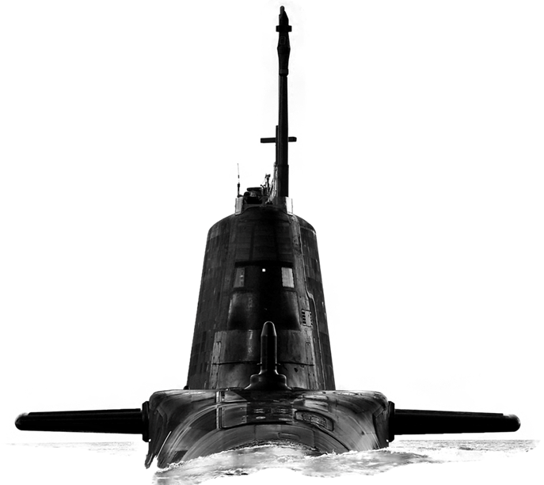

Version: 1.0

Date: 12th January 2023

**CONTENTS**

Confidentiality..............................................................................................................3

Introduction..................................................................................................................3

Background…………...................................................................................................3

Purpose of the Request for Information (RFI).............................................................3

RFI Procedure............................................................................................................ 4

How to Delivery Responses to this RFI………............................................................4

Contacts......................................................................................................................4

Timeframe...................................................................................................................5

Annex A - Request for Information Questionnaire……….........................................A-1

**Confidentiality**

1. All information included in this Request for Information (RFI) is confidential and only for the named addressee. No information included in your response, or in discussions connected to it, will be disclosed to any other party.

**Introduction**

1. The Submarine Delivery Agency (SDA) hasn’t sourced Personal Locator Beacons for submarines for several years. This RFI seeks to understand the current market pricing and lead times for the supply of Personal Locator Beacons.
2. The supply of Personal Locator Beacons for submarine is critical to ensuring platform safety. The SDA is seeking information to inform potential future procurements, and we would like to invite your company to answer a few questions to explore ways in which this can be achieved.
3. This RFI is not a bidding opportunity but a means by which industry can provide information. Any resulting procurement activity will be conducted competitively.

**Scope**

1. It is important to note that the Personal Locator Beacons the SDA require must comply with the following specifications:

Technical Details

* Operating Temperatures: -20o to +55o C (air)
* Casing: Impact resistant and depth rated to a minimum of 200 meters.
* Mounting Options: The ability to be attached to the single man life raft.
* Alerting Radius: Minimum threshold 20 nautical miles.
* Positive indication of successful operation.
* Homing alertment via 121.5 MHz
  + Search and rescue sources use 121.5 Mhz.
* Power requirement: Preferably an end user replaceable commercial off the shelf Alkaline Battery. However, if an Alkaline Battery is not possible, please present alternatives.
* Battery Life: minimum of 3 years in storage
* Operational Life: A minimum of 24 hours of transmission once activated.
* Maximum Dimension: 20cm x 10cm x 5cm
  + Smaller Dimension are desirable
* Maximum weight of 500g
  + Lighter weights are desirable.

Controls and Operation

* Automatic Activation: Seawater activated.
* Manual Activation: Switch activation

Note: Unit must be capable of automatic seawater and manual activation without opening and/or removing the unit from its pressure tight case.

**Purpose of the RFI**

1. This RFI aims to achieve two outcomes:
2. To gather information about the current market for the provision of Personal Locator Beacons for Submarines.
3. Develop a Procurement Strategy that will deliver best value for money for Defence.

**RFI Procedure**

1. This Request for Information will be advertised on the Defence Sourcing Portal (DSP) and Contracts Finder and issued to all who request an RFI together with other companies whom the MOD believes may be able to provide useful intelligence on this requirement.
2. Responses to this RFI will be reviewed by subject matter experts from different functional areas within the Submarine Delivery Agency. Following receipt of responses to this RFI the Authority may initiate follow on engagement with either individual potential suppliers, groups of potential suppliers or all potential suppliers. This may be undertaken in writing or through virtual meetings.
3. Any details provided in response to this RFI or during subsequent engagement will be used for information purposes only and will not be used to determine the potential suppliers who will be invited to bid, should the Authority proceed to tender.
4. The results and analysis of this RFI shall not constitute any form of pre-qualification exercise. Any formal procurement process will be undertaken in accordance with EU Procurement Law.
5. Nothing in this RFI, or any other engagements with Industry prior to a formal procurement process, shall be construed as a representation as to the Authority’s ultimate decision in relation to the future requirement.

**How to deliver responses to this RFI**

1. To respond to this RFI please complete the form at Annex A and return electronically to [Harry.Partridge101@mod.gov.uk](mailto:Harry.Partridge101@mod.gov.uk) no later than 13:00 30 January 2023. Responses will be acknowledged by email.

**Contacts**

1. Please raise questions relating to this RFI by email to [Harry.Partridge101@mod.gov.uk](mailto:Harry.Partridge101@mod.gov.uk)

**Timeframe**

1. This is the timeframe for the RFI and follow-on activity:

16January 2023 – RFI Published on Defence Sourcing Portal.

13.00 30 January 2023 – Last date for submission of answers to RFI.

**Personal Locator Beacons Request for Information**

|  |  |
| --- | --- |
| **Question** | **Answer** |
| Company Name |  |
| Company Address |  |
|  |  |
| Name of Company representative completing the RFI |  |
| Contact details (e-mail and telephone number) |  |
| Company web site address |  |
|  |  |
| Main products/services/line of business |  |
| Main market sector/customers |  |
| Number of years in this market sector |  |
|  |  |
| Pricing |  |
| 1. What is your price range per unit for a Personal Locator Beacon at the above specification? Where more than one unit is available, what are the key differences or features? |  |
| 1. What would be a ROM cost for the supply and shipping of 336 Personal Locator Beacons at the above specification? Shipping will be to the UK. |  |
| Order Quantity/Contract Duration |  |
| 1. To what extent can discounts be offered on volume orders and at what level might these be available? |  |
| 1. What would be the estimated lead time for the supply and shipping of 336 Personal Locator Beacons at the above specification? Shipping will be to the UK. |  |
| Contract composition |  |
| 1. Does your organisation envisage being able to cover all the requirement described? Where elements cannot be fulfilled, please set those out here along with any alternatives. |  |
| 1. To what extent is the Personal Locator Beacons able to be powered by alternative batteries? |  |
| 1. Are there any risks or concerns specific to this market that the SDA should be aware of? |  |