Request for Quotation
Phase 2 Tees Tidelands Footpath Crossing: Working in partnership to deliver Green Infrastructure
Date: April 2024
Version: 03

Request for Quotation
Phase 2 Tees Tidelands Footpath Crossing: Working in partnership to deliver Green Infrastructure
You are invited to submit a quotation for the requirement described in the specification, Section 2.
Please confirm by email, receipt of these documents and whether you intend to submit a quote or not.
Your response should be returned to the following email address by:
Email: Vicky.ward@naturalengland.org.uk
Date: Friday 31st May 2024
Time: 12.00noon
Ensure you include the name of the quotation and ‘Final Submission’ in the subject field to make it clear that it is your response.
Contact Details and Timetable
Vicky Ward will be your contact for any questions linked to the content of the quote or the process. Please submit any clarification questions via email and note that, unless commercially sensitive, both the question and the response will be circulated to all tenderers.
Action | Date
Date of issue of RFQ | 24 April 2024
Deadline for clarifications questions | 10 May 2024 at 12:00pm
Deadline for receipt of Quotation | 31st May 2024 at 12:00pm
Intended date of Contract Award | 14th June 2024
Intended Contract Start Date | 21st June 2024
Intended Delivery Date / Contract Duration | 30th August 2024

Section 1: General Information
Glossary
Unless the context otherwise requires, the following words and expressions used within this Request for Quotation shall have the following meanings (to be interpreted in the singular or plural as the context requires):
“Authority” | means Natural England who is the Contracting Authority.
“Contract” | means the contract to be entered into by the Authority and the successful supplier.
“Response” | means the information submitted by a supplier in response to the RFQ.
“RFQ” | means this Request for Quotation and all related documents published by the Authority and made available to suppliers.

Conditions applying to the RFQ
You should examine your Response and related documents ensuring it is complete and in accordance with the stated instructions prior to submission.
Your Response must contain sufficient information to enable the Authority to evaluate it fairly and effectively. You should ensure that you have prepared your Response fully and accurately and that prices quoted are arithmetically correct for the units stated.
By submitting a Response, you, the supplier, are deemed to accept the terms and conditions provided in the RFQ. Confirmation of this is required in Annex 2.
Failure to comply with the instructions set out in the RFQ may result in the supplier’s exclusion from this quotation process.
Acceptance of Quotations
By issuing this RFQ the Authority does not bind itself to accept any quotation and reserves the right not to award a contract to any supplier who submits a quotation.
Costs
The Authority will not reimburse you for any costs and expenses which you incur preparing and submitting your quotation, even if the Authority amends or terminates the procurement process.
Self-Declaration and Mandatory Requirements
The RFQ includes a self-declaration response (Annex 1) which covers basic information about the supplier, as well as any grounds for exclusion. If you do not comply with them, your quotation will not be evaluated.
Any mandatory requirements will be set out in Section 2, Specification of Requirements and, if you do not comply with them, your quotation will not be evaluated.
Clarifications
Any request for clarification regarding the RFQ and supporting documentation must be submitted via email no later than the deadline for clarifications set out in the Timetable. The Authority shall be under no obligation to respond to queries raised after the clarification deadline.
The Authority will respond to all reasonable clarifications as soon as possible but cannot guarantee a minimum response time. The Authority will publish all clarifications and its responses to all suppliers via email unless deemed commercially sensitive.
If a supplier believes that a request for clarification is commercially sensitive, it should clearly state this when submitting the clarification request. However, if the Authority considers either that:
- the clarification and response are not commercially sensitive; and
- all suppliers may benefit from its disclosure,
then the Authority will notify the supplier (via email), and the supplier will have an opportunity to withdraw the request for clarification by sending a further message requesting the withdrawal of the clarification request. If not withdrawn by the supplier within 2 working days of the Authority’s notification, the Authority may publish the clarification request and its response to all suppliers and the Authority shall not be liable to the supplier for any consequences of such publication.
The Authority reserves the right to seek clarification of any aspect of a quotation and/or provide additional information during the evaluation phase to carry out a fair evaluation. Where the Authority seeks clarification on any aspect of the quotation, the supplier must respond within the timeframe requested by the Authority.
Amendments
The Authority may amend the RFQ at any time prior to the deadline for receipt. If it amends the RFQ the Authority will notify you via email.
Suppliers may modify their quotation prior to the deadline for Responses. No Responses may be modified after the deadline for Responses.
Suppliers may withdraw their quotations at any time by submitting a notice via the email to the named contact.
Conditions of Contract
The Authority’s Standard Research and development terms and conditions (used for purchases under £50k) can be located on the Natural England Website and will be applicable to any contract awarded as a result of this quotation process. The Authority will not accept any changes to these terms and conditions proposed by a supplier.
Suppliers should note that the quotation provided by the successful bidder will form part of the Contract.

Prices
Prices must be submitted in £ sterling, exclusive of VAT.

Disclosure
All Central Government Departments, their Executive Agencies and Non-Departmental Public Bodies are subject to control and reporting within Government. In particular, they report to the Cabinet Office and HM Treasury for all expenditure. Further the Cabinet Office has a cross-Government role delivering overall Government policy on public procurement, including ensuring value for money and related aspects of good procurement practice. For these purposes, the Authority may disclose within Government any details contained in your quotation. The information will not be disclosed outside Government during the procurement.
In addition, the Authority is subject to the Freedom of Information Act 2000 and the Environmental Information Regulations 2004, which provide a public right of access to information held by public bodies. In accordance with these two statutes, the Authority may be required to disclose information contained in your quotation to any person who submits a request for information pursuant to those statutes.
Further to the Government’s transparency agenda, all UK Government organisations must advertise on Contract Finder in accordance with the following publication thresholds:
- Central Contracting Authority’s: £12,000
- Sub Central Contracting Authority’s and NHS Trusts: £30,000
For the purpose of this RFQ the Authority is classified as a Central Contracting Authority with a publication threshold of £12,000 inclusive of VAT.
If this opportunity is advertised via Contracts Finder, we are obliged to publish details of the awarded contract including who has won the contract, the contract value, and indicate whether the winning supplier is a small and medium-sized enterprise (“SMEs”) or voluntary organisation or charity. A copy of the contract must also be published with confidential information redacted.
By submitting a Response, you consent to these terms as part of the procurement.

Disclaimers
Whilst the information in this RFQ and any supporting information referred to herein or provided to you by the Authority have been prepared in good faith the Authority does not warrant that this information is comprehensive or that it has been independently verified.
The Authority does not:
- make any representation or warranty (express or implied) as to the accuracy, reasonableness or completeness of the RFQ;
- accept any liability for the information contained in the RFQ or for the fairness, accuracy or completeness of that information; or
- accept any liability for any loss or damage (other than in respect of fraudulent misrepresentation or any other liability which cannot lawfully be excluded) arising as a result of reliance on such information or any subsequent communication.
Any supplier considering entering into contractual relationships with the Authority following receipt of the RFQ should make its own investigations and independent assessment of the Authority and its requirements for the goods and/or services and should seek its own professional financial and legal advice.

Protection of Personal Data
In order to comply with the General Data Protection Regulations 2018 the supplier must agree to the following:
You must only process any personal data in strict accordance with instructions from the Authority.
- You must ensure that all the personal data that we disclose to you or you collect on our behalf under this agreement are kept confidential.
- You must take reasonable steps to ensure the reliability of employees who have access to personal data.
- Only employees who may be required to assist in meeting the obligations under this agreement may have access to the personal data.
- Any disclosure of personal data must be made in confidence and extend only so far as that which is specifically necessary for the purposes of this agreement.
- You must ensure that there are appropriate security measures in place to safeguard against any unauthorised access or unlawful processing or accidental loss, destruction or damage or disclosure of the personal data.
- On termination of this agreement, for whatever reason, the personal data must be returned to us promptly and safely, together with all copies in your possession or control.
General Data Protection Regulations 2018
For the purposes of the Regulations the Authority is the data processor.
The personal information that we have asked you provide on individuals (data subjects) that will be working for you on this contract will be used in compiling the tender list and in assessing your offer. If you are unsuccessful the information will be held and destroyed within two years of the award of contracts. If you are awarded a contract it will be retained for the duration of the contract and destroyed within seven years of the contract’s expiry.
We may monitor the performance of the individuals during the execution of the contract, and the results of our monitoring, together with the information that you have provided, will be used in determining what work is allocated under the contract, and in any renewal of the contract or in the award of future contracts of a similar nature. The information will not be disclosed to anyone outside the Authority without the consent of the data subject, unless the Authority is required by law to make such disclosures.

Equality, Diversity & Inclusion (EDI)
The Client is striving to create a diverse and inclusive working environment where every individual has equality of opportunity to progress and to apply their unique insights to making the UK a great place for living. The Service Provider is expected to respect this commitment in all dealings with Natural England staff and service users.
Suppliers are expected to:
- support Defra group to achieve its Public Sector Equality Duty as defined by the Equality Act 2010, and to support delivery of Defra group’s Equality & Diversity Strategy.
- meet the standards set out in the Government’s Supplier Code of Conduct
- work with Defra group to ensure equality, diversity and inclusion impacts are addressed (positive and negative) in the goods, services and works we procure, barriers are removed and opportunities realised.

Sustainable Procurement
Addressing global sustainability impacts and realising additional community benefits within commercial activity is core to Defra group’s approach, working with its supply chain is key to achieving sustainable outcomes. In addition to supporting Defra group to meet its outcomes we look to understand and reduce negative sustainability impacts associated with our commercial activity and realise benefits.
The Client encourages its suppliers to share these values, work to address negative impacts and realise opportunities, measure performance and success.
Suppliers are expected to have an understanding of the Sustainable Development Goals, the interconnections between them and the relevance to the Goods, Services and works procured on the Client’s behalf.

Conflicts of Interest
The concept of a conflict of interest includes but is not limited to any situation where an Involved Person or Relevant Body has directly or indirectly, a financial, economic or other personal interest which might be perceived to compromise their impartiality and independence in the context of the procurement procedure and/or affect the integrity of the contract award.
We expect suppliers to mitigate appropriately against any real or perceived conflict of interest through their work with government. A supplier with a position of influence gained through a contract should not use that position to unfairly disadvantage any other supplier or reduce the potential for future competition.
Where the supplier is aware of any circumstances giving rise to a conflict of interest or has any indication that a conflict of interest exists or may arise you should inform the Authority of this as soon as possible (whether before or after they have submitted a quotation). Tenderers should remain alert to the possibility of conflicts of interest arising at all stages of the procurement and should update the Authority if any new circumstances or information arises, or there are any changes to information already provided to the Authority. Failure to do so, and/or to properly manage any conflicts of interest may result in a quotation being rejected.
Provided that it has been carried out in an open, fair and transparent manner, routine pre-market engagement carried out by the Authority should not represent a conflict of interest for the supplier.

Section 2: The Invitation
Specification of Requirements
Background on Natural England - What we do
We are the government’s adviser for the natural environment in England, helping to protect England’s nature and landscapes for people to enjoy and for the services they provide.
Natural England is an executive non-departmental public body, sponsored by the Department for Environment, Food & Rural Affairs. Further information can be found at www.gov.uk/natural-england
We provide practical advice, grounded in science, on how best to safeguard England’s natural wealth for the benefit of everyone.
Our remit is to ensure sustainable stewardship of the land and sea so that people and nature can thrive. It is our responsibility to see that England’s rich natural environment can adapt and survive intact for future generations to enjoy.
The Tees Estuary Nature Recovery Partnership is a multi-partnership project that was formally launched in July 2023. It is one of twelve national nature recovery projects that have been funded by DEFRA and Natural England to take forward the objectives of the National Nature Recovery Network (NRN) and to demonstrate national delivery of the Environment Act (2021) at landscape-scale through habitat creation and enhancement, species recovery, carbon sequestration, improvements to access, clean air and water at landscape scale.

The Partnership area covers 17,179 hectares to include both sides of the Tees Estuary and existing international, national and local nature designations (see Appendix 1 for area map). Creating networks and improving connectivity across this landscape for both nature and people lies at the heart of Partnership’s ambition, underpinned by a desire to deepen and build upon the commitment to strengthening collaborative working across organisations already delivering nature conservation projects in the area, the communities who live there, and the industrial business who are based in and around the Estuary.

Phase 2 Tees Tidelands Footpath Crossing: Working in partnership to deliver Green Infrastructure.

Background to the specific work area relevant to this opportunity.
The Tees Tidelands footpath project is a multi-partnership project that aims to create an 8-mile circular footpath route to connect communities, wetlands and sites of nature, and features of historical and cultural interest. The proposed footpath will link existing footpaths around RSPB Saltholme Nature Reserve (known as RSPB Saltholme), Cowpen Bewley village, Cowpen Bewley Woodland Park and Greatham Village.
Phase 1 of the footpath project was completed in April 2023. This included a full review of existing footpath, cycle and public transport infrastructure in the footpath area, alongside completion of a baseline conditions assessment and identification of opportunities and areas for improvement to the footpath network. Phase 1 identified that the southern section of the new proposed footpath route will cross 2 x chambers that protect the mixed gas pipeline corridor that runs across ground and under Cowpen Bewley Road.
Please see Appendix 2 for a map of the new proposed circular walking route.
Please see Appendix 3 for a map of proposed south section of the footpath route.
Please see Appendix 4 for images of the pipeline chambers in situ.

Specification of Requirements
This piece of research is Phase two of the Tees Tidelands footpath project and we are looking to commission this to start in June 2024. We want to appoint contractors / consultants to work with Natural England, RSPB Saltholme and an identified Nationally Significant Infrastructure Project (NSIP) to complete a technical investigation and methodological research report that will achieve two aims.
Aim 1:
Make full technical recommendations, via a research report, regarding the safe planning and construction options for the south section of the proposed footpath route. This includes safe and effective planning, engineering and fabrication/design/cost options for the 2 x structures that will allow the footpath to cross the identified 2 x pipeline chambers. The chambers are built from concrete with a steel protective hood and protect the mixed gas pipeline corridor as it traverses from above ground to lay under Cowpen Bewley Road.
Aim 2:
This research also aims to provide an example of good practice in collaborative working between an NSIP project and local environmental organisations to improve green infrastructure whilst meeting myriad health and safety requirements. The outcomes of this research will be shared with partners and wider organisations to act as an example of good practice to inform the potential to develop future green infrastructure projects alongside NSIP projects located within and external to designated SSSI sites.
The research report will therefore document methodologies and best-practice approaches used to effectively engage and work with the identified infrastructure project and e-NGOs in order to achieve positive outcomes for the construction of new green infrastructure.

Additional information:
It is envisaged that the successful contractor will undertake some in-person and online consultation work with partners and will visit the site where the section of the new proposed footpath meets the pipeline chambers in order to be able to assess risk and health and safety, to be able to successfully deliver the above outcomes.
It is expected that this piece of research will influence the development of the Footpath Project. Completed reports will be used by legal teams to determine project outcomes. Documents could also be used to assist future planning and funding applications. It is envisaged that this research will contribute to a larger body of research that evidences good practice in collaborative working: in particular partnership working between nationally significant infrastructure projects and e-NGOs.
Specific Skills and Knowledge Requirements
- Technical knowledge and expertise within the fields of engineering and fabrication design.
- Ability to undertake specialist risk assessments and apply specific health and safety requirements relating to working with pipeline corridor chambers.
- Understanding of practical delivery issues in multi-partner/multi-agenda projects.
- Good communication skills.
- Ability to engage with a range of partners / stakeholders.
- Ability to manage sensitive data and information.
- Ability to write research reports for use in multiple contexts.

Sustainability
Natural England protects and improves the environment and is committed to reducing the sustainability impacts of its activities directly and through its supply chains. We expect the Contractor to share this commitment and adopt a sound, proactive sustainable approach in keeping with the 25-year environmental plan/our commitments compliant with all applicable legislation. This includes understanding and reducing direct and indirect sustainability impacts and realising opportunities, including but not restricted to; resilience to climate change, reducing greenhouse gas emissions, water use and quality, biosecurity, resource efficiency and waste, reducing the risk of pollution, biodiversity, modern slavery and equality, diversity & inclusion, negative community impacts.
As a delivery partner, the successful contractor is expected to pursue sustainability in their operations, thereby ensuring the Contracting Authority is not contracting with a supplier whose operational outputs run contrary to the Contracting Authority’s objectives. The successful contractor will need to approach the project with a focus on the entire life cycle of the project.

Quotation Content

Submitted quotations should include the following information:

- Outline of the approach the contractor will undertake on this brief.
- Any examples of similar types of work you have undertaken.
- Qualifications / experience of the individuals undertaking this work; identify who will be the main individuals involved in managing and delivering this contract. This must include details of any separate partner consultants, consortium members or subcontractors.
- Details of professional indemnity insurance.
- Risk assessment, provide an overview of the potential risks you have identified associated with the delivery of this work, and how you will manage these risks throughout to ensure that milestones are met, and delivery is completed to the required standard in a safe manner.
- Health and Safety, include details on how H&S will be managed and provide a copy of your health and safety policy if you have one.
- Sustainable Practice, highlight how your environmental policies/accreditation will ensure that sustainability is pursued in your operations and work delivery.
- The cost should be fully set out as directed by the Request for Tender and Commercial Response Template. Fees will be deemed to be inclusive of all staff and subcontractor costs and include costs for transport, subsistence, data processing and other associated costs and expenses.
- Confirmation of consultant day rates for any additional works.
- Total price including VAT.

Payment
The Authority will raise purchase orders to cover the cost of the services and will issue to the awarded supplier following contract award.
The Authority’s preference is for all invoices to be sent electronically, quoting a valid Purchase Order number on completion of the project.
It is anticipated that this contract will be awarded for a period of six weeks to end no later than 31 March 2024. Prices will remain fixed for the duration of the contract award period. We may at our sole discretion extend this contract to include related or further work. Any extension shall be agreed in writing in advance of any work commencing and may be subject to further competition.

Evaluation Methodology
We will award this contract in line with the most economically advantageous tender (MEAT) as set out in the following award criteria:
Technical – 60%
Commercial – 40%

Evaluation Criteria
Evaluation weightings are 60% technical and 40% commercial, the winning tenderer will be the highest scoring combined score.
Technical (60%)
Award Criteria | Weighting (%) | To include:
Technical | 60%
Proposed methodology | 20 | 1) Demonstrate a clear understanding of the nature of the requirements.  2) Be a clear, practical, achievable, and cost-effective methodology to deliver these requirements.  3) Provide information in sufficient detail to allow a full appraisal of the suitability of the approach to deliver for the project.
Recent Experience of carrying out similar contracts | 15 | - Evidence of skills, knowledge and experience in carrying out similar contracts.
Management of Health & Safety | 15 | 1). Evidence of skills and experience in working with myriad and complex health and safety demands to satisfy requirements of multiple partners.  2) Details of how you will manage and mitigate potential H&S risks relating to the project.
Key Personnel | 10 | - Provide information regarding the knowledge, skills and experience of key personnel who will be involved with this contract.
Commercial | 40% | Cost completion of Commercial Response Template with schedule of rates. Prices must include VAT if applicable.

Technical evaluations will be based on responses to specific questions covering key criteria which are outlined below. Scores for questions will be based on the following:
Description | Score | Definition
Very good | 100 | Addresses all the Authority’s requirements with all the relevant supporting information set out in the RFQ. There are no weaknesses and therefore the tender response gives the Authority complete confidence that all the requirements will be met to a high standard.
Good | 70 | Addresses all the Authority’s requirements with all the relevant supporting information set out in the RFQ. The response contains minor weaknesses and therefore the tender response gives the Authority confidence that all the requirements will be met to a good standard.
Moderate | 50 | Addresses most of the requirements with most of the relevant supporting information set out in the RFQ. The response contains moderate weaknesses and therefore the tender response gives the Authority confidence that most of the requirements will be met to a suitable standard.
Weak | 20 | Substantially addresses the requirements but not all and provides supporting information that is of limited or no relevance or a methodology containing significant weaknesses and therefore raises concerns for the Authority that the requirements may not all be met.
Unacceptable | 0 | No response or provides a response that gives the Authority no confidence that the requirement will be met.

Technical evaluation is assessed using the evaluation topics and sub-criteria stated in the Evaluation Criteria section above.
Separate submissions for each technical question should be provided and will be evaluated in isolation. Tenderers should provide answers that meet the criteria of each technical question.

Commercial (40%)
The Contract is to be awarded as fixed price which will be paid according to the completion of the deliverables stated in the Specification of Requirements.
Suppliers are required to submit a total cost to provide the deliverables stated in the Specification of Requirements. In addition to this the Commercial Response template must be completed to provide a breakdown of the whole life costs used in the delivery of this requirement.

Calculation Method
The method for calculating the weighted scores is as follows:
- Commercial
Score = (Lowest Quotation Price / Supplier’s Quotation Price) x 40% (Maximum available marks)
- Technical
Score = (Bidder’s Total Technical Score / Highest Technical Score) x 60% (Maximum available marks)
The total score (weighted) (TWS) is then calculated by adding the total weighted commercial score (WC) to the total weighted technical score (WT): WC + WT = TWS.
Information to be returned
Please note, the following information requested must be provided. Incomplete tender submissions may be discounted.
Please complete and return the following information:
- Completed Commercial Response template.
- Separate response submission for each technical question (in accordance with the response instructions)
- Completed Mandatory Requirements (Annex 1)
- Completed Acceptance of Terms and Conditions (Annex 2)

Award
Once the evaluation of the Response(s) is complete all suppliers will be notified of the outcome via email.
The successful supplier will be issued the contract, incorporating their Response, for signature. The Authority will then counter sign.

Annex 1 Mandatory Requirements
Part 1 Potential Supplier Information
Please answer the following self-declaration questions in full and include this Annex in your quotation response.
Part 1.1 Potential Supplier Information:
Question no. | Question | Response
1.1(a) | Full name of the potential supplier submitting the information
1.1(b) | Registered office address (if applicable)
1.1(c) | Company registration number (if applicable)
1.1(d) | Charity registration number (if applicable)
1.1(e) | Head office DUNS number (if applicable)
1.1(f) | Registered VAT number
1.1(g) | Are you a Small, Medium or Micro Enterprise (SME)? | (Yes / No)
Note: See EU definition of SME https://ec.europa.eu/growth/smes/business-friendly-environment/sme-definition_en
Part 1.2 Contact details and declaration
By submitting a quotation to this RFQ I declare that to the best of my knowledge the answers submitted and information contained in this document are correct and accurate.
I declare that, upon request and without delay you will provide the certificates or documentary evidence referred to in this document.
I understand that the information will be used in the selection process to assess my organisation’s suitability to be invited to participate further in this procurement.
I understand that the authority may reject this submission in its entirety if there is a failure to answer all the relevant questions fully, or if false/misleading information or content is provided in any section.
I am aware of the consequences of serious misrepresentation.

Question no. | Question | Response
1.2(a) | Contact name
1.2(b) | Name of organisation
1.2(c) | Role in organisation
1.2(d) | Phone number
1.2(e) | E-mail address
1.2(f) | Postal address
1.2(g) | Signature (electronic is acceptable)
1.2(h) | Date

Part 2 Exclusion Grounds
Part 2.1 Grounds for mandatory exclusion
Question no. | Question | Response
2.1(a) | Please indicate if, within the past five years you, your organisation or any other person who has powers of representation, decision or control in the organisation been convicted anywhere in the world of any of the offences within the summary below.
 | Participation in a criminal organisation. | (Yes / No)  If yes please provide details at 2.1 (b)
 | Corruption. | ((Yes / No)  If yes please provide details at 2.1 (b)
 | Fraud. | (Yes / No)  If yes please provide details at 2.1 (b)
 | Terrorist offences or offences linked to terrorist activities | (Yes / No)  If yes please provide details at 2.1 (b)
 | Money laundering or terrorist financing | (Yes / No)  If yes please provide details at 2.1 (b)
 | Child labour and other forms of trafficking in human beings | (Yes / No)  If yes please provide details at 2.1 (b)
2.1(b) | If you have answered yes to question 2.1(a), please provide further details.  Date of conviction, specify which of the grounds listed the conviction was for, and the reasons for conviction.  Identity of who has been convicted  If the relevant documentation is available electronically please provide the web address, issuing authority, precise reference of the documents.
2.1 (c) | If you have answered Yes to any of the points above have measures been taken to demonstrate the reliability of the organisation despite the existence of a relevant ground for exclusion? (i.e. Self-Cleaning) | (Yes / No)
2.1(d) | Has it been established, for your organisation by a judicial or administrative decision having final and binding effect in accordance with the legal provisions of any part of the United Kingdom or the legal provisions of the country in which the organisation is established (if outside the UK), that the organisation is in breach of obligations related to the payment of tax or social security contributions? | (Yes / No)
2.1(e) | If you have answered yes to question 2.3(a), please provide further details. Please also confirm you have paid or have entered into a binding arrangement with a view to paying, the outstanding sum including where applicable any accrued interest and/or fines.

Part 2.2 Grounds for discretionary exclusion
Question no. | Question | Response
2.2(a) | The detailed grounds for discretionary exclusion of an organisation are set out on this webpage, which should be referred to before completing these questions.  Please indicate if, within the past three years, anywhere in the world any of the following situations have applied to you, your organisation or any other person who has powers of representation, decision or control in the organisation
2.2(b) | Breach of environmental obligations? | (Yes / No)  If yes please provide details at 2.2 (f)
2.2(c) | Breach of social obligations? | (Yes / No)  If yes please provide details at 2.2 (f)
2.2(d) | Breach of labour law obligations? | (Yes / No)  If yes please provide details at 2.2 (f)
2.2(e) | Shown significant or persistent deficiencies in the performance of a substantive requirement under a prior public contract, a prior contract with a contracting entity, or a prior concession contract, which led to early termination of that prior contract, damages or other comparable sanctions? | (Yes / No)  If yes please provide details at 2.2 (f)
2.2 (f) | If you have answered Yes to any of the above, explain what measures been taken to demonstrate the reliability of the organisation despite the existence of a relevant ground for exclusion? (Self Cleaning)

Annex 2 Acceptance of Terms and Conditions
I/We accept in full the terms and conditions appended to this Request for Quote document.
Company ____________________________________________________
Signature ____________________________________________________
Print Name ____________________________________________________
Position ____________________________________________________
Date ____________________________________________________

Appendix 1:
Tees Estuary Nature Recovery Partnership
Boundary map – 17,170ha

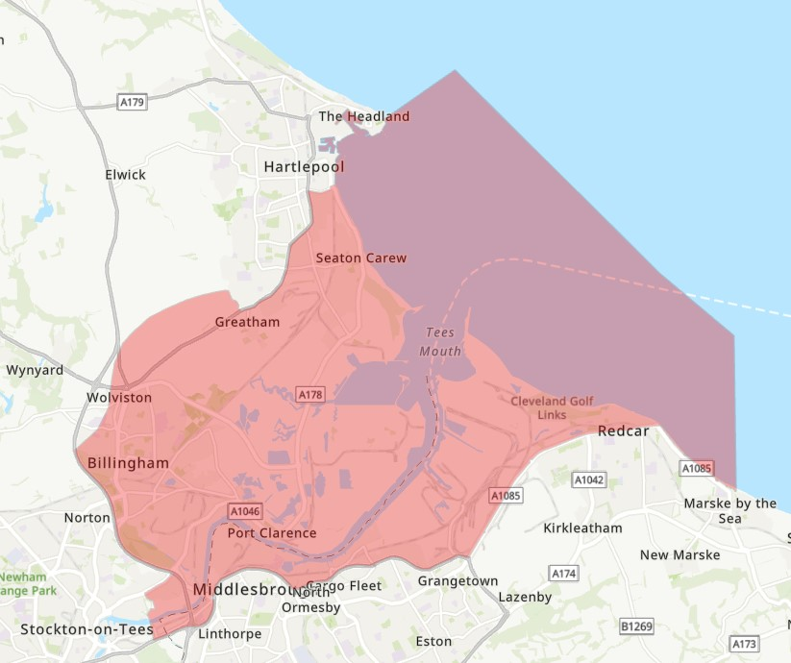

Appendix 2:
Tees Tidelands Footpath: Map of the proposed new circular walking route.

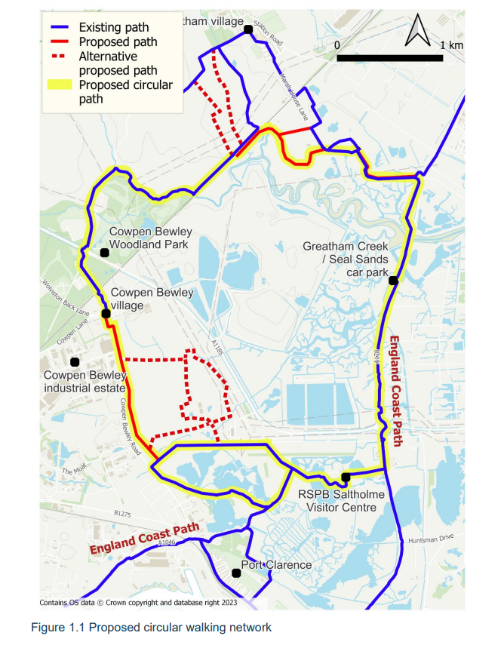

Appendix 3:
Proposed route for the new southern section of the circular footpath.

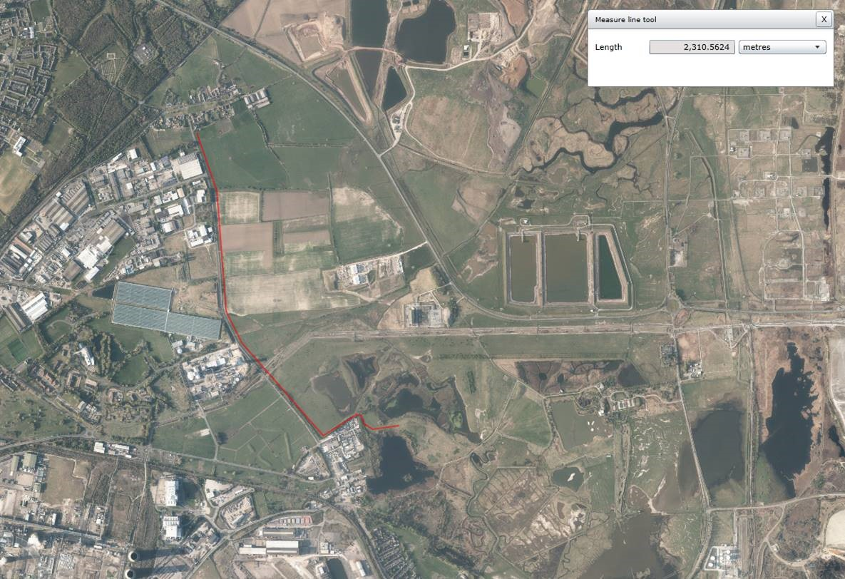

Appendix 4:
Images of Pipeline corridor chambers
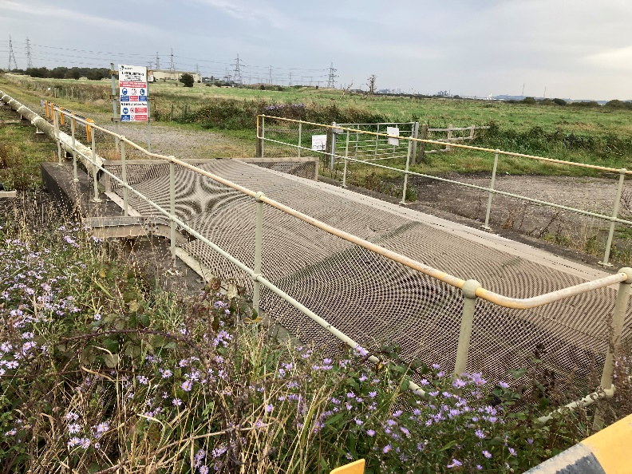
Image 1: Pipeline Chamber 01

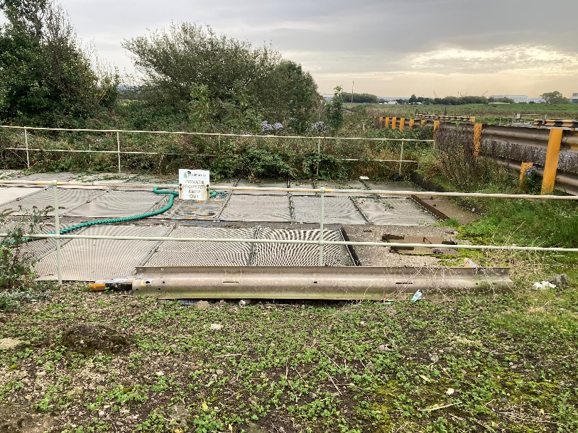

Image 2: Pipeline Chamber 02

