

**Tender information for Hertford Town Council**

**External Repairs and Decorations to Hertford Castle**

**Delivery of Service:** By end of May 2025

**Value:** £5k - £25k depending on extent of works

**Deadline:** 24 February 2025 – midday

**Grade I Listed Castle - Historic Building Works**

Listing information and detail of windows: Castle gatehouse, subsequently residence, Local Authority offices since 1912. c1460-65, altered and extended late C18, C19 and C20. Late C18 windows on all floors of Gothick style, stone mullioned with moulded lancet heads, stone surrounds and dripmoulds, with divided glazing. These are all 2-light, with exception of 3-light window centrally set on second floor, many installed in original embrasures which were widened as necessary.

**SPECIFICATION OF WORKS**

**1. General Requirements**

**1.1 Conservation Compliance**

* All works must comply with Listed Building Consent requirements
* Contractor must demonstrate previous experience with Grade I listed buildings
* Method statements required for approval before commencement
* All works to be supervised by suitably qualified specialist

**1.2 Product Requirements**

* All materials must be historically appropriate
* Materials to match existing where replacement required

**2. Preparation Works**

* 1. **Windows**
* Clean all surfaces and remove all loose and flaking paint using hand tools only
* No mechanical sanding permitted without specific approval
* Allow adequate drying time between washing and decoration
* Protect all glass and architectural features during works
* Apply wood filler / putty where required, approved for use for heritage buildings

**2.2 Doors**

* Clean all surfaces using appropriate cleaning methods
* Ensure all ironmongery is protected during works

**2.3 Guttering and RWPs**

* Clean all surfaces thoroughly
* Remove corrosion using appropriate methods
* Notify Council of any damaged sections
* Ensure all joints and fixings are secure

**3. Decoration Specification**

**3.1 Windows and doors and Lobby**

* Prime bare timber with suitable primer
* Maintain consistent finish across all windows and doors
* Paint windows, doors and external lobby with exterior paint to match existing (undercoat and top coat)
* Ensure adequate drying time between coats

**3.2 Guttering and RWPs**

* Apply appropriate metal primer to bare areas
* Two coats minimum of exterior black metal paint (undercoat and top coat)
* Ensure complete coverage of all surfaces
* Match current colour scheme

**3.3 Stonework – above doors to main lawn**

• Remove loose or flaking stone. Apply appropriate product to stabilise stonework

**5. Environmental Conditions**

**5.1 Working Parameters**

* Temperature must be between 8°C and 25°C during application
* No painting during wet weather or high humidity
* Protection required against adverse weather
* No works in direct sunlight on relevant surfaces
* Monitor moisture content of timber before application

**6. Protection Measures**

**6.1 Building Protection**

* Protect all adjacent surfaces
* Cover ground areas below working zones
* Protect all architectural features
* Ensure safe access equipment
* Minimise impact on building users

**6.2 Health and Safety**

* Risk assessments and methods statements required
* COSHH assessments for all materials
* Appropriate PPE to be worn
* Safe access equipment to be used
* Price to include cherry picker, ladders, scaffolding as required

**7. Other**

* Two references to be included in tender submission
* Warranty documentation to be included

**Information to tenderers**

Photos below are provided to give an idea of the scope of work and current condition.

The following areas are **not** part of this tender:

* Redecoration of the Conservatory

Windows to redecorate are circled below.

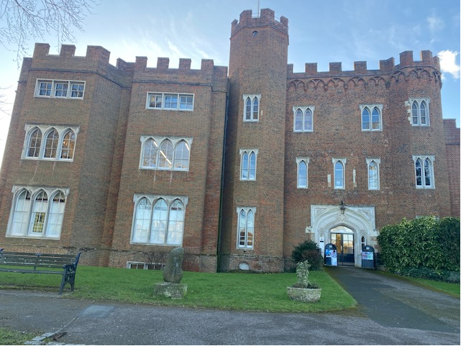  
**East Elevation**

Item 6

Item 5

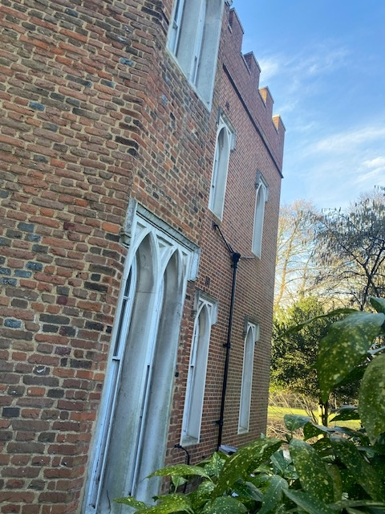 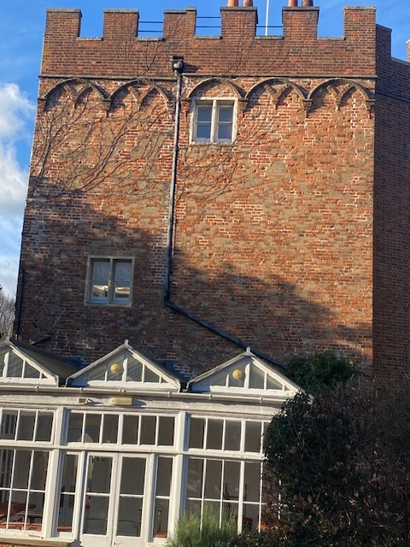 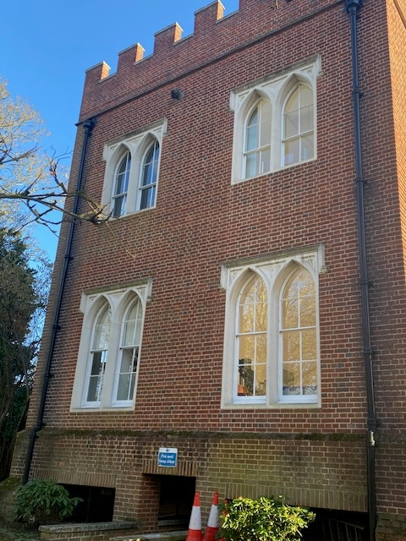

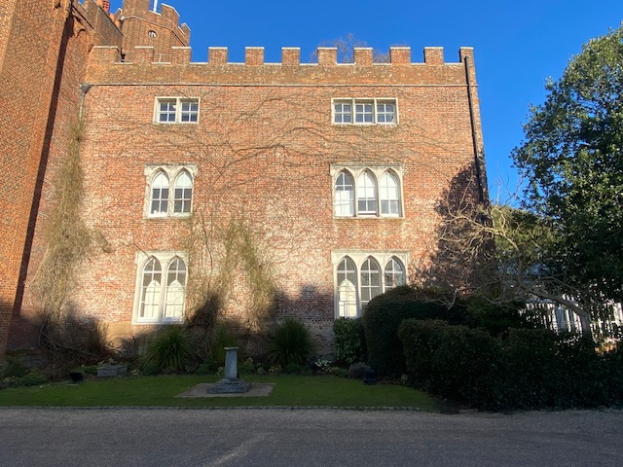

**West Elevation – south end**

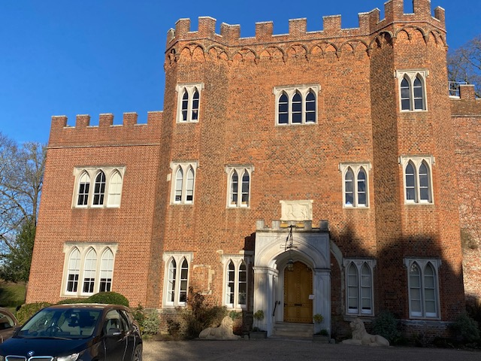

**West Elevation - north end**

Item 4

Item 3

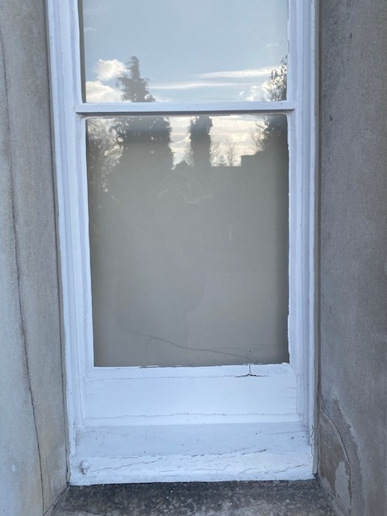 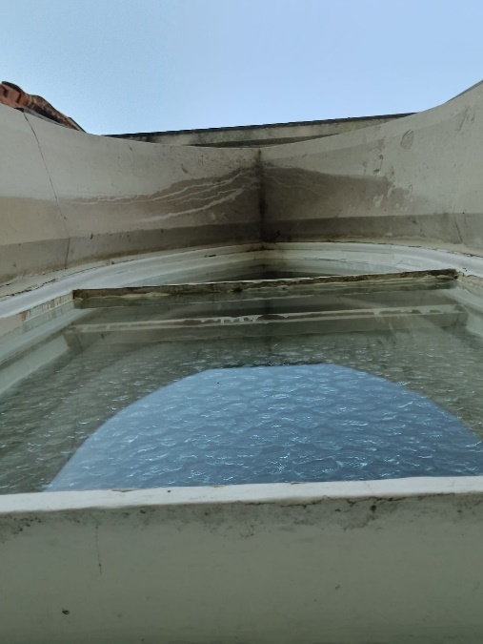

**Detail showing condition of some of the windows.**

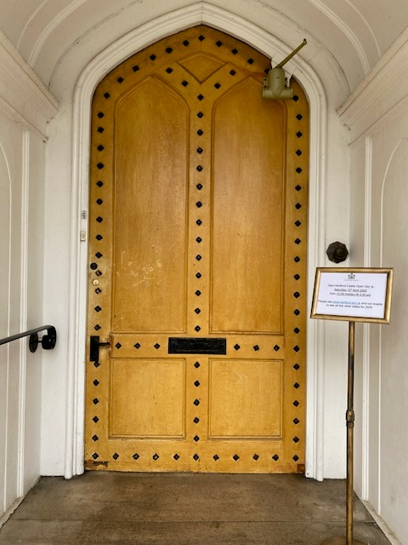 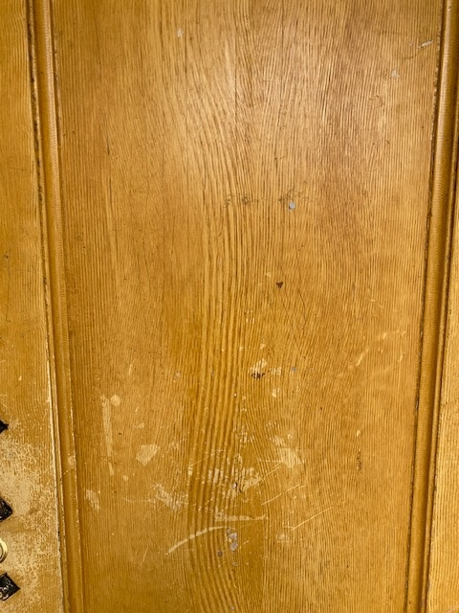

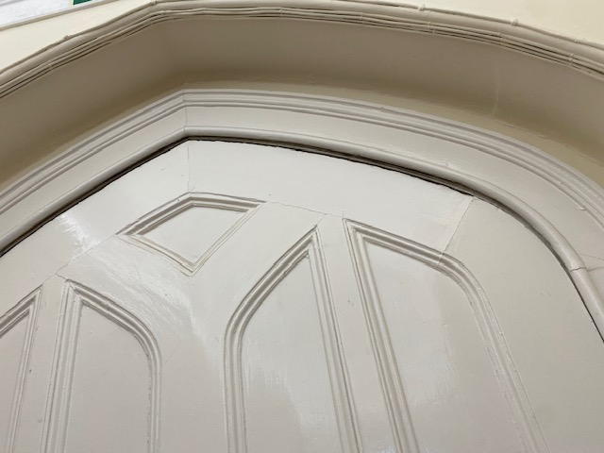 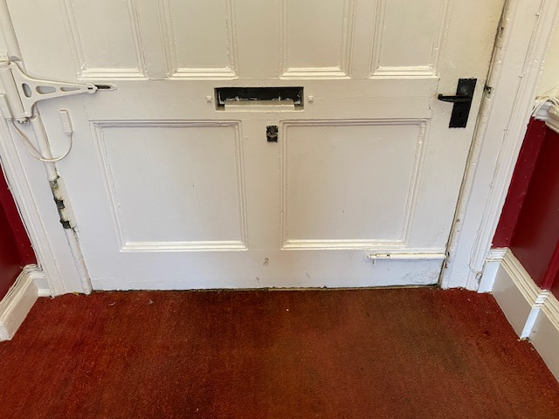

**Item 4. Main Entrance Door**

Tenderers are advised to visit the site and carry out a full survey before submitting a tender price.

**Contact Nick Kirby or Stewart Bray to make arrangements – 01992 552885**

[**Nick.kirby@hertford.gov.uk**](mailto:Nick.kirby@hertford.gov.uk) **or** [**stewart.bray@hertford.gov.uk**](mailto:stewart.bray@hertford.gov.uk)

**Tender submission**

Evidence of suitable experience in undertaking similar work will be essential to the successful bid.

Tender documentation should include a statement regarding the environmental sustainability commitments of your company in relation to this work.

Tender document should evidence that the company has necessary Health and Safety competency and guarantee that ALL decorators / craftsperson’s are skilled in their job roles and have the right equipment and tools to work safely.

**Works Required**

|  |  |  |  |  |
| --- | --- | --- | --- | --- |
|  | Item | Work required |  | Price |
| 1 | Decorations | Carry out external painting decorations to all windows (highlighted with red circle) guttering and RWP's to a high standard as listed in the specification of works.  Wash down, clean and inspect for defects all other windows. Report back to estate of any defects found and remedial work for consideration by the Council.  Works to include cutting back and disposal of all vegetation around all windows, guttering and rain water pipes to give at least 300mm clearance in all directions  Report back with quotations to estate on any defects to guttering & rain water pipes and provide repair if agreed by the Council**.**  **Note: No internal decorations are required**.  **Decoration of Conservatory is not required.** |  |  |
| 2 | Cherry picker hire (MEWP) and Castle scaffolded section (if required) | Eg 16m Diesel Mewp.  Tender to estimate hire period (based on decoration program time)  Tenderer to carry out site survey to ensure that the machine quoted for is suitable for the site. No additional payments will be made if found to be unsuitable. |  |  |
| 3 | Main Entrance (Inside of stone lobby) | Scrape off loose paint, stabilise and re paint in white. |  |  |
| 4 | Main Entrance Door | Carry out preparation and repairs to lower part of door where top layer has been removed  Draft proof and fit suitable draft excluders (tenderer to provide specific details of proposed draft excluded and method of fixing)  Prepare surface and paint and regrain door exterior to match existing  Paint all iron work to match existing |  |  |
| 5 | Rear Entrance from Main Lawn - Stabilise stonework | Remove loose or flaking stone around rear entrance to castle and stabilise. |  |  |
| 6 | Gutter / Downpipe left of Lawn door | Clean and rod gutter, hopper and pipe |  |  |

Total price of work (exc VAT) £____________

Please advise of any additional costs / extras not covered above:

**Other Information:**

The Town Council will require references. Please supply full contact details of at least two clients where you have undertaken this work previously, ideally to a historic building.

On contract award, the successful tendered is to a provide schedule of work and timescales

Your returned tender document must be returned by **Midday, Friday 28 February 2025** via email to: nick.kirby@hertford.gov.uk