Luton Wellbeing Service Model

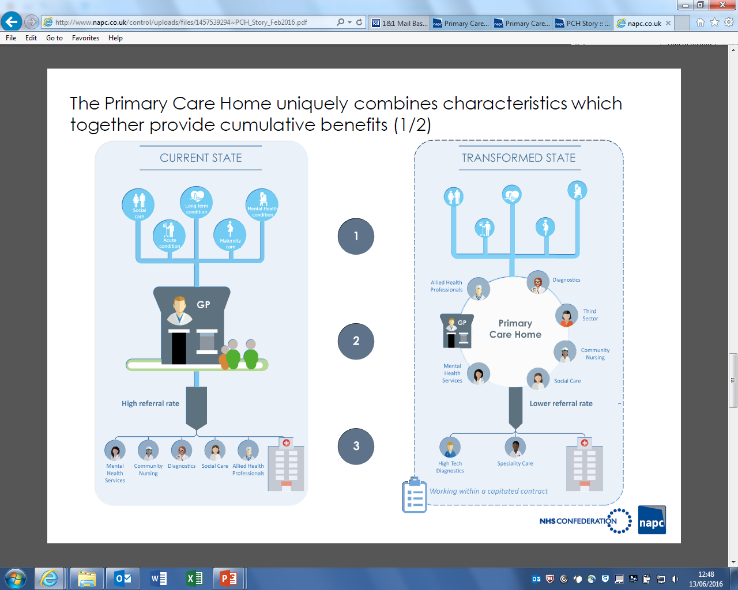

Primary/community-based mental wellbeing service:
- Primary care mental health assessment & liaison service
- IAPT – Talking Therapies
- Community physical wellbeing service including weight management, movement/ exercise, stop smoking
- Social prescription (all practices)

Phase One will include all IAPT Services and Healthy Living Services, Social Presciptions and Smoking Cessation services

Phase Two will be the development of the Primary Care Mental Health Assessment and Liaison Service.

Phase Three will relate to further agreed Children’s Services wellbeing services.

