Crown Commercial Service
_________________________________________________________________________
Call Off Order Form for Management Consultancy Services

THE CONCLAVE BUSINESS CASE REVIEW

FROM

ACCENTURE (UK) LIMITED

TO

CROWN COMMERCIAL SERVICE
_________________________________________________________________________

12/08/2013
PART 1 – CALL OFF ORDER FORM

SECTION A

This Call Off Order Form is issued in accordance with the provisions of the Framework Agreement for the provision of Management Consultancy Services dated 04 September 2018.

The Supplier agrees to supply the Services specified below on and subject to the terms of this Call Off Contract.

For the avoidance of doubt this Call Off Contract consists of the terms set out in this Call Off Order Form and the Call Off Terms.

Order Number | To be confirmed following Contract award.
From | Crown Commercial Service  ("CUSTOMER")
To | Accenture (UK) Limited  ("SUPPLIER")
Date | Monday 11 August 2020  ("DATE")

SECTION B

- call off contract period

Commencement Date:
Monday 11 August 2020
Expiry Date:
Friday 11 September 2020
There is an option to extend for up to one week

- Services

2.1. | Services required:  See Annex 1 – Statement of Requirements

- PROJECT Plan

3.1. | Project Plan:  The following Contract Milestones shall apply;  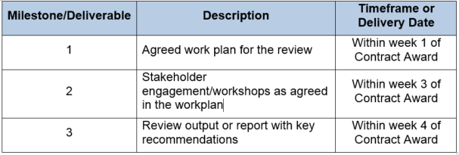

- contract performance

4.1. | Standards:  The Authority will measure the quality of the Suplier’s delivery by;  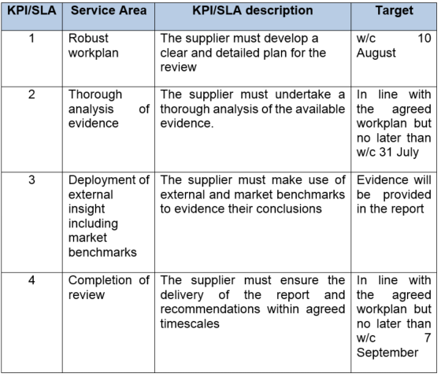
4.2 | Service Levels/Service Credits:  Not applied
4.3 | Critical Service Level Failure:  Not applied
4.4 | Performance Monitoring:  Not applied
4.5 | Period for providing Rectification Plan:  The period of ten (10) Working Days in Clause 39.2.1(a)

- personnel

5.1 | Key Personnel:  For Crown Commercial Service (The Customer)  [REDACTED]  For Accenture (The Supplier)  [REDACTED]
5.2 | Relevant Convictions (Clause 28.2 of the Call Off Terms):  In Clause 28.2 of the Call Off Terms

- PAYMENT

6.1 | Call Off Contract Charges (including any applicable discount(s), but excluding VAT):  The maximum value of the Contract will be up to £50,000.00 (ex VAT) and cannot exceed this amount.  These rates are to remain firm for the duration of the Contract including any Contract extensions.  [REDACTED]
6.2 | Payment terms/profile (including method of payment e.g. Government Procurement Card (GPC) or BACS):  Payment can only be made following satisfactory delivery of pre-agreed certified products and deliverables.  Before payment can be considered, each invoice must include a detailed elemental breakdown of work completed and the associated costs.
6.3 | Reimbursable Expenses:  Not permitted
6.4 | Customer billing address (paragraph 7.6 of Call Off Schedule 3 (Call Off Contract Charges, Payment and Invoicing)):  Invoices should be submitted to: supplierinvoices@crowncommercial.gov.uk.
6.5 | Call Off Contract Charges fixed for (paragraph 8.2 of Schedule 3 (Call Off Contract Charges, Payment and Invoicing)):  Shall be fixed for the full term of the Contract  Full details of the Contract charges can be found in Section 6.1 of the Call Off Order Form
6.6 | Supplier periodic assessment of Call Off Contract Charges (paragraph 9.2 of Call Off Schedule 3 (Call Off Contract Charges, Payment and Invoicing)) will be carried out on:  Not Applicable
6.7 | Supplier request for increase in the Call Off Contract Charges (paragraph 10 of Call Off Schedule 3 (Call Off Contract Charges, Payment and Invoicing)):  Not Permitted

- LIABILITY and insurance

7.1 | Estimated Year 1 Call Off Contract Charges:  The maximum overall sum of this Contract shall be £50,000.00 (ex VAT)
7.2 | Supplier’s limitation of Liability  In Clause 37.2.1 of the Call Off Terms
7.3 | Insurance  In Clause 38.3 of the Call Off Terms

- TERMINATION and exit

8.1 | Termination on material Default  In Clause 42.2.1(c) of the Call Off Terms
8.2 | Termination without cause notice period  The period of thirty (30) Working Days in Clause 42.7 of the Call Off Terms
8.3 | Undisputed Sums Limit:  In Clause 43.1.1 of the Call Off Terms
8.4 | Exit Management:  In Call Off Schedule 9 (Exit Management)  The exit strategy is to be applied where poor Supplier performance requires early termination of the Contract will be to first attempt to rectify any issues with Accenture.

- supplier information

9.1 | Supplier's inspection of Sites, Customer Property and Customer Assets:  Not Applicable
9.2 | Commercially Sensitive Information:  [REDACTED]

- OTHER CALL OFF REQUIREMENTS

10.1 | Recitals (in preamble to the Call Off Terms):  Recital A
10.2 | Call Off Guarantee (Clause 4 of the Call Off Terms):  Not required
10.3 | Security:  Short form security requirements
10.4 | ICT Policy:  Not applied
10.6 | Business Continuity & Disaster Recovery:  In Call Off Schedule 8 (Business Continuity and Disaster Recovery)  Disaster Period:  For the purpose of the definition of “Disaster” in Call Off Schedule 1 (Definitions) the “Disaster Period” shall be for the duration of the Contract.
10.7 | NOT USED
10.8 | Protection of Customer Data (Clause 35.2.3 of the Call Off Terms):  Not Applicable
10.9 | Notices (Clause 56.6 of the Call Off Terms):  Customer’s postal address:  Crown Commercial Service  5th Floor,  151 Buckingham palace Road,  London  SW1W 9SH  Supplier’s postal address:  30 Fenchurch Street,  London  EC3M 3BD
10.10 | Transparency Reports  Not Applicable
10.11 | Alternative and/or Additional Clauses from Call Off Schedule 14 and if required, any Customer alternative pricing mechanism:  Not Applicable
10.12 | Call Off Tender  [REDACTED]
10.13 | Publicity and Branding (Clause 36.3.2 of the Call Off Terms)  Not Applicable
10.14 | Staff Transfer  Not Applicable
10.15 | Processing Data  Call Off Schedule 17  Customer Data Protection Officer  Name: Carmelle Sutcliffe  Email:carmel.sutcliffe@crowncommercial.gov.uk  Supplier Data Protection Officer  Name [REDACTED]  Email [REDACTED]
Contract Reference: | CCCC20B21
Date: | Monday 10 August 2020
Description Of Authorised Processing | Details
Identity of the Controller and Processor | The Parties acknowledge that for the purposes of the Data Protection Legislation the Customer is the Data Controller and the Supplier is the Data Processor.
Use of Personal Data | Managing the obligations under the Call Off Contract Agreement, including exit management, and other associated activities,
Duration of the processing | For the duration of the Framework Contract plus 7 years.
Nature and purposes of the processing
Type of Personal Data | Full name  Worplace address  Workplace Phone Number  Workplace email address  Names  Job Title  Compensation
  Tenure InformationQualifications or Certifications
  Nationality
  Education & training history
  Previous work history
  Personal Interests
  References and referee details
  Driving license details
  National insurance number
  Bank statements
  Utility bills
  Job title or role
  Job application details
  Start date
  End date & reason for termination
  Contract type
  Compensation data
  Photographic Facial Image
  Biometric data
  Birth certificates
  IP Address
  Details of physical and psychological health or medical condition
  Next of kin & emergency contact details
  Record of absence, time tracking & annual leave
Categories of Data Subject

FORMATION OF CALL OFF CONTRACT
BY SIGNING AND RETURNING THIS CALL OFF ORDER FORM (which may be done by electronic means) the Supplier agrees to enter a Call Off Contract with the Customer to provide the Services in accordance with the terms Call Off Order Form and the Call Off Terms.
The Parties hereby acknowledge and agree that they have read the Call Off Order Form and the Call Off Terms and by signing below agree to be bound by this Call Off Contract.
In accordance with paragraph 7 of Framework Schedule 5 (Call Off Procedure), the Parties hereby acknowledge and agree that this Call Off Contract shall be formed when the Customer acknowledges (which may be done by electronic means) the receipt of the signed copy of the Call Off Order Form from the Supplier within two (2) Working Days from such receipt.
For and on behalf of the Supplier:
Name and Title | [REDACTED]
Signature | [REDACTED]
Date | 14th August 2020
For and on behalf of the Customer:
Name and Title | [REDACTED]
Signature | [REDACTED]
Date | 18 August 2020

