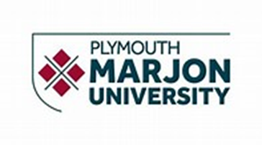

**Specification**

**For**

**Plymouth Marjon University Campus Development Plan**

This Service Specification defines the required service, including the required outcome(s) and outputs.

**Contract Ref:- Masterplan-Bailey OJEU Ref:- 2019/S 099-239965**

**Contents**

1. **Our ‘Beautiful’ C****ampus**
2. **In****troduction**

1. **Scop****e of the Contract****: -**
   * + 1. **Purpose, Approach and Vision;**
       2. **Campus Development Plan Aims and Objectives;**
       3. **Analysis – Strengths, Opportunities & Constraints;**
       4. **Campus Development Plan Strategies… Prospects & Probabilities;**
       5. **Conclusion;**
       6. **Success & Achievement;**

1. **Statement of Requirem****ents**

**1.** **Our ‘Beautiful’ Campus**

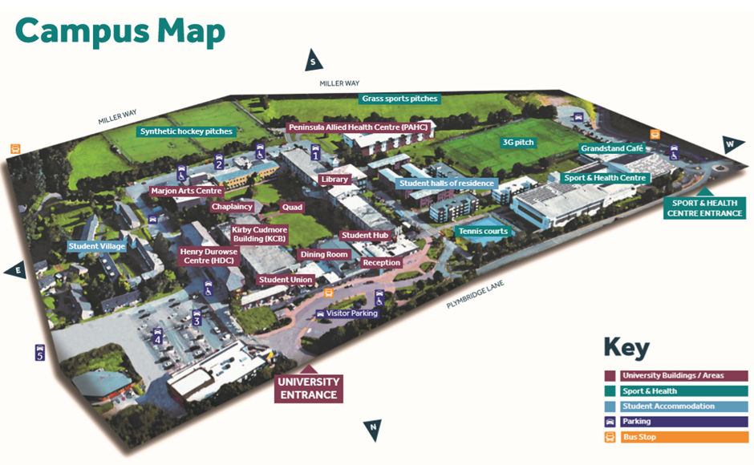

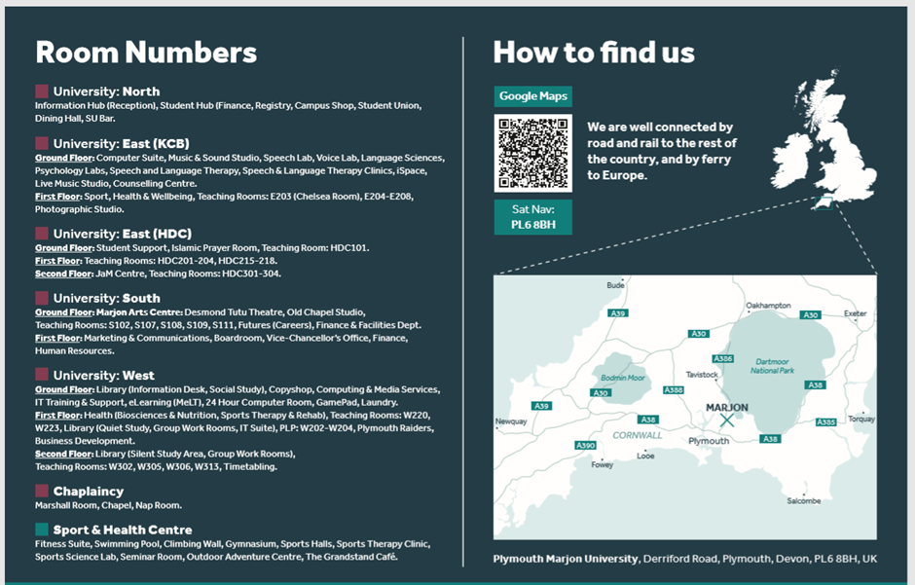

1. **Introduction**

Plymouth Marjon is a small university with a green and spacious campus, and world-class facilities in a spectacular part of the world. With strong support and an ambitious community, its students achieve more than they ever thought possible. Specialisms include teaching, sport, health and wellbeing, social sciences, business, and performing arts.

Our Values - Our Values are at the heart of everything we do.

They were developed by our staff, are inspired by the stories of our students, by our history and by our hopes and ambitions for the future. They encourage both the ability and the aspiration to improve lives for all.

Put simply, everyone at Marjon expects their colleagues to behave with fairness and decency, both to each other and to students. You can expect the same in return from your peers and from the University as a whole. We are wholeheartedly committed to be an inclusive and fair community where every voice counts. We’re not perfect, but if we ever fail at this, we want to know.

We also expect you to commit yourself wholeheartedly to the broader principles and spirit of our Values. We expect you, whatever your role, to encourage ambition and independence, being an empowering force both within your teams and with the students you have contact with. We expect you to bring a positive spirit of curious inquiry to everything you do, always questioning how things could be done better for students, for your colleagues, or for the University as a whole. We expect you to thank colleagues for a job well done and to share achievements together.

We have big ambitions, but above all we are people focused and we expect humanity and grace from all those who work for us.

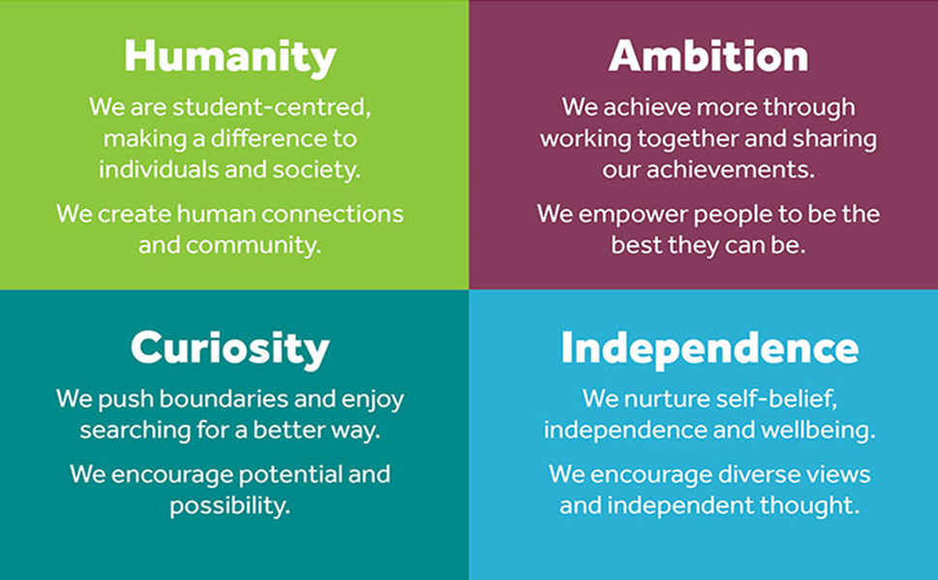

At Marjon, students build strong working relationships with a network of supporters, from their Personal Development Tutors to their lecturers to the Student Union, and therefore achieve more than they ever thought possible. They work side-by-side with us to improve and develop the University to make their experience as rich and rewarding as possible.

All our programmes involve work placements of some sort, and all students are trained in critical graduate-level skills such as presenting with impact, applying for jobs, managing interviews and influencing others. We work very closely with key employers on all programmes, linking our students to a network of contacts to help them in their future careers.

Our results speak for themselves: more than 95% of students find employment or move into further study within six months of graduating, and we have three courses which have scored 100% satisfaction in the National Student Survey 2017. We were also named the top University in the UK for social mobility in a one-off report in 2014, demonstrating the power of giving students both the skills to succeed and the confidence to use them.

Additional general information about Marjon can be found at [marjon.ac.uk](http://www.marjon.ac.uk/)

**The Marjon Growth Plan:**

This growth plan addresses the critical developments for Marjon in the period from the implementation of the Higher Education and Research Act 2017 and the Teaching Excellence Framework (TEF) to the demographic upturn in 2021.

The plan addresses a wide range of issues in the life of the University, but does so under three key headings:

1. Proud to be Marjon

2. Centred on Student Success

3. Building a Vibrant Future

This [**d****ocument**](https://www.marjon.ac.uk/media/old-2015-website-images/Marjon-Growth-Plan-2017-2021-FINAL.pdf) is deliberately short, providing an ambitious direction of travel. Indicative rather than exhaustive, it will be supported where appropriate by a series of strategy and action documents, for example: personalised learning and retention; values in action; graduate careers; curriculum development; REF 2021 plan; estate redevelopment; estate utilisation; civic and business interface; collaborative provision and international.

1. **Scope of the Contract**

Plymouth Marjon University require a clear and considered Campus Development Plan to be developed in partnership with Marjon professionals, students, staff and the local community that serves as the key to environmental, physical, social wellbeing and economic revival of our beautiful campus.

Our Campus Development Plan is to be developed and designed specifically to support and reflect our academic excellence through the built environment and underpin our ambition to maintain and grow the aims and ambitions for the city and future success of Plymouth Marjon University.

We have structured our specification to focus on the following key areas: -

1. **Purpose, Approach and Vision**

**6. Success & Achievement**

**2. Campus Plan Aims and Objectives**



**5. Conclusion**

**3. Analysis – Strengths, Opportunities & Constraints**

**4. Campus Plan Strategies… Prospects & Probabilities**

1. **Purpose, Approach and Vision**

The overarching purpose of the Campus Development Plan is to recommend a series of strategies for the creation of a unified campus that is both identifiable and integrated, not only with the city, but the wider South West. Providing an environment that enhances the experiences of students, staff, visitors and the wider community. These integrations are an essential activity to develop and promote continued growth and success of Plymouth Marjon University, and the estate provides the solution for this to happen.

Plymouth Marjon University predominantly require the approach to be transformational in regard of our current estate, through modification of existing buildings in place of demolition and re-builds. The outputs of the resultant Campus Development Plan also need to be futureproofed in order to inform the Universities Capital Project framework to 2025. The Campus Development Plan MUST also promote health and well-being by providing an environment that inspires and encourages healthy working and living.

Our vision is that the Campus Development Plan provides options, opportunities and cohesion fit for the 4th Industrial Revolution ‘Education 4.0’. Ensuring that our Digital Strategy feeds into and supports the campus development.

Plymouth Marjon University Campus History

The Plymouth Marjon University you see today is the product of more than 170 years’ progressive educational growth. Originally founded in the early 1840s in response to the growing demand for trained teachers, the two constituent colleges (St Mark’s and St John's) were originally based in London, moving to Plymouth in 1973.

The campus for Marjon in Plymouth was designed by Kendrick Findlay Partners creating a sleek modernist campus in a beautiful setting with views from the moors to the Plymouth Sound.

The campus has had a number of additions over the years, changing the form of the original buildings. The landscaping of the campus is also quite different from the original and there is much opportunity across the campus for significant improvements, and an opportunity to make more of the setting.

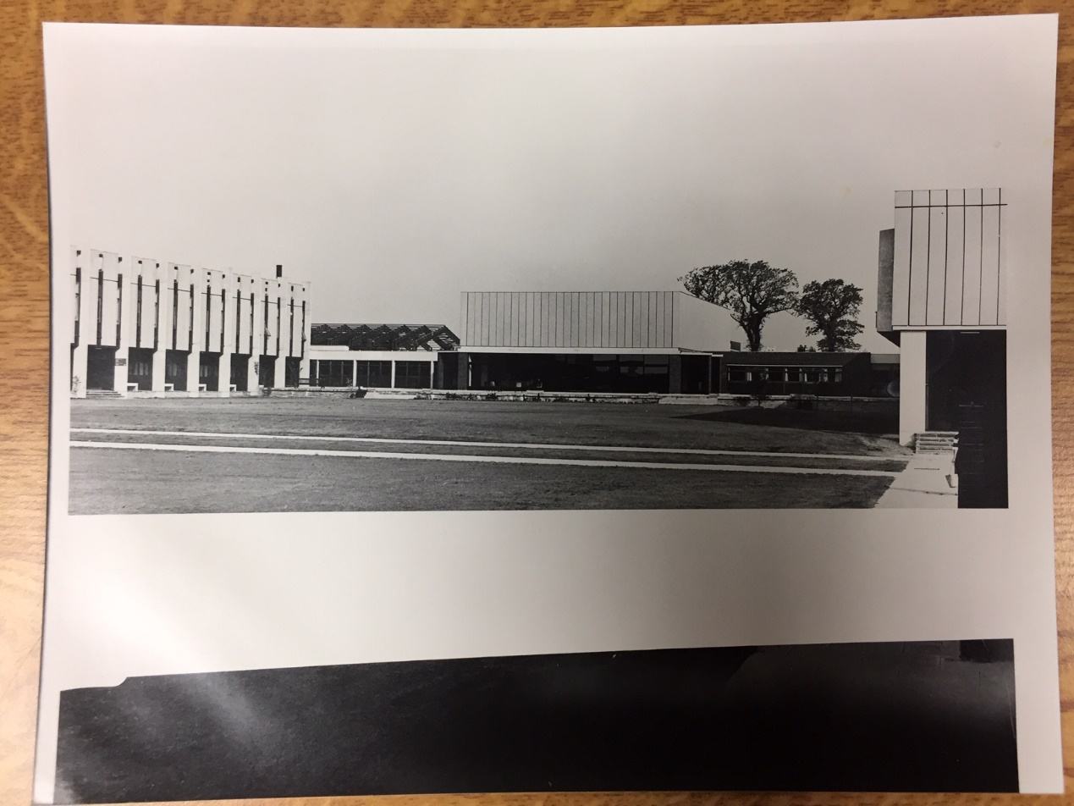

Figure 1: View of North Quad Early 1970s

The campus currently has some distinct areas; the main portion of the academic campus wraps around a University Quad which originally had a ground level opening revealing views out that took in the spectacular vista to the south of the campus. The sports centre sits to the west of the campus, and in between there are seven halls of residence. The student village (accommodation), and staff houses are towards the east side of the campus.

Parking and service roads dominate the spaces around the University’s buildings which detracts from the experience of enjoying the outdoor spaces that so often attract people to the South West of England. There are a few major tenants on the campus. The University of Plymouth, who occupy the PAHC Building (where 880 students are taught) will be vacating the academic building in 2022. The Department of Education have a (currently unoccupied) studio school on campus, there is a small nursery school and a helicopter pad (used by Derriford Hospital).

1. **Campus Development Plan** **Aims and Objectives**

From inception the Campus Development Plan aims and objectives, include but are not limited to: -

Driving the Growth Plan:

* Using the Marjon Campus to facilitate growth, diversification and supporting the strategic aims of the University;
* Making the most of the estate & facilities;
* Can the campus enable new ways of working?
* Better space utilisation, innovative academic delivery and enhanced brand?
* Can we achieve a 50% growth in student numbers with the current estate?
* Can we use our estate and infrastructure to help drive this growth?

Space Utilisation:

* Understanding where the true needs are for more space & opportunities for efficiency.
* Teaching & Learning Frequency: 35% Occupancy: 28% Utilisation: 10%
* Academic Offices Frequency: 35%
* Professional Services Frequency: 45%
* Office Average Desk Utilisation: 28%
* Highest Utilisation 3 x Counselling Rooms & the Swimming Pool

Student Need:

* Understanding what students need for success and what they lack or need more of;

Faculty Need:

* Understanding the faculties opportunities for growth and needs for today;

Local Need:

* How does Marjon respond to the local community, the local economy and stand out among SW HE providers;

Commercial Revenue:

* Bring the community into the campus. Responding to the local economy & needs;
* Opportunities for the facilities to be used for events, conferences and tourism;
* Flexing the campus to help our neighbours and support local business growth (incubators, accelerators, co-working either in partnership with our Business School or independently);
* An asset to Devon & South West: -
  + Proud to be Marjon
  + Building a vibrant future

Utilising our facilities much more effectively & accommodating growth:

* Marjon has the space to grow. Intelligent use of the campus is preferable to spending several £millions on new buildings;
* Fewer better utilised spaces means we can offer an enhanced pedagogical environment;
* Build trigger points into the strategy to accommodate tranches of growth;
* Short term commercial usage opportunities; whilst Marjon develops and grows to utilise under used buildings and facilities (alongside permanent commercial use)

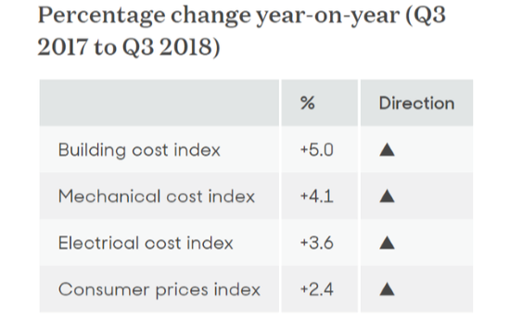

Education 4.0:

* Modern Infrastructure to Support the Activity on Site
* Working with the Digital Innovation Team, Academics, staff and student to provide a modern service that works for Marjon.
* JISC analysis to be undertaken in Autumn 2019
* Digital Strategy to feed into and support the campus development: -
  + Designed for digital natives
  + Fit for the 4th Industrial Revolution

More Student Accommodation:

* Occupancy is over 90%;
* Many 2nd & 3rd years would like to live on campus;
* Currently unable to provide the accommodation to satisfy the demand;
* Expanded student village?

Green, sustainable, low-carbon campus:

* Zero / Low carbon;
* Establish what would it take to make Marjon a zero/low carbon campus?
* Responding to the momentum from Paris COP21, SDGs, national legislation and the Plymouth Plan;
* Simple building physics and a good user experience conducive for work and learning;
* It also often means big financial savings;
* Does your QS factor in revenue spend across a building's life?
* Developer, owner & operator!
* Making use of the beautiful Marjon campus.
* Better pedestrian & cycling experience, end the tyranny of the car!
* Major landscaping works, especially in the quad, around the entrances of buildings and making more of the natural capital.

Health & Wellbeing benefits

* Proud to be Marjon;
* Centred on Student Success;
* Building a Vibrant Future;

Full Estates & Infrastructure Strategy & Campus Development Plan

* Holistic view of the campus, looking at the University's core strategy;
* Creating a campus that can respond to growth with in-built flexibility;
* Accommodate a 1,000 + student cohort through: -
  + Growth;
  + Education 4.0;
  + Sustainability;
  + Beautiful;

1. **Analysis – Strengths, Opportunities & Constraints**

Acknowledging that the achievement of a detailed and meaningful analysis, will come to fruition from the scrutiny and exploration of several specialist disciplines, for example, Architects, Designers, Planners, Quantity Surveyors, Engineers, Landscapers, Business Strategists, Feasibility Consultants, Investment Specialists. Plymouth Marjon University have identified the following: -

Strengths

* provide options and direction on how we can develop the campus over the long-term;
* recommend guiding investment in the University estate over the short to medium term;
* promote and advertise the various elements of the campus buildings, facilities and spaces and how these can be connected and integrated with the City;

Opportunities

* design and develop a campus that improves first impressions by breathing new life into our iconic buildings;
* recognising that the campus has a beautiful landscape, but that this is engulfed by an abundance of parking - cars must be a lessor dominance over time!
* Improving cycle/pedestrian connectivity and encourage greater recreational use of our extensive facilities;

Constraints

* the Campus Development Plan is balanced with current and future affordability;
* there is a focus on realistic delivery and commercial reality;
* consideration and mitigation of an increasingly competitive ‘University’ market, ensuring that the solutions continue to meet the expectations of its students and staff;
* that the current social, economic, transportation and environmental context of the city are understood and embedded in all development proposals;

*Please note that the information contained within Sections 2 and 3 above will involve significant cultural and behavioral change that would benefit from the consideration and application of ‘Nudge’ theories and concepts.* [*https://en.wikipedia.org/wiki/Nudge_theory*](https://en.wikipedia.org/wiki/Nudge_theory)

**4. Campus Development Plan** **Strategies… Prospects & Probabilities**

It is essential that the strategy addresses, reflects and builds upon Plymouth Marjon Universities unique and unified identity, by celebrating the campus setting within the City of Plymouth by being both a recognisable ‘University Quarter’ and an integrated and permeable part of the City. In addition, encourage and create the cohesion of all aspects of the campus, whether it be reconnecting a campus fragmented by roads, consolidating diverse buildings, or promoting inter-faculty connection around shared indoor and outdoor teaching spaces.

Another crucial aspect is that the strategy creates a campus that truly embodies the University’s ethos and ambition in sustainably environmental design, illustrated by the momentum from Paris COP21, SDGs, national legislation and the Plymouth Plan. By creating green spaces of all scales to help promote learning, well-being and healthy lifestyles, by giving precedence and ease in the campus to walkers and cyclists. That in turn encourage sustainable forms of transport and also enliven the campus spaces with positive forms of movement and support safe efficient movement across campus.

Finally, the strategy, prospects and probabilities to develop growth that will safeguard the Universities ability to grow and supply current and future student demands with excellent facilities.

1. **Conclusion**

Plymouth Marjon University requires a complete review of our campus in its entirety, that informs ‘fit for purpose’ and relevant development opportunities for the estate, to enable and allow the University to grow in line with our academic and faculty plans and ambitions. Including the development of a sustainability strategy that makes a positive contribution to the University and the management of climate change.

1. **Success & Achievement**

This will be accomplished by applying and engraining all of the information contained within this specification, accompanying links, resources and attachments. Specifically, the importance and need for the Campus Development Plan to be detailed and reference how the programme will support the University’s mission, vision, identity and aspirations, that enhances and develops our identity.

1. **Statement of Requirements**

Instructions for Completion

Tenderers are required to complete the box titled ‘Tenderer Response’- **Please ensure that your responses to each of the requirements below, are structured and presented in a conducive manner that addresses and responds to the salient points of each requirement.**

Each question must be answered in its own right. Tenderers must not answer any of the questions by cross referencing other questions or other materials e.g. reports located on your website. (Please note that Plymouth Marjon University reserves the right to mark a Tenderer down or exclude them from the procurement if the submission contains any ambiguities or lacks clarity.)

Please note that the Statement of Requirements have been categorised as either ‘Mandatory’ or Pass/Fail the definitions for each of these are: -

Mandatory (weighting 100%) = Plymouth Marjon University have determined the requirements designated as ‘mandatory’ are obligatory to the success and requirement outputs of the required service/solution.

The Structure of the Statement of Requirements is categorised four discrete areas as per the following: -

1. Project Overview & Campus Development Plan Objectives;
2. Sustainability & Zero Carbon;
3. Programme;
4. Communications and Stakeholder Engagement;

Requirements

1. Project Overview & Campus Development Plan Objectives – **Mandatory – Weighting 35%**

**Supporting Information**: -

Plymouth Marjon University has an ambitious growth plan, increasing student numbers by 50% and attracting a cohort of 1,000 undergraduates. The University needs to set out an estates development plan and strategy that reflects this ambitious growth plan, makes much more of the University’s unrivalled geographic setting and sets out a marker for practical low-carbon design.

The plan will be useful as a core strategic document for the University as it grows over the next decade, dealing with short term issues, such as poor space utilisation and suitability, medium-term requirements, such as redesigned teaching spaces reflecting pedagogical innovation as well as setting out a strategy for campus growth over the long-term.

**2030 Campus Vision:** The Plymouth Marjon University Campus will be regularly referred to as the most beautiful university campus in the UK. Photographs of the campus will feature regularly in positive news stories about higher education. Students who visit the University on open days will leave with Marjon at the top of their choice list, having been impressed and inspired by the unrivalled facilities, beautiful landscaping and architecture.

The campus will be considered a sustainability and zero-carbon milestone, demonstrating how 20th Century Buildings can be reimagined to create comfortable, low-carbon buildings adaptable to the modern higher education demands. The new buildings on campus will be revered for their aesthetic, but also respected for their considered flexibility, to ensure their usefulness in 2040, 2050 and the many decades beyond.

Residents of Plymouth and the South West will regularly visit the campus, which has now become the cultural and sporting hub of the north of Plymouth. Visitors will receive world-class health and wellbeing support, swim and relax in the sports and health centre, watch five star shows and performances in the Marjon Arts Centre or come to the campus with work, utilising the professional conference and events spaces.

Students living on campus will be spoiled with a choice when selecting their accommodation, a range of accommodation offers will suit the variety of budgets, personal needs and support requirements our diverse student body has. Options for a mix of communal living experiences will be available on campus, and second, third years and postgraduates will be attracted to the dedicated campus accommodation offers for them.

Teaching and Learning spaces will be highly utilised, classrooms will be flexible and adaptable to the modern teaching requirements of higher education. Courses with specialist technical spaces will reflect the professional environment our students will end up working in and continue to wow prospective students visiting the campus. There will be plenty of spaces for students to engage in informal learning activities, with spaces that support study regardless of their location, from the library, to the refectory and gardens in the quad.

Staff will work in modern spaces designed and supporting the different work activities they undertake in their role. The spaces will be inherently flexible and allow staff from different departments to work collaboratively when suitable but also find quiet spaces for focussed work when required.

Students and staff will enjoy the spaces between the buildings as much as their time inside. Privately owned cars will no longer dominate the campus, the buildings will be broken up by beautiful landscaping that ties the natural desire lines to the main campus activities. Students will regularly be stopped in their tracks by a sighting of some majestic wildlife, sound of birdsong or panoramic view. On occasions they may decide to tear it up on the dedicated mountain bike track or relax with a book in the sensory garden with a gentle background buzz of Marjon bees.

While those who had visited the Plymouth Marjon Campus 10 years before will feel the space has been transformed, they will notice that it is still recognisable. The best parts of the 1970s modernist heritage will be celebrated but the spaces inside the buildings will be distinctly modern showing off the teaching and learning spaces inspiring our students to be leaders in their work lives during 4th Industrial Revolution.

All of this will have been achieved with sensible and well considered interventions. The investment in the campus will have accurately reflected the growth in student numbers and university business. Where incorrect anticipations had been made in the 2020s, the campus was flexible enough to adapt and grow in the direction the University took.

**Main Project Objectives:**

The primary aim of this project is to provide an architectural Campus Development Plan, development and space strategy for the University. It needs to reflect the vision for the campus and the University’s Growth Plan. The plan needs to understand how the campus has developed over the years and the reasons as to why, understand the current campus usage and set out the likely future usage.

The approach to delivering the strategy and plan needs to ensure that the plan is developed in a way that reflects the higher education landscape, considers the demographic opportunities and the likely anticipated changes in education. It should take a holistic view of the campus but also look to the wider landscape and opportunity, including the Plymouth & SW Devon Joint Local Plan.

The plan needs to consider how Plymouth Marjon University responds to the warnings from the International Panel on Climate Change (IPCC) about the urgency in which zero carbon emissions must be met.

Stakeholder engagement is key. Staff, students and other key stakeholders must feel that they have been able to input into the process and have their ideas and concerns considered in the development of the plan.



Figure 2: Children Playing in original North Quad & Terrace

**Additional Objectives:**

Access: The University has a diverse range of staff and students who have a wide variety of different needs and accessibility requirements.

Building Condition & Suitability: Each building should be assessed for its suitability for use, opportunities for reusing academic buildings as residential or vice versa should be assessed. A lifespan of the building needs to be assessed, allowing the University to determine which buildings should be demolished and replaced and which should be maintained and refurbished.

Reflecting the Marjon Values: <https://www.marjon.ac.uk/about-marjon/working-for-the-university/our-values/> Plymouth Marjon University is incredibly proud of its values, and genuinely applies them to its approach to campus life. The Plan needs to consider how it reflects and encourages these values.

Design Palette: The University lacks a consistent approach to materials, colours, landscaping and planting. A palette of materials, and/or design principles which could be used in future projects would be highly valued by the University.

***Tenderers are required to provide their approach, including what practices and methods your will use/apply that encompass the requirement above* in its entirety.** Tenderers attention is particularly drawn to the vison and objectives to offer Plymouth Marjon University your considerations and how these will be applied to this project. Tenderers may want to consider the relevant elements of an architectural Campus Development Plan, estates strategy, space plan or commercial strategy in developing their proposal for the plan. Plymouth Marjon University welcome, visuals and / or mood boards that would be relevant, or that demonstrate the approach would be welcome, however Tenderers are left to determine what they feel is the best way to demonstrate their approach.

|  |
| --- |
| **Tenders Response – Please note page limit of 6 A4 pages – using font Arial 11)** |
|  |

1. Sustainability & Zero Carbon – **Mandatory – Weighting 25%**

Climate change is one of the most pressing issues of our time. Addressing it requires a transition to a low/zero-carbon economy. It is essential that the Campus Development Plan is structured and applies processes that are environmentally responsible and resource-efficient throughout a building's life-cycle: from planning to design, construction, operation, maintenance, renovation, and demolition. In 2018 the IPCC set out a stark warning urging countries to do much more, much faster to achieve zero carbon. 2030 has been set out as a marker, which matches the likely conclusion for campus developments that will be set out in this plan

Plymouth Marjon University believe that the following (whilst not an exhaustive list) need to be comprehensively appraised, and incorporated into the development of our Campus Development Plan: -

* The impact on capital cost and project viability & the technical feasibility;

High Efficiency Lighting & Controls;

Improved Insulation

Photovoltaics/Wind Turbines

* A mechanism for saving operational costs that in turn limit environmental impacts;

Behavioural & Cultural

Change

Natural Ventilation & Lighting

* Achieve a positive reputation that can be marketed to influence and encourage student growth;

Building Management Systems

***Tenderers are required to present a plan that will set out your approaches for environmental sustainability, low and no-carbon design and how our ambitions can be achieved within normal development budgets. For the University’s development over the next 10 years.*** Tenderers attention is particularly drawn to this being a once in a generation opportunity for the University to achieve science-based carbon targets. The ambition is for this to be achieved with good, considered design from the outset rather than expensive additions and retrofitting at a later date/stage.

|  |
| --- |
| **Tenders Response – Please note page limit of 4 A4 pages – using font Arial 11)** |
|  |

1. **Programme – Mandatory – Weighting 5%**

Plymouth Marjon University requires the tenderer to provide an outline of the approach to take the University through the development of the plan and campus strategy.

***Tenderers are required to present a plan that includes their approach to management of client meetings, stakeholder interactions and communications, approvals, schedules and quality assurance controls.*** Tenderers attention is particularly drawn to the inclusion of the following :-

* Deliverables at each stage
* Indicative timeline
* Opportunities or constraints
* Any assumptions or resource implications for the University

|  |
| --- |
| **Tenders Response – Please note page limit of 3 – A4 pages – using font Arial 11)** |
|  |

1. **Communications and Stakeholder Engagement – Mandatory – Weighting 5%**

Plymouth Marjon University places great emphasis on robust collaborative and working relationships with our suppliers’ and where applicable their allocated team(s) specifically in relation to:

Stakeholder mapping and engagement; Change controls; Charges and cost monitoring; Ordering procedures; Receipt and acceptance procedures; Payment procedures; Budget procedures; Resource Management and planning; Operational and management reporting; Asset management; Progress meetings and Escalation etc.,

The Campus Development Plan will require input from a wide variety of campus users and stakeholders, this should both inform the strategic development of the plan, but also inform campus users of how their input is being considered.

Marjon Key Stakeholders: -

Students;

Vice Chancellor;

Director of Estates and IT Infrastructure;

Director of Finance;

Academic Staff;

Marketing;

Other members of Marjon Senior Management Team

***Tenderers are required to present a*** ***holistic approach to stakeholder engagement and key communication approaches that will ensure that the requirements and future journey of the campus plan, is understood and supported where necessary in relation to management of client meetings, stakeholder interactions and communications, approvals, schedules and quality assurance controls.*** Tenderers attention is particularly drawn to the inclusion of the following: -

* Establishing and developing a working partnership with Marjon and partners;
* Managing the successful delivery of all services within the scope of the specification;
* Meeting or exceeding all agreed service levels;
* Ensuring attainment of customer satisfaction;
* Seeking and developing with the client opportunities for cost savings, innovation, including environmental and sustainability options;
* Understanding the integrated operations of each system and their critical interfaces;
* Making operational systems judgements and decisions based on best practice and essential service requirements, to ensure continuity of service;
* Attending liaison/contract review meetings with the Marjon;
* Make recommendations for improving the services;

|  |
| --- |
| **Tenders Response – Please note page limit of 4 – A4 pages – using font Arial 11)** |
|  |