

**FCDO British Embassy Baghdad, Iraq**

**Prior Information Notice**

The Foreign, Commonwealth & Development Office (FCDO) is seeking expressions of interest from potential suppliers for several projects FCDO are seeking to take forward at the British Embassy Baghdad (BEB) in Iraq and are currently exploring how to best deliver these important projects.

We would like to understand which suppliers are interested in tendering for these projects. Further details are provided below on each project to help you better understand the background, project status and planned work.

**The intent of this EOI is to inform the potential bidders of the proposed tender action and for FCDO to understand if suppliers are interested in these projects. No formal assessment of capability or down selection of bidders will be carried out in relation to any responses received as a result of this process.**

Before making a final decision regarding the procurement route, the FCDO reserves the right to change our proposed direction at any stage and to undertake this procurement using alternative routes.

FCDO may withdraw from this market consultation process and any subsequent tendering process at any point and will not be liable for any costs incurred by a supplier participating in this EOI or further competition, including if the process is amended, cancelled or withdrawn.

Please confirm interest by providing responses to the questions below in Annex A and e-mailing Douglas Beveridge (Commercial Lead-Estates) by close of play 9th August 2024.

**BEB Overview**

In 2004 the British Embassy compound in Baghdad was created by constructing new facilities around an existing former school building.

There are a number of infrastructure and estates projects that need to be addressed to keep the BEB compound operational.

**BEB Compound Overview:**

Compound size: 1.1 Km perimeter

Compound area: 105,643 square meters (10.5 hectares)

Number of Residents: Up to 330 on site at any one time

Security – Close protection security and Ghurkhas provide site security and live on compound

The site is supported by a Technical Works Group (TWG) 2x Morson staff and 30 locally engaged maintenance staff.

Map of Compound

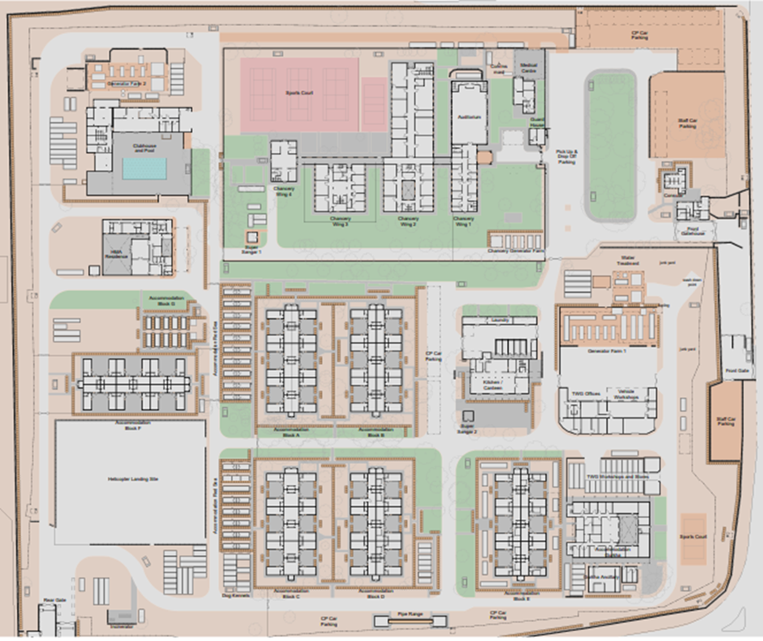

The site buildings and facilities include: Embassy (former school), HMA Residence, accommodation pods, staff club, swimming pool, tennis courts, canteen, laundry, workshops, Ghurkha accommodation block and a helipad.

**Baghdad Project Status:**

FCDO appointed FCDO Services and Apex Core Limited to undertake detailed condition surveys of the buildings, infrastructure and building services. This has concluded with a schedule of work for FCDO to take forward. The work has been split into 10 phases and we are specifically considering phases 1 & 2 which is the subject of this EOI.

Phases 1 & 2 include the highest priority items including security improvements, building services improvements and work to address duty of care/ health & safety issues.

FCDO Services and Apex Core are currently progressing detailed design work for Phases 1 & 2 so we can prepare tender/s. Phases 1 and 2 are described in the Scope of Work below

**Scope of Work:**

Summary

1 Chancery wall replacement/ rebuild

2 Generator farms overhead protection

3 Rear gate upgrade

4 Supporting MEP works

5 HESCO removal and re-landscaping

6 Mechanical, electrical and plumbing upgrade works:

• Water filtration services

• Sewage treatment plant replacement

• Incinerator works

• Pool plant replacement

• HMA residence a/c upgrade

• Clubhouse HVAC replacement

• Super sangar M&E upgrade

1. **Chancery Wall** to provide a secure “fall back perimeter” to the Chancery compound.

Scope of work: The existing wall (approx. 600 linear meters length and 2m tall) will be demolished and replaced with anti-climb, anti-borrow modular wall system with mounted Delhi railings.

i. Demolition of original wall

ii. Removal of trees and obstructions

iii. Substantial groundworks to create new foundations

iv. Modular pre-cast concrete wall installation with multiple vehicle and pedestrian access points

v. Making good works to paths, pavements and roadways

vi. Enabling works for CCTV and Access control

vii. Lighting installation

**Indicative cost range:** £2.5m – £3.5m

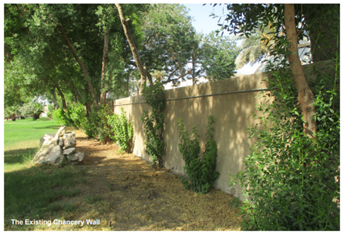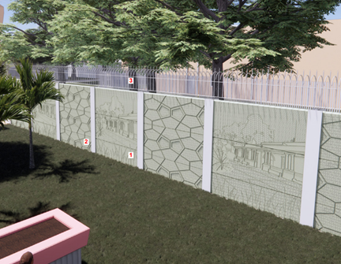

Existing Proposed

1. **Overhead Protection** to the compound’s three generator farms to ensure resilience of compound infrastructure. The generator farms include electrical infrastructure, water treatment facilities and fuel stores.

Scope of work: Replacement/ upgrade of overhead protection system over the 3 generator farms at BEB. The upgraded system needs to protect critical generators from missile / mortar impacts and is designed to trigger the explosive and absorb impact, leaving generators and other equipment operational below.

i. Removal of current overhead protection structure

ii. Potential amendments to existing concrete slab and footings

iii. Steel portal frame erection

iv. Creation of blast protection ballast layer within the roof void

v. Amendment / Replacement of existing protective walling.

**Indicative cost range:** £1m - £2m

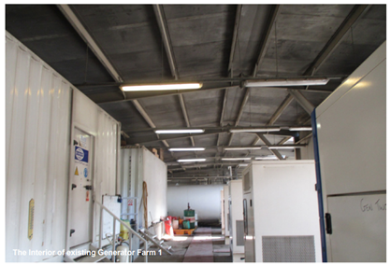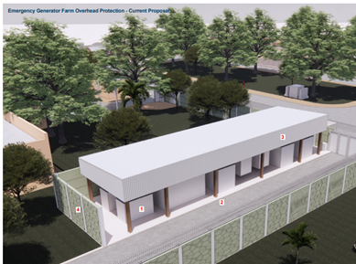

Existing Proposed

3. **Rear gate upgrade**

Scope of work: The new design will add automatic gate systems and enhanced vehicle attack protection along with amended traffic routes.

i. Removal of existing structure components in secure sequence

ii. Reconfiguration of concrete structure in some areas

iii. Installation of new gates, bollards and access control

iv. Amendments to access routes and roadway signage

Indicative cost range: £0.75m - £1.25m

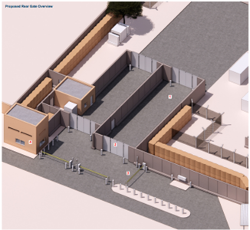

New Arrangement

1. **Supporting MEP works**

Scope of works:

**Chancery Wall**

1. New security wall perimeter lighting along wall line (internal only)
2. Conduits and cable ways for supporting services installation (to the internal and external side)
3. Power supplies to the vehicle entry points (4 points)
4. Power supplies to the pedestrian entrances (4 points)

**Overhead Protection**

1. Reconfiguration of lighting services for all three generator farms (1, 2 and emergency)
2. Coordination with new fuel tank for emergency generator farm
3. Conduits and cable ways for security services

**Rear Gate**

1. Power supplies to new bi-fold HVM gates on external exit lane
2. Power supplies to new bi-fold HVM gates on internal exit lane
3. Power supplies to drop-arm vehicle management barriers
4. Power supplies to new bi-fold gates on external entry lane
5. Power supplies to new bi-fold gates on internal entry lane
6. M&E refurbishment to the Rear Gatehouse

**Indicative cost range:** £0.5m - £0.75m

1. **HESCO removal and re-landscaping**

Scope of work: The HESCO walls originally erected at BEB circa 2005 are starting to erode and present a health and safety issue. The metal link cages were filled with local sand and the salt content within that sand has eroded the metal structure causing collapse. Some HESCO walls have already been removed, some will be removed completely and some need to be replaced with a modular wall to give ongoing blast protection to certain areas. Much of the existing greenery on the compound, especially around the accommodation blocks has had to be removed (it was growing around the HESCO) leaving the compound bare, austere and more akin to a military camp. Once the HESCO is removed a landscaping scheme, supported by a sustainable irrigation system from existing unused boreholes, will be implemented to soften the landscape, reduce dust and provide a cooling effect. Planters, screens and earth mounds will be designed to offer indirect fire and ballistic protection, improving the liveability while retaining safety and security elements.

i. Removal of HESCO cages with contents stockpiled

ii. Stockpiled materials to be used in future landscaping works where required

iii. Installation of modular pre-cast concrete walling to replace HESCO in some areas

1. Re-landscaping to provide passive security protection, re-greening and sustainable irrigation
2. Landscaping to include hard and soft landscaping and planting
3. Installation of new low level wayfinding lighting

**Indicative cost range:** £4m - £5m

1. **Mechanical, electrical and plumbing upgrade works**

The MEP work includes:

Improvements to the water filtration services which are currently below standard.

Scope of work: Provision of new water filtration service with reverse osmosis chlorination and silver dosing water treatment systems to provide potable water on compound.

Replacement of the sewage treatment plant which has been out of operation for several years.

Scope of work: New sewage treatment plant to be installed with the simplest operation to ensure that local team can look after the equipment with minimal external input.

Improvements to the incinerator.

Scope of work: Improvements are part of the electrical infrastructure upgrade and will provide a small local generator on a changeover facility to support the incinerator.

Replacement of the swimming pool plant which has reached end of its design life.

Scope of work: Replacement of filtration equipment, pumping units and water treatment services.

Removal of R22 (banned refrigerant gas) and replacement HVAC systems in the Residence and clubhouse.

Electrical upgrades to the super sangars

Scope of work: Provision of new lighting, small power and electrical distribution board, potential cooling space and UPS for the comms and IT equipment.

**Indicative cost range:** £3.5m - £4.5m

**FCDO Project Team:**

Eddie Hannah, Head of Estates: Senior Responsible Owner

Mark Burgess and Terry Bedford: Project Directors

The project is supported by a Strategy & Planning Manager, Estates Surveyor and Commercial lead

Located at BEB: Corporate Services team

Appointed Team:

FCDO Services: Design and Project Management

Apex Core Limited: MEP Design

**Visiting and Working at BEB:**

* Individuals require SC clearance and SAFE+ to visit Post.
* As a SAFE+ Post all UK visitors (including contractors) are met at the airport and transferred to Post by our close protection teams.
* Commercial flights (not direct) are available to Baghdad.
* Visas are straightforward for short visits (59 days) British Passport holders: $80 US Dollars paid on arrival. Longer terms visits will require formal visa application.
* Visitors must remain on compound and will be provided living accommodation, canteen services for breakfast, lunch and dinner.
* Visitors can make use of the facilities on compound including club/ bar, gym, pool. There is a small shop on compound along with medical facilities.
* Medical clearance is required before travelling to Iraq/ Post.
* FCDO has experience of obtaining local building materials in Baghdad. Getting materials and equipment shipped into Iraq/ Baghdad can be challenging but is something that FCDO/ Post in Baghdad are able to support.

**Proposed Project timescales/ ITT:**

We are currently developing our approach for project delivery and this will be informed by the responses to this call for Expressions of Interest.

Below is a schedule of proposed key activities (subject to change):

|  |  |
| --- | --- |
| **Activity** | **Date** |
| Return of EOI | 9th August 2024 |
| Bidders Event (all interested bidders) | 15th August 2024 |
| 1-2-1 Teams Contractor meetings (if required) | w/c 19th August 2024 |
| FCDO finalise procurement strategy | End August 2024 |
| Issue ITT | September 2024 |
| Proposed Bid Deadline | Early October 2024 |
| Tender Evaluation | October 2024 |
| Contract Award | End October 2024 |

Please Note: the timetable above is indicative.

**Annex A**

1. **Questions**

In order to help us understand the potential interest and capacity of the supplier market to deliver these projects please respond to the questions below. *Please note, answers to these questions are not part of a shortlisting exercise.*

| **No** | **Question** | **Response** |
| --- | --- | --- |
|  | Would you be interested in bidding for the projects noted above? Please provide a Yes/ No in relation to each project. | 1. Chancery wall replacement/ rebuild   Yes/ No   1. Generator farms overhead protection   Yes/ No   1. Rear gate upgrade   Yes/ No   1. Supporting MEP   Yes/ No   1. HESCO removal and re-landscaping   Yes/ No   1. Mechanical, electrical and plumbing upgrade works   Yes/ No |
|  | Do you have the capacity/capability to deliver the projects noted above? |  |
|  | Would you plan to use sub-contractors? | Yes/ No  If yes, what discipline and where located? |
|  | Are you able to meet the timescales outlined above? |  |
|  | Does your organisation have experience of working on construction projects of a similar scale in this region? |  |
|  | Does your organisation have access to local suppliers or supply chains who would be willing to subcontract in this location or region? |  |
|  | Please provide feedback in relation to any potential challenges/ risks you foresee in contracting to work in Baghdad/ Iraq.  *For example: ability to secure adequate insurance when working in Iraq.* |  |
|  | The FCDO's preferred form of contract is NEC4: Engineering and Construction Contract Option A.  Does your organisation have experience of working under this form of contract?  Would your organisation have any concerns with working under this form of contract on a project of this nature? |  |
|  | The above overview notes a requirement for SC and SAFE+ training, do you foresee any issues with this requirement? |  |
|  | Please detail any additional observations on the information provided, if appropriate. |  |

Responses provided by:

(Insert name):

(Signed);

(Date):