

RFI0062
REQUEST FOR INFORMATION
Novel Approaches to Decorative Ships’ Crests and Badges

RFI Title: RFI0062
Issue Date: 18/12/26
Reference: [RFI0062]
Version: 1.0

Contents
1. Introduction 3
2. Background 4
3. RFI intended outcomes 6
4. RFI Procedure 6
5. How to submit responses to this RFI 6
6. Confidentiality & Proprietary Information 7
7. Costs of preparing your RFI response 7
8. Contact 7
9.Annex A 8

Introduction

This RFI is not a bidding opportunity but a means by which industry can provide information. Any resulting procurement activity will be conducted competitively.
Please note:
This RFI is an information gathering exercise, no further discussions with industry are planned at this stage however any future procurement activity will be advertised in line with public procurement regulations on the Defence Sourcing Portal and Contracts Finder.
- Background

The Royal Navy is seeking to explore innovative approaches to the design and production of ship crests and badges. These artefacts are not merely decorative - they are strategic tools that support Defence Engagement objectives and strengthen relationships with allies, partners, and dignitaries. When presented during ceremonial occasions or diplomatic exchanges, they serve as tangible symbols of respect, professionalism, and cultural sensitivity, reinforcing the Navy’s reputation as a trusted defence partner.
Current policy emphasises that gifting must contribute to Defence objectives, demonstrate value to the Royal Navy and the wider MOD, and reflect appropriate use of public funds. Crests and badges are therefore designed and presented with purpose: to embody the heritage and ethos of the Service while promoting goodwill and operational cooperation. They are a visible link to the Navy’s proud history and a reminder of its enduring values.
As the Navy evolves to meet the demands of being a modern, agile force, these symbols must also reflect contemporary identity. The recent adoption of the tagline “Lead, Fight, Win” by the First Sea Lord signals a clear intent to project strength, leadership, and adaptability. This initiative seeks to explore how crests and badges can continue to honour tradition while embracing innovation in design, manufacturing, and presentation.
The current manufacturing specifications for ship crests and badges mounted on a traditional plaque are as follows:
Shape. The shape of the badges is to be one of the following heraldic designs:
- Circular - surrounded by a twisted – rope frame and surmounted by a Naval Crown.
- Diamond - surrounded by a twisted – rope frame and surmounted by a Naval Crown.
- Pentagonal - surrounded by a twisted – rope frame and surmounted by a Naval Crown.
- Shield – surrounded by a twisted – rope frame and surmounted by a Naval Crown.
- Circular - surrounded by a twisted - rope frame without a Naval Crown.
- Shield – without twisted rope and without Naval Crown.
Size: 9.5cm inside diameter of frame for circular badges, and in proportion for diamond-shaped and pentagonal badges. The following provided is a requirement:
- Circular - 9.5 cm diameter within rope frame, within the following parameters 1.3-1.5 cm diameter rope frame, mount to extend 2 cm around badge. Naval Crown 8 cm x 4 cm at widest points.
- Diamond – in proportion as stated above within rope frame, within the following parameters 1.3-1.5 cm diameter rope frame, mount to extend 2 cm around badge. Naval Crown 8 cm x 4 cm at widest points.
- Pentagonal - in proportion as stated above within rope frame, within the following parameters 1.3-1.5 cm diameter rope frame, mount to extend 2 cm around badge. Naval Crown 8 cm x 4 cm at widest points.
- Shield - in proportion as stated above within rope frame, within the following parameters 1.3-1.5 cm diameter rope frame, mount to extend 2 cm around badge. Naval Crown 8 cm x 4 cm at widest points.
- Royal Marines’ Shield - 9 cm top width, 10.5 cm height, mount 15 cm top width 17.5 cm height, Royal Marines scroll underneath width 9cm. The surface of the mount itself is to be flat.
All badge designs should be raised by 0.7 cm on the mount itself. These measurements are required badges, however for the samples within the tender, an allowance of +/-2mm is allowable on all measurements.
Examples of approved ships crests and badge designs:
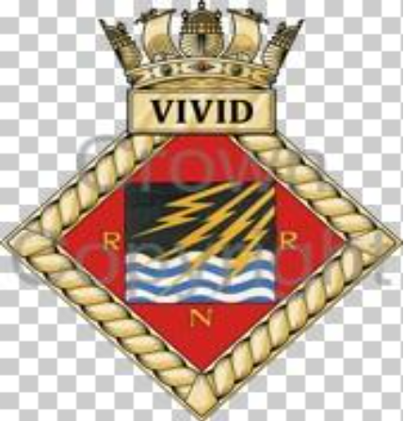
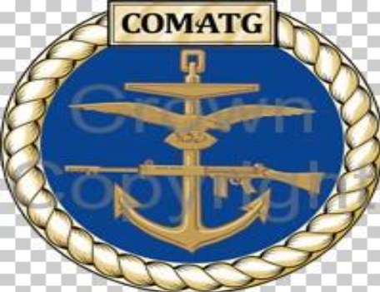
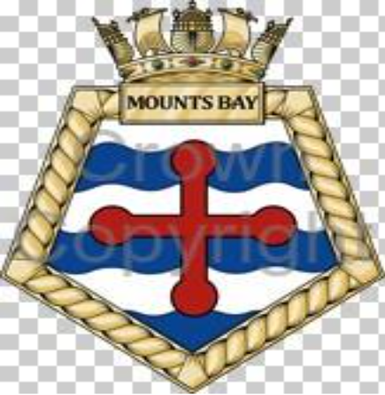

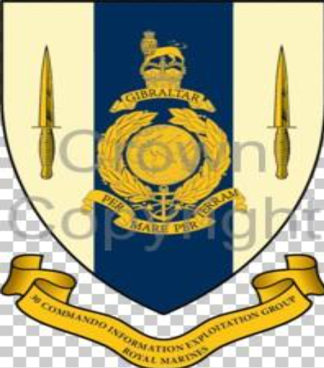
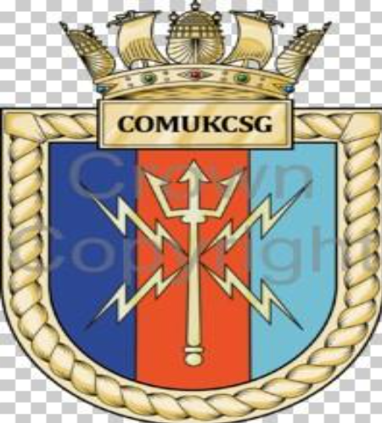
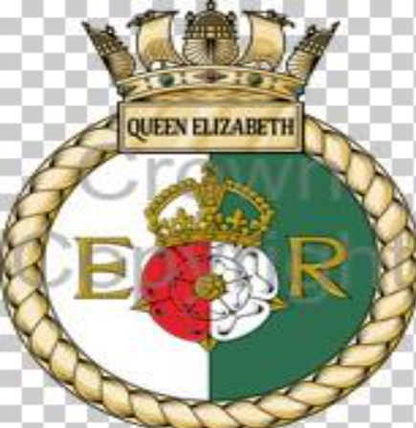

Innovation and flexibility are key to this concept research. The Authority invites industry to share ideas, technologies, and processes that challenge conventional thinking and offer fresh perspectives. While the specification above represents the current standard and should be treated as the baseline for any compliant solution, respondents are encouraged to propose innovative techniques or materials that enhance quality, sustainability, or durability while respecting heraldic identity. In addition, the Authority is open to considering completely alternative approaches for presenting ships’ badges for official or ceremonial use, provided proposals maintain the integrity and symbolism of the approved designs. Responses should demonstrate creativity and adaptability, ensuring that future solutions maintain symbolic significance while meeting evolving requirements.
- RFI intended outcomes

This RFI aims to achieve the following three (3) outcomes:
1. Develop further the Authority’s understanding of the different technologies and capabilities available in the market, both current and emerging.
2. Align Authority requirements with industry standards and processes.
3. Enable the Authority to develop a procurement strategy that will deliver best value for money for Defence.
4. Inform future thinking about how ship crests and badges can best reflect a modern, agile Royal Navy in both design, manufacturing, and overall look - including consideration of alternative presentation concepts, user experience, and the continued integrity of heraldic symbolism.
- RFI Procedure

Responses to this RFI will be reviewed by subject matter experts from different functional areas within Navy Command Headquarters.
If upon review of your submission any clarifications or additional information is required, you will be contacted using the details provided in your RFI response.
Any details provided in response to this RFI will be used for information purposes only and will not be used to determine the potential Suppliers who will be invited to bid, should the Authority proceed to tender.
The results and analysis of this RFI shall not constitute any form of pre-qualification exercise.
Any formal procurement process will be undertaken in accordance with the relevant Procurement Law.
Nothing in this RFI, or any other engagements with Industry prior to a formal procurement process, shall be construed as commitment by the Authority in relation to any future requirement(s) or any future procurement(s).
- How to submit responses to this RFI

Respondents should provide responses in accordance with the format provided in Annex A quoting the RFI reference on all documentation and emails.
Please do not submit additional documents such as company overviews, the purpose of the RFI is to collect information related to the technical solution, any additional documents will not be included in the review process.
Any responses received after the deadline will be passed to the subject matter experts for information, however they may not be included in the RFI review meetings which are to be held immediately following the deadline.
Once completed, please return electronically to the e-mail address(es) shown below in section 9, no later than 18:00, 30/01/26.
Responses will be acknowledged electronically by return e-mail.
- Confidentiality & Proprietary Information

No information included in your response, or in discussions connected to it, will be disclosed to any other third party.
Proprietary information, where included, should be kept to minimum and must be clearly marked.
For this RFI, any documentation submitted should be of the classification OFFICIAL.
- Costs of preparing your RFI response

Any costs relating to the preparation and submission of a response to this RFI are the sole responsibility of the respondent.
- Contact

Quoting the RFI reference, please submit
- any requests for clarification
- all responses to this RFI and
- any questions regarding Classification of document(s) intended for submission, to:
NAVYCOMRCL-RFI@mod.gov.uk
The deadline for RFI questions is the 14/01/26. All questions and responses will be published alongside the RFI details on Contracts Finder and the Defence Sourcing Portal, within the original Early Engagement Notice no later than 3-5 working days after the query deadline.

- Annex A

RFI0062 (Novel Approaches to Decorative Ships’ Crests and Badges)
Question | Answer
Company Name
Company Address
Is the company a Small - Medium Enterprise (less than 250 employees)?
Name of Company representative completing the RFI
Contact details (e-mail and telephone number)
Company web site address
Main products/services/line of business
Main market sector
Number of years in this market sector
QUESTIONS
Current Specification & Compliance
- What technologies, processes, or capabilities do you currently offer for the design and manufacture of bespoke items such as crests and badges?

- What materials and production methods do you recommend for durability, sustainability, and cost-effectiveness?

- How do your processes align with recognised industry standards and best practices?
- What factors influence cost in your production process, and how can economies of scale or alternative methods deliver best value for Defence?
Balancing Tradition and Modernity
- How can your solutions balance traditional heraldic standards with modern design principles to reflect a contemporary Royal Navy identity?
- How adaptable are your solutions to evolving requirements, such as changes in branding or design philosophy?
Innovation and Alternatives
- What innovative concepts or approaches could transform how crests and badges are produced or presented?
- Are there alternative concepts or formats for presenting ships’ badges - beyond traditional crests mounted on plaques - that you believe could enhance their impact, symbolism, or practicality for official or ceremonial use? Please describe any such concepts, including potential benefits and challenges.
- How would your proposed innovations or alternative concepts ensure the continued integrity and symbolism of the approved badge designs?
User Experience & Value
- How do your proposed solutions (traditional or alternative) enhance the experience for recipients, users, or audiences in ceremonial or diplomatic contexts?
Innovative solutions are most welcome, even if they do not meet all the requirements above, we would welcome the opportunity to consider the positives and negatives.

