

INVITATION TO TENDER
&
STATEMENT OF REQUIREMENT

Communications Department Communications Database

CPV Code:
- 48500000 – Communications and multimedia software package
48600000 – Database and operating software package
72320000 – Database Services

Tender Reference: ORR/CT/18-38

Purpose of document
The purpose of this document is to invite proposals for a Communications Department Communications Database for the Office of Rail and Road (ORR).
This document contains the following sections:
1. Introduction to the Office of Rail and Road
2. Statement of Requirement
3. Tender Proposal & Evaluation Criteria
4. Procurement Procedures

1. Introduction to the Office of Rail and Road (ORR)

The ORR protects the interests of rail and road users. We are improving the safety, value and performance of railways and roads, today and in the future.
Our railway health, safety, economic and road functions overall are driven by UK and EU legislation. We are accountable to Parliament and the public to protect the people who use, interact or work on the railway; ensure fair access to a rail network which is becoming increasingly congested; ensure Highways England delivers its major programme of investment and other performance commitments; and protect the interests of future users by working with the industry and funders as they develop the network of tomorrow.
We regulate Network Rail including setting the targets it has to achieve and report regularly on its performance. We regulate health and safety standards and compliance across the whole rail industry. We also oversee competition and consumer rights issues – driving a better deal for rail passengers and taxpayers. We also regulate the HighSpeed1 link to the channel tunnel.

Since April 2015, we’ve been monitoring Highways England to hold the company to account on its commitments to improve performance and efficiency of England’s Strategic Road Network.

ORR currently employs approximately 300 personnel and operates from 6 locations nationwide. The majority of personnel are located at ORR’s headquarters, One Kemble Street, London.

Our six strategic objectives for 2017-18
1. Health and Safety: Protecting passengers, the workforce and the travelling public is at the heart of what we do. We will continue to hold industry to account to deliver safety improvements, focusing especially on level crossings, the train-to-platform gap, and through overseeing better design at the outset.
2. Better Rail customer service: Our response to the recent ‘super-complaint’ highlights more which can be done to deliver a better deal for passengers in respect of compensation for delays. We shall, as promised, monitor operators’ progress closely here, as indeed we shall on complaints handling, on provision for disabled passengers, and on information provided during disruptions.
3. Value for money from the railway: The rail network is in the middle of a challenging, multi-billion pound investment programme. We want to see the infrastructure owner, train operator and freight company working together to improve efficiency and boost value for money for taxpayers, fare payers and funders. We will continue to monitor and report on Network Rail’s performance to help ensure that it operates as a world-class, efficient asset management company.
4. Better highways: Highways England now has a £15bn, five-year plan with eight specific targets. Our role is to monitor its progress on this. These targets include a 40% reduction in the number of people killed or seriously injured by 2020; a road user satisfaction score of 90% by March 2017; clearing 85% of incidents within an hour; and making £1.2 billion of savings on capital expenditure.
5. Promoting a dynamic and commercially sustainable rail sector: Our vision for the future will be set out in our first core document outlining the next periodic review (PR18), which we will consult on from later in the spring.
Building on the recommendations of the Shaw review, PR18 will consider options for route based regulation, underpinned by a strong system operator and for an effective charging and incentives regime for Network Rail as the network monopoly.
6. High performing regulation: Structural and funding changes shaping both the rail and road networks mean that a high performing regulator is more vital than ever. We are continually developing our professional expertise to ensure maximum, positive impact. Working across rail and road in a joined up manner is also supporting us in developing and applying proportionate, risk-based regulation.

Supplying ORR
The ORR procurement unit is responsible for purchasing the goods and services necessary for ORR to achieve its role as the economic and health & safety regulator of the rail industry.
The ORR Procurement unit subscribes to the following values:
- to provide a modern, efficient, transparent and responsible procurement service;
- to achieve value for money by balancing quality and cost;
- to ensure contracts are managed effectively and outputs are delivered;
- to ensure that processes have regard for equality and diversity; and
- to ensure that procurement is undertaken with regard to Law and best practice.
For further information on ORR please visit our website: www.orr.gov.uk
Small and Medium Enterprises

ORR considers that this contract may be suitable for economic operators that are small or medium enterprises (SMEs) and voluntary organisations. However, any selection of tenderers will be based on the criteria set out for the procurement, and the contract will be awarded on the basis of the most economically advantageous tender.
Small and Medium Enterprises and Voluntary Organisations:
Enterprise Category | Headcount | Turnover | or |  | Balance Sheet Total
Micro | <10 | ≤ € 2 million |  | ≤ € 2 million
Small | <50 | ≤ € 10 million |  | ≤ € 10 million
Medium | <250 | ≤ € 50 million |  | ≤ € 43 million
Large | >251 | > € 50 million |  | > € 43 million

Please ensure that you indicate how your organisation is categorised on the Form of Tender document which should be submitted along with your proposal.
2. Statement of Requirement
2.1 Background to the project
The Office of Rail and Road (ORR) is the independent regulator for Britain's rail industry.
We are the economic regulator for railway infrastructure (Network Rail and High Speed 1); the health and safety regulator for the rail industry as a whole – including mainline, metro, tramways and heritage railways across Britain; and the industry's consumer and competition authority.
We also have responsibility as the Highways Monitor, the independent monitor of Highways England who look after the strategic road network e.g. motorways and most A roads.
The Communications Department is made up of a number of teams:
• Customer Correspondence;
• Internal Communications;
• Media, Campaign and Digital
• External Affairs

2.2 Project Objectives & Scope
ORR is seeking to procure a system to record, manage and evaluate all external
engagement across its Media, Campaigns & Digital; External Engagement, and; Customer
Correspondence Teams. The resultant contract will be for up to 36 months with the
option to extend for a further 12 months. It will commence at the end of October 2018.

ORR has a current provider of database functionality to the communications department.

The teams using the database are:

Customer Correspondence
The Customer Correspondence Team (CCT) key responsibilities are:
- Handling general enquiries and complaints;
- Freedom of Information (FoI) and Environmental Information Regulation (EIR) requests; and
- Planning applications.

On average CCT receives per annum 1600 general enquiries, 200 FoIs and 700 items of correspondence concerning planning. The database must be capable of monitoring performance targets set for each team, CCT targets are:
- 95% of all general enquiries and complaints cleared within 20 working days of receipt;
- 90% of all FoI requests cleared within 20 working days of receipt; and
- Planning correspondence cleared within the designated deadline (this can vary from 20 days to three months).
Media, Campaigns and Digital
Our Media team is responsible for handling enquiries from journalists, producing and distributing press releases, social media, organising press briefings and interviews, and agreeing lines to take on key ORR public statements.
Transport issues in particular rail and road issues attract high media interest, both locally and nationally; for example a serious rail accident, investment plans, delays to rail services/road users etc.
The system needs to be capable of
- storing details of the media team’s interactions with journalists
- creating statements and press releases and disseminating these to journalists, including the ability to attach media content and branding
Important to this, the system must be able to capture the following key data as a minimum:
- Name of journalist;
- Media outlet;
- Contact details (phone, email and twitter handle);
- Deadline;
- When the story will be printed/broadcast;
- Details of request/angle of story; and
- Details of any interview bids.
We require the system to work with an appropriate database of journalists; we currently use Gorkana.
External Affairs
External Affairs encompasses parliamentary, stakeholder and strategic engagement. It aims to maintain effective relationships with our stakeholders to ensure our credibility as an effective independent regulator for rail and monitor for roads. This includes planning communication strategies and aligning key messages, making sure that the right people from ORR are meeting the right people out in industry and that what is being discussed is in line with our corporate messaging.
It also is responsible for maintaining records of engagement activity – including meetings, speeches, conferences or parliamentary hearings, for example, to support proper management of materials, briefings and publications, , as well as a forward planner of upcoming activity. This team also covers insight work on audiences and issues.
The team deal with a wide range of stakeholders on a regular basis including:
- Transport Ministers;
- Shadow Ministers;
- Department for Transport officials;
- Network Rail;
- Rail Delivery Group;
- Train and Freight Operating Companies;
- Trade Unions;
- MPs;
- Transport Select Committee;
- Safety and Rail APPGs
- Parliamentary Advisory Committee on Transport (PACTs);
- Rail Accident Investigation Branch (RAIB); and
- Rail Safety and Standards Board (RSSB).
- Trade / Professional / Business representative groups
- Consumer representative groups.
- Local and subnational government groups.
In managing these key relationships, the team engage with stakeholders through various events e.g. forums, conferences, holding roundtable discussions, exhibitions
As a non-ministerial government department, ORR is accountable to Parliament. Parliamentary Questions (PQs) are a key means in which this accountability is delivered.
The DfT is ORR’s sponsoring department. MPs and peers therefore ask questions to the Secretary of State for Transport and when they deem that information from ORR is required to provide information to help a response, officials will contact ORR and the process highlighted in the flow chart below will be started.
PQs are usually received at short notice and require a quick turnaround, in some cases the same day of receipt. The number of PQs we receive is low compared with other Government bodies, usually 20 per year. Details are published in Hansard.
We would like to explore the possibility of how the proposed database solution would link to other key Parliamentary information currently used e.g. Parliament website and list of current MPs and Lords, Dods etc. This functionality would be extremely useful in sending out invitations, reports and logging historic communication with the stakeholder.
Please note parliamentary activity also encompasses the devolved nations./
This flow chart demonstrates the process for answering parliamentary questions;
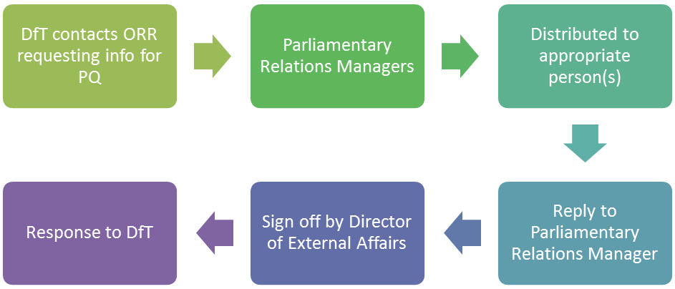
A further route of accountability to Parliament is through written enquiries from Members of Parliament and peers. Correspondence will often be more detailed than a PQ and often prompted by a constituent who has raised a specific concern with an MP and asked them as their representative.
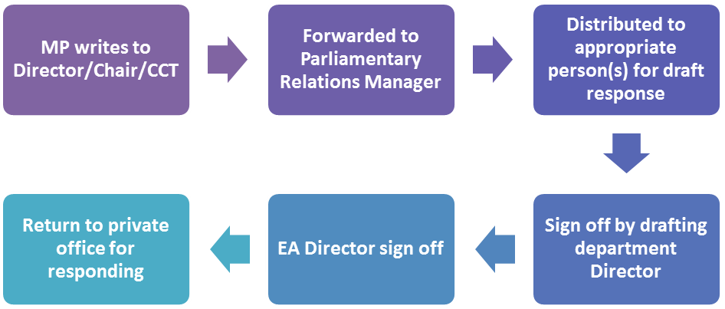
The external affairs team also manages the organisation’s main lists of stakeholder contact details and interactions. It issues regular mailings both via outlook email and mail chimp software.
These lists are segmented and curated by various criteria to enable targeting and research.
The individual stakeholder records, and those for corporate bodies, are also used to track interactions – ie last contact, recent statements, areas of concern etc . As well as records of individuals, the EA team also tracks individual events – meetings, conferences etc for planning and research purposes.

2.3 Project Outputs, Deliverables and Contract Management
In addition to the functionality set out in 2.2 above, the EA database should be able to carry out the following standard functions:
- Single keying of data;
- Transfer of information from applications to the database e.g. cut/paste data from Word/Excel/email etc;
- Allow all users to access and input data at the same time;
- A central, prominent planner function that collates and highlights key upcoming events and issues.
- Allow documents to be attached to the relevant case records, events or individual contacts, and hyperlinks to documents held on other websites;
- Track each stage of a particular case/correspondence/enquiry and provide a status report;
- Produce standard outputs, including summary dashboards, planners, reports etc, in a range of formats, including graphically.
- Overarching search function;
- Security of data;
- Input of a range of targets, KPIs;
- Create tailored dashboards for each team with cross over/links if required;
- Allow for development and mass-update of data sets;
- Campaign planning tools; and
- Store documents electronically.
- Provide alerts
- Provide standard and bespoke management information/reports – such as planners, correspondence reports etc.
- Compatible with ORR’s operating system and key software – Windows / MS Office. Currently ORR sits on the GSI network.
- Integrate with other database providers where necessary – ie Dods, Gorkana
- Integrate with mailing software – ie Mailchimp, Outlook.
- Be available remotely for colleagues working outside of main office / travelling etc.
- Provide an acceptable uptime guarantee to provide assurance of access in event of a crisis situation.
- Provide a level of segmentation of information access – ie restrict access to media lines / confidential items, or read/write access.
- Facilitate segmentation of datasets- ie contacts – by tagging/grouping or similar approach.
- Support GDPR-compliant record keeping.
- Facilitate transfer of records from existing system.

2.4 Project Timescales
The provisional project timetable is as follows:
- End of tender – late September
- Kick off meetings with successful bidder – early October
- Handover of service / commencement of new contract – 11 October 2018

Extension option:

Subject to mutual agreement between the two parties the contract let as a result of this tender may be extended for the provision of similar or complimentary goods or services, up to 12 month(s) and £10,000 excluding VAT.

2.5 Budget and Payment Schedule
The maximum budget for this piece of work, excluding any possible extension, is £30,000 (inc. of expenses, exc. of VAT) over 36 months.
2.6 Further project related information for bidders
Intellectual Property Rights
ORR will own the Intellectual Property Rights for all project related documentation and artefacts.

Transparency requirements
Please note ORR is required to ensure that any new procurement opportunity above £10,000 (excluding VAT) is published on Contracts Finder, unless the ORR is satisfied it is lawful not to. Once a contract has been awarded as a result of a procurement process, ORR is required to publish details of who won the contract, the contract value and indicate whether the winning supplier is a SME or voluntary sector organisation.
Confidentiality

All consultants working on the project may be required to sign a confidentiality agreement and abide by the Cabinet Office’s protective marking guidelines, which ORR uses to protectively mark a proportion of its information. In addition, the consultant may be required to sign additional confidentiality agreements as required by external stakeholders.

Sub-Contractors

Contractors may use sub-contractors subject to the following:
- That the Contractor assumes unconditional responsibility for the overall work and its quality;
- That individual sub-contractors are clearly identified, with fee rates and grades made explicit to the same level of detail as for the members of the lead consulting team.
Internal relationships between the Contractor and its sub-contractors shall be the entire responsibility of the Contractor. Failure to meet deadlines or to deliver work packages by a subcontractor will be attributed by ORR entirely to the Contractor.

3. Tender Response & Evaluation criteria
3.1 The Tender Response
The proposals for this project should include an outline of how your software and associated support will meet the requirement outlined in section (ii) “Statement of Requirement”. The following information should be included:
a) Understanding of customer's requirements

- Demonstrate an understanding of the requirement and overall aims of the project.

b) Approach to customer's requirements
- Provide an explanation of the proposed approach and any methodologies bidders will work to;

- Details of your assumptions and/or constraints/dependencies made in relation to the project

- What support bidders will require from ORR;
c) Case Studies

- Please provide up to two case studies where a similar requirement has been met by your proposed software

d) Pricing- Software costs, set up and training costs, a fixed annual licence fee for the software, support and maintenance costs, a breakdown of professional service day rates provided
e) Terms and Conditions

Please provide your terms and conditions

3.2 Evaluation Criteria
Tenders will be assessed for compliance with procurement and contractual requirements which will include:

- Completeness of the tender information
- Completed Declaration Form of Tender and Disclaimer
- Tender submitted in accordance with the conditions and instructions for tendering
- Tender submitted by the closing date and time
- Compliance with contractual arrangements.

Tenders that are not compliant may be disqualified from the process. We reserve the right to clarify any issues regarding a Bidder’s compliance. It will be at ORR's sole discretion whether to include the relevant Bidder’s response in the next stage of the process.
The contract will be awarded to the Bidder(s) submitting the ‘most economically advantageous tender’. Tenders will be evaluated according to weighted criteria as follows:
Methodology (25%)
The proposal should set out the methodology by which the project requirement will be initiated, delivered and concluded. In particular, it must:
a) Explain the methodology and delivery mechanisms to ensure that the requirements of this specification are met in terms of quality;
b) Explain how your organisation will work in partnership with ORR’s project manager to ensure that the requirement is met
- Explain how your organisation will engage with external stakeholders;
- Outline how the proposed approach utilises innovative consultation methodologies to develop a diverse and comprehensive evidence-base

Delivery (10%)
The proposal should set out how and when the project requirement will be delivered. In particular, it must:
a) Explain how this work will be delivered to timescale and how milestones will be met, detailing the resources that will be allocated to each stage;
b) Demonstrate an understanding of the risks, and project dependencies and explain how they would be mitigated to ensure project delivery;
c) Explain the resources that will be allocated to delivering the required outcomes/output, and what other resources can be called upon if required.

Experience (25%)
The proposal should set out any experience relevant to the project requirement. In particular, it must:
a) Provide CVs of the consultants who will be delivering the project;
b) Highlight the organisation’s relevant experience for this project, submitting examples of similar projects.

Cost / Value for money (40%)
A fixed fee for delivery of the project requirement (inclusive of all expenses), including a full price breakdown for each stage of the project and details of the day rates that will apply for the lifetime of this project.
Please provide pricing options and a breakdown of
- Software costs
- Set up and training costs
- a fixed annual licence fee for the software
- Support and maintenance costs
- A breakdown of professional service day rates provided
Marking Scheme
Score 0 | Unanswered or totally inadequate response to the requirement. Complete failure to grasp/reflect the core issues
1 | Minimal or poor response to meeting the requirement. Limited understanding, misses some aspects
3 | Good understanding and interpretation of requirements, providing clear evidence of how the criterion has been met
5 | Excellent response fully addressing the requirement and providing significant additional evidence of how the criterion has been met and how value would be added

4. Procurement procedures
Tendering Timetable
The timescales for the procurement process are as follows:

Element | Timescale
Invitation to tender issued | 03/09/2018
Deadline for the submission of clarification questions | 10/09/2018 @5pm
Deadline for submission of proposals | 17/09/2018 @5pm
Shortlisted suppliers notified | 19/09/2018
Interviews and presentations* | 24/09/2018
Award contract | 25/09/2018
Project Inception Meeting | 28/09/2018
*Please ensure that the Project Manager and other key consultants who will be delivering this work are available to give presentations on the interview date

Tendering Instructions and Guidance
Amendments to ITT document
Any advice of a modification to the Invitation to Tender will be issued as soon as possible before the Tender submission date and shall be issued as an addendum to, and shall be deemed to constitute part of, the Invitation to Tender. If necessary, ORR shall revise the Tender Date in order to comply with this requirement.
Clarifications & Queries
Please note that, for audit purposes, any query in connection with the tender should be submitted via the ORR eTendering portal. The response, as well as the nature of the query, will be notified to all suppliers without disclosing the name of the Supplier who initiated the query.
Submission Process
Tenders must be uploaded to the ORR eTendering portal no later than the submission date and time shown above. Tenders uploaded after the closing date and time may not be accepted. Bidders have the facility to upload later versions of tenders until the closing date/time.
Please submit the Form of Tender and Disclaimer certificate along with your proposal. If you are already registered on our eTendering portal but have forgotten your login details, please contact the portal administrator.
An evaluation team will evaluate all tenders correctly submitted against the stated evaluation criteria.
By issuing this Invitation to Tender ORR does not undertake to accept the lowest tender, or part or all of any tender. No part of the tender submitted will be returned to the supplier

Cost & Pricing Information
Tender costs remain the responsibility of those tendering. This includes any costs or expenses incurred by the supplier in connection with the preparation or delivery or in the evaluation of the tender. All details of the tender, including prices and rates, are to remain valid for acceptance for a period of 90 days from the tender closing date.
Tender prices must be in Sterling.
Once the contract has been awarded, any additional costs incurred which are not reflected in the tender submission will not be accepted for payment.

References
References provided as part of the tender may be approached during the tender stage

Contractual Information
Following the evaluation of submitted tenders, in accordance with the evaluation criteria stated in this document, a contractor may be selected to perform the services and subsequently issued with an order.

Any contract awarded, as a result of this procurement will be placed with a prime contractor who will take full contractual responsibility for the performance of all obligations under the contract. Any sub-contractors you intend to use to fulfil any aspect of the services must be identified in the tender along with details of their relationship, responsibilities and proposed management arrangements.

The proposal should be submitted in the form of an unconditional offer that is capable of being accepted by the ORR without the need for further negotiation. Any contract arising from this procurement will be based upon ORR’s standard Terms & Conditions (see Form of Agreement attached). You should state in your proposal that you are willing to accept these Terms & Conditions.

The ORR does not expect to negotiate individual terms and expects to contract on the basis of those terms alone. If you do not agree to the Conditions of Contract then your tender may be deselected on that basis alone and not considered further.
The ORR may be prepared to consider non-fundamental changes to the standard terms and conditions in exceptional circumstances. If there are any areas where you feel you are not able to comply with the standard ORR terms and conditions, then details should be submitted as a separate annex to the proposal using the following format:

Clause Number | Existing Wording | Proposed Wording | Rational for amendment

Any services arising from this ITT will be carried out pursuant to the contract which comprises of:

- ORR Terms & Conditions;

- Service Schedules;

- this Invite to Tender & Statement of Requirement document; and

- the chosen supplier’s successful tender.

ORR’s Transparency Obligations and the Freedom of Information Act 2000 (the Act)
The ORR is a central Government department and as such complies with the Government’s transparency agenda. As a result, there is a presumption that contract documentation will be made available to the public via electronic means. The ORR will work with the chosen supplier to establish if any information within the contract should be withheld and the reasons for withholding it from publication.
Typically the following information will be published:
- contract price and any incentivisation mechanisms
- performance metrics and management of them
- plans for management of underperformance and its financial impact
- governance arrangements including through supply chains where significant contract value rests with subcontractors
- resource plans
- service improvement plans
Where appropriate to do so information will be updated as required during the life of the contract so it remains current;

In addition, as a public authority, ORR is subject to the provisions of the Freedom of Information Act 2000. All information submitted to a public authority may need to be disclosed by the public authority in response to a request under the Act. ORR may also decide to include certain information in the publication scheme which it maintains under the Act. If a bidder considers that any of the information included in its proposal is commercially sensitive, it should identify it and explain (in broad terms) what harm may result from disclosure if a request is received and the time period applicable to that sensitivity. Bidders should be aware that even where they have indicated that information is commercially sensitive ORR may be required to disclose it under the Act if a request is received. Bidders should also note that the receipt of any material marked “confidential” or equivalent by the public authority should not be taken to mean that the public authority accepts any duty of confidence by virtue of that marking. If a request is received ORR may also be required to disclose details of unsuccessful bids
Please use the following matrix: to list such information:
Para. No. | Description | Applicable exemption under FOIA 2000

