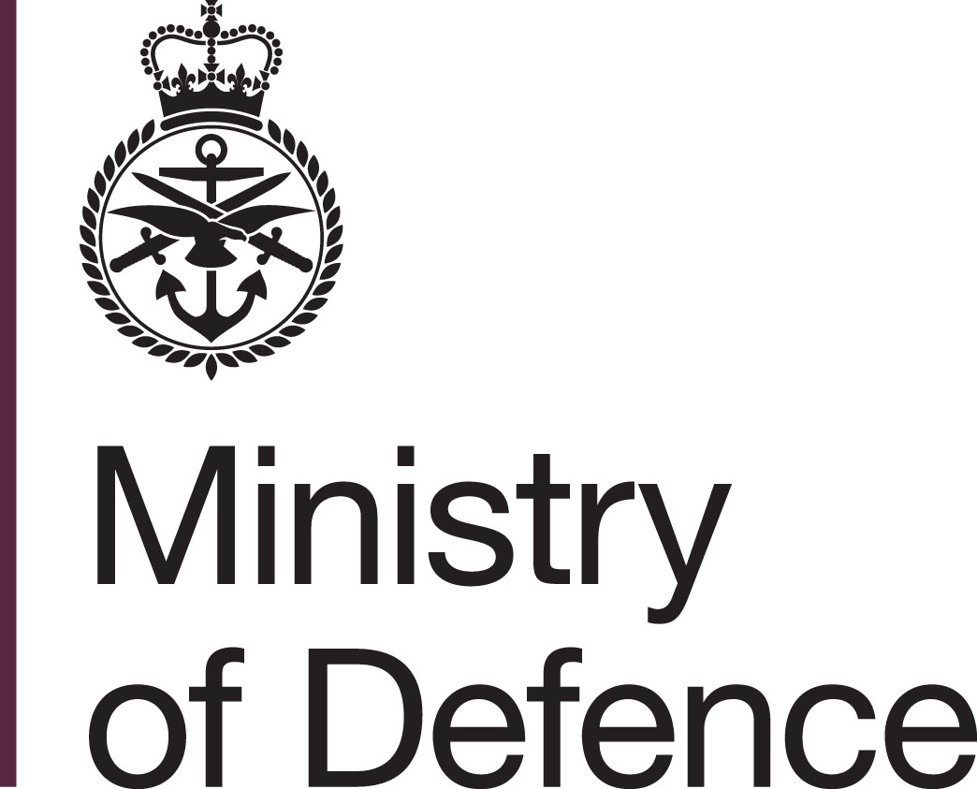
Nathan Lewis
Head Office Commercial
Business Partner 4
Imjin Barracks
Gloucester GL3 1HW
Tel: 07812510256
Email: Nathan.lewis677@mod.gov.uk
Eastern Advisory Group Limited
12 Northfields Prospect
Putney Bridge Road
London SW18 1PE
For the attention of: Dr Richard Connolly

Our reference: 702541450

Date: 21 January 2022

Dear Sirs,

Offer of Contract for Defence Costs Study

- You are hereby informed of the Authority’s requirement and you are invited to accept the Offer of Contract, detailed in the attached Schedule of Requirements. The Schedule describes the requirements and sets out the Contract terms and conditions which will take effect on acceptance by you of the Authority’s Offer.
- If you wish to accept this Offer, please complete and sign both copies of the DEFFORM 10 returning one copy to me at the address shown above by post within 10 working days of the date of this Offer. Your acceptance of the Authority’s Offer must be unqualified. If you do not accept the Authority’s Offer within the period specified, then the Authority’s Offer will lapse.
- No Contract will come into existence until you have accepted the Authority’s Offer in accordance with paragraph 2 above. Accordingly, prior to your unconditional acceptance of this Offer, the Authority shall not be responsible in any way whatsoever for any:
- work undertaken by you; or
- costs incurred by you.
- When you have accepted the Authority’s Offer in accordance with paragraph 2 above, you must proceed with the performance of the Contract.

- Nothing contained in this Offer and in the attached Schedule shall be construed as notifying or implying acceptance by the Authority of any estimated or suggested price or of any condition of Contract which may have been referred to orally or in writing in any previous discussion or correspondence.

Yours sincerely

Nathan Lewis
Head Office Commercial Business Partner 4

Signed

Richard Connolly
Director, Eastern Advisory Group
24th January 2022

