ACTIVITY/PROJECT: Informal Play Area, Abbotswood Shopping Centre, Yate
ASSESSED BY: Andrew Sanders, Landscape Architect, Community Spaces improvement team.
DATE: June 2019
ASSESSMENT STAGE: DESIGN [PRE TENDER STAGE]

Site Location: Grassed area adjacent to Abbotwood Shopping Centre, Yate, closest post code BS37 4NG
Description of activity or project: Creation of a bespoke informal play area on a grassed area of public open space. Including the installation of timber play equipment, seating, surfacing and associated groundworks. Anticipated duration of works on site, 3-4 weeks.
Site description: The area of works is within a local shopping centre precinct which is owned by Yate Town Council. The wider area is grassed with some mature trees bisected with pedestrian footpaths and paved areas.
Site access: There are several pedestrian paths used by the general public to access the area from the public car park to the rear of the shopping centre. Vehicle access is from Rodford Way direct to the car park. Site traffic and deliveries will need to be managed to avoid conflict with members of the public and pedestrians using the shops and adjacent paths.
Hazard risk rating system:
Severity Index |  |  | Likelihood index
5 | Death |  | 5 | Certain
4 | Serious injury / infection / illness requiring medical attention and long incapacitation period |  | 4 | Very likely to occur
3 | Minor injury / infection / illness requiring medical attention and short incapacitation period |  | 3 | Quite likely to occur
2 | Minor injury / infection / illness requiring short recovery period but not proper medical attention. |  | 2 | Unlikely to occur
1 | Trivial/nuisance (minor cut, grazes, bruises, skin rashes ) |  | 1 | Remote possibility
NB: Items scoring 2 or less not included on risk assessment

Risk Assessment: Significant risks identified
ENVIRONMENT / ACTIVITY | HAZARD | SEVERITY | LIKELIH’D | RISK FACTOR  (S x L) | COMMENTS/ PROPOSED CONTROLS
Delivery lorries and contractor vehicles entering and exiting the site and crossing areas of publically assessable land | Conflict between contractor’s vehicles, and general public. Risk of collision death or injury to walkers, motorists and site operatives. | 5 | 4 | 20 | Traffic management measures to be put in place including warning signs, supervision by site operative of plant machinery/delivery vehicle movements and consideration of working times. If necessary create localised temporary footpath diversions with fencing to avoid working areas.
Hitting services during works | Injuries to site operatives possibly fatal | 5 | 4 | 20 | Service information to be provided by client. Contractor to carry out CAT scan prior to digging. Use banksman during powered excavations.
Unattended machinery, materials and equipment left on site overnight. | Injury to people particularly children visiting the site being able to access machinery and excavations | 4 | 4 | 16 | Keep site secure from public at all times with temporary fencing. Keep materials and unsecured equipment in secured container or vehicles. Do not leave excavations open overnight, generally keep the site tidy and remove rubbish regularly to avoid hazard.
Installation of bespoke play equipment | Injury to site operatives and children visiting site outside of working hours | 4 | 3 | 12 | Use appropriately trained operatives, use appropriate machinery, wear hard hats and PPE, don’t leave partially erected and in unsafe condition, secure structures before leaving site.

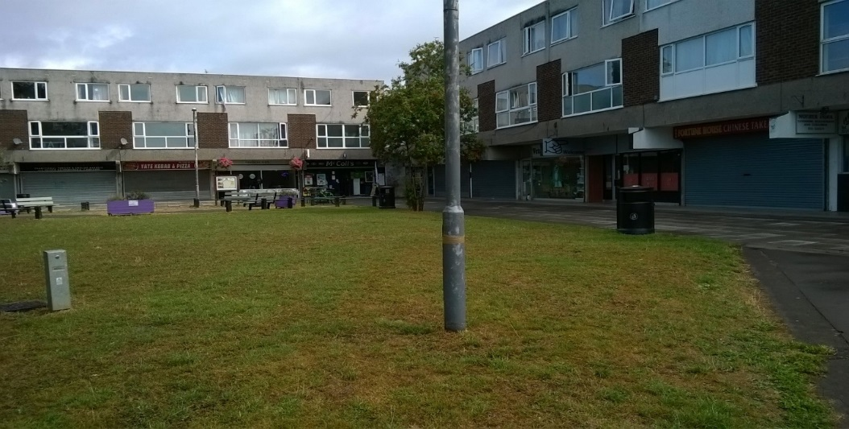
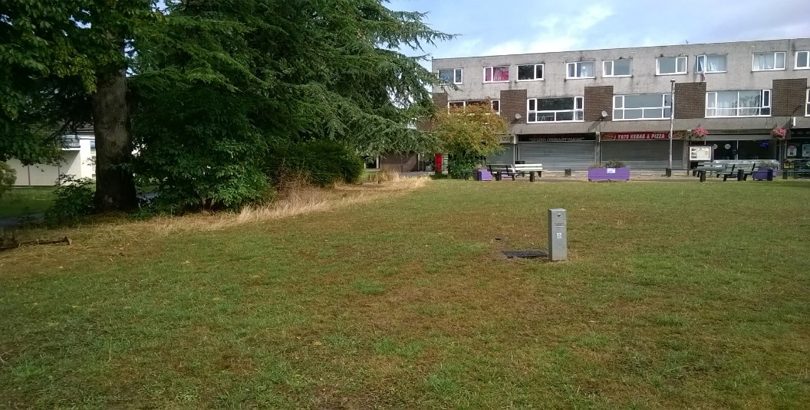
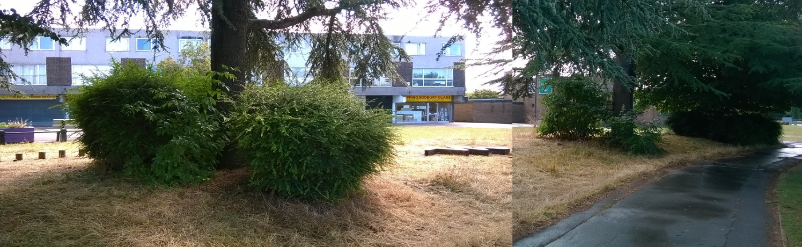
General photo of site area and shopping precinct, taken looking north.

Photo of western boundary, showing mature trees and adjacent footpath.

