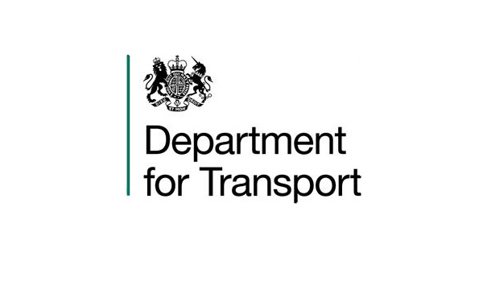

VARIATION TO CONTRACT FORM

Contract Name: The Provision of Legal Advisers on East West Rail and Land

CONTRACT REF: CCLL18A09

Current CCS ref: CCLL18A09-01

Variation Number: 1

Effective from: 26th July 2018

Between:

The Department for Transport (hereinafter called “the Client”) and DLA Piper LLP (hereinafter called “the Contractor”)

The Contract is varied as follows:

- This is a variation to the contract between the Client and the Contractor.
The Terms and Conditions of Contract as previously agreed and amended between the Client and the Contractor will still apply but with the following amendments:

The original Contract term was for 5 months (26th February 2018 until 25th July 2018) and the value was £85,000 (ex VAT).

The Contract shall be extended by a further 6 months and 6 days from 26th July 2018 until 31st January 2019 and the value shall be increased by 194% to a total value of £250,000 (ex VAT).

2. Words and expressions in this Variation shall have the meanings given to them in the Contract.

3. The Contract shall remain effective and unaltered except as amended by this Variation.

SIGNED

For the Client: For the Contractor:

[REDACTED] [REDACTED]

Full Name: [REDACTED]
Full Name: [REDACTED]
Title: [REDACTED]
Title: [REDACTED]

Date: 09/07/2018 Date: 09/07/2018

