**Letter of Appointment**



Dear Sirs 1st June 2019

**Letter of Appointment**

**PHE –** **Strategic Evaluation Partner**

This Letter of Appointment is issued following a competitive tender in accordance with Public Contract Regulations 2015 OJEU Restricted Tender 2018/S 234-534978 dated 5th December 2018.

Capitalised terms and expressions used in this letter have the same meanings as in the Call-Off Terms unless the context otherwise requires.

|  |  |
| --- | --- |
| Agreement Number: | **ECM 6734** |
| From: | Public Health England ("Client") |
| To: | Wavemaker Ltd ("Agency") |

|  |  |
| --- | --- |
| Effective Date: | 1st June 2019 |
| Expiry Date: | End date of Initial Period 31st May 2020  End date of Maximum Extension Period 31st May 2024  Minimum written notice to Agency in respect of extension: three months for each of the four 12-month extensions. |

|  |  |
| --- | --- |
| Services required: | Scope of work;  These services are set out in Section 2 (Services offered) and refined by:  the Client’s Brief attached at Annex A and the Agency’s Proposal attached at Annex B.  Note: Purchase Orders are raised for each specific assignment under this agreement. |
| Key Individuals: | TBA |

|  |  |
| --- | --- |
| Call Off Contract Charges (including any applicable discount(s), but excluding VAT): | In accordance with the Agency’s Proposal at Annex B. |
| Insurance Requirements | Additional public liability insurance to cover all risks in the performance of the Call-Off Contract, with a minimum limit of £1 million for each individual claim.  Additional employers' liability insurance with a minimum limit of £1 million indemnity.  Additional professional indemnity insurance adequate to cover all risks in the performance of the Call-Off Contract with a minimum limit of indemnity of £1 million for each individual claim.  Product liability insurance cover all risks in the provision of Deliverables under the Call-Off Contract, with a minimum limit of £1 million for each individual claim. |
| Client billing address for invoicing: | payables@phe.gov.uk |

|  |  |
| --- | --- |
| Alternative and/or additional provisions: | N/A |

**FORMATION OF CALL OFF CONTRACT**

**BY SIGNING AND RETURNING THIS LETTER OF APPOINTMENT (which may be done by electronic means) the Agency agrees to enter a Call-Off Contract with the Client to provide the Services in accordance with the terms of this letter and the Call-Off Terms.**

**The Parties hereby acknowledge and agree that they have read this letter and the Call-Off Terms.**

**The Parties hereby acknowledge and agree that this Call-Off Contract shall be formed when the Client acknowledges (which may be done by electronic means) the receipt of the signed copy of this letter from the Agency within two (2) Working Days from such receipt.**

**For and on behalf of the Agency: For and on behalf of the Client:**

Name and Title: Name and Title:

Signature: Signature:

Date: Date:

**Annex A**

**Client Brief**

In accordance with the attached brief:



**Annex B**

**Agency Proposal**

In accordance with the attached Stage 1 and Stage 2 Proposals:

**Redacted**

All prices are indicative based on current understanding and exclude VAT.

Travel and Subsistence shall only be chargeable outside the M25 area.

**Annex C**

**Call-Off Terms**

In accordance with the attached Call-Off Terms:



**Annex D**

**Service Level Agreement (SLA)**

The Agency will be measured against SLAs as described in this schedule.

The Agency fills in the SLAs quarterly and sends them 10 days ahead of the review meeting to the Client’s procurement team for internal distribution. The Client’s key marketeers will also fill in a customer satisfaction survey

Performance will be self-measured quarterly and validated by the Client when necessary.

Following the 4 quarterly reviews, yearly performance will be averaged.

The Client will withhold 10% of the total project costs, payment of which is subject to satisfactory performance during the calendar year of both SLAs as below and the quarterly Customer Satisfaction Survey (which is an internal PHE Document)

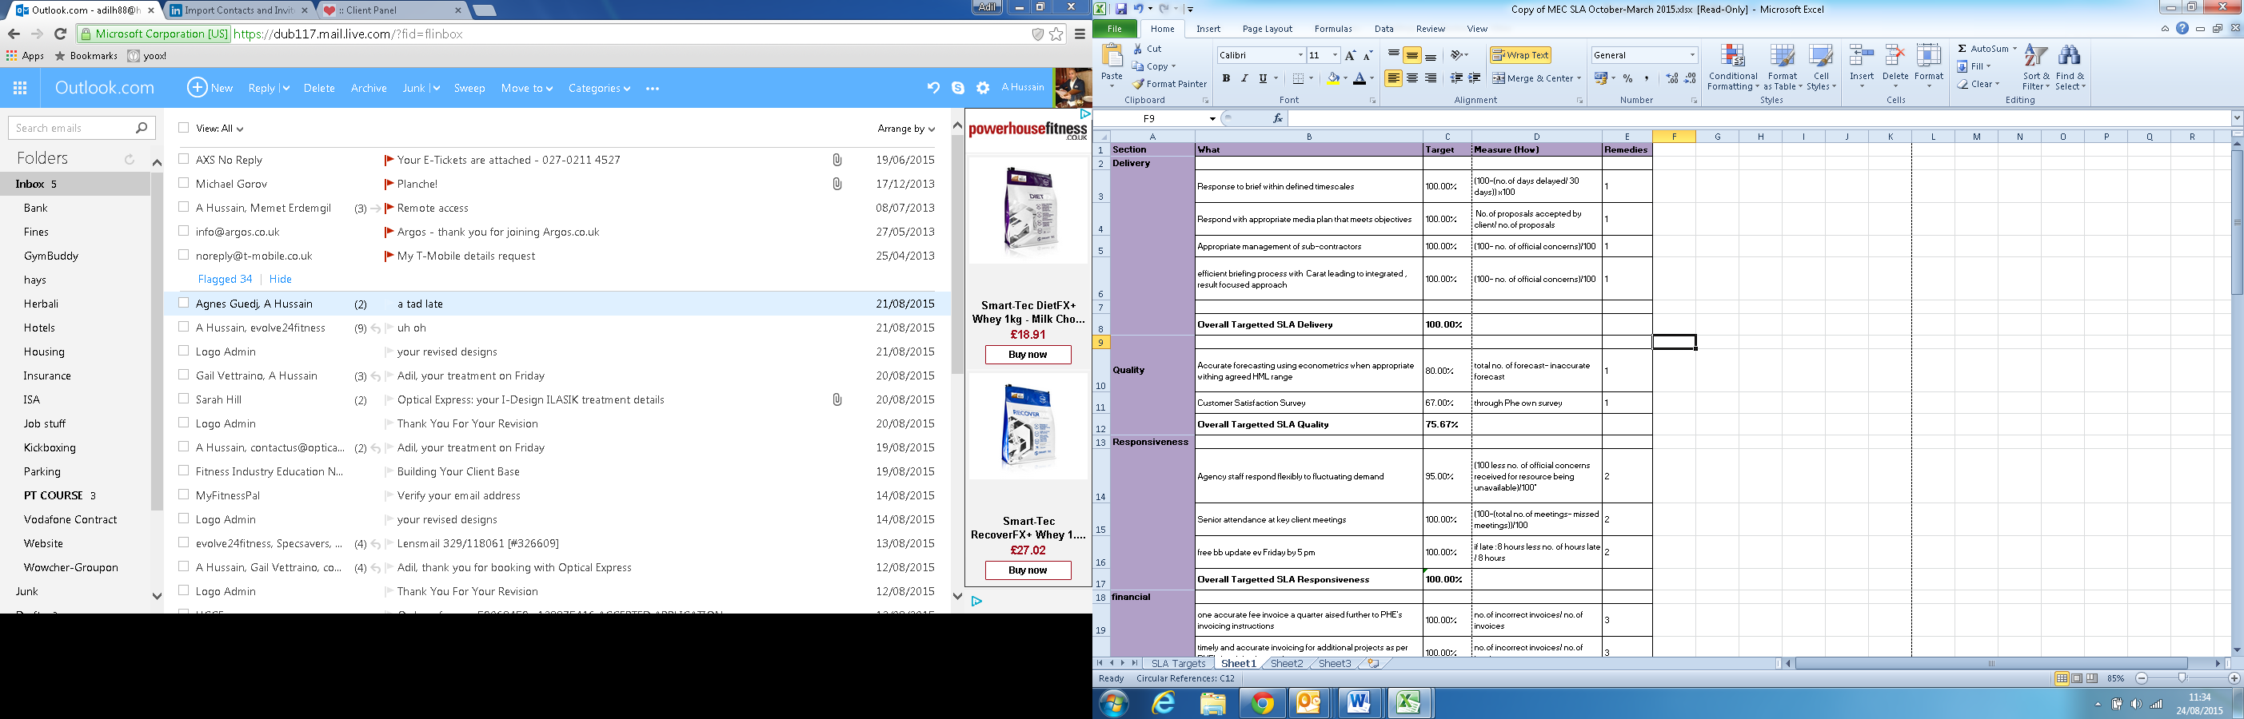

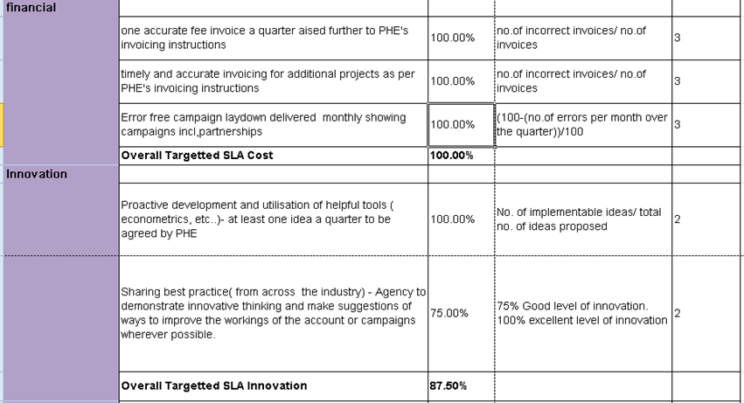

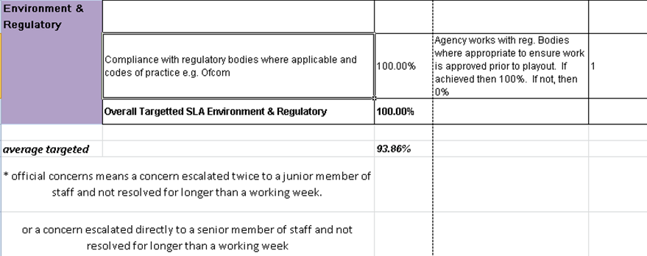

**ESCALATION CHART**

