

FOOTPATH REPAIRS -

PROJECT BRIEF FOR PEOPLE’S PARK

WARWICK ROAD

BANBURY OX16 0AD

QUERIES CONTACT

Mike P Hall
Recreation & Amenities Manager
mike.hall@banbury.gov.uk
Telephone 01295 250340
Mobile 07825 308548

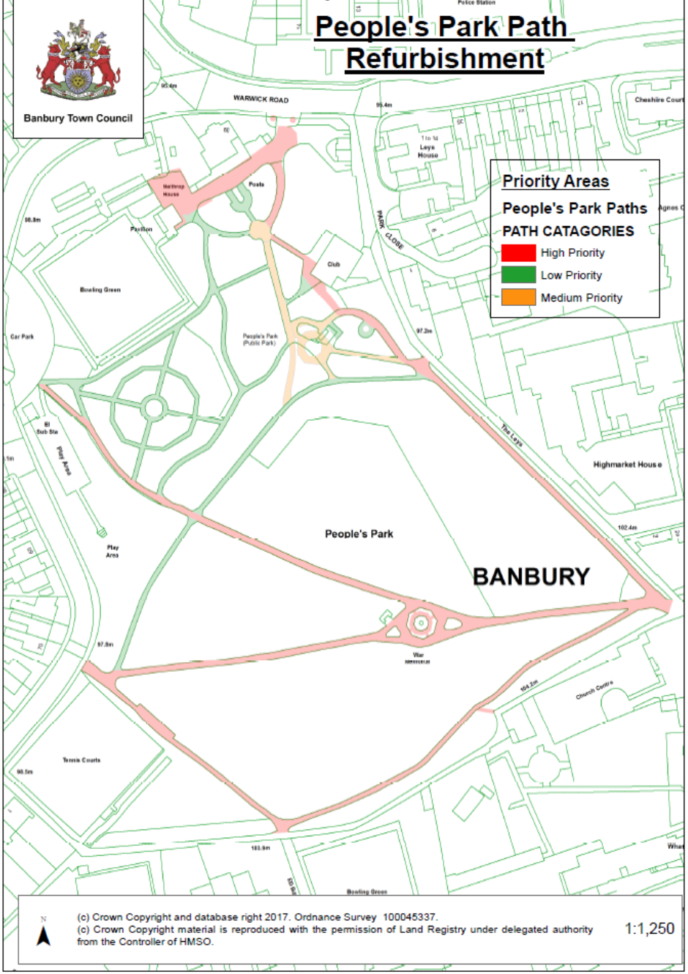
L
K
J
I
H
G
F
E
D
B
A
C

CONTRACT BRIEF FOR FOOTPATH REPAIRS

Banbury Town Council is seeking expressions of interest from potential contractors to undertake footpath repairs through the park over the next few years with a programme of work that will allow each individual footpath to be repaired on an annual basis (please see attached map).
Tenderers wishing to be considered for this work MUST submit their expression of interest to Banbury Town Council by Friday 11th May 2018.
The specification for the work will be released once a short list of contractors has been drawn up, which will be based on the locality/ experience of the company and whether the contractor can show that it has undertaken works of this nature in similar locations.
People’s Park is the most prestigious park located in Banbury and the work must be carried out with this in mind therefore any damage incurred (especially to the soft landscaping around the park) to be reinstated to the entire satisfaction of Banbury Town Council at the contractors own expense.
The works will be split into various sections with the primary area located around the War Memorial. This work must be completed to ensure there is no disruption to any events being held in the park especially the Remembrance Day Services in November. The contractor must also avoid work on the site during school holidays and weekends therefore should programme this in for completion by the end of September.
The paths in the park are in constant daily pedestrian use therefore diversions must be put in place whilst the work is being done, for the general public traversing the site.
Paving around the War Memorial (identified within the red circle on the map) will have been replaced prior to this contract being let and on no account must this be damaged in any way, when the footpath repairs are being undertaken; any costs involved to reinstate any damage caused, will be taken off amounts owed for the contract. The footpath area around the War Memorial has the highest priority for repair in the 2018/ 19 financial year.
The attached map below shows the footpaths to be repaired. Many of these paths have very mature trees located near them and on no account must the roots of these be damaged and therefore contractors must comply with BS 5837:2012 and the Arboricultural Association Practice Note APN12 which can be downloaded off the internet.
Dependent upon budget it is anticipated that the work could take approximately 5 years to complete with a single footpath being repaired on an annual basis unless additional budget provision becomes available or the prices quoted allow for additional work.

FOOTPATHS
- Area Around War Memorial and soft landscaping
- War Memorial to Bath Road Car Park (A to B on the plan)
- The Leys entrance to bowls club pavilion (C to D on the plan) – includes some crazy paving that is in good condition.
- Continuation of path from front of pavilion to service road (E to F on the plan)
- War Memorial to Bath Road (A to H on the plan)
- The Shades entrance to Bath Road (G to H on the plan)
- The Leys entrance to The Shades entrance (C to G on the plan)
- The service road to the Community Garden including entrance to People’s Park from Warwick Road (I to J on the plan). This is a joint access with the adjoining property with funding split between Banbury Town Council and the property owner.
- Footpath link past and including around aviary including other possible areas located on the front lawn (K to L on the plan)

PRIORITY PATHS
  - WITH APPROXIMATE DIMENSIONS
ID | FOOTPATH LOCATION | SURFACE TYPE | TYPE | PRIORITY | AREA | X_AXIS | Y_AXIS
012B | War Memorial area (WM) | footpath | bitmac | High | 212 | 445188 | 240568
009 | C - H (EX WM) | footpath | bitmac | High | 213 | 445108 | 240611
010 | A - B | footpath | bitmac | High | 277 | 445108 | 240611
013 | C - G | footpath | bitmac | High | 288 | 445203 | 240531
014 | G - H | footpath | bitmac | High | 244 | 445096 | 240524
008A | C - F | footpath | bitmac | High | 357 | 445228 | 240627
ERd1 | J - I | hardstanding | entrance & car park | High | 493 | 445112 | 240736
ERd2 | J - I | hardstanding | bitmac | High | 3 | 445132 | 240758
ERd3 | J - I | hardstanding | btmac | High | 3 | 445140 | 240758
WM | EXCLUDED | hard paving | WAR MEMORIAL | High | 38 | 445188 | 240569
WM02 | EXCLUDED | hard paving | WAR MEMORIAL | High | 19 | 445188 | 240569
007 | K - L | footpath | bitmac | Medium | 51 | 445169 | 240669
006B | K - L | footpath | bitmac | Medium | 55 | 445128 | 240716
006C | K - L | footpath | bitmac | Medium | 156 | 445136 | 240684
A001 | K - L | hard paving | crazy paving | Medium | 158 | 445156 | 240679
A002 | K - L | footpath | bitmac | Medium | 13 | 445153 | 240664
003 | MIDDLE & LINKING PATHS ADJACENT TO FRONT LAWN | footpath | bitmac | Low | 164 | 445110 | 240663
004 | MIDDLE & LINKING PATHS ADJACENT TO FRONT LAWN | footpath | bitmac | Low | 27 | 445122 | 240699
005 | MIDDLE & LINKING PATHS ADJACENT TO FRONT LAWN | footpath | bitmac | Low | 35 | 445131 | 240664
011 | MIDDLE & LINKING PATHS ADJACENT TO FRONT LAWN | footpath | bitmac | Low | 299 | 445139 | 240644
001A | MIDDLE & LINKING PATHS ADJACENT TO FRONT LAWN | footpath | bitmac | Low | 190 | 445078 | 240671
001B | MIDDLE & LINKING PATHS ADJACENT TO FRONT LAWN | footpath | bitmac | Low | 23 | 445060 | 240653
FL01 | MIDDLE & LINKING PATHS ADJACENT TO FRONT LAWN | footpath | bitmac | Low | 65 | 445121 | 240727
FL02 | MIDDLE & LINKING PATHS ADJACENT TO FRONT LAWN | footpath | bitmac | Low | 64 | 445112 | 240717
FL03 | MIDDLE & LINKING PATHS ADJACENT TO FRONT LAWN | footpath | bitmac | Low | 29 | 445143 | 240701
FL04 | MIDDLE & LINKING PATHS ADJACENT TO FRONT LAWN | hardstanding | bitmac | Low | 17 | 445156 | 240679
RGdn | MIDDLE & LINKING PATHS ADJACENT TO FRONT LAWN | footpath | bitmac | Low | 339 | 445088 | 240650
SGdn | MIDDLE & LINKING PATHS ADJACENT TO FRONT LAWN | hard paving | crazy paving | Low | 15 | 445156 | 240679

This table follows the colour coding shown on the map above with the paths highlighted in red being the high priority areas with the greatest pedestrian footfall over them. It is the wish of Banbury Town Council that those identified in amber or green will be dealt with through the refurbishment programme as necessary however this will be dependent upon the financial cost and whether budget provision can be identified.

APPROXIMATE PATH DIMENSIONS
Description | Section | ID Number | Length | Width | Unit | Area | Unit | Kerbed | Concrete Base | Notes
 | Old tree pit areas (x 2) by entrance to park (diameter) |  | 2 |  |  | 3 | m² | X | X
Access Road to rear of Neithrop House Total Area |  | I - J | 66 |  | lin m. | 449 | m² | X | X
Front Lawn Paths Total Area |  |  | 104 |  | lin m. | 237 | m² | X | X
Path 001 | from semi-circle path - end of lawn area |  | 115 | 2 | lin m. | 190 | m² | √ | X | Partial wood edging
Path 002 | By Play Area included in 010 above |  |  | 2 | lin m. |  | m² | X | X
Path 003 | Around outside of rose garden |  | 93 | 2 | lin m. | 140 | m² | X | X
Path 004 | Link path 3 - 6 |  | 21 | 2 | lin m. | 32 | m² | √ | Unknown
Path 005 | Southern link path 3 - 6 |  | 25 | 2 | lin m. | 44 | m² | X | X
Path 006 | Path from middle path past Aviary to semi-circle path | K - L | 62 | 2 | lin m. | 131 | m² | X | X
Path 007 | To Aviary from 008 | INC Path 006 above | 26 | 2 | lin m. | 58 | m² | X | X
Path 008 | Parallel path to The Leys to front gate icludes crazy paved path | C - D  E - F | 216 | 3 | lin m. | 561 | m² | X | X
Path 009 | Main path to War Memorial | C - A | 64 | 2 | lin m. | 146 | m² | Partial | Unknown
Path 010 | War memorial to rose garden | A - B | 164 | 2 | lin m. | 377 | m² | √ | √
Path 011 | Middle path |  | 172 | 2 | lin m. | 361 | m² | √ | √
Path 012 | War memorial to tennis courts | A - H | 98 | 2 | lin m. | 215 | m² | √ | √
Path 013 | Southern path | C - G | 162 | 2 | lin m. | 275 | m² | X | X
Path 014 | By Tennis Courts | G - H | 98 | 2 | lin m. | 188 | m² | √ | Unknown
Total Area |  |  | 1,316 |  | lin m. | 2,956 | m²
Aviary Total Area |  |  | 45 |  | lin m. | 13 | m²
Rose Garden Total Area |  |  | 212 |  | lin m. | 306 | m²
War Memorial Total Area |  |  | 102 |  | lin m. | 212 | m²
Approximate Total Area of Road/ Paths in People's Park |  |  | 1,849 |  | lin m. | 4,195 | m²

The measurements shown are as accurate as they can be without being properly surveyed. The table shows those paths that have some edging or are laid on a concrete base. Site visits are advised as no additional claims will be accepted, once the contract is let.

