

Bid Pack For Open Market Competition
This procurement event will be conducted in accordance with the Public Contract Regulations 2015, specifically Chapter 8, Below Threshold Procurements.
Attachment 2 – How To Bid Including Evaluation Criteria
Contract Reference: The Provision of MBTI Training for HM Treasury
Contents
1
Bid Pack For Open Market Competition 1
1. How To Make Your Bid 2
2. How The Questionnaires Are Structured: 2
3. Award Criteria 11
4. Marking Scheme 13
5. Quality Evaluation 14
6. Price Evaluation 15
7. Final Decision to Award 17
8. Further Information 18

How To Make Your Bid

Your bid must be made by the organisation that will be responsible for providing the deliverables if your bid is successful.

Remember to:

Accept or Decline this Bid Pack. If you Decline please provide a reason for doing so

Enter your bid into the e-Sourcing Suite. We can only accept bids that we receive through the e-Sourcing Suite

Make sure you answer every question

Each question must be answered in its own right. You must not answer any of the questions by cross referencing other questions or other materials e.g. reports located on your website.

Submit your bid in good time and before the bid submission deadline.

Upload ONLY those attachments we have asked for in line with the requirements specified – any other supporting evidence, certificates for example, will be requested separately by us.

If we do not require attachments and have specified this please only use the Text Boxes provided for your answer.

Check for messages in the e-Sourcing Suite throughout the competition.

Press the Submit all Draft Bids button when your bid is ready, otherwise we will not be able to see it.

If you are unsure, ask questions before the Clarification Questions Deadline.

How The Questionnaires Are Structured:

A summary of all the questions in the quality questionnaire, along with the marking scheme, and weightings for each question is set out below:

QUESTIONNAIRE 1 - KEY PARTICIPATION REQUIREMENTS

QUESTIONNAIRE 2 - CONFLICTS OF INTEREST

QUESTIONNAIRE 3 - INFORMATION ONLY

QUESTIONNAIRE 4 - QUALITY - PROPOSAL DETAILS

QUESTIONNAIRE 5 - QUALITY - RELATIVE EXPERIENCE

QUESTIONNAIRE 6 - QUALITY – ACCOUNT MANAGEMENT

QUESTIONNAIRE 7 – PRICE
QUESTIONNAIRE 1 - KEY PARTICIPATION REQUIREMENTS

Response Guidance

The following questions are ‘Pass/Fail’ questions. If Potential Bidders are unwilling or unable to answer “Yes”, their submission will be deemed non-compliant and shall be rejected. Potential Bidders should confirm their answer by selecting the appropriate option from the drop down menu.

Question Number | Question |  | Your Response
1.1 | Do you accept the competition rules as described in Attachment 1 – About the Procurement? | Yes/No
1.2 | Have you read, understood and accepted the Bid Pack and all associated attachments, specifically Attachment 3 - Statement of Requirements? | Yes/No
1.3 | Do you agree, without caveats or limitations, that in the event that you are successful Attachment 5 - Terms and Conditions will govern the provision of this contract? | Yes/No
1.4 | Do you confirm your Organisation’s e-Sourcing suite profile is complete and accurate at the time the bid closed and that any amendments made following acceptance of this event will be notified to the buyer in writing? | Yes/No
1.5 | Please confirm that you understand that CCS reserve the right to use a credit reference agency to obtain a financial risk score for you and any members of your consortium or any nominated guarantor(s)? | Yes/No
1.6 | Do you agree without caveat or limitations that you will provide upon request any relevant Insurance or Accreditation certificates? | Yes/No
1.7 | Potential providers should state how they comply with the technical requirements prescribed by ‘Cyber Essentials’. If the Potential provider has a current and valid cyber essentials certificate awarded by one of the government approved Cyber Essentials accreditation bodies within the last 12 months (see: https://www.gov.uk/government/publications/cyber-essentials-scheme-overview) they should provide a copy of that certificate as part of their response. If they do not hold current certification they should set out in detail how they comply with the relevant technical requirements of Cyber Essentials, which can be found here: https://www.cyberstreetwise.com/cyberessentials/files/requirements.pdf | Yes/No
1.8 | (i) The method used by Authority staff to submit personal information (e.g. Myers Briggs-related information) to a supplier web portal must be encrypted and appropriately secure.  (ii) Similarly, any reports containing personal information which the supplier provides to Authority staff must also be encrypted and appropriately secure whether provided by a web portal of via email.  Please describe the options you can provide/support for the ensuring that 6.2(i) and (ii) are processed in an appropriately secure way.  Please note: The method of encryption used for 6.2(i) and (ii) must be agreed with the Authority. | Yes/No
1.9 | Potential Providers should state whether they hold any relevant independent security-related certification (i.e. such as ISO27001) and, where they have, provide copies of any relevant certificates as part of their response. | Yes/No
1.10 | Potential Providers are asked to confirm whether the pre-employment checks they subject their staff to are at least equivalent to the Government Baseline Personnel Security Standard. | Yes/No
1.11 | Potential Providers are asked to describe the measures they have in place to ensure compliance with the GDPR https://ico.org.uk/for- organisations/guide-to-the-general-data-protection-regulation-gdpr/principles/  They should also confirm whether any Authority data that would be stored/processed as part of this requirement would be hosted, and would remain within the UK. Where a Potential Provider is considering proposing a solution in which part of the solution is either (a) hosted outside the UK or (b) supported by system administrator staff based outside the UK, the countries involved must be clearly stated. | Yes/No
1.12 | Please confirm that you have the ability to supply a Facilitator who will need to be MBTI® accredited and experienced with working with diverse groups and senior professionals. | Yes/No

QUESTIONNAIRE 2 – CONFLICTS OF INTEREST

Response Guidance

Question 2.1 is a ‘Yes/No’ question and will dictate whether or not question 2.2 needs to be answered.

Question 2.2 is a Pass / Fail question. Potential Bidders are required to provide details of how the identified conflict will be mitigated. The Contracting Authority will review the mitigation in line with the perceived conflict of interest, to determine what level of risk this poses to them.

Therefore, if Potential Bidders cannot or are unwilling to suitably demonstrate that they have suitable safeguards to mitigate any risk then their Bid will be deemed non-compliant and will be rejected.
Question Number | Question | Your Response
2.1 | Please confirm whether you have any potential, actual or perceived conflicts of interest that may by relevant to this requirement. |  | Yes/No
2.2 | We require that any potential, actual or perceived conflicts of interest in respect of this Bid Pack are identified in writing and that companies outline what safeguards would be put in place to mitigate the risk of actual or perceived conflicts arising during the delivery of these services. |  | Text Box

QUESTIONNAIRE 3 – INFORMATION ONLY

Response Guidance

The following questions are for information only and do not form part of the evaluation. Information provided in response to these questions may be used in preparation of any Contract Award and any omissions may delay completion of this procurement exercise.
Question Number | Question | Your Response
3.1 | What are your details:  - Name (registered name if registered)  - Office address (registered address if registered)  - Website address (if applicable)  - Date of registration (if applicable) or date of formation  - Registration number (company, partnership, charity etc.) if applicable  - DUNS number (of head office, if applicable)  - VAT number | Text Box
3.2 | What is your trading status:  - Public limited company  - Limited company  - Limited liability partnership  - Other partnership  - Sole trader  - Third sector  Other | Text Box
3.3 | Are you a Small, Medium or Micro Enterprise (SME)?  See the definition of SME | Text Box
3.4 | Please provide details of where the Award Outcome should be directed. Your response must include their;  - Full Name  - Role/Title  - Registered Address  - Email Address | Text Box
3.5 | Please provide details of any sub-contractors you propose to use in order to meet your obligations should you be awarded a Contract. Your response must include their;  - Trading Name(s)  - Registered Address(es) and contact details  - Goods/Services to be provided | Text Box

QUESTIONNAIRE 4 - QUALITY – PROPOSAL DETAILS 30%

Response Guidance
Potential Bidders MUST answer ALL the following questions. The method of response, page limit on attachments and evaluation criteria is set per question.

Attachments may be submitted in Microsoft Word, Excel. PDF format and must be in Arial font size 11. Page limits include the use of headers footers and diagrams. Upload ONLY those attachments we have asked for – any other supporting evidence, certificates for example, will be requested separately by us

No costings should be included in responses to this Questionnaire.
Question Number | Question | Your Response | Minimum Acceptable Score | Maximum Available Score | Weighting 30%
4.1 | How would you structure the workshop sessions and what would be the important takeaways? | Attachment | 66 | 100 | 30%
4.2 | What flexibilities do you have in place to ensure that you are able to meet the delivery timetable? | Text Box | 66 | 100 | 40%
4.3 | What would be your priority subject matter for the workshop? |  | 66 | 100 | 30%

QUESTIONNAIRE 5 - QUALITY – RELEVANT EXPERIENCE 40%

Response Guidance
Potential Bidders MUST answer ALL the following questions. The method of response, page limit on attachments and evaluation criteria is set per question.

Attachments may be submitted in Microsoft Word, Excel. PDF format and must be in Arial font size 11. Page limits include the use of headers footers and diagrams. Upload ONLY those attachments we have asked for – any other supporting evidence, certificates for example, will be requested separately by us

No costings should be included in responses to this Questionnaire.
Question Number | Question | Your Response | Minimum Acceptable Score | Maximum Available Score | Weighting 40%
5.1 | Please provide details of the experience you have of successfully running this type of event with large groups. In your response you should provide:  - Examples/testimonials from clients for whom you have delivered this type of training successfully |  | 66 | 100 | 40%
5.2 | Please provide details of any other training requirements that you have successfully delivered for a central government department in the past two years. In your response you should provide:  - Examples/testimonials from clients for whom you have delivered this type of training successfully |  | 66 | 100 | 40%
5.3 | Please provide details of how you gather feedback, include in your response how quickly you aim to respond to feedback from a session? |  | 66 | 100 | 20%

QUESTIONNAIRE 6 - QUALITY – ACCOUNT MANAGEMENT 10%
Response Guidance
Potential Bidders MUST answer ALL the following questions. The method of response, page limit on attachments and evaluation criteria is set per question.

Attachments may be submitted in Microsoft Word, Excel. PDF format and must be in Arial font size 11. Page limits include the use of headers footers and diagrams. Upload ONLY those attachments we have asked for – any other supporting evidence, certificates for example, will be requested separately by us

No costings should be included in responses to this Questionnaire.
Question Number | Question | Your Response | Minimum Acceptable Score | Maximum Available Score | Weighting 10%
6.1 | Please provide details of your risk register and how you plan to document risks for this requirement and details of your risk management plan for this requirement. |  | 66 | 100 | 40%
6.2 | Please provide details of how you would plan to prioritise issues that occur and what precautions you have in place to tackle any issues? |  | 66 | 100 | 40%
6.3 | Potential Providers should describe in detail what physical security measures they will have in place in any data centres, or other buildings, used to host the Authority’s data. |  | 66 | 100 | 20%

QUESTIONNAIRE 7 – PRICE 20%
Response Guidance

Potential Bidders must enter costs by uploading the relevant Attachment 4 - Price Schedule at the question level on the e-Sourcing event.

Prices should be submitted in pounds Sterling inclusive of any expenses but exclusive of VAT.

Potential Bidders will be scored in accordance with the marking scheme at Section 2.
Question Number | Question | Your Response | Minimum Acceptable Score | Maximum Available Score | Weighting 20%
7.1 | Please confirm, by selecting ‘YES’ that you have attached a completed Price Schedule to the response to this question. In so doing, you are also confirming that prices offered are inclusive of any expenses, exclusive of VAT and firm for the period following the Deadline for Submission as stated in the Attachment 1 - Bid Pack. | Yes/No  Attachment

Award Criteria

The award stage consists of a quality evaluation and a price evaluation.

The award of the resultant contract will be on the basis of the ‘Most Economically Advantageous Tender’ (MEAT) or price only.

The weighting for the quality evaluation is 80%; and, the price evaluation is 20%.

Award process - What you need to do

Answer the questions in section 2 above in the e-Sourcing suite.

Complete the Attachment 4 – Price Schedule

You must upload your completed Price Schedule into the e-Sourcing suite at questionnaire 7.

What we will do
1 | Compliance Check  First, we will complete a mandatory evaluation to make sure that you have answered all questions and have completed the Attachment 4 - Price Schedule in line with our instructions. All bids passing the mandatory evaluation will be progressed to the Quality Evaluation.
2 | Quality Evaluation  We will give your responses to the QUALITY questionnaires to the Contracting Authority’s evaluation panel. Each evaluator will independently assess your responses to the quality questions using the response guidance and the evaluation criteria.  They will give a score and a reason for their score for each question they are assessing. The evaluators will enter the scores and reasons into the e-Sourcing suite.  If the evaluation panel wishes to clarify any areas of your bid, bid clarification questions will be issued via the e-Sourcing suite on an individual basis.
3 | Consensus  Once the evaluators have independently assessed your answers to the questions we will arrange for the evaluators to meet. We will facilitate the discussion.  At this meeting, the evaluators will discuss the quality of your answers and review their scores and reasons for that score. The discussion will continue until they reach a consensus regarding the score, and reason for that score, for each question.  These final scores will be used to calculate your quality score.  If the evaluation panel wishes to clarify any areas of your bid, bid clarification questions will be issued via the e-sourcing suite on an individual basis.
4 | Quality Threshold  If you have not met the minimum acceptable score for each question, you will be excluded from the competition. We will tell you that you have been excluded from the procurement and why at award stage. If this is a 2 Stage Evaluation, we will advise you at the point in which Stage 2 invitations are sent.
5 | Evaluate Pricing  We will then evaluate your price and calculate your price score using the evaluation criteria specified.  If we wish clarify any areas of your bid, bid clarification questions will be issued via the e-Sourcing suite on an individual basis.
6 | Final Score  Your quality score will be added to your price score, to create your final score.
7 | Award  Award will be made to the successful bidder, subject to contract.  We will notify successful and unsuccessful bidders providing feedback.  If the successful bidder does not accept the Contract we may offer a Contract to the next highest scoring Bidder but only where they have met the minimum pass score.

Marking Scheme

The evaluation criteria set out below will be used during the Quality Evaluation:

Marking Scheme | Description
100 - Good | The response fully meets all requirements with detail provided minimising risks to delivery.  The response is comprehensive and unambiguous, demonstrating a thorough understanding of the requirements and provides details of how the requirement will be met in full without additional support from the Contracting Authority, other than that outlined within the statement of requirements.
66 – Acceptable – Minor Concerns | The response is acceptable and meets all the basic requirements. However, the response, is not sufficiently detailed to minimise risk and/or the proposed approach may require additional support (in addition to that outlined in the Statement of Requirements) from the Contracting Authority to meet its deliverables.
33 – Non Acceptable - Major Concerns | The response has met some, but not all elements of the requirement, which poses risk that the proposal will not meet the deliverables required.  The response does not demonstrate a full understanding of the requirement posing major concerns.
0 - Unsuitable | The response does not meet any of the requirements or no response has been provided. An unacceptable and/or non-compliant response with serious reservations, demonstrating no understanding of the requirement.

Quality Evaluation

Questionnaires Q1 and Q2 are mandatory question(s) and will be evaluated PASS / FAIL. If you fail any of these questions, you will be excluded from the competition. We will tell you that your bid has been excluded.

When the consensus meeting has taken place and the final score for each question has been agreed by the evaluators, your final score for each question will be multiplied by that questions weighting to calculate your weighted score for that question.

Each weighted score for each question for each Lot you have submitted a bid for will then be added together to calculate your quality score.

Please see table A below for an example of how your quality score will be calculated.
Table A – EXAMPLE ONLY

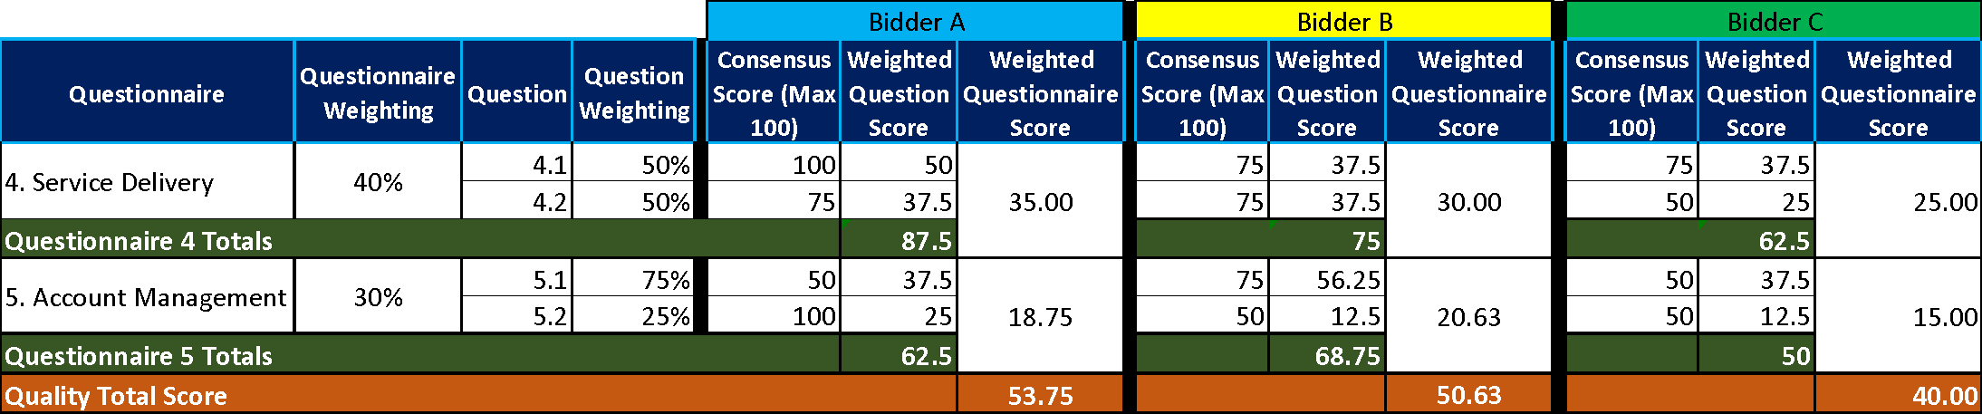

Price Evaluation

This section contains information on how to complete Attachment 4 - Price Schedule and the price evaluation process.

How to complete your Attachment 4 – Price Schedule

Read and understand the instructions in the Attachment 4 - Price Schedule, and in this section before submitting your prices.

Your prices should compare with the quality of your offer.

Your prices must be sustainable and inclusive of all costs for example your operating costs and profit.

Your prices are to exclude VAT.

Pricing is to be inclusive of expenses.

The currency is British pounds sterling, up to two decimal places.

The percentages submitted shall be up to two decimal places.

Pricing will be:

Rounded to the nearest £10.

Zero bids will not be allowed.

We will investigate where we consider your bid to be abnormally low.

The prices submitted shall not exceed the relevant framework contract rates.

You must download and complete the Attachment 4 – Price Schedule you are submitting a bid for. Further detail may be provided within the Attachment 4 – Price Schedule.

When you have completed your Attachment 4 - Price Schedule, you must upload this into the e-Sourcing Suite at question Q7. If you do not upload your Attachment 4 – Price Schedule your bid may be rejected from this competition.

Do not alter, amend or change the format or layout of the Attachment 4 – Price Schedule.

Price Evaluation Process

This is how we will evaluate your pricing:

We will check you have completed the Attachment 4 – Price Schedule as instructed.

Failure to complete the Attachment 4 - Price Schedule as instructed may result in your bid being deemed non-compliant and may be rejected from this competition.

The price evaluation will be undertaken separately to the quality evaluation process.

The Potential Bidder with the lowest total price will be awarded the maximum score available.

All other Potential Bidders will get a price score relative to the lowest total price.

The calculation we will use to evaluate your total price per element, you are bidding for, is as follows:
Price Score = Lowest total price * maximum score available Potential Bidders total price

Please see table B below for an example of how your Price score will be calculated.
Table B – EXAMPLE ONLY
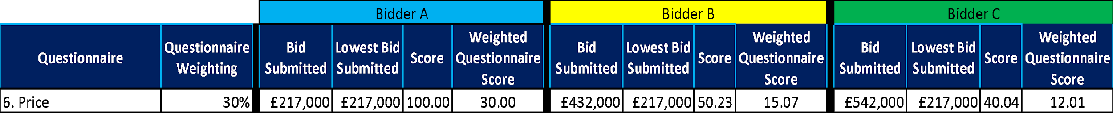

Where we consider any of the total price(s) you have submitted to be abnormally low will ask you to explain the price(s) you have submitted (as required in regulation 69 of the Public Contract Regulations 2015).

Final Decision to Award

We will add your quality score to your price score to calculate your final score.

Please see table C below for an example of how your Quality score and Price score will be added together to identify your final score.
Table C – EXAMPLE ONLY:
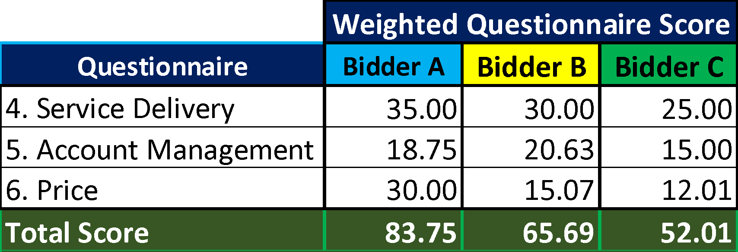

The bidder with the highest final score will be awarded the contract. However, if this is a 2 Stage Evaluation the final scores up to this point will act as a gateway to Stage 2 as outlined in “What we will do” point 7.

Two Stage Evaluation

The following will only apply if Stage 7 of “What we will do” above is adopted.

Where a 2 Stage Evaluation has been conducted the final score from Stage 1 will now be added to the score from Stage 2 to show a final score as demonstrated in the table below:

Please see table D below for an example of how your Stage 1 score and Stage 2 score will be added together to identify your final score.

Table D – EXAMPLE ONLY:
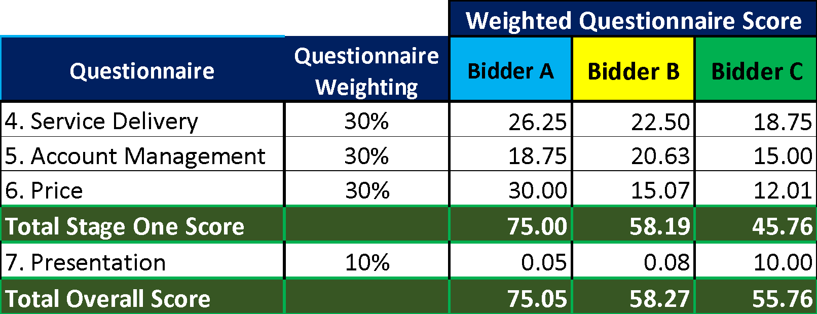

Further Information
  - We will tell you if you have been successful or unsuccessful via the e-Sourcing Suite.

