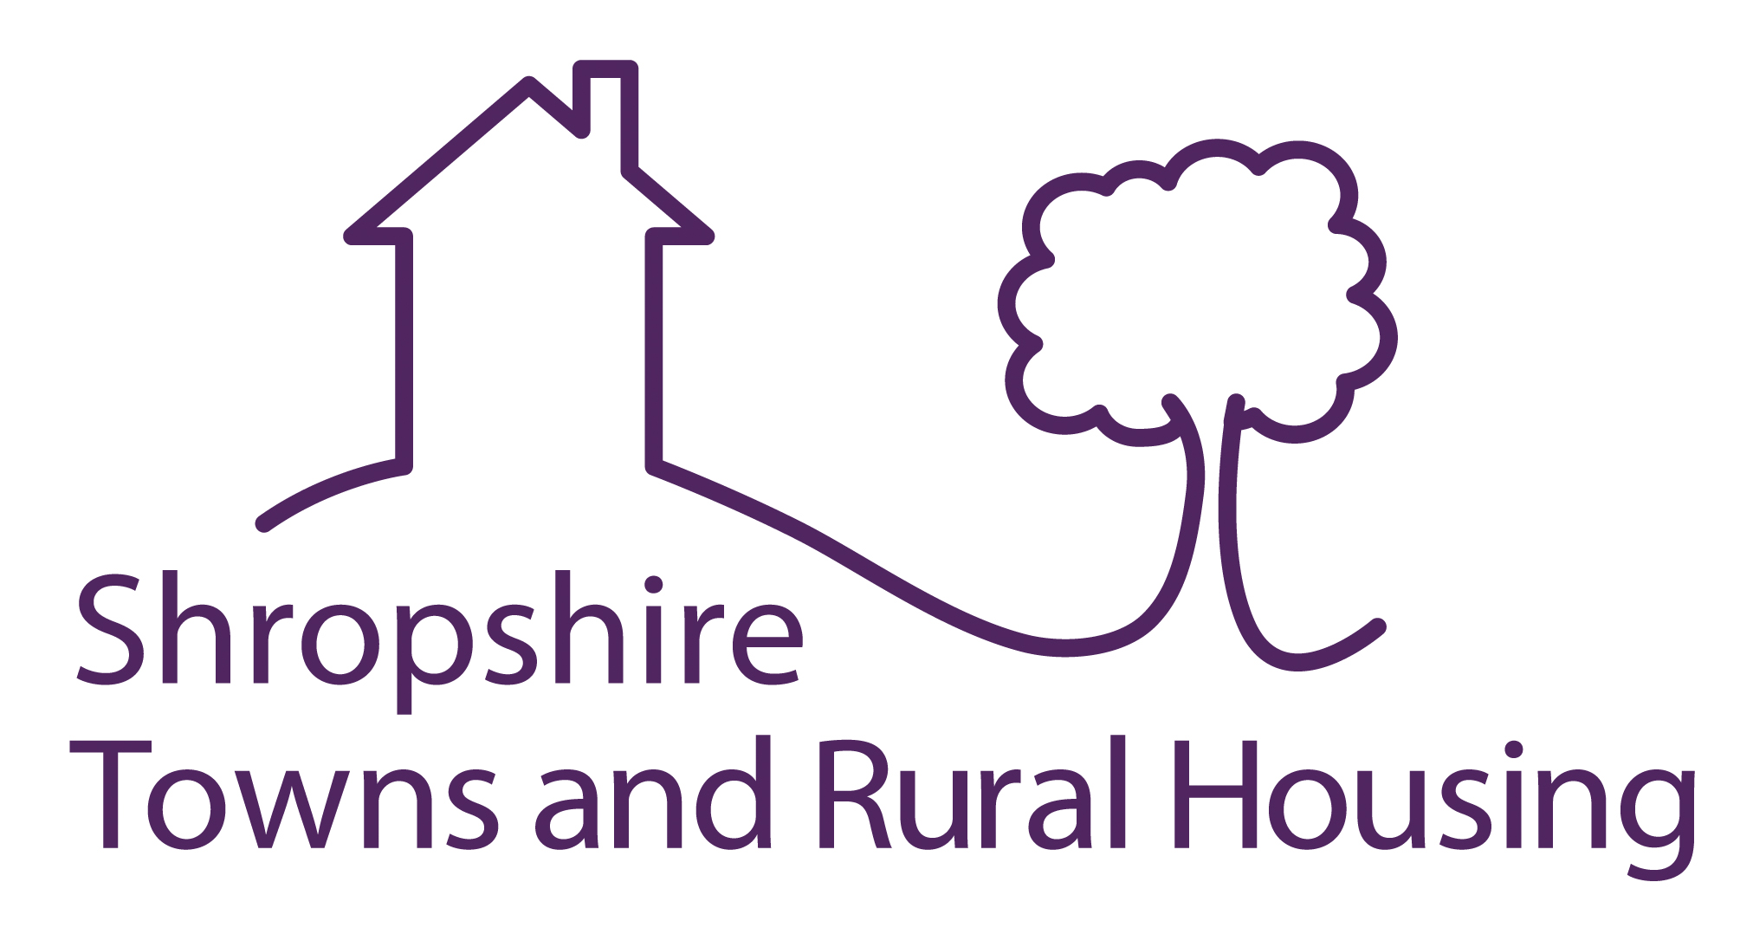

Expression of Interest to Tender for Aids and Adaptations Works

Applicants are invited to express an interest in tendering for Aids and Adaptations works to Shropshire Council owned properties in the North and West of Shropshire for an initial period of 8 Months with the potential of further works. Works will commence ASAP and no later than 1st August 2022

Shropshire Towns and Rural Housing manage a stock of approx. 4100 dwellings for Shropshire Council. Properties are tenanted, sheltered and supported housing stock throughout the rural towns and villages in and around Bridgnorth and Oswestry.

This contract will consist of providing 35-50 level access showers shared between the two geographical areas The basis of the tender is a NHF Form of Contract 2011 (REV6:2019). Priced framework. All works must be completed no later than 31st March 2023, estimated value up to £250,000.

This will be a single stage tender process. Following the closing date of the Expression of Interest, Tender packs will be sent to contractors which will include:
- Invitation to Tender
- Price Framework
- NHF Form of Contract
- Technical Specification
- Schedule of Rates. Version 7.2 NHF Disabled Adaptation Works
- KPI Framework

If you wish to express your interest please apply by email to:
Steve Gray MRICS, Procurement and Contracts Officer steve.gray@starhousing.org.uk
Quoting the reference PM040 or in writing to the above at:
Shropshire Towns and Rural Housing. The Spruce Building. Sitka Drive. Shrewsbury Business Park. Shrewsbury.SY2 6LG.
The deadline for expressions of interest to be received at Shropshire Towns and Rural Housing office is Friday 6th May 2022

