|  |
| --- |
|  |
| Invitation to Tender |
| Downs to the Sea – Wet and Wadery |

***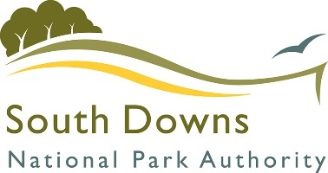

Contents

Document A: Instructions and Information 3

Document B: A Brief Introduction 5

The RSPB 5

The Downs to the Sea Project 5

Pulborough Brooks: Wet and Wadery 6

Document C: Specification 7

1. Hydrological Control Structures 7

1.1 Sluices 7

1.2 Pipe Dam 10

2. Weir Removal 12

3. Track Upgrades 12

4. Standard Required Paperwork 13

Document D: Company Information 14

Document E: Form of Offer 18

Cost 18

Approach to the Project 18

References 18

Document F: RSPB Terms and Conditions 20

Document G: Certificate of Bona Fide Offer 21

Annex 1: Site Maps 22

Annex 2: Works Maps 24

Map 1: Hydrological Control Structures 24

Map 2: Weirs 25

Map 3: Track Upgrades 26

Annex 3: Expenses Policy 27

22/04/2025

Dear Tenderer,

You are invited to tender in competition with others to provide the goods and/or services specified below to the RSPB.

TENDER FOR THE SUPPLY OF:

**Downs to the Sea – Wet and Wadery** including, hydrological control structure installation, weir removal and track upgrades.

Period 01/01/2025 to 31/10/2025

The following documents are enclosed and must be, where applicable, completed and signed on behalf of the supplier.

Your tender response should be emailed to [ruth.gillies@rspb.org.uk](mailto:ruth.gillies@rspb.org.uk).

Only tenders submitted in accordance with the RSPB’s Terms and Conditions will be considered. Any tenders that are incomplete, or received after the time indicated, may be disregarded.

If you wish to discuss any aspect of this tender prior to tendering, please email questions to [ruth.gillies@rspb.org.uk](mailto:ruth.gillies@rspb.org.uk).

Site visits are mandatory.

If you do not wish to tender on this occasion, please let us know.

Yours faithfully,

Ruth Gillies

Project Manager – Downs to the Sea

RSPB

# Document A: Instructions and Information

1. This document is designed to be completed electronically. You are required to mark boxes, insert information or submit additional documentation in response to the questions herein. Whilst the text boxes should expand as you add text, if there is insufficient space for your response please attach a separate document clearly marked with the name of your Company, the reference number and the number(s) of the question(s) to which it relates. Please ‘sign’ this document by adding your name to the end of Document G.
2. If you are unable to comply with a request for information or provide documentation requested then a written account explaining the absence of the information must accompany the return of this tender. Please be aware that the failure to respond to any of the questions, without a written reason, may result in a negative evaluation of that element within the overall evaluation of this questionnaire.
3. The RSPB may require supplementary information or clarification or further evidence of the information given. The RSPB may wish to visit reference sites given as evidence of relevant experience.
4. The RSPB may request interviews with all or a selection of applicants or none. Applicants will be notified in due course. The ability of suppliers may also be determined by, amongst other factors, references, certification, site visits and ‘mystery shopping’.
5. Please answer the questions specifically for your company, NOT for the group if you are part of a group of companies. Please note the term “Company” refers to: Sole proprietor, partnership, incorporated company, co-operative, or voluntary organisation as appropriate.
6. During the term of this agreement and for 1 year thereafter, neither party shall solicit to work for it any person who is or was employed by the other party and who has been involved in the provision of the Services at any time during the preceding 12 months. For the avoidance of doubt, if a person who is or was employed by the other party at the relevant time responds to a publicly advertised recruitment campaign, the recruiting party shall not be deemed to have solicited that person from the other party. If either party is in breach of this it shall pay to the other party an amount equivalent to the gross salary paid by that other party to the relevant employee for the final 12 months of employment.
7. No charge will be made to the RSPB by applicants for any preparation costs accrued during the tender process, whether the applicant was successful or not.
8. You are invited to submit your best offer for the work as detailed below. The RSPB reserves the right to undertake post-tender negotiations.
9. Roles:

Principle Designer: RSPB

Principal Contractor: Not yet appointed.

1. It should be noted that in any contractual relationship that is subsequently entered into, reference will be made to the detailed information provided in the formal response to this tender document provided by the successful organisation. Thus answers and information given in your reply will become a binding part of the contractual obligations between yourselves and the RSPB.
2. Timetable

|  |  |
| --- | --- |
| Invitation to Tender document sent out | 02/05/2025 |
| Tender documents to be returned | 02/06/2025 12:00 |
| Tender Review by Pannel | 05/06/2025 |
| Award of contract | 06/06/2025 |
| Commencement of services / orders for goods | 15/07/2025 – dependant on receival of consents by RSPB. |
| End of contract* | 31/10/2025 – if consents are not received in time, works will be delayed until 2026 and will be re-tendered in January 2026. |

* Three-year contracts may be extended for a further year.

1. The RSPB does not bind itself to accept the lowest or any Tender, and reserves the right to accept part only of a Tender. RSPB reserves the right to procure individual elements of the required solution from one or more supplier as appropriate.

Whilst the RSPB aims to provide feedback on failed submissions this may not always be possible, and the RSPB is under no obligation to do so.

1. Tender Evaluation Process

*Tenders that fail to meet essential requirements may be excluded from consideration.*

Tenders that fulfil essential requirements will be evaluated on the basis of the most economically advantageous tender, weightings as detailed below.

|  |  |
| --- | --- |
| **Criterion** | **Weighting** |
| Price | 35% |
| Relevant experience | 35% |
| Environmental considerations | 30% |

# Document B: A Brief Introduction

## The RSPB

For details on the RSPB’s challenges and achievements in the previous financial year please go to

[How the RSPB is Run | About Us - The RSPB](https://www.rspb.org.uk/about-the-rspb/about-us/how-the-rspb-is-run/)

For an overview of the RSPB please go to:

[About the RSPB - The RSPB](https://www.rspb.org.uk/about-the-rspb/)

The RSPB is the largest wildlife conservation charity in Europe with over one million members.

Our purpose is to advance the conservation of birds, other wildlife, and the natural world, by protecting and restoring habitats and landscapes, saving species and connecting people to nature. We carry out conservation work that you can see from space, built from the ground up. We believe that the planet is facing a nature and climate emergency and that we have a moral duty to pass on the natural world in a better state to future generations.

Our vision is a shared world where wildlife, wild places, and all people thrive. We believe we’re all connected by the wonder of nature. The health of the natural world is fundamental to the survival of all species and has the right to flourish. We know that birds, other wildlife and the habitats on which these depend are interconnected. We recognise that the health and resilience of individuals, our society and the economy is dependent on the health and sustainability of the planet’s ecosystems. We believe that we have the greatest impact when our strategy is informed both by our understanding of the state of species and ecosystems and our core beliefs.

To support our mission and vision we manage 226 nature reserves, supporting over 18,700 species covering more than 159,000 hectares. Our nature reserves encompass many of the UK’s important habitats including lowland wet grassland, reedbeds and estuaries. More about our mission can be found [here](https://www.rspb.org.uk/about-the-rspb/about-us/our-mission/).

## The Downs to the Sea Project

The Arun Valley, running through the South Downs National Park (SDNP), is one of the most biodiverse floodplain wetlands in England. It contains a string of RSPB reserves which are some of the most highly designated sites in the South Downs National Park, and southern England. This critical natural heritage faces a multitude of threats, such as climate change, development, fragmentation and pollution. Here, and across the SDNP, one of the biggest issues is water – quantity and quality for people and wildlife and flood storage. These are issues which are only becoming more pressing in the face of climate change.

Downs to the Sea has been established as a multi-partner project, led by the South Downs National Park Authority, to tackle these issues with the aim of helping to restore and protect crucial ponds and wetlands that are instrumental in nature recovery and resilience to climate change at scale, providing multiple ecosystem services: water for homes and farms, flood storage, wildlife habitat and recreation.

The project will also connect with underserved audiences and those most vulnerable to health and wellbeing problems in the area and leave a legacy that highlights and supports the need for recovery and resilience in our communities, for both people and nature.

The RSPB projects included in Downs to the Sea will see vital restoration works on a string of functionally connected nature reserves down through the Arun Valley, at **RSPB Pulborough Brooks and Amberley Wildbrooks**, and at **Ferry Pool wetlands** on the coast, **part of RSPB Pagham Harbour and Medmerry**. These sites are internationally designated for their wildlife but need urgent investment to meet their ecological potential and build climate resilience.

The RSPB sites that are subject of this invitation to quote are:

i) RSPB Amberley Wild Brooks (AWD)- TQ 03052 13247.

c/o RSPB Pulborough Brooks

Upperton’s Barn

Wiggonholt

Pulborough

RH20 2EL

Work will focus on improving lowland wet grassland across the RSPB sites to benefit RSPB priority species (breeding waders and wintering wildfowl) through a combination of the following:

* enhancing wetland features by creating scrapes, islands, foot-drains and reprofiling ditches;
* improving water level management and control through installation of sluices, pumps and culverts, and the creation of bunds and berms to reduce water loss and increase our ability to hold and control water, enabling us to balance salinity levels at Ferry Pools and increase the sites’ climate resilience into the future;
* reducing disturbance through access improvements (footpath improvements, installing stock fencing)
* reducing mammalian predation through the installation of predator exclusion fencing.

These projects will play a key role in catalysing the restoration of the wider 970km2 Arun valley floodplain.

## Pulborough Brooks: Wet and Wadery

The wetland at Pulborough Brooks has potential to be a haven for breeding waders and wildfowl. However, there is little control over water on the site. This means that during flood events in winter, water cannot leave site quickly enough. However, when the water levels do drop, they fall too far, and water becomes scarce.

By installing 4 new hydrological structures, water control can be regained across the site to create ideal habitat for the flora and fauna found on the SSSI.

Access around site is also very difficult which hinders management. Upgrading tracks so they are solid will make management possible in areas that are sometimes inaccessible.

# Document C: Specification

The successful supplier will supply a service to which the following points will apply:

The information below is a statement of minimum requirements and is not intended to limit creative or original thinking in the preparation of proposals.

## Hydrological Control Structures

### Sluices

* Supply and Install stoplog sluices at the three locations on Map 1 in Annex 2.
* Pre-cast concrete box section with wing walls and stoplog sluice frame with two H42C B headwalls (width of 1375mm and a height of 1425mm).
* Eco-friendly concrete should be used for the pre-cast sluice frames.
* A custom twin-pipe box will be needed in the three locations requiring 2x450mm pipes (see figures 1 - 4 below).
* A dedicated drawdown pipe with penstock or flap valve arrangement is required on all sluices - this can be manually opened for increased drawdown effect.
* Boards should be provided, with fine control at the top.
* Eel passes must be supplied and installed
* The pipe insertion through the dam needs to be packed with clay, possibly supplemented with bentonite.
* Any joints on the box structure/wings must be sealed with polyurethane sealant and bentonite.
* Clay (or as near to clay as possible) will be sourced on site.
* The dams should be keyed 2m into the ditch sides and 1m into the bed.
* A core of higher quality clay should be used for the area shown in grey on the below figures.
* The dams should have a height of 2.5m, a span including the key of 9m, a crest width of 3m, and 1:3 gradient sides.
* The volume of the core will be around 67m3.
* The volume of lower quality clay for each sidefill will be around 95m3 (162m3 per dam).
* The below cross sections show the depth and width of the ditch at each sluice location.
* No soil management is required.
* No waste management is required. Delivery packaging can be disposed of by RSPB.
* **Please provide a quote per sluice**

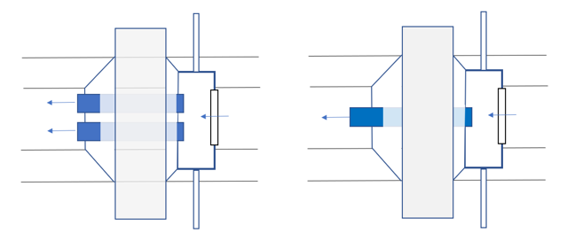

Figure 1 Plan view of a double pipe stop-log sluice structure

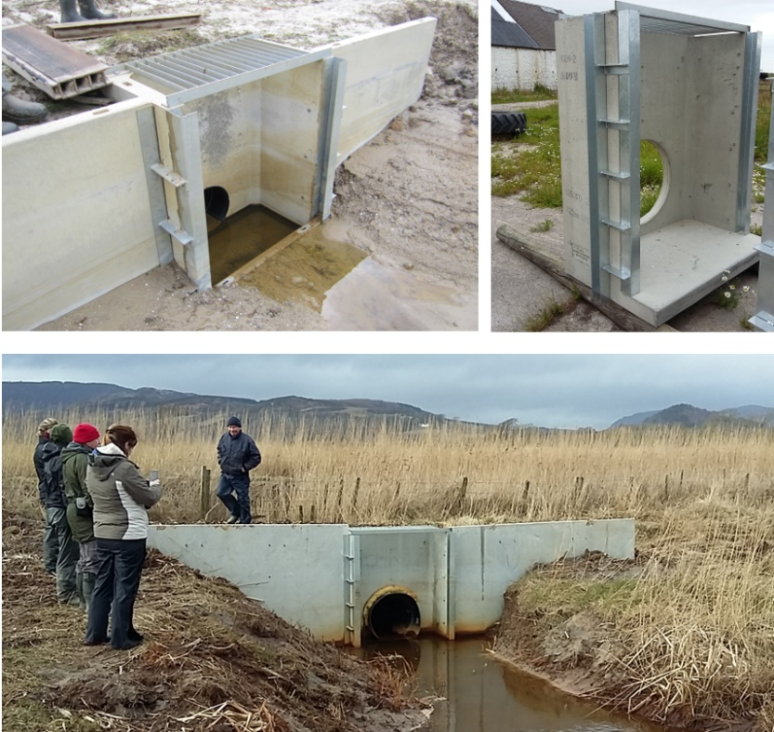

Figure 3 Image of pre-cast single pipe stop-log sluice

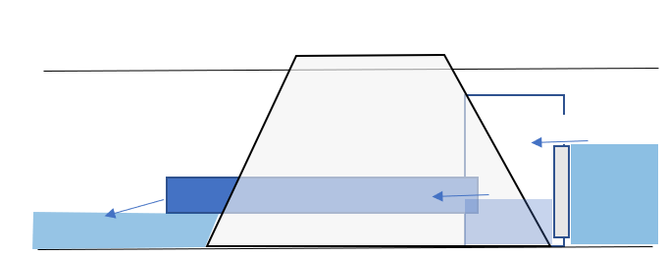

Figure 2 Sectional view of a stop-log sluice

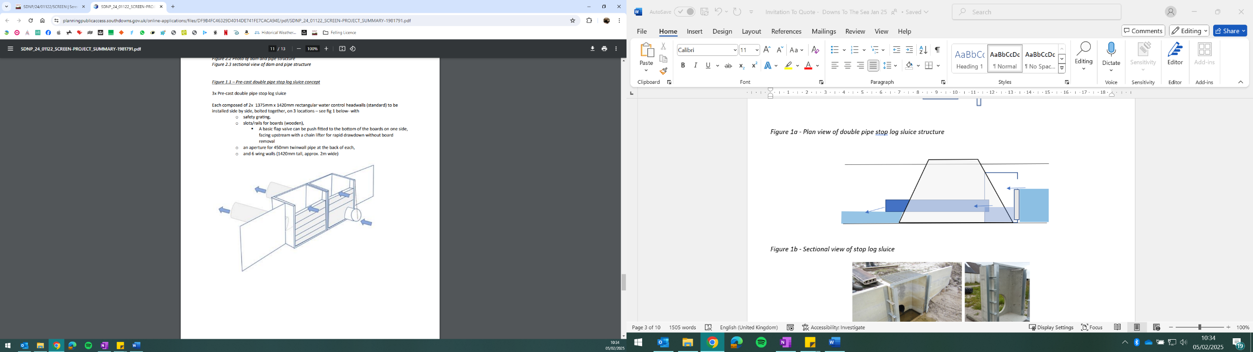

Figure 4 Design of sluices as submitted in the planning permission

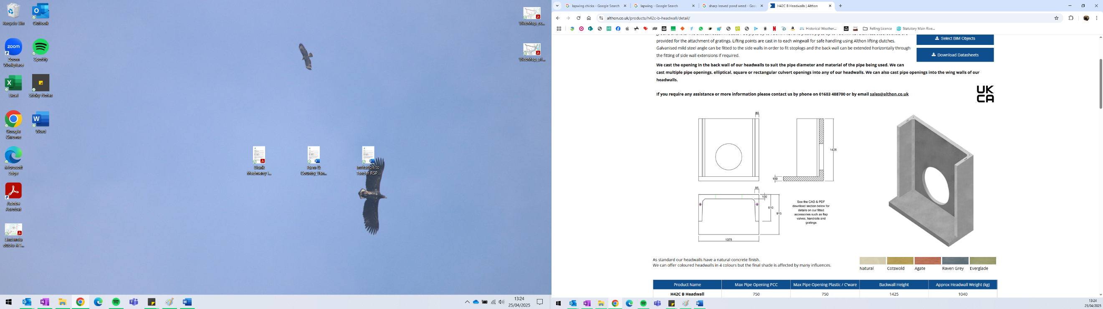

Figure 5 Diagram of H42C B Headwall (mm)

Figure 4 Sluice A - Ditch Cross Section

Figure 5 Sluice B - Ditch Cross Section

Figure 6 Sluice C - Ditch Cross Section

*Are you able to meet this specification in full?*

*If so, please give details below*

*If not, please state any differences in service offered*

|  |
| --- |
| Specification met? Yes /Part met  / No (tick as appropriate)  Details |

### Pipe Dam

* Supply and install a pipe dam structure at the location marked on Map 1 in Annex 2.
* 2 x 300mm HDPE twinwall pipes
* Right angles (elbows) and suitable collars should be provided (see figure 8 - 12 below).
* The pipe insertion through the dam needs to be packed with clay, possibly supplemented with bentonite.
* Any joints on the box structure/wings must be sealed with polyurethane sealant and bentonite.
* Clay (or as near to clay as possible) will be sourced on site.
* The dams should be keyed 2m into the ditch sides and 1m into the bed.
* A core of higher quality clay should be used for the area shown in grey on the below figures.
* The dams should have a height of 2.5m, a span including the key of 9m, a crest width of 3m, and 1:3 gradient sides.
* The volume of the core will be around 67m3.
* The volume of lower quality clay for each sidefill will be around 95m3 (162m3 per dam).
* The below cross section shows the depth and width of the ditch at the dam location.
* No soil management is required.
* No waste management is required. Delivery packaging can be disposed of by RSPB.

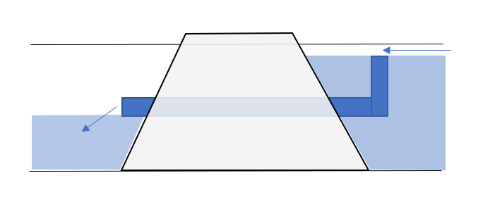

Figure 9 Sectional view of pipe dam structure

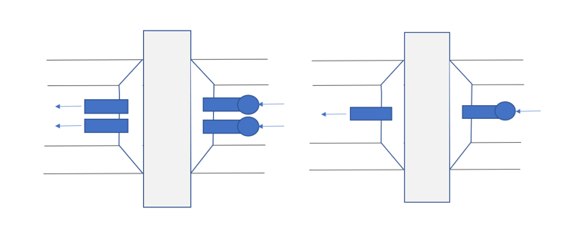

Figure 8 Plan view of double pipe dam and pipe structures

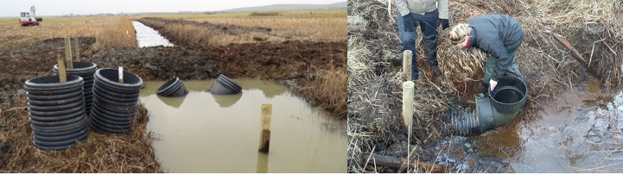

Figure 10 Images of dam and pipe structures

Figure 11 Pipe Dam - Ditch Cross Section

*Are you able to meet this specification in full?*

*If so, please give details below*

*If not, please state any differences in service offered*

|  |
| --- |
| Specification met? Yes /Part met  / No (tick as appropriate)  Details |

## Weir Removal

* Remove the 2 tilting weirs as marked on Map 2 in Annex 2.
* Return the area to the profile of the existing ditch.
* Dispose of the weirs off site using a licenced waste contractor.
* No soil management is required.
* **Please provide a quote per weir.**

*Are you able to meet this specification in full?*

*If so, please give details below*

*If not, please state any differences in service offered*

|  |
| --- |
| Specification met? Yes /Part met  / No (tick as appropriate)  Details |

## Track Upgrades

* Upgrade the tracks marked on Map 3 in Annex 2 to the below specification (Figure 12).
* Total:1400m (subject to change depending on budget)
* No soil management is required.
* No waste management is required. Delivery packaging can be disposed of by RSPB.

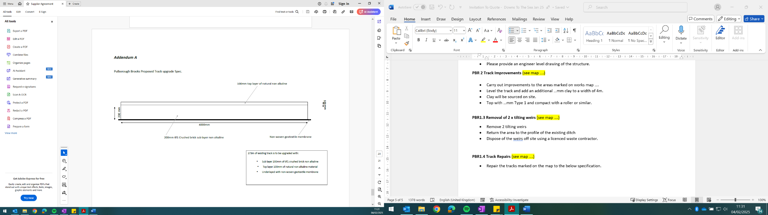

Figure 12 Specification of track

1400m

Type 1

Type 1

*Are you able to meet this specification in full?*

*If so, please give details below*

*If not, please state any differences in service offered*

|  |
| --- |
| Specification met? Yes /Part met  / No (tick as appropriate)  Details |

## Standard Required Paperwork

To include:

* Risk Assessment
* Method Statement
* Construction Management Plan

*Are you able to meet this specification in full?*

*If so, please give details below*

*If not, please state any differences in service offered*

|  |
| --- |
| Specification met? Yes /Part met  / No (tick as appropriate)  Details |

# Document D: Company Information

|  |  |
| --- | --- |
| **1.0** | **General** |
|  |  |
| **1.1** | **Registered Name**    **Trading Name (if different)** |
|  |  |
| **1.2** | **Correspondence Details**  **Name of person applying on behalf of the company**    **Address:**    **Telephone:**    **Mobile:**    **Email:** |
|  | **Registered office Address (if different from above)** |
|  |  |
| **1.3** | **Company Registration No (if applicable)**    **VAT registration number (if applicable)** |
|  |  |
| **1.4** | **Date company was founded (if a limited company, date of incorporation)** |
|  |  |
| **1.5** | **Company structure and nature of company**  Please outline the nature of the company, whether it is a partnership, sole trader, plc etc.    Is the company proposed as party to the contract part of a larger organisation? If so please explain the relationship between the various parts of the organisation, up to the ultimate holding company.    Current number of full time equivalent staff currently employed by the company (not larger parent company) |
|  |  |
| **1.6** | **Accreditation by / Membership of Trade Association(s)**  **Is your Company registered with any industry accreditation body? YES  NO**  **If yes, please provide details:**    **Is your Company on any public sector Framework agreements? YES NO**  **If yes, please provide details:**    **Please state membership of any professional bodies/ other associations below:** |
| **1.7** | **Quality Assurance**  **Is all / part of your company ISO9001 Quality Assured? YES NO**  **Is all / part of your company ISO14001 Quality Assured? YES NO**  **If yes please provide copy of certification**  **Do you have any other Quality Assurance? If Yes, please summarise details below** |
|  |  |
| **1.8** | **Environmental Commitments**  **Is all / part of your company registered under Science Based Targets Is all / part of your company registered or signed up to Science Based Targets (**[**https://sciencebasedtargets.org/net-zero**](https://sciencebasedtargets.org/net-zero)**), SME Climate Hub (**[**https://smeclimatehub.org/uk/**](https://smeclimatehub.org/uk/)**),  ISO 14064, ISO 14067 or a similar scheme to calculate and reduce your impact on the climate?**  **YES NO**  **If Yes, please summarise details below** |
|  |  |

|  |  |
| --- | --- |
| **2.0** | **Financial & Business Probity** |
|  |  |
| **2.1** | **Judgements etc.**  **Are there any judgements, claims or suits pending or outstanding against your company?**  **Yes  No** If Yes, please provide full details  **Has your company ever failed to complete a contract?**  **Yes  No** If Yes, please provide full details |

|  |  |
| --- | --- |
| **2.2** | Please answer all of the following questions as they apply to your Company’s circumstances. Please confirm that:  1) being a company, no resolution has been passed or Order of the Court made for the company’s winding up otherwise than for the purposes of bona fide reconstruction or amalgamation, nor has a receiver, manager or administrator on behalf of a creditor been appointed in respect of the company’s business or any part thereof, nor is it the subject of any proceedings for any of the above procedures, nor is it the subject of similar procedures under the law of any other state.  **Confirmed  Not confirmed  Non-applicable**  2) being a partnership, it has not granted a trust deed or become otherwise apparently insolvent, or it is not the subject of a petition presented for sequestration of its estate.  **Confirmed  Not confirmed  Non-applicable**  3) being an individual, you are not bankrupt, or have not had a receiving order or administration order made against you, or have not made a composition or arrangement or trust deed with or for the benefit of your creditors, or have not made any conveyance or assignment for the benefit of your creditors, or have not had a petition presented for sequestration of your estate or do not appear to be able to pay or to have no reasonable prospect of being able to pay a debt within the meaning of the Insolvency Act or any similar procedure under the law of any EC member state.  **Confirmed  Not confirmed  Non-applicable**  4) no Directors, Partners, Associates or the Company Secretary have been involved in any Company which has been liquidated or gone into receivership.  **Confirmed  Not confirmed  Non-applicable**  5) none of the Directors, Partners, Associates or the Company Secretary have been convicted of a criminal offence relating to the conduct of their business or profession.  **Confirmed  Not confirmed  Non-applicable**  6) neither the Company nor any of the Directors, Partners, Associates or Company Secretary has committed an act of grave misconduct in the course of their business or profession.  **Confirmed  Not confirmed  Non-applicable**  7) all obligations relating to the payment of taxes under the law of any part of the United Kingdom or the EC member state in which the Company is established has been fulfilled  **Confirmed  Not confirmed  Non-applicable**  8) all obligations relating to the payment of social security contributions under the law of any part of the United Kingdom or the EC member state in which the Company is established have been fulfilled.  **Confirmed  Not confirmed  Non-applicable**  If you have ticked **‘Not confirmed’** for any questions above please give details here |

|  |  |
| --- | --- |
| **2.3** | Please list the names of any Director, Partner, Associate or Company Secretary who have been employed by the RSPB, giving department and dates.    Please give details of any Director, Partner, Associate or Company Secretary who have a relative who is employed by the RSPB at a senior level.    Please list the names of any Director, Partner, Associate or Company Secretary who have any involvement in other Companies who provide services to the RSPB    Is any work being undertaken or likely to be undertaken during the next three years by the Company or staff within it which could give rise to a conflict of interest through acting for third parties or otherwise? If yes, please explain the actual or likely circumstances and how such potential conflicts of interest would be handled. |

|  |  |  |  |  |  |
| --- | --- | --- | --- | --- | --- |
| **2.4** | **Insurances (a scanned copy of each certificate may be requested)** | | | | |
|  |  | **Insurer** | **Policy No** | **Value of Cover** | **Expiry Date** |
|  | Employers Liability |  |  |  |  |
|  | Public Liability |  |  |  |  |
|  | Prof. Indemnity |  |  |  |  |
|  | All Risks  (if applicable) |  |  |  |  |

|  |  |
| --- | --- |
| **2.5** | **Has your company (or any building/project you have undertaken) won any awards, accolades or recognition?**  **YES  NO** If yes please provide full details. |

|  |  |
| --- | --- |
| **3.0** | **Health & Safety and Environment** |
|  |  |
| **3.1** | Has your company been served with any enforcement or prohibition notices or been prosecuted in the past 5 years for breaches of health & safety legislation?  **YES**  **NO** If yes please provide full details. |
| **3.2** | Has your company been served with any enforcement or prohibition notices or been prosecuted in the past 5 years for breaches of environmental legislation?  **YES  NO** If yes please provide full details. |
| **3.3** | Has your company been served with any enforcement or prohibition notices or been prosecuted in the past 5 years for breaches of data protection legislation?  **YES  NO** If yes please provide full details. |
| **3.4** | Have any restrictive clauses in relation to your company’s Employer’s Liability, Public Liability or Professional Indemnity Insurance policies been enforced in the last 5 years due to past Health & Safety performance?  **YES**  **NO**  If yes please provide full details. |

# Document E: Form of Offer

## Cost

Please complete the attached Pricing Schedule spreadsheet.

## Approach to the Project

What would be your approach to this project (including methods, any management and control procedures, quality assurance, resources etc.)? (Attach separate document if needed)

## References

Suppliers are requested to provide details of three references from their existing clientele of hydrological projects on sensitive ecological sites, supplying full name, address, telephone number, email address, contact name, period of Contract and the estimated annual value of the Contract. In supplying this information, Suppliers shall have granted the RSPB permission to seek such information as deemed necessary, in relation to the Suppliers performance with their nominated references.

Reference 1

|  |  |  |
| --- | --- | --- |
| Company Name |  | |
| Address |  | |
| Telephone No |  | Ext |
| Email |  | |
| Contact |  | Dates of work |
| Nature of work done |  | Value of contract |

Reference 2

|  |  |  |
| --- | --- | --- |
| Company Name |  | |
| Address |  | |
| Telephone No |  | Ext |
| Email |  | |
| Contact |  | Dates of work |
| Nature of work done |  | Value of contract |

Reference 3

|  |  |  |
| --- | --- | --- |
| Company Name |  | |
| Address |  | |
| Telephone No |  | Ext |
| Email |  | |
| Contact |  | Dates of Work |
| Nature of work done |  | Value of contract |

# Document F: RSPB Terms and Conditions

The basis of the contractual agreement between RSPB and the applicant is detailed in the [‘RSPB Terms and Conditions of Purchase of Goods and Services’](https://www.rspb.org.uk/about-the-rspb/about-us/how-the-rspb-is-run/supplier-terms-and-conditions/) – please click on this link to download. In applying for this tender you are explicitly agreeing to be bound by these Terms and Conditions for the duration of the contract. If you require any alterations to these Terms and Conditions please state your issues below. (Attach separate document if needed)

The RSPB expects that all suppliers it works with to adhere to certain ethical and environmental standards. Please download the [RSPB Ethical and Environmental Procurement Policy](https://www.rspb.org.uk/about-the-rspb/about-us/how-the-rspb-is-run/supplier-terms-and-conditions/) and tick this box if you agree to be bound by its terms and conditions 

An NEC3 contract will be used for this work. Therefore the Terms and Conditions of this will also apply.

The RSPB expects that all suppliers it enters into a contract with to adhere to the RSPB Expenses policy (as outlined in Annex 3) where Travel and Subsistence is required. This is to ensure costs are kept at a reasonable rate and remain affordable for the charity. You can find a copy of the expenses policy included in this tender pack (Document H), please confirm you have read and agree to this policy by ticking the box.

☐ I have read and agree to be bound by the RSPB Expenses policy for travel & subsistence.

# Document G: Certificate of Bona Fide Offer

We certify that this offer is made in good faith, and that we have not fixed or adjusted the amount of the offer by or under or in accordance with any agreement of arrangement with any other person. We also certify that we have not, and we undertake that we will not:

1 a) communicate to any person other than the person inviting these offers the amount or approximate amount of the offer or proposed offer, except where the disclosure, in confidence, of the approximate amount of the offer was necessary to obtain insurance quotations required for the preparation of the offer;

b) enter into any agreement with any other person that s/he shall refrain from making an offer or as to the amount of any offer to be submitted;

2 pay, give or offer or agree to pay or to give any sum of money or other valuable consideration directly or indirectly to any person for doing or having done or causing or having caused to be done in relation to any offer or proposed offer for the goods/services any act or thing of the sort described in 1 a) or 1 b) above.

We acknowledge that if we acted or shall act in contravention of this certificate, the RSPB will be entitled to cancel the agreement and to recover from ourselves the amount of any loss and expense resulting from such cancellation.

I state that everything in this tender submission is truthful, that if found to be untruthful the RSPB can terminate any agreement between the RSPB and the company formed on the basis of this tender, and we will pay to the RSPB any loss or expenses the RSPB suffers as a result of such untruthfulness, whether an agreement is entered into or not.

In this certificate, the word “person” includes any persons and any body or association, corporate or unincorporated; “any agreement or arrangement” includes any transaction, formal or informal, and whether legally binding or not.

|  |  |
| --- | --- |
| Signed |  |
| On behalf of |  |
| Date |  |

**Please note: a name added in an electronic document is functionally equivalent to a signature.**

**Annex 1: Site Maps

# Annex 2: Works Maps

## A map of a city AI-generated content may be incorrect.Map 1: Hydrological Control Structures

## Map 2: Weirs

**Map 3: Track Upgrades

# A close-up of a document AI-generated content may be incorrect.Annex 3: Expenses Policy