
Bid Pack For Call Off Competition
Attachment 2 – How To Bid Including Evaluation
Criteria
Contract Reference: CCCC18B14 - The Provision Of Specialist Strategic Guidance, Challenge And Engagement To The Surveillance Camera Commissioner

Contents
Bid Pack For Call Off Competition 1
1. How To Make Your Bid 2
2. How The Questionnaires Are Structured: 2
3. Award Criteria 13
4. Marking Scheme 15
5. Quality Evaluation 16
6. Price Evaluation 17
7. Final Decision to Award 19

How To Make Your Bid

Your bid must be made by the organisation that will be responsible for providing the deliverables if your bid is successful.

Remember to:

Accept or Decline this Bid Pack. If you Decline please provide a reason for doing so

Enter your bid into the e-Sourcing Suite. We can only accept bids that we receive through the e-Sourcing Suite

Make sure you answer every question

Each question must be answered in its own right. You must not answer any of the questions by cross referencing other questions or other materials e.g. reports located on your website.

Submit your bid in good time and before the bid submission deadline.

Upload ONLY those attachments we have asked for in line with the requirements specified – any other supporting evidence, certificates for example, will be requested separately by us.

If we do not require attachments and have specified this please only use the Text Boxes provided for your answer.

Check for messages in the e-Sourcing Suite throughout the competition.

Press the Submit all Draft Bids button when your bid is ready, otherwise we will not be able to see it.

If you are unsure, ask questions before the Clarification Questions Deadline.

How The Questionnaires Are Structured:

A summary of all the questions in the quality questionnaire, along with the marking scheme, and weightings for each question is set out below:

QUESTIONNAIRE 1 - KEY PARTICIPATION REQUIREMENTS

QUESTIONNAIRE 2 - CONFLICTS OF INTEREST

QUESTIONNAIRE 3 - INFORMATION ONLY

QUESTIONNAIRE 4 - QUALITY - PROJECT SPECIFIC EXPERIENCE

QUESTIONNAIRE 5 - QUALITY - METHODOLOGY

QUESTIONNAIRE 6 - QUALITY - ACCOUNT MANAGEMENT AND DELIVERY

QUESTIONNAIRE 7 – PRICE

QUESTIONNAIRE 1 - KEY PARTICIPATION REQUIREMENTS

Response Guidance

The following questions are ‘Pass/Fail’ questions. If Potential Bidders are unwilling or unable to answer “Yes”, their submission will be deemed non-compliant and shall be rejected. Potential Bidders should confirm their answer by selecting the appropriate option from the drop down menu.

Question Number | Question | Your Response
1.1 | Do you accept the competition rules as described in Attachment 1 – About the Procurement? | Yes/No
1.2 | Have you read, understood and accepted the Bid Pack and all associated attachments, specifically Attachment 3 - Statement of Requirement? | Yes/No
1.3 | Do you agree, without caveats or limitations, that in the event that you are successful, Attachment 5 - Terms and Conditions will govern the provision of this contract? | Yes/No
1.4 | Do you confirm your organisation’s e-Sourcing suite profile is complete and accurate at the time the bid closed and that any amendments made following acceptance of this event will be notified to the buyer in writing? | Yes/No
1.5 | Do you confirm that your organisation is compliant with the Data Protection Act 2018? | Yes/No
1.6 | Do you confirm the staff you have proposed for this project have Counter Terrorist Check security clearance? | Yes/No

QUESTIONNAIRE 2 – CONFLICTS OF INTEREST

Response Guidance

Question 2.1 is a ‘Yes/No’ question and will dictate whether or not question 2.2 needs to be answered.

Question 2.2 is a Pass / Fail question. Potential Bidders are required to provide details of how the identified conflict will be mitigated.

The Contracting Authority will review the mitigation in line with the perceived conflict of interest, to determine what level of risk this poses to them. Therefore, if Potential Bidders cannot or are unwilling to suitably demonstrate that they have suitable safeguards to mitigate any risk then their Bid will be deemed non-compliant and will be rejected.
Question Number | Question | Your Response
2.1 | Please confirm whether you have any potential, actual or perceived conflicts of interest that may by relevant to this requirement. | Yes/No
2.2 | We require that any potential, actual or perceived conflicts of interest in respect of this Bid Pack are identified in writing and that companies outline what safeguards would be put in place to mitigate the risk of actual or perceived conflicts arising during the delivery of these services. | Text Box

QUESTIONNAIRE 3 – INFORMATION ONLY

Response Guidance

The following questions are for information only and do not form part of the evaluation. Information provided in response to these questions may be used in preparation of any Contract Award and any omissions may delay completion of this procurement.
Question Number | Question | Your Response
3.1 | Please provide details of where the Award Outcome should be directed. Your response must include their;  - Full Name  - Role/Title  - Registered Address  - Email Address | Text Box
3.2 | Please provide details of any sub-contractors you propose to use in order to meet your obligations should you be awarded a Contract. Your response must include their;  - Trading Name(s)  - Registered Address(ees) and contact details  - Goods/Services to be provided | Text Box

QUESTIONNAIRE 4 - QUALITY – PROJECT SPECIFIC EXPERIENCE – WEIGHTING 40%

Response Guidance
Potential Bidders MUST answer ALL the following questions. The method of response; page limit on attachments and evaluation criteria is set per question.

Attachments may be submitted in Microsoft Word, Excel. PDF format and must be in Arial font size 11. The page limit for this question is set at a question level. Page limits include the use of headers footers and diagrams. Upload ONLY those attachments we have asked for.

No costings should be included in responses to this Questionnaire.

Question Number | Question | Your Response |  | Minimum Acceptable Score |  | Maximum Available Score |  | Weighting
4.1 | Staff Experience:  Please detail organisational and staff experience and expertise relevant to meeting the requirement set out in Attachment 3.  Your responses should provide specific examples/case studies and cover:  - Expertise and experience of delivering advice and guidance as stated in attachment 3  - What value the staff will bring to this requirement.  Please also include CVs of staff that will be involved in the project. This should be one side of A4 only and will not be counted as part of the page limit.  Page limit of four (4) sides singular of A4 (Excluding short CV’s). | Attachment |  | 66 |  | 100 |  | 30%
4.2 | Research Expertise:  The Authority requires the Supplier to detail their relevant experience and expertise showing how this will contribute to the delivery of this contract. The Supplier shall refer to relevant successful projects of a similar size and scope in outlining their capability.  The Supplier is required to detail the following evidence:  - Of detailed knowledge of the use of surveillance cameras, both overtly and covertly  - Of a detailed working knowledge of the legislative requirements police forces must meet when operating surveillance cameras  - Of knowledge of the use of surveillance cameras in operational policing  Page limit of one (1) side singular of A4. | Attachment |  | 66 |  | 100 |  | 30%
4.3 | Please outline your experience in providing specialist advice to fellow regulators such as:  - Information Commissioners Office  - Biometric Commissioners Office  - Forensic Science Regulators Office  - Investigative Powers Commissioner  Page limit of one (1) side singular of A4. | Attachment |  | 66 |  | 100 |  | 30%
4.4 | The Authority requires the supplier to outline their detailed knowledge and understanding of the role of Her Majesty's Inspectorate of Constabulary and Fire & Rescue Services (HMICFRS) and (structures, policies and procedures of police).  Please outline how this will enable you to deliver on the project.  Page limit of one (1) side singular of A4. | Attachment |  | 66 |  | 100 |  | 10%
QUESTIONNAIRE 5 - QUALITY – METHODOLOGY – WEIGHTING 30%

Response Guidance
Potential Bidders MUST answer ALL the following questions. The method of response; page limit on attachments and evaluation criteria is set per question.

Attachments may be submitted in Microsoft Word, Excel. PDF format and must be in Arial font size 11. The page limit for this question is set at a question level. Page limits include the use of headers footers and diagrams. Upload ONLY those attachments we have asked for.

No costings should be included in responses to this Questionnaire.

Question Number | Question |  | Your Response |  | Minimum Acceptable Score |  | Maximum Available Score |  | Weighting
5.1 | Please describe your proposed approach to meet the requirement objectives as set out in Attachment 3  Page limit of one (1) side singular of A4. |  | Attachment |  | 66 |  | 100 |  | 40%
5.2 | How will you provide strategic support to the SCC (Surveillance Camera Commissioner) in terms of the impact of emerging technology and potential overlaps with fellow regulators. Where the level of competency falls outside that is available within the core team or broader advisory groups.  Page limit of two (2) sides singular of A4. |  | Attachment |  | 66 |  | 100 |  | 40%
5.3 | How will you support a factual analysis of the current legislative landscape in relation to surveillance cameras and also identify key issues arising from that analysis.  Page limit of one (1) side singular of A4. |  | Attachment |  | 66 |  | 100 |  | 20%

QUESTIONNAIRE 6 - QUALITY – ACCOUNT MANAGEMENT AND DELIVERY – WEIGHTING 10%

Response Guidance
Potential Bidders MUST answer ALL the following questions. The method of response; page limit on attachments and evaluation criteria is set per question.

Attachments may be submitted in Microsoft Word, Excel. PDF format and must be in Arial font size 11. The page limit for this question is set at a question level. Page limits include the use of headers footers and diagrams. Upload ONLY those attachments we have asked for.

No costings should be included in responses to this Questionnaire.

Question Number | Question | Your Response | Minimum Acceptable Score | Maximum Available Score | Weighting
6.1 | Please describe your proposed approach to project management in reference to the requirement in Attachment 3.  Your response should include:  - The roles and responsibilities of individuals (and organisations where Potential Providers are using subcontractors).  - Resource allocation for the project stages (broken down by staff/grade level).  - Your approach to stakeholder engagement and communication of progress to the Customer.  - A draft project plan in line with the Milestones in Attachment 3.  - Your approach to ensuring all Milestones and deadlines will be met.  Page limit of two (2) sides singular of A4. | Attachment | 66 | 100 | 50%
6.2 | Please provide details of quality assurance, quality control and risk management processes for this project.  Your response should include:  - Your approach to Quality Assurance including an outline of potential risks and mitigating arrangements for carrying out this research.  - How you will handle complaints, ethical issues and data security issues, and ensure compliance with General Data Protection Regulation (GDPR).  Page limit one (1) side singular of A4. | Attachment | 66 | 100 | 50%

QUESTIONNAIRE 7 – PRICE – WEIGHTING 20%

Response Guidance
Potential Bidders must enter costs by uploading the relevant Attachment 4 - Price Schedule, at the question level on the e-Sourcing event.

Prices should be submitted in pounds Sterling inclusive of any expenses but exclusive of VAT.

Potential Bidders will be scored in accordance with the marking scheme at Section 2.

Question Number | Question | Your Response | Minimum Acceptable Score | Maximum Available Score | Weighting
7.1 | Please confirm, by selecting ‘YES’ that you have attached a completed Price Schedule to the response to this question. In so doing, you are also confirming that prices offered are inclusive of any expenses, exclusive of VAT and firm for the period following the Deadline for Submission as stated in the Attachment 1 – About the Procurement. | Yes/No  Attachment |  |  | 100%

Award Criteria

The award stage consists of a quality evaluation and a price evaluation.

The award of the resultant contract will be on the basis of the ‘Most Economically Advantageous Tender’ (MEAT) or price only.

The weighting for the quality evaluation is 80%; and, the price evaluation is 20%.

Award process - What you need to do

Answer the questions in section 2 above in the e-Sourcing suite.

Complete the Attachment 4 – Price Schedule

You must upload your completed Price Schedule into the e-Sourcing suite at questionnaire 7.

What we will do
1 | Compliance Check  First, we will complete a mandatory evaluation to make sure that you have answered all questions and have completed the Attachment 4 - Price Schedule in line with our instructions. All bids passing the mandatory evaluation will be progressed to the Quality Evaluation.
2 | Quality Evaluation  We will give your responses to the QUALITY questionnaires to the Contracting Authorities evaluation panel. Each evaluator will independently assess your responses to the quality questions using the response guidance and the evaluation criteria.  They will give a score and a reason for their score for each question they are assessing. The evaluators will enter the scores and reasons into the e-Sourcing suite.  If the evaluation panel wishes to clarify any areas of your bid, bid clarification questions will be issued via the e-Sourcing suite on an individual basis.
3 | Consensus  Once the evaluators have independently assessed your answers to the questions we will arrange for the evaluators to meet. We will facilitate the discussion.  At this meeting, the evaluators will discuss the quality of your answers and review their scores and reasons for that score. The discussion will continue until they reach a consensus regarding the score, and reason for that score, for each question.  These final scores will be used to calculate your quality score.  If the evaluation panel wishes to clarify any areas of your bid, bid clarification questions will be issued via the e-sourcing suite on an individual basis.
4 | Quality Threshold  If you have not met the minimum acceptable score for each question, you will be excluded from the competition. We will tell you that you have been excluded from the procurement and why at award stage.  If this is a 2 stage evaluation, we will advise you at the point in which stage 2 invitations are sent.
5 | Evaluate Pricing  We will then evaluate your price and calculate your price score using the evaluation criteria specified.  If we wish to clarify any areas of your bid, bid clarification questions will be issued via the e-sourcing suite on an individual basis.
6 | Final Score  Your quality score will be added to your price score, to create your final score.
8 | Award  An award will be made to the successful bidder, subject to contract.  We will notify successful and unsuccessful bidders providing feedback.

Marking Scheme

The evaluation criteria set out below will be used during the Quality Evaluation:
Marking Scheme | Description
100 - Good | The response fully meets all requirements with detail provided minimising risks to delivery.  The response is comprehensive and unambiguous, demonstrating a thorough understanding of the requirements and provides details of how the requirement will be met in full without additional support from the Contracting Authority, other than that outlined within the statement of requirements.
66 – Acceptable – Minor Concerns | The response is acceptable and meets all the basic requirements. However, the response, is not sufficiently detailed to minimise risk and/or the proposed approach may require additional support (in addition to that outlined in the Statement of Requirements) from the Contracting Authority to meet its deliverables.
33 – Non Acceptable - Major Concerns | The response has met some, but not all elements of the requirement, which poses risk that the proposal will not meet the deliverables required.  The response does not demonstrate a full understanding of the requirement posing major concerns.
0 - Unsuitable | The response does not meet any of the requirements or no response has been provided. An unacceptable and/or non-compliant response with serious reservations, demonstrating no understanding of the requirement.

Quality Evaluation

Questionnaires Q1 and Q2 are mandatory question(s) and will be evaluated PASS / FAIL. If you fail any of these questions, you will be excluded from the competition. We will tell you that your bid has been excluded.

When the consensus meeting has taken place and the final score for each question has been agreed by the evaluators, your final score for each question will be multiplied by that questions weighting to calculate your weighted score for that question.

Each weighted score for each question for each Lot you have submitted a bid for will then be added together to calculate your quality score.

Please see table A below for an example of how your quality score will be calculated.

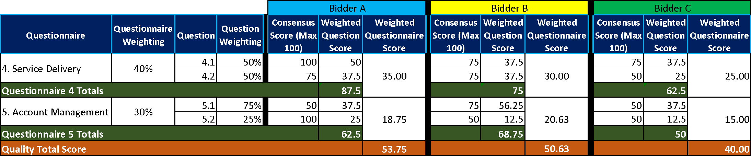
Table A – EXAMPLE ONLY

Price Evaluation

This section contains information on how to complete Attachment 4 - Price Schedule and the price evaluation process.

How to complete your Attachment 4 – Price Schedule

Read and understand the instructions in the Attachment 4 - Price Schedule, and in this section before submitting your prices.

Your prices should compare with the quality of your offer.

Your prices must be sustainable and inclusive of all costs for example your operating costs and profit.

Your prices are to exclude VAT.

Pricing is to be inclusive of expenses.

The currency is British pounds sterling, up to two decimal places.

The percentages submitted shall be up to two decimal places.

Pricing will be based on:

Eight (8) hour Working Day; and

Rounded to the nearest £10.

Zero bids will not be allowed.

We will investigate where we consider your bid to be abnormally low.

The prices submitted shall not exceed the relevant framework contract rates.

You must download and complete the Attachment 4 – Price Schedule you are submitting a bid for. Further detail may be provided within the Attachment 4 – Price Schedule.

When you have completed your Attachment 4 - Price Schedule, you must upload this into the e-Sourcing Suite at question Q7. If you do not upload your Attachment 4 – Price Schedule your bid may be rejected from this competition.

Do not alter, amend or change the format or layout of the Attachment 4 – Price Schedule.

Price Evaluation Process

This is how we will evaluate your pricing:

We will check you have completed the Attachment 4 – Price Schedule as instructed.

Failure to complete the Attachment 4 - Price Schedule as instructed may result in your bid being deemed non-compliant and may be rejected from this competition.

The price evaluation will be undertaken separately to the quality evaluation process.

The Potential Bidder with the lowest total price per element will be awarded the maximum score available for that element.

All other Potential Bidders will get a price score relative to the lowest total price.

The calculation we will use to evaluate your total price per element, you are bidding for, is as follows:
Price Score = Lowest total price * maximum score available Potential Bidders total price

Please see table B below for an example of how your Price score will be calculated.
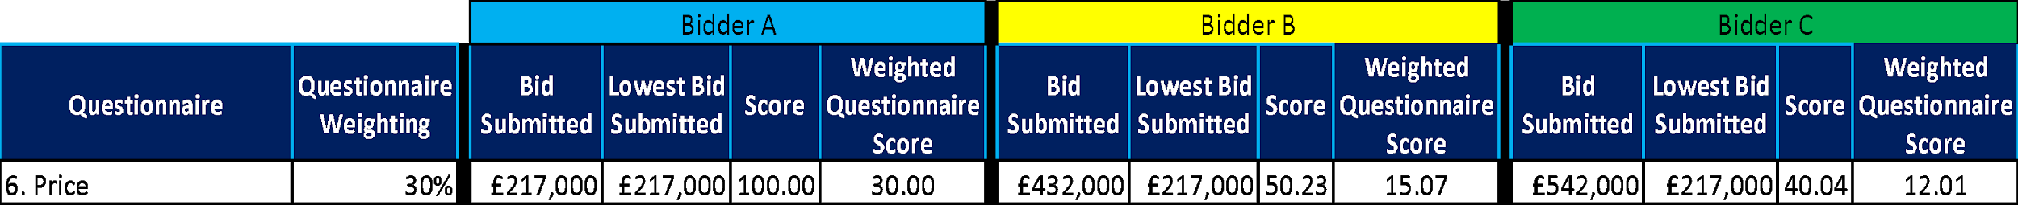
Table B – EXAMPLE ONLY

Where we consider any of the total price(s) you have submitted to be abnormally low will ask you to explain the price(s) you have submitted (as required in regulation 69 of the Public Contracts Regulations 2015).

Final Decision to Award

We will add your quality score to your price score to calculate your final score.

Please see table C below for an example of how your Quality score and Price score will be added together to identify your final score.
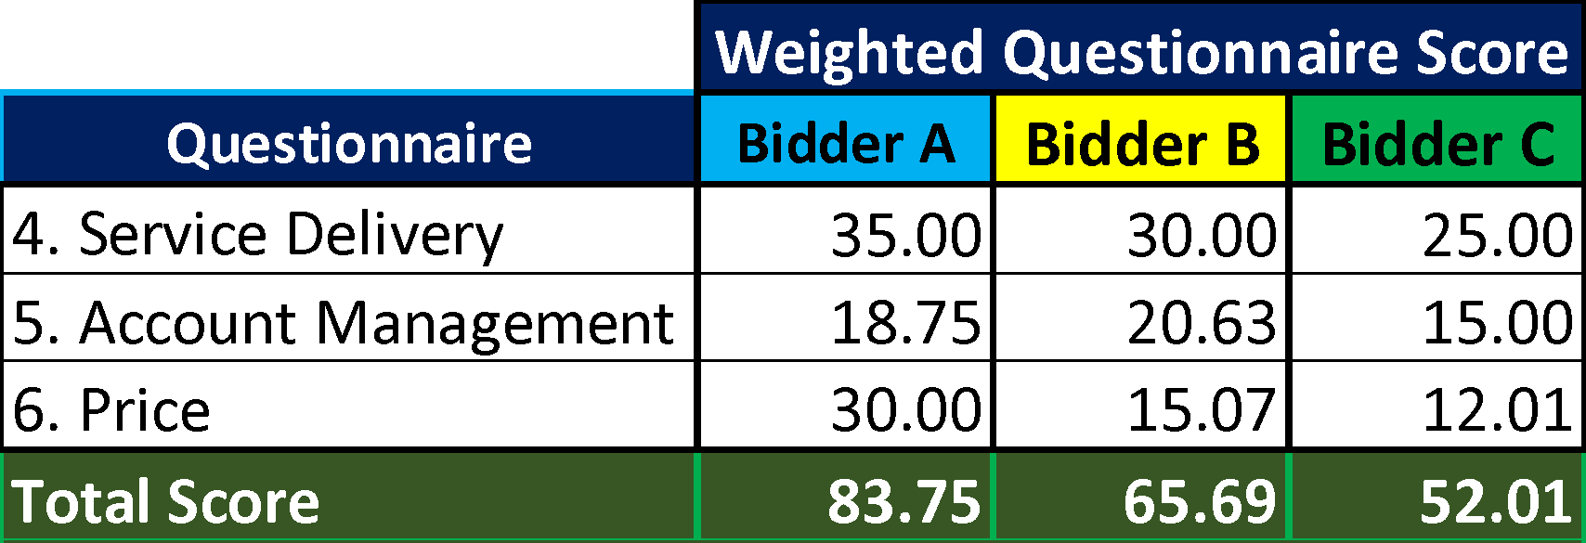
Table C – EXAMPLE ONLY:

The bidder with the highest final score will be awarded the contract. However, if this is a 2 Stage Evaluation the final scores up to this point will act as a gateway to Stage 2 as outlined in “What we will do” point 7.

Two Stage Evaluation

The following will only apply if Stage 7 of “What we will do” above is adopted.

Where a 2 Stage Evaluation has been conducted the final score from Stage 1 will now be added to the score from Stage 2 to show a final score as demonstrated in the table below:

Please see table D below for an example of how your Stage 1 score and Stage 2 score will be added together to identify your final score.

Table D – EXAMPLE ONLY:
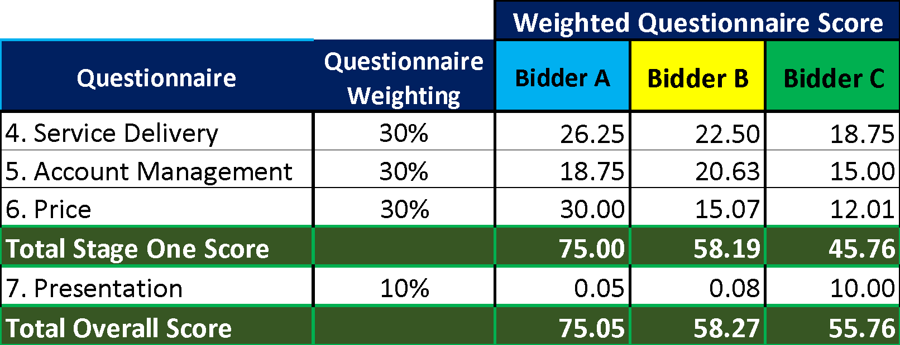

- Further Information
  - We will tell you if you have been successful or unsuccessful via the e-Sourcing Suite.

