**Tendring District Council**

**Specification**

**TDC Sports Facilities-**

**Legionella Control**

**07/2022**



**Our Vision**

***To put community leadership at the heart of everything we do through delivery of high quality, affordable services and working positively with others.***

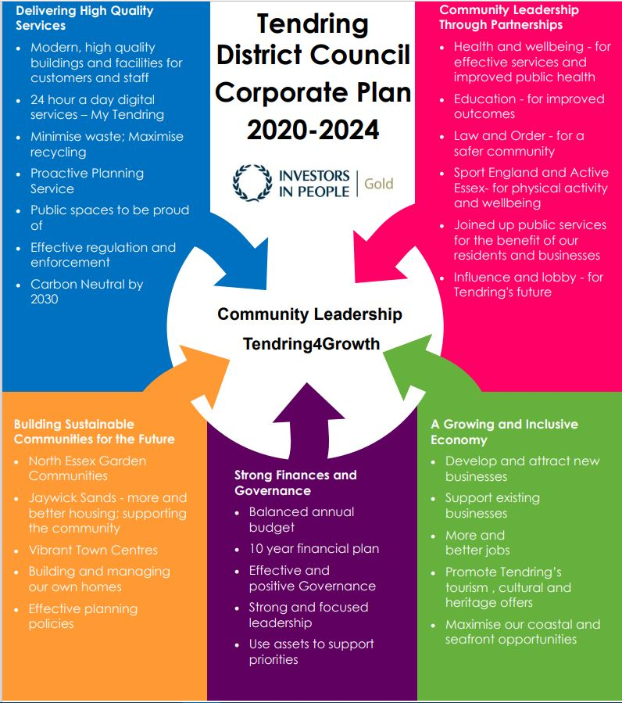

**Our Values**

♦ Councillors and staff uphold **personal integrity, honesty** and **respect** for others

♦ **Innovative, flexible, professional** staff **committed** to delivering excellence

♦ Recognising the diversity and equality of individuals

♦ Working **Collaboratively**

1. **Executive summary**

3 Year Pool/ Spa Sampling & Domestic Legionella Control for the following sites/ facilities.

Tendring District Council operates 3 Sports Facilities within the Tendring peninsula. Each site is a thriving facility & based at the heart of the community. We pride ourselves on offering safe, hygienic, friendly & customer focussed facilities within an ever evolving environment. We endeavour to find the best value for the services that we provide & the products that we use within our facilities. The following facilities will be included within the contract;

1. Clacton Leisure Centre, Vista Road, Clacton-on-Sea , Essex CO15 6DB
2. Walton-on-the-Naze Lifestyles, Princes Esplanade, Walton on the Naze, Essex CO14 8PZ
3. Dovercourt Bay Lifestyles, Low Road, Dovercourt, Essex CO12 3TA

Details of Goods, Services or Works to be tendered

Water Systems included within the Contract;

Domestic Mains Water

Domestic Cold Water down Service

Domestic Hot Water down Service

Closed Systems

Water Softeners & RO Systems

Pool/ Spa

Monthly Servicing

PWTAG Spec Samples- Pool & Spa as outlined in Contractual Obligations

Quarterly Servicing

Legionella sampling – Domestic

Legionella sampling- Pool & Spa

Bi-annual Servicing

Closed system analysis completed every 6 months on closed system heating across all sites.

Annual Servicing

* Calorifiers

Inspection or purge to drain as applicable.

* Cold Water Storage Tanks

Inspect CW tank & complete remedial work as required.

Check the CW tank temperature remote from the ball valve & the incoming mains temperature (to be completed summer or as indicated by temperature profiling).

Clean & disinfect all Cold Water Storage Tanks across all sites.

* POU Filters

Service & disinfect as per Manufacturers guidelines. Record service date & lifespan.

* Annual audit of all log books to ensure compliance to regulations.

Contractual Obligations

Clacton Leisure Centre

* Monthly pool water analysis for TVC’s, coliforms, E.Coli & pseudomonas aeruginosa.
* Monthly relaxation pool water analysis for TVC’s, coliforms, E.Coli & pseudomonas aeruginosa.
* Quarterly Legionella sample from both the pool & relaxation pool.
* 6 Legionella samples from the domestic hot & cold water system every quarter, this equates to 24 samples per annum.
* Clean & disinfect 3x Cold water storage tanks annually.
* Annual service of Chlorine Dioxide unit.
* Annual service of RPZ valve.
* Annual service of Water softener services within Salt Inhalation Room.

Walton-on-the-Naze Lifestyles

* Monthly pool water analysis for TVC’s, coliforms, E.Coli & pseudomonas aeruginosa.
* Monthly kids pool water analysis for TVC’s, coliforms, E.Coli & pseudomonas aeruginosa.
* Quarterly Legionella sample from both the main pool & kid’s pool.
* 3 Legionella samples from the domestic hot & cold water system every quarter, this equates to 12 samples per annum.
* Annual service of Chlorine Dioxide unit.
* Annual service of RPZ valves.
* Annual service of Water softener services.

Dovercourt Bay Lifestyles

* Monthly pool water analysis for TVC’s, coliforms, E.Coli & pseudomonas aeruginosa.
* Quarterly Legionella sample from both the main pool.
* 3 Legionella samples from the domestic hot & cold water system every quarter, this equates to 12 samples per annum.
* Clean & disinfect 6x Cold water storage tanks annually.
* Annual service of Water softener services.
* Annual service of RPZ valve.

1. **Requirements for proposal**

All works/ servicing to be completed to Control the Risk from Legionella as directed in Legislation; Health & Safety at Work Act 1974, The Control of Substances to Health Regulations 2002 & The Management of Health & Safety at Work Regulations 1999. Guidance will be sought from The Control of Legionella Bacteria in Water Systems – ACOP- L8 2013 & Legionnaires Disease, technical guidance parts 1, 2 & 3.

All Contractors will need to ensure that the following insurance levels are in place throughout the duration of the Contract. Evidence will be required prior to the confirmation of a contract with any relevant renewal information subsequently relayed to the Operations Manager.

* + Employer’s Liability Insurance  = £5m
  + Public Liability Insurance = £5m
  + Professional Indemnity Insurance = £5m

Where companies are unable to provide evidence of a Safeguarding Policy we would require them to sign up to Tendring District Council’s Safeguarding Policy. Information can be requested from the Operations Manager as applicable.

All Contractors working on site must be aware of Asbestos within the building & must have read the Asbestos Management Plan prior to the commencement of any works. Any Contractors working within these environments will be required to complete a Permit to Work, see section 5(v) & sign/comply with the Asbestos Management Plan taking all necessary precautions.

Permits to Work will be required to be completed on each visit on site where applicable. Please report to the Duty Officer at Reception who will organise a Permit. This must be displayed within your work area whilst on site.

Evidence must be provided to ensure contractors are a current registered member of the Legionella control Association. The following categories must also be included within the membership;

* Legionella Risk Assessment Services
* Water Treatment Services
* Hot & Cold Monitoring & Inspection Services
* Cleaning & Disinfection Services
* Training Services
* Legionella Analytical Services & Plant Equipment Services

Copies of Staff Qualifications will be required ensuring that Staff who complete works hold the relevant qualifications/ experience to ensure they are competent to complete the works in line with the relevant governing body & industry standards.

1. **Timescales**

The key dates for this RfQ are:

RfQ Response Deadline: 08/09/2022

Contract Start:

Contract Duration: 3+1+1

To organise Site visits please contact Daniel Kerridge at [dkerridge@tendringdc.gov.uk](mailto:dkerridge@tendringdc.gov.uk) and CC [Michael.banahene@essex.gov.uk](mailto:Michael.banahene@essex.gov.uk)

|  |  |
| --- | --- |
| **Project Milestone** | **Date** |
| Site visits finish | 29th July 2022 |
| Clarifications close | 29th July 2022 5pm |
| Tender close | 8th August 2022 5pm |

1. **The** **Authority’s Policies** **& Statements**

The bidder will need to adhere with the below policies and statements.

* Data Protection (please see Appendix D)
* Freedom of Information (please see Appendix F.

**Modern Slavery**

The bidder self-certifies that they are taking steps to ensure that there is no modern slavery or human trafficking (as defined in the Modern Slavery Act 2015) in their organisation or supply chain relating to the requested services/supplies requirements.

Here is a link to the Act: <http://www.legislation.gov.uk/ukpga/2015/30/contents/enacted>

**Health and Safety**

The bidder self-certifies that they adhere to the Health & Safety at work Act. Any Here is a link to the Act: <http://www.hse.gov.uk/legislation/hswa.htm>

**Environment**

The bidder confirms that they are aware of Tendring District Council’s Environmental Statement, and should they be successful, they are committed to working with the Council fulfil the vision outlined in the Statement.

<https://www.tendringdc.gov.uk/environment>

1. **E-procurement requirements**

Tendring District Council has an fully automated Purchase to Pay (P2P) system.

The successful bidder will be able to:

* View their orders online;
* Update their status;
* Notify delivery; and
* Submit and monitor the status of electronic invoices, once they have been submitted.

Orders will be sent electronically to the successful bidder’s central e-mail address from the contract start date.

The successful bidder will be expected to submit electronic invoices from the contract start date. On approval of the electronic invoice an automatic payment will be made via BACS, direct to the successful bidder’s bank account supported by an e-mailed remittance advice, in line with Tendring District Council’s contracted payment terms.