Request for Proposal

I am writing on behalf of NHS Arden and Greater East Midlands Commissioning Support Unit (AGCSU) (hereby known as the Authority); seeking Procurement & Contract Management Resource via this Request for Proposal (RfP), the details of which are set out in Annex A to this letter.

If you are interested in quoting for this requirement, please complete:
- The organisation details form within Appendix B
- The questions contained within Appendix C utilising the written response template contained within Appendix E
- The finance template at Appendix D.

Your response should answer each question required and demonstrate how you meet the evaluation criteria contained within Appendix A. Your response must be in the format requested otherwise this may be rejected as being uncompliant.

We will be looking to appoint a provider to commence this work from 07th October 2019, so the ability to mobilise resource(s) quickly is essential.

Please return your response via email to agcsu.southprocurement@nhs.net by no later than 5pm 01st October 2019.

Your proposal must be valid for acceptance for 30 days from the deadline for receipt. Your response constitutes an offer / bid and if the Authority accepts that offer then a legally binding contract will exist.

Respondents accept that the Authority is subject to the Freedom of Information Act and government transparency obligations which may require the Authority to disclose information received from you, to third parties.

This letter and your response do not give rise to any contractual obligation or liability, unless and until such time as, the Authority issues a letter referencing this Request for a Proposal accepting your proposal. The Authority does not make any commitment to purchase and shall have no liability for your costs in responding to this Request for Proposal.

If you have any queries about this letter or the requirement, please submit your questions via email to agcsu.southprocurement@nhs.net and a response shall be sent as soon as is possible.

Yours sincerely,

Camilla Ball
Head of Procurement
Advisory Services Team, NHS Arden and Greater East Midlands Commissioning Support Unit

17th September 2019 – Published to Contracts Finder

Service Specification
for the
Provision of Procurement, Contract Management and Commercial Support
to the
Medicines Value Programme

Background and Introduction
The NHS spends c£16 billion a year on medicines. Driving better value from medicines spend is central to ensuring financial sustainability.

To support these ambitions, NHS England has embarked on a Medicines Value Programme (MVP) to deliver better value and improved outcomes from its investments in medicines. The program encompasses the full spectrum of NHS medicines spend including primary care, acute care and specialised commissioning. The SRO for the MVP is the Commercial Medicines Director.

The program seeks to develop, document and embed best practice commercial techniques and processes that support the aims of the MVP and can form the building blocks for future activity.

This specification is seeking specialist contracting, procurement and commercial support to the Commercial Medicines Directorate.

Overview
As part of this programme, NHS England (NHSE) has contracted NHS Arden & Greater East Midlands Commissioning Support Unit (AGCSU) for support. AGCSU is now seeking support (as a sub-contractor) for the following work streams:

- A pilot Contracts Management Database
- The proposed transition of the approval process for new HIV antiretrovirals from NHSE to NICE, including implications for business as usual and scoping of and recommendations for national policies
- Expert commercial and procurement advice to the end of a medicines trial and transition to business as usual
- Scope and develop a national incentive scheme for medicines
- Provide procurement advice and support to a strategic category management work programme for medicines.

Deliverables required

The deliverables required under each project are as follows:

- A pilot Contracts Management Database;
  - Create a template to record electronically current medicines contract/supplier(s)/provider(s) metadata ready for verification and upload on to the Jaggaer system (pilot),
  - Carry out a deep dive on all systems and locations (including electronic and paper records) to find existing contract information, held by the Commercial Medicines Directorate, and record this in the template, for those medicines in the pilot
  - Identify paper documentation and transform to electronic documentation for any paper records of contracts for those medicines in the pilot,
  - Carry out a deep dive on all contract documentation and produce a report that identifies gaps, issues or missing parts of any contract for those medicines in the pilot,
  - Add all current suppliers to the Jaggaer system for those medicines in the pilot,
  - Add all current contract data to the Jagger system (as sourced and transformed as described above) for those medicines in the pilot,
  - Develop a project and implementation plan for the pilot of the Jaggaer system,
  - If the pilot is successful to engage with and work with Jagger to plan the Jagger-delivered initial training for staff at the Commercial Medicines Directorate (in line with the contract with Jagger, no other purchase is permitted),
  - Work with the Jagger team to develop a training manual that can be used by all current and new staff,
  - Develop a handover from the project to implement the Jagger system pilot, including a closing report with lessons learnt.

- To support the proposed transition of the approval process for new HIV antiretrovirals from NHSE to NICE, including implications for business as usual and scoping of and recommendations for national policies;
  - To undertake scoping of current national policy process and make recommendation on future national policy process,
  - To propose a transition strategy and project plan to the recommended future national appraisal and policy process (as above) including stakeholder mapping and outline communication plan, risk register with mitigations and timeline with appropriate milestones,
  - Propose a transition governance process for NHSE that supports the transition strategy including (but not limited to as the project may develop and may have additional requirements); Terms of Reference, governance structure and supporting guidance documentation; this will need to be approved as appropriate by NHSE,
  - Develop a strategy for the procurement of HIV antiretroviral’s in line with the new approach; highlighting the potential options, risks and any mitigations, constraints and interdependencies and taking account of any relevant national policies.

- Expert commercial and procurement advice to the end of a medicines trial and transition to business as usual
  - Assess a current approach to market for a medicines trial (the purchase of drug(s) which was competitively tendered and is now in contract) and develop a set of recommendations for scaling-up to a national strategy to procure following the trail,
  - To work with NHSE Programme of Care to develop a national procurement strategy and project plan to implement this including stakeholder mapping and outline communication plan, risk register with mitigations and timeline with appropriate milestones; this will form part of a recommendation by the Commercial Medicines Directorate for scrutiny and ratification by NHSE as appropriate.

- Scope and develop a national incentive scheme for medicines;
  - Develop an Outline Business Case (OBC) for a national incentive scheme for medicines, to include an options appraisal, risks, mitigations, constraints, dependencies, commercial considerations, evidence and data, concluding with defined outcomes that should be sought and their key benefits.

- Provide procurement advice and support to a strategic category management work programme;
  - Provide specialist procurement oversight, advice and support to the Commercial Medicines Directorate strategic category management work programme,
  - Establish a governance structure and plan for appraisal of the work programme objectives and deliverables, including developing the initial objectives,
  - Produce a reporting structure and report template for reporting progress – including highlighting any risks, appraisals/actions and making written recommendations to the programme board as required,
  - Provide the above-mentioned report, reporting progress of the programme.

Timescales
The term will commence as soon as is possible and the first available start date is believed to be 07th October 2019. The contract end date will be 31st March 2020 (dates are inclusive).

Resource expectation
A suitably experienced and knowledgeable level of resource is expected to amount to 1 whole time equivalent (37.5 hours per week).

Location
There is a requirement to regularly attend NHS Offices at Fosse House, Leicester and Skipton House, London, where key members of the Medicines Value / Commercial Medicines Directorate reside. However, there is also an opportunity to work flexibly at any of AGCSU sites or from home/own offices, when NHS England permits.

Expenses
Travel and any other expenses incurred in delivering this contract are to be covered by the Provider and will NOT be reimbursed separately.

Pricing

Please provide a full breakdown of your proposed costs ensuring that your bid does not exceed the maximum financial budget for this work. The maximum budget for this work is £84,000, excluding VAT but is fully inclusive of all expenses. Any bid exceeding £84,000 will be rejected.

It is expected that the successful Supplier will invoice once a month, to be submitted in arrears.

Form of Contract
NHS terms and conditions for provision of services contract will apply to this RfP:
https://assets.publishing.service.gov.uk/government/uploads/system/uploads/attachment_data/file/681011/NHS_TERMS_AND_CONDITIONS_FOR_THE_PROVISION_OF_SERVICES__CONTRACT_VERSION_.docx

Appendix A – Evaluation Methodology
Please Note:

- This procurement will be evaluated as to which Bidder provides the most economically advantageous Bid.

- Organisation details (Appendix B) – Completion of accurate data and information will be evaluated as “Pass” and the proposal will be considered further. If this section contains anomalies or missing data your proposal may be evaluated as “Fail” and may not be considered further.

- Quality (Appendix C) – The quality questions will be evaluated using the “0-5 criteria” contained further within this Appendix B. A threshold score for each question has been contained and is detailed within Appendix C; Bidders must meet the threshold score for each and every question in order for their Proposal to be considered further.

- Price (Appendix D) – The maximum budget for this work is £84,000, excluding VAT but is fully inclusive of all expenses. Any bid exceeding £84,000 for the period will be rejected.

- Providing the Quality responses on Appendix E – as detailed further from page 7.

The evaluation will be undertaken in the following stages:

Stage | Description
1 | Price evaluation (Appendix D). Any bid exceeding £84,000 for the period will be rejected.
2 | Any Bid that is not rejected at Stage 1 will have a Price evaluation score given (as described below).
3 | Quality evaluation (responses to questions included in Appendix C, on Appendix E for each question).
4 | Adding of Quality and Price evaluation scores to create final scores and rank Bidders as to who offers the most economically advantageous Bid.

Due to the timeline for this process, the moderation process (to achieve a consensus score between individual evaluators) may take place without prior individual evaluations; i.e. the individual evaluators will meet to review bids and agree consensus scores for each question in one meeting, and without having evaluated as an individual beforehand).

Price Evaluation Criteria

The below table details the scoring and weighting method for this RFP
Criteria | Weighting | Sub-criteria | Sub-Criteria Weighting
Quality | 80 | Scored | Quality will be assessed against the responses to the questions in Appendix C
Price | 20 | Scored | Linear Analysis – Using 20% as price weighting  Scores are awarded according to lowest cost and the ratio of the other bidders’ costs related to this baseline.  Worked Example (figures not representative, example only)  Bidder A submits a bid for £84,000  Bidder B submits a bid for £80,250  Bidder C submits a bid for £64,000  Bidder D submits a bid for £84,500
  Bidder | Cost (£) | Calculation | Score (%)
  Bidder A | 84,000 | (64,000/84,000)x20% | 15.24
  Bidder B | 80,250 | (64,000/80,250)x20% | 15.95
  Bidder C | 64,000 | (64,000/64,000)x20% | 20
  Bidder D | 84,500 | FAIL – Bid above max. budget. | FAIL

Quality Evaluation Criteria

Proposals will be evaluated in line with the following evaluation criteria

Scored questions evaluation mechanism
Assessment | Score | Interpretation
Excellent | 5 | Exceeds the requirement. Exceptional demonstration by the Bidder of the relevant ability, understanding, experience, skills, resource & quality measures required to provide the supplies / services. Response identifies factors that will offer potential added value, with evidence to support the response, including evidence of innovative approaches.
Good | 4 | Satisfies the requirement with minor additional benefits. Some minor additional benefits by the Bidder of the relevant ability, understanding, experience, skills, resource & quality measures required to provide the supplies / services. Response identifies factors that will offer potential added value, with evidence to support the response.
Acceptable | 3 | Satisfies the requirement. Demonstration by the Bidder of the relevant ability, understanding, experience, skills, resource & quality measures required to provide the supplies / services, with evidence to support the response.
Minor Reservations | 2 | Minor reservations. Some minor reservations of the Bidder’s relevant ability, understanding, experience, skills, resource & quality measures required to provide the supplies / services, with limited evidence to support the response.
Major Reservations | 1 | Major reservations. Considerable reservations of the Bidder’s relevant ability, understanding, experience, skills, resource & quality measures required to provide the supplies / services, with little or no evidence to support the response.
Unacceptable | 0 | Does not meet the requirement. Does not comply and/or insufficient information provided to demonstrate that the Bidder has the ability, understanding, experience, skills, resource & quality measures required to provide the supplies / services, with little or no evidence to support the response.

Quality question response format

For the questions requiring a text response, a template (Appendix E) has been provided within the attachments area of the ITT.
This has been provided to allow Bidders to include diagrams, pictures, tables etc. to properly present responses.
Please note, the ENTIRE RESPONSE must be included in this page limit, including diagrams, tables etc. and any response outside of the stated page limit will not be evaluated, also embedded documents will not be evaluated.
This template must be used for all responses where the question details a number of pages are allowed for a response.
The page margins have been set and must not be moved; the font and size (Arial 11) has also been set and must not be changed; the paragraph settings (0pt) and line spacing options (single) have been set and must not be changed.
Bidders may add a title page to the template, and for the actual response to start on page 2, if this facilitates the Bidding process; Bidders should be aware that if they choose to do this, material on page 1 will not be evaluated. Bidders should not embed documents to this template as these will not be opened and will not be evaluated.
The page margins have been set as follows:
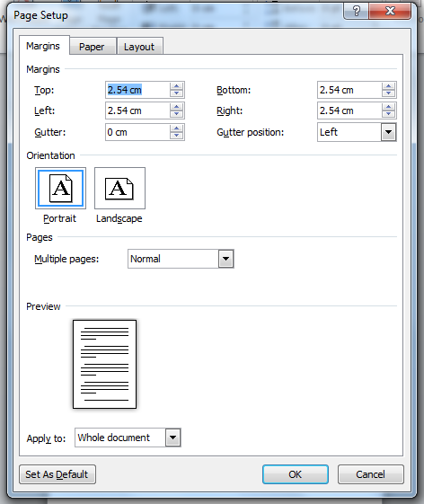

The paragraph settings have been set as follows:
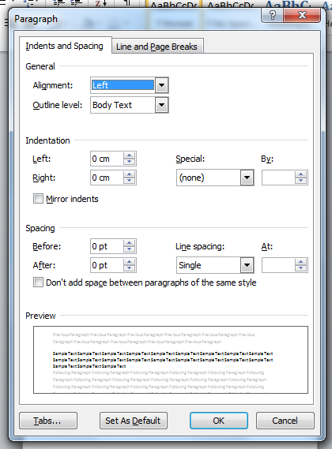
The font settings have been set as follows:
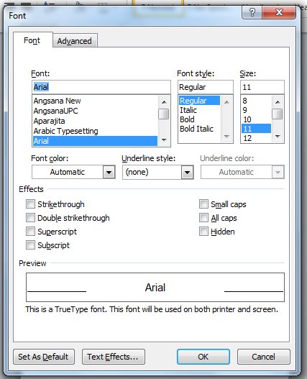

If a Bidder changes any of the settings on the template, these will be re-set to the published template, and the information evaluated will be that that is seen within the stipulations of that question; for example, if a question has a page limit of 4 pages, and the re-formatted response goes on to 5 pages, then the information contained within the first 4 pages will be evaluated, and the remainder of the information discarded.
For one question, additional attachments for CVs / resumes, have been requested and these should be attached to the response also. These additional documents must meet the requirements as stated in the question; however, Bidders do not need to use the provided template for these documents. Bidders should only attach the documents that have been requested; any other material will not be accepted and will not be evaluated. Bidders are able to attach multiple documents, where requested, by zipping several documents together. Bidders should ensure that when zipping documents that these aren’t then encrypted / password protected, as they will not be accessible by the evaluation panel.

Failure to return a completed Final Tender by the deadline may result in the disqualification of the Bidder from participating in this Procurement.

Finance question response format

Appendix D should be completed and submitted with each Bid. The maximum budget for this work is £84,000, excluding VAT but is fully inclusive of all expenses. Any bid exceeding £84,000 for the period will be rejected.
Appendix B – Organisation Details
Complete each section of the table below for your proposal to be considered
Company Information
Company Name
Registered Office Address
Telephone Number
Assignment Director/Partner
Email address for correspondence
Assignment lead (if different to assignment director)
Contact details for Assignment lead

Appendix C

Please Note:

Maximum page limits will apply to each of the response questions below. Exceeding these limits will result in your submission being rejected. A template has been provided for your responses at Appendix E (separate document).

Quality Questions:
Question Number | Question | Minimum Acceptable Score - Threshold | Maximum Available Score | Weighting 80% Quality total
1 | Please give an overview of how you will undertake the deep dive of contractual information and prepare the data for loading to the Jagger system.  Please include your experience of such work in your response.  Text response required - Format MS Word template provided.  Page limit 3 pages. | Bidders must score at least 3 – Acceptable | 5 - Excellent | 6.5%
2 | Please describe your approach to reviewing and developing national policy, as required for HIV antiretrovirals and the end-of-trial medicine.  Please include your experience of such work in your response.  Text response required - Format MS Word template provided.  Page limit 3 pages. | Bidders must score at least 3 – Acceptable | 5 - Excellent | 20%
3 | Please describe your Procurement, Contracting and Commercial experience and how this is relevant to this requirement (i.e. large scale or national projects, purchasing of medicines).  Text response required - Format MS Word template provided.  Page limit 2 pages.  Please also include CV / resumes for the proposed staff as appendices (these are NOT counted in the above Page limit). | Bidders must score at least 3 – Acceptable | 5 - Excellent | 25%
4 | Please describe how you will pass on capability and learning to NHS England, including how this demonstrates commitment to knowledge transfer from you to NHS England to enable programme success.  Text response required - Format MS Word template provided.  Page limit 1 page. | Bidders must score at least 3 – Acceptable | 5 - Excellent | 15%
5 | Please describe your outline plan and process to support the strategic category management work programme (and the requirements detailed in the specification).  Please include your experience of such work in your response.  Text response required - Format MS Word template provided.  Page limit 2 pages. | Bidders must score at least 3 – Acceptable | 5 - Excellent | 13.5%

Cost question:
Question | Question | Maximum cost | Maximum Available Score | Weighting 20% cost total
Price | Please complete and return Appendix D.  Appendix D. | £84,000, excluding VAT and including all expenses. | 20% | 20%

