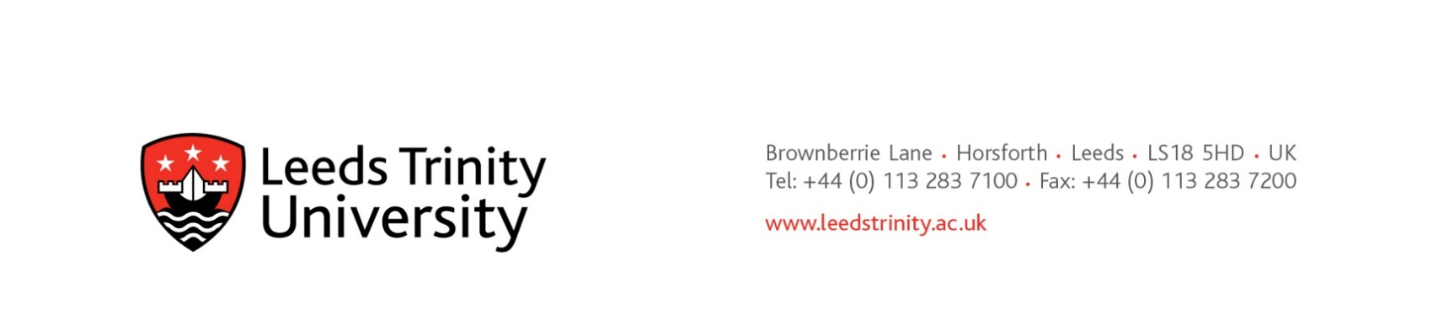

12th July 2023

**Preliminary Market Consultation**

**Provision of cafeteria and catering services at City Centre Campus**

Dear potential supplier,

In respect of the above Leeds Trinity University seeks advice from independent experts/authorities/market participants with a view to developing the scope and specifications needed to plan and conduct its procurement procedures.

For the avoidance of doubt, no call for competition has been made, and no contract award opportunity identified. All relevant information exchanged or resulting from this preliminary market consultation will be documented and may be communicated to other candidates and tenderers participating in any resultant procurement procedure.

**Introduction to our requirements:**

Leeds Trinity University is seeking to understand supply options and pricing from caterers for the provision of café services for a new city centre campus due to open in September 2024.

The new campus, located at Trevelyan Square is in the heart of the city, just minutes away from Leeds train station and adjacent to the Trinity Shopping Car Park and the Marriott Hotel.

The campus will offer a range of modern facilities and services over six floors to ensure students can make the most of their studies and outside of term-time to support business engagement events and conferences. Courses that will run on campus include Business, Law, Computer Science, Construction and the Built Environment. Typically, 600 students will be expected on campus at any one point.

A café is to be located on the ground floor accessible to students, staff and other visitors. The public will be able to access the café. Also located on the ground floor will be a large flexible plenary space for teaching and events of up to 100 people and an entrepreneur hub, encouraging business engagement and public interaction such as through provision of law clinics.

The expectation is that this will provide an enhanced coffee shop style menu with a quality coffee and a range of excellent value ‘grab and go’ lunch and snack options.

The café, including a seating area, will cover a space 166sqm with additional seating in an adjoining courtyard area. Please see enclosed a provisional floorplan which will be developed with the chosen provider.

With the exception of snack and drink vending machines, no other catering provision will be on the campus.

Sustainability is an important part of the LTU strategy, and we will be looking for a provider to work collaboratively with us to drive forwards sustainability through design and operation, including contributing towards a revised sustainable food policy.

The successful catering provider will be able to demonstrate the following;

* A menu choice to meet diverse catering requirements, with a particular emphasis on vegetarian and vegan options and meet religious beliefs
* An accredited Environmental Management System or ISO 14001 and a commitment to minimising the environmental impact when fulfilling the requirements of the contract
* Be committed to implementing a reusable coffee cup scheme and offer discounts for customers bringing their own cup
* A commitment to local suppliers and use seasonally available ingredients wherever possible
* Value for money for students and customers, benchmarked against other University providers
* Ability to flex provision when confronted with unexpected change and fluctuating demand
* Provide catering 52 weeks of the year including for events such as conferences and Graduation.
* A real living wage employer
* Bring innovation to catering provision, particularly with reagrd the HE sector.

Requests to participate in this preliminary market consultation will be received until **1700h Monday 7th August 2023.** Thereafter, the university will assess the level of interest received, and advise accordingly.

In the first instance, please indicate your interest and address queries by e-mail to [Mark Hayter](mailto:m.hayter@leedstrinity.ac.uk), Head of Procurement. Please note that due to annual leave, responses and acknowledgements may be delayed.

We hope to hear from you soon

With kind regards

[Mark Hayter](mailto:m.hayter@leedstrinity.ac.uk)

Head of Procurement