

|  |  |  |  |
| --- | --- | --- | --- |
| REFERENCE : | | **FsAST/A400MTS/AM Force Trg Life Rafts/SOR/V4.0** | |
| TITLE : | | | |
| **FLIGHT SIMULATION & SYNTHETIC TRAINING (FsAST) PROJECT TEAM**  **Statement of requirement FOR**  **THE PROVISION OF TRAINING LIFE RAFTS FOTHE AIR MOBILITY FORCE – RAF BRIZE NORTON** | | | |
| VERSION: | **3** | DATE : | **10 Jun 23** |

|  |  |
| --- | --- |
| PROJECT : | **A400M Training Service** |
| SECONDARY REF : | **Training Life Rafts** |
| ORIGINATOR : | **Flight Simulation & Synthetic Trainers PT** |

|  |  |
| --- | --- |
| APPROVED FOR ISSUE : |  |
| NAME : | **MR D Macintosh** |
| SIGNATURE : |  |
| DATE : | **10 Jun 2023** |

PREPARED AND ISSUED BY:

Flight Simulation & Synthetic Trainers Project Team

Walnut 2B,

MOD Abbey Wood

BRISTOL,

BS34 8JH

Tel : +44 (0) 30 679 81800

|  |
| --- |
| THIS DOCUMENT IS THE PROPERTY OF HER BRITANNIC MAJESTY'S GOVERNMENT and is issued for the information of such persons as need to know its contents in the course of their official duties. Any person finding this document should hand it to a British forces unit or to a police station for its safe return to the Ministry of Defence, D MOD Sy, London SW1A 2HB, with particulars of how and where found. THE UNAUTHORISED RETENTION OR DESTRUCTION OF THE DOCUMENT IS AN OFFENCE UNDER THE OFFICIAL SECRETS ACTS OF 1911-1989. (When released to persons outside Government service, this document is issued on a personal basis and the recipient to whom it is entrusted in confidence, within the provisions of the Official Secrets Acts 1911-1989, is personally responsible for its safe custody and for seeing that its contents are disclosed only to authorised persons). |

**DOCUMENT CHANGE RECORD**

This is a controlled document. Additional copies should be obtained through the issuing authority. Amendment shall be by whole document replacement. Proposals for change should be forwarded to the issuing authority ([desfsast4-TSLO@mod.uk](mailto:desfsast4d@mod.uk)).

|  |  |  |  |
| --- | --- | --- | --- |
| **Version** | **Details Of Amendments Made** | **Amended By** | **Date** |
| 1 | Initial Draft | D Macintosh | Apr 22 |
| 2 | Final Draft | D Macintosh | May 22 |
| 3 | Defence Sourcing Portal Ready | D Macintosh | 10 May 22 |
| 4 | 12 monthly review prior to Contract Award | D Macintosh | 10 Jun 23 |
|  |  |  |  |
|  |  |  |  |
|  |  |  |  |

**Statement of requirement**

**THE PROVISION OF SPECIFIC TO TYPE TRAINING LIFE RAFTS FOR ATLAS AND VOYAGER AIRCREW**

Reference: **MAA RA 2130**

**Background**

1. The Reference specifies the Requirement for military aircrew to be Qualified to use all Safety Equipment (SE) used onboard their aircraft. Furthermore, they are also required to complete recurrent training in the use of such equipment. SE used for training is to be suitably representative and exhibit the same dynamics and principles of operation as the live aircraft version. This Requirement specifically addresses the procurement of Training Life Rafts (TLRs) for the Air Mobility Force at RAF Brize Norton.

**Issue**

1. The Atlas and Voyager aircraft life raft equipment is not suitable for training use. This is due to cost, durability, and size (in the case of Voyager). Currently, only generic training can be delivered using C130 equipment, which is not compliant with the Reference. The inability to carry out specific to type critical emergency equipment training carries a potential increased Risk to Life (RtL). This level of continued RtL is not considered tolerable by the DH. Therefore, there is a Requirement for reproduced and representative[1] equipment to support ‘wet’ life raft training.

**Training Requirement**

1. Live aircraft Life Raft examples are available in a dry static classroom environment for general familiarization and survival accessory location. This Requirement relates specifically to the achievement of wet life raft training, typically in a chlorinated swimming pool environment. The Training Objectives to be enabled are as follows:
   1. Carry out Multi Engine (ME)[2] survival drills in a pool utilising specific to type Aircrew Equipment Assemblies (AEA) and associated safety Equipment (SE).
   2. Demonstrate operating procedures for specific to type ME Life Preservers (LPs) in association with a life raft and ancillary equipment in a pool.
   3. Demonstrate life raft righting drills in a pool using specific to type ME life raft and ancillary equipment.
   4. Demonstrate life raft pre-boarding actions in a pool using specific to type ME life raft and ancillary equipment.
   5. Demonstrate life raft after-boarding actions in a pool using specific to type ME life raft and ancillary equipment.

**Requirement**

1. The Requirement is to provide 3 of each specific to type Atlas and Voyager Training Life Rafts (TLRs) to RAF Brize Norton to support initial and recurrent SE training. Examples are illustrated in Figs 1 and 2. The detailed Requirement is as follows:

|  |  |
| --- | --- |
| **Req** | **Common Requirements** |
| 4.01 | The TLRs will be durable and easily repairable. |
| 4.02 | The TLRs will be capable of repeated immersion in chlorinated water (typically a swimming pool). The expected average usage for each raft type is two immersions per month. |
| 4.03 | The TLRs will have a service life of at least 5 yrs at the predicted usage rate. |
| 4.04 | The TLRs will be capable of inflation via the use of an electric blower or portable compressed air system. |
| 4.05 | The TLRs will be fitted with Gemini A5 Inflation/Deflation Valves, or similar, to aid inflation/deflation. These should be fitted to the underside of the inflation tubes for operation. |
| 4.06 | The TLRs will be constructed of polyurethane coated nylon material for ease of maintenance as support facilities already exist. |
| 4.07 | The TLRs will be fitted with ballasted space model CO2 inflation cylinders, of representative weight to a live discharged cylinder. The dummy cylinders should be made from a non-corrosive material or coating. |
| 4.08 | The TLRs will be clearly marked ‘Training Use Only’. |
| 4.09 | Full technical instructions will be provided, both for regular servicing, and for repair. |
|  | **Atlas (A400M) Specific – Fig 1** |
| 4.10 | Three reproduced and representative specific to type full size TLRs will be provided. The life rafts are octagonal (4.5m across flats), with integral roof pillars and covering. The raft will include a manually inflatable floor. Two boarding ports will be provided on two opposite sides. |
| 4.11 | The Atlas TLRs boarding ladder and step will be modelled accurately. |
| 4.12 | The Atlas TLRs will have a red webbing righting strop fitted to the underside. |
| 4.13 | The Atlas TLRs will have a yellow hull, with orange roof. |
| 4.14 | The Atlas TLRs will be equipped with emergency manual bellows and sea anchor. |
|  | **Voyager (A330) Specific – Fig 2** |
| 4.20 | Three reproduced and representative specific to type reduced size TLRs will be provided. The life rafts double as escape slides, and the live aircraft parts are approximately 2.2m wide, by 9.55m long. Roof pillars auto inflate, but the roof is manually rigged, see figs 3-5. |
| 4.21 | The Voyager TLRs will be the same width as the live version, but the length should be truncated to half-length (4.8m) in order to be more practical. |
| 4.22 | The live aircraft part has very different designs at either end. Although the Voyager TLRs will be truncated, each boarding end will be modelled accurately. |
| 4.23 | The Voyager TLRs will include a representative roof cover and rigging mechanism. |

**Priced Options**

1. The following priced options are required:

|  |  |
| --- | --- |
| 5.01 | There is a potential for the TLRs to be used for sea training. This would require the TLRs to be fitted with a gaseous inflation system rather than a fan, and be capable of repeated saltwater immersion. Any cost delta for a Sea Water version should be priced as an option. |
| 5.02 | The provision of a portable reversible inflation/deflation device should be priced as an option. |
| 5.03 | The provision of a common repair kit, scaled for 5 years of use, should be priced as an option. This should include any recommended spares for the Gemini valves and inflation/deflation device. |

**Assumptions**

1. The following assumptions are made:

|  |  |
| --- | --- |
| 6.01 | The precise Life Raft dimension data will be made available by the Authority during an industry day, when live examples will be available to be surveyed. |
| 6.02 | The TLRs shall be representative, but are not required to be manufactured from aircraft standard materials. |
| 6.03 | The TLRs shall not be equipped with survival ancillary equipment, such as Locator Beacons, this equipment will be trained on a dry static aircraft example. |
| 6.04 | The Brize Norton SERCO SES (Safety Equipment Section) will maintain, service, and repair the TLRs as required by the maintenance schedule. |
| 6.05 | The Brize Norton SERCO SES (Safety Equipment Section) will store the TLRs when not in use. |
| 6.06 | The Brize Norton SERCO SES will be responsible for the transportation to/from the training location, and all inflation/deflation activities. |
| 6.07 | The Brize Norton SERE Section will be responsible for the supervision and conduct of all TLR training activities. |

**Dependencies**

1. None identified.

**Security**

1. Security classification of the project will be UK Unclassified.

**In Service Date**

1. This Requirement is targeted to fill an existing Training Gap against which a significant Duty Holder Risk is being held. Therefore, the TLRs are required to enter service as soon as practical.

**Acceptance**

1. The TLRs will be accepted on behalf of the Authority by Life Raft Bay SME’s for technical aspects, and RAF Brize Norton SERE personnel for training and operational aspects.

**Warranty**

1. The TLRs shall be subject to a 12 month warranty for non-wear and tear type faults from the acceptance date, recognizing the predicted usage rate.

**Follow On Purchases**

1. There is a potential requirement for follow-on purchases both for attrition replacements, and for other large aircraft types.

**Quality Assurance**

1. The tenderer shall comply with:

* AQAP 2110 Edition D - NATO QA Requirements for design, development, and Production.
* DEFCON 627 - Certificate of Conformity.
* DEF CON 68 - Supply Of Data For Hazardous Articles, Materials And Substances.

D R Macintosh

FsAST Atlas TSLO

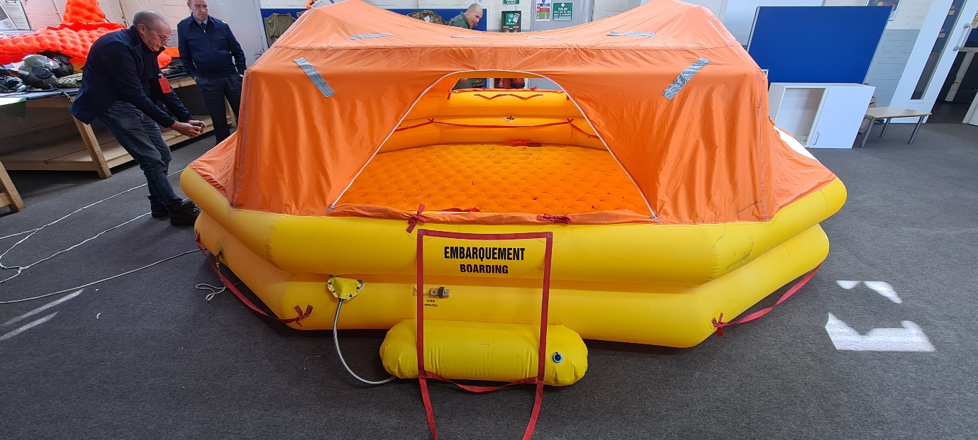

Fig 1 – Atlas (A400M) Multi-Seat Life Raft.

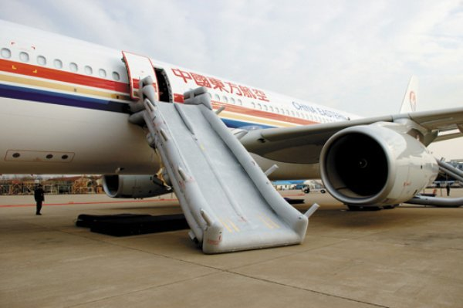

Fig 2 – A330 Slide/Raft.

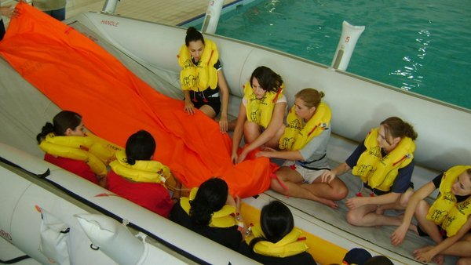

Fig 3 – A330 Cover deployment

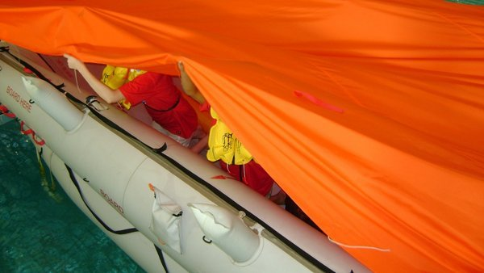

Fig 4 – A330-Rigging the Cover

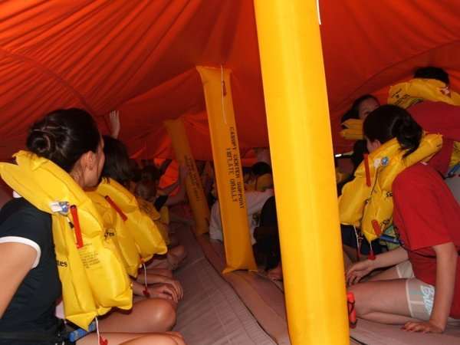

Fig 5 – A330-Buttoned Up

1. Representative in this context refers to a targeted fidelity training device, that will enable specific to type training. Dimensions may be approximate.
2. The term Multi Engine implies the use of large multi-seat life rafts.