
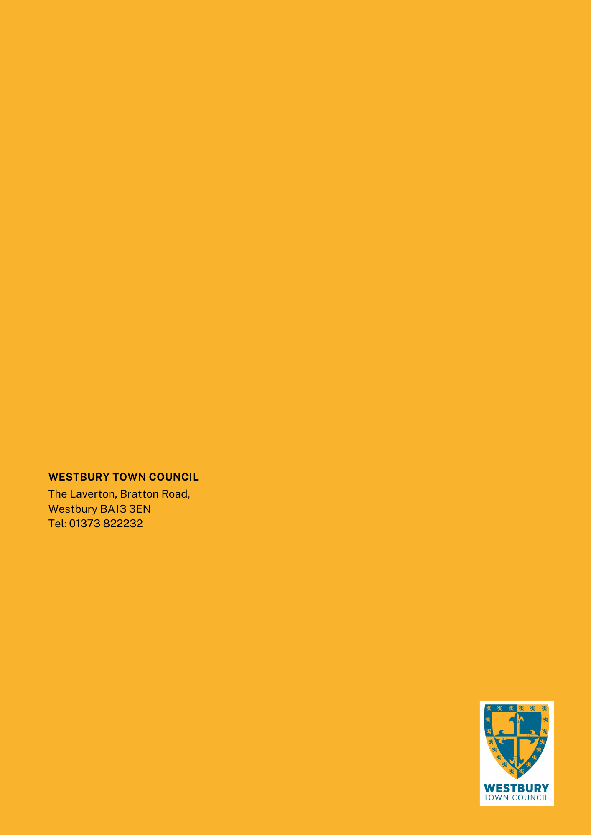


WTC 01 2025
Date 17/10/2025
Westbury Town Council: Public Toilet Refurbishment
Quality Assessment Questionnaire
Westbury Town Council
The Laverton, Bratton Road
Westbury, Wiltshire BA13 3EN
www.westburytowncouncil.gov.uk
info@westburytowncouncil.gov.uk
01373 822232

DOCUMENT 4

Structure of Submission
The table below sets out the Questions to be answered and Weighting.

Question |  | Word Limit | Tender Weighting
1 | Site set up, management & welfare | 1000 | 20%
2 | Project Approach & Programme | 1000 | 20%
3 | Quality & Risk Management | 1000 | 15%
4 | Design Management & Co-ordination | 1000 | 15%
5 | Project examples | 2000 | 30%

Delivering the Contract
WTC must be confident the standards, reliability and professionalism of your organisation will always meet WTC’s expectations and values. More details about WTC’s vision and priorities can be found www.westburytowncouncil.gov.uk

Please proceed to question 1

Question 1
Describe how your organisation will set up the construction sites at Warminster Road and High Street to deliver the projects, and ensure that WTC’s objectives, as described in the ER’s, are met. Please provide drawings showing the arrangement at both sites.
Please consider the following:
- The provision of welfare for the site workers and any site compounds.
- How the works will be separated from the Public and safe walking routes.
- Hoarding and fencing arrangements.
- Material storage arrangements.
- Access and egress to and from the site.
- Vehicle parking and arrangements for deliveries.
- Waste disposal and the proposed location of any skips.
- Communication strategy – How will your organisation engage with the local community to inform them of progress and any impact arising from the works.
Bidder Response- Max 1000 words

Question 2
Describe how your organisation will approach the project. Provide an organogram for the project team and programme for the construction of the project, showing proposed start and completion dates and key milestones.
Please consider the following:
- Responsibility: Provide details of the project team in an organogram, including the site manager and project director. Identify who will be responsible for managing the programme, quality, cost control, and client liaison.
- Programme: Provide a proposed project programme including start and finish dates and key milestones for the delivery of the project.
- Describe your organisations approach to the project delivery, and how this will be managed through the defined stages of design, mobilisation, enabling works, main construction, fit-out, commissioning and handover.
- Describe how the team will work in an integrated manner and engage with design, cost management, programme and resolve any clashes and optimise buildability, cost and value for money.
- Procurement strategy: Describe your organisations approach to procuring the materials required for delivering the project.
- Behaviour: How will you ensure your workforce demonstrates the behaviours expected by WTC when working in the community.

Bidder Response Max 1000 words

Question 3
Describe your organisations approach to Quality and Risk Management for the project.
Please consider the following:
- How you will identify and manage risks on the project.
- Provide an example of any risk registers used on similar projects.
- How will your organisation ensure the project is delivered to a high standard of quality?
- Provide details of your organisations approach to quality management and any supporting examples of how this has been used on previous projects.

Bidder Response Max 1000 words

Question 4
Describe how your organisation will approach the management of Design & co-ordination with the construction works.
Please consider the following:
- Your organisations process for managing design, within a design and build contract
- Who will be responsible for managing and co-ordinating design?
- How will your organisation ensure design compliance with Building regulations
- How will change requests from the Employer be managed?

Bidder Response Max 1000 words

Question 5
Please provide 3 examples of similar, or relevant projects your organisation has delivered within the last 5 years.
Bidder Response Max 2000 words

