This Contract is made between:

**Public Health England** (which expression shall include its successors in title) of Wellington House, 133-135 Waterloo Road, London SE1 8UG (the "Authority")

and

**Costello Medical Consulting Ltd**, of 50-60 Station Road, Cambridge, Cambridgeshire, CB1 2JH (the "Contractor")

The following is agreed:

1. The Contract is made up of the following documents:
2. This Form of Contract for **PHE - Corporate - Asymptomatic Bacteriuria Screening in Pregnancy**
3. PHE Conditions of Contract (as included in the tender documents).
4. The Contractor’s tender response (including prices detailed in the Commercial Envelope of the tender response).
5. Specification for PHE - Corporate - Asymptomatic Bacteriuria Screening in Pregnancy as included in the tender documents.

(all of the above documents taken together (as amended in accordance with this Contract) being referred to as the “Contract”)

1. If there is an inconsistency between any of the documents listed above, a higher listed document shall prevail over a lower listed document, i.e. document (a) shall prevail over all other documents; document (b) shall prevail over documents (c) and (d).
2. The Contract will commence on the date that signatures are added by both the Authority and the Contractor.
3. The duration of the Contract will be until completion of the project, but in any case, no later than the 29th October 2021.

Signature: Signature:

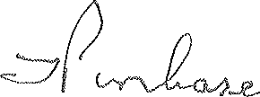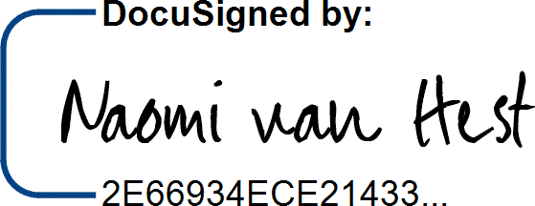

For and on behalf of the Authority For and on behalf of the Contractor

Name: Timothy John Purchase Name:

Job Title: Lead Category Manager Job Title:

Naomi van Hest

Consultant Health Economist

Date: 29th April 2021 Date:

04-May-2021 | 10:11 AM BST