Specification and Conditions of Contract

For

Refurbishment

To

Great Dunmow Public Toilets
Town Square
White Street
Great Dunmow
CM6 1BD

March 2023

CONTENTS

Instruction to Tenderers

Certificate of Bona Fide Tender

Part 1: Terms & Conditions of Contract

Part 2: Materials & Workmanship

Part 3: Schedule of Works

Appendix A: Original construction drawings

Appendix B: Curtailage of site

Appendix C: Bushboard Washrooms

Appendix D: Drainage reports

INSTRUCTION TO TENDERERS
Return of Submission

The Contractor shall submit a hard copy of the tender submission only; this is to include the certificate of bona fide tender and a priced copy of this Specification. The tender submission should be delivered or sent by post to reach:

The Town Clerk
Great Dunmow Town Council
Foakes House
47 Stortford Road
Great Dunmow
Essex CM6 1DG

by no later than noon on Friday 14 April 2023.

The envelope must be clearly marked as “Great Dunmow Public Toilets”.

Proof of postage will not be accepted as confirmation of receipt by the deadline.

Tender Queries

All queries in connection with this tender enquiry must be submitted to Roy Emmerson by email to roy.emmerson@emmersonbarnett.co.uk

Tender Site Visits and Meetings

The Contractor will be required to visit site during the tender process in order to ascertain a full understanding of the existing site and the project. Site visits can be arranged via Terry on operations@greatdunmow-tc.gov.uk.

Tender Information

A set of ‘tender documents’ including both drawings and specification have been prepared by consultants employed by the Employer prior to the date of this tender. These are set out in within tender pack. It is intended that these drawings specifications and documents will form the ‘contract documents’ as referenced under the JCT Minor Works Contract 2016.

Tenderers are required to check and satisfy themselves as to the adequacy and completeness of the information contained within the ‘tender documents’. If any tenderer has any comments or queries or if he believes that it is appropriate to make any alterations to the drawings specifications and documents contained within the ‘tender documents’ he is required to do so with his tender.

Acceptance of Tenders

The Employer and his representatives offer no guarantee that the lowest or any tender will be recommended for acceptance or accepted, nor will they be responsible for any costs incurred in the preparation of any tenders. The Employer reserves the right to reject all tenders and re tender the work at a later date.

Tendering Procedure

This will be in accordance with the principles of the JCT Tendering Practice Note – current at the Date of Tender.

Inability to Tender

If the Contractor cannot tender for any parts of the work as defined in the tender documents he must inform the Contract Administrator as soon as possible during the tender period defining the relevant parts and stating the reason for his inability to tender.

Contractual & Procurement Arrangements
Contractual Arrangement
Details of the contractual arrangements are outlined in the Preliminaries and General Conditions.

Tender Submission

Tender Information To Be Provided

It is the Employer’s intention to procure the Works with a a single-stage tender process based on the JCT Minor Works Contract 2016. The tendering Contractor’s submission is to be based on the information contained in this Tender Document and the Contractor is required to submit the following within their tender:

Completed Form of Tender and Declaration of Non-Collusion Schedule of Works

• Fully priced Schedule of Works for all works required by the Tender Documents

Construction Programme

• Programme for the whole works fully detailing overall duration, procurement and construction activities, up to completion and handover of the project.

Contract Conditions and Contract Amendments

• The Contractor is to append a letter to the Form of Tender accepting the Contract Conditions.

Risk Register

- Identification of any risks with mitigation proposals.
- Proposals on Risk Management implementation.
- Proposal of mitigating disruption to the tenant to the lower ground floor

Methodology of Works

- Identification of the logistics / methodology proposed as well as the proposed site setup.
- Provide a Site Logistics Plan / Methodology based on constraints, neighbouring, planning issues
etc.
- Site Logistics drawing of proposed site infrastructure and access

Proposed Supply Chain

- Identification of the proposed supply chain and subcontractor list.

Health & Safety

- The health and safety policies and procedures of your company / parent company
Accident and illness records for the past five years.
- Records of previous Health and Safety Executive enforcement actions.
- The number and type of staff responsible for health and safety on this project with details of their qualifications and duties

Pricing Preliminaries

The Contractor must submit a detailed build-up of his pricing of the Preliminaries before his tender is accepted. "Fixed charges" (charges for work the cost of which is to be considered independent of duration) and "time related charges" (charges for work the cost of which is to be considered as dependent on duration) must be shown separately.

Errors in Pricing Documents

Will be dealt with in accordance with the JCT Tendering Practice Note 2017 current at the date of Tender.

Period of Validity

Tenders must remain open for consideration (unless previously withdrawn) for not less than 6 months from the date fixed for the submission or lodgement of tenders.

Criteria for Selection

The successful Contractor will be selected on the best balance of:
- The experience, calibre and attitude of the proposed resident Project Manager and resident team.
- The demonstrated depth of understanding of the project and the efficiency of the construction
proposals.
- The demonstrated ability to work as part of a team in a challenging situation.
- The proposed programme.
- The proposed supply chain.
- The demonstrated ability to control cost/budget.
- Approach to health and safety during the contract period.
- Previous experience of similar contracts, similar projects and Employer references.
- Approach to quality and on-site quality control procedures.
- The commercial offer.

Tenderers should ensure that their submission is self-contained and fully representative of their suitability for an appointment as Contractor for the project. Contractors should also note that: The Employer is not obliged to accept any offer the selection of the Contractor will not be determined solely by the commercial offer or any one of the above criteria.
CERTIFICATE OF BONA FIDE TENDER
Certificate of Bona Fide Tender

TENDER FOR REFURBISHMENT
at Great Dunmow Public Toilets Town Square White Street Great Dunmow CM6 1BD

Sir/s,

The essence of selective tendering is that the Employer shall receive bona fide competitive tenders from all those tendering. In recognition of this principle, we certify that this is a bona fide tender intended to be competitive, and that we have not fixed or adjusted the amount of the tender by, or under, or in accordance with, any agreement or arrangement with any other person. We also certify that we have not done, and we undertake that we will not do at any time before the latest hour and date specified for the return of this tender, any of the following acts:

(i) communicating to a person other than the person calling for those tenders the amount or approximate amount of the proposed tender, except where the disclosure, in confidence, of the approximate amount of the tender was necessary to obtain insurance premium quotations required for the preparation of the tender.

(ii) entering into any agreement or arrangement with any other person that he shall refrain from tendering or as to the amount of any tender to be submitted.

(iii) offering, or paying, or giving, or agreeing to pay or give any sum of money or valuable consideration directly or indirectly to any person for doing, or having done, or causing or having caused to be done in relation to any other tender or proposed tender for the said work any act or thing of the sort described above.

In this certificate, the word "person" includes any persons and anybody or association, corporate or non-corporate, and "any agreement or arrangement" includes any such transaction, formal or informal and whether legally binding or not.

Date .......................................................

Signed (as in Form of Tender) ...........................................................................

For and on behalf of ..........................................................................................

PART 1

TERMS & CONDITIONS OF CONTRACT

GENERAL CONDITONS OF CONTRACT

1.0 Description of Site

The property is a detached building comprising public toilets (ladies, gents and accessible) constructed in early 2000’s.

  - ACCESS

  - Access to the site will be determined by the Contractor at the time of inspection and laid out within the programme of works and all works will be limited to the property defined.

3.0 THE CONTRACTOR

3.1 The definition to mean the firm or company undertaking the works.

3.2 The Contractor will be confined to the immediate areas of the works.

3.3 The Contractor will be deemed to have inspected the site and all documents and drawings and be satisfied with the nature of the works and restrictions stated. No claim through lack of knowledge will be entertained.

4.0 DOCUMENTS

  - The tender documents and contract documents may be inspected at the offices of Emmerson Barnett Limited, Stanbrook Mead, Stanbrook, Thaxted, Essex CM6 2NQ.

  - DESCRIPTION OF WORK

  - The works comprise refurbishment.

  - Any drawings prepared and issued with the tender documents are to be read in conjunction with the specification and schedule of works.

- CONTRACT DOCUMENTS

  - The contract documents shall comprise of the form of contract, the specification and any drawings.

- FORM OF CONTRACT

The Minor Works Building Contract 2016.

Schedule 2 base date. | 4 April 2023.
4th Recital CIS. | The Employer is not a contractor.
5th Recital CDM Regulations. | The CDM Regulations apply in full given the requirements of CDM 2015.
Article 7 Arbitration. | Article 7 Schedule 1 applies.
Clause 2.2 - Date of commencement of the works. | Likely to be Spring 2023.
Clause 2.2 - Date for completion. | Within 4 weeks.
Clause 2.8 - Liquidated damages. | At the rate of £3,000 per week or part thereof.
Clause 2.10 - Rectification period. | 12 months.
Clause 4.3 – Interim payments. | Fortnightly. Payment terms are 30 days.
Clause 4.3 – Payments due prior to practical completion. | 95%.
Clause 4.3 - Payments due after practical completion. | 97.5%.
Clause 4.8.1 - Supply of documentation for computation of accounts to be finally certified. | 3 months.
Clause 5.3 - Contractors public liability insurance. | £5,000,000
Clauses 5.4a, 5.4b - Insurance of the works – alternative provisions. | Clause 5.4b applies.
Clauses 5.4a and 5.4b percentage to cover professional fees. | 20%.
Clause 7.2 - Adjudication. | The adjudicator is President or Vice President of the Royal Institution of Chartered Surveyors.
Schedule 1 Arbitration. | President or Vice President of the Royal Institution of Chartered Surveyors.
8.0 PARTIES TO CONTRACT

Employer: Great Dunmow Town Council
Foakes House
47 Stortford Road
Great Dunmow
Essex CM6 1DG

Contract Administrator: Emmerson Barnett Limited
Stanbrook Mead
Stanbrook
Thaxted
Essex CM6 2NQ

Principal Designer: Emmerson Barnett Limited
Stanbrook Mead
Stanbrook
Thaxted
Essex CM6 2NQ

9.0 | TENDERS
9.1 | The Employer does not bind themselves to accept the lowest of any tender and will not be responsible for any costs incurred by the Contractor in preparing the tender. The employer reserves the right to proceed with the whole or any portion of the works as they shall decide.
9.2 | Tenders shall remain open for acceptance for 6 months.
10. | INSURANCE
10.1 | The Contractor shall submit to the Surveyor evidence of policies and receipts for all insurances, which he is required to take out prior to commencement.
11.0 | GENERAL SUPERVISION
11.1 | The Contractor shall be responsible for co-ordination and supervision and administration of the works including sub-contractors, suppliers, Local Authorities, Statutory Undertakers and others engaged on the works.
12.0 | PROGRAMME
12.1 | Prior to instruction the Contractor will provide a detailed programme of works proposed for the various stages or phases of the works completed dates in relation to the overall contract period.
13.0 | SITE MEETINGS
13.1 | Formal site meetings will be held monthly throughout the contract with informal meetings every fortnight.
14.0 | WATCHING AND LIGHTING
14.1 | The Contractor shall provide all watching and lighting temporary barricades required during the contract period.
15.0 | OVERTIME
15.1 | Included in the Contractor’s tender will be overtime which may be necessary for work which cannot be reasonably executed during normal working hours.
16.0 | STATUTORY NOTICES AND FEES
16.1 | The Contractor is to give all requisite notices and pay fees required by statutory authority.
17.0 | SCHEDULE OF RATES
17.1 | The successful Contractor will be required to provide to the surveyor a schedule of rates on which his tender is based and all variations with extras or omissions should be measured and valued at the prices stated.
18. | DRAWINGS AND SCHEDULES
18.1 | The Contractor shall submit to the Contract Administrator all shop drawings for inspection in sufficient time to allow them to be properly assessed and comments taken into account prior to the commencement of specialist work.
18.2 | The Contractor shall be responsible for checking all schedules supplied by the Contract Administrator and also drawings supplied by specialists.
18.3 | In the event of any discrepancy being found in schedules and drawings, if the Contractor considers additional detailed drawings are required, then the Contractor shall report such discrepancies or apply in writing for additional detailed drawings at least 28 days before works are programmed to be executed.
18.4 | The Contractor shall ascertain from drawings and schedules any holes or recesses which may be required, in time to form them as works proceed. The Contractor is responsible for obtaining data from all specialist sub-contractors and suppliers and for handing it to the Contract Administrator free of charge on, or before, practical completion. These details to be submitted to the employer.
i) Duplicate copies of all specialist drawings.

ii) Details of the operation of all installations.

iii) Manufacturer’s recommendations for maintenance of specialist installations.

19.0 | DAMAGE TO WORK AND INSURANCE
19.1 | The Contractor shall indemnify the employers from and against all actions, costs, claims, losses, demands, damages and liabilities whatsoever or howsoever arising out of in connection with or by reason of carrying out the work or any part thereof and shall insure or cause to be insured such risks to the reasonable satisfaction of the employer and on demand shall produce to the employers the policy or policies of such insurance the receipts for current premiums therefore.
20.0 | DAMAGE TO SITE AND ADJOINING PROPERTIES
20.1 | The Contractor shall maintain proper control over all employed persons and is responsible for making good at his own expense any damage occurring to any part of adjoining properties caused by or in consequence of carrying out these works.
21.0 | PROSPECTIVE PROFITS
21.1 | The employer reserves the right of adding or omitting any of the works included in this contract without liability to the Contractor for any prospective profit.
22.0 | SUPPLY OF TOOLS, LABOUR, PLANT, EQUIPMENT, SCAFFOLDING ETC.
22.1 | The Contractor will be responsible for the proper execution and completion of the whole of the contract works for the protection of all the work, the materials on site, the adjoining property and the public. He is to supply everything necessary including labour, plant, materials, scaffolding planks, shoring, carriage, freightage and all tarpaulins, sheets, sheds, platforms and coverings required to protect all works and materials from the weather or other source of injury. The siting of any structure is to be approved by the surveyor prior to erection.
23.0 | PROTECTION
23.1 | The Contractor is to supply adequate protection during the course of the works to those parts not affected by the works and any damage sustained is to be made good at the Contractors expense.
24.0 | WEATHER PROTECTION
24.1 | The Contractor shall at his own expense and to the satisfaction of the surveyor protect from injury by weather all work and materials, which may be so, affected.
25.0 | INTERPRETATION OF WORKS
25.1 | In the event of the Contractor being in any doubt regarding any materials or works specified hereafter having a due regard for normal trade practice he shall at the time of formulating this tender exercise his judgement in reading into the contract document their true intent. He shall furthermore draw the Surveyor’s attention to such items when submitting his tender.
26.0 | ALTERNATIVE METHODS AND MATERIALS
26.1 | Any variation which the Contractor may suggest with a view to simplifying work or economising costs without sacrifice to quality or design will be considered by the surveyor.
27.0 | DESCRIPTION OF MATERIALS AND WORKMANSHIP
27.1 | All materials shall be in accordance with the latest British Standard Specification where such exists and work shall not be inferior to the standards laid down in the latest Code of Practice.
28.0 | SAFETY
28.1 | The Contractor is to observe and comply in all respects with all the Health and Safety at Work Act, 1974 and all other relevant acts as far as they affect this contract.
28.2 | THE CONSTRUCTION (DESIGN & MANAGEMENT) REGULATIONS 2015 (CDM REGS)  The Construction (Design & Management) Regulations 2015 will apply in full. Therefore, the contractor is to allow for all costs related to this including, but not restricted to, the preparation of a Construction Phase Plan, Health & Safety File upon completion, preparation of risk assessments, method statements, inductions, toolbox talks, etc.  Not withstanding the above the contractor should ensure compliance with the requirements of the Health & Safety at Work Act 1974 (HSW Act), the Management of Health & Safety at Work Regulation 1992 (MHSW Regulations), Personal Protective Equipment at Work Regulations 1992 and all other relevant health and safety legislation. Hard hats are to be worn at all times on site.
29.0 | SAFETY BARRIERS
29.1 | The contract shall supply all necessary warning notices and rails, fences, footways and the like on or about the site and the works that may be considered for the safety of any person in the Contractors working area and for those whose safety the Contractor is legally responsible. These protective works to be provided, maintained and altered from time to time and cleared away by the Contractor who shall make good any damage arising therefrom.
30.0 | MATERIALS
30.1 | Materials to comply with the current British Standards Specification where such is applicable or otherwise of the best of its type available.
31.0 | LABOUR
31.1 | A properly qualified supervisor is to be constantly employed on the site whilst work is proceeding and none other than skilled workman are to be employed except labourers and apprentices.
31.2 | The works shall be carried out in the full conformity of the specification with specialist supplier’s instructions and the issue of any relevant British Standard Code of Practice where applicable or the best standards of such work generally accepted.
32.0 | FIRST AID
32.1 | The Contractor shall provide proper and sufficient first aid equipment having regard to the nature and extent of the contract including the clearing away of all rubbish and clearing up. The Contractor will cart away all debris rubbish and surplus materials as it accumulates during the progress of works and keep the surrounding area free of building materials and rubbish at all times. The Contractor will restrict parking of any vehicles whatsoever outside the curtilage of the site previously referred to.
33.0 | VARIATION ORDERS
33.1 | No claim by the Contractor for extra work or works in variance of the schedule and specification of the works can be considered unless covered by a Variation Order issued and signed by the Surveyor or his representatives.
34.0 | TEMPORARY LIGHTING AND POWER
34.1 | The contractor will be permitted to use the existing supply.
35.0 | TOILETS
35.1 | The Contractor will be permitted to use the existing facilities.
36.0 | WATER
36.1 | The contractor will be permitted to use the existing supply.
37.0 | REMOVAL OF RUBBISH
37.1 | The Contractor shall provide for cleaning up and carting away from the site of his works and surrounding areas from time to time as the works proceed and on completion all unwanted materials and rubbish from whatsoever source leaving the works and surrounding areas clear of all Contractors plant and material.
38. | CLEARING UP ON COMPLETION
38.1 | On completion the Contractor shall clean down and polish where necessary all floors, walls, fittings, paintwork, glazing and signage etc. and leave the whole of the works clean, sound and in perfect condition ready for immediate use.
39.0 | NOISE CONTROL
39.1 | The attention of the Contractor is drawn to the provision of Section 60 of the Control of Pollution Act 1974 with reference to the control of noise in relation to any demolition or construction works and the need, particularly where such works are adjacent to occupied premises where a high sensitivity of noise may be appreciated, to ascertain from the proper authority what requirements or restrictions, if any, shall apply to the works in this respect. The restrictions may relate to the type of plant used, the method of working to be adopted, the hours of working permissible and may, in addition, impose a maximum noise level at the site boundary which may not be exceeded. The attention of the Contractor is also drawn to the provision of Section 61 of the Control of Pollution Act 1974 with reference to the issue of prior consent and any application form available to them. The Contractor to be held responsible for complying with such requirements, restrictions or consent, together with any stipulations to which his attention may be drawn from time to time by the competent authorities and is to allow in his tender for any costs or expenses arising from such compliance. No instruction issued by the Contract Administrator to the Contractor or his representative shall relieve the Contractor from compliance with The Control of Pollution Act 1974.
40.0 | SAFEGUARD TO WORKS, PLANT AND MATERIALS (THEFT OR DAMAGE)
40.1 | The Contractor will allow for the safeguard of works, materials, plant against damage, theft and risk of accident, and for the provision of any watching and lighting.
40.2 | The Contractor will allow for the safeguarding of existing building, boundary walls, fences, roads, services adjacent to the works, or to which the Contractor is allowed access from damage that may be caused by the works by the Contractor’s sub-contractors’ or suppliers’ transport. The Contractor is to notify the adjacent occupiers of their intention to erect scaffold/access equipment and its approximate duration remaining in place.
40.3 | The Contractor is responsible for confirming with the proper authorities before executing the work on the site, that existing drains, pipes, services, etc., have been sealed off or disconnected as may be required, and for making any diversion or otherwise as may be required.
40.4 | Any services encountered during the work shall be temporarily supported, the position noted and reported to the Project Manager pending a decision of the appropriate Authority as to their diversion or otherwise.
40.5 | In the event of loss or theft of any plant, tools, materials, etc., the Contractor shall be required to replace them at his own expense.
41.0 | PUBLIC AND PRIVATE ROAD - MAINTENANCE
41.1 | The Contractor will be responsible for the repairing of all damage or disturbance caused during the course of the works to public and private roads, footpaths or other land, and will maintain all approaches to the site free from mud and debris, and will comply with all Traffic Regulations governing the area.
42.0 | TEMPORARY DRAINAGE AND PUMPING
42.1 | The Contractor shall be responsible for keeping the work free from water which shall be pumped out and drained away at his own expense and shall provide and maintain any temporary drainage that may be necessary.
43.0 | FIRE PRECAUTIONS
43.1 | The Contractor shall take all reasonable precautions to avoid the outbreak of fire on the site of the works and in adjacent buildings. The Contractor’s suggested fire precautions shall be discussed and agreed with the Contract Administrator and all “No Smoking” rules applicable shall be observed.
43.2 | Fire escape routes and signs shall be kept clear of obstructions at all times. All inflammable rubbish shall be disposed of quickly and not allowed to accumulate on site. Acetylene., propane, butane or similar gas cylinders shall be stored in properly constructed fireproof stores sited not less than 8m from the nearest building and shall be appropriately signposted “DANGER” “NO SMOKING” or “NAKED LIGHTS”.
43.3 | Fire extinguishers suitable to the risk must be provided by the Contractor and should be immediately available at all times, particularly when any hot work or other work constituting a fire risk is taking place. Water/gas extinguishers are suitable for all normal free burning materials, i.e. paper, wood fabrics, etc. Carbon dioxide extinguishers are suitable for fires involving live electrical equipment (but switch off first) and flammable liquids. The contract Administrator should be consulted where additional information and/or number of extinguishers necessary is required.
44.0 | HOURS OF WORK
 | Shall normally be between 08h00 - 18h30 Monday – Friday but may be carried on outside of these hours to suit the Employers requirements.
45.0 | SIGNBOARDS
 | The Contractor is to allow for fitting of signboards provided by the Employer.
46.0 | PREWORKS SCHEDULE
 | The Contractor is to carry out a Pre Works Schedule of all glazing to elevations noting in particular any broken, scratched or scored window or door panes.
47.0 | LIAISON WITH TENANTS AND CARETAKER
 | A degree of liaison will be required with the Employer’s representative on a daily basis. The contractor shall allow for such liaison within his tender.

PART 2

MATERIALS & WORKMANSHIP

Generally

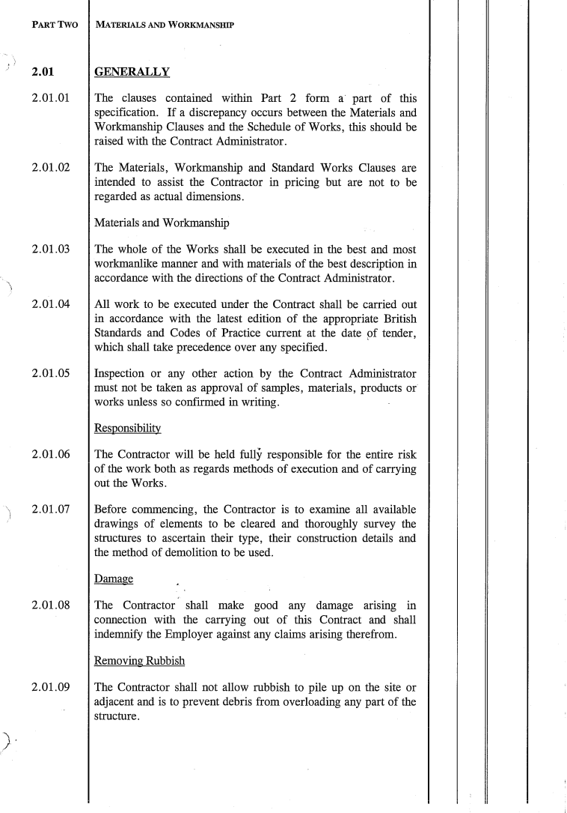
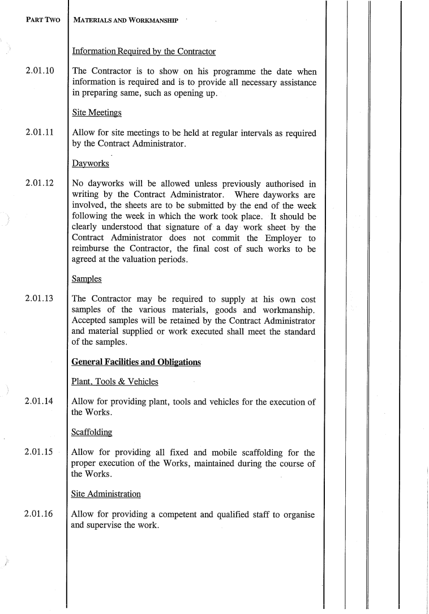
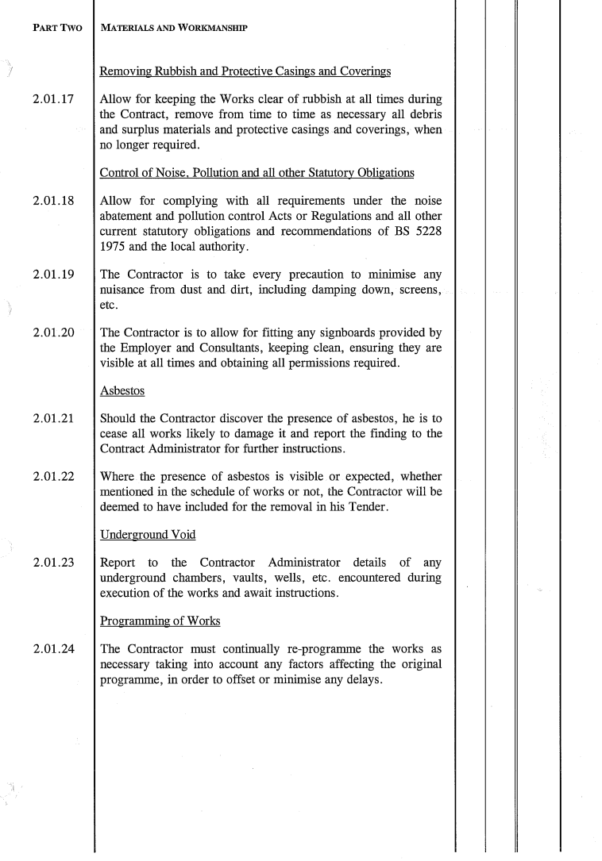
PART 3

SCHEDULE OF WORKS

 | SCHEDULE OF WORKS
1.0 | GENERAL
1.1 | The contractor will be expected to establish their own welfare and compound facilities in the immediate vicinity of the building. Compound to be secured with heras fencing and statutory signage displayed. The area outlined red in Appendix B shows the curtailage of the site but part of this will be occupied by temporary facilities (not part of this contract).
1.2 | All operatives will be required to wear corporate clothing. The foreman is to maintain a site register for operatives and visitors.
1.3  1.4  1.5 | All areas are to be kept clear at all times and the contractor will be responsible for making good any damage caused.  No radios will be permitted, nor will swearing and no cigarette butts are to be left on the ground.  All necessary signage is to be prominently displayed.
1.6 | The CDM Regulations apply (CDM Regulations 2015 as from 6 April 2015). The contractor must act as Principal Contractor and prepare a Construction Phase Plan.
1.7 | If the contractor considers the 4 week duration is not long enough, they are to notify the Contract Administrator on their tender return.
2.0 | ACCESS
2.1 | Provide and maintain, for the full duration of the work, altered and adapted as necessary all access equipment to facilitate the works. No access equipment to be left accessible outside of working hours but removed and chained elsewhere.
3.0 | ASBESTOS
3.1 | Based upon its age, it can be presumed that no asbestos containing materials are present.
4.0 | STRIPPING OUT
4.1 | Carefully strip out the existing cubicles, wall boarding, sanitaryware, plumbing, doors, floor tiling, etc., cart away and make good to all surfaces disturbed.
4.2 | The existing Wallgate units must be removed by Wallgate as they are under contract.
5.0 | CUBICLES, SANITARYWARE, ETC.
5.1 | Provide and install the Bushboard Washrooms system as detailed in Appendix C to include, but not limited to:  - Fully framed panel cubicles  - Panel cubicle/duct and wall linings/screens  - Preplumbed panels  - Sanitary appliances  - Wash basins with integral dryer and soap dispenser  - Part M accessible toilet pack  - Electroflo individual sensors  - Single flush sensor cistern  - Taps
5.2 | All sanitaryware to be white.
5.3 | Colour of cubicles, etc. to be selected.
5.4 | Connect all sanitaryware to the cold water supply using fully insulated pipework.
5.5 | Connect all wastes to the drainage using uPVC pipes. It is essential that the minimum recommend fall is achieved; ideally, it should be exceeded.
5.6 | To the accessible toilet, provide and fit a new Part M compliant pack with grab and support rails, etc.
5.7 | To the accessible toilet provide and fit a EHD Hydra 9 Hand Dryer in satin (QBIC Washrooms, 020 7965 7257).
5.8 | To the accessible toilet provide and fit a soap dispenser in satin (similar to existing).
5.9 | Connect to electrical supplies.
5.10 | Within the accessible toilet, provide and fit a wall mounted 820mm long drop down baby changing unit in white with all cushions, etc.
5.11 | To all cubicles provide and fit a Jumbo Toilet Roll Dispenser in silver together with 10No boxes of toilet rolls.
5.11 | Test and commission upon completion.
5.12 | Upon completion provide 3No sets of cubicle hinges and locks to the Employer for future use.
5.13 | Provide a 12 month fully comprehensive maintenance contract for the Wallgate units in the name of the Employer.
5.14 | To the walls inside the ladies and gents toilets, provide and fit male & female pictogram images (3D) similar to the attached, minimum height 480mm.
5.15 | To the accessible toilet door, provide and fit matching signs indicating accessible toilet and baby change facility.
5.16 | Within the toilets (ladies, gents and accessible) replace the existing mirrors to match.
6.0 | CEILING & WALL FINISHES
6.1 | To all walls not covered by the Bushboard Washrooms system (excluding the fairfaced brickwork in the entrance), provide and fit Altro Whiterock colour Rich Woodgrain 9902 in strict accordance with manufacturer’s instructions (Altro 01462 707700).
6.2 | To include dressing into window reveals.
6.3 | Across the face of the 4No glass block windows, provide and fit 12mm thick polycarbonate smashproof panels secured to internal white finished beading or angles with “snake eye” screws. The purpose of this is to prevent people leaving rubbish on the window boards.
6.4 | To all ceilings, provide and fit Altro WhiteRock White in strict accordance with manufacturer’s instructions (Altro 01462 707700).
6.5 | To the walls in the cleaner’s cupboard, provide and fit Altro WhiteRock White in strict accordance with manufacturer’s instructions (Altro 01462 707700). Reit shelving.
6.6 | All joints and perimeters to be sealed.
7.0 | DOORS
7.1 | Carefully remove all internal doors, cart away and make good.
7.2 | Provide and install a new solid core timber door to the accessible toilet complete with pair and a half butts, lever furniture, pull handles, coat hooks, internal lock and external RADAR key operation in brushed SAA to comply with the Building Regulations and disabled access requirement.
8.0 | FLOORS
8.1 | Remove all existing floor tiles and make good.
8.2 | Remove the existing floor bolts behind the main entrance doors and make good.
8.3 | To the accessible toilet provide and install a new stainless steel square wet room trapped gully and connect to the below ground drainage.
8.4 | To all floors, provide and lay new latex/screed to achieve a positive 1:40 slope towards the gullies/external door opening. This is to be water tested prior to laying of the floor covering and there must be no ponding of water.
58.5 | To all floors provide and lay new Altro Marine 20/T20 in strict accordance with manufacturer’s instructions (Altro 01462 707700).
8.6 | To include new coved skirtings with formers.
8.7 | To the cleaner’s cupboard, apply a self levelling latex and new Altro Marine 20/T20 in strict accordance with manufacturer’s instructions (Altro 01462 707700).
8.8 | All joints and perimeters to be sealed.
9.0 | DRAINAGE
9.1 | Refer to Appendix D, drainage reports from Invincible Drain Care.
9.2 | Carry out all work identified within their reports.
9.3 | Upon completion undertake a further jetting of the drains to remove any debris and issue a new CCTV survey confirming they are clear and free flowing.
10.0 | ELECTRICAL
10.1 | Replace the existing light fittings using recessed LED spotlights fitted with the anti-drug blue light system. To achieve 300 lux throughout.
10.2 | Lighting to remain on timeclock as existing.
10.3 | Existing emergency lighting to remain.
10.4 | Renew the external lighting and within the cleaner’s cupboard to match existing but with LED lamps.
10.5 | Undertake a fixed wire electrical test and issue a report.
10.6 | Allow the provisional sum of £1,000 for upgrading to be expended as directed by the Contract Administrator.
10.7 | External accessible toilet alarm to be retained.
11.0 | EXTERNAL
11.1 | To the main entrance doors, remove all existing locks, etc. and make good. Provide and fit new top and bottom security deadlocks, top and bottom jamb bolts to the slave leaf and black pull handles to both leafs.
11.2 | Sweep down the roof to remove moss, debris, etc.
11.3 | Replace the gutters and downpipes using 150mm deep flow Ogee in black cast aluminium including all brackets, clips, stop ends, etc. and connect to drains.
11.4 | To the rear area (behind the railings), remove all weeds, moss, etc. and leave clear.
12.0 | REDECORATION
12.1 | Thoroughly prepare in strict accordance with manufacturer’s instructions all surfaces ready for redecoration.
12.2 | To the cleaner’s cupboard, apply 2No coats of emulsion to the ceiling with 1No undercoat and 1No gloss finishing coat to the loft hatch and surround.
12.3 | Apply a stabilising coat and 2No full coats of smooth masonry paint to the rendered façades.
12.4 | To all previously treated surfaces (cladding, doors, fascias, etc.) apply 2No coats of Bedec Barn Paint in matt black.
12.5 | Strip back all varnished surfaces.
12.6 | Apply 1No undercoat and 1No gloss finishing coat to all internal doors, frames, external railings, Great Dunmow Town Map display, etc.
12.7 | Apply 2No coats of stain varnish to the external signboard.
13.0 | UPON COMPLETION
13.1 | Externally, renew the “TOILET” sign with Great Dunmow coat of arms to match existing in brushed SAA.
13.2 | Thoroughly clean to a “sparkle” standard including window, sanitaryware, grilles, lights, etc.
13.3 | Redress the insulation in the loft.
13.4 | Clear site and leave clean and tidy.
14.0 | IDENTIFIED H&S RISKS
14.1 | Manual handling. Wear suitable PPE and ensure operatives are trained in correct methods.
14.2 | General accidents. Ensure the site is kept clean and tidy and fully segregated from occupiers, visitors and public.
14.3 | Generation of dust. Wet down during the works and ensure suitable PPE is used. All cutting tools must be fitted with vacuum extraction.
14.4 | Work at height. All access to be safely installed and maintained. Trained operatives to be employed.
14.5 | Comply with COHSS requirements.
14.6 | Slips and trips. Ensure all areas are kept clear and safe for use by residents, visitors, etc.
15.0 | CONTINGENCY
15.1 | Allow the provisional sum of £5,000 for contingencies to be expended as directed by the Contract Administrator.
 | Sub-Total
 | Overheads, preliminaries, etc.
 | TOTAL
 | We, having read the Conditions of Contract and other documents delivered to us and having examined the drawings referred to therein, do hereby offer to execute and complete in accordance with the Conditions of Contract the whole of the Works described for the sum of:
 | We undertake to perform all functions and duties and exercise the powers of the Principal Contractor in accordance with the Construction (Design and Management) Regulations 2015
 | Our tender is open for acceptance by you for 6 months and we undertake to commence the contract on the date for possession stated in the Appendix to the Conditions.
 | We certify that this is a bona fide tender and that we have not disclosed any information or entered into any agreement or made any offer to any person or body that could prejudice your intention to obtain truly competitive tenders.
 | We understand that no pledge is given to accept the lowest or any tender and the Employer shall have no liability for any costs incurred in preparation of this Tender.

Name of contractor: | ………………………….
Signed by: | ………………………….
Print name: | ………………………….
Date: | ………………………….
Note: THE PRICED SCHEDULE OF WORKS ARE TO BE RETURNED WITH THE FORM OF TENDER. EACH ITEM IS TO BE INDIVIDUALLY PRICED AND ‘INC’ SHOULD NOT BE USED.

Appendix A: Original construction drawings
Appendix B: Curtailage of site
Appendix C: Bushboard Washrooms
Appendix D: Drainage reports

