# TMPS05-IC01 VQ SKILLS ASSESSMENT TEST

|  |  |
| --- | --- |
| **Title** | Repair an Infra Red Gas Detector |
| **Qualification** | ECITB Level 3 Diploma in Engineering Construction Maintenance |
| **Qualification Unit/s** | MPS05 Repair Components |
| **Discipline** | Instrument and Control |

**Unit Specific Test**

This test assesses the candidate’s ability to demonstrate the application of the skills assessment criteria in an ECI context and therefore provides evidence of technical competence as defined in thequalification unit.Each unit specific test contributes towards achievement of this qualification, the number of tests taken is dependent on the amount of evidence required to fulfil all the qualification’s assessment criteria. Note: elements of units MPS01 & MPS02 are also assessed through this test.

**Note:** All skills criteria must be demonstrated at least twice during the assessment process for the full qualification.

**VQ Skills Assessment Test Description**

The candidate is required to respond to reports from Operations of an “Optical Fault’ on an Infra Red Gas Detector located in a Hazardous Area on site. It will be assumed that the Gas Detector has been inhibited by Operations and is therefore safe to work on.

**Objective**

To ensure the candidate has the skills, knowledge and demonstrates behaviours and the ability to respond in a safe and efficient manner to apply repairs to the IR Gas Detector in a timely manner using both experience and by referencing technical information. The candidate will be required use appropriate tools and techniques to repair the reported optical fault and return the IR Gas Detector to service and report the findings to Operations. On completion of the repairs a function test will need to be applied to confirm operational compliance.

**VQ Skills Assessment Test Requirements**

* Appropriate Safe System of work documentation, this may include but is not restricted or limited to:
* Work Control Certificates (Permit)
* Isolation Procedures
* Inhibit-Override Procedures
* A fully functional IR Gas Detector
* Range of spare components including Replacement IR Detector, Covers, Circuit Boards etc.
* Fire and Gas Loop Drawing
* Calibration Tools and Equipment
* Fire and Gas Layout Drawing
* Manufacturers Maintenance Manual for reference (as required)
* Tools including: spanners, screwdrivers, crimping tool, Allen keys etc.
* Appropriate PPE including: overalls, hardhat, gloves, era protection, eye protection etc.

**Specification**

The IR Gas Detector will need to be repaired in line with the Manufacturers Maintenance Manual guidelines and returned into full operational service before handing over to Operations.

# EXAMINER INSTRUCTIONS

**Test Area**

The test area must replicate, as far as reasonably practicable, that expected within a typical process facility. This should include replication of access/egress, complexity of process pipework and suitable points of isolation. The gas detector should be just one of a series of detectors located in a hazardous area zone. The gas detector should be connected to a fully operational campfire and Gas Detection System. All tools and equipment must be in good working order. The IR Detector must have a contaminated mirror that is restricting the monitoring feedback from the IR source causing the detectors to go into “Optical Fault” mode.

The process area should display appropriate signage to identify the hazards/risks and PPE to be worn. The “Unsafe” and “Safe” areas should be clearly identified. The examiner must include additional complexity by including one of the following into the assessment:

* Confined space
* Contaminated environment
* Requirements for continual air sampling
* Access structures
* Working at height
* DSEAR conditions
* Problem solving which may include fault diagnosis

The Examiner must select a minimum of one of the identified “contingency” scenarios specified on the examiner results sheet and put this to the candidate at a suitable point during the technical test.

## PASS/REFERRED

The candidate is expected to complete the test, being observed using correct methods and techniques to complete the scope of work to achieve a ‘PASS’. Where the candidate does not achieve the set criteria this is recorded as ‘REFERRED’ in the test system and a brief note recorded on the criteria not met in the test activity.

## Health and Safety

The examiner must observe that the candidate:

1. Understands relevant aspects of current Health and Safety Legislation and demonstrates this understanding at all times
2. Follows the Safe System of Work Procedures and authorisations associated with the scope of work
3. Wears appropriate PPE at all times
4. Follows correct Manual Handling techniques
5. Must act and behave in a safe and professional manner at all times

**Practical Test**

The examiner must observe the candidate:

1. Received and understood the requirements of the task
2. Checked the status of the Fire and Gas Interface Panel to confirm fault indication
3. Obtained and read all technical information relating to the task
4. Familiarised themselves with their role and responsibility in line with the Safe System of Work Procedures
5. Visited work site to confirm that access to the gas detector was possible
6. Confirmed with Operations that F&G inhibit was in place
7. Selected appropriate tools and equipment to allow a safe and effective investigation into the fault and carry out repairs
8. Signed onto the Control of Work Certificate to their level of responsibility
9. Signed out a Gas Monitor to allow work on live terminals and completed the appropriate documentation
10. Located the faulty IR Gas Detector using the Fire and Gas Layout Drawing as a reference
11. Confirmed that no gas was detected in the area and placed the Gas Monitor in a suitable location taking into consideration wind direction
12. Confirmed with Operations the intention to start investigation work on the Gas Detector
13. Use appropriate tools to dismantle the weather protection cover from the detector
14. Checked the condition of the optical mirror
15. Correctly identified that the likely cause of the fault was down to contamination of the optical mirror
16. Followed manufacturers procedures to clean the optical mirror using appropriate cleaning materials in line with recommendations
17. Checked the integrity of the seals on the weather protection cover in order to identify the root cause of the contamination
18. Replaced the weather protection cover to the IR Gas Detector in line with manufacturers guidelines using appropriate tools
19. Confirmed the security of the IR Gas Detector
20. Carried out a visual inspection of the detector checking for mechanical damage and ATEX compliance
21. Confirmed with Operations the status of the IR Gas Detector was zero and where applicable made adjustments using an appropriate tool
22. Confirmed with Operations that a function test of the IR Gas Detector was about to be applied
23. Sourced a certified and approved Test Gas Cylinder of the appropriate characteristics to allowed a function test of the detector
24. Connected the Test Gas Cylinder to the calibration nozzle of the IR Gas Detector
25. Set the flow rate of gas to the IR Gas Detector to the appropriate rate identified in the Manufacturers Maintenance Manual
26. In collaboration with Operations confirmed that both the response time and calibration of the IR Gas Detector was in compliance with Manufactures Guidelines
27. Removed the Test Gas Cylinder from the IR Gas Detector and waited an appropriate period before confirming with Operations that the IR Gas Detector was reading zero
28. Gave a final check of the security of the IR Gas Detector
29. Ensured that the area around the IR Gas Detector was free from contamination
30. Confirmed with operations that the testing of the IR Gas Detector was complete and that any applied inhibits could be removed
31. Left work signed in a safe and clean condition
32. Disposed of any waste material in line with site waste management procedures
33. Returned the Gas Monitor to the Permit Office and completed documentation
34. Signed off any Control of Work documentation in line with their level of responsibility and Safe Systems of Work Procedures
35. Returned tools and equipment to the correct storage location and stored them appropriately

**CANDIDATE INSTRUCTIONS**

**TMPS05-IC01 VQ SKILLS ASSESSMENT TEST**

|  |  |
| --- | --- |
| **Title** | Repair an Infra Red Gas Detector |
| **Qualification** | ECITB Level 3 Diploma in Engineering Construction Maintenance |
| **Qualification Unit/s** | MPS05 Repair Components |
| **Discipline** | Instrument and Control |

**VQ Skills Assessment Test Description**

The candidate is required to respond to reports from Operations of an “Optical Fault’ on an Infra Red Gas Detector located in a Hazardous Area on site. It will be assumed that the Gas Detector has been inhibited by Operations and is therefore safe to work on.

**Objective**

To ensure the candidate has the skills, knowledge and demonstrates behaviours and the ability to respond in a safe and efficient manner to apply repairs to the IR Gas Detector in a timely manner using both experience and by referencing technical information. The candidate will be required use appropriate tools and techniques to repair the reported optical fault and return the IR Gas Detector to service and report the findings to Operations. On completion of the repairs a function test will need to be applied to confirm operational compliance.

**Specification**

The IR Gas Detector will need to be repaired in line with the Manufacturers Maintenance Manual guidelines and returned into full operational service before handing over to Operations.

**Practical Test**

Using appropriate methods, the candidate must locate, and identify the cause of the fault and where possible rectify the fault in order to return the loop back into operational condition and regulatory compliance

Follow the stages indicated below:

1. Identify and obtain information on specification
2. Follow Safe System of Work Procedures
3. Communicate and confirm with third parties planned activities
4. Confirm that work can commence and that risk control measures have been applied
5. Obtain information to allow a full and comprehensive diagnosis of the fault
6. Apply techniques to locate the fault
7. Determine the feasibility for repair of the fault
8. Repair the fault
9. Return the detector to operational condition
10. Reinstate the plant and equipment and work area
11. Handover the equipment to operations in line with procedure

Images have been provided to give a representation of the minimum standard and complexity of the equipment and materials to be used for this VQ Skills Test.

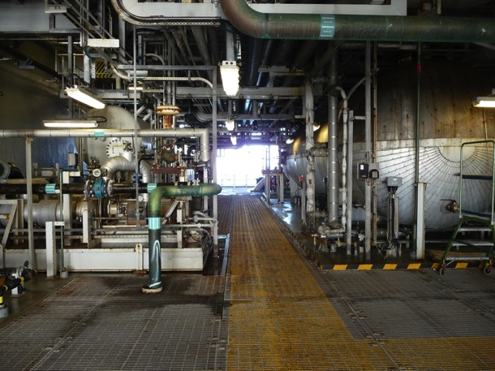 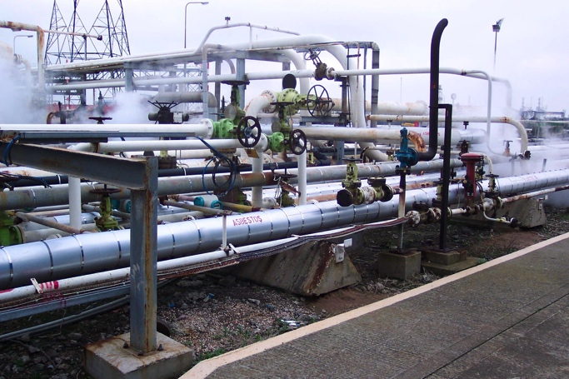 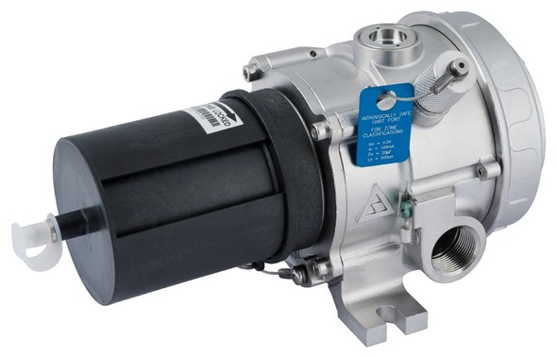

Images show the complexity of the process area in which the IR Gas Detector must be located and a typical Infra Red Gas Detector.

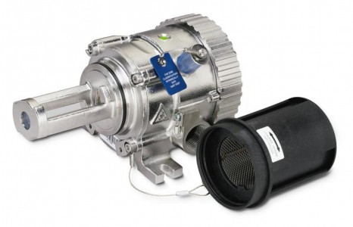 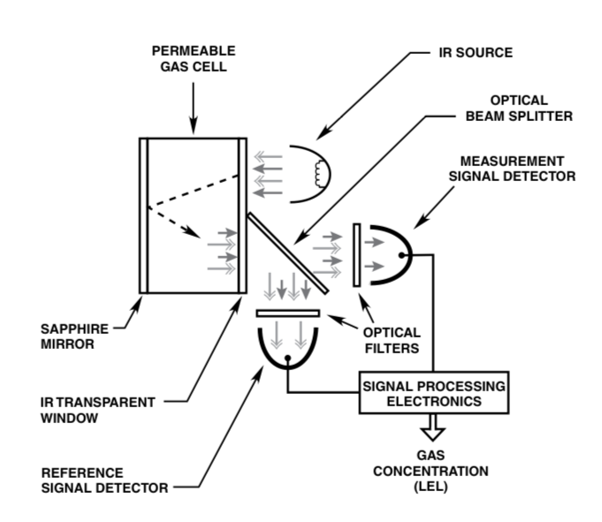

Images show a typical IR Gas Detector design and the principal of Optical Reference

# Examiner Result Sheet

|  |  |
| --- | --- |
| VQ Skills Assessment Test No: | TMPS05-IC01 |
| VQ Skills Assessment Test Name: | Repair IR Gas Detector |
| VQ Unit Number/s & Title/s: | MPS05 Repair of Components |
| Skills Assessment Criteria Reference Numbers: | S5.1, S5.2 & S5.3 |
| Candidate Name: | <<CANDIDATE_NAME>> |
| Location: | <<LOCATION>> |
| Date: | <<DATE>> |

|  |  |  |  |
| --- | --- | --- | --- |
| Item | Skill Description | Referred | Pass |
| 1 | Did the candidate receive and understand the requirements of the task? |  |  |
| 2 | Did the candidate check the status of the Fire and Gas Interface Panel to confirm fault indication? |  |  |
| 3 | Did the candidate obtain and read all technical information relating to the task? |  |  |
| 4 | Did the candidate familiarise themselves with their role and responsibility in line with the Safe System of Work Procedures? |  |  |
| 5 | Did the candidate visit the work site to confirm that access to the gas detector was possible? |  |  |
| 6 | Did the candidate confirmed with Operations that F&G inhibit was in place? |  |  |
| 7 | Did the candidate select appropriate tools and equipment to allow a safe and effective investigation into the fault and carry out repairs? |  |  |
| 8 | Did the candidate sign onto the Control of Work Certificate to their level of responsibility? |  |  |
| 9 | Did the candidate sign out a Gas Monitor to allow work on live terminals and completed the appropriate documentation |  |  |
| 10 | Did the candidate locate the faulty IR Gas Detector using the Fire and Gas Layout Drawing as a reference? |  |  |
| 11 | Did the candidate confirm that no gas was detected in the area and placed the Gas Monitor in a suitable location taking into consideration wind direction? |  |  |
| 12 | Did the candidate confirm with Operations the intention to start investigation work on the Gas Detector? |  |  |
| 13 | Did the candidate use appropriate tools to dismantle the weather protection cover from the detector? |  |  |
| 14 | Did the candidate check the condition of the optical mirror? |  |  |
| 15 | Did the candidate correctly identified that the likely cause of the fault was down to contamination of the optical mirror? |  |  |
| 16 | Did the candidate follow manufacturers procedures to clean the optical mirror using appropriate cleaning materials in line with recommendations? |  |  |
| 17 | Did the candidate check the integrity of the seals on the weather protection cover in order to identify the root cause of the contamination? |  |  |
| 18 | Did the candidate replace the weather protection cover to the IR Gas Detector in line with manufacturers guidelines using appropriate tools? |  |  |
| 19 | Did the candidate confirm the security of the IR Gas Detector? |  |  |
| 20 | Did the candidate carry out a visual inspection of the detector checking for mechanical damage and ATEX compliance? |  |  |
| 21 | Did the candidate confirm with Operations the status of the IR Gas Detector was zero and where applicable made adjustments using an appropriate tool? |  |  |
| 22 | Did the candidate confirm with Operations that a function test of the IR Gas Detector was about to be applied? |  |  |
| 23 | Did the candidate source a certified and approved Test Gas Cylinder of the appropriate characteristics to allowed a function test of the detector? |  |  |
| 24 | Did the candidate connect the Test Gas Cylinder to the calibration nozzle of the IR Gas Detector? |  |  |
| 25 | Did the candidate set the flow rate of gas to the IR Gas Detector to the appropriate rate identified in the Manufacturers Maintenance Manual? |  |  |
| 26 | Did the candidate, in collaboration with Operations, confirm that both the response time and calibration of the IR Gas Detector was in compliance with Manufactures Guidelines? |  |  |
| 27 | Did the candidate remove the Test Gas Cylinder from the IR Gas Detector and waited an appropriate period before confirming with Operations that the IR Gas Detector was reading zero? |  |  |
| 28 | Did the candidate give a final check of the security of the IR Gas Detector? |  |  |
| 29 | Did the candidate ensure that the area around the IR Gas Detector was free from contamination? |  |  |
| 30 | Did the candidate confirm with operations that the testing of the IR Gas Detector was complete and that any applied inhibits could be removed? |  |  |
| 31 | Did the candidate leave the work signed in a safe and clean condition? |  |  |
| 32 | Did the candidate dispose of any waste material in line with site waste management procedures? |  |  |
| 33 | Did the candidate return the Gas Monitor to the Permit Office and completed documentation? |  |  |
| 34 | Did the candidate sign off any Control of Work documentation in line with their level of responsibility and Safe Systems of Work Procedures? |  |  |
| 35 | Did the candidate return tools and equipment to the correct storage location and stored them appropriately? |  |  |

|  |  |  |  |
| --- | --- | --- | --- |
| Item36 | Knowledge Description | Referred | Pass |
| Did the Examiner observe any shortfalls in knowledge by the candidate during the observed assessment? |  |  |
| Any areas where the candidates did not demonstrate full knowledge must be recorded below. | | |

|  |  |  |  |
| --- | --- | --- | --- |
| Item | Behaviour Description | Referred | Pass |
| 37 | Did the candidate demonstrate, during the assessment, to those involved either directly or indirectly including the examiner, work colleagues, supervisors, contractor etc. a range of good behaviours, within the subject areas listed below. (mark with a “tick” as appropriate)Safety ☐Risk awareness ☐Communications ☐Quality ☐Conscientious ☐Initiative ☐Ethical and environmental sustainability ☐Critical thinking ☐ |  |  |
| Comments to support the behavioural assessment must be recorded below. | | |

|  |  |  |  |
| --- | --- | --- | --- |
| Item | Contingency Scenarios | Referred | Pass |
| 38 | The Examiner must select a minimum of one of the identified “contingency” scenarios recorded below and put this to the candidate at a suitable point during the technical test. The Examiner must ensure that the candidate responded to the contingency scenario in line with that expected by industry standards. The Examiner must identify which contingency scenario was selected below.No Fire and Gas Loop Drawing was available ☐Gas Detector was located at height ☐Optical Mirror was found to be damaged ☐No suitable Test Gas was available ☐IR Gas Detector was found to have mechanical Damage ☐ |  |  |
| Comments to support the contingency assessment must be recorded below. | | |

|  |
| --- |
| Time taken / comment |
| REFERRED/PASS |

|  |  |
| --- | --- |
| Technical Examiner’s Name: |  |
| Technical Examiner’s Signature: |  |