**Peat dam specification**

The peat dams are semi-permeable dams constructed from peat soil and vegetation, using a **low ground pressure** 360o excavator to handle the material. The method for installing peat dams has become frequently used as part of a suit of techniques for restoring hydrology on peatlands especially in the South Pennines and this is the technique being proposed here.

**Appendix 1** is a copy of the fact sheet produced by Moors for the Future which outlines the basic technique.

**Appendix 2** specifies the construction of low peat dams.

Borrow pits are often used as an additional source of material for dam construction in both techniques.

It is proposed that the work will be carried out as soon as possible post bird breeding i.e. 1st August but be complete by the 31st March. Access and ability to carry out the works will be constrained primarily by the weather. The aim will be to complete the works before ground conditions deteriorate in the winter (on average). Conditions will be monitored regularly during any work period to ensure the safety of the contractors and that no damage occurs to the peat soils as a result of machinery movements.

Potentially sensitive features such as recently restored habitat, streams, saturated ground and flushes will be avoided during vehicle movements. This also includes areas where there are archaeological remains and features.

The features that are to be blocked are mostly shallow natural erosion features that are well vegetated on a relatively flat plateau. Construction would generally start at the top of gully systems and where flows are low. The majority of the dams would be small to medium 1.5-2.5 m, with some larger peat dams of 2.5-4m metres across flat gully bottoms with gentle gradients. Some of the features are remnants of artificial drainage grips that may still be active. The overall aim of using peat and vegetation is to slow the flow of water running off the slope so dams may be individual or in sequences down a feature. Appendix 2 describes the construction of low peat dams, including the use of borrow pits, in the wider gullies which over top rather than shed the water to the surrounding ground.

The contractors will be required to work closely with RSPB representatives, particularly at the beginning of the project, to ensure best practice is being adhered to. It will be important to monitor weather and ground conditions and halt operations if both or either deteriorate. The exact location of individual dams will be finalised once site surveys have been completed and discussed with contractors to ascertain what locations are practical or possible to block.

**Map 1** indicates the work areas under the Nature for Climate grant where suitable features suitable for peat dam installation occur, and the works are planned take place.

**Map 2** indicates approximate routes for access by the machines and potential areas where there is archaeology to be avoided.

The work areas are generally at the top of watersheds where flows are slow and gradients shallow. Machines may use other routes depending on ground conditions and changes to due vegetation development, the effects of water table restoration from previous works. Routes may have to be used more than once to access certain areas as there may be no alternative routes available. In this case ground disturbance will be monitored closely. Routes in and around the specific work areas will not be known prior to work starting and will not be recorded.

The machinery would be tracked 360-degree excavators of between 5-8 tonnes with wide bog tracks working in pairs as a minimum. Access across the terrain on route to the work area must be aided by the use of bog mats or ramps brought up with the machines. Bog mats will be used on a regular basis by machine operators when installing dams on the edges of erosion gullies to stop machine tracks digging into the gully edges and when tracking around the site.

Routes will be identified in advance as far as possible. A banksmen will walk ahead of the machines when tracking to the work site confirming the best route and marking any sensitive features with flags or similar if appropriate. All sensitive and especially wet areas will be avoided

The landowner and Natural England will immediately be informed of any major incidents e.g. where there is a health and safety issue, a threat to water quality, significant damage to a SSSI feature.

Previous works of a similar nature consented by Natural England have been successfully carried out on Crowden in 2017 and Ashway Gap in 2019, 2020, 2021 using identical techniques on similar ground with excellent results.

Re-fuelling will be carried out on site on a regular but efficient basis. Spill kits and drip trays will be on standby with the contractors at all times and will be used during refuelling. The fuel will be transported to the machines as required in standard, purpose made double skinned containers mounted on the back of a **low ground pressure** ATV. Special attention will be made to refuel away from watercourses, streams, flushes, sensitive areas and saturated ground to avoid the possibility of spillages being ingested by SPA bird species. This type of arrangement is frequently used for these machines across sensitive moorland habitats. It may be possible to store fuel overnight in secure tanks on the ATV to save on journeys across to and from work areas.

To access the site each day it is expected that contractors walk out to their machines where possible, thus minimising the need for vehicle access. Where required, low ground pressure vehicles will be used such as quad bikes, Argocats or Softracks or similar with a maximum 3 PSI ground pressure. Such vehicle movements will be kept to a minimum and if possible, only be used for re-fuelling.

Daily records of works will be kept using GPS devices to records dam locations.

All operations on site will conform to any COVID related guidance in force at the time.

**Appendix 1**

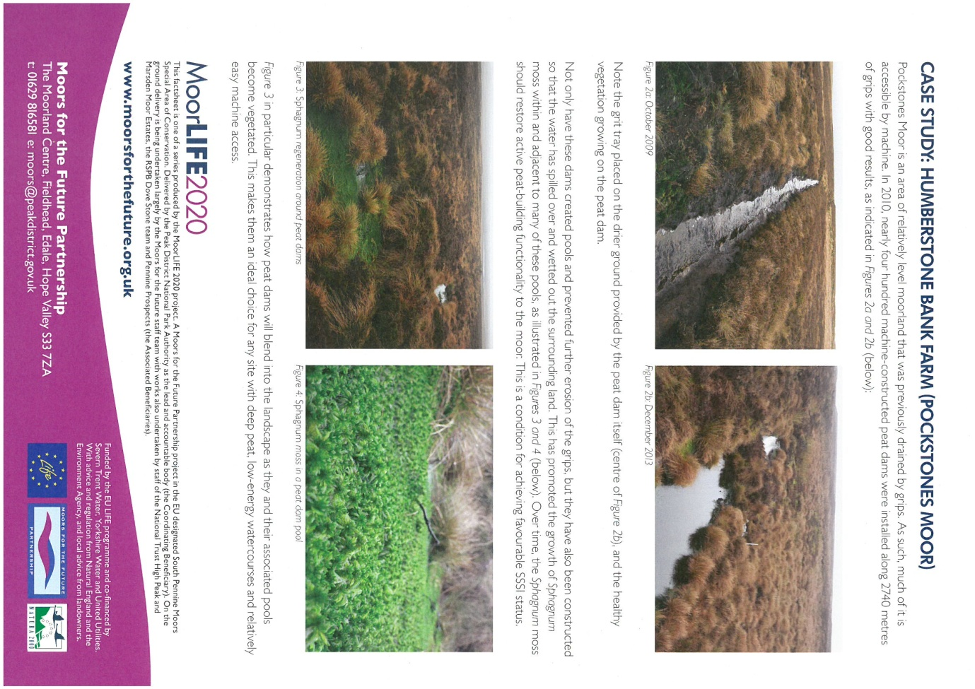

**Appendix 2**

#### Low Peat Dam Construction

###### Locations for Low Peat Dam Construction

* + 1. Low Peat Dam will be installed within peat-based gullies that are not suitable for Peat Dams; these are:
       1. (e.g. where they are wider than 4-5 metres
       2. the sides of gullies/grips do not allow for dispersing water to the sides
       3. the peat depth is <80cm/>30cm).

###### Construction of Low Peat Dams

1. Low Peat Dams will create shallow pools that will contain some water year-round (see **Fig. 3 & 4 photo**).
2. Construction will start at the top of water systems (gullies and grips) and continue downslope.
3. Low Peat Dam will have a natural finish and high degree of aesthetic and visual integration with the surrounding habitat.
4. Well-humified, ‘putty-like’ peat will be used to construct the dam wall, (extracted from “borrow-pits” to the side of the gully or within it, taken from beneath the drier, less humified peat at the surface, borrow-pits must be located on a sufficient depth of peat to prevent exposure of the underlying mineral ground when extracting the peat for dam construction. ).
5. Low Peat Dams will be well-turved with appropriate vegetation, (e.g. sphagnum, cotton grasses and heather), to withstand overtopping by excess water.
6. Low Peat Dam walls will be twice as deep in cross-section as they are tall, with gently sloping sides (see **Fig. 1** side view).
7. They will be keyed in to the channel sides as Peat Dams normally are;
8. They will be constructed such that excess water will overtop the dam wall and not cut around the sides;
9. They will be constructed at any width to fully span the width of the channel.

###### Specification of machine-built Peat Dams

1. Construction of Low Peat Dams will broadly follow the process below
2. Remove vegetation turves from the area that will contain the Low Peat Dam and borrow pit that are ideally located within the gully upstream from the Low Peat Dam location (see **Figure 1**, side view) or immediately adjacent to the gully, depending upon suitability of the site, and place to one side.
3. Turves must be removed with enough peat to ensure that the roots remain intact.
4. Excavate far enough down to remove all cracked and degraded peat. The amount excavated will vary depending upon the location; the key will be to ensure that all degraded and cracked peat is removed.
5. Place the excavated peat to one side, separate from the vegetation turves.
6. Along the line of the Dam, dig out wet, 'putty-like’ peat blocks, invert them and replace them.
7. Squash the peat plugs with the excavator bucket to seal any remaining cracks and create a smooth foundation on which to build the low peat dam.
8. Take additional wet, ‘putty-like’ peat needed to build the low peat dam from the borrow pit.
9. The borrow pit should be close to the Dam and located either from areas on either side of the gully, or within the pool area behind it (see **Figure 1**, side view). This may depend on:
   1. The width of the gully/height of the dam – if the gully bottom is long and a low (300-400mm) then it is acceptable to borrow from behind the Low Peat Dam.
   2. If the excavator is working from the gully bottom, again it is acceptable to borrow from behind the Low Peat Dam.
   3. The siting of borrow pits to the side of the gully must be suitably spaced so as to not form a string of excavation hollows as these could act as a secondary parallel drain (Thom et al, 2019).  Where dams are closer together, it may be appropriate to alternate the sides of the drain that the pits are sited to reduce any possible connectivity
10. Place the extracted blocks of peat along the Dam foundation to build the Dam wall to a height of between 300 mm and 600mm above the surrounding peat surface. The height is dependent on the following:
    1. Peat depth at gully bottom
    2. Availability of borrowed peat
    3. Gully width
    4. Volume of water that may be stored.
11. The additional height is to allow for the material to settle after construction.
12. Each layer of the Dam should be squashed down and smoothed with the bucket to seal any gaps.
13. The low/overtopping point is determined during construction; it will allow this potential erosion area to be prepared and reinforced to withstand overtopping see **Figure 1 & 2**, uphill and downhill view.
14. The finished Dam wall will be approximately twice as deep in cross-section as it is tall (see **Figure 1**, side view) and slope gently on each side.
15. Use vegetation turves removed in **step Cii** to cover the surface of the Low Peat Dam wall.
16. Turves should be placed to avoid gaps between individual turves that could develop into erosion channels, especially at the low-point created in **step Cxvi.** This point should not have a turves overlapping, but rather the most vegetated turve placed across the overtopping point with no joint or gap.
17. In-fill the borrow pit using any degraded and cracked peat removed in **Civ**.
18. Once all excess peat is placed into the borrow pit, it should be firmed down using the weight of the excavator bucket.
19. The sides of the borrow pit should be profiled to a gentle slope from base to top edge.
20. Use any remaining turves removed in **step Cii** to cover the surface of the borrow pit.
21. The turf vegetation and the vegetation at the edges of the borrow pit can be stretched to increase the coverage across the borrow pit surface, if required. **See Fig 4**
22. When the low peat dams reach capacity, it is expected that the water will overtop the low peat dam.

Figure 1 – Low Peat Dams (Top & Side views)

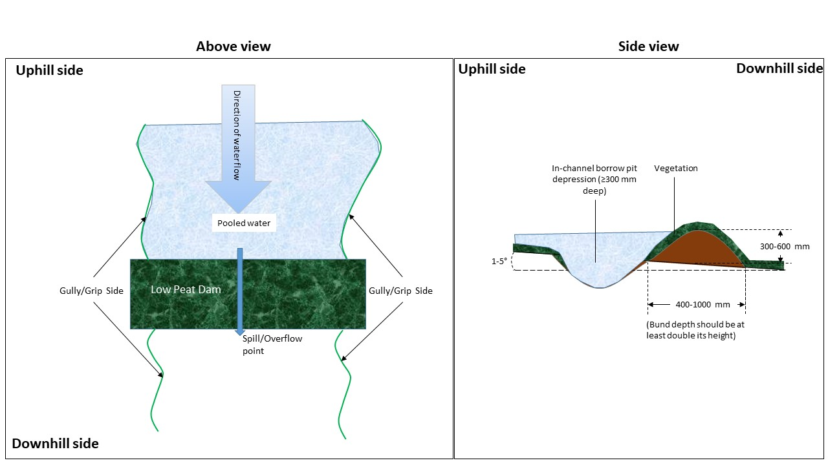

Figure 2 – Low Peat Dams (Top & Side views)

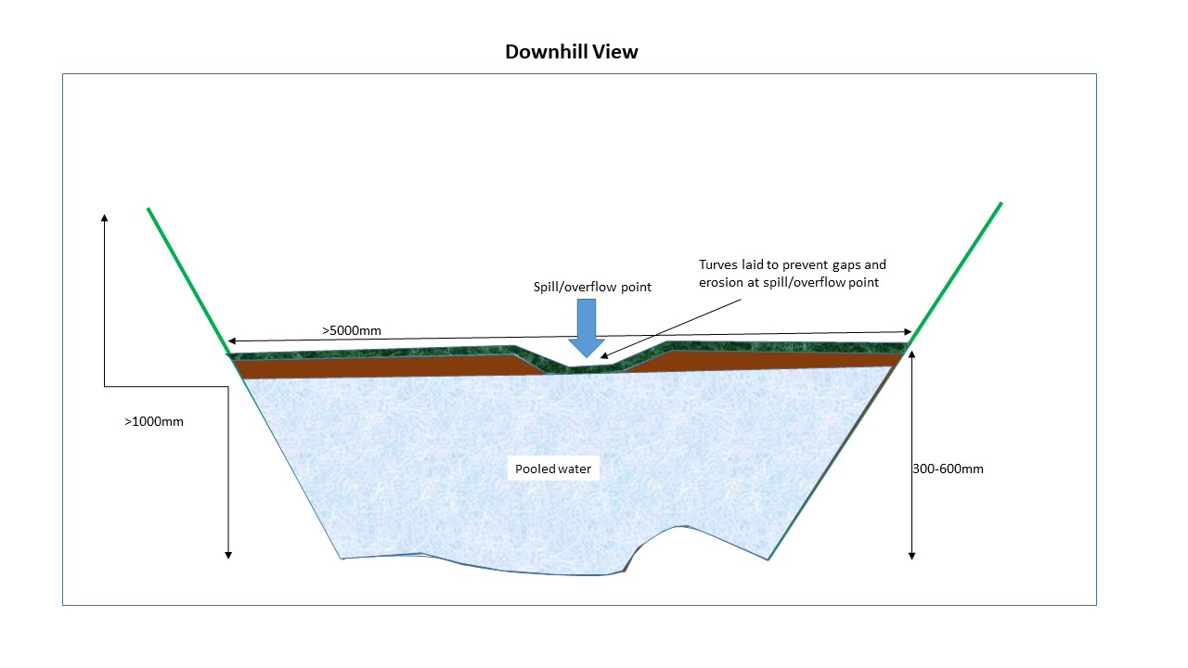

**Figure 3 and 4 Low peat dams holding water**

