Horningsham Parish Council

Installation of a Play area at Horningsham Village Hall

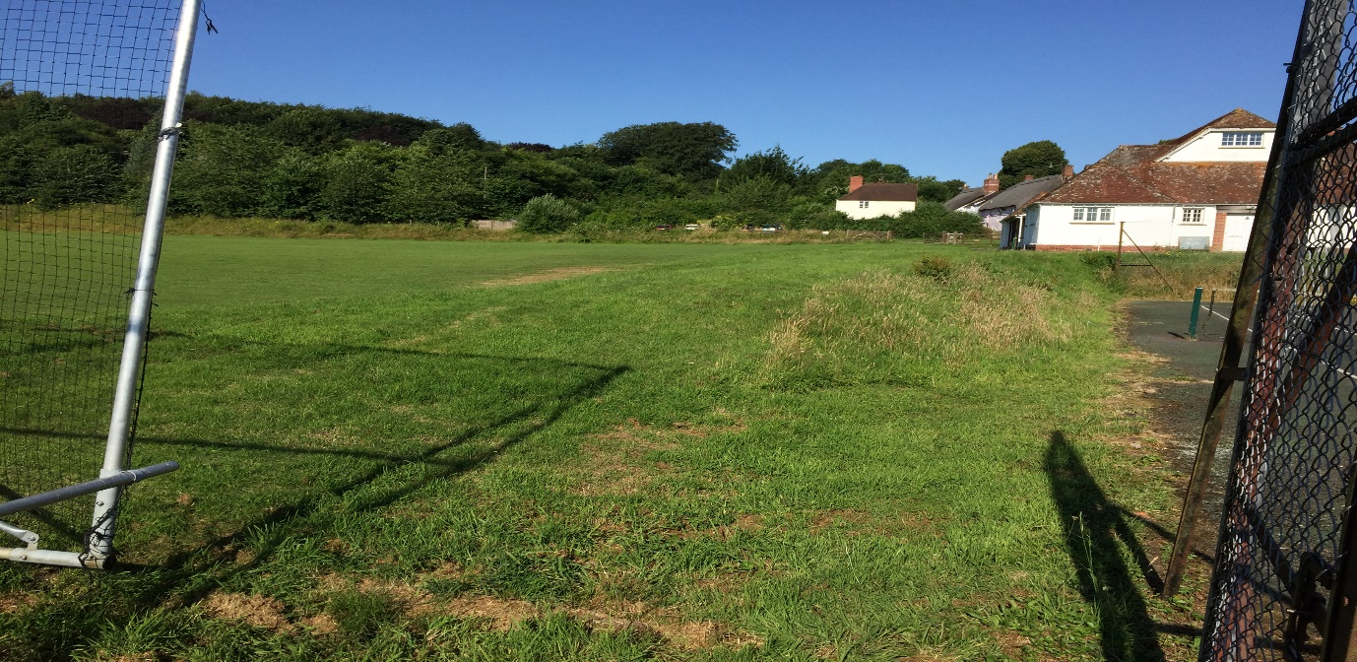

Description

Design and installation of a new play area at Horningsham Village Hall. The equipment required has been requested by the Community & School following a consultation process.

There is no need for planning permission for the equipment confirmation has been sought from the Unitary Authority.
The area specified sits alongside a tennis court, the area will be levelled by volunteers/Farmer in the community, ready for the installation.
It is understood that there are no services beneath the site.
An ecology survey and assessment report was commissioned and carried out by the Longleat estate on the area, with no significant findings.
About the Buyer
Horningsham Parish Council
Parish Clerk Sarah Jeffries PSLCC
Telephone 07540611906
Email horningsham@virginmedia.com
Website: www.Horningsham.org

Equipment Required

Age range +3 years

Supply and install a Climbing unit with two slides, walkways but no rooftops, this unit needs to have visual and physical activities.

Supply and install a 2.4m Log timber Swing with Flat Seats.

Supply and install a 1.8m Log timber Swing with Cradle Seats.
Supply and install a Wooden Log Climber

Supply and install a Wooden Trail

Supply and install a set of Roll Over Bars

Supply and install fencing @ 1000mm High to surround play area

Supply and install a 1300mm wide wooden self-closing Gate

Supply and install Grass guard Tiles

Supply and install a Timber retaining wall, 9 metres by 1 metres against bank edge price to include all the groundworks for the wall, footings, uprights etc.
A ROSPA Post Installation Inspection
The area specified sits alongside a tennis court, as per the photograph above the area will be levelled by volunteers/Farmer in the community, ready for the installation. Any spoil can be left on site to be made into a bund. Bund site to be agreed
The area is accessible at any time of day to view for quotation process.
Area marked in red on the below mapping, highlights the Site.

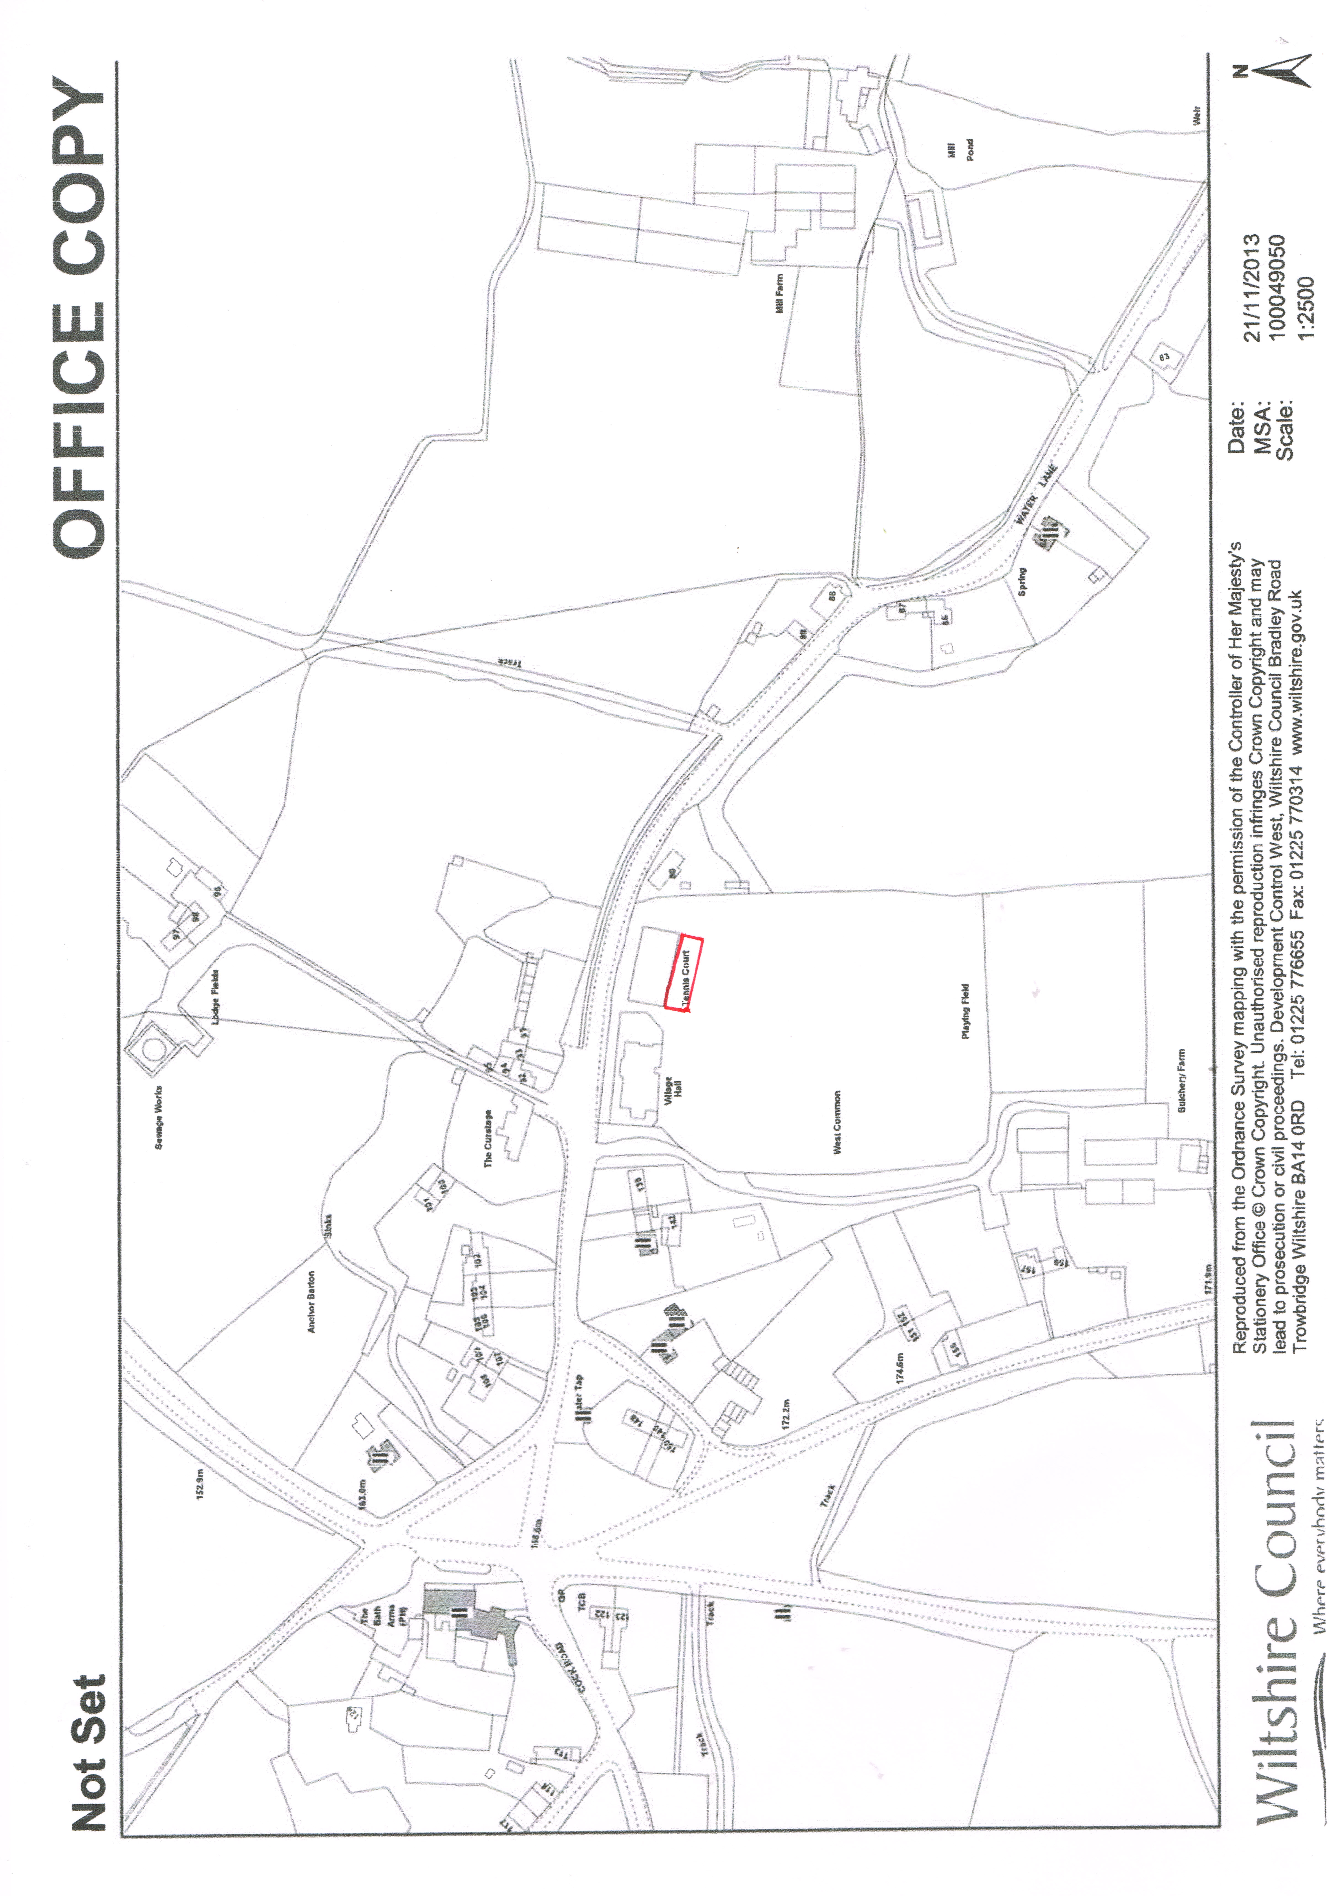
The Parish Council has obtained Grant funding for this project from the below sources.
Wiltshire Unitary Council Area Board, Creys Trust, Community fund raising event, Tesco Bags for all, Community Land Fill Grant and the Longleat Charitable Trust.
A National Lottery Grant was not approved and the feedback given on the failure to obtain a grant. The Community does not have enough obese children within its Community to hit the criteria.
It has taken two years to obtain the money available and has a limit of £26,000 to spend on the play area project. The grants have been secured with the equipment specified.

The Parish Council would like any tenders to be sent to the Clerk by the 26th November 2018.
They are keen for the project to be completed by the end of February/March 2019 or as early as is possible weather dependant.

