Fire Management Plan
Site: Fleet Pond Local Nature Reserve
Land owner: Hart District Council
Reviewed: 03/03/2022 by Liz Vango-Smith

1.0 General Site Info

Site Name: Fleet Pond LNR
Designations: Site of Special Scientific Interest (SSSI)
Ownership: Hart District Council
Total area (Hart DC): 56.07 hectares:
- Open water: 31.17 hectares
- Dry heathland: 3 hectares (dry)
- Wet heathland: 3.2 hectares
- Woodland: 11.3 hectares
- Reedbed: 2.7 hectares
- Marsh: 4.7 hectares

Adjacent landowners: Residential properties from Chestnut Grove, Wellington Avenue, Kennilworth Road, Avondale Road, etc, Network Rail railway line, Ministry of Defence are landowners of adjacent greenspace.

Map A: Extent of Hart District Council land for Fleet Pond:
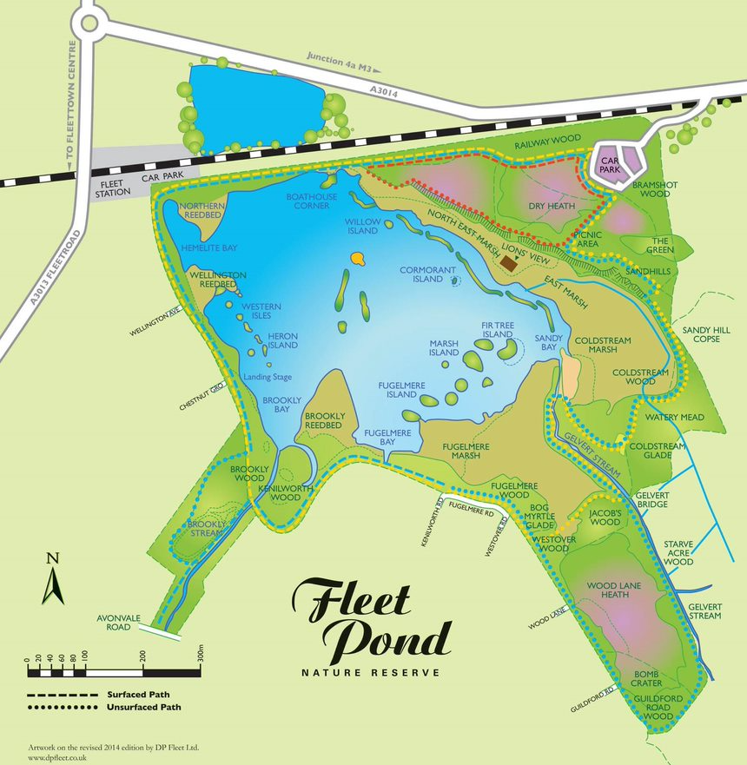
2.0 Access

Combination padlock code: 6237

OS Grid Reference: SU 822 550
What3Words Reference:
Primary access from car park track (under going renovation March 2022 – July 2022, surface is uneven whilst working taking place but emergency vehicles will still be able to access during the works. Combination code to enter the contractors compound is 1967), MOD land (locked gates, need MOD key to access)

Vehicles:
- From Cove Road A3013, over railway bridge marked Fleet Pond (SU 829 544, What3Words: duplicity.shrubbery.cowering) right down track to the car park (SU 824 552, What3Words meals.called.additives). [Height Barrier]. Gravel track built to take 20 tonne loads
- March 2022 – June 2022 – no height barrier in place whilst the access track improvement works take place, will be re-instated at the top of the track upon completion.
- MOD Access area, SU 827 549 (What3Words: disband.ulterior.sharpen) – may need MOD key to access from here

By foot:
- From Fleet Station main car park (SU 817 552, What3Words: outsmart.improvise.relies)
- From end of Wellington Avenue, Fleet (SU 816 550, What3Words: garlic.failed.sulky)
- From end of Chestnut Grove, Fleet (SU 818 549, What3Words: unscrew.unclaimed.follow)
- From Avondale Road entrance (SU 817 545).
- From end of Kenilworth road / Fuglemere road, Fleet (SU 822 547, What3Words: foggy.machinery.hands)
- From end of Westover road (SU 823 546, What3Words: furniture.cosmic.caskets)
- From end of Guildford road (SU 825 543, What3Words: insolvent.camp.pulps)

Air Ambulance Access:
- MOD Access area, SU 827 549 (What3Words: disband.ulterior.sharpen) – may need MOD key to access from here
- Sandy bay (waters edge of pond) SU 825 548 (What3Words:eternally.broads.feelers)
- Access track to boat house corner SU 823 523 (What3Words: streaks.skewed.decimals)

Nearest Hospital (A&E Dept): Frimley Park Hospital
Portsmouth Road
Frimley
Surrey
GU16 7UJ
Tel: 01276 604604

Local Police Station: Hampshire and Isle of Wight Constabulary
Civic Offices,
Harlington Way,
Fleet,
Hampshire.
GU51 4AE.
Tel: 0845 045 4545

Nearest Fire Stations: Hartley Wintney Fire Station
Brewery Lane, Hartley Wintney, Hampshire

Hampshire Fire and Rescue Service
Rushmoor Fire Station
Lynchford Road, Farnborough, GU14 6BF

Map B: Access routes, water supply and restrictions
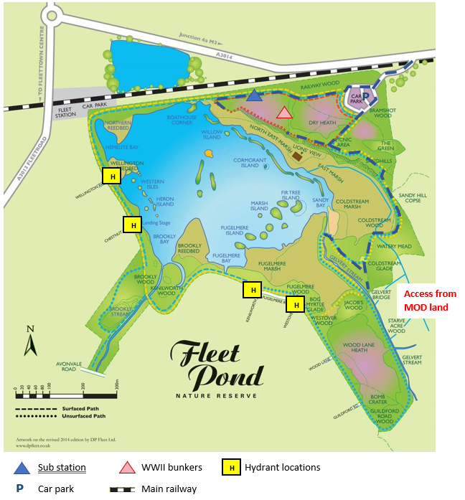

3.0 Key Habitats

Ecologically sensitive and high priority areas are indicated on Map B, include lowland heathland, reedbed and fen.

Lowland Heathland
- Priority area for controlling fire and minimising damage
- High Fire Risk – Heather, gorse
- Recovery Time – 10-20 years

Reedbed/fen/marsh
- Priority area for controlling fire and minimising damage
- High Fire Risk – Dry reed areas
- Recovery Time – 5 – 15 years
- Wet marsh areas at lower fire risk compared to other areas, although recovery time similar to other priority habitats

Protection of life and property is paramount, but as this is a significant site of biological interest, it is also important to protect the high value habitats and associated wildlife. Therefore, efforts should be taken to minimise fire damage, particularly on the lowland heathland and grassland areas.

Map C: location of woodland habitats on site and grazing compartments
Grazing compartments shown in orange
Coniferous woodlands: Bramshot Wood (adjacent to car park), Fuglemere Wood (South of Fuglemere Marsh)
Deciduous woodlands: remaining wooded areas on site (in green below)

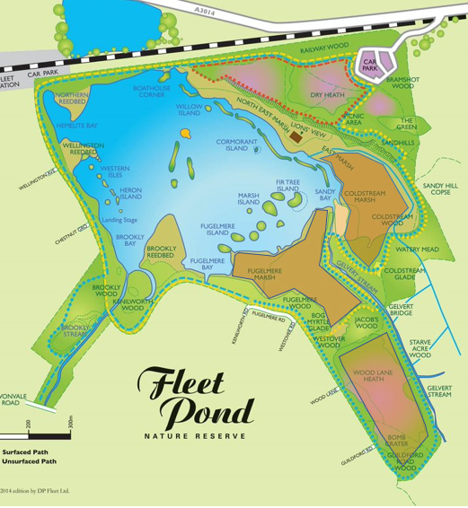

4.0 Special Danger Areas

The site has 24 / 7 year round open access to members of the public.

The open water is of particular risk. Boating in row boats is permitted during fishing season only with a permit.

Ice is an issue in winter months, historically the pond was used for ice skating but has not been thick enough continuously for this since the mid 1970’s. Current policy is to post appropriate warning signage to keep off the ice following RoSpa guidance. It is against the site byelaws to skate on the pond.

Nearly all the reedbed and marsh areas are closed to the public but this does not stop some individuals going into them. Some of these areas are fenced off.

Danger from discarded cigarettes or matches and children’s play activities. Deliberate lighting of fires or stoves / BBQs prohibited by park byelaws.
Disposable BBQ’s are frequently lit in the pick nick area, at Sandy bay and in areas next to the Car Park during the summer months.

Periodic controlled burnings of “lop and top” by staff and volunteer groups.

Cattle are on site from March/April to October/November in the large purple area indicated on Map C, above. Physical fencing is around the periphery of the grazing areas, with access into grazing areas via vehicle access gates.

Danger Period

Fires – April - October. Extended in times of drought.
Burnt out cars – anytime in the main car park
Water issues – summer for illegal swimming and inflatables

5.0 Fire Prevention Measures

General Fire Prevention Measures include:

- Lighting of fires by staff or contractors will cease during very dry weather and will only take place between September and April.
- At the present time there are no plans to carry out prescribed/controlled heather burning.
- Any bonfires will take place in an area cleared of undergrowth, dry leaf matter and a suitable distance from tree canopies. Consideration will be given to wind direction and the affect of smoke on nearby properties and roads
- Fires must be extinguished before the area is vacated and checked the following day
- Fire patrols carried out as part of regular duties during periods of high risk
- Contractors to follow Bonfire Protocol, which can be found at the end of this document
- Met Office Severity Index can used to produce fire severity assessment, which can further inform level of preventative measures required

Currently Existing on Site:

Fire Breaks
The pond itself, the London to Basingstoke main railway line along the northern boundary of the site

Fire Watches and Patrols
To be carried out as part of normal duties. In periods of high risk evening and weekend patrols may be authorised.
6.0 Equipment and Water Supplies

Equipment and Water Supplies
Equipment is based at the Countryside Workshop, Old Pump House Close off Kenilworth Lane, Fleet, Hampshire, GU51 3DN.

Vehicles available: 3x 4wd vehicles each capable of towing, 1 x tractor capable of towing

Equipment available:
1 x water bowser 1100 litres, road going, 1 x water pump – flow rate
140L/min, 10 x fire beaters, chain saws, fire beaters and hand tools.
Small petrol-powered engine boats available from nearby workshop (Old Pump House Close)

Water on site
- 4 hydrants located on public roads (see Map B)
- Fire pump/engine access to wares edge at Boat House corner through main site car park, where no other water source options available
- Domestic mains supply at Countryside Workshop (Old Pump House Close)

7.0 Emergency Contacts

Key Personnel
Normal working hours for Hart Countryside Service staff are Monday – Friday 08:30 to 16:30. Staff will be on-call evenings and weekends during the grazing season (April – September). If required on site, staff response time is approximately 15 minutes during work hours and between 15 – 60 minutes outside working hours.

Emergency Phone (April – Sept)  On-call ranger  07721 433649 | Hart District Council head office (office hours)  01252 622122
Fleet Pond Site Ranger  Sam Kerr  07769 164281 | Grazier  James Noyce  07729 778376
Senior Ranger  Liz Vango-Smith  07760 172834  07753 324408 (personal) | Fleet Pond Society

7.0 Incident procedure

- All incidents no matter how small are to be reported to Hart Countryside Services.
- In Emergency Dial 999 or 121 on a mobile, this can give your position automatically.
- If on site, go to, or nominate someone to meet the emergency Services at the best access point and direct them to the incident.
- Comply with all reasonable requests by the emergency services.
- Follow Hart District Council incident reporting procedure.
- If you are trained in first aid, appropriate rescue techniques, have appropriate rescue equipment to hand and / or trained in fire fighting and are able to do something about the incident without putting yourself in undue risk then you should take effective action.
- If it is necessary for livestock to be removed from site the grazier (James Noyce) must be contacted for assistance.

8.0 Bonfire Protocol

The number of people required when controlled burning takes place depends on the size of the burn and other resources available, such as water tenders, etc. Adequate numbers of personnel and fire beaters should be available in the event of flare up and/or the burn jumping the brake line. A mobile water supply should be on site and/or a pump from adjacent water source. Back-pack (knap sack) sprayers should be available for spot fires.

Fire Location
- Fire site to be free from obstructions and well away from buildings, trees and hazards such as overhead cables
- There should be multiple entrance and exit points to the fire site and supervisor should ensure everyone is aware of any loading and fire use procedures

Storage of materials
- Stacking of timber for burning should be a sufficient distance away from the fire site so that it will not catch fire and the pile for burning should be minimal at all times
- Timber should be stacked in the same direction as much as possible, for ease of removal and loading
- All fuel (e.g. matches, dry kindling, newspaper, etc) should be out of the fire break area unless being used to start or reignite the fire
- Sufficient water should be within easy reach to put out any fire issues, such as embers, fire creep, wind carried fires, etc

Burning procedures
Fire supervisor to carry out appropriate fire risk assessment prior to commencing any fires, to include identifying suitable site location, access, local conditions, emergency plans and contacts.

- Controlled burns of vegetation should only be carried out in 0 - light winds with humidity at 50 - 60% and the mean air temperature must be below 50 degrees F.
- The area to be burnt should be surrounded by an area clear of vegetation at least 4 metres wide. Burn should be carried out against the wind, where possible.
- Bonfires should not be lit if there is a high risk of the surrounding vegetation catching light and / or large embers being dispersed widely. They should not be lit in high winds.
- The fire brigade should be informed before controlled burns or bonfires are lit. (Telephone 01329221228)
- At least one person should have a mobile phone with them when having a bonfire or carrying out controlled burn or other fire

Fire Issues
If any fire looks to be getting out of control then the fire supervisor should arrange to call the emergency services on 999 as soon as possible. The site manager should also be informed as soon as it is appropriate and safe to do so.

Fire supervisor and all fire users should be aware of appropriate fire safety.

Document to be reviewed annually and after incidents.
Next review February 2023

