

**Enterprise Space Category**

**Market Engagement May 2025**

**Request for Information**

**Version 1**

Issued: 6 May 2025

UK Classification: OFFICIAL



UK Ministry of Defence © Crown copyright 2022

Contents

Confidentiality 3

Introduction 3

Background 3

Purpose of this RFI 4

RFI Procedure 4

How to respond to this RFI 5

Annex A - Enterprise Space Category Tree 6

# Confidentiality

1. All information included in this Request for Information (RFI) is confidential. No information included in your response, or in discussions connected to it, will be disclosed outside of the Enterprise Space Category Team. General themes and overall analysis of supplier responses will inform future market engagement activity.

# Introduction

1. The Enterprise Space Category (ESC) is a cross-government Category, under the stewardship of Victoria Cope (2* Defence Digital Commercial Director) as part of the Defence Enterprise approach to Category Management. The aim of the ESC is to share intelligence, insights, challenges and to identify opportunities for working together across the space value chain. This is a major step as part of collaborative working across the Space domain to build a single Space Enterprise Category Strategy with a focus on strategic alignment and engaging the market as “one” Government to drive innovation and implement best practice procurement methodologies.
2. This RFI shares the Enterprise Space Category Tree and invites responses to help us understand the structure of the space market, geographical distribution of supplier facilities and to explore the ways in which we may work together in the future.
3. This RFI is not a bidding opportunity but a means by which industry can provide information. This is a continuation of the ESC ongoing market engagement activity and is not specific to any current or future procurement.

# Background

1. The ESC currently encompasses all procurement activities required by the UK MOD to deliver space related capabilities. This covers satellite communications (SATCOM), Ground Stations, Land and Maritime Terminals, Position, Navigation and Timing (PNT), Intelligence, Surveillance and Reconnaissance (ISR) and Space Domain Awareness (SDA). By far the largest and most significant of these capabilities is the SATCOM programme (SKYNET) procured and managed by Defence Digital. This provides commercial and military satellites worldwide and supporting infrastructure to ensure highly assured communications for operations at home and in the deployed theatre. The ESC has an annual spend of £390m.
2. The Defence Space Category Team has been established for a number of years and formed as an early part of the implementation of Category Management within the MOD. The objective was to work with the wider TLBs and enabling organisations across Defence to implement radical reform of procurement practices. The aims and objectives of the joint team were to achieve best-practice procurement and target savings through rigorous commitment to category management principles and significant improvement of relationships with its supply base. In February 2024 the Enterprise Space Category (ESC) was established with an intent to expand the Space Category beyond the MOD to include other Government Departments such as Cabinet Office (Crown Commercial Services (CCS) and Department for Science, Innovation and Technology (DSIT) as well as UK Space Agency (UKSA). A monthly Space Category Steering Group has been established as part of the governance process which oversees the ESC Category outputs as well as sharing insights and best practice.

# Purpose of this RFI

1. This RFI aims achieve the following outcomes:
   1. To share the Enterprise Space Category Tree with space market participants;
   2. To elicit the views of space market participants about the degree to which the Enterprise Space Category Tree reflects the market;
   3. To understand the composition of the space market and how it maps to the Enterprise Space Category Tree;
   4. To begin to map the geographical location of supplier facilities by sub category;
   5. To identify challenges within the space market; and
   6. To capture preferences and suggestions for future communication and collaboration between the MOD and space market.

# RFI Procedure

1. This Request for Information will be advertised on the Defence Sourcing Portal (DSP) and Contracts Finder. To widen participation, the link to this will also be issued through existing communications networks such as trade associations and to suppliers who have already participated in Enterprise Space Category events.
2. Responses to this RFI will be analysed by the Enterprise Space Category Team and will inform the ongoing work of the ESC. This could involve further engagement with individual space market participants, groups of space market participants or full market engagement. Themes identified during this exercise might also inform our planned agenda of round table sessions. Future engagements may be undertaken in writing, virtually or at in-person events.
3. This RFI is not procurement specific. Responses provided to this RFI will not constitute any form of pre-qualification or tender and will not lead to a formal procurement activity. The work of the ESC may, however, shape the way that future procurements are conducted across the Category.

# How to respond to this RFI

1. Responses are requested to this RFI by no later than 23 May 2025.
2. The RFI takes the form of a questionnaire (MS Forms) which can be found at the following link or scan the QR code:

[Enterprise Space Category Supplier Questionnaire](https://forms.office.com/e/KdjmU2qc2h)

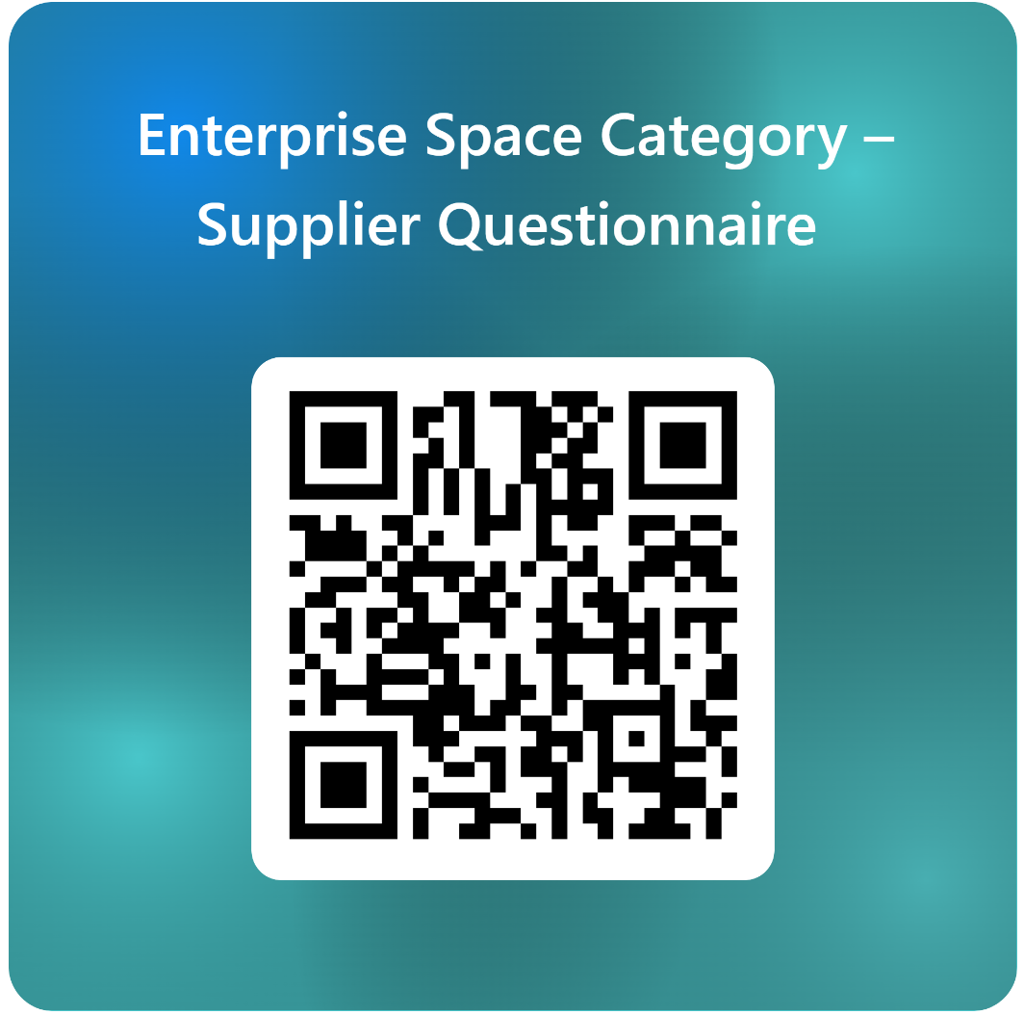

1. Please contact us by email if you experience any issues in completing the questionnaire.

Contact email: [UKStratComDD-CM-Space-ESC@mod.gov.uk](mailto:UKStratComDD-CM-Space-ESC@mod.gov.uk)

## Annex A - Enterprise Space Category Tree

