Pre-construction Information
The aim of pre-construction information is to provide details to any contractor tendering/quoting for construction work where RSPB is the client in order that they may plan the work, develop their risk assessments and, if required, produce a construction phase plan.

Key Project Information
Site address and location | RSPB Pulborough Brooks  Visitor Centre – Upperton’s Barn  Wiggonholt  Pulborough  West Sussex  RH20 2EL
Project Description and intended use of final structure/building | Installation of 3 stoplog sluices and 1 pipe-dam structure. To be used to control water levels on the SSSI wetland. Removal of 3 defunct weirs.
Planned start date of construction phase | 01/08/2025
Planned finish date of construction phase | 31/10/2025
Reason for planned finish date of construction phase | Site will be too wet to carry out works after this period. Cannot start earlier due to bird breeding season and consent restrictions.
Other important project dates

Client Project Management Arrangements
Client Brief | Invitation to Tender attached.
Arrangements for communication of all parties through the project | All communication via the RSPB Project Manager
Arrangements for co-ordination of on-going design work and handling design changes | As soon as it becomes known that a design element is to be modified the design change shall be developed based on risk assessment regarding execution, maintenance and repair.  The Principal Contractor shall be required to update, amend and modify as necessary the detailed construction phase Health and Safety Plan to address any health and safety risks associated with individual design elements, modified during the works.  Any changes should be reported to the RSPB Project Manager.

Key Dutyholders
Client name and address | RSPB Pulborough Brooks  Visitor Centre – Upperton’s Barn  Wiggonholt  Pulborough  West Sussex  RH20 2EL
Designer | RSPB Hydrologist
Principal Contractor (if already appointed) | Not yet appointed.
Contractor(s)

Site Location Map
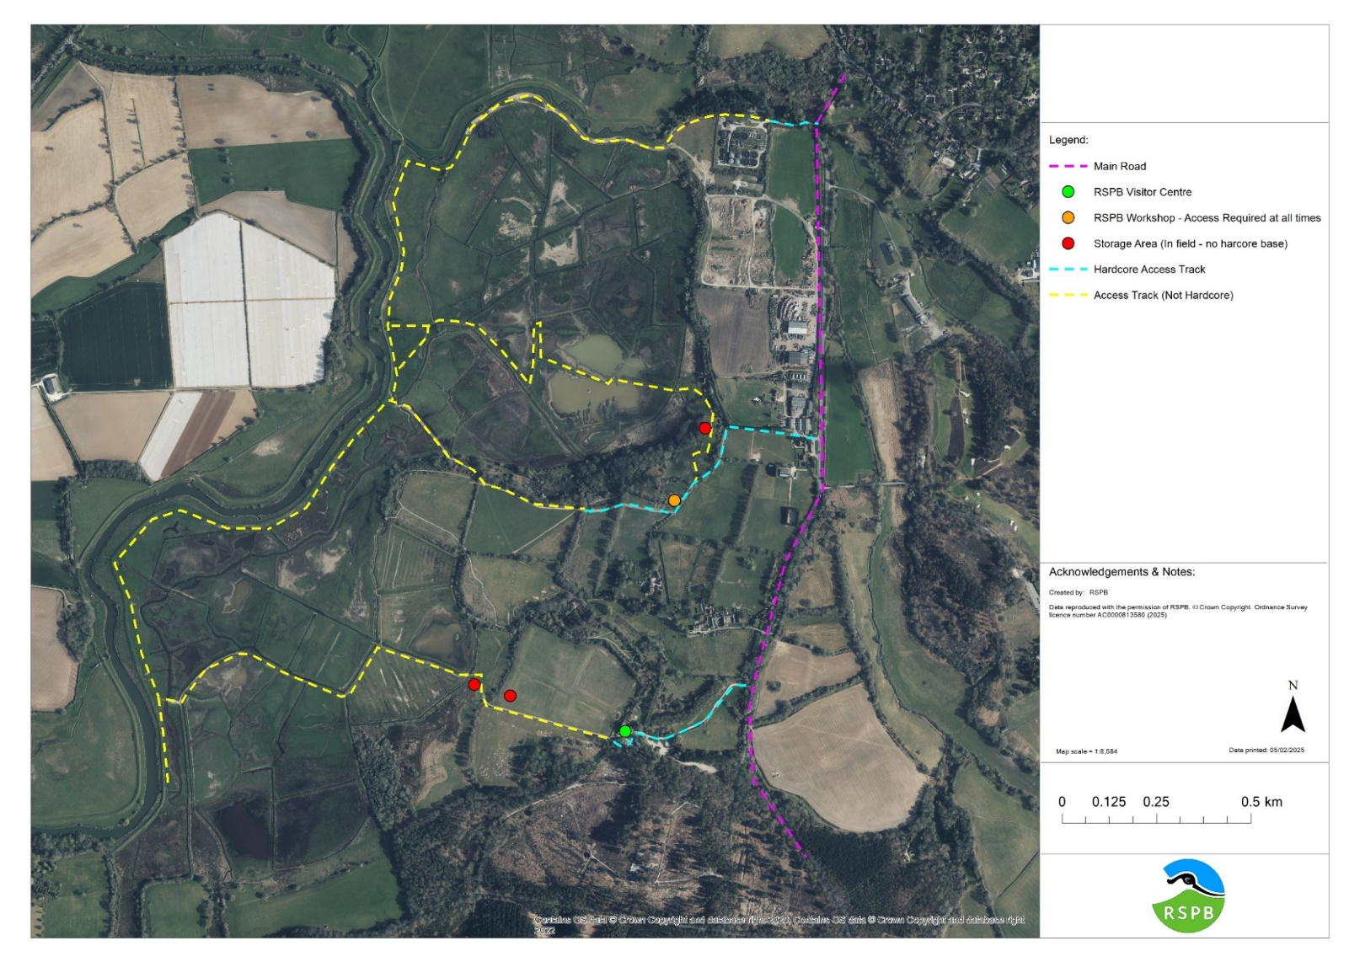

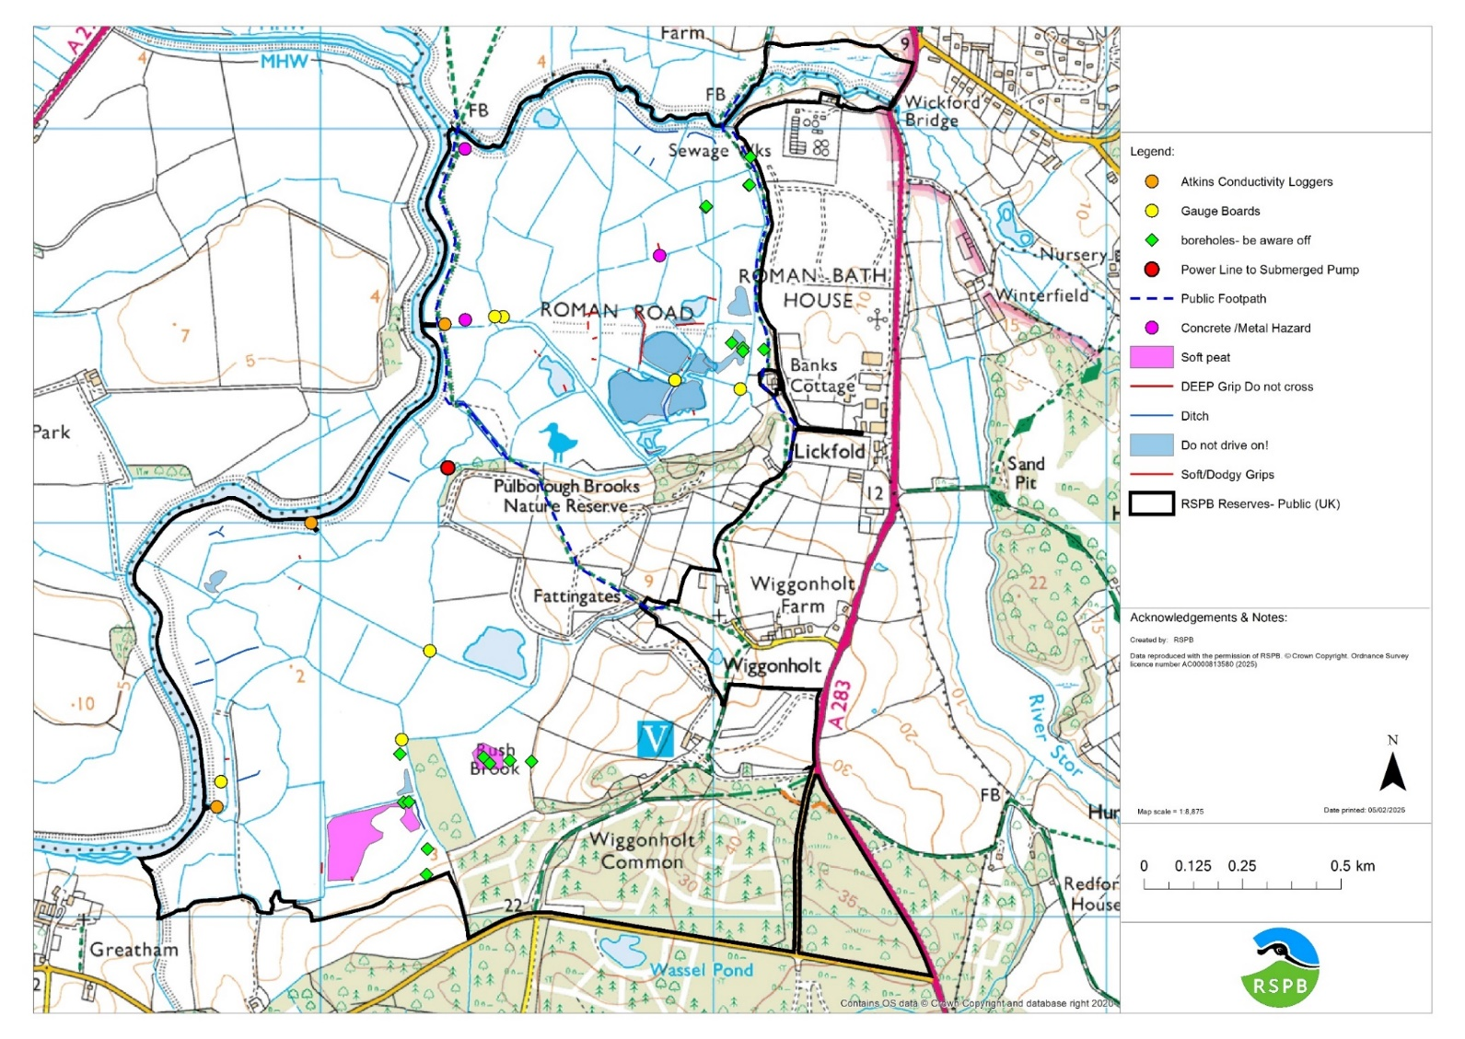

Emergency Procedures
Relevant emergency contact details (e.g. Keyholders, Building’s alarm company, Network Rail, Police, Environment Agency, site graziers) | RSPB Project Manager – Ruth Gillies – 07751 400077 – ruth.gillies@rspb.org.uk  RSPB Senior Site Manager – Oriole Wagstaff – 07595 092346 – oriole.wagstaff@rspb.org.uk
Details of nearest hospital or medical facilities | St. Richards Hospital  Spitalfield Lane  Chichester  West Sussex  PO19 6SE
Type of emergency services access e.g. 4WD, air or routine | 4WD
Fire Evacuation Plan | Fire Risk Assessment attached.
Procedure if Asbestos Containing materials Disturbed | N/A
Discovery of UXO | Follow advice attached below. Call 01993 886682.
Environmental emergency plans | Pollution Prevention Plan attached.
Habitat emergency Plans

The following is information on the project held by the client to be considered in designing out health and safety risk during construction and for future use and maintenance of the building/structure

General Site Information
Details of site security required and where compound areas are to be provided: | Little security on site other than padlocked field gates. Storage areas marked on the above access map.
Details of site transport requirements, parking restrictions, and any vehicle movement restrictions | Speed limit of 5 mph on site.  Vehicles must not be kept in the RSPB car park on days specified by the RSPB Project manager (these will be days when events are taking place etc.)
Details of any unauthorised areas or other authorisation requirements | Access to the workshop and yard must be kept clear at all times. If this is to be blocked at any time for any period, contact the RSPB Project Manager.
Details of any dates/times where access not permitted or restricted? | Site access 24/7.  Visitor centre opening times: 10am – 4pm
Parking/turning arrangements for plant and vehicles | Plant can be kept in the locations marked as storage areas on the access map.
Restrictions on deliveries/waste collection/storage | All deliveries should be communicated to the RSPB Project Manager, to ensure little impact to the RSPB’s daily work. Storage of plant and materials in the locations marked on the access map.
Areas of public/visitor access close to works | Public footpaths are marked on the above hazard map.  Some access routes are on public footpaths.  Vehicles may need to cross over permissive paths.  Vehicles may need to move through the visitor centre car park.
Welfare provision | Green Container in the compound near the visitor centre can be used. This has a toilet, shower, seating area, sink, kettle, fridge, tea/coffee etc.
Smoking arrangements | No smoking permitted anywhere on site.
Details of any previous land use or adjacent land uses that may impact on/be impacted by the work | Cattle and graziers will be on site. All gates must be left as found. Graziers should not be prevented from carrying out their required work.  The access to the workshop is also used by our neighbours. The yard at the entrance to this track (Link Farm and Southern Transit Engineering Services) is not owned by the RSPB and should never be used for any part of the project. It must not be blocked at any time and can only be used for access. Any damage to this yard must be reported to the RSPB Project Manager and repaired at the contractor’s expense.
Any permit to work requirements | Disturbance licence for schedule 1 birds – provided by RSPB. RSPB to provide tool talk on disturbance rules.
Fires & Hot Work | Fires are not permitted as part of this contract

Site Specific Hazards
Existing services including known buried services, overhead cables and masts | Known hazards are marked on the above map.
Existing ground conditions, underground structures or water courses: | Hardstanding and non-hardstanding tracks are marked on the above access map.  Watercourses are shown on the hazard map.  There are no underground structures we are aware of. Boreholes are marked on the attached hazard map but are also visible above ground.
Previous structural modifications: | N/A
Information about existing structures: | Weirs to be removed – Tilting Weirs with concrete sidewalls
Ground conditions and contaminated land – include details of any soil surveys | Areas of known soft ground are marked on the above hazard map. However, care should be taken as there could be unmarked areas. Access tracks should be followed where possible.  Access tracks should be relatively dry during the work period, depending on weather.
Risk of engulfment in swampland/earthfall etc. | Areas of peat and soft ground are present on site. Known areas are marked on the above hazard map. If a vehicle becomes stuck, immediately contact the Project Manager or Site Manager to determine best next steps.
Requirement to work at height | N/A
Difficulties relating to plant and equipment: | There is one bridge to cross. We do not have information of weight limits for this bridge, so use will be at the contractor’s discretion.
Details of asbestos management plan. Where intrusive work will be undertaken outline requirement for refurbishment and demolition survey | There is no known asbestos in the locations of this work.  If asbestos is found, contact the RSPB Project Manager immediately.
Existing storage of hazardous materials | RSPB’s Hazardous Materials are stored in a COSHH cabinet at our workshop. There is no space here to store contractor materials.
Any risks to the contractor arising from the clients’ activities (visitors/animals /events etc) | There are cattle on site. Please keep a safe distance and leave all gates as found. If there are any issues, contact the RSPB Project Manager immediately.  This is a visitor site so there is an array of footpaths. Care including banksmen, warning sounds and signage/cones should be taken when using or crossing paths or manoeuvring around the visitor centre and car park.
Details of any hazardous materials likely to be involved in the work | Fuels (Petrol, Diesel).
Details of any fragile roofs | No rooves involved.
Any regime for legionella flushing that will be required for the duration of the works | No Legionella flushes required.
Identify any health hazards – e.g. noise/vibration/biological agents/zoonoses/ticks/leptospirosis | Ticks – Lyme Disease  Leptospirosis  Vibration and noise from machinery

Habitat & Environmental Site Information
Waste | The old weirs should be disposed of, off-site by a licenced waste contractor.  Waste soil and or ditch slubbing’s should be spread thinly and flatly in the field, at least 2m away from the top of the ditch bank. No low-points or tracks should be covered.
Water | Water on site is unsafe and polluted. Many ditches are large and deep. Flooding (over-topping the river wall) are unlikely but not impossible. All contractors must sign up to the EA flood alert system for this area.
Record any restrictions necessary to avoid danger or damage to property, including effluent treatment plants and associated structures such as soakaways. Identify measures to protect water supplies, catchment areas and archaeological, nature conservation and environmental interests. | Biosecurity measures should be in place to prevent spread of invasive species.  Wheels, tracks and buckets of machinery should be cleaned before coming onto site and before leaving site.
Arrangements for protected species | Mitigation statements outlined in the planning permission must be followed.  Natural England Protocol for Anisus vorticulus (Little Whirlpool Ramshorn Snail) must be followed. You will be acting under the licence of the Site Manager, attached below.  Work must my confined to the areas outlined to prevent damage to designated plants and Anisus vorticulus.

Existing Plans, Drawing and Documents

Relevant plans, drawings and documents included with this pre-construction information
Planning Permission and Conditions | Anisus vorticulus Protocol
UXO information | Fire Risk Assessment
Anisus vorticulus Licence | Pollution Prevention Plan
Anisus vorticulus Mitigation Statement

Completed By: Ruth Gillies
Date: 24/03/2025

