

EMERGENCY PLAN
(Eastern Solent Reserves)
Version 2.6 05/08/2024

IF THE EMERGENCY SERVICES ARE REQUIRED, PHONE THEM IMMEDIATELY ON 999 BEFORE DOING ANYTHING ELSE.
Contact details for relevant people are at the end of this document.
Maps and grid references begin on page 4.
All staff members and volunteers have the discretion to close the visitor centre if needed.

Unexploded munitions
All of the reserves have the potential for unexploded munitions as a result of training and bombardment during the second world war.
If found or suspected, report to senior staff member and/or 999 and ask for coastguard, close immediate area as possible and await coastguard. Report on PRIME following.
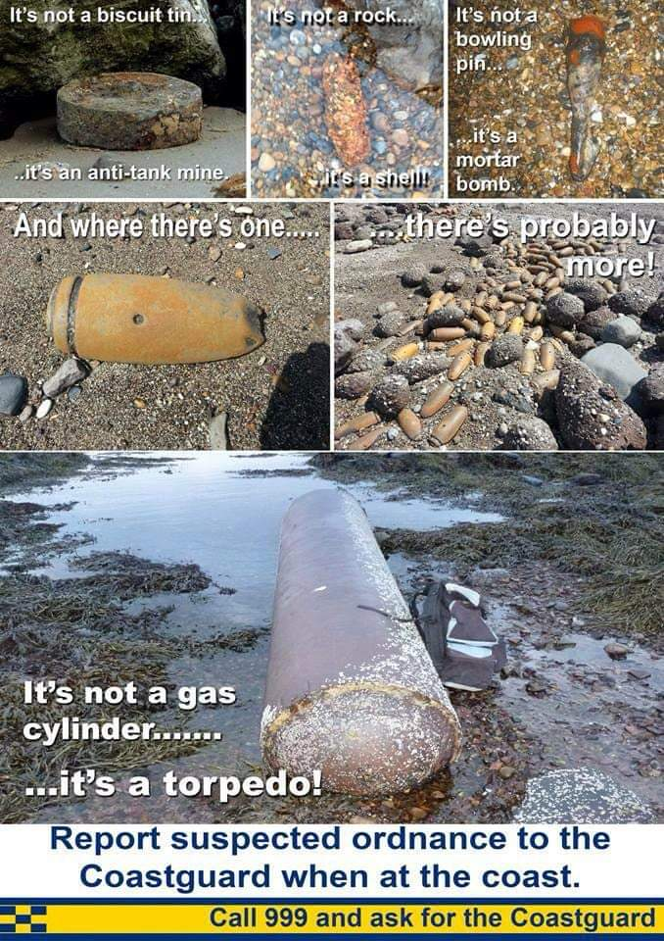
Severe Weather Action Plan (East Solent Reserves)

Potential effects of severe weather

High winds
Strong winds can lead to damage to buildings. Electricity lines, branches or even whole trees may fall over footpaths, car parks, or Ham Road.

Hot weather
In hot, dry weather, fire is a risk particularly in areas with high density of gorse at Medmerry. During school holidays, children lighting fires exacerbates the risk.

Wintry weather
Icing of paths, car parks and road can occur at any time during the winter.

Precautions in response to severe weather
 | Immediate actions | Actions following severe weather
High winds | The senior member of reserve staff present will decide whether to close the Visitor Centre and call off volunteers, and put out a notification on social media channels warning visitors. Closure is not possible due to the open access nature of the sites and the PRoW network. | Wardens / volunteers to carry out basic checks for tree damage.
Prolonged dry weather leading to countryside fire risk | Temporary warning signs to be erected to alert visitors to the conditions. | None.
Wintry weather | The Visitor Centre car park and surrounding paths will be gritted daily by the warden team / volunteers if iced over. | None.

Pre-prepared signs and other equipment
As a minimum, the following signs (or similar) will be held ready for use on the reserve in severe weather conditions.
“No Entry - Path Temporarily Closed Due To Tree Damage”

A supply of barrier taping will be kept to close off dangerous areas as quickly as possible.

During an emergency, wardening staff will carry radios for communicating with staff based at the Visitor Centre (main channel), and mobile phones as back-up.

Contacting emergency services
Staff on site should assess the need for emergency services and call them out as appropriate. In an emergency police, ambulance or the fire-rescue services can be contacted by dialling 999 or 112.

Stopping outdoor activities
Outdoors activities must be stopped if the weather or conditions are unsuitable. Staff, volunteers, contractors and visitors will need to be warned.

If a public event has to be cancelled due to severe weather, the event leader will decide whether to cancel, and inform the rest of the site team.

For further information, please consult Code of Practice no. 7 of the Health & Safety Handbook or contact the Health & Safety Adviser

Wildfire Emergency Plan
If a fire is reported by a member of the public, get as much detail as possible:
- Location
- Scale
- What is burning?

Determine if the Fire & Rescue Service (FRS) have been informed. If not call 999 immediately and pass on the information you have including any access requirements there may be. Plan for a member of staff to meet the FRS to facilitate access and pass on any further information.
The senior staff member on site will determine if there is a need to put any access restrictions in place to ensure the safety of those on site. This may require the Site Manager, Warden or suitable delegate to attend the fire site to be able to make an informed decision, ensuring their own safety at all times. If the fire is in or close to public areas, measures should be put in place to restrict access to the area until such time the FRS have determined the area to be safe. This may include closure of the reserve or closure of specific paths.
Where the fire is away from public areas it is unlikely any restrictions will be necessary, unless there is a requirement for emergency service vehicles to access via public areas. The Duty Manager will determine any public access restrictions in consultation with the FRS.
Ensure all workers understand any restrictions in place and are able to communicate to all visitors.
The Site manager will need to assess any damage caused by the fire or fire-fighting operations and determine if the site can re-open with or without restrictions.
Do not attempt to fight a fire unless the fire is small and contained i.e. in a dustbin. In such a situation, source a suitable fire extinguisher to put out the fire.
All fires will be reported on the Prime incident database.

Wildfire assessment Eastern Solent reserves: Low to medium
 | LIKELIHOOD OF FIRE STARTING:
FORESEEABLE OUTCOME: | Unlikely | Likely | Very likely
Minor | Very low | Low | Medium
Moderate | ●Low● | ●Medium● | High
Substantial | Medium | High | Very high

Pollution Prevention Plan

- Identified activities, risks and control measures
Essential control measures
- Drainage plan (add below)
- Training for staff and volunteers to deal with spills (online training available on I-Learn)
- Assess the need for spill kits by type of risk and potential size of risk e.g. a coach leaking diesel/oil or small spills from Gerry cans. They can be as simple as cat litter, a shovel, paper towels and plastic bags in a sealed plastic bucket or you can buy them off-the-shelf.
- Mark stopcocks so anyone on site can find them
- Report near misses and incidents on Prime
- Emergency plan

Risks on site (delete where not relevant)
Potential Pollution Source | Risk area | Control measures
Oil storage for heating and machinery re-fuelling | - leaks | - Keep records of usage to spot when it is unusually high,  - Monitor levels in the tank and check pipes and ground for a leak every month  - Visually check tanks and ancillary equipment regularly - at least annually - for signs of corrosion or perishing of hoses  - Keep the area around the tank clear of tall vegetation
 | - Refuelling tractors at fuel store | - Where any refuelling it to take place, spill kits must also be available.
 | - Refuelling machinery on site | - All vehicles utilised to complete the works detailed in Annex 1 (see Management plan consent) to be refuelled more than 10m from a watercourse  - Any machinery/vehicles requiring re-fuelling should be re-fuelled on a track or hardstanding, away from any water bodies/courses.  - Spill kits to be taken out on site.
 | - Contractors doing work on site refuelling vehicles | - Explain procedures as part of exchange of information
 | - Delivery of fuel | - Check tank can hold amount ordered  - Supervise deliveries of oil to tanks to ensure that the lorry doesn’t back into the tank, that the delivery person remembers to switch off the pump once the tank is full and that they remember to disconnect the pipe before they drive off – these all happen!
Waste oil from vehicles and machinery | - Oil changes in the tractor | - Appropriate receptacles & storage containers used with adequate capacity  - Waste oil disposed of promptly by a licensed contractor or to a licensed waste site
Release of sediments into water bodies | - Working near water bodies | - In the design of excavation works, consider the use of sediment traps & ways of working to stop sediment reaching water courses  - Monitor impact of work whilst working
 | - Run off from poached, churned areas and/or bare soil,  - piles of aggregate, rotting vegetation etc. | - Identify through cross-compliance work  - Site piles of aggregate, etc. under cover or on hard standing if possible
Septic tank/STP/Cess pit | - sewerage leakage  - failure of system | - Inspection protocol of septic tanks and cesspits (e.g. every month)  - Any foul smell, seepages of discoloured water, sudden appearance of nettles, unexpected levels in the tanks, sound of running water to be investigated  - Keep the area around the tank clear of tall vegetation  - Use environmentally friendly cleaning products without anti-bacterial agents
Portaloos | - sewerage leakage or of disinfectant | - Position where unlikely to be affected by adverse weather and ideally away from trees
Pesticides | - See Code of Practice 24 | - Ensure storage facilities are well maintained  - Ensure spill kits in vicinity of pesticide use and storage  - Ensure waste pesticides are stored and disposed of appropriately, following on label instructions  - Identify areas where any washings can be disposed of and apply for relevant permission from environment agency
Vehicle washing | - Run off of soapy water | - Wash vehicles off site in facilities designed for the purpose  - If done on site, then use bio-degradable “eco” products  - Area of hard-standing with drainage to septic tank if septic tank suitable – check manual
Oil/petrol from parked cars/other visiting vehicles | - Leaks from vehicles | - Spill kit to hand designed for biggest regular visiting vehicles i.e. staff cars up to coaches  - Manholes/other drainage points are fitted with oil receptors at larger sites > 50 cars or covers available
Run-off from Fire Service hose pipes in event of a fire |  | - Consider how to protect water bodies and habitats from firewater
Flood | - Burst pipes  - Flooding from rain/river | - Turn off water supply at stopcock  - Stopcock marked on plan below  - Follow advice of emergency services  - Move perishables upstairs if time  - Close off oil tank valves to heating system if time
Waste storage | - See COP D2 Waste management | - Make sure waste is contained and kept dry  - Ensure regular collections  - Keep compost heaps aerated to avoid leachate

- Drainage Plan
An accurate drainage plan helps visualise the information above making it easier to see where the main risks are. Identify your site drains and associated infrastructure, giving you a clear understanding of your pollution risks and pathways. The plan should cover the area around buildings showing immediate linkages to sensitive areas of the reserves e.g. ditches, rivers etc. Use your site hazard map as a base. There are three things that should be included on your drainage plan.

- Surface and foul drainage
Your drainage plan should identify all the underground drainage networks, clearly showing foul and surface systems. Foul drains (usually identified in red) lead to sewage treatment works, whereas surface water drains (usually identified in blue) lead directly into the environment. Your site drainage plan should show all manholes, rainwater pipes, gullies and drainage channels. In addition, the plan should show the drain flow; as in what direction the water flows underground and clearly showing the point at which any water leaves your site.

- Potential pollution sources
Mark any key features on your site such as oil tanks, septic tanks, toilets with mains drainage, vehicle wash-down areas etc. should clearly be shown on your drainage plan. This may include oil interceptors, soakaways, storm water attenuation systems and water recycling installations. How effluent enters the drainage system and whether interceptors are on the foul or surface drainage network should be very clear. If there is a high risk of pollutants entering surface drainage and thereby rivers and ditches, consider fitting an interceptor and or buying a cover.

- Above ground gradients
Above ground gradients will show you at a glance how surface water will flow over your site and enter the underground drainage system. These should be shown clearly on your drainage plan and be used to respond quickly in the event of an incident or spillage. You can then place spill and absorbent material in strategic locations to intercept pollution before it enters the drainage system.

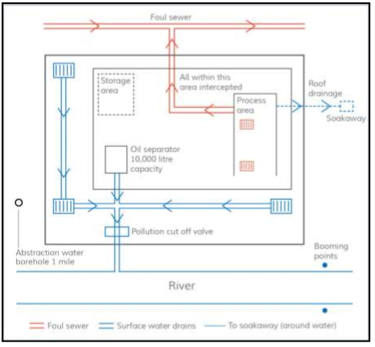
Figure 1 example of a drainage plan
If you have a number of potential pollution sources on site and/or sensitive habitats nearby then there is more detail here:
http://www.netregs.org.uk/media/1436/gpp-21-final.pdf
- Stopcock(s) Plan
Describe location of stopcocks and mark on a plan
Figure 1: Example from Ynys-hir
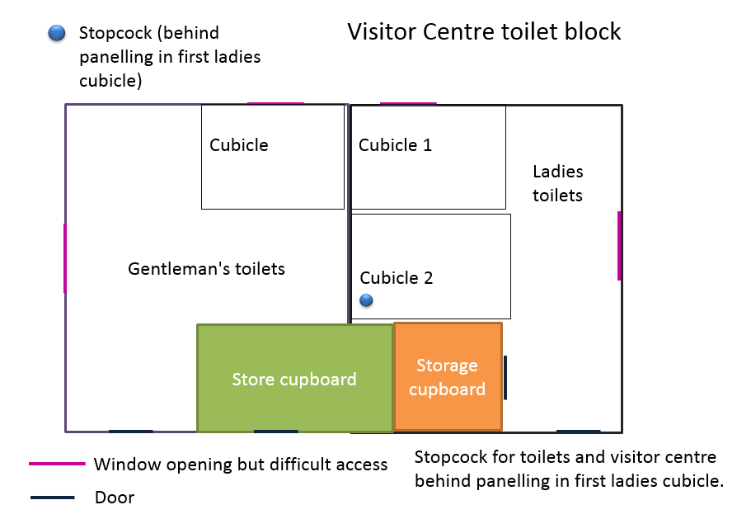

- Spill kit types and locations
If you identified the need for spill kits in Section 1, list the type and location here.
Spill kit | Uses | Location
Fuel spill kits | Small oil/pesticide spills | In cars. Spares kept in corridor on top of Lost Property locker
Chemical spill kit | To contain larger oil / pesticide spills | In corridor on top of Lost Property locker

There is a 20 minute training module on using spill kits on I-learn under Health and Safety (Course: Spill Kit: Chemicals and Oils (rspb.org.uk)).
- Incidents/Accidents/near misses
Near misses are useful ways to spot potential causes of pollution incidents and identify changes to working practices to make these less likely.
The site manager (or designee) will report any near misses or incidents via the RSPB PRIME incident reporter, which will help us to spread the learning.

Primary Contacts

Emergency Services contact | 999
Pollution hotline - England, Scotland & NI | 0800 80 70 60 (24 hrs)
Pollution hotline - Wales | 0300 065 3000 (24 hrs)
Floodline - England, Wales and Scotland | 0345 988 1188
Flooding incident line - NI | 0300 2000 100

Basic Emergency access info (staff will be able to give more detail if needed):

Pagham Harbour – this reserve has limited vehicular access, especially to long stretches of publicly accessible footpaths along the western side and northern boundaries of the reserve. Access to the islands is usually possible at low tide, on foot, depending on shingle and mud conditions. However, in some years the traditional walking routes become impassable and a boat must be used to access the islands. This requires specialist knowledge of the channels and must never be attempted on one’s own. A relevant RYA powerboat certificate must be held by the boat operator, which includes the marine aspect of the training.
Ambulances and fire appliances should be able to attend incidents wherever car access is specified.
There are not many opportunities for helicopter landing sites. The most likely site would be the currently disused Pagham Spit car park. This is secured by a coded padlock (6829) which all staff and emergency services are aware of.
Medmerry – has a hard-surfaced track circumnavigating the reserve. Part of this route is designated as an alternative route for emergency vehicles trying to reach Selsey, in the event of the B2145 road being blocked or full of traffic. This track is suitable, at low speed, for any 2-wheel drive vehicle, fire appliance or ambulance.
The islands at Medmerry can be accessed by boat, and some on foot, however there are very many ditches and channels that criss-cross the intertidal areas, and it is easy to lose one’s bearings and become cut off by a channel that fills up with the tide.
Some of the large, open fields are flat enough with no overhead cables to allow for helicopter landings in the event of an emergency within the intertidal areas.
Langstone Harbour – All of the reserve islands are offshore and only accessible by boat approximately 2.5 hours either side of high tide. At low tide, the only access is via dangerous mud crossings from Farlington Marshes which should not be attempted without the correct equipment and knowledge. Any emergencies will likely need coastguard or RNLI support.
West Hayling – Access is via two the carparks at North Hayling and Haylig Holt. The billy trail serves as access along the length of west hayling and the gate is currently (August 21’) in a state of long term disrepair needing no further keys or codes.
Pilsey Island – Access is via the gate post to Baker Barracks and then south to Pilsey carpark. Pilsey is a shingle ridge with saltmarsh behind it. Safe access is via the shingle only.

The following maps and tables give outline information on the main access points on each reserve, and the location of car parks which could be used as muster points / incident command locations in the event of an emergency.

PAGHAM HARBOUR - Locations | Centre Grid ref | Nearest Access | Grid Reference for Access | Type of vehicle required | Possible hazards
Tern Island | SZ876959 | Church Norton Car Park | SZ871956 | 4x4 & boat | Intertidal, no lone working
Church Norton Spit - Restricted Access Areas | SZ877956 | Church Norton Car Park | SZ871956 | 4x4 | Trips falls and intertidal
Church Norton Spit - Open Access Areas | SZ874953 | Church Norton Car Park | SZ871956 | 4x4 | Trips falls and intertidal
Church Norton Foreshore | SZ880957 | Church Norton Car Park | SZ871956 | 4x4 | Trips falls and intertidal
Norton Priory Paddock | SZ872955 | Through Priory | SZ870955 | Car | ditches, Stock etc
Norton Priory Grassland | SZ872955 | Through Priory | SZ870955 | Car | ditches, Stock etc
Poplar Copse | SZ873956 | Church Norton Car Park | SZ871956 | Car | Falling branches and trips
Glebe Meadow (Field behind hide) | SZ873958 | Church Norton Car Park | SZ871956 | Car | ditches, Stock etc
The Mound | SZ873957 | Church Norton Car Park | SZ871956 | Car | ditches, Stock etc
Norton Priory Woods | SZ871953 | Through Priory | SZ870955 | Car | Falling branches and trips
West Side incl. Thrift Shelf | SZ868964 | Gate Ferry Corner | SZ856961 | Foot and 4x4 | Trips, falls
 |  | Church Norton Car Park | SZ871956 | Car and Foot, Helicopter Land Thrift Shelf
Ferry Long Pool | SZ860964 | Gate Ferry Corner | SZ856961 | Foot and 4x4 | ditches, trips and falls
Ferry Small Pool | SZ857963 | Gate Ferry Corner | SZ856961 | Foot and 4x4 | ditches, trips and falls
West Side Copse/Reedy Marsh | SZ870962 | Church Norton Car Park | SZ871956 |  | ditches, trips and falls
Ferry Field | SZ854964 | Gate on Southern Water Access Road to North | SZ852964 | Car to gate 4x4 | Cars, dogs, ditches, trips and falls
Visitor Centre and Tip Area | SZ858966 | Visitor Centre Car Park | SZ856965 | Car | ditches, trips and falls
Workshop | SZ856967 | Visitor Centre Car Park | SZ856965 | Car | Machinery, tools, equipment
Tramway | SZ859966 | Visitor Centre Car Park | SZ856965 | 4x4 | ditches, trips and falls
Yeoman's Field | SZ860972 | Gate of Mill Road Sidlesham | SZ859971 | 4x4 | ditches, trips and falls
Chapel Meadow | SZ859974 | Sidlesham end of Tramway | SZ860972 | 4x4 | ditches, trips and falls
Mill Pond Marsh | SZ858977 | Sidlesham end of Tramway | SZ860972 | 4x4 | ditches, trips and falls
Halsey’s Fields | SZ868977 | Gate in to Driftwood Stud | SZ861978 | 4x4 | ditches, Stock etc
Slipe Field | SZ880973 | Gate North west corner | SZ881975 | 4x4 | Dogs, ditches, trips and falls
Pagham Rife Field | SZ877978 | Salthouse Track | SZ878976 | 4x4 | ditches, Stock etc
Halsey’s 4 (Owl Copse) | SZ871978 | Salthouse Track | SZ878976 | 4x4 | ditches, Falling branches and trips
Halsey’s 5/Owl Point Field | SZ870981 | Gate in to Driftwood Stud | SZ881975 | 4x4 | ditches, Stock etc
North Fields, Honer | SZ868990 | Track Through Chalder Farm | SZ867992 | Car and 4x4 | ditches, Stock etc
and Chalder/Bramber |  | Track Through Marsh Farm | SZ868985 | Car and 4x4
 |  | Track through Bramber Farm | SZ871995 | Car and 4x4

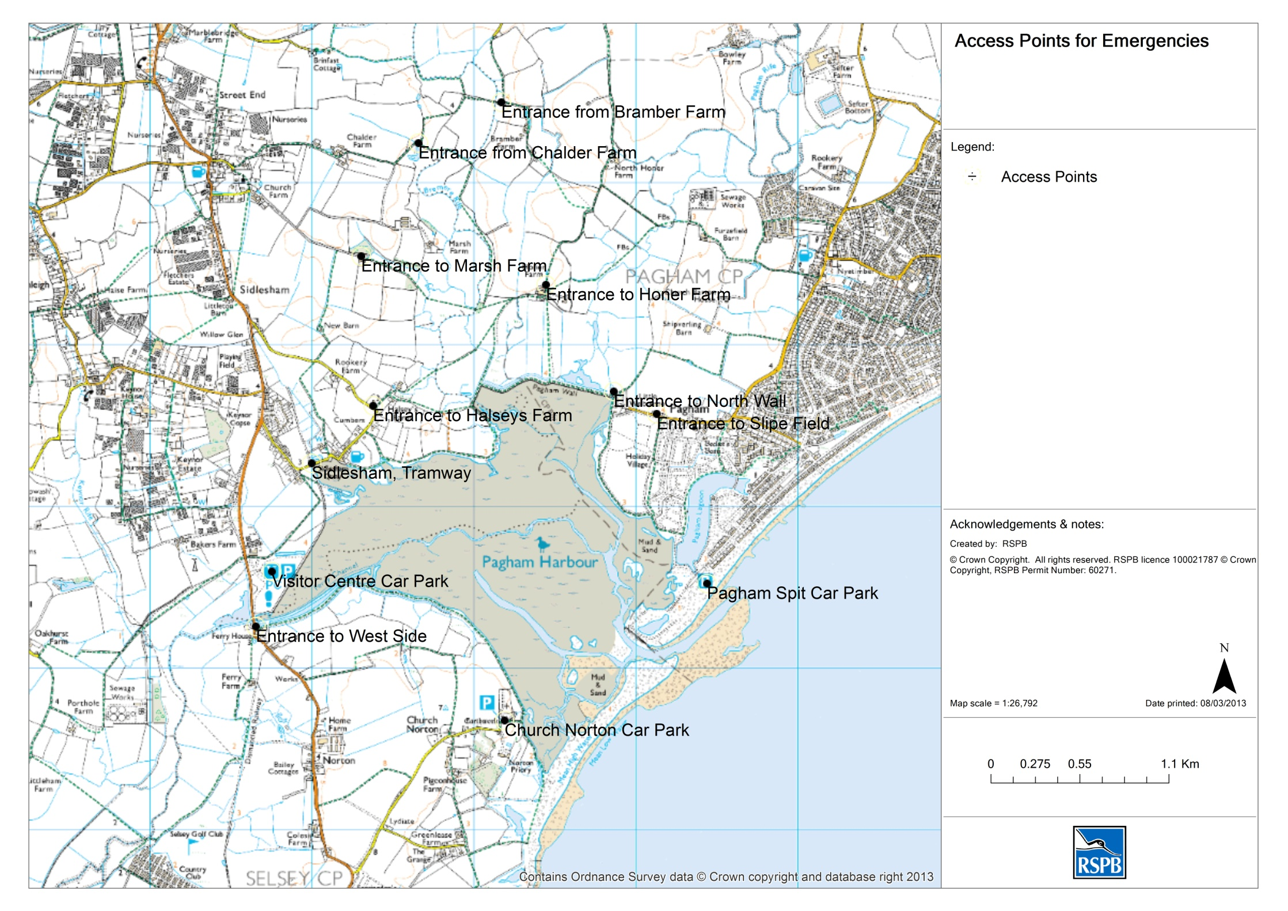
Access points – Pagham Harbour

MEDMERRY - Locations | Postcode | Nearest Access | Grid Reference for Access | Type of vehicle required | Possible hazards
Earnley car park (access point) | PO20 7JL | Drove Lane | SZ 8163 9668 | Car | Cars, dogs, horses, cycles, ditches, farm traffic.
Easton Lane car park (access point) | PO20 7NU | Easton Lane | SZ 8340 9676 | Car | Cars, dogs, horses, cycles, ditches, farm traffic.
Wilson’s Farm (access point) | PO20 7NX | Ham Lane | SZ 8410 9602 | Car | Cars, dogs, horses, cycles, ditches, farm traffic.
Ham Lane (access point) | PO20 7NY | Ham Road | SZ 8427 9546 | Car | Cars, dogs, horses, cycles, ditches, farm traffic.
Chainbridge (access point) | PO20 9EL | Off Warner’s Lane, Bunn Leisure | SZ 8428 9451 | Car | Cars, dogs, horses, cycles, ditches.
Southern Water compound | PO20 7NE | Opposite visitor centre, Selsey road | SZ 8499 9592 | Car | Tankers, cycles, dogs.
Breach viewpoint (Toe End) rock amour | PO20 9BH | Through Bunn Leisure | SZ 8343 9413 | Car | Cars, dogs, horses, cycles, beach & rocks with large gaps in between. Twisted/broken ankles, cut off by tides, swimming incidents.
Stilt Pools rock armour |  | Through from Earnley entrance | SZ 8231 9522 | Car / 4x4 | Cars, dogs, horses, cycles, beach & rocks with large gaps in between. Twisted/broken ankles, cut off by tides, swimming incidents.
Marsh Barn |  | Through from Earnley entrance | SZ 8266 9637 | Car / 4x4 | Cars, dogs, horses, cycles, ditches, farm traffic, dangerous structure.
Cycle path between Visitor Centre and Medmerry |  | From Visitor centre end | SZ 8499 9592 | Car / 4x4 | Tankers, cycles, dogs.
 |  | From Ham Road end | SZ 8427 9546 | Car / 4x4 | Cars, dogs, horses, cycles, ditches, farm traffic.
Intertidal areas |  | From all access points | Various | 4x4 / helicopter in open fields | Ditches, deep mud, being cut off by tides, livestock.
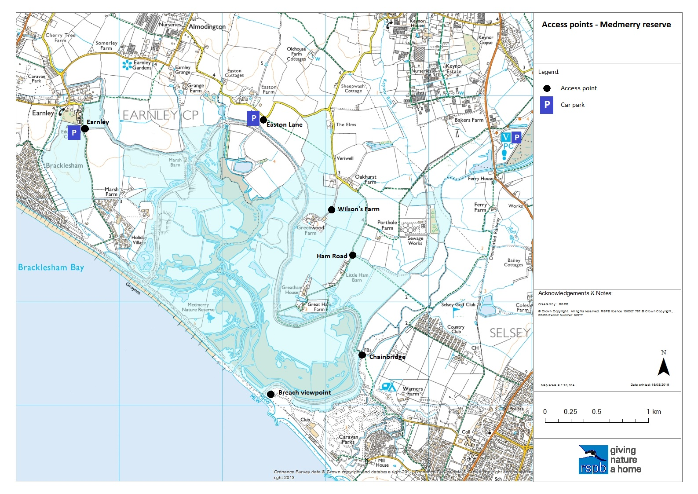

Langstone Harbour - Locations | Postcode | Nearest Road Access | Grid Reference | Type of vehicle required | Possible hazards
Long Island public landing area |  | N/A | SU703038 | Boat/Helicopter | Sea, mudflat
The Round Nap |  | N/A | SU702034 | Boat/Helicopter | Sea, mudflat, seabird colony
South Binness southern point |  | N/A | SU700029 | Boat/Helicopter | Sea, mudflat, seabird colony
Bakers Island recharge site |  | N/A | SU693036 | Boat/Helicopter | Sea/mudflat/seabird colony
West Hayling LNR – Hayling Holt car park | PO11 0LG | Havant Road, Hayling Island | SU717029 | Car | Sea/mudflat/seabird colony

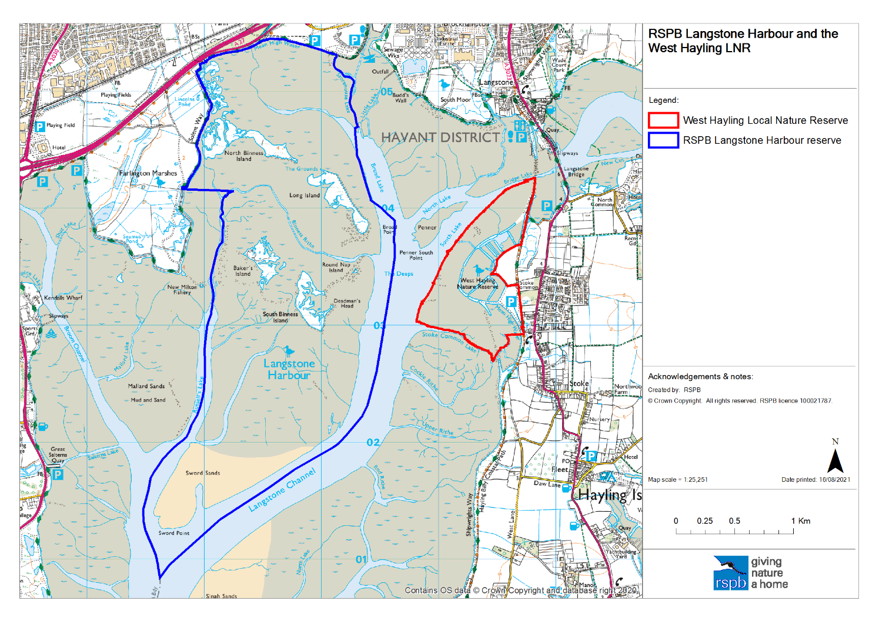
Pagham and Medmerry Gate access codes
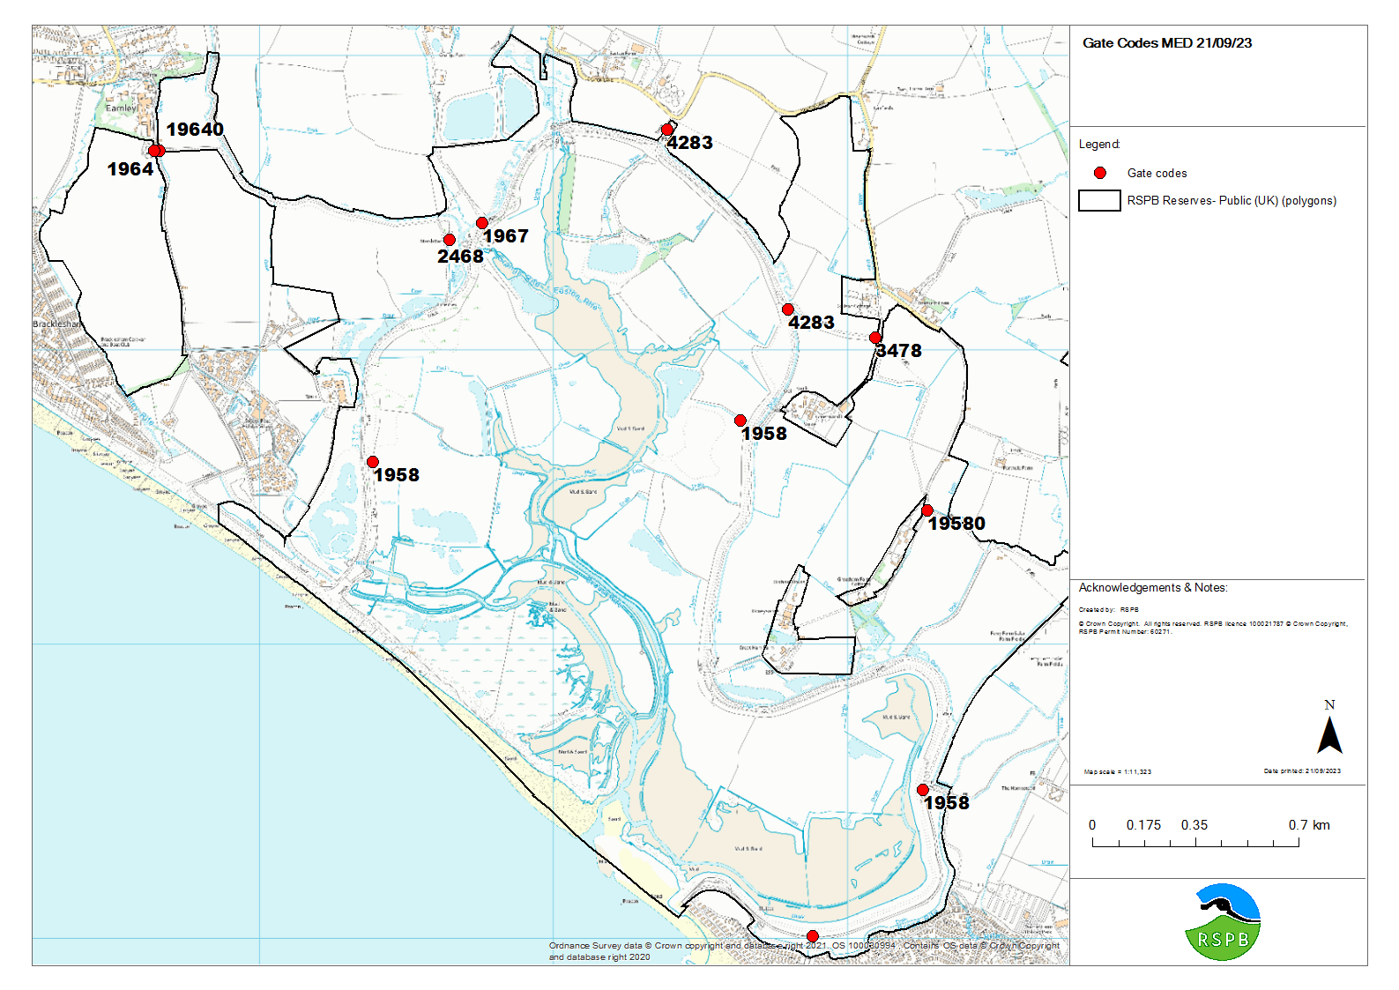
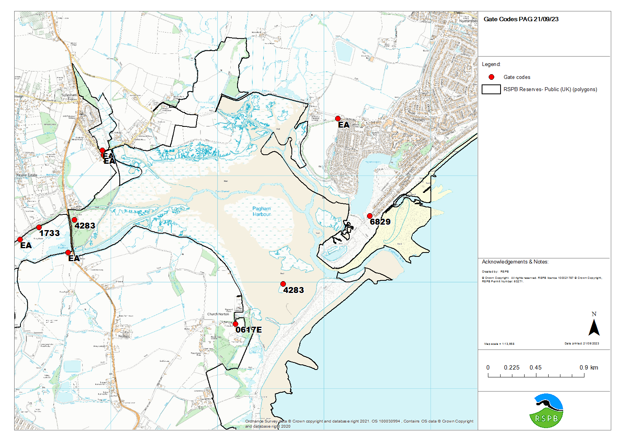

Local Utilities on Reserve:

Overview maps from utilities providers have been included below in the emergency plan. More detailed versions with the 1:500 scale blocks can be accessed in the ‘Site Hazard Map work’ folder in the HSE folder on the S drive.

  - Electricity cables & wires
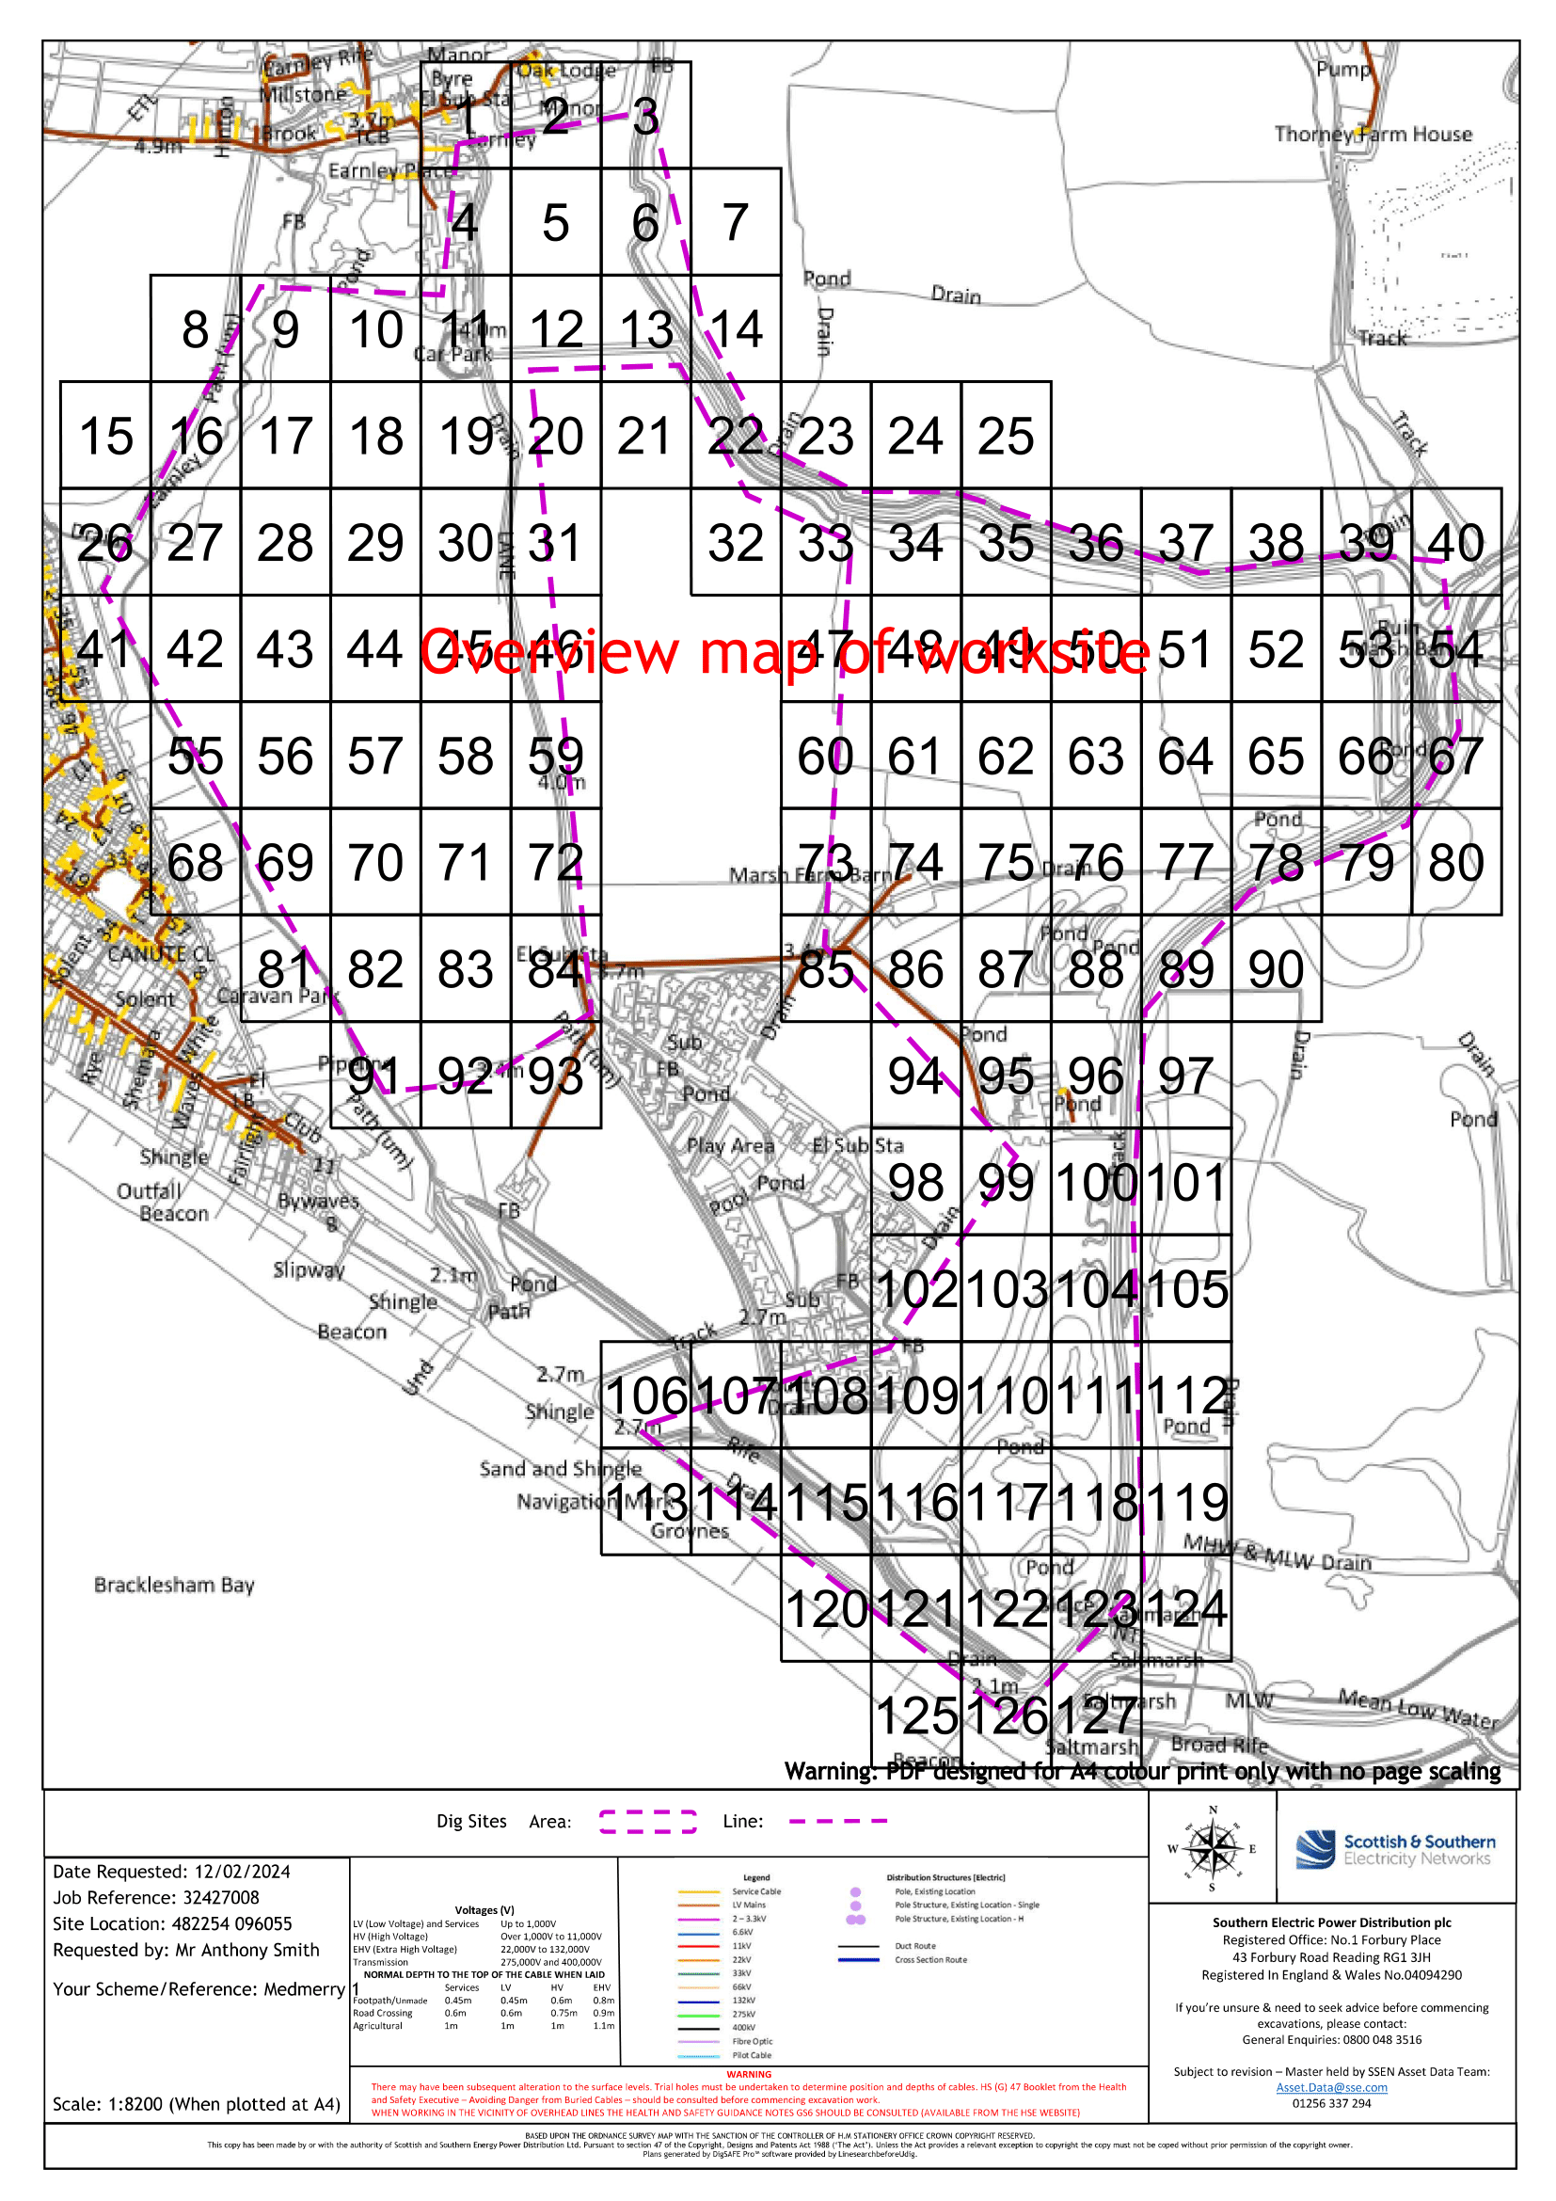
  - 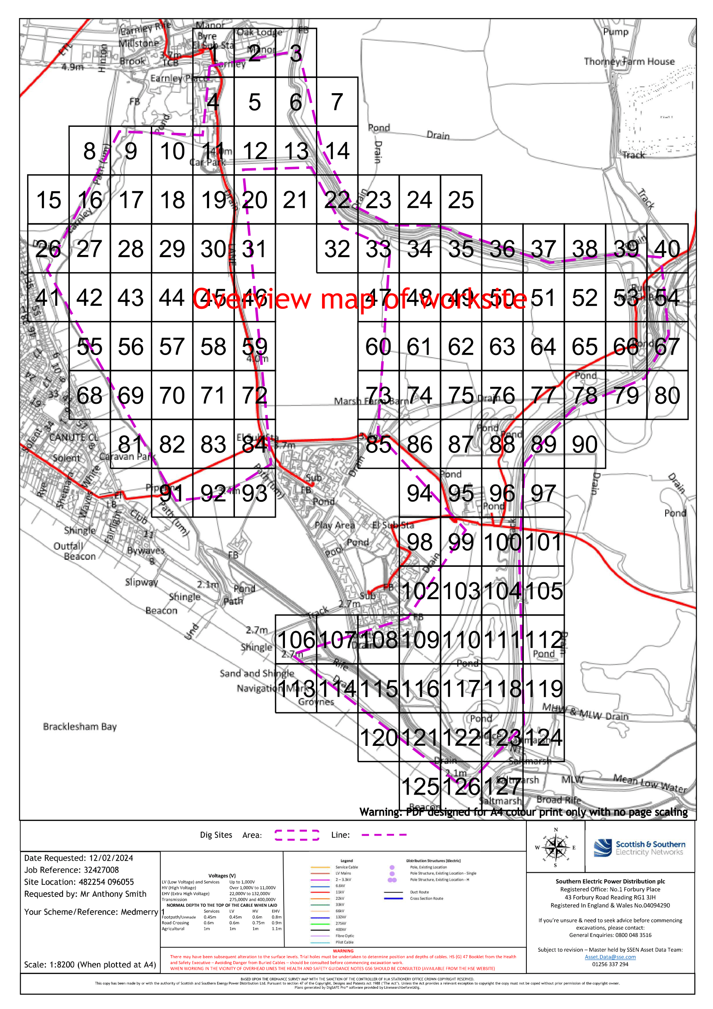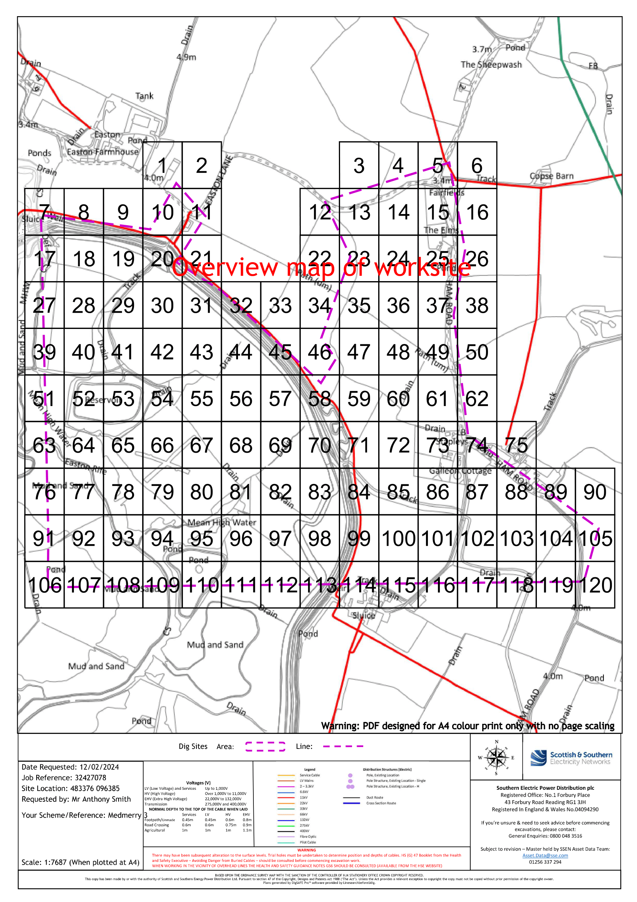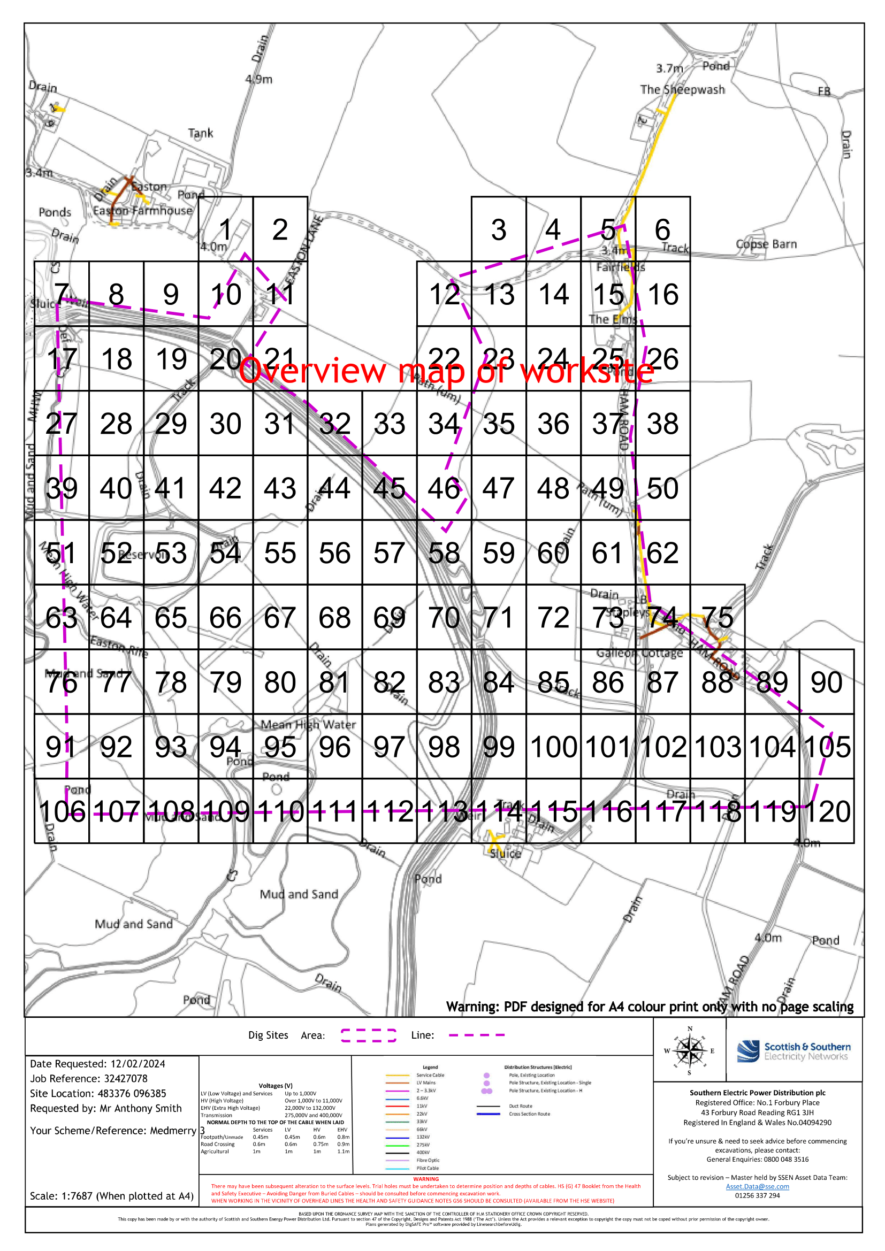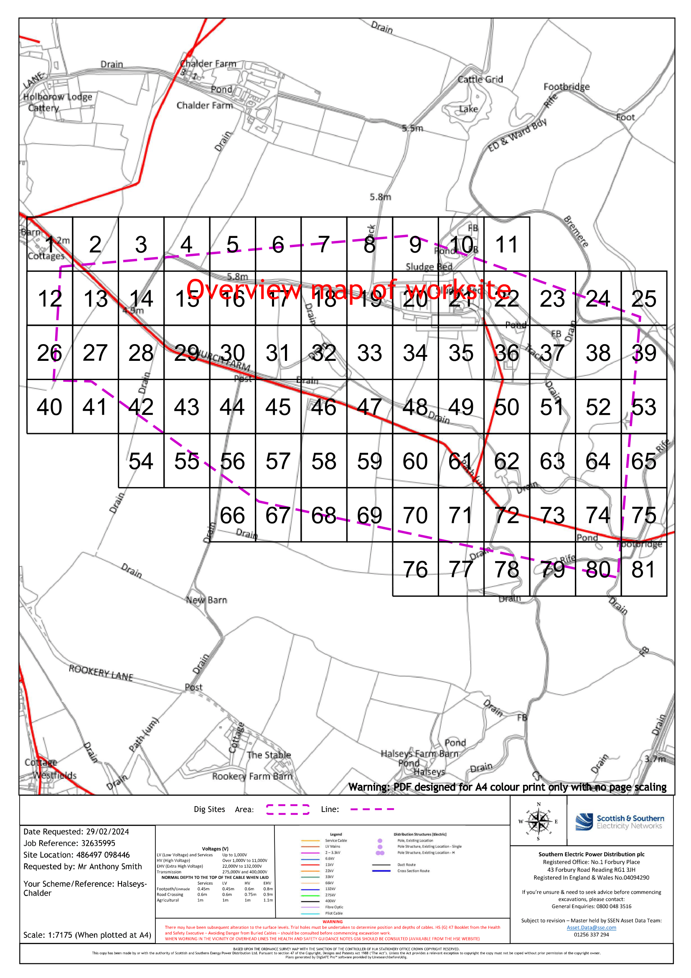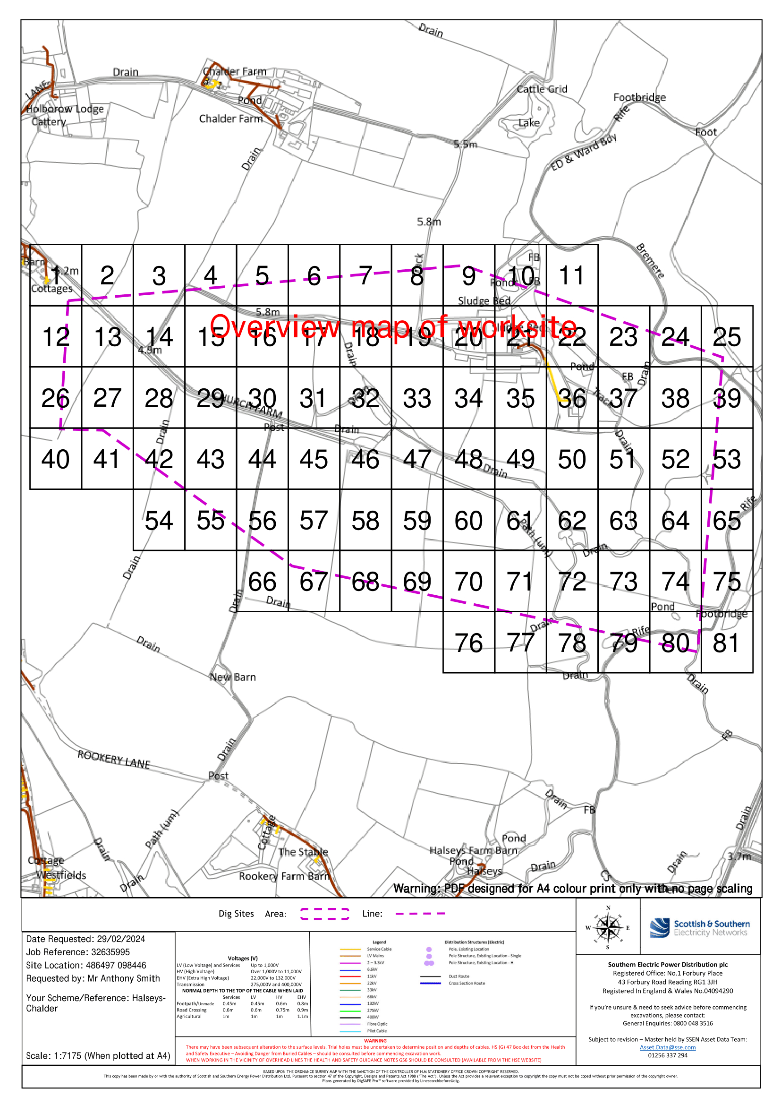

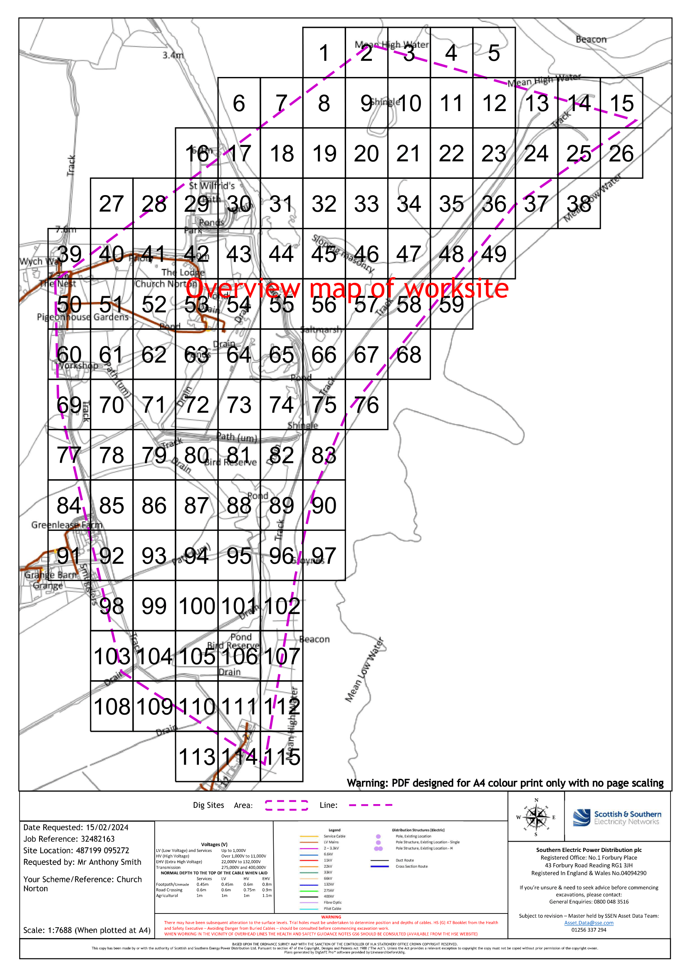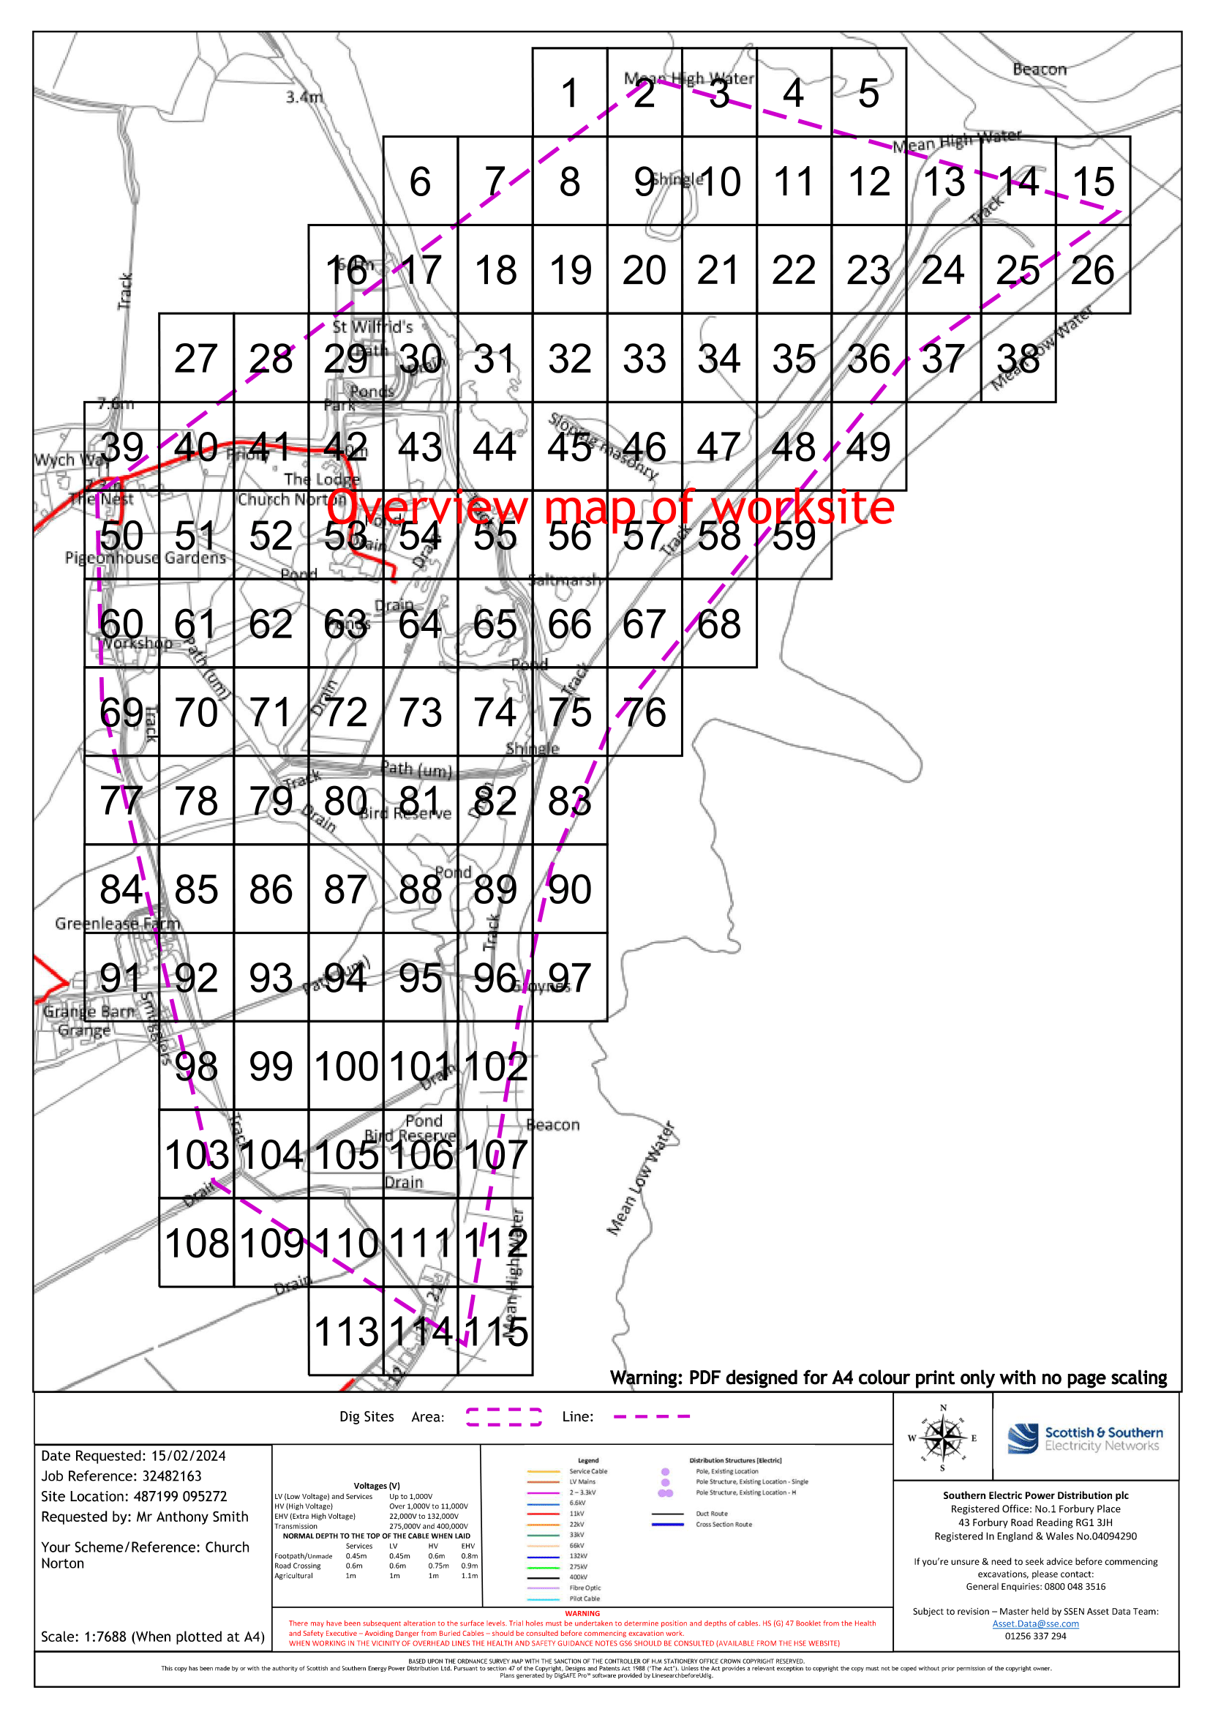
  - Gas pipes
  - 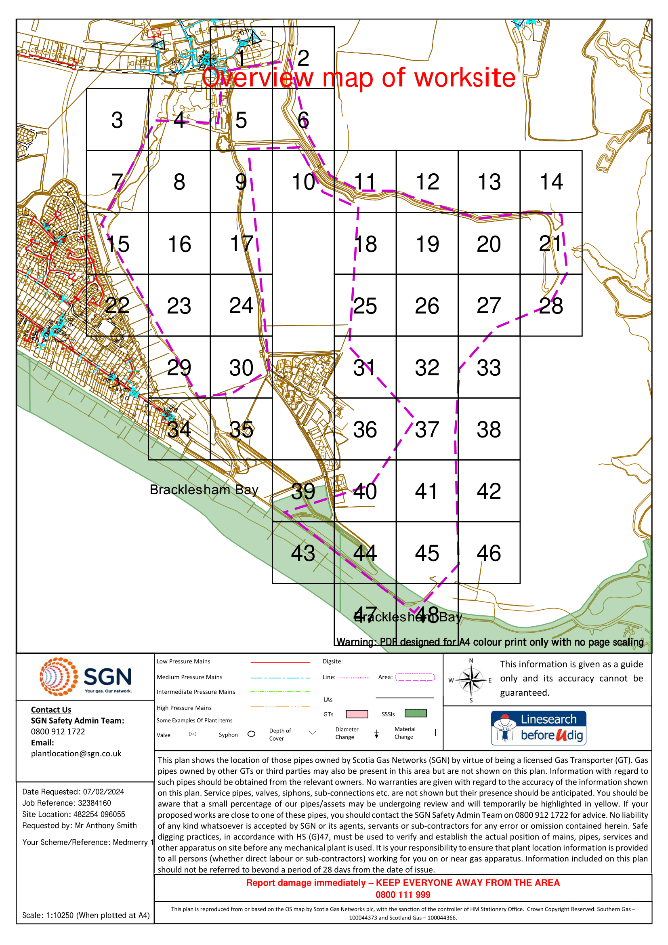
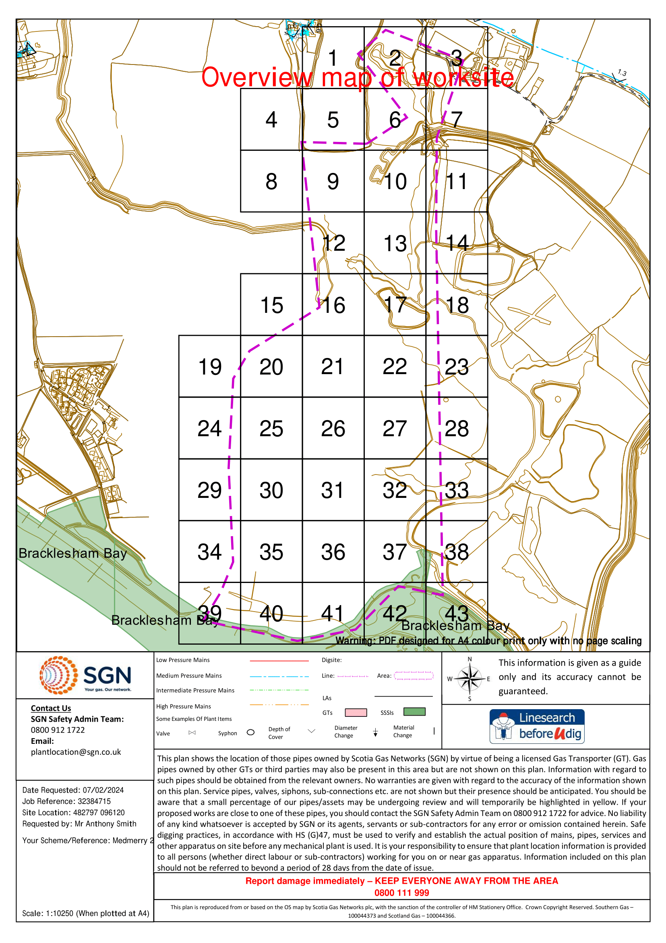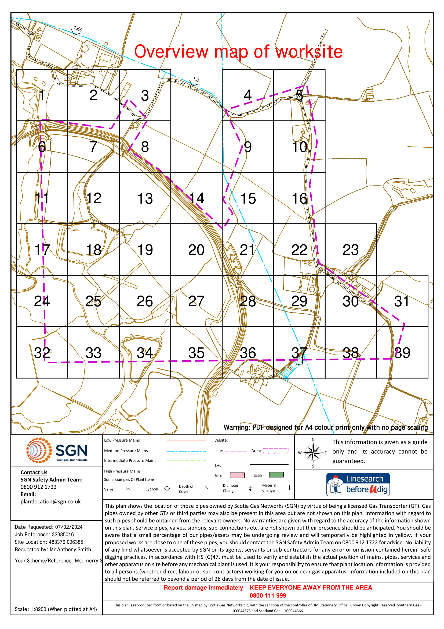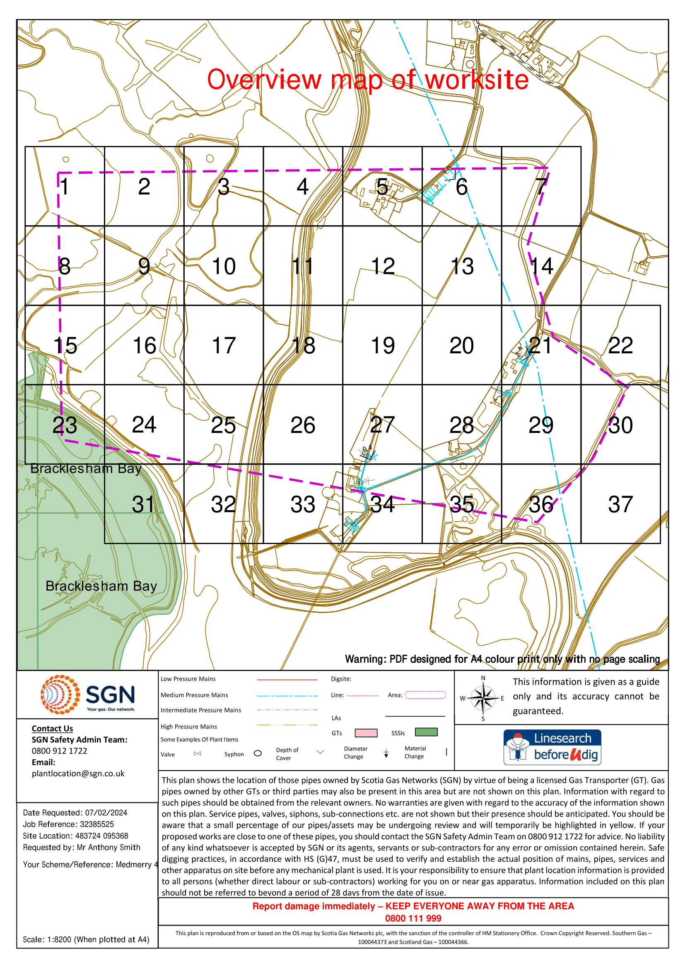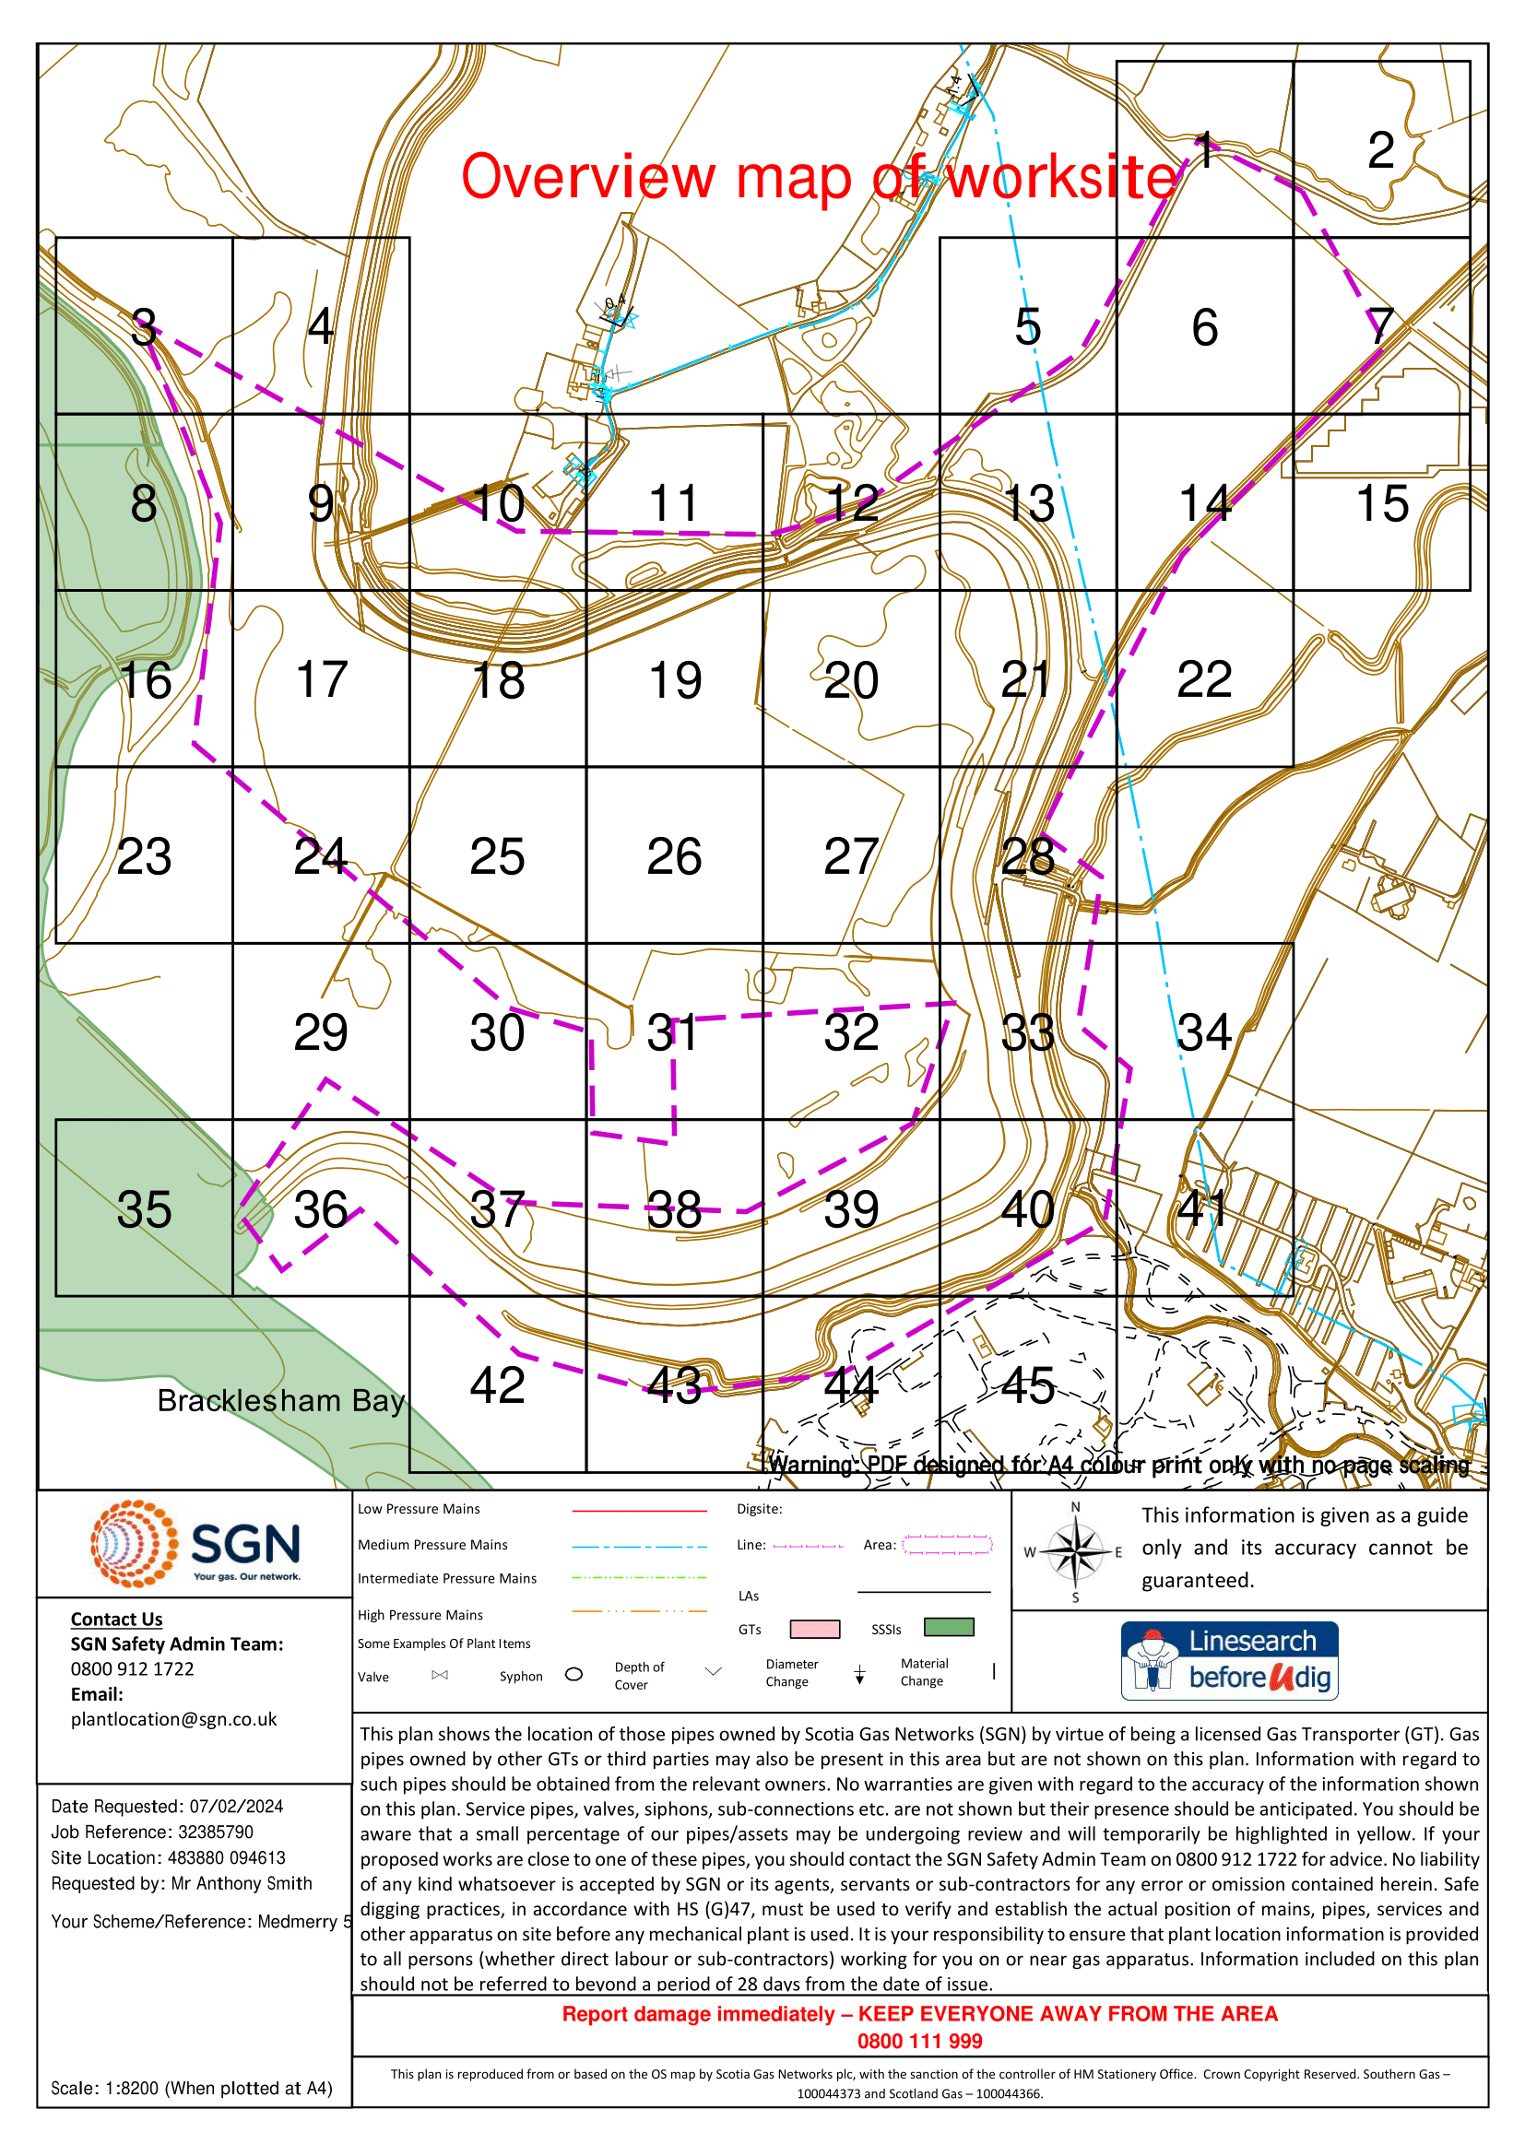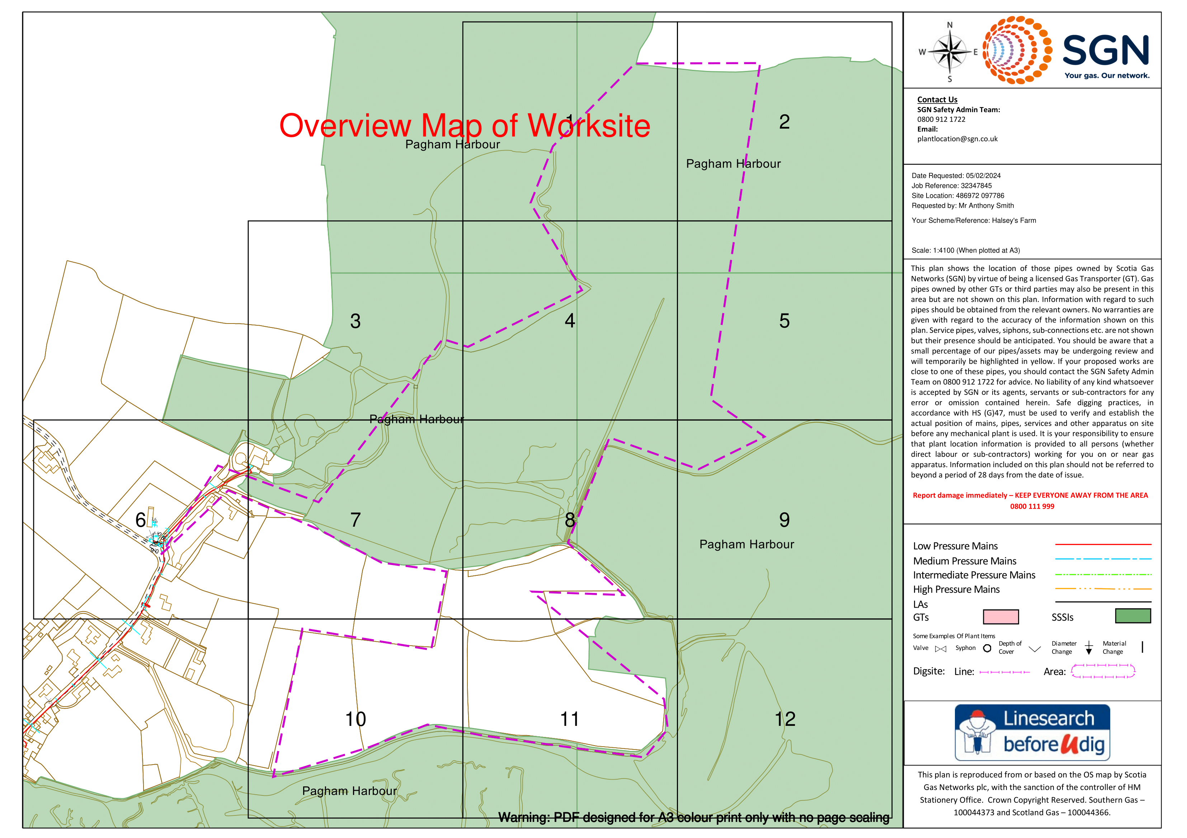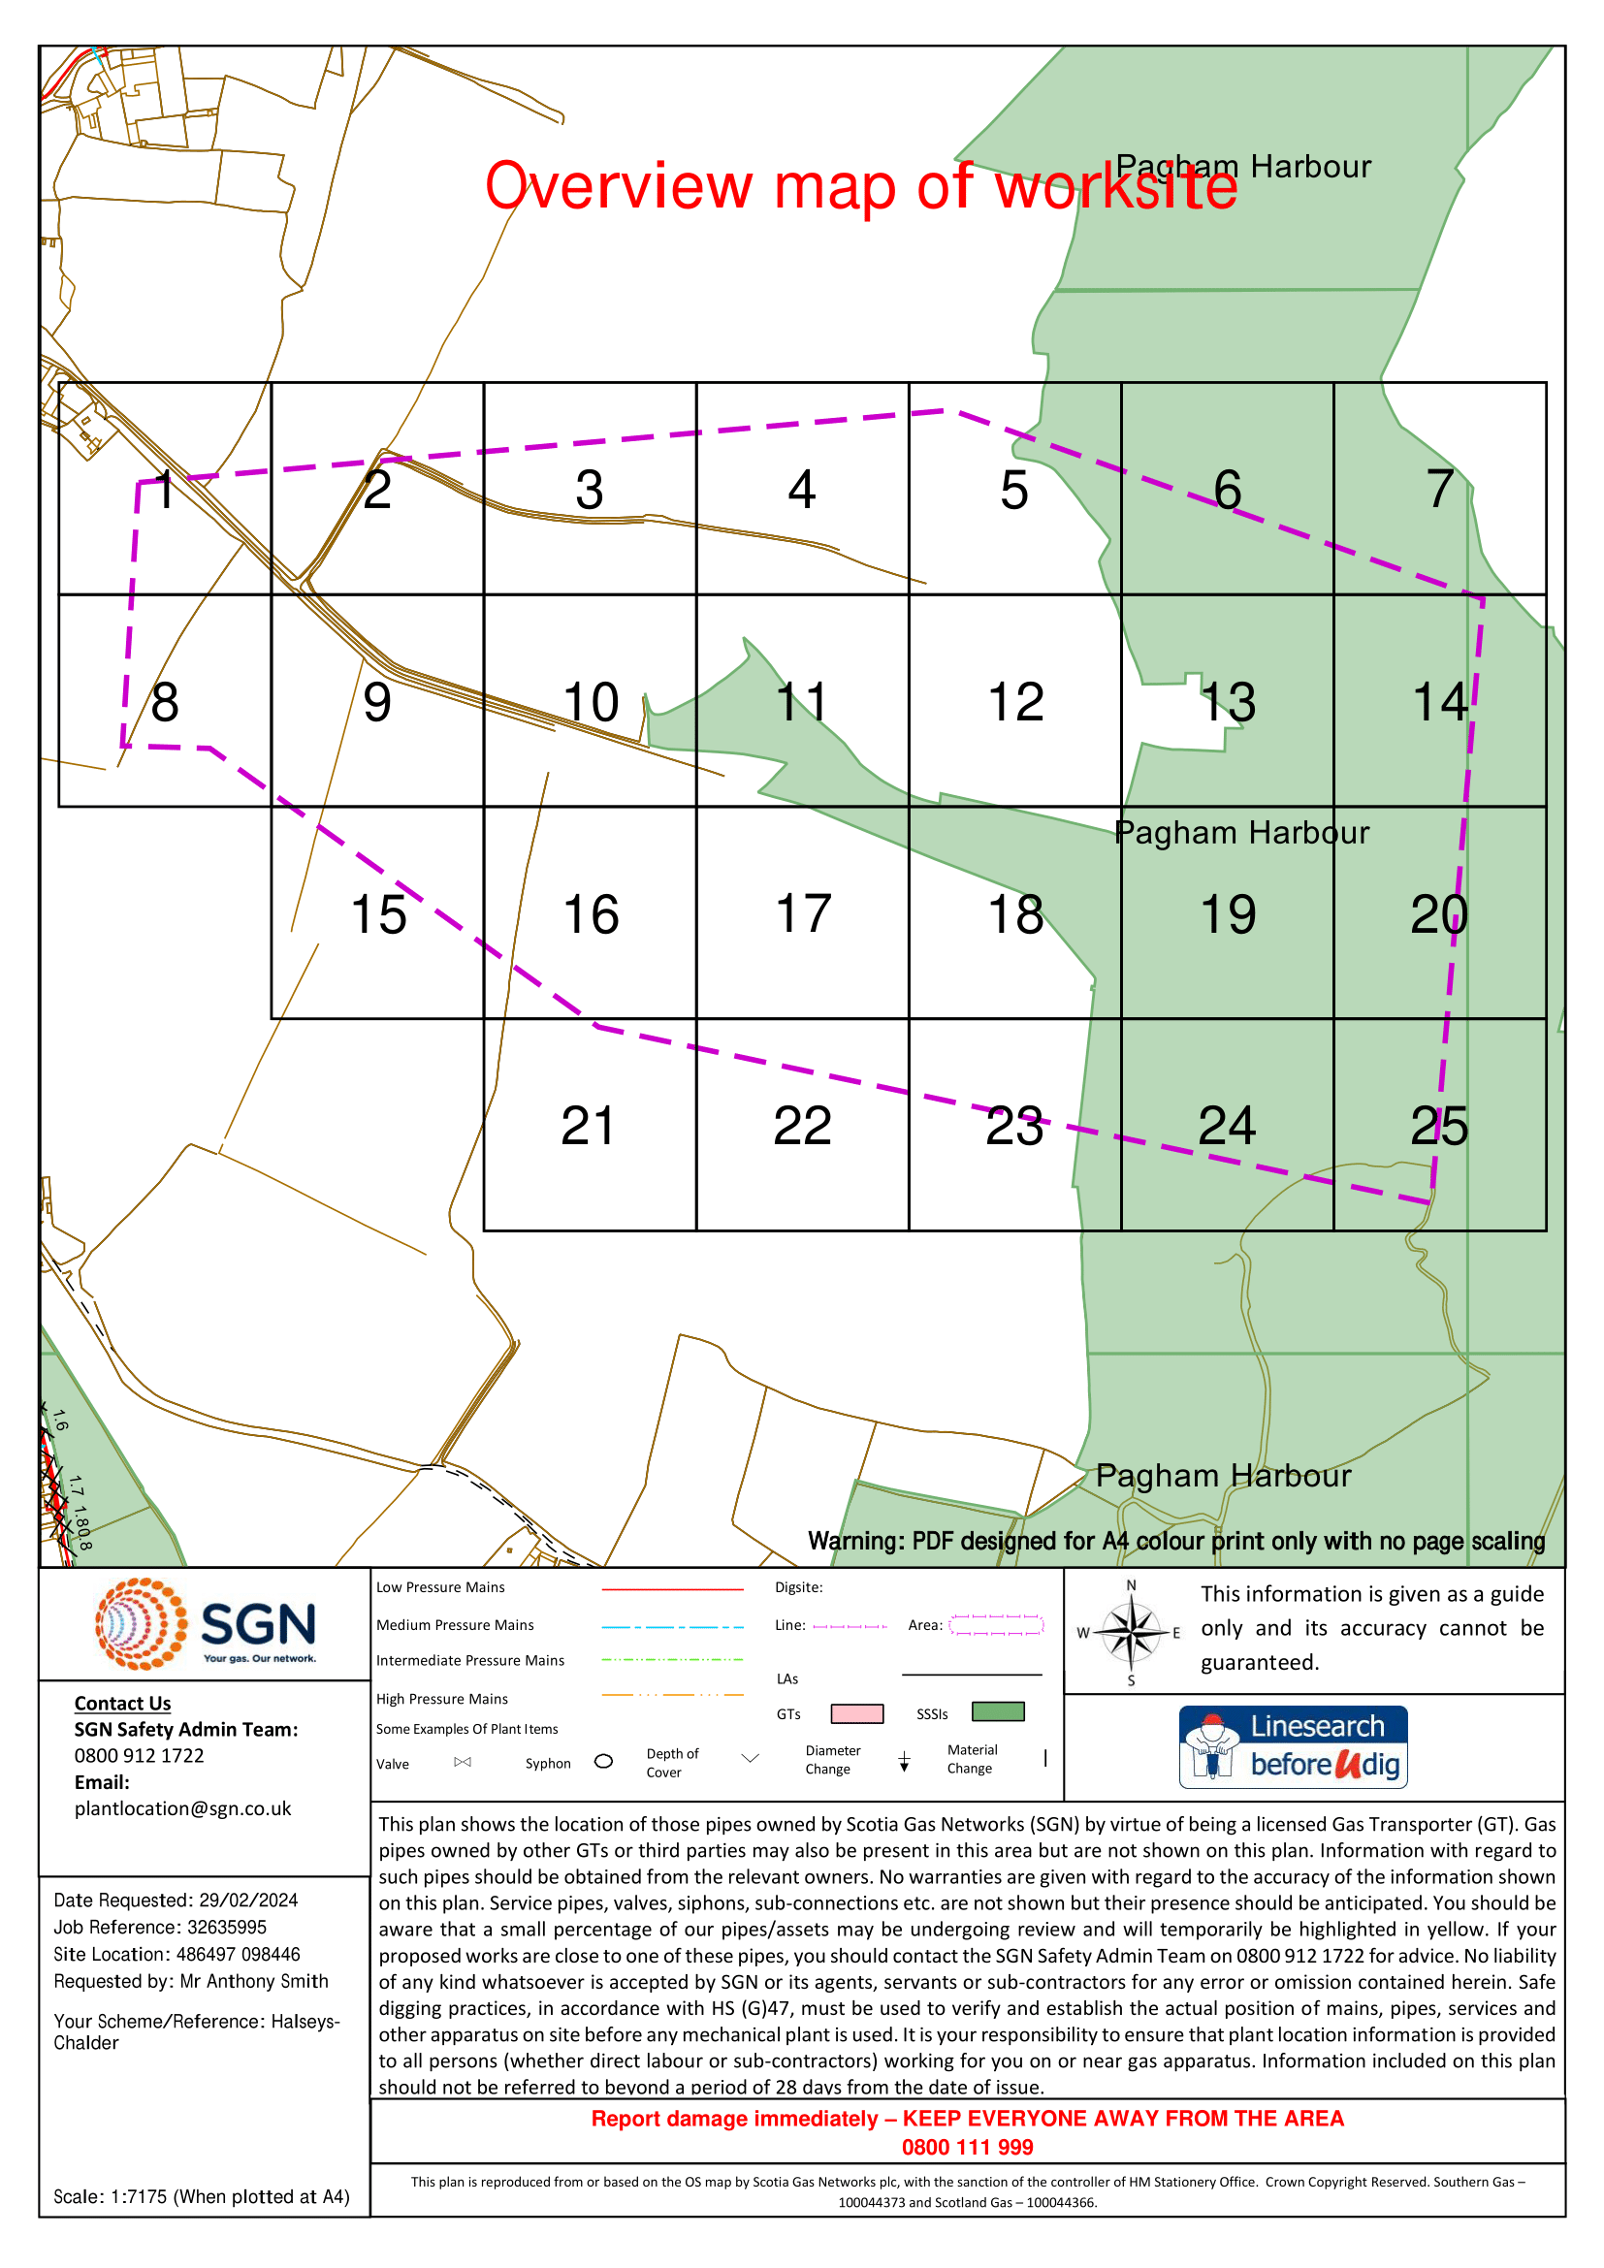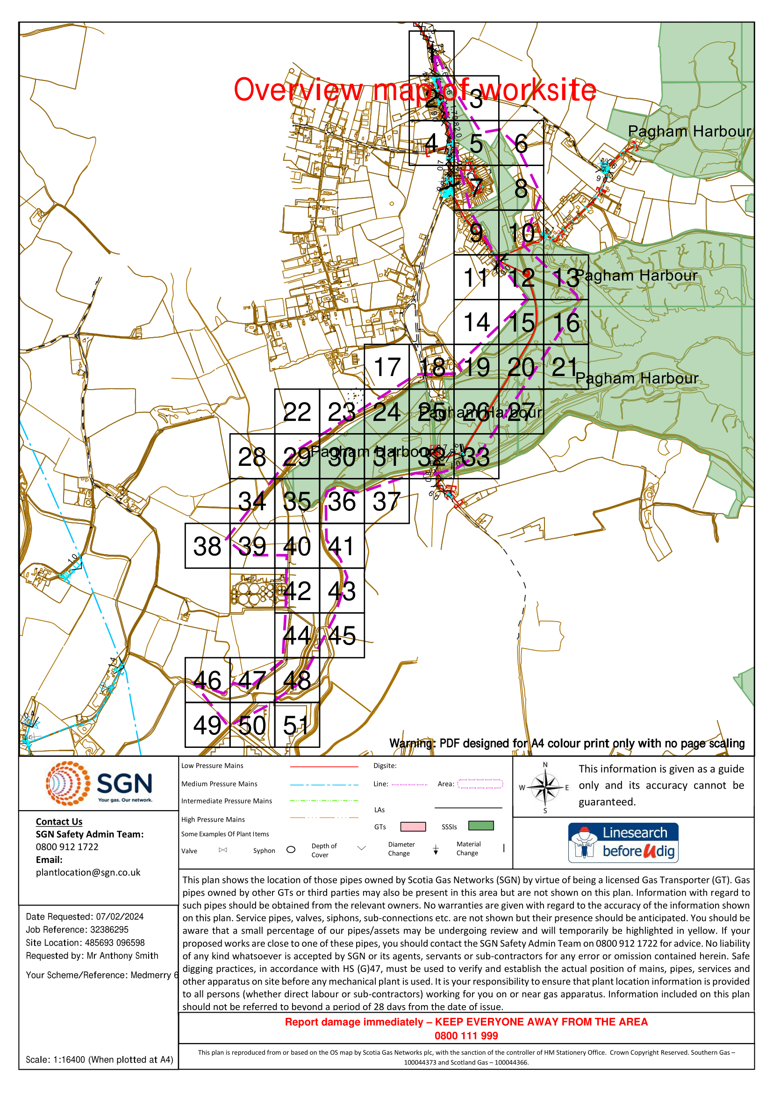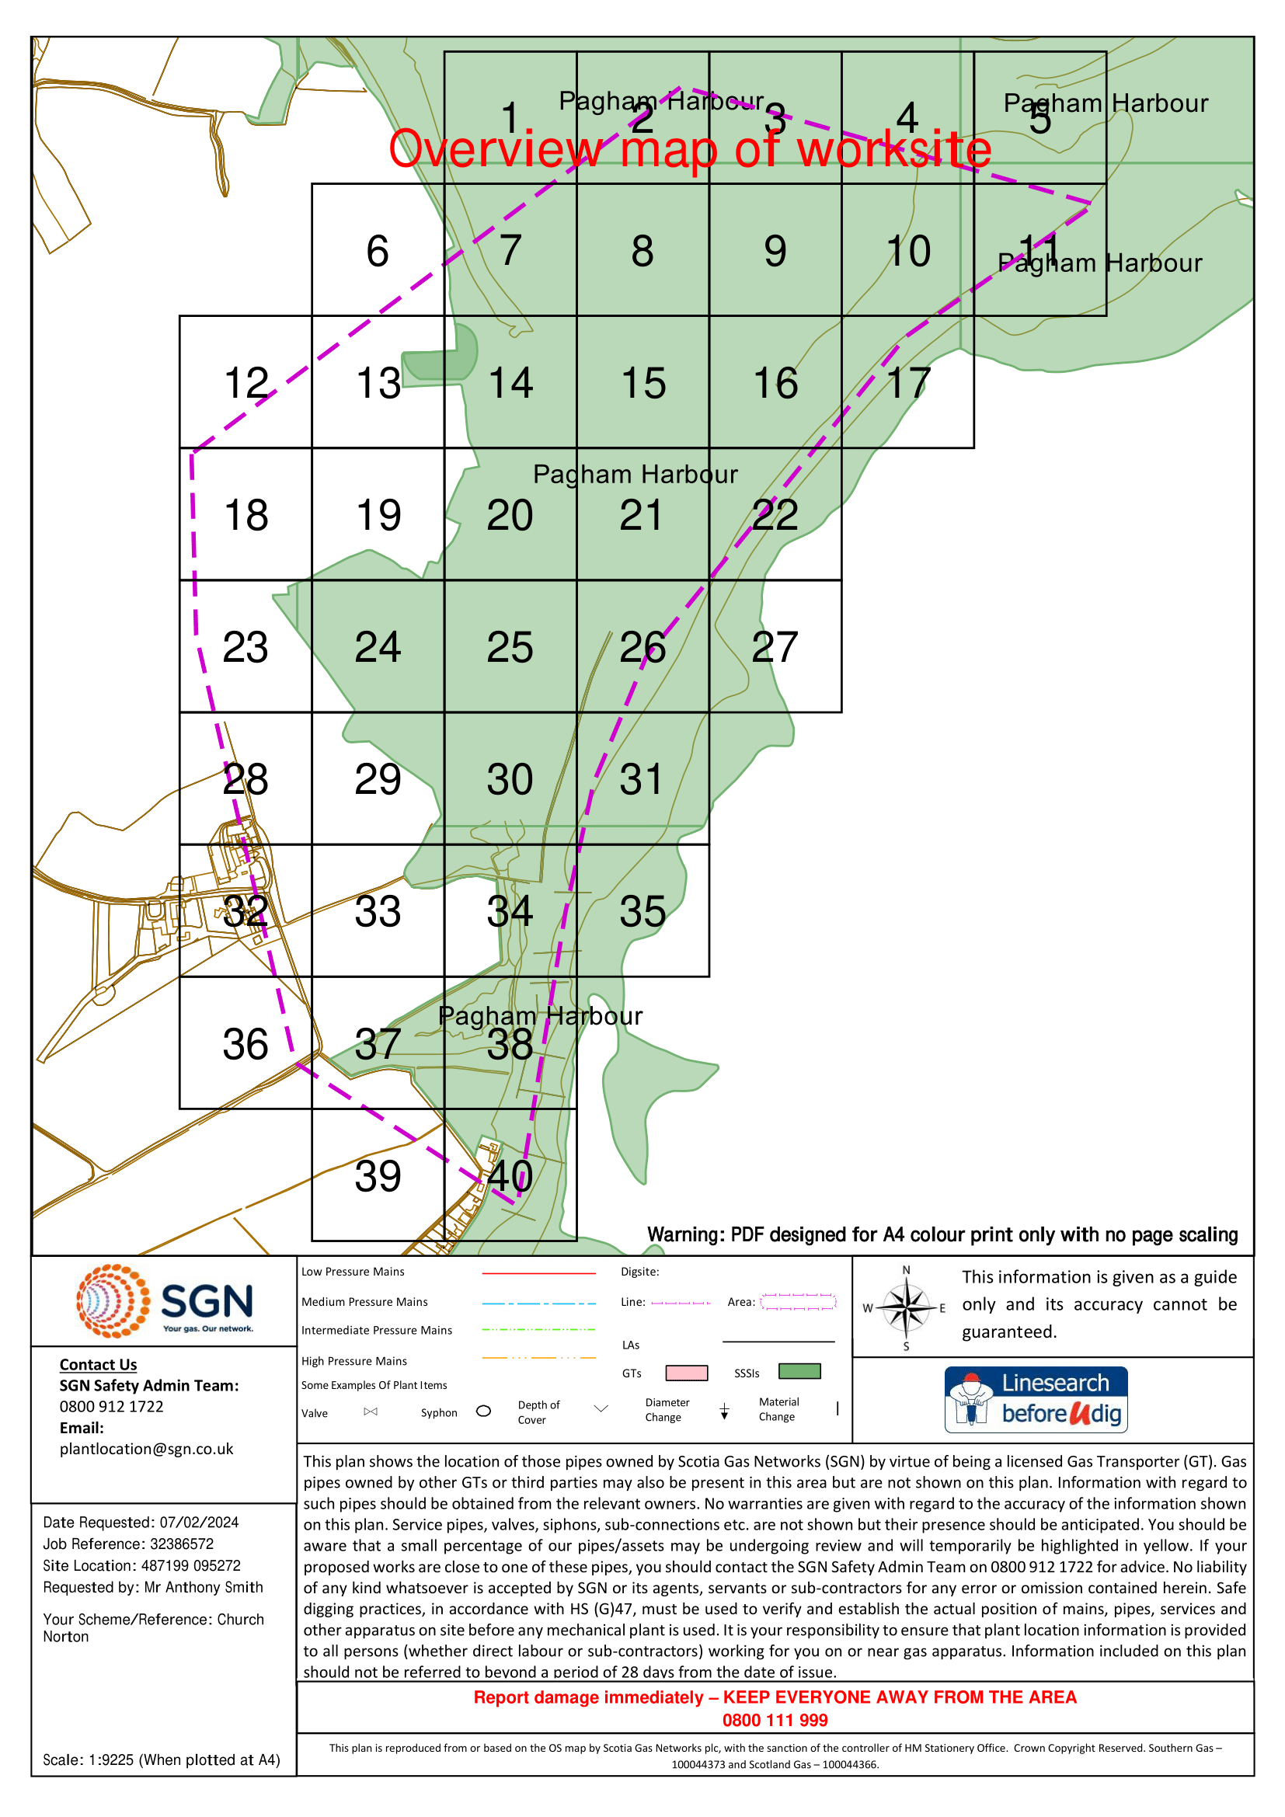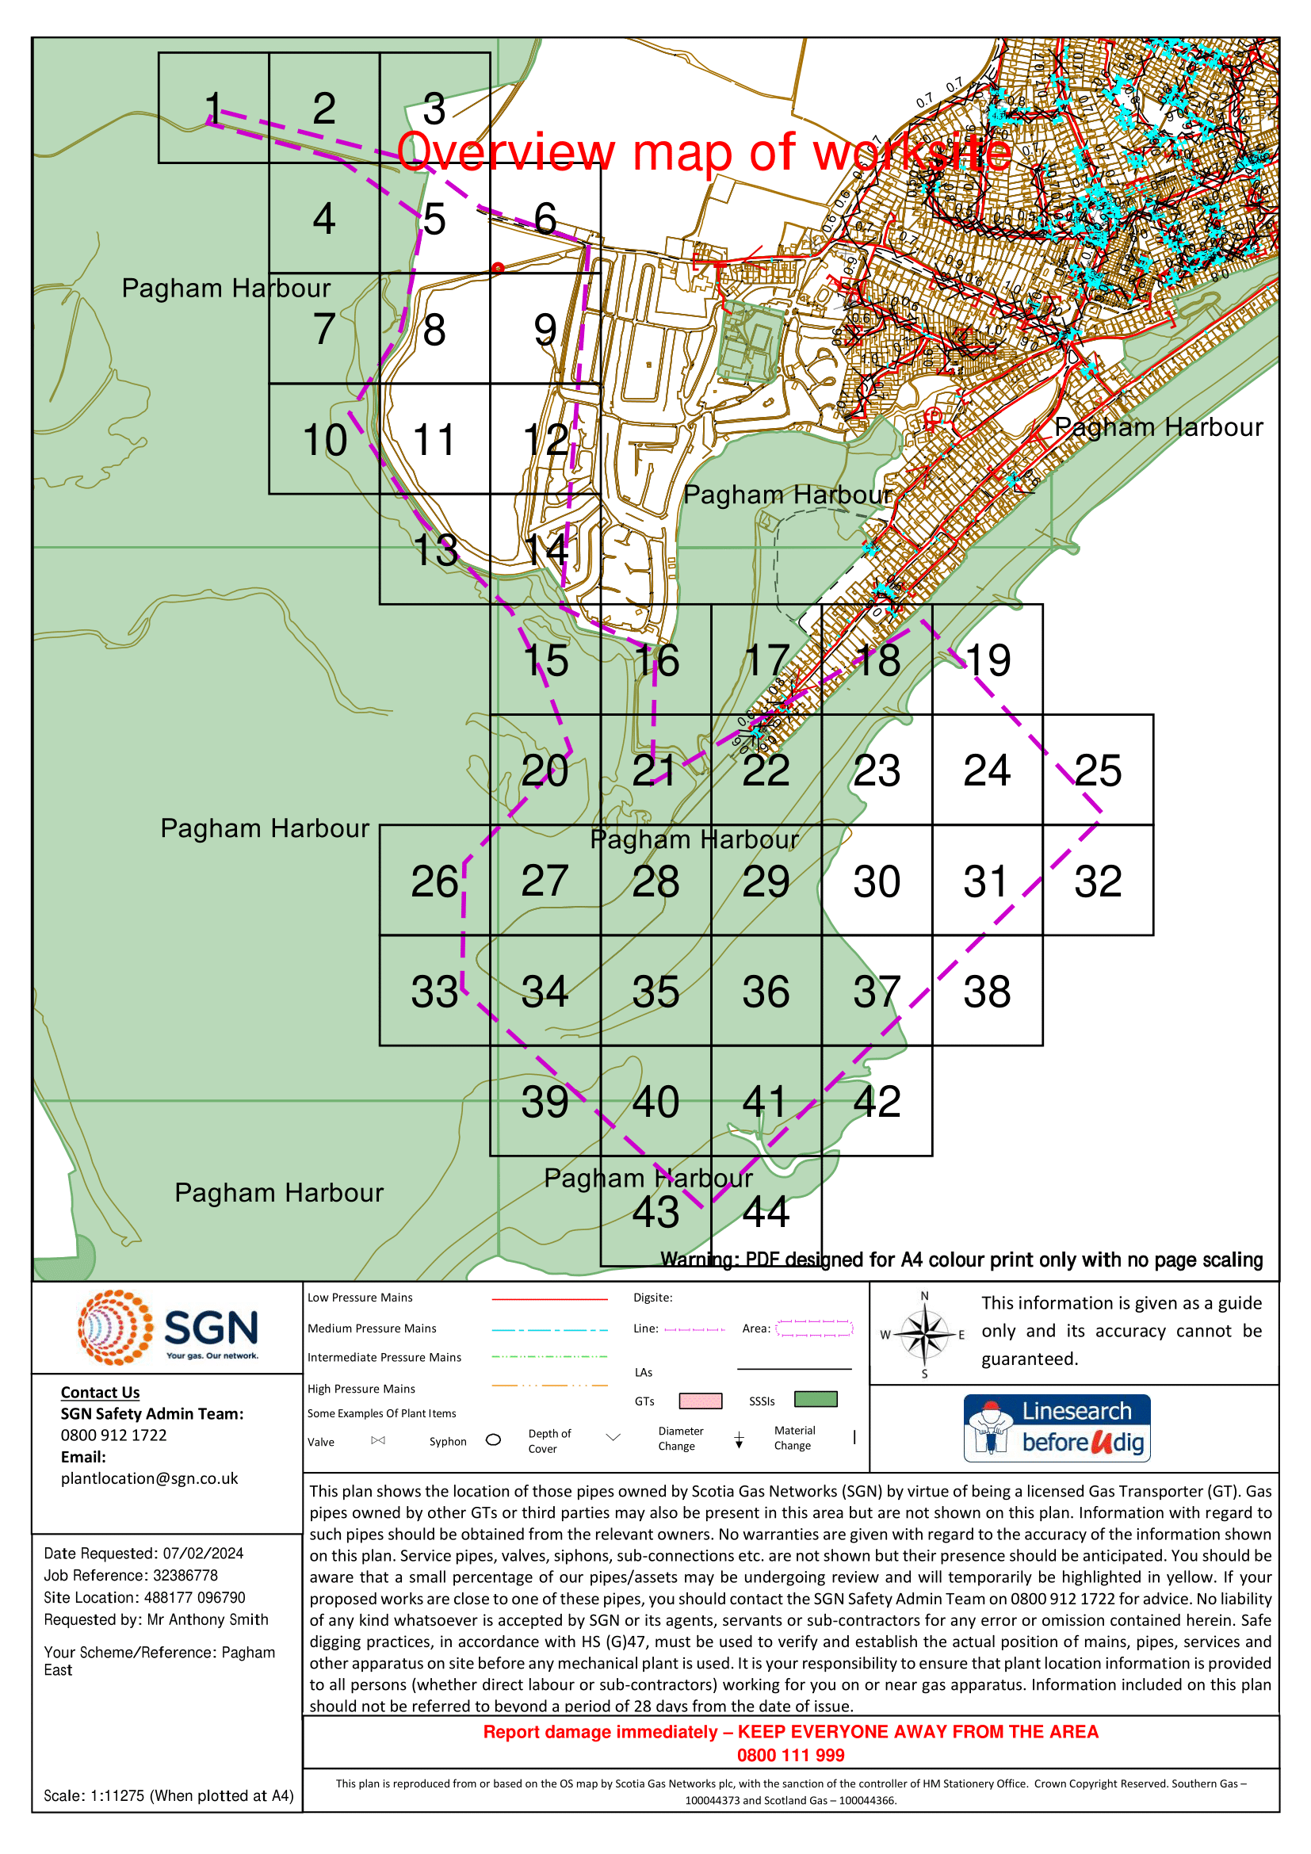
  - Water pipes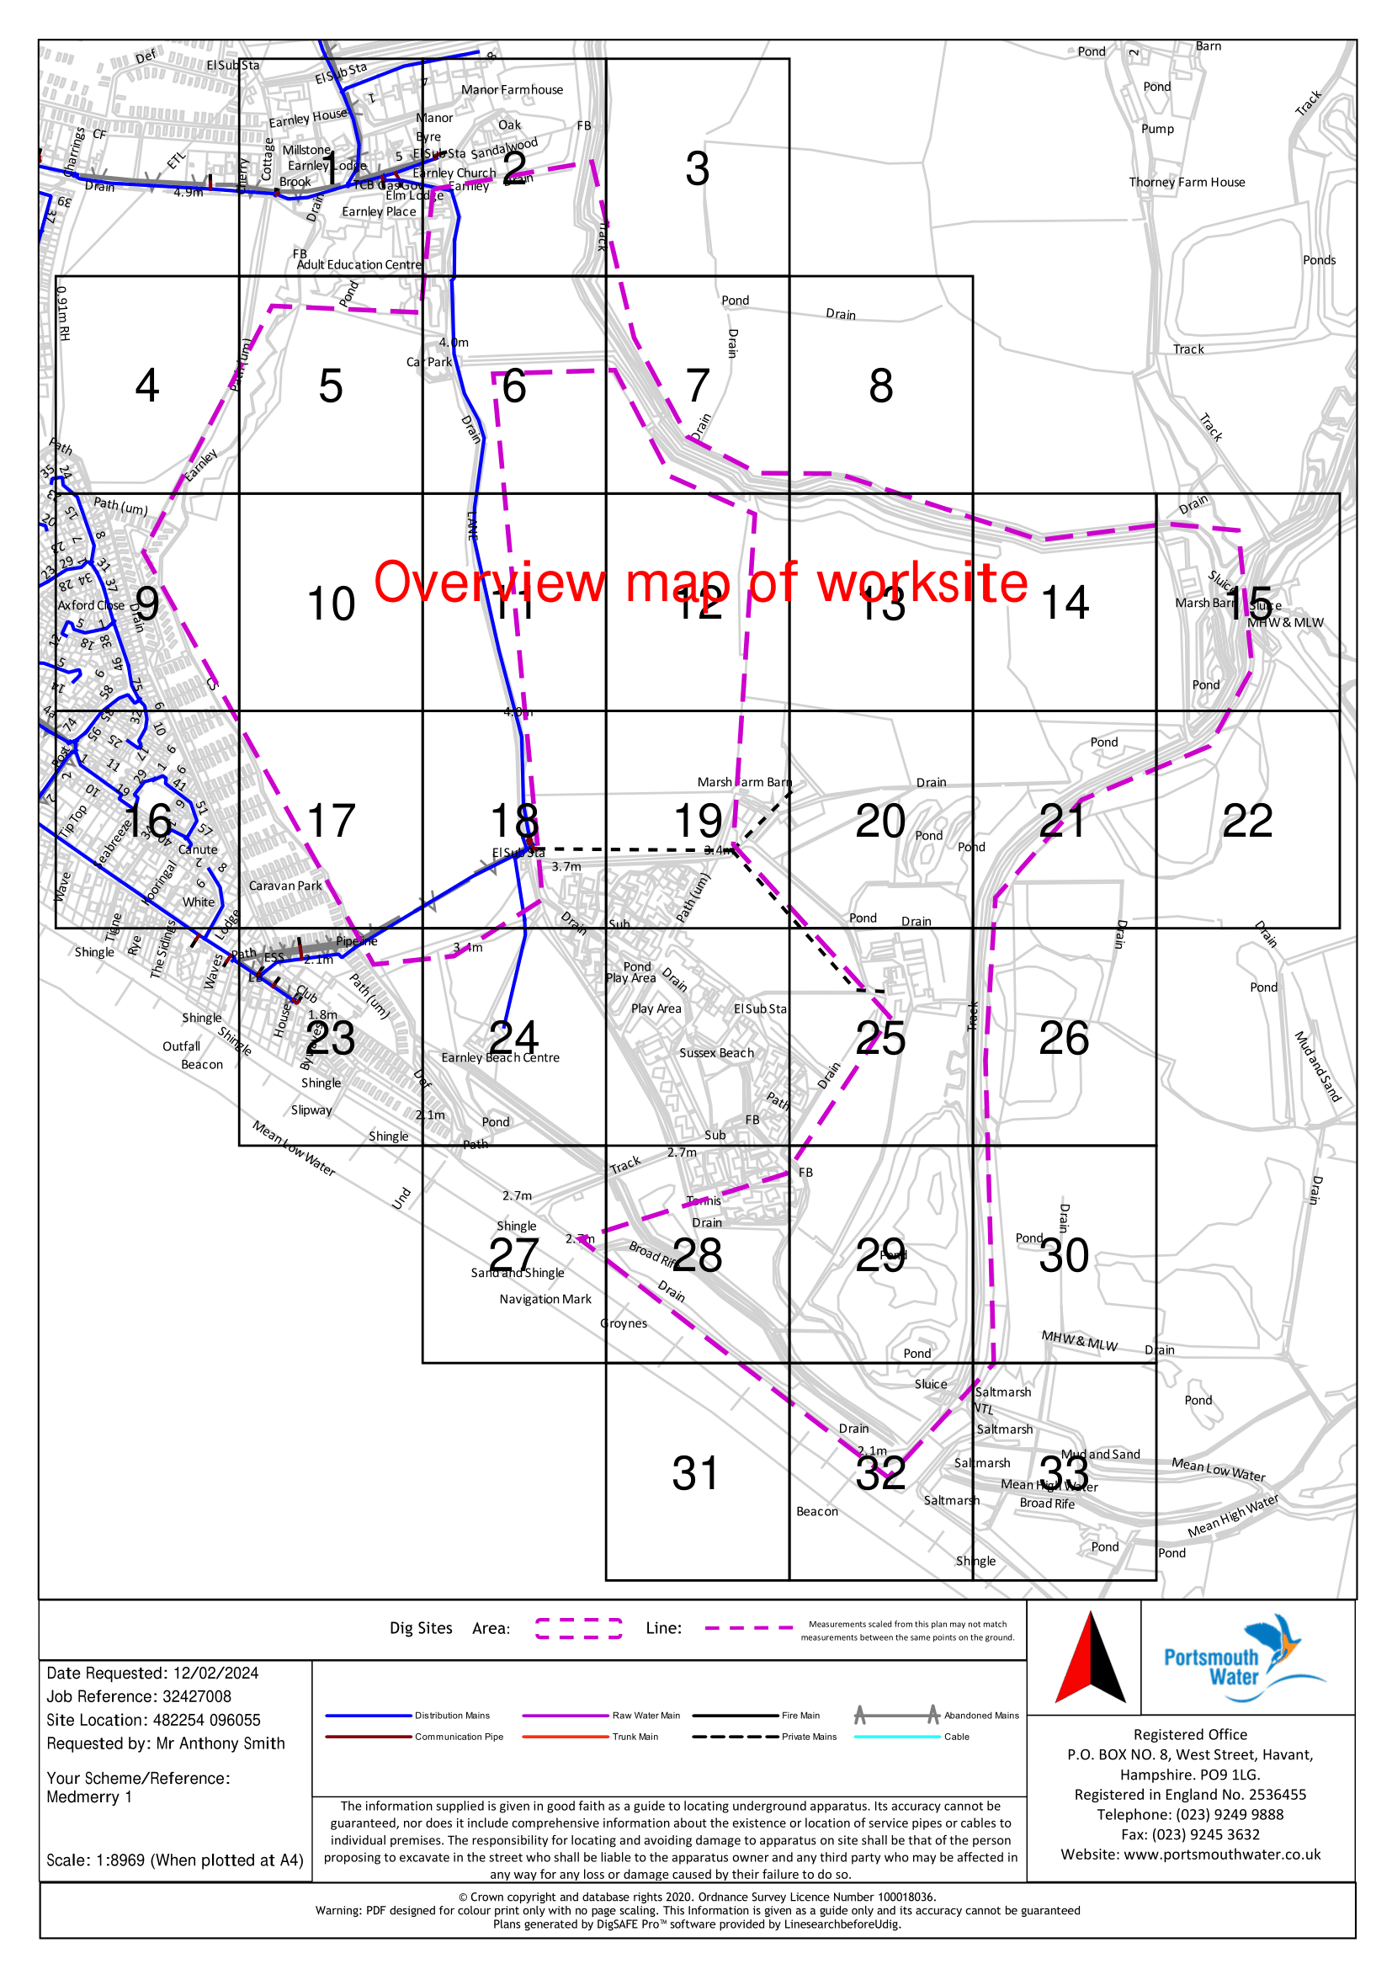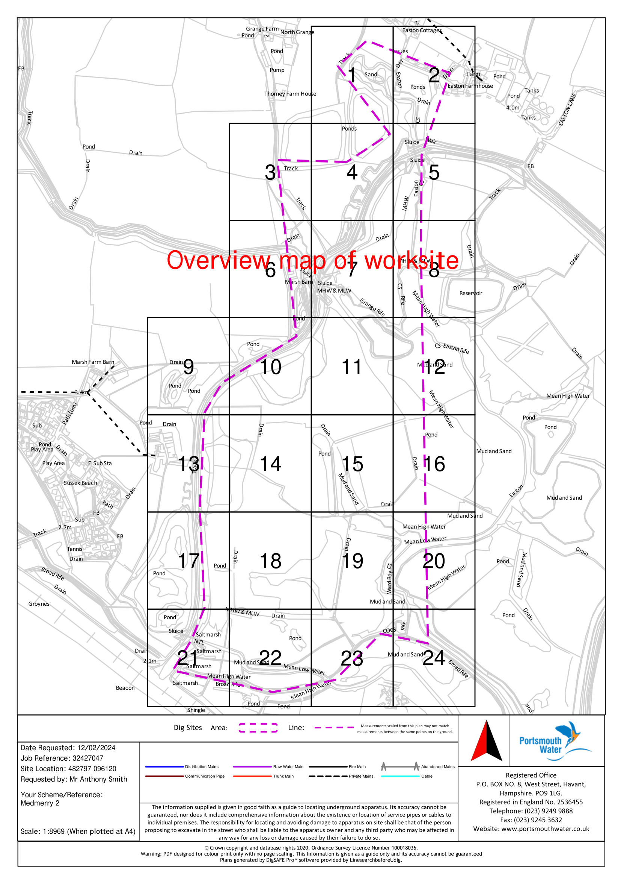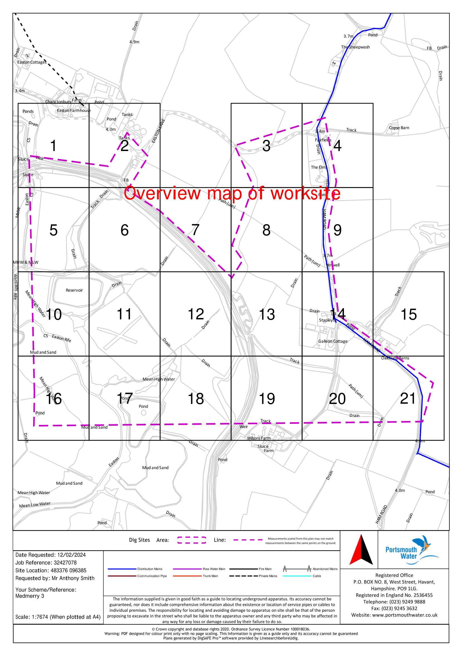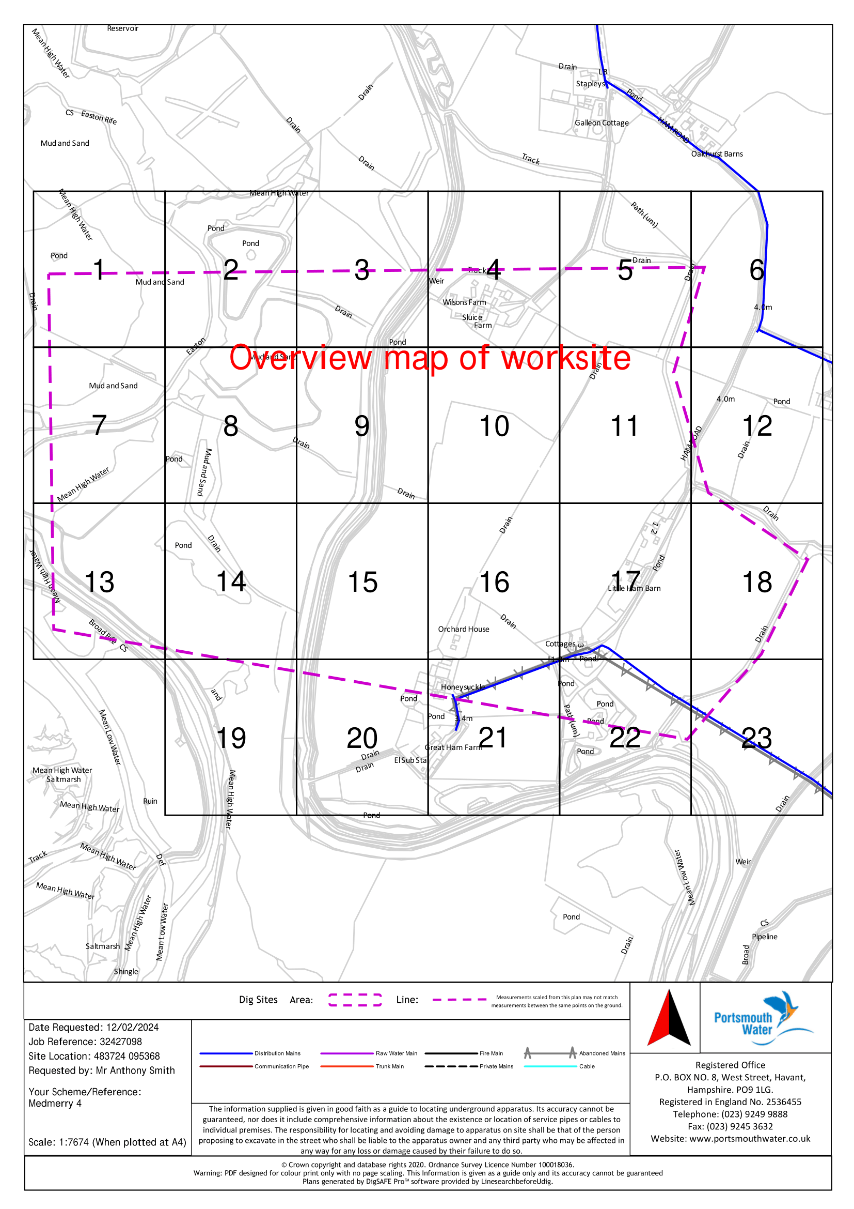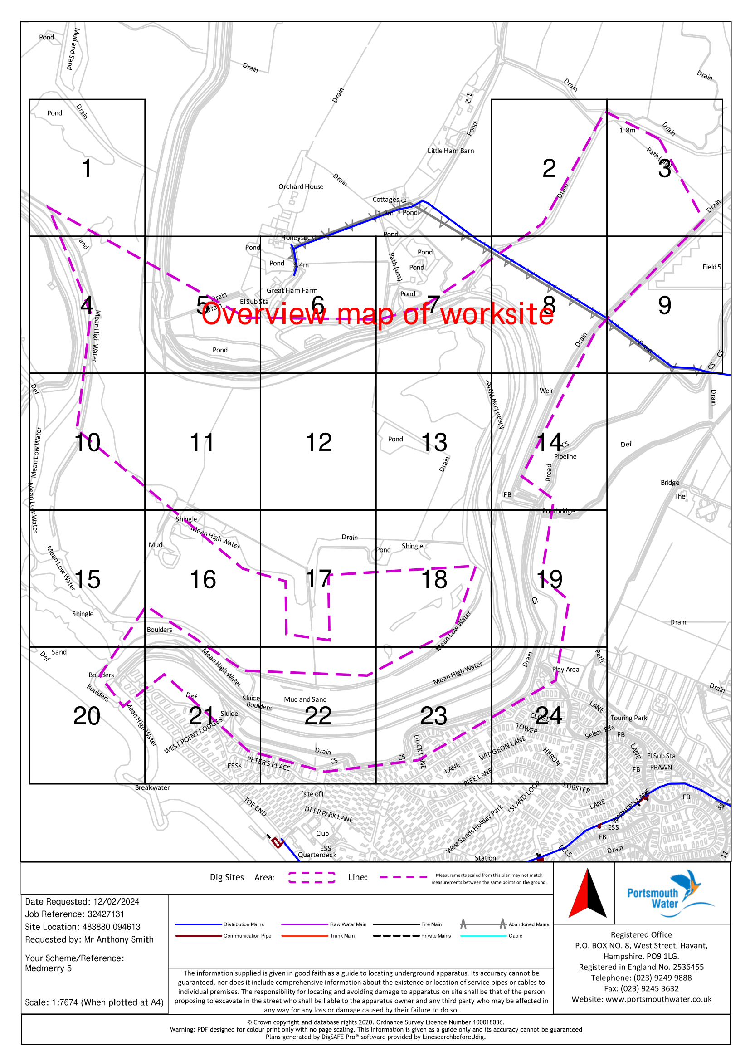

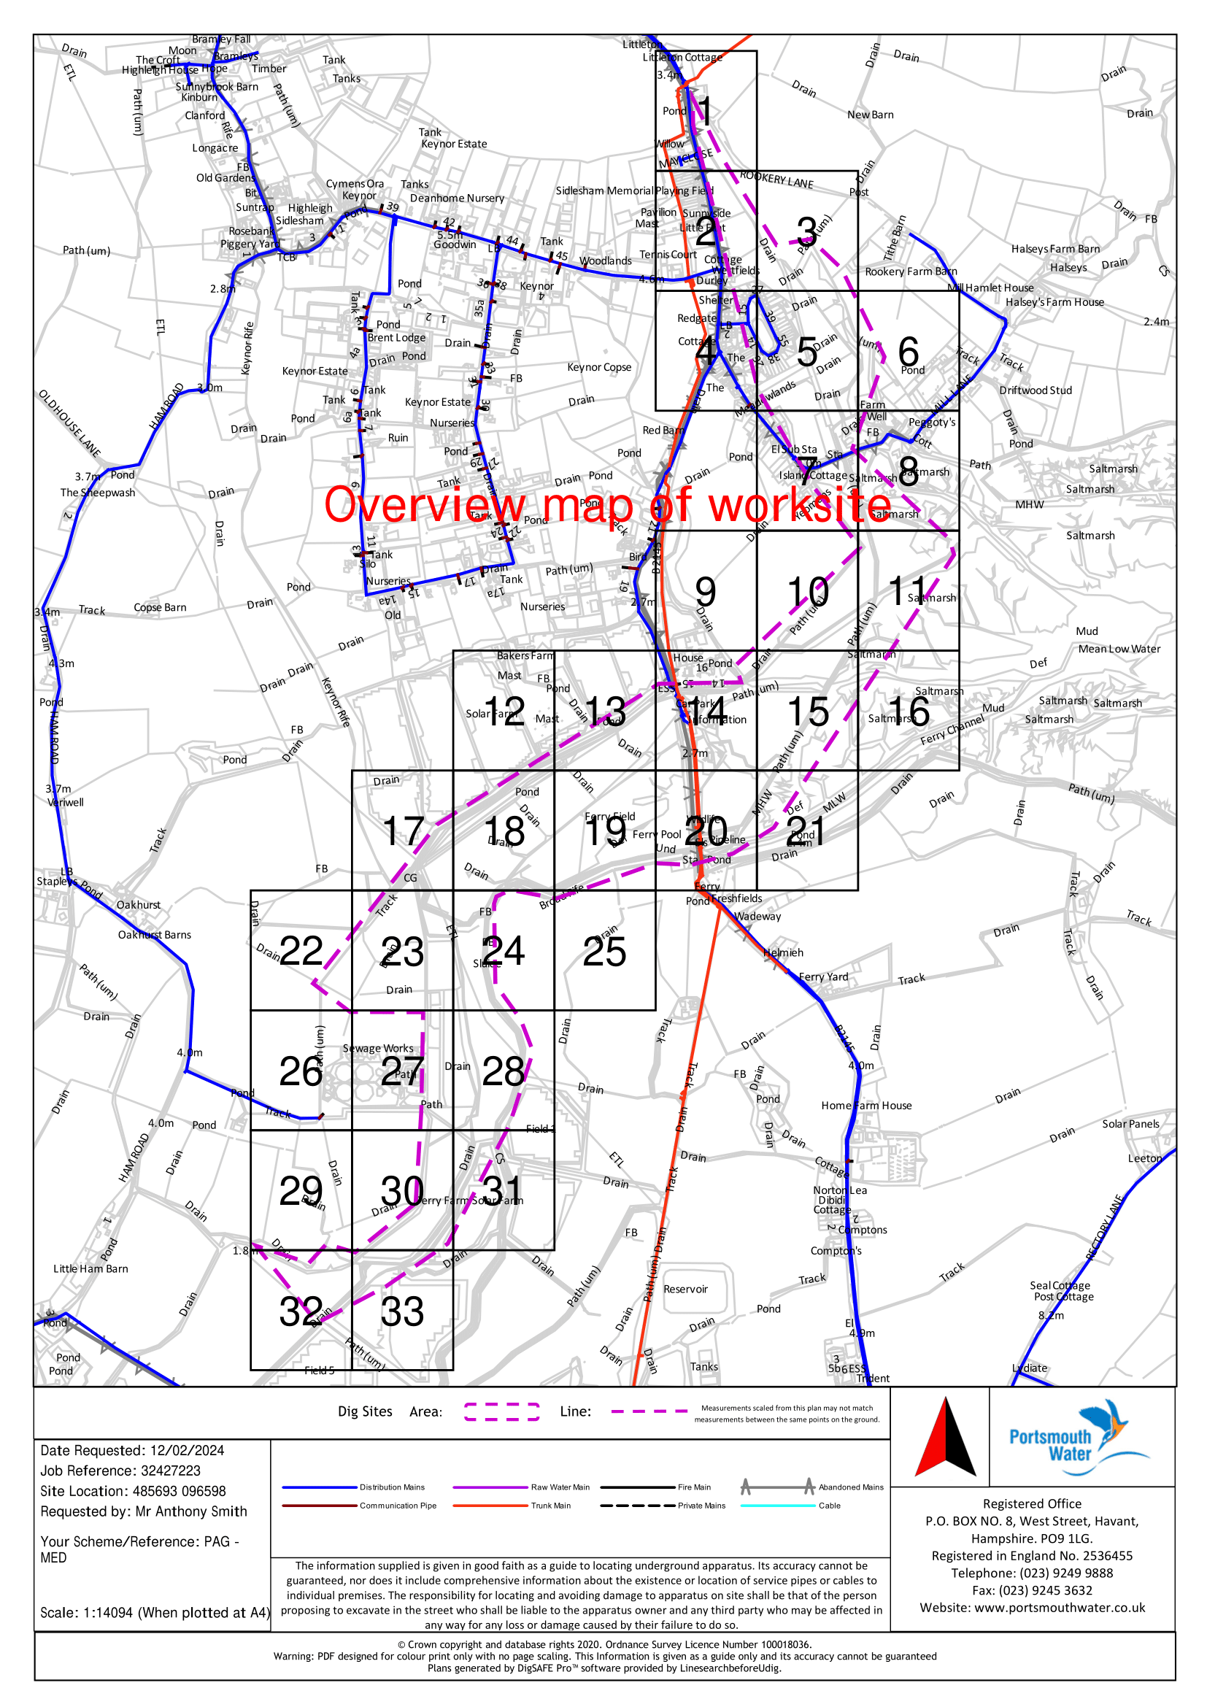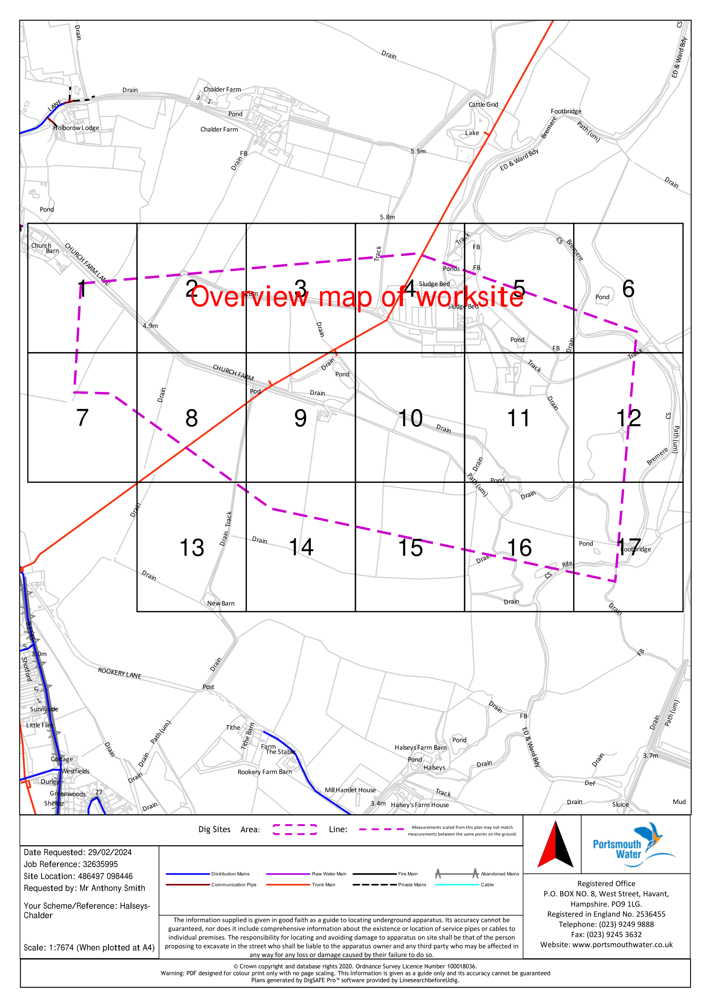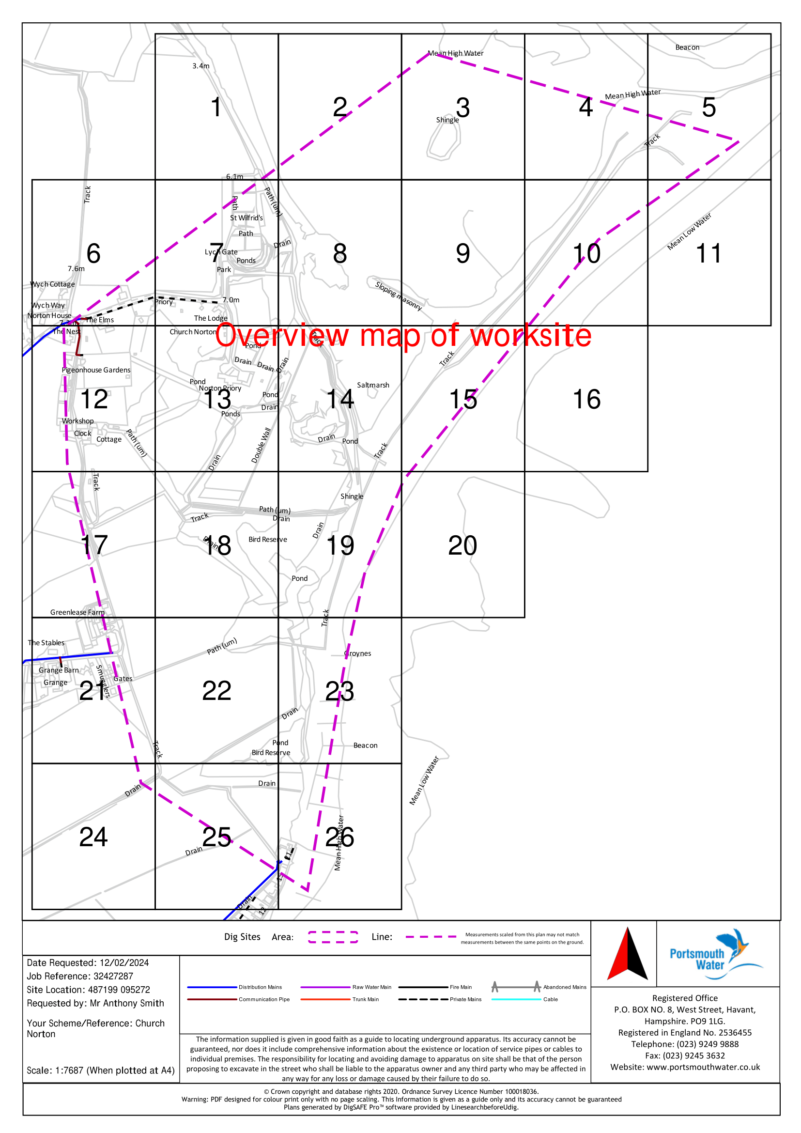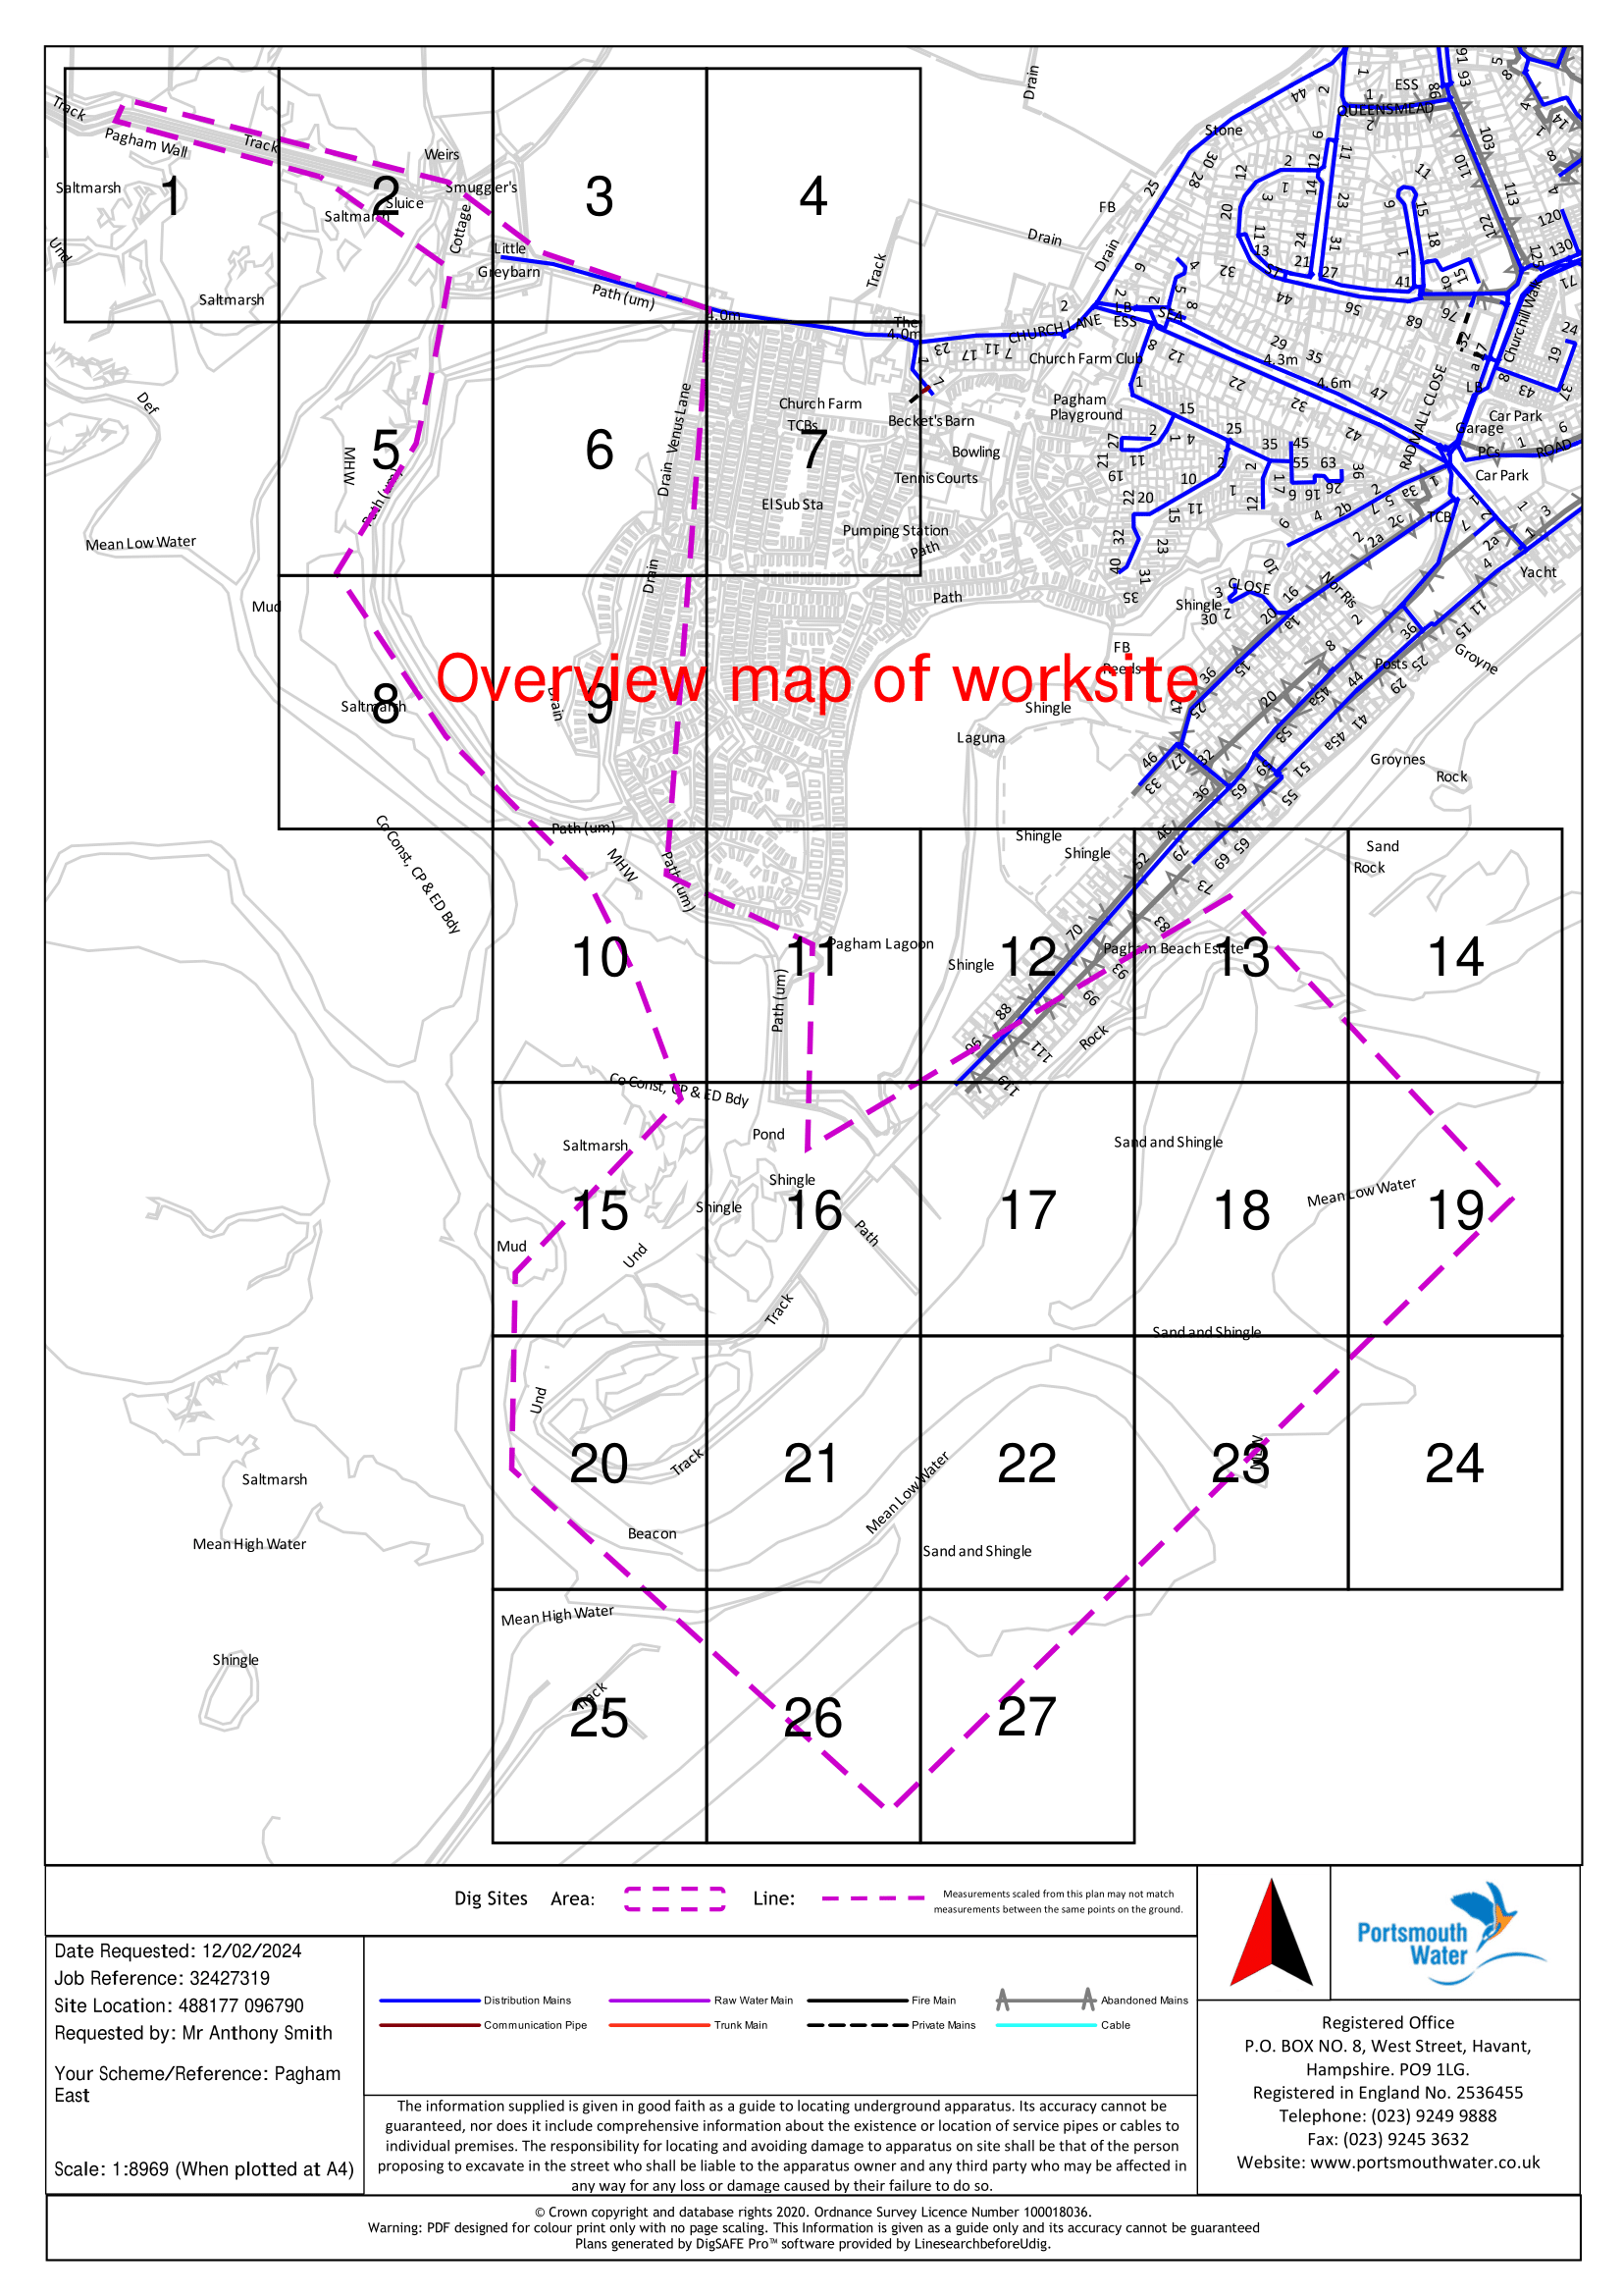Visitor Centre emergencies:

The most senior member of staff on duty has complete discretion to close the visitor centre as needed.

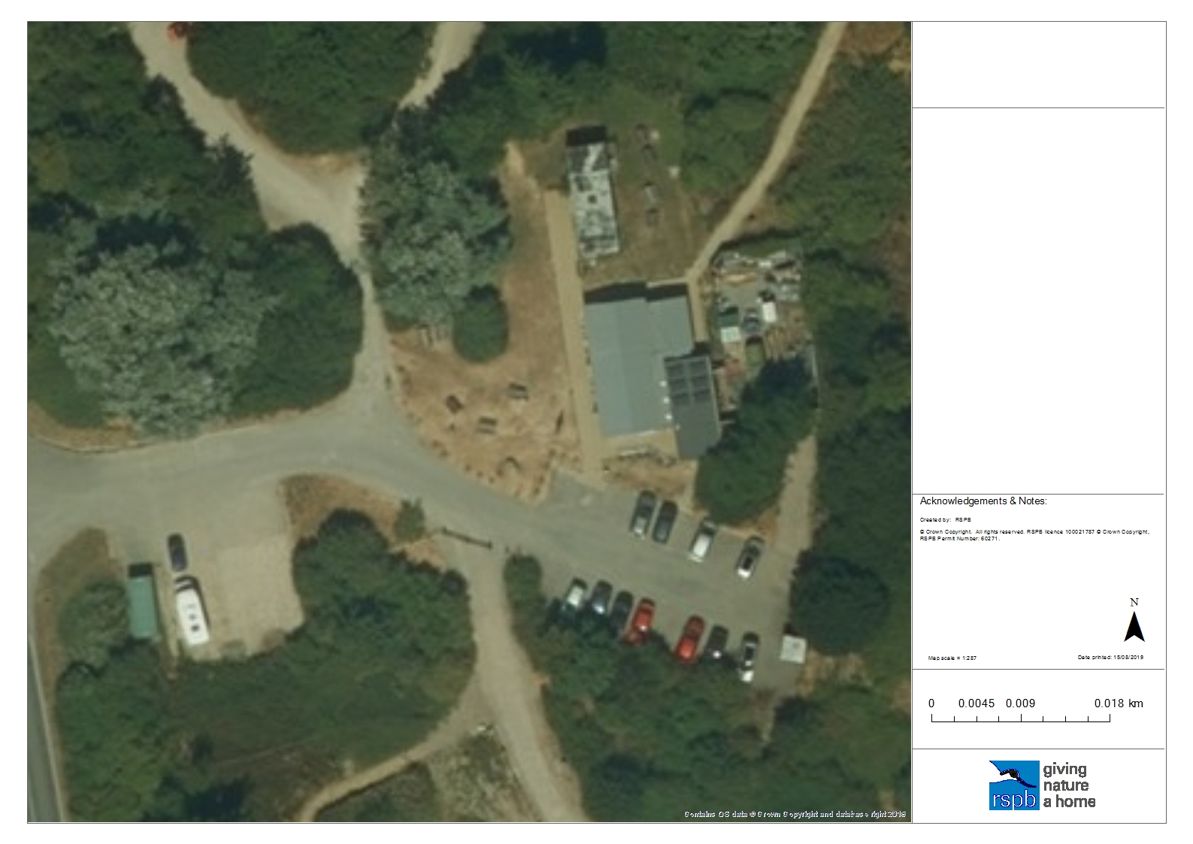
Surface drain grill

Inspection chamber

Downpipe

Downpipe ending in a water butt

Surface “open” drain

Estimated run of pipes

Sink outflow to outside drain
?
RSPB Pagham Harbour LNR
Surface drainage plan, 2019
?

Water supply stop cocks

1. Mains supply from road.

2. Stopcock under sink in
office kitchen. Also stop
valve for outside tap in
corridor to the right-
hand side of the desk.

3. Stopcock for toilets in
gent’s toilet.

4. Stopcock for classroom
under sink. Requires the
moving of a drawer unit.
2
1
RSPB Pagham Harbour LNR
Water supply plan, 2019
3
4
All pipework runs are indicative only

Emergency contacts: (to be treated as CONFIDENTIAL)

Wardens during working hours – Anthony Smith 07710 760408
Luke Parham 07525 802662
Richard Hackett 07540 013151
Site Manager in working hours – Adam Taylor 07738 029327
Site Manager out of working hours 07891 989738
Visitor Experience Manager (VEM) – Roy Newnham 07703 885322
Community Conservation Ranger – Gail Richens 07709 627095
Office during working hours – 01243 641508

Area Manager during working hours – Yianni Andrews 07531 337450
Operations Director in working hours – Debs Fraser 07901 804018

Sussex Fire & Rescue 999/112
Ambulance Service 999/112
Sussex Police 999/112
Coastguard 999/112 For non-emergency – 02392 552100

Environment Agency (pollution, spills etc) 24hr Hotline – 0800 80 70 60
Natural England (anything affecting the SSSI) office hrs only – 0300 060 3900

Other useful numbers:

Office alarms Christie Intruder Alarms (CIA) 02392 265111
Sewerage alarm (Tank full) Cleaning Services Group (CSG) 01243 783899
Sewerage alarm (Pump issue) Arun Pumps 01903 776447
Out of hours emergency (see note on box) 07887 500195
Cleaners BCB 01243 512 536
APP Bikes Director – Simon White 01892 320257
07753 837947
Arun District Council Waste & recycling 01903 737754
Environmental Health & Dogs 01903 737755
Chichester DC Dog Warden (Jo Dixon) 01243 785166
Community Warden Selsey (Neil) 07768 206974
Community Warden Medmerry (Drew) 07825 681547
Coastal Officer (Martin Gillham) 01243 672133
Bin emptying BIFFA (account no R32183) 0800 601 601
Ice cream supplies Caroline’s Dairy 01243 641001
Photocopier Ricoh UK Ltd – Account no 1457213444 08457 44 55 65
Contract no 22485662 0330 123 0311
Coffee Machine Bewleys 01494 436426
Dumped car removal SRC Recycling Ltd 01243 542380
Electrical problems Bradley Electrical 01243 850428
Fire extinguishers West Sussex Fire & Rescue 01243 772870
Injured wildlife Brent Lodge 01243 641672
RSPCA 0300 1234 999
Plumbing issues SIR Services (Rob Fogden) 01243 641794

Other useful number: (continued)

Pest Control Contract with Arun DC (Tony Wicks) 01903 737755
Chichester Harbour Conservancy Harbour Office 01243 510985
Radio problems Adur Communications (Phil) 01903 879526
RNLI Non-emergency – Community Safety Volunteer 07790 485734
Emergency – via 999/112, ask for Coastguard/RNLI
Rights of Way issues WSCC Access Ranger (Kathy Eels) 01243 777620
Sussex Wildlife Trust (Ferry Field) Mark Monk-Terry 01273 492630
RSPB Regional Office (SERO) – Brighton 01273 775333
Toilet supplies PHS Direct (account no 263367) 01827 255500
Vehicles Transport Manager @ the Lodge 01767 693528
Servicing through CLM 01908 219319
MOT booking 01908 219219
Travellers Liaison Officer @ WSCC 01243 642139
West Sussex CC 24hr emergency line for trees on roads 01243 642105

For other reserve contacts, such as tenant farmers or graziers, please refer to the agreements and “Exchanges of Information” in the Compliancy folders.

For other RSPB contacts such as Land Agency, Conservation or Ecology use the relevant intranet pages or searches.

