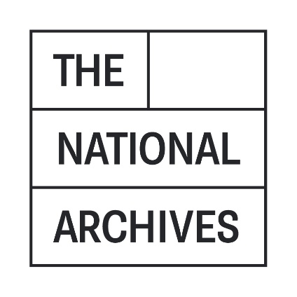

CLOSING DATE FOR SUBMISSIONS – 5PM (UK TIME), 7 October 2021
CLARIFICATION QUESTIONS AND RESPONSES

The National Archives has received a number of clarification questions relating to this opportunity. Those questions, and their associated responses, can be found below.

Q1: Which Network are you currently with?
A1: As mentioned on the ITT our current Network Provider is EE [3.3]

Q2: Are you with this Network director or through a telecoms provider?
A2: This is through an agreement directly with EE (part of the BT Group) [3.3]

Q3: Are you looking to move away from this network if so why?
A3: We are not necessarily looking to move away from this Network Provider, we are submitting this Tender request as our current contract will expire shortly.

Q4: Would The National Archives be open to using a procurement framework such as RM3808 or negotiate the terms and conditions for this contract?
A4: We are aware of the procurement framework RM3808, however have chosen to publish this opportunity via Contracts Finder because we want to ensure we are open to all potential suppliers on this occasion. Our terms and conditions are available on the Tender document via this link here but if you have any suggested alterations then please detail this in your submission clearly.

Q5: The link in Section 8 of the ITT document appears to refer to a general “short form” contract for public sector suppliers, not specifically mobile?
A5: That is correct.

Q6: Would you be prepared to accept a contract via one of the CCS mobile-related frameworks (e.g. Lot 10 or Lot 6) or accept a supplier contract on our standard terms and conditions?
A6: We are aware of the procurement framework RM3808, however have chosen to publish this opportunity via Contracts Finder and therefore the contract will be on our standard terms. However, if you propose using your standard terms and conditions, then please detail these clearly in your submission and show how they differ from our standard terms. Your proposal will be evaluated and scored under the Quality criteria; at the sole discretion of TNA, any proposed terms which are deemed advantageous to TNA (compared with our standard terms) may attract additional Quality scoring points and any proposed terms which are deemed disadvantageous to TNA (compared with our standard terms) may have Quality points deducted.

Q7: Do you have any figures for the data usage across the mobile estate for the last 12 months, broken down monthly?
A7: Our data usage for 2020-2021 was 203.82GB over 12 months which works out as an average of 16.98GB per month.

Q8: Are the existing handsets / iPads locked to the EE network?
A8: Some of our handsets are locked however we will be asking for these to be released at the end of the contract.

Q9: The T&Cs link in the document takes me to gov.uk website and there are a lot of T&Cs on the page but not that directly relates to the National Archives.
A9: The link on the Invitation to Tender directs you to the standard Government terms and conditions for Services. Our contract mirrors this almost exactly, but for your information, I have attached a copy of our standard contract template.

Q10: To understand more about your Mobile calling profiles, can you provide usage data please?
A10: Our data usage for 2020-2021 was 203.82GB over 12 months.

Q11: What proportion of your Mobile users calls are to internal colleagues?
A11: We do not have figures on the proportion of calls to internal colleagues but we do estimate this to be very low as we use a mobile unified communications platform.

Q12: What proportion of your Mobile users calls are to National Archives non geographic numbers?
A12: Over the last 12 months we have had 17 instances of calls to “03” prefix numbers; we very rarely incur additional charges for non-geographic calls.

Q13: Can you confirm how many sites you have for the roll out to consider?
A13: Our roll out is over one site only.

Q14: Would it be acceptable to provide our own terms and conditions as part of our response? We suggest our own as these are more suitable for the provision of Mobile Communication services whereas the Short Form Contract is generic.
A14: If you propose using your standard terms and conditions then please detail these clearly in your submission and show how they differ from our standard terms. Your proposal will be evaluated and scored under the Quality criteria; at the sole discretion of TNA, any proposed terms which are deemed advantageous to TNA (compared with our standard terms) may attract additional Quality scoring points and any proposed terms which are deemed disadvantageous to TNA (compared with our standard terms) may have Quality points deducted.

Q15: What Framework are you looking to procure through?
A15: We are not procuring through a framework for this tender.

Q16: If Network Services 2 the maximum contract period is 36 months with no extensions allowed.
A16: Please see the previous answer.

Q17: Could you please define what you mean by Aggregate vs Shared tariff options?
A17: Shared data is that there is a collective data allowance that can be used over all users regardless of how many users are added i.e. 200GB data shared over 50 users. Aggregated data means that data capacity is based on individual users rather than collectively so if additional users are added then additional data is added to the collective package i.e. 50 users = 200GB to share, 55 users = 250GB to share etc.

Q18: Are you wanting devices or not as 5.8 asks for our tech-fund options? If you are where on the commercial spreadsheet would you like the tech fund to go?
A18: We are not looking for devices at this time. Please stipulate either on a supporting document or on “additional costs” section of the spreadsheet [R8, R9 + R10].

