Tendring District Council

RFQ Specification

VIABILITY STUDY RELATED TO THE TENDRING COLCHESTER BORDERS GARDEN COMMUNITY DEVELOPMENT PLAN DOCUMENT

^{5th} August 2022
Version 0.1

Our Vision
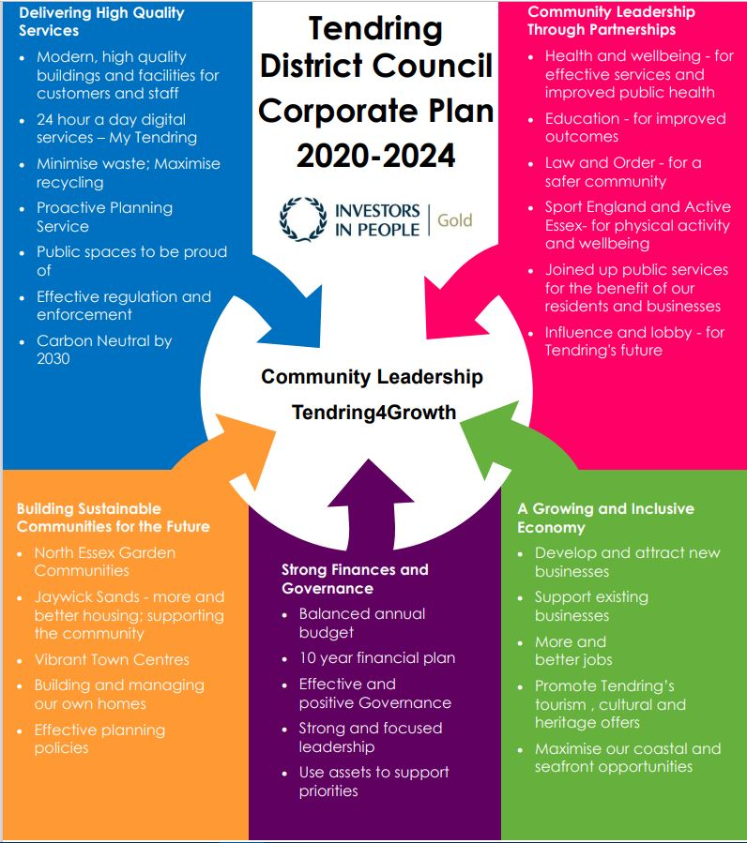
To put community leadership at the heart of everything we do through delivery of high quality, affordable services and working positively with others.

Our Values
♦ Councillors and staff uphold personal integrity, honesty, and respect for others
♦ Innovative, flexible, professional staff committed to delivering excellence
♦ Recognising the diversity and equality of individuals
♦ Working Collaboratively

- Specification

Introduction
Tendring District Council and Colchester Borough Council in partnership with Essex County Council (the Councils) seek to appoint consultants to undertake a viability study related to the preparation of the emerging Tendring Colchester Borders Garden Community Development Plan Document (DPD). The study will:
- advise the Councils on viability of the policies and land use proposals as set out in the DPD in accordance with national policy and guidance.
- to test and provide evidence that the proposed infrastructure and policy requirements are viable, to form background evidence for consideration via an Examination in Public of the DPD.
In 2021, Tendring District Council (TDC) and Colchester Borough Council (CBC) both agreed to formally adopt the ‘North Essex Authorities’ Shared Strategic Section 1 Local Plan’ (Section 1 Local Plan(External link)) which, amongst other things, identifies the broad location of the Garden Community and sets out the Strategic Policies and the overarching requirements and expectations that it will need to meet.
The Councils are working towards a masterplanned approach to the development alongside the DPD as a policy document, which will generate a proposed spatial approach informed by both technical evidence and community/stakeholder engagement. The Draft DPD (Our Draft Plan for the Garden Community | Creating a Place for Life (tcbgardencommunity.co.uk) was subject to consultation in Spring 2022. The Publication version of the DPD is intended to be finalised by the end of 2022 with an Examination in Public in 2023. Sitting alongside the DPD, will be an illustrative strategic masterplan which will be used to provide evidence regarding land uses, site capacity, infrastructure requirements and phasing.

Site to be appraised
The viability study will relate to the proposed Tendring Colchester Borders Garden Community (TCBGC) to be allocated in the DPD. (shown in Appendix A and B).

Background
The TCBGC is a joint project between Tendring District Council, Colchester Borough Council and Essex County Council. It is a planned new community, which will be a sustainable and attractive place to live, work and visit. It is based on Garden Community principles. Section 1 of the North Essex Authorities shared Local Plan, as adopted by the Colchester and Tendring Councils, provides between 2,200 and 2,500 homes, 7 hectares of employment land within the Plan period as part of an expected overall total of between 7,000 and 9,000 homes and 25 hectares of employment land to be delivered overall.
The Garden Community will also provide transformational infrastructure, such as a new link road between the A120 and A133 and a new Rapid Transit System for new and existing residents (with funding from the Housing Infrastructure Fund). Development will take place over many years with an ‘infrastructure first’ approach to delivery. This will see key facilities and services provided alongside the new homes.
The TCBGC is part of a long-term vision of the Councils to help meet the future growth of the area in a more strategic way. This involves embedding innovation and sustainability in all aspects of planning for the future.

Core Objective
- To undertake a viability assessment in relation to the TCBGC site, that considers all policy requirements as set out in the Development Plan Document, is robust and meets the requirements of the National Planning Policy Framework and Planning Practice Guidance.

Scope
- Using an appropriate model, undertake a viability assessment of the scheme.
This should provide an assessment of the viability of the scheme as whole taking into account:
  - a range of land uses such as residential (including build to rent and care homes), employment (including each individual business park), retail and leisure;
  - Infrastructure and policy requirements;
  - Any other policies contained in the DPD having an influence on scheme viability; and
  - Scheme phasing.
The above should take into account a review of the overall value of the proposals set against all costs, making suitable allowances for other policy requirements such as affordable housing and matters set out in the infrastructure delivery plan.
- Provide input to the masterplanners in relation to viability considerations during the preparation of a strategic masterplan and which will ultimately provide the basis for the final viability assessment.
- Provide commentary on the approach to overall deliverability, taking into account the nature of the scheme, the anticipated timescale over which it will be delivered and the range of potential mechanisms that would be expected to be deployed to fund the infrastructure.
- Potentially provide evidence in relation to viability and deliverability at the Examination in Public (to be determined at a later date, and to be costed based on day rates for any additional work).
- Potentially support the Councils in viability related discussions with the scheme developers (to be determined over time, and to be costed based on day rates for any additional work).

Methodology
Considerable work has already been undertaken to consider the viability of the scheme as part of the North Essex Authorities Shared Section 1 of respective Local Plans. This was thoroughly considered as part of the Examination in Public which occurred from 2018-2020. Through this process, the Tendring Colchester Borders Garden Community was considered to be viable and deliverable and is now defined in adopted Local Plans by both CBC and TDC.
Consultants should fully review this previous work and firstly consider whether certain information and assumptions that have already been debated are suitable to be carried forward. Should the consultants consider alternative assumptions to be appropriate, a clear and robust rationale will be needed to justify deviation from previously approved positions. Some assumptions will clearly have changed since the previous work (for example in respect of cost and value inflation) and will require updating. It is important to note that the Section 1 process was also considered against previous versions of the National Planning Policy Framework and evolution of guidance as set out in the National Planning Practice Guidance.
The overall assessment should meet the requirements of the current National Planning Policy Framework and, in particular the Planning Practice Guidance Note on viability; which sets the government’s recommended approach to a viability assessment.
As a minimum the Consultants will be required to:
- Review all existing material (including analysis and evidence base material relating to the site form the North Essex Shared Section 1 and to the Draft DPD).
- Compile and maintain a list of key assumptions that will be deployed in the assessment process, with an explanation of their rationale and sources.
- Liaise closely with a client group containing Officers from the Councils and obtain sign off as the work proceeds.
- At an early stage populate a suitable viability appraisal tool with the best currently available data (anticipated to relate to the analysis of site capacity as per the existing work on masterplan options and infrastructure costings work), to begin to understand the viability position from the outset of the commission.
- Engage with landowners, developers, and infrastructure and affordable housing providers to secure evidence on costs and values to inform the viability assessment.
- Provide advice and input to the masterplanning team on key viability influences and considerations that can be considered as part of preparing the strategic masterplan.
- Prepare an interim position on viability suitable to be published and taken to a meeting of the Joint Committee overseeing preparation of the DPD to give an indication of project viability, anticipated to be required around September 2022.
- Provide final deliverables to be published and taken to a meeting of the Joint Committee to provide background evidence to support the final DPD and its submission to PINS, anticipated to be required around December 2022.
The viability assessment should conclude with a professional and robust assessment of overall viability, based upon understood and reliable metrics for projects of this scale and nature. It is anticipated that this will need to consider whether a traditional comparison of residual land value to benchmark land value is appropriate and/or alternative metrics should be considered (such as Internal Rate of Return or other).
The above analysis should also be set out in a clear and easily understood executive summary. The information will need to be suitable to act as a benchmark for future viability assessments.

Key Outputs
The main outputs the Council will expect from the assessment are:
- A Key Assumptions Log to capture the position on assumptions to be used as part of the analysis.
- An Interim Paper on scheme viability, providing initial summary findings on scheme viability in advance of finalisation of the DPD.
- A final report containing
  - A detailed explanation of methodology consistent with good practice, the NPPF, NPPG and other relevant principles and practices.
  - A clear explanation of the basis of all assumptions, including a robust rationale for any changes from previous recognised positions.
  - A clear summary of the overall position on viability, capable of demonstrating deliverability of the proposal and soundness of the DPD.
  - Some brief commentary on other deliverability considerations, such as setting out how the approach to viability ought be monitored over time, and how suitable funding can be secured, such as through S106, or future Infrastructure levy arrangements.
  - A suitable summary of data/information/extracts of the modelling analysis as an Appendix to enable stakeholders to review the calculations.
- An executive summary should also be produced which summarises the work, and is presented in a simple manner for a non-technical audience in line with the requirements of the NPPG.

Relevant Background Studies
Relevant background reports and indicative concept plans for the TCBGC can be found on the Colchester and Tendring web sites:
Adopted TDC and CBC Shared Section 1
Previous Evidence base and related papers (considering matters pertinent to viability) as considered by the Shared Section 1 Examination in Public
Current policies as set out in the TCBGC Draft Plan (Reg 18)
Existing Evidence Base Related to the Draft Plan (including work on spatial options)

- Timetable

The proposed timetable for this employment for guidance:
Publish RFQ | 05.08.2022
Clarifications | Midday on the 26.08.2022
RFQ Submission deadline | Midday on the 09.09.2022
Evaluations | 12.09.2022 – 22.09.2022
Award notification | 23.09.2022
Contract start | 26.09.2022
Contract end date | TBC between the supplier and TDC

- Payment
Payment to contractors will be made on receipt of invoice AFTER the completion of each works and in accordance with the council’s procurement and payment policies.

- Evaluation Criteria
The RFQ will be evaluated on passing the mandatory requirements, and a submission weighting of 80% Quality (Section A) and 20% Price (Section B).

SECTION A – QUALITY – 80% Weighting

Quality Technical Questions

Scores will be awarded on a 0-5 basis and then weighted in accordance with the table below.

If on any question you score below 3, this will classify as a failed score and a failed bid overall.

Scoring Methodology Table A:

0 | Wholly Unsatisfactory - No response or the whole response is irrelevant to all of the question and evaluation criteria.
1 | Unsatisfactory - The response only covers a minor element of the question and evaluation criteria and lacks relevant evidence regarding competence, capacity, and ability to successfully fulfil the requirements of the question.
2 | Partially Acceptable - The response covers more than one element of the question and evaluation criteria but lacks relevant evidence regarding competence, capacity and ability to successfully fulfil the requirements of the question.
3 | Acceptable - The response addresses most of the question and evaluation criteria but some areas contain limited relevant evidence regarding competence, capacity, and ability to successfully fulfil the requirements of the question.
4 | Very good - The response fully addresses the question and evaluation criteria and provides relevant evidence regarding competence, capacity, and ability to successfully fulfil the requirements of the question.
5 | Outstanding - The response fully addresses the question and evaluation criteria and provides relevant evidence regarding competence, capacity and ability to successfully fulfil the requirements of the question and goes beyond expectations to offer an outstanding level of performance or an additional benefit which exceeds specified requirements.

The following parameters are shown as a guide to the scoring:
The total score for each Technical Question statement scored will not exceed 5 and will carry equal weight. There are mandatory minimum assessments set out below; failure to reach these scores in anyone may result in a failure mark and the consultant will be excluded before price evaluation takes place.

Questions 1-3 | Mandatory Minimum
Q1 – Technical Question 1 | Score 3 – Satisfactory Response
Q2 – Technical Question 2 | Score 3 – Satisfactory Response
Q3 – Technical Question 3 | Score 3 – Satisfactory Response

Technical Evaluation  80% | Question | Evaluation Criteria | Weighting
1. | Please give full details of your understanding and how you would proceed with the brief. Including robustness and suitability of the proposed approach / methodology.  Please give examples of work that you have completed to a high quality that corresponds with the requirements of the brief. | A clear understanding and interpretation of the tasks identified within the brief. Including robustness and suitability of the proposed approach / methodology.  Proven track record in delivering high quality work that corresponds with the requirements of the brief – ability to demonstrate work that has been scrutinised via similar Examination in Public processes with related Local Plans / DPD being found sound. | 55%  Scoring methodology: Table A (please see pg 3)
2. | Please detail the skills and experience of your team, and please give examples of similar work you have carried out. | Relevant knowledge, skills and experience of the team and experience within the team of undertaking similar commissions. | 15%  Scoring methodology: Table A (please see pg 3)
3. | Please detail your suitability of the proposed project management and quality control arrangements. | Suitability of the proposed project management and quality control arrangements. | 10%  Scoring methodology: Table A (please see pg 3)

Documentation
Consultants should prepare a tender response incorporating the following:

- Narrative outlining your understanding of the tasks set out in the Specification of Requirements and your timeline for completion.
- Proposed approach/methodology and detailed work programme
- Breakdown of days and costs for each consultant set against the principal tasks identified.
- Day rates for any potential subsequent work.
- Details of how any sub-contracted work will be managed
- Statement on quality assurance.
- Experience, skills, team CVs.
- Details of appropriate referees who may be contacted.
- Evidence of appropriate insurance including professional indemnity.
- Please state if you are a Small or Medium Enterprise (SME) or Voluntary, Community or Social Enterprise (VCSE).

Tender responses should be provided as either Word or PDF format using Arial font size 12, and be no longer than 6 pages of core content (excluding a cover page, index, individual CV’s and insurance details).

Project Management
The Council’s Client Team will be led by Gary Guiver (acting Director of Planning) and a nominated lead Officer/representative to act as a day-to-day contact on the work. Consultants should identify their nominated Project Director and Project Manager as part of their submission.

Programme of Work
Consultants should specify the process/methodology to be used in the completion of each of the tasks identified in the Specification of Requirements. Consultants should also identify any anticipated risks and/or constraints in delivering the outputs required and outline their proposed solution(s) to mitigate these factors. Any further general measures identified that may assist in achieving the objectives of this work should be identified separately.

Consultants will need to schedule and accommodate regular meetings with the Council’s Client Team as part of their programme of work

Performance and Quality
The Council expects all work it commissions via consultants to be of the highest quality in terms of intellectual content and accuracy, as well as presentation. Consultants should include in their submission a Statement demonstrating how they will achieve high quality outputs and who will be accountable for the review of outputs prior to their submission to the Council.

TDC’s Contractual Arrangements
The successful consultants will be obliged to adhere to the Council’s terms and conditions of contract. The Council’s STANDARD DRAFT FORM OF CONTRACT FOR SERVICES is attached at Appendix C.

The fee will be exclusive of VAT. No price fluctuations will be allowed unless agreed in advance by the Council’s Client Director.

Further Information
For further information about this commission please direct any enquiries by email to tendringdc@essex.gov.ukby the closing date for questions of 12:00 noon on 26.08.2022. All questions will be collated, and responses published on the Council’s website (Doing Business with the Council – Opportunities) and Contracts Finder as soon as possible after that date, alongside the original Request for Quotation document.

SECTION B – PRICING – 20% Weighting

A pricing matrix spreadsheet has been included as part of the RFQ documentation issued (Appendix E).

This pricing matrix spreadsheet is separated into two elements:
Removal, Supply and Fit - 80% Weighting and Additional Prices - 20% Weighting,
which creates the overall 100% price.

The Additional Prices are to be called off of the contract for three years, from the contract start date – three years. The contract start date is subject to discussion and confirmation with the awarded bidder. The prices that are input in the Additional Prices are fixed for the term of the contract.

Please complete the spreadsheet as per the instructions stated within the document and return the completed spreadsheet as part of your RFQ submission.

All prices should be exempt of VAT and include any additional costs.

For more information, please refer to the Tendring RFQ – Appendix A.

- The Authority’s Policies & Statements

The bidder will need to adhere with the below policies and statements.
- Data Protection (please see Appendix D)
- Freedom of Information (please see Appendix F.

Modern Slavery
The bidder self-certifies that they are taking steps to ensure that there is no modern slavery or human trafficking (as defined in the Modern Slavery Act 2015) in their organisation or supply chain relating to the requested services/supplies requirements.
Here is a link to the Act: http://www.legislation.gov.uk/ukpga/2015/30/contents/enacted

Health and Safety
The bidder self-certifies that they adhere to the Health & Safety at work Act. Here is a link to the Act: http://www.hse.gov.uk/legislation/hswa.htm

Environment
The bidder confirms that they are aware of Tendring District Council’s Environmental Statement, and should they be successful, they are committed to working with the Council fulfil the vision outlined in the Statement.
https://www.tendringdc.gov.uk/environment

- E-procurement requirements
Tendring District Council has a fully automated Purchase to Pay (P2P) system.

The successful bidder will be able to:

- View their orders online;
- Update their status;
- Notify delivery; and
- Submit and monitor the status of electronic invoices, once they have been submitted.

Orders will be sent electronically to the successful bidder’s central e-mail address from the contract start date.

The successful bidder will be expected to submit electronic invoices from the contract start date. On approval of the electronic invoice an automatic payment will be made via BACS, direct to the successful bidder’s bank account supported by an e-mailed remittance advice, in line with Tendring District Council’s contracted payment terms.

- Submission

Return of Submission

Clarification Questions deadline is: 26/08/2022. All clarifications must be to:
tendringdc@essex.gov.uk

The deadline for your submission is 09/09/2022 and must be sent to our locked email address:Tenderbox3@tendringdc.gov.uk Submissions will only be accepted by this method and before the deadline.

Additional copies MUST NOT be submitted in hard copy to any other recipient or member of the Council, or email copied or forwarded to additional email recipients. This is likely to disqualify your submission and could nullify the tender exercise.

There is a receipt limit of 20 megabytes per email on the Council email system. We do not accept files from download sites. For large files you may like to send zip files up to 20Mb per email. here is a large file rejection automated notice set up which will alert you if this is the case.

We also have an automated delivery receipt on these secure email accounts. If you do not receive this response from the Procurement team it is likely that your submission has failed to reach our Server so, please resend and failing that contact procurement@tendringdc.gov.uk

You are advised to allow enough time before the deadline for any delays or errors reaching our server or rejection for oversize etc.
The onus is on you, the responder, to ensure that emails are received by us before the deadline.
The Council does not bind itself to accept the lowest or any quotation/tender.

