Soft Market Test
For
Interactive Artificial Intelligence Chat and Reporting Project
Cambridgeshire County Council
Ref: SladeDyke-Ramsey-KR-2025

Section 1: Introduction

General Requirements
  - The purpose of this document is to briefly explain to suppliers the business and technical requirements and the expected scope of an Interactive Artificial Intelligence (AI) Chat and Reporting Project in order that suppliers can explain the relevance of products, services and their experience to the requirements.

  - Please note: this market testing exercise is not an invitation to tender or a request for formal expressions of interest. This document does not form any part of an invitation to tender. CCC is issuing this request for information only. Any supplier invited to present to CCC is doing so to support market research only and to help make any potential procurement process more focused and efficient. No supplier selection or supplier preference is implied.

Confidentiality and Freedom of Information (FOI)
  - Please note: all information included in this Soft Market Testing is confidential and only for the recipients’ knowledge. No information included in this document or in discussions connected to it may be disclosed to any other party without prior written authorisation.

  - All responses will be treated confidentially. However, please be aware that we are subject to the disclosure requirements of the FOI Act and that potentially any information we hold is liable to disclosure under that Act. For this reason, we strongly advise that any information you consider to be confidential is labelled as such. In the event that a request is subsequently made for disclosure under FOI the request will be dealt with in accordance with the legislation.

Background
  - Cambridgeshire County Council is a Lead Local Flood Authority (under the Flood and Water Management Act 2010) and has the responsibility to manage the following types of flooding:
- surface water flooding - includes internal property flooding from rain runoff from surfaces such as roads, roofs and patios.
- ordinary watercourses - includes flooding from drains and ditches, but excludes main rivers that are managed by the Environment Agency.
- groundwater flooding - includes flooding caused by heavy and continuous rain capable of increasing the groundwater levels.

Our responsibilities as a flood authority include investigating and reporting on significant
flood events in the county that are mostly related to internal property flooding, and establishing actions which may alleviate flooding and promote flood resistance and resilience in communities across Cambridgeshire.

Soft Market Test Timetable
  - Please read this document and if you feel that your organisation is able to contribute to this exercise please complete the survey by following this link by 14 February 2025.

https://forms.office.com/e/5mpMXdJcdZ

  - Potential responders will not be prejudiced in any future procurement processes by either responding or not responding to this soft market test exercise.

Section 2: Identification of Requirement

Current Situation
5.1 Repeated flooding occurs from Slade Dyke in Ramsey where the risk is increased by an ongoing problem of fly tipping which increases in warmer weather and persists into the winter months.

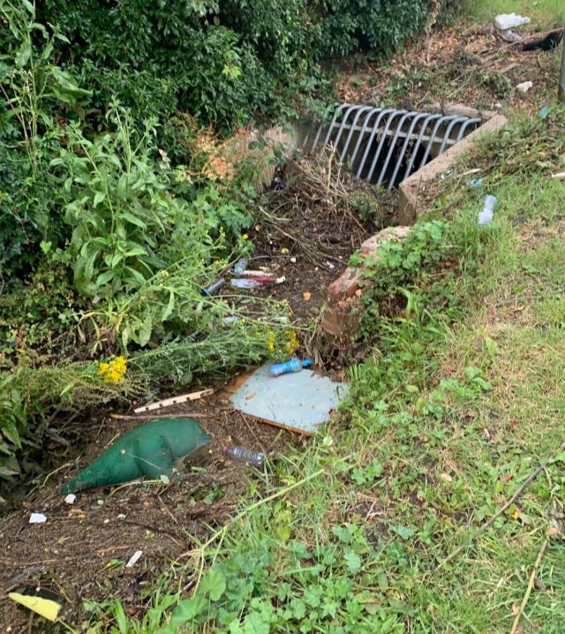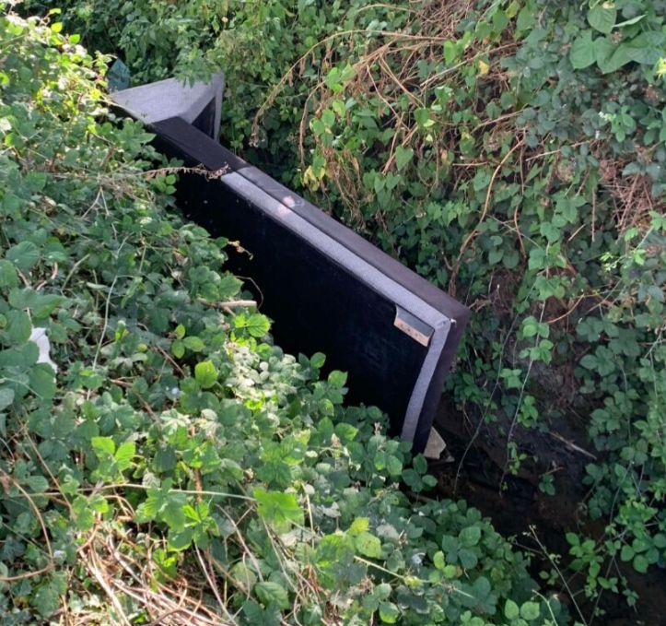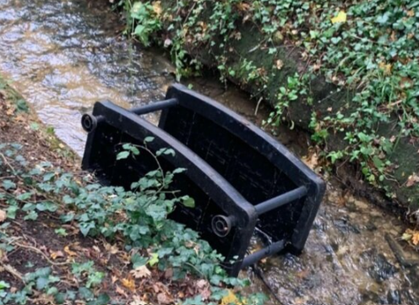
Resident testimonial:
“My neighbour and I cleaned the dyke out the weekend before and aren't able to continue doing it every week, I have a small child and this eats into my time spent with him. The situation is getting ridiculous.” May 2024

Our Requirements
  - We aim to source an AI chat and reporting tool to increase public awareness and assist in tackling fly tipping and increased flood risk associated with this in our pilot location.

By increasing awareness, the project aims to reduce the disconnect between local authorities, residents impacted and residents contributing to the problem.

We are looking for a solution which delivers an AI chat bot that users can be signposted to primarily while outdoors in the affected area, and access immediately and easily on their smartphone, such as via a weblink or QR code. The AI chat will then inform them of the impact of fly tipping on their community in a humanistic friendly but informative way, so they feel like they are chatting with a real person.

The technology will be accessible to a wide age range via smartphones and can also be promoted through local community groups. The system will also give residents the opportunity to report fly tipping to the relevant council authorities, giving them agency in the process of reducing risk.

By adding a reporting tool which can be time coded this allows local authorities to consult CCTV for evidence against fly tippers, this empowers the community further and addresses some mental health and wellbeing concerns.

We are looking for a solution that will:
- Provide an automated community engagement hub (AI chat) accessed by members of the local community via a QR code displayed near the issue (fly tipping / flooding).
- Include sentiment and language analysis built in to give humanistic answers, conversational content makes it accessible to more people in the community.
- Data capture.
- Reporting tool.
- Signage - Printing and installation of signs to display the QR Code and information about the project.

As a minimum requirement, responses must include evidence of previous successful work with AI tools in the community, flood risk, and with Local Authorities, Environment Agency etc.

