

Request for Information
Stonewater Limited

Leadership Development – Values-based coaching style
February 2022
Table of Contents
Introduction 3
Current Position 4
Requirement 5
Replying to the Request for Information 6

1. Introduction
Our significant and progressive house-building programme aims to build a minimum of 1,500 new homes a year from 2022/23 and we have a good pipeline of development to achieve this, driven by our vision of everyone having the opportunity to have a place that they can call home. We plough our surplus into building new homes, improving our existing housing stock and investing in customer services.
We are also the largest management partner for Legal & General Affordable Homes, supporting the organisation in delivering its ambitious development plan of building 3,000 homes by 2022, by leading on Legal & General's housing operations across England.
We recognise that the way we work matters too. We are committed to providing homes that are energy efficient and are working towards Government's targets for carbon neutrality. Our Environment Strategy helps us minimise the resources we use as an organisation and manage our impact on the environment.
Our talented 800+ employees embody our values – being ambitious, passionate, agile, commercial and ethical. Recently, we built on our previous successes and achieved a ‘Two Star’ Outstanding rating in the 2021 Best Companies Top 100 best not-for-profit organisations.
With an annual turnover of around £191 million and £1.8 billion in assets, Stonewater is a strong, dynamic and well-managed social business, with a long-term rating of A+ by independent credit ratings agency, S&P Global Ratings and a top G1/V1 governance and viability ranking from the Regulator of Social Housing.

2. Background to the Requirement
Stonewater has an established Values Based Leadership Model (see Fig. 1) and we have delivered two iterations of Leadership Development based on this model.

Figure 1. Stonewater Leadership model

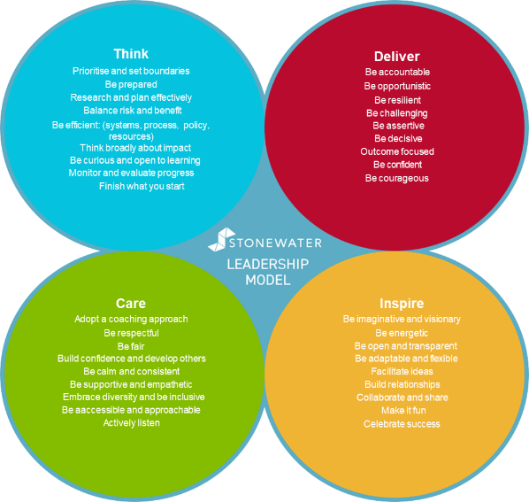

The most recent was our “An Agile Leader” program (see diagram below) designed and delivered by an external partner and specifically designed to support our leaders through the pandemic and the VUCA environment. This program consisted of four modules:
- Ambi-dextrous thinking
- Authenticity
- External Perspective
- Continuous Learning

Figure 2. An Agile Leader model

The audience for this program was our Executive team, our Operational Director Group (ODG) and our Senior Leadership Job House, and consisted of around 80 people. We delivered the sessions virtually via an external provider, supported by additional material hosted on our LMS and created by our in-house L&D team. Following a survey in October 2021, we were able to understand which aspects of the program were effective, what delegates valued about the content and approach and how they would improve it if we were to run another program in the future. (Appendix 1)

3. Current Position

We have recently concluded the rollout of the existing program and are looking to develop a new learning offer for our leaders across the business (approx. 150 people) that aligns to our strategic direction, post-pandemic. We would also be keen to explore how the messages and themes of this new program could be adapted to create a colleague version, addressing the same themes but from a different perspective.
Following a review of recent insight including Best companies survey, Institute of Customer Services (ICS) survey, stakeholder contributions and a review of our People Strategy alongside our Organisation Strategy, we have identified a number of areas that we feel we need to develop capability:
- Working more collaboratively, in a less silo manner, proactively seeking (innovative) solutions to problems that occur across our services
- Team based learning in addition to personal development; encouraging and empowering colleagues to seek the opportunities to learn from mistakes by working together rather than seeking apportion blame
- Coaching and feedback skills where listening rather than telling is encouraged and colleagues’ feel their voice is truly heard; developing the skills of colleagues to find their own solutions and providing the opportunities to learn something new every day
- Engage and inspire others in a shared vision; helping colleagues to see the part they each play in a bigger picture
We are keen to use the concepts of Peter Senge’s The Learning Organisation, in particular Systems Thinking and person-centred approaches to problem solving, to help us design and develop this new program and are looking for a partner who can work with us to achieve this.
As explained, we see this a program having two key strands – one for our Leaders and one for our Colleagues, adapted appropriately for the audiences but with complementary content, which means we are collectively working towards making Stonewater a Learning Organisation.
If we achieve this, we believe the following would represent how it would feel to our colleagues:
- I am able to feedback to others if opportunities/issues rise and know I will be listened to
- I am able to ask for help or guidance and know I will be respected and supported to move forward
- I am able to spot the areas for improvement, raise them and know I will be heard
- I am able to look at the ways we work together with an openness that focuses on the big picture and the roles we all play
- I am able to see the opportunities to learn something new every day, through the day to day

We have an Organisational Capability (OC) team responsible for the diagnosis, development and delivery of learning and capability solutions to the organsiation. This is through a mix of both internal, external and co-delivery approaches. A member of the OC Team would manage the contract with accountability sitting with the Head of OC.
We would anticipate this partnership being for an initial period of 12 months with the option to extend. We would also wish to explore the option to retain the rights to the designed material and program content, to allow for the possibility of internal delivery once the contract has concluded.
Clarifications
If you have any clarification regarding the contents of this document, please contact sarah.newton@stonewater.org

Requirements

- Provide a clear outline of what you can deliver to meet the brief as outlined
- Demonstrate how you would design and deliver content that suits a variety of different delivery methods and learning preferences.
- Provide an outline of delivery options possible, such as a blend of virtual and face to face, that demonstrates alignment and complement our hybrid-working approach at Stonewater
- Content should be aligned to and complement the existing Stonewater Leadership model (Think, Care, Inspire and Deliver) whilst exploring the concepts of The Learning Organisation model (P. Senge)
- Provide an indication of:
  - Budget
  - Required resources
  - Technical applications and solutions available
  - Timescales
  - Design approach – fully bespoke, off the shelf, mixture
  - How you would work with us as a partner
- Demo of sample content that represents what you could provide for us
- Ability to host material, track delegate progress and measure success, preferably linking to our existing learning management system.

Replying to the Request for Information

  - Introduction
Suppliers are asked to complete section 5.2 – 5.5

Requirements Review
Please provide a response against each point in the table below as outlined within section 4, confirming whether you;
- Fully meets requirement
- Partially meets requirement
- Unable to meet requirement
Where a supplier is unable to provide a response that fully meets the requirement stated, more detail is requested in the third column of the table.

Requirement | Response | Additional Comments

  - Indicative Costs
Using the information supplied about Stonewater’s requirement, suppliers are asked to provide potential contract costs. Costs provided are only indicative and will not be assessed as part of any future tender.

Details - Insert types of costs, dependent on the project | Costs (ex VAT.) | Comments
Total

  - Indicative Timescales
Interested parties are required to provide a high level estimate for the delivery of Stonewater’s requirement based on the information provided in this document.
  - References
Interested parties are required to provide three examples from within the past 2 years of projects delivered that match Stonewater’s requirements.
Customer Name | Contact Name and Email Address | Date Project went live | Summary of the project/Requirement

Customer Name | Contact Name and Email Address | Date Project went live | Summary of the project/Requirement

Customer Name | Contact Name and Email Address | Date Project went live | Summary of the project/Requirement

Appendix 1 - Summary of Leadership program feedback
