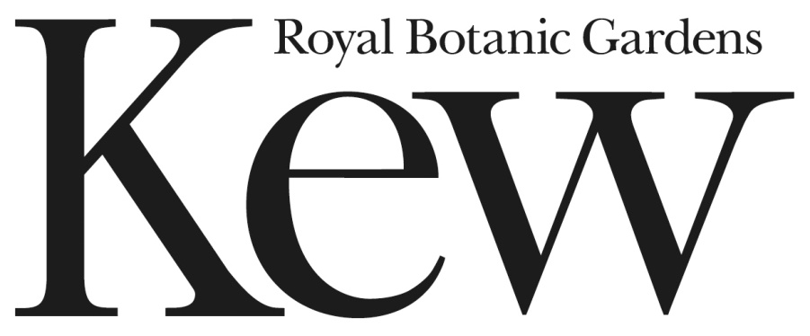

Clarifications v0.2

Clear Topped Archival Storage Boxes

Contract Reference: RBGKEW/357

(This document is for information)

Please see further information below in response to clarification questions received about our requirement.

Question 1: How many orders were placed in the past 6 years?

Answer 1: Six orders have been placed over the past 6 years. One in 2011, two in 2012, two in 2014 and one in 2015.

Question 2: Would it be possible to upload some photographs of the current boxes?

Answer 2: Please see below for photographs of some of our carpological specimens in storage boxes.

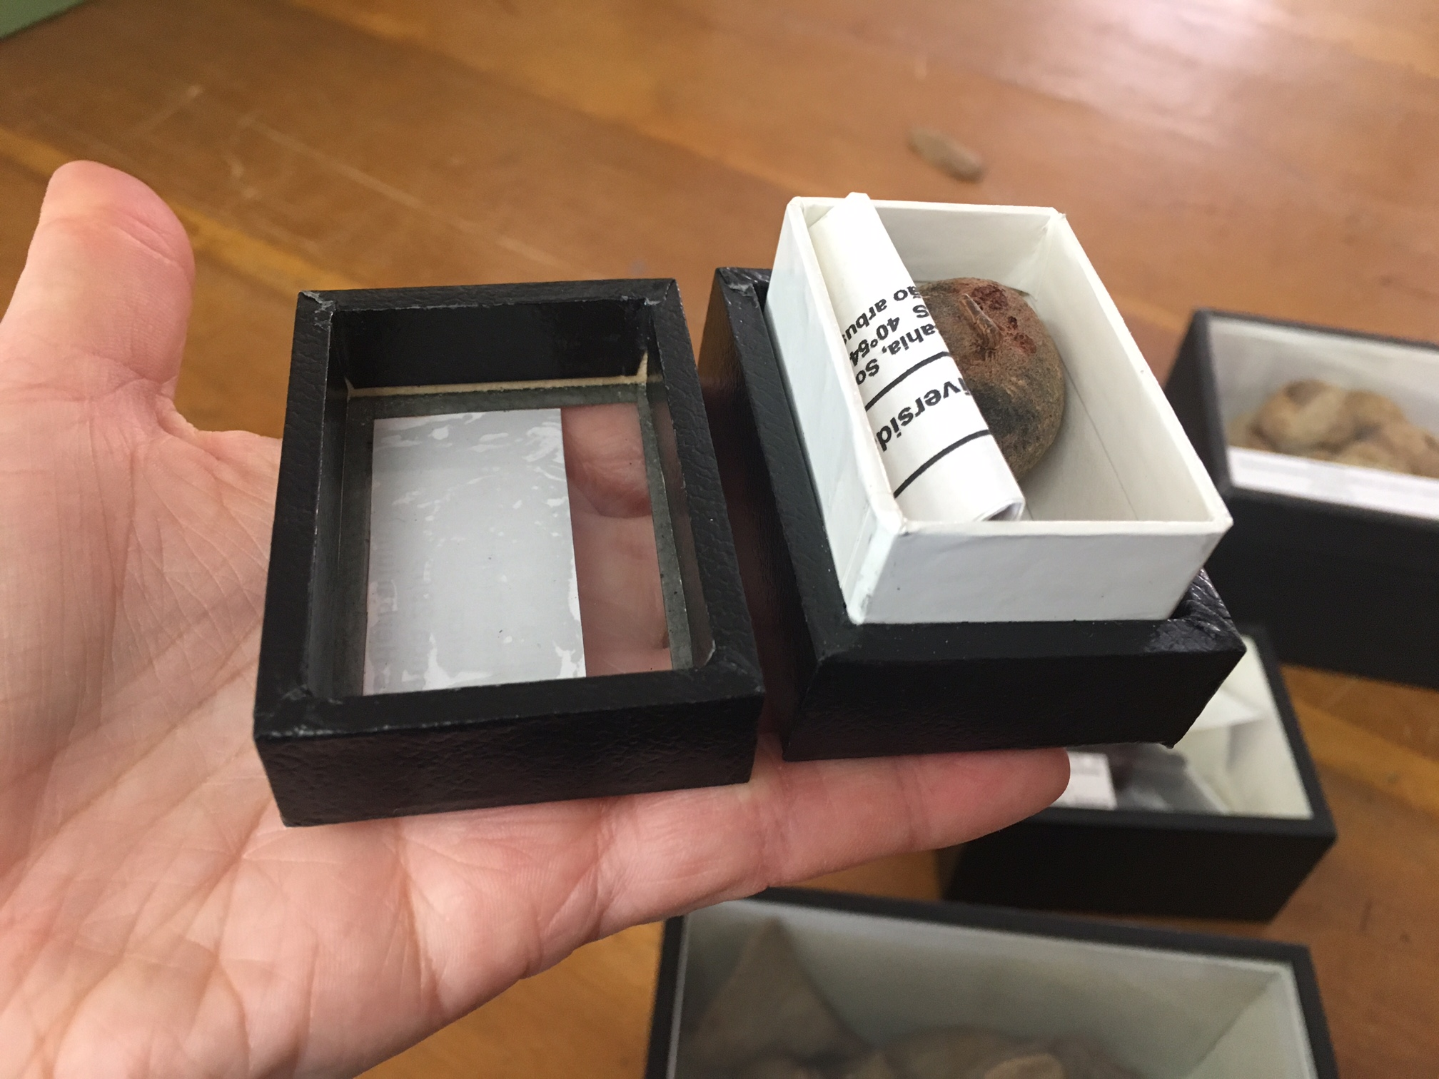

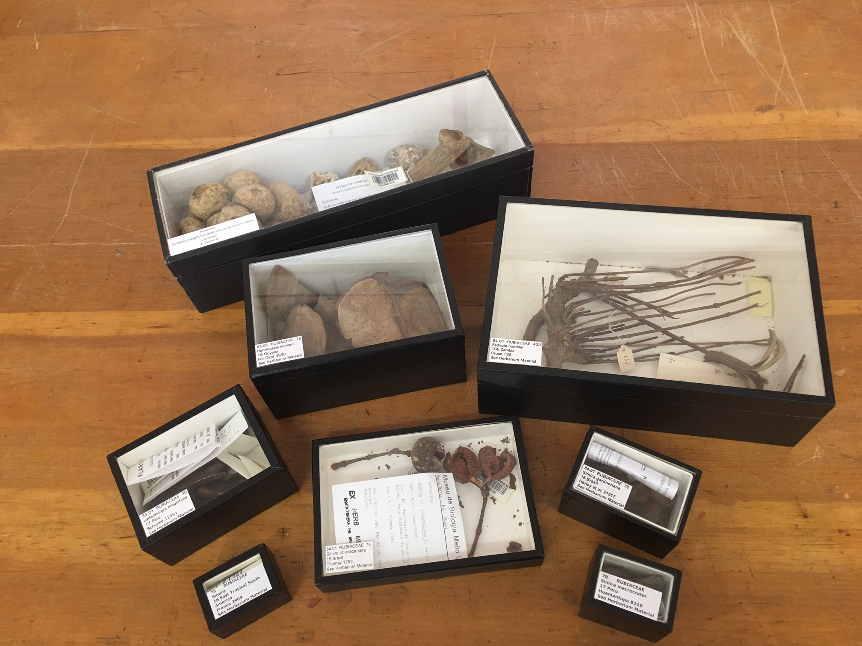

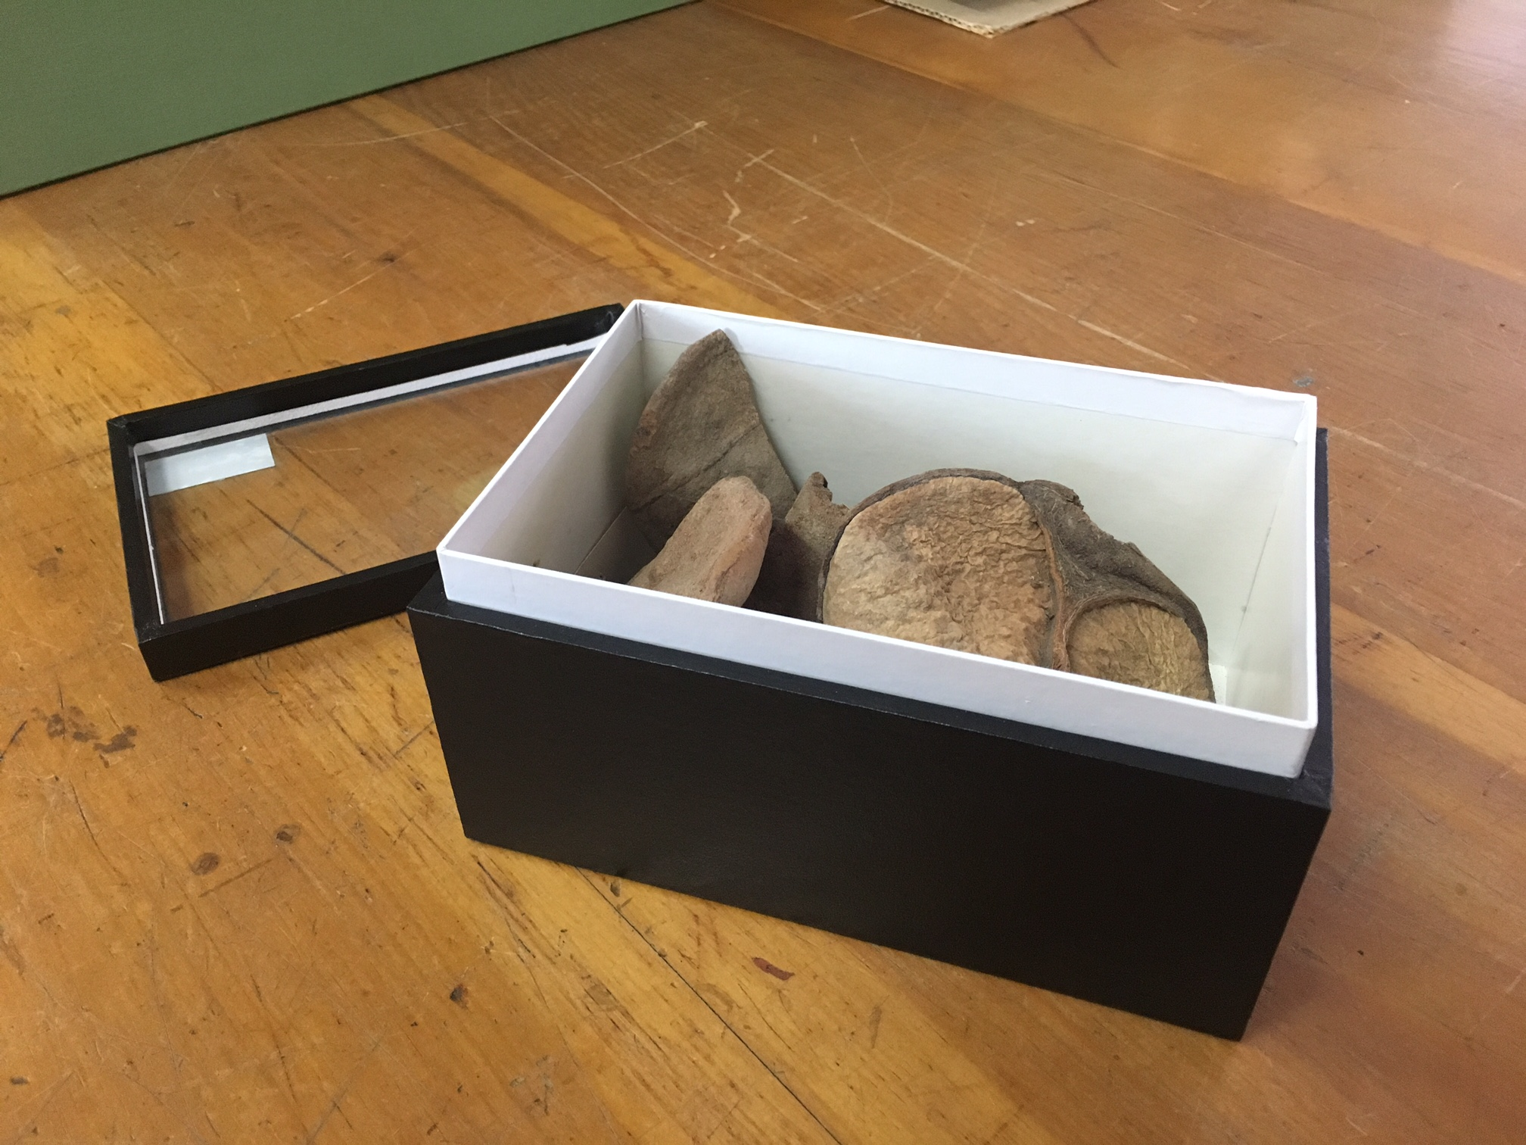

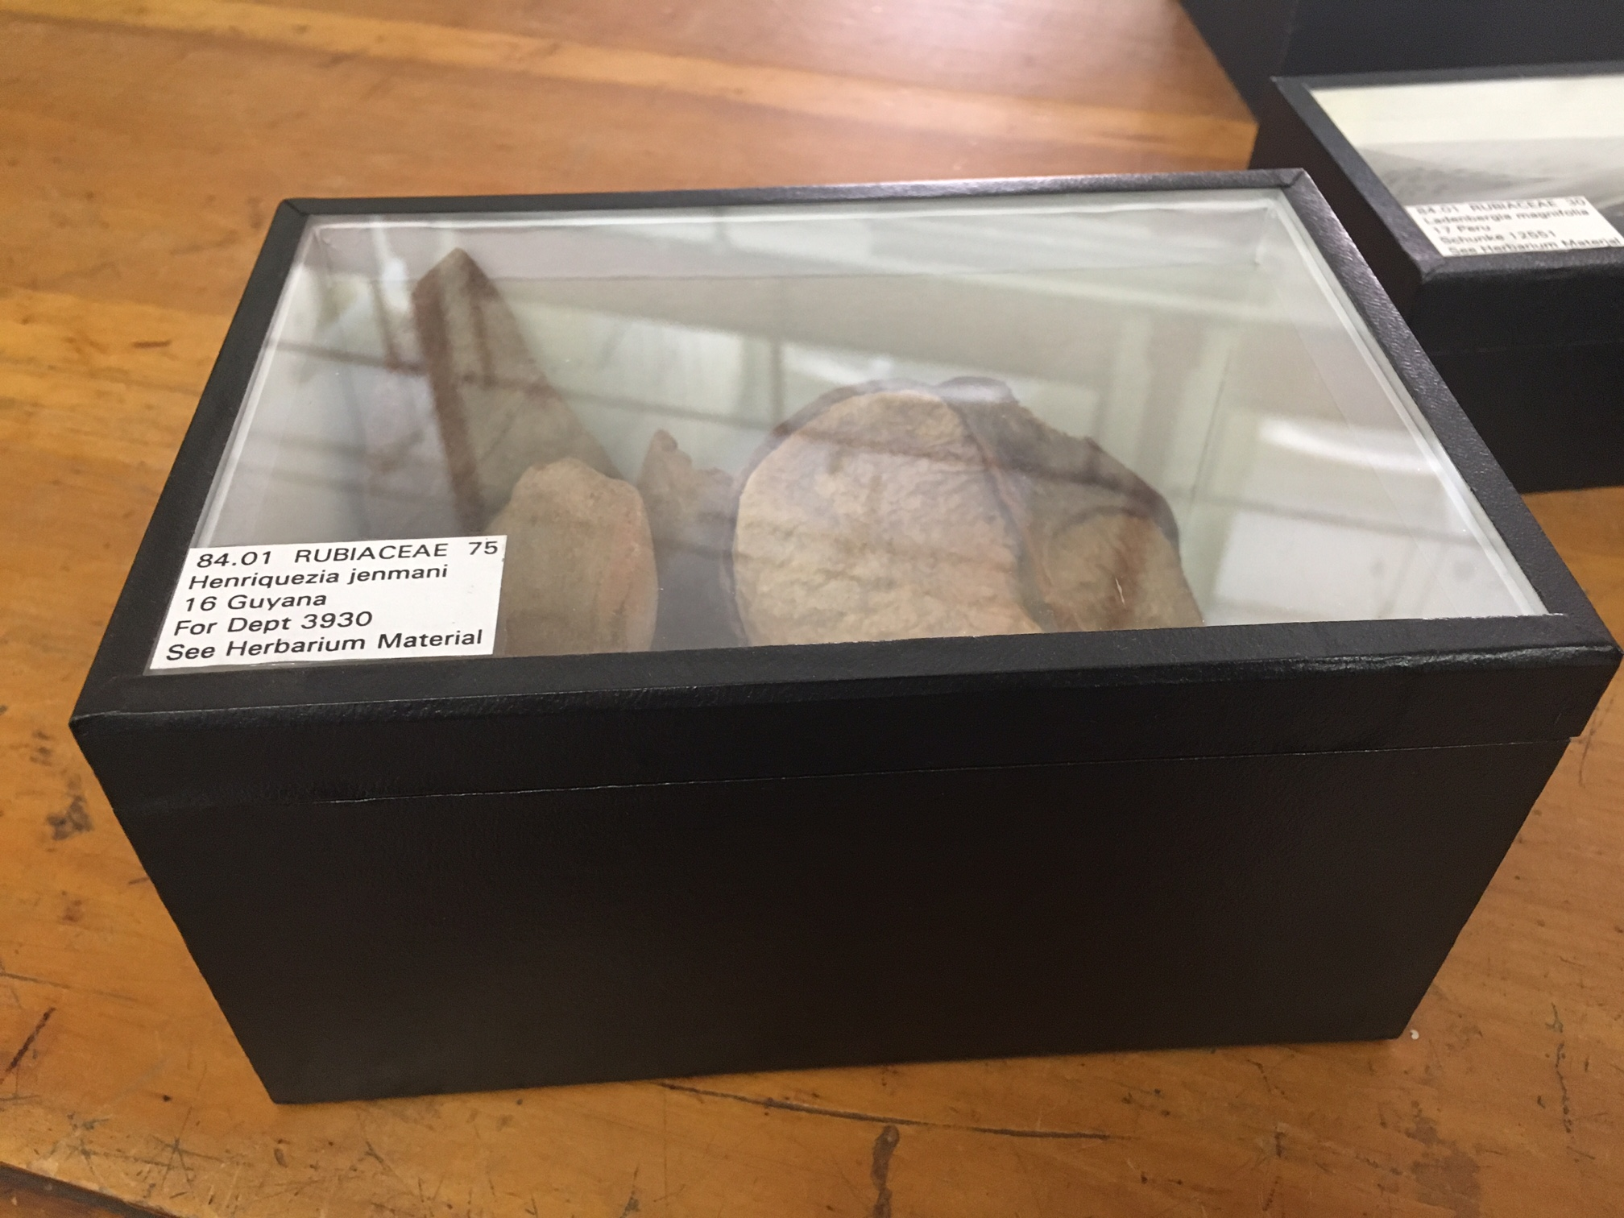

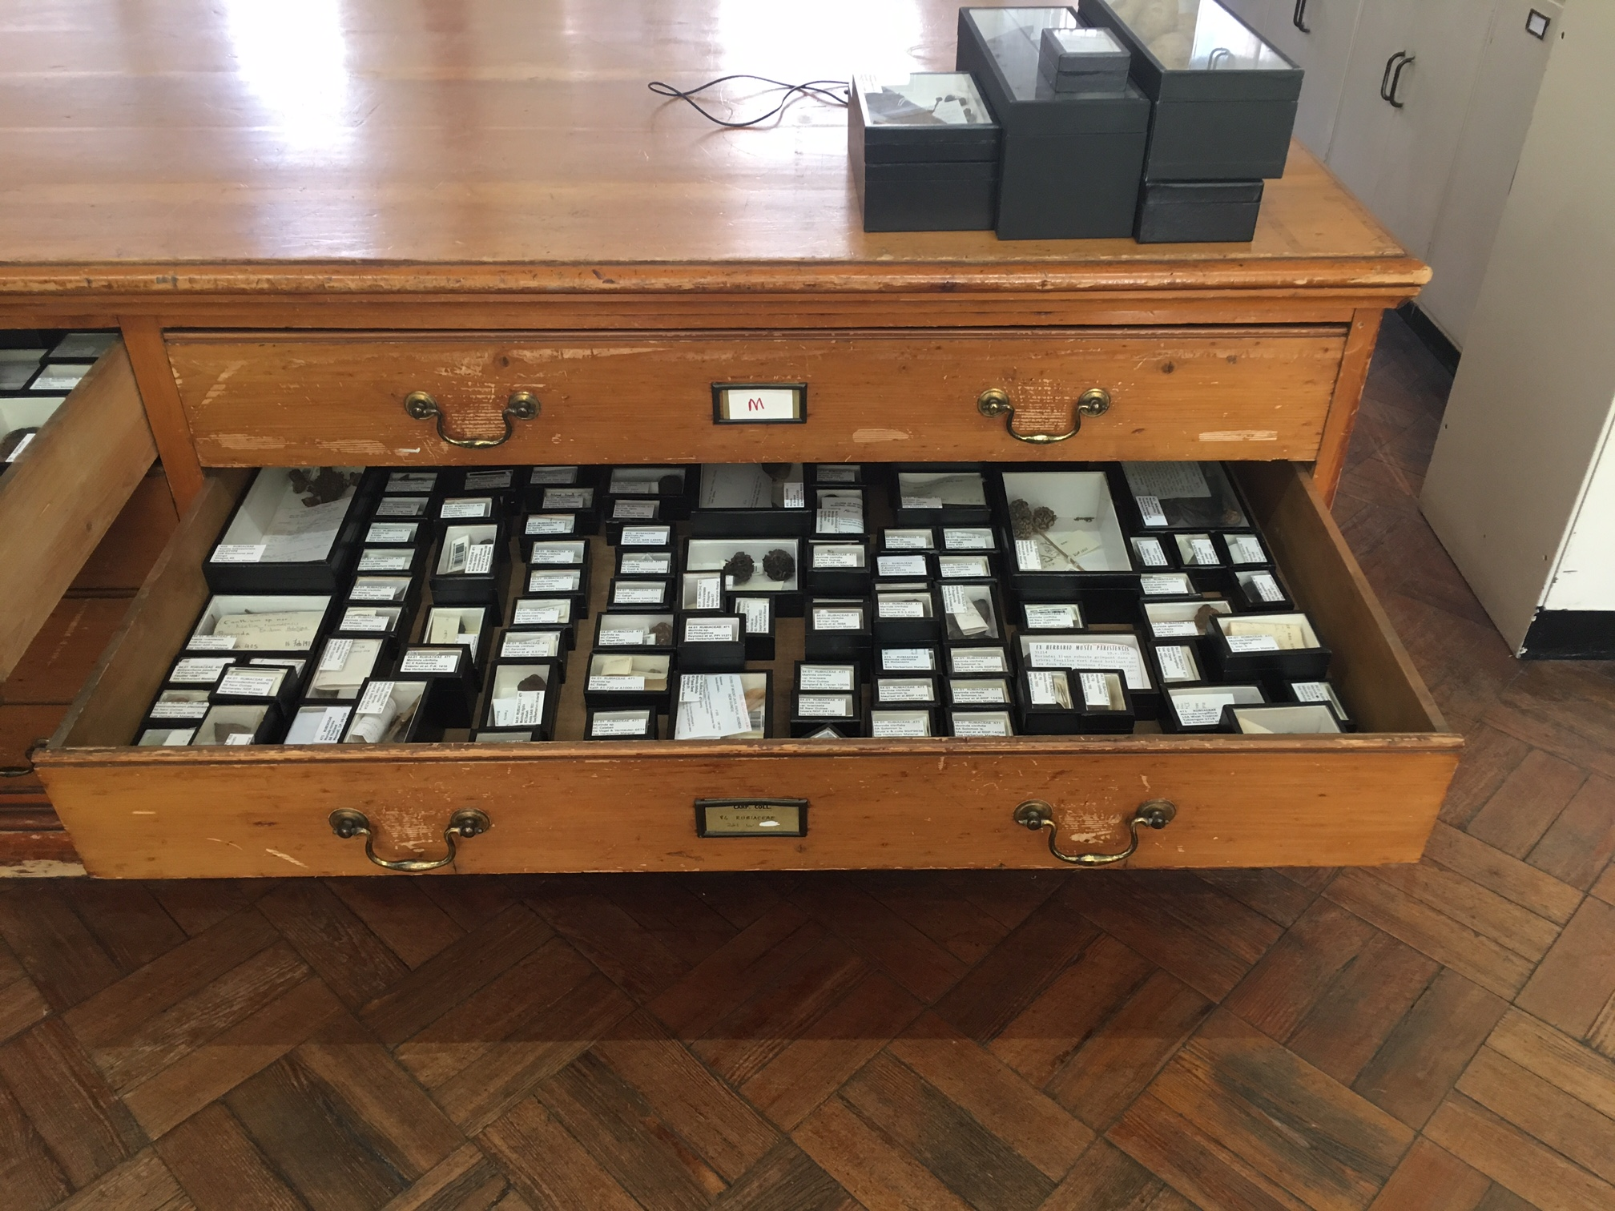

Question 3: Is it possible to obtain a sample of the current boxes?

Answer 3: It is not possible to supply a sample of the boxes used currently. Our requirement for the new contract is detailed in the specification.

Question 4: Should the window be made of glass?

Answer 4: The window should be fully transparent, durable, and non-scratch. You may propose glass or another material which meets the requirement detailed in the specification.

Question 5: Regarding criteria no 4, what would be a percentage of minimal off-gassing?

Answer 5: Our preference is for conservationally sound materials which present no off-gassing of deleterious substances (especially gaseous and vaporous acidity). As such, we would not want to specify a percentage level of acceptable off-gassing.

Question 6: Are there any criteria for outer dimensions?

Answer 6: No. The internal dimensions, in line with the tolerances specified, are a critical factor.

Question 7: Would alternative colours to black be acceptable?

Answer 7: Our preference is for black, to match the rest of our collection, but we would consider other colours.

