

BIDDER LOGGING IN FOR THE FIRST TIME

UK SHARED BUSINESS SERVICES EMPTORIS TRAINING MODULE

Following registration as a supplier you will follow this process to gain access to Emptoris and your procurement documents.
Whilst this procurement is being managed by UK SBS the Emptoris system administration is managed by Crown Commercial Service (CCS) so Bidders will on occasion receive system generated mails from CCS rather than UK SBS.
If Bidders have any problems logging onto the system please do not hesitate to contact CCS on Tel: 0345 010 3503.
SCOPE OF TRAINING:

- Logging onto the systems

- Resetting passwords

LOGGING ONTO THE SYSTEM

- Initially Bidders will receive an email from CCS confirming their login:

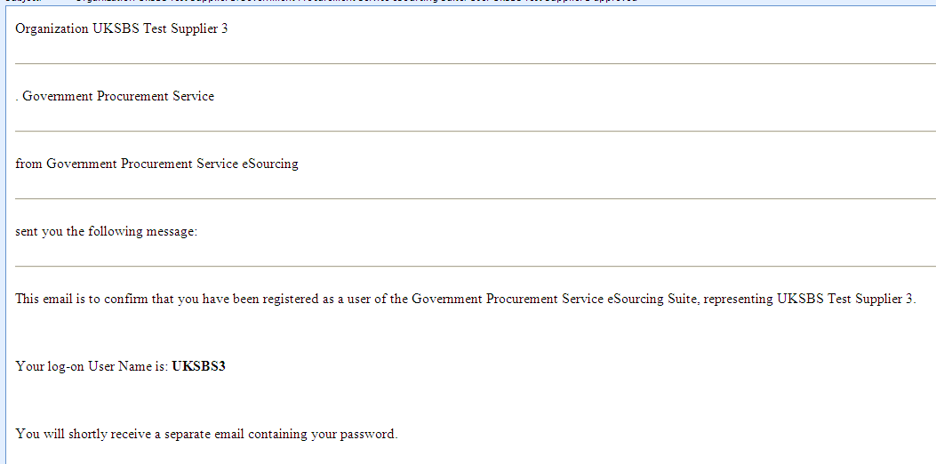

- Bidders will receive a second email confirming your temporary password:

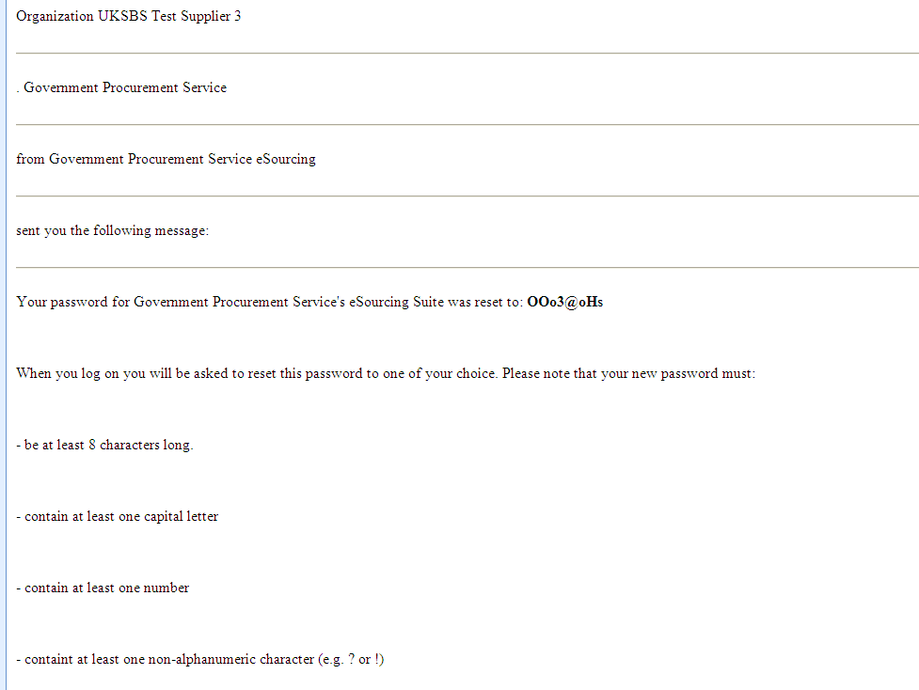

- Bidders will now need to log in to create a permanent password. The URL is https://gpsesourcing.cabinetoffice.gov.uk/sso/jsp/login.jsp

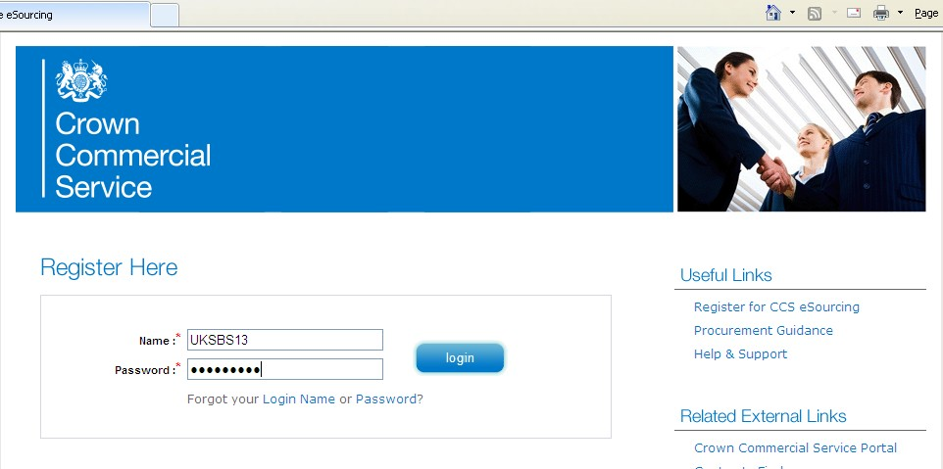

RESETTING PASSWORDS

- Then reset your password ensuring it includes at least one capital letter and one character, for example Bidwinner#1.
- The next screen you will see will provide details of the System Usage Agreement and Bidders must click on ‘I agree’ to gain access to the documents:

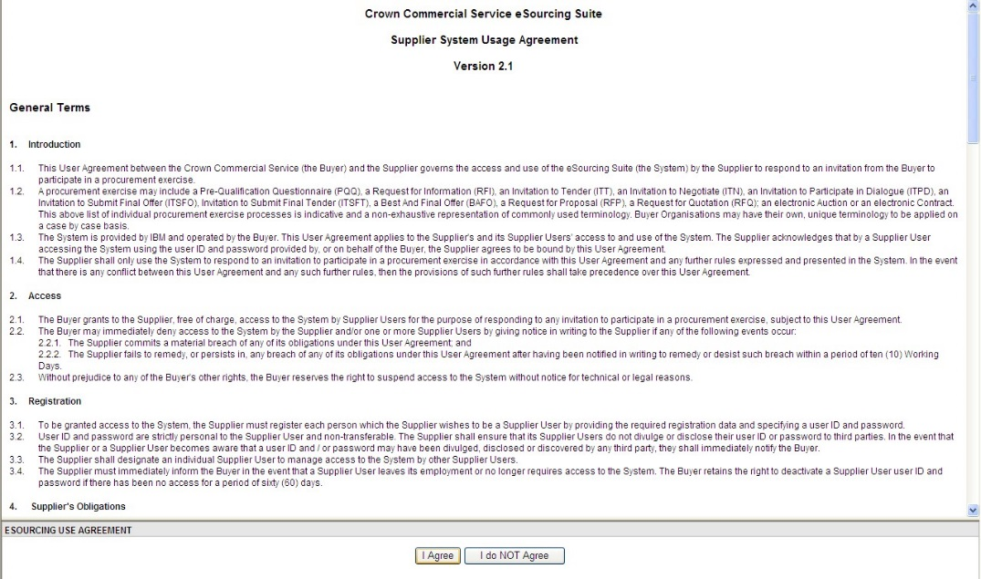

The next page Bidders will face will have details of the specific procurements you have access to.
In the event that the Procurements expected are not on this page, or you have been invited to the wrong procurement please contact Crown Commercial Service Tel 0345 410 3503.
To respond to an RFx review our training slides.

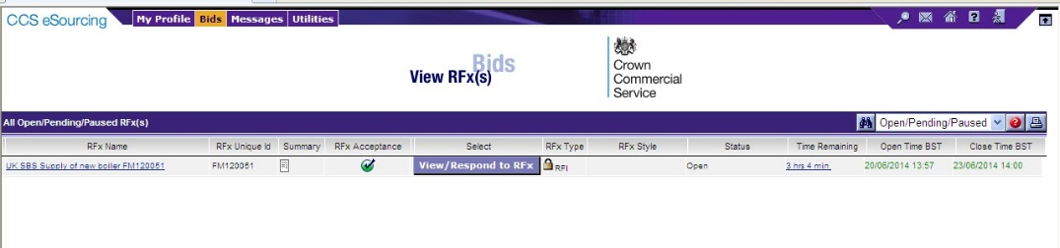

The slides contained within this presentation were created using the Emptoris e sourcing suite and Internet Explorer 8.

UK Shared Business Services Ltd makes no guarantees that the functionality available in these screen shots will be fully replicated in the live Emptoris e sourcing suite, nor if using an alternative web browser to IE8.

Any Bidder using these training materials should do so at their own risk and UK Shared Business Services Ltd does not make any commitment to their accuracy.

In using these training materials the Bidder commits that UK Shared Business Services Ltd shall be in no way liable should the Bidder be unable to complete any or all of their Bid or Response submission.

TEMPLATE VERSION CONTROL

Version | Date | Author(s) | Comment
1.0 | 05/12/2013 | James Aldred | Final Template Version
1.1 | 23/06/2014 | James Aldred | Updated to reflect CCS rebranding

