England 2014 to 2020 European Structural and Investment Funds Growth Programme

European Regional Development Fund and European Social Fund Branding and Publicity Requirements

July 2017

This document is guidance on the subject of branding and publicity requirements in projects funded through the European Regional Development Fund (ERDF) and European Social Fund (ESF) – separate publicity requirements will be available in relation to the European Agricultural Fund for Rural Development. It does not constitute legal advice, nor does it imply any waiver of the legal obligations of recipients of ERDF and ESF grants. In this document we use the Department, which means MHCLG in respect of the European Regional Development Fund and DWP in respect of the European Social Fund. The Department does not accept any liability relating to the use of this document.

Contents 2
Section 1 – Introduction to the requirements 4
1. Introduction to the Publicity and Branding Requirements 4
EU Regulations 4
Section 2 – Logos 6
Supporting Notes: 9
2.1 The Logo 9
2.2 Rules on Colour 10
2.3 Location and Size 10
2.4 Clearance Zone 11
2.5 Incorrect use of the Logo 11
2.6 Visual examples of the Logos available 12
2.7 Community Led Local Development (CLLD) 13
Section 3 – Publicity 14
3.1 Plaques – ERDF Only 15
3.2 Billboards – ERDF Only 17
3.3 Posters 19
3.4 Print and Publications 21
3.5 Electronic Materials 23
3.6 Media and PR Activity 25
3.6.1 Notes to editors (select the correct one) 25
3.7 Events, Conferences, Seminars and Workshops 26
3.8 Informing Beneficiaries/Participants of European Programme Funded Projects 27
3.9 List of Operations 29
3.10 Evidencing Publicity Activities 29
Section 4 – Contact Us 30
Contact information 30
Section 5 – Further information 31
Section 6 – UK Government Logo 32

Section 1 – Introduction to the requirements

Introduction to the Publicity and Branding Requirements

Extracts from the relevant Regulations are set out at the start of each section in a grey shaded box. The content of these boxes is not exhaustive and users should ensure they refer directly to the Regulations, the guidance on the Europa website and seek their own specialist advice from professional advisers.
This guidance aims to:

- set out the minimum requirements under EU law in relation to branding and publicity for the European Regional Development Fund and European Social Fund as part of the England 2014 to 2020 European Structural and Investment Funds (ESIF) Growth Programme (the Programme); and
- provide supporting notes to aid compliance with these requirements.

EU Regulations
To help promote and publicise the activities and impact of the Programme, the European Commission have published branding and publicity requirements which are detailed in:

- European Union Regulation 1303/2013, articles 115-117 and Annex XII, European Union Regulation 1304/2013, article 20 for the Youth Employment Initiative; and
- Commission Implementing Regulation 821/2014, chapter II and Annex II.

(together the Regulations).

The Regulations must be followed by anyone developing and delivering projects funded by the ERDF and ESF, or managing the Programme. Compliance with the Regulations will form part of the terms of funding agreements which will be issued to beneficiaries prior to the approval of funding. These terms are contractual provisions placed on beneficiaries, delivery partners and all sub-contractors that are involved in any operation which is part-funded by ERDF and ESF. As part of this, ESF Co-financing Organisations must ensure that these requirements are met by organisations that provide match funding for ESF projects through separate contracts with the CFO. The consequences of non-compliance may lead to financial repayment of funding.

It is the responsibility of beneficiaries funded by ERDF and ESF to ensure that they meet these requirements and they must ensure all parties producing any publicity materials regarding the project fully appreciate the requirements contained in the Regulations.

In the case of Financial Instruments funded through the European Regional Development Fund, the Regulations and requirements must be complied with by the body that implements the Financial Instrument.

Audits and verification checks will be carried out on projects by the appropriate managing authority and audit authority in England, and by the European Commission. In many cases communications activities will be audited within this process. It is therefore vital that projects not only meet the requirements but also retain verifiable evidence of compliant communication activities undertaken.

Section 2 – Logos
European Union Regulations No 1303/2013
Chapter II Information and Communication - Annex XII
Article 2.2. (2.2.1)

Responsibilities of the beneficiaries

1. All information and communication measures provided by the beneficiary shall acknowledge support from the Funds to the operation by displaying:

(a) the Union emblem in accordance with the technical characteristics laid down in the implementing act adopted by the Commission under Article 115(4), together with a reference to the Union; and
(b) a reference to the Fund or Funds supporting the operation.
Where an information or communication measure relates to an operation or to several operations co-financed by more than one Fund, the reference provided for in point (b) may be replaced by a reference to the European Structural Investment Funds.

European Union Implementing Regulation No 821/2014
Technical characteristics for displaying the Union emblem and the reference to the Fund or Funds supporting the operation.

Article 4

1. The Union emblem referred to in point 1(a) of Section 2.2 of Annex XII to Regulation (EU) No 1303/2013 shall be displayed in colour on websites. In all other media, colour shall be used whenever possible and a monochrome version may only be used in justified cases.
2. The Union emblem shall always be clearly visible and placed in a prominent position. Its position and size shall be appropriate to the scale of the material or document being used. For small promotional objects the obligation to make reference to the Fund shall not apply.
3. When the Union emblem, the reference to the Union and the relevant Fund are displayed on a website: (a) the Union emblem and the reference to the Union shall be visible, when landing on the website, inside the viewing area of a digital device, without requiring a user to scroll down the page; (b) the reference to the relevant Fund shall be made visible on the same website.
4. The name ‘European Union’ shall always be spelled out in full. The name of a financial instrument shall include a reference to the fact that it is supported by the Funds. The typeface to be used in conjunction with the Union emblem may be any of the following fonts: Arial, Auto, Calibri, Garamond, Trebuchet, Tahoma, Verdana, Ubuntu. Italic, underlined variations or font effects shall not be used. The positioning of the text in relation to the Union emblem shall not interfere with the Union emblem in any way. The font size used shall be proportionate to the size of the emblem. The colour of the font shall be reflex blue, black or white depending on the background.
5. If other logos are displayed in addition to the Union emblem, the Union emblem shall have at least the same size, measured in height or width, as the biggest of the other logos.

European Union Implementing Regulation 821/2014

Graphic standards for creating the Union emblem

Article 3

The Union emblem shall be created in accordance with the graphic standards set out in Annex II.

Annex II

Graphic standards for creating the Union emblem and the definition of standard colours.

SYMBOLIC DESCRIPTION Against a background of blue sky, twelve golden stars form a circle representing the union of the peoples of Europe. The number of stars is fixed, twelve being the symbol of perfection and unity.

HERALDIC DESCRIPTION On an azure field a circle of twelve golden mullets, their points not touching.

GEOMETRIC DESCRIPTION

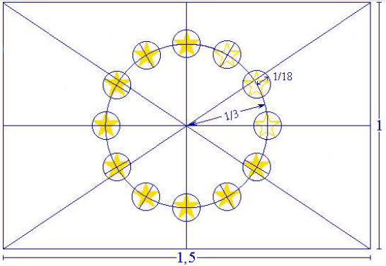

The emblem has the form of a blue rectangular flag of which the fly is one and a half times the length of the hoist. Twelve gold stars situated at equal intervals form an invisible circle whose center is the point of intersection of the diagonals of the rectangle. The radius of the circle is equal to one third of the height of the hoist. Each of the stars has five points which are situated on the circumference of an invisible circle whose radius is equal to one eighteenth of the height of the hoist. All the stars are upright, i.e. with one point vertical and two points in a straight line at right angles to the mast. The circle is arranged so that the stars appear in the position of the hours on the face of a clock. Their number is invariable.

REGULATION COLOURS

The emblem is in the following colours:

- PANTONE REFLEX BLUE for the surface of the rectangle;
- PANTONE YELLOW for the stars.

FOUR-COLOUR PROCESS

If the four-colour process is used, recreate the two standard colours by using the four colours of the four-colour process.

- PANTONE YELLOW is obtained by using 100 % ‘Process Yellow’
- PANTONE REFLEX BLUE is obtained by mixing 100 % ‘Process Cyan’ and 80 % ‘Process Magenta’.

INTERNET
PANTONE REFLEX BLUE corresponds in the web-palette colour RGB:0/51/153 (hexadecimal: 003399) and PANTONE YELLOW corresponds in the web-palette colour RGB: 255/204/0 (hexadecimal: FFCC00).

MONOCHROME REPRODUCTION PROCESS

Using black, outline the rectangle in black and print the stars in black on white.

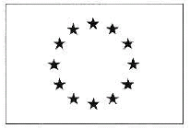

Using blue (Reflex Blue), use 100 % with the stars reproduced in negative white.



REPRODUCTION ON A COLOURED BACKGROUND

If there is no alternative to a coloured background put a white border around the rectangle, the width of the border being 1/25th of the height of the rectangle.



Supporting Notes:

2.1 The Logo
In order to ensure a harmonised visual identity for information and communication measures for operations under the Programme, beneficiaries must display the European Union emblem together with the words ‘European Union’ and a reference to the relevant fund (the Logo) in the correct form and presentation in all correspondence and activity related to the Programme.

It is mandatory that the Logo is used and applied correctly, prominently and consistently on all websites, publicity materials and project documentation produced in relation to a project supported by the ERDF and ESF.

Visual examples of the Logo are available for each of the European funding streams. The correct version of the Logo must be used for the fund or funding streams being referred to.

- European Regional Development Fund Logo - for use when only in receipt of European Regional Development Fund funding.
- European Social Fund Logo - for use when only in receipt of European Social Fund funding.
- European Structural and Investment Funds Logo – for use if in receipt of more than one funding stream.

Only one version of the Logo should be used in a single piece of publicity material or project documentation, however, all versions of the Logo can be used alongside those of other funding partners provided the Logo is at least as large as the biggest of the other funding partner logos.

Each version of the Logo is specifically designed to include the mandatory requirements set out in the Regulations.

A zip file containing versions of the Logo in various formats can be found via the following link: https://www.gov.uk/government/publications/european-structural-and-investment-funds-useful-resources.

2.2 Rules on Colour
The requirements on the colour of the Logo are set out in the Regulations, excerpts of which can be found in the grey box above.

If justified, e.g. the material is printed only in black (on a white background), a black and white version of the Logo may be used.

The Logo works best in colour on a white background. However, if it appears on a dark or coloured background, the black text of the Logo may be hard to read. By exception, it is permitted to use the white-out version of the Logo in those cases.

When using the white-out version, the European Union emblem itself must not change colour.



In all cases it is important that the background should be uncluttered and provides enough contrast to ensure clarity.

2.3 Location and Size
The Logo should be placed in a prominent and suitable position on all publicity materials and project documentation (for examples of potential publicity materials, see section 3.4). If used alongside other logos, the Logo should be at least equal in size to the largest of the other logos and appropriate to the scale of the material and documents being used.

As a minimum, the Logo should be used at 25mm height (portrait Logo) and 40mm width (landscape Logo).

Portrait Logo
Landscape Logo

40mm



25mm

For use on small promotional items, it is permissible to just include the EU emblem and reference to the European Union.

There are separate size requirements for use of the Logo on plaques and billboards – see section 3 of this guidance for further details.

2.4 Clearance Zone
To prevent any visual interference the Logo must be positioned in its own clear space, with a suitable ‘clearance zone’ left clear around its edges. Also, it should not be placed immediately against a document edge.

2.5 Incorrect use of the Logo
- The Logo must not be stretched, squashed, broken up or reproduced in colours other than those listed in the Regulations.
- The Logo must not be reproduced in a different typeface or be rotated.
- The Logo must not have any other wording or illustration added to it.
- The Logo must not use Italic, underlined variations or font effects.
- The Logo font must not deviate from the font types listed in the Regulations.
- The positioning of the text in the Logo must not interfere with the European Union emblem in any way.
- When resizing the Logo it must stay in proportion and must not become distorted.
- Pixelation or blurring of the Logo resulting from the use of an incorrect format/ insufficient resolution must be avoided.

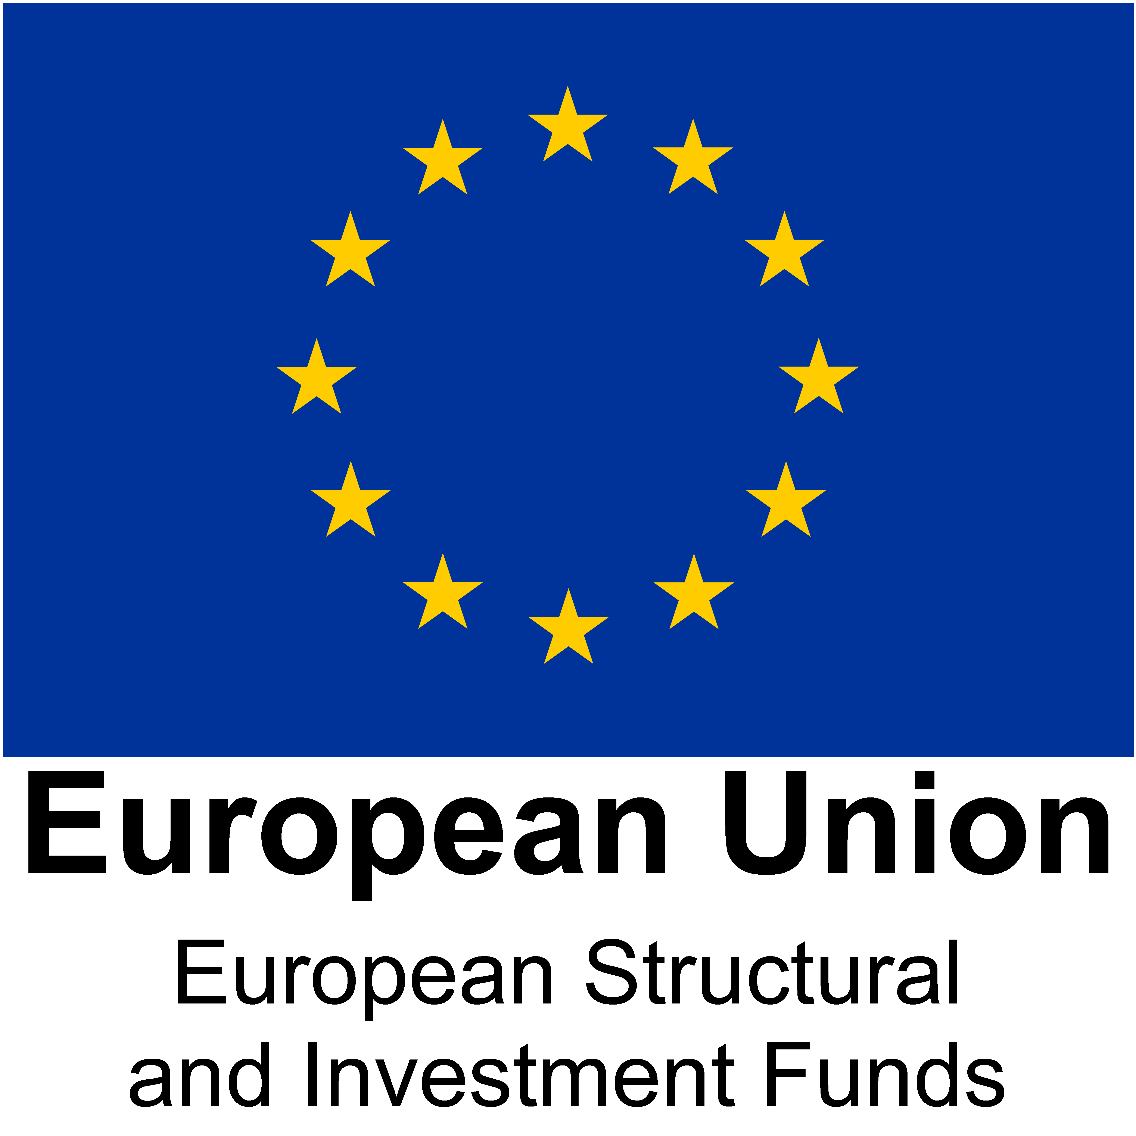
X Do not rotate Logo X Do not squash/stretch Logo

2.6 Visual examples of the Logos available
There are two Logo options (portrait and landscape) available for use in relation to projects funded by the European Regional Development Fund, European Social Fund and ESIF. These are available in colour, black and white or white-out depending on the type of document.

Option 1 – Landscape Logos

European Regional Development Fund
European Structural and Investment Funds
European Social Fund


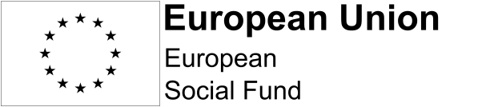








Option 2 – Portrait Logos
European Regional Development Fund

European Social Fund

European Structural and Investment Funds





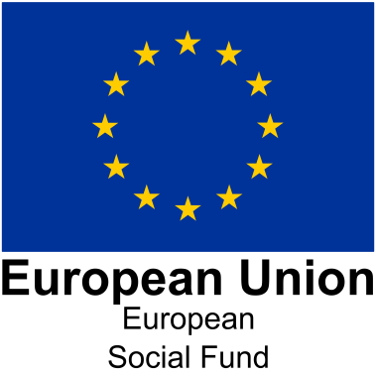

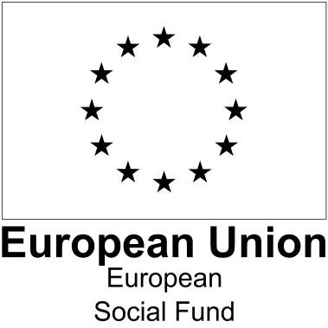
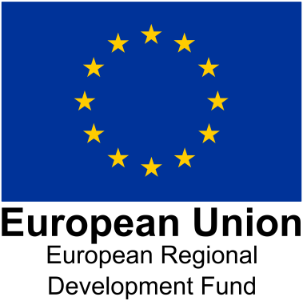

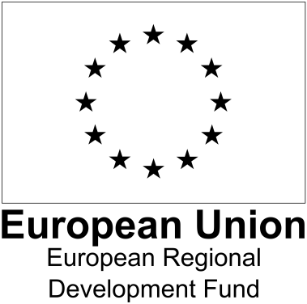

2.7 Community Led Local Development (CLLD)

All CLLD implementation activities and materials (i.e. at the level of the local action group, accountable body and within local projects funded through the delegated grant schemes) need to be branded using the ESIF logo. With the following exceptions:

- Strategies that are only drawing on ESF need to be branded as ESF.
- If any CLLD operations generate activity that requires the display of a plaque (capital costs over €500,000) the plaque would need to be ERDF branded in accordance with ERDF regulations.

Section 3 – Publicity
The table below shows the specific publicity activity that must be complied with in relation to projects funded by the European Regional Development Fund and/or European Social Fund as part of the Programme.

 | European Regional Development Fund | European Social Fund
Plaques | - *
Billboards | - *
Posters | - *
Print and Publications
Electronic Materials
Media and PR Activity
Events, Conferences, Seminars and Workshops

Informing Beneficiaries / Participants
Description of Activity on website (List of Operations)
Evidencing Publicity Activities

* Read the specific rules on which ERDF projects these relate to.

3.1 Plaques – ERDF Only
European Union Regulations No 1303/2013

Chapter II Information and Communication - Annex XII
Article 2.2 (2.2.5)

5. No later than three months after completion of an operation, the beneficiary shall put up a permanent plaque or billboard of significant size at a location readily visible to the public for each operation that fulfils the following criteria:

(a) the total public support to the operation exceeds EUR 500 000;
and

(b) the operation consists of the purchase of a physical object or of the financing of infrastructure or of construction operations.
The plaque or billboard shall state the name and the main objective of the operation. It shall be prepared in accordance with the technical characteristics adopted by the Commission in accordance with Article 115(4).
European Union Implementing Regulation 821/1204 Chapter II

Technical characteristics of permanent plaques and temporary or permanent billboards

Article 5

- The name of the operation, the main objective of the operation, the Union emblem together with the reference to the Union and the reference to the Fund or Funds to be displayed on the temporary billboard referred to in point 4 of Section 2.2 of Annex XII to Regulation (EU) No 1303/2013 shall take up at least 25 % of that billboard.
- The name of the operation and the main objective of the activity supported by the operation, the Union emblem together with the reference to the Union and the reference to the Fund or Funds to be displayed on the permanent plaque or permanent billboard referred to in point 5 of Section 2.2 of Annex XII to Regulation (EU) No 1303/2013 shall take up at least 25 % of that plaque or billboard.

Supporting Notes

Where required by the Regulations, beneficiaries of funding from the European Regional Development Fund must put up a permanent plaque or billboard in a location readily visible to the general public, no later than 3 months after the completion of the project. Projects that fulfil both (a) and (b) criteria stated on the previous page are required to display a permanent plaque or billboard. If a project does not comply with both, please read the section on posters.

All plaques must be produced and funded by the beneficiary and should be of a significant size (at least 300mm x 300mm). The cost of producing the plaque should be considered when developing and planning the project.

Below is an example to show how the requirements of the Regulations could be presented.

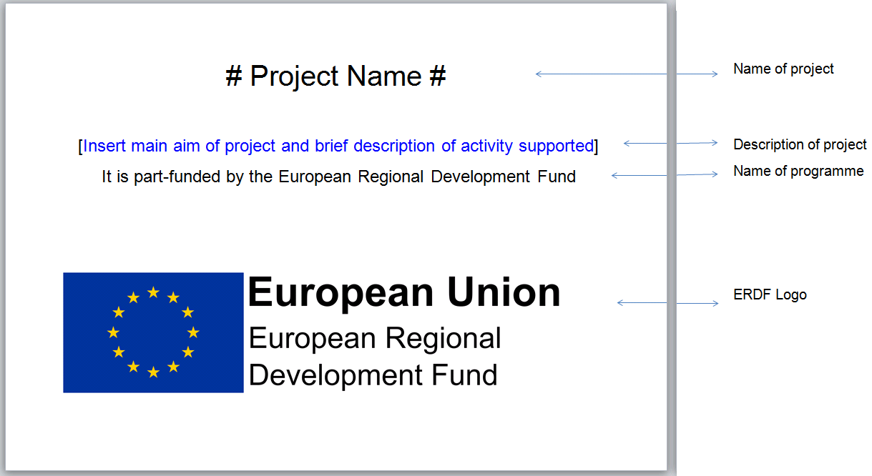

3.2 Billboards – ERDF Only
European Union Regulations No 1303/2013

Chapter II Information and Communication - Annex XII

Article 2.2 (2.2.4-2.2.5)
4. During implementation of an ERDF or Cohesion Fund operation, the beneficiary shall put up, at a location readily visible to the public, a temporary billboard of a significant size for each operation consisting of the financing of infrastructure or construction operations for which the total public support to the operation exceeds EUR 500 000.
5. No later than three months after completion of an operation, the beneficiary shall put up a permanent plaque or billboard of significant size at a location readily visible to the public for each operation that fulfils the following criteria:

(a) the total public support to the operation exceeds EUR 500 000;

and

(b) the operation consists of the purchase of a physical object or of the financing of infrastructure or of construction operations.

The plaque or billboard shall state the name and the main objective of the operation. It shall be prepared in accordance with the technical characteristics adopted by the Commission in accordance with Article 115(4).
European Union Implementing Regulation 821/1204, Chapter II

Technical characteristics of permanent plaques and temporary or permanent billboards

Article 5

- The name of the operation, the main objective of the operation, the Union emblem together with the reference to the Union and the reference to the Fund or Funds to be displayed on the temporary billboard referred to in point 4 of Section 2.2 of Annex XII to Regulation (EU) No 1303/2013 shall take up at least 25 % of that billboard.

- The name of the operation and the main objective of the activity supported by the operation, the Union emblem together with the reference to the Union and the reference to the Fund or Funds to be displayed on the permanent plaque or permanent billboard referred to in point 5 of Section 2.2 of Annex XII to Regulation (EU) No 1303/2013 shall take up at least 25 % of that plaque or billboard.

Supporting Notes

Where required by the Regulations, beneficiaries of funding from the European Regional Development Fund must erect a billboard at the start of the works. Billboards should be sited to maximise the opportunities for it/ them to be seen by the public. Projects that fulfil both (a) and (b) criteria stated on the previous page are required to display a billboard. If a project does not comply with both, please read the section on posters.

When the project is completed, the billboard should be replaced by a permanent plaque or permanent billboard no later than 3 months after project completion (see section 3.1 above).

Below is an example to show how the requirements of the Regulations could be presented.

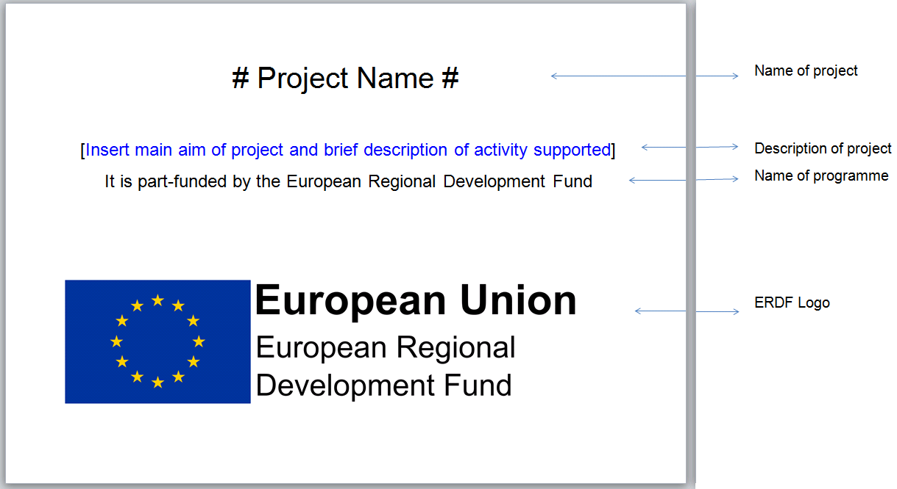

3.3 Posters
European Union Regulation No 1303/2013

Chapter II Information and Communication - Annex XII

Article 2.2 (2.2.1 – 2.2.2)

Responsibilities of the beneficiaries

1. All information and communication measures provided by the beneficiary shall acknowledge support from the Funds to the operation by displaying:
(a) the Union emblem in accordance with the technical characteristics laid down in the implementing act adopted by the Commission under Article 115(4), together with a reference to the Union;
(b) a reference to the Fund or Funds supporting the operation.
Where an information or communication measure relates to an operation or to several operations co-financed by more than one Fund, the reference provided for in point (b) may be replaced by a reference to the ESI Funds.
2. During implementation of an operation, the beneficiary shall inform the public about the support obtained from the Funds by:

(b) placing, for operations not falling under points 4 and 5 (regarding plaques and billboards), at least one poster with information about the project (minimum size A3), including the financial support from the Union, at a location readily visible to the public, such as the entrance area of a building.

European Union Implementing Regulation 821/1204, Chapter II

Technical characteristics for displaying the Union emblem and the reference to the Fund or Funds supporting the operation

Article 4 (4.1-4.2)

1. The Union emblem referred to in point 1(a) of Section 2.2 of Annex XII to Regulation (EU) No 1303/2013 shall be displayed in colour on websites. In all other media, colour shall be used whenever possible and a monochrome version may only be used in justified cases.
2. The Union emblem shall always be clearly visible and placed in a prominent position. Its position and size shall be appropriate to the scale of the material or document being used. For small promotional objects the obligation to make reference to the Fund shall not apply.
European Union Regulation No1304/2013

Youth Employment Initiative
Article 20

Any document relating to the implementation of an operation and issued for the public or for participants, including an attendance or other certificate, shall include a statement to the effect that the operation was supported under the Youth Employment Initiative.

Supporting Notes

Beneficiaries of ERDF and ESF funding that are not required to display a plaque or billboard (see sections 3.1 and 3.2 above) must display at least one poster with information about the project at a location readily visible to the public. This location should be the location of the operation.

Beneficiaries include, but are not restricted to:

- all European Social Fund (and match) providers and their partners/ subcontractors delivering the project, who must display at least one poster at each location where the project is delivered to participants. For each project, providing the criteria set out in this guidance are met, the content of the poster can be the same irrespective of the posters’ location or whether it is displayed by a provider or partner/ sub-contractor;
- European Regional Development Fund projects where the total public contribution to the project is less than €500,000; and
- any other beneficiary not covered by the bullets above or the billboard/ plaque requirements in sections 3.1 and 3.2 above.
Example poster templates are available for projects funded by the European Regional Development Fund and European Social Fund. Projects can also develop their own poster designs as long as these comply with the requirements of the Regulations.

Under European Social Fund co-financing arrangements the European Social Fund poster template can apply to activity that is 100% funded by the European Social Fund or 100% funded by domestic match funding. Beneficiaries that are in receipt of funding from European Social Fund Co-financing Organisations (CFO) and are unclear on what they are required to display should contact their CFO.

Where a project is in receipt of Youth Employment Initiative (YEI) funding, this must be acknowledged on the project poster. See poster templates.

3.4 Print and Publications
European Union Regulations No 1303/2013

Chapter II Information and Communication - Annex XII

Article 2.2 (2.2.1 and 2.2.3)

Responsibilities of the beneficiaries
1. All information and communication measures provided by the beneficiary shall acknowledge support from the Funds to the operation by displaying:
(a) the Union emblem in accordance with the technical characteristics laid down in the implementing act adopted by the Commission under Article 115(4), together with a reference to the Union;

(b) a reference to the Fund or Funds supporting the operation.
Where an information or communication measure relates to an operation or to several operations co-financed by more than one Fund, the reference provided for in point (b) may be replaced by a reference to the ESI Funds.

- Any document, relating to the implementation of an operation which is used for the public or for participants, including any attendance or other certificate, shall include a statement to the effect that the operational programme was supported by the Fund or Funds.

European Union Implementing Regulation 821/1204, Chapter II

Technical characteristics for displaying the Union emblem and the reference to the Fund or Funds supporting the operation

Article 4 (4.1 - 4.2)

1. The Union emblem referred to in point 1(a) of Section 2.2 of Annex XII to Regulation (EU) No 1303/2013 shall be displayed in colour on websites. In all other media, colour shall be used whenever possible and a monochrome version may only be used in justified cases.
2. The Union emblem shall always be clearly visible and placed in a prominent position. Its position and size shall be appropriate to the scale of the material or document being used. For small promotional objects the obligation to make reference to the Fund shall not apply.

European Union Regulation No1304/2013

Youth Employment Initiative
Article 20

- Any document relating to the implementation of an operation and issued for the public or for participants, including an attendance or other certificate, shall include a statement to the effect that the operation was supported under the Youth Employment Initiative.

Supporting Notes

All printed documents and publications produced by projects funded by one or more of the European funds must acknowledge and reference the funding received in accordance with the Regulations. This extends to a variety of materials and documents including, but not restricted to:

- General advertisements, job advertisements and notices
- Leaflets, brochures, flyers and posters
- Case studies
- Exhibition banners and display panels
- Invitations
- Business cards
- Promotional items
- Newsletters
- Stationery
- Letterheads and compliment slips
- Reports and papers
- Project documentation - for example timesheets, induction material etc.
- Procurement material
- Job descriptions

Small promotional items, such as pens, only need to include the European Union emblem together with the words ‘European Union’. See Logo requirements (see section 2) for more details.

Where a project is jointly funded by the Youth Employment Initiative and the European Social Fund any document issued for the public or for participants (including for participants an attendance or other certificate), shall also include a statement to the effect that the operation was supported under the Youth Employment Initiative.

Electronic and hard copies of all materials should be kept as evidence of compliance with the Regulations.

3.5 Electronic Materials
European Union Regulation No 1303/2013

Chapter II Information and Communication - Annex XII
Article 2.2
Responsibilities of the beneficiaries

All information and communication measures provided by the beneficiary shall acknowledge support from the Funds to the operation by displaying:

(a) the Union emblem in accordance with the technical characteristics laid down in the implementing act adopted by the Commission under Article 115(4), together with a reference to the Union;
(b) a reference to the Fund or Funds supporting the operation.

Where an information or communication measure relates to an operation or to several operations co-financed by more than one Fund, the reference provided for in point (b) may be replaced by a reference to the ESI Funds.

2. During implementation of an operation, the beneficiary shall inform the public about the support obtained from the Funds by:

(a) providing on the beneficiary's website, where such a website exists, a short description of the operation, proportionate to the level of support, including its aims and results, and highlighting the financial support from the Union.

European Union Implementing Regulation 821/1204, Chapter II

Technical characteristics for displaying the Union emblem and the reference to the Fund or Funds supporting the operation
Article 4 (4.1-4.3)

1. The Union emblem referred to in point 1(a) of Section 2.2 of Annex XII to Regulation (EU) No 1303/2013 shall be displayed in colour on websites. In all other media, colour shall be used whenever possible and a monochrome version may only be used in justified cases.
2. The Union emblem shall always be clearly visible and placed in a prominent position. Its position and size shall be appropriate to the scale of the material or document being used. For small promotional objects the obligation to make reference to the Fund shall not apply.

3.When the Union emblem, the reference to the Union and the relevant Fund are displayed on a website:

(a) the Union emblem and the reference to the Union shall be visible, when landing on the website, inside the viewing area of a digital device, without requiring a user to scroll down the page;

(b) the reference to the relevant Fund shall be made visible on the same website.

European Union Regulation No1304/2013

Youth Employment Initiative
Article 20

- The beneficiaries shall ensure that those taking part in an operation are specifically informed of the Youth Employment Initiative support provided through the ESF funding and the specific Youth Employment Initiative allocation.

- Any document relating to the implementation of an operation and issued for the public or for participants, including an attendance or other certificate, shall include a statement to the effect that the operation was supported under the Youth Employment Initiative.

Supporting Notes
Where a website has been developed specifically by the beneficiary for a project funded by ERDF and / or ESF, the full colour version of the Logo must be placed on the homepage.
Where the beneficiary is placing details of the funded project on a website, which is not exclusively for the project, for example its own website featuring non European funded activities, the full colour version of the Logo must be placed on the main project specific page. This does not preclude the beneficiary from also placing the Logo on the homepage where they feel this is appropriate.
The regulatory text in the grey box above states requirements regarding the visibility of the logo on digital devices. It is required that the logo should be visible when landing on at least one digital device e.g. a desktop PC computer screen. However if a new website is being developed then it would be advisable to take this requirement into consideration to allow the logo to appear on landing on various digital devices.

During the implementation of a project, beneficiaries must provide on their website a short description of the project, including its aims and results, and highlight the financial support from the European Union – including a reference to any Youth Employment Initiative funding received. This can appear on either the homepage or separate page(s) within the website.

In addition to the requirements in relation to websites, beneficiaries should ensure that all electronic materials relating to projects funded by ERDF and / or ESF acknowledge and reference the funding received by displaying the appropriate version of the Logo. This extends to a variety of materials including, but not restricted to:

- E-newsletters
- Presentation slides
- Press notices
- Email footers and signatures
- Audio visual material including films, video, DVDs, CD Roms
- Social media tools including Facebook and Twitter

Copies of all electronic materials should be kept as evidence of compliance with the Regulations.

3.6 Media and PR Activity
A cost effective way to promote projects is through the local media and trade press. It is good practice to develop press releases for the launch of the project, and subsequently to announce key milestones and achievements. In some circumstances (particularly for the European Regional Development Fund) the Department may produce a press release.

All press releases relating to projects supported by the European funding streams must include:

- A text reference to the relevant European funding support in the main body of the release;
- The ‘notes to editors’ (see section 3.6.1 below) for the relevant funding stream; and
- The relevant version of the Logo for the funding stream.

Quotes to show the support for the project from the Department may also be available for significant announcements – beneficiaries should contact their local communications representative within the Department (contact details are set out in section 4 below).

Please note that the funding agreement for the project should be in place before any media or PR activities to publicise the project are commenced.

If a beneficiary, delivery partner or sub-contractor is interviewed by the media (print, tv or radio), with the aim to produce a news story about the project, or produces a radio or TV advertisement to promote the project, reference should be made to the relevant European funding stream. A reference to Youth Employment Initiative funding should also be included where used as part of European Social Fund support.

Original copies of press releases and copies of any coverage obtained as a result of the press release should be retained as evidence of compliance with the Regulations.

3.6.1 Notes to editors (select the correct one)
European Regional Development Fund

The project (either has received or is receiving up to) £[INSERT AMOUNT] of funding from the England European Regional Development Fund as part of the European Structural and Investment Funds Growth Programme 2014-2020. The Ministry of Housing, Communities and Local Government (and in London the intermediate body Greater London Authority) is the Managing Authority for European Regional Development Fund. Established by the European Union, the European Regional Development Fund helps local areas stimulate their economic development by investing in projects which will support innovation, businesses, create jobs and local community regenerations. For more information visit https://www.gov.uk/european-growth-funding.

European Social Fund
The project (either has received or is receiving up to) £[INSERT AMOUNT] of funding from the European Social Fund as part of the 2014-2020 European Structural and Investment Funds Growth Programme in England. The Department for Work and Pensions (and in London the intermediate body Greater London Authority) is the Managing Authority for the England European Social Fund programme. Established by the European Union, the European Social Fund helps local areas stimulate their economic development by investing in projects which will support skills development, employment and job creation, social inclusion and local community regenerations. For more information visit https://www.gov.uk/european-growth-funding.

European Social Fund – Youth Employment Initiative version

The project (either has received or is receiving up to) £[INSERT AMOUNT] of funding from the European Social Fund and Youth Employment Initiative as part of the 2014-2020 European Structural and Investment Funds Growth Programme in England. The Department for Work and Pensions (and in London the intermediate body Greater London Authority) is the Managing Authority for the England European Social Fund programme. Established by the European Union, the European Social Fund helps local areas stimulate their economic development by investing in projects which will support skills development, employment and job creation, social inclusion and local community regenerations. For more information visit https://www.gov.uk/european-growth-funding.

European Structural and Investment Funds

The project (either has received or is receiving up to) £ [INSERT AMOUNT] of funding from the England European Structural and Investment Funds Growth Programme 2014-2020. The Ministry of Housing, Communities and Local Government and the Department for Work and Pensions (and in London the intermediate body Greater London Authority) are the Managing Authorities for European Regional Development Fund and European Social Fund funding through the Growth Programme, funds established by the European Union to help local areas stimulate their economic development. By investing in projects the funds will help to support innovation, businesses, skills and employment to improve local growth and create jobs. For more information visit https://www.gov.uk/european-growth-funding.

3.7 Events, Conferences, Seminars and Workshops
Conferences, seminars, exhibitions and events are an ideal way to promote a project supported by European funding. All materials and documents produced for an event in advance, on the day and after the event including invitations, tickets, press releases, exhibition stands, and presentation slides must acknowledge and reference the funding received by displaying the appropriate version of the Logo.

For projects funded by European Regional Development Fund beneficiaries should notify their local communications representative within the Department about the event in order to give them a chance to attend and/or provide programme exhibition stands. In some circumstances it may be possible to provide a Minister or a representative from the Programme to speak at an event.

3.8 Informing Beneficiaries/Participants of European Programme Funded Projects
European Union Regulation No 1303/2013

Chapter II Information and Communication - Annex XII

Article 2.2 (2.2.1-2.2.3)

Responsibilities of the beneficiaries

1. All information and communication measures provided by the beneficiary shall acknowledge support from the Funds to the operation by displaying:

- the Union emblem in accordance with the technical characteristics laid down in the implementing act adopted by the Commission under Article 115(4), together with a reference to the Union;

- a reference to the Fund or Funds supporting the operation.

Where an information or communication measure relates to an operation or to several operations co-financed by more than one Fund, the reference provided for in point (b) may be replaced by a reference to the ESI Funds.

2. During implementation of an operation, the beneficiary shall inform the public about the support obtained from the Funds by:

- providing on the beneficiary's website, where such a website exists, a short description of the operation, proportionate to the level of support, including its aims and results, and highlighting the financial support from the Union;

- placing, for operations not falling under points 4 and 5, at least one poster with information about the project (minimum size A3), including the financial support from the Union, at a location readily visible to the public, such as the entrance area of a building.

3. For operations supported by the ESF, and in appropriate cases for operations supported by the ERDF or Cohesion Fund, the beneficiary shall ensure that those taking part in an operation have been informed of this funding.

Any document, relating to the implementation of an operation which is used for the public or for participants, including any attendance or other certificate, shall include a statement to the effect that the operational programme was supported by the Fund or Funds.

European Union Regulation No1304/2013

Youth Employment Initiative

Article 20

20.1The beneficiaries shall ensure that those taking part in an operation are specifically informed of the Youth Employment Initiative support provided through the ESF funding and the specific Youth Employment Initiative allocation.

  - Any document relating to the implementation of an operation and issued for the public or for participants, including an attendance or other certificate, shall include a statement to the effect that the operation was supported under the Youth Employment Initiative.

Supporting Notes

All beneficiaries, delivery partners and sub-contractors (including 100% match-funded projects funded by European Social Fund CFOs) must ensure that they have provisions in place to notify those taking part in activities associated with the project about the support from the specific fund and the European Union at the start of their activity.

Ways to achieve this include:

- Mention during induction sessions as part of a training course.
- Note the support in any contracts or paperwork given to participants.
- State the support in internal newsletters and bulletins.
- Provide the participant with a leaflet explaining the European investment in the project.
- Ensure that plaques and posters are used in line with the Regulations.
- Use of the relevant funding stream Logo on publications and electronic media, in line with the Regulations.

3.9 List of Operations
The regulations relating to the list of operations are: Commission Regulations (1303/2013): Chapter II, Article 115 (sub article 2) and Annex XII, Article 1.

The Department is required to publish a ‘List of Operations’ that have received support from European funds online. The list will be published on the England 2014-2020 ESIF Growth Programme homepage on GOV.UK. Please be aware that in accepting an offer of ERDF and / or ESF funding, beneficiaries also agree to details of the project being included in the list.

3.10 Evidencing Publicity Activities
Regular monitoring and audits can take place a long time after the project has been completed. Therefore beneficiaries, delivery partners and sub-contractors should ensure all evidence is kept until advised by the Department that it is safe to dispose of it. Guidance about document retention is available from local Programme teams.

It is important to remember that any publicity materials produced and services used must also adhere to the European Union procurement rules and regulations.

Failure to provide appropriate evidence is identified as one of the most common audit failings and is subject to a high degree of attention from UK and European Commission verification and audit visits.

If a project is unable to evidence adherence to the publicity requirements, a financial penalty may be imposed.

Section 4 – Contact Us

Contact information
For further information on publicity and branding requirements please contact:

European Regional Development Fund
esif@communities.gov.uk

European Social Fund
ESF.2014-2020@dwp.gsi.gov.uk

European Agricultural Fund for Rural Development
The local Defra Rural Development team. GPEnquiries@rpa.gsi.gov.uk

Greater London Authority

esf@london.gov.uk or erdf@london.gov.uk

Section 5 – Further information
- Logos – https://www.gov.uk/government/publications/european-structural-and-investment-funds-useful-resources
Logo formats available are:
- Low resolution images suitable for most web applications (png)
- Low resolution images suitable for small scale print (jpeg)
- High resolution images suitable print production (eps)

- Publicity templates and Glossary – https://www.gov.uk/government/publications/european-structural-and-investment-funds-useful-resources

The following documents are available for reference/use:
- examples of Poster templates for the European Regional Development Fund, European Social Fund (including where there is also Youth Employment Initiative funding) and European Structural and Investment Funds
- examples of Press release templates for the European Regional Development Fund, European Social Fund and European Structural and Investment Funds – which include the editors notes requirement set out in section 3.6/3.6.1 of this guidance.
- a glossary for 2014-2020 European Structural and Investment Funds

- European Union Regulation No 1303/2013
- European Union Regulation No 1304/2013
- European Commission Implementing Regulation EU No 821/2014
- Greater London Authority

Section 6 – UK Government Logo



Some projects may also be required to display a UK Government logo.

Where the UK Government is a funding partner of a European Regional Development Fund project, the ‘Funded by UK Government’ logo displayed above must also be used.

The use of the ‘Funded by UK Government’ logo can also apply in some cases where UK Government funding is being used as match funding for a European Social Fund project. For European Social Fund projects if the UK Government funded product or service being used as match is already recognised through the use of a Government Department logo or Government branded product/programme, there is no requirement to use the ‘Funded by UK Government’ logo.

Please note that the requirement to display the ‘Funded by UK Government’ logo is not a requirement under the Regulations.

If organisations running ERDF and ESF projects believe that the ‘Funded by UK Government’ logo requirement may apply to them; they should email marketing@communities.gov.uk for further guidance and logo image files.

The European Structural and Investment Funds Growth Programme funds comprise the European Regional Development Fund, the European Social Fund and part of the European Agricultural Fund for Rural Development.
This covers organisations delivering funds as well as fund of funds.
Throughout this document, unless indicated otherwise, the phrase ‘Managing Authority’ or ‘Department’ will mean the European Regional Development Fund (ERDF) Managing Authority (Department for Communities and Local Governement and its Growth Delivery Team), the European Social Fund (ESF) Managing Authority (Department for Work and Pensions) and the London Intermediate Body (Greater London Authority).
The term used in the European Union Regulations to refer to each of the discrete activities that is covered by an ESIF funding agreement. ‘Operation’ is usually synonymous with ‘project’ but in some cases an operation may include a number of projects within it.
Section 2.7 explains how this regulation should be applied to operations delivering Community Led Local Development (CLLD)
There are no ERDF only CLLD proposals.
ESF does not support capital investment so such activity would be ERDF only.

