**Brighton & Hove City Council**

**Holiday Activities and Food (HAF) Programme**

**2021**

**Information and Application Form for Easter 2021**

1. **Overview**

The Holiday Activities and Food (HAF) programme is a new national government initiative from the Department for Education which will fund local authorities to offer enriching activities and free healthy meals to children in the city aged four to 16 who are eligible for benefits-related free school meals (FSM).

DfE guidance can be found [here](https://www.gov.uk/government/publications/holiday-activities-and-food-programme/holiday-activities-and-food-programme-2021).

This is an exciting new programme for the city’s most disadvantaged children, young people and their families. The council is seeking to work in partnership with activity and food providers in the city to make the holidays healthy and fun for children and young people.

The HAF programme will run for one week at Easter, four weeks in the summer and for one week at Christmas 2021.

This is information and an application form for holiday activity and food providers in the city who wish to apply for funding to run activities for four days in the Easter holidays 2021.

Because of the short timescale, limited budget, and the difficulty planning programmes as a result of Covid-19, the Easter 2021 HAF programme in Brighton & Hove is being run as a pilot. The council is not anticipating being able to offer the HAF programme to all eligible children in the city at Easter.

The council is aiming to reach as many children and young people as possible, also ensuring that there is sufficient provision across the city for children with special educational needs and disabilities (SEND).

1. **Our approach in Brighton & Hove**

This information is for holiday activity and food providers who would like to apply to deliver the HAF programme at Easter 2021. Information relating to the summer and Christmas holidays will be issued later in 2021.

The council wants to offer a programme of enriching activities with healthy food which:

* provides for those in wards with the highest number of children on FSM as shown on the map in appendix 1
* ensures that both primary and secondary school children and young people are provided for
* is accessible to and meets the needs of the diverse range of children and young people in the city, including those with SEND, and
* can be offered within the budget available.

HAF provision should run for four hours a day, for four days, Monday to Friday over the Easter 2021 school holidays which run from 6to16 April 2021[1]. The four days of session delivery do not have to run consecutively and can be delivered split across both weeks of the Easter holidays. Sessions do not have to be at a particular time of day (for example providers may wish to run afternoon/evening sessions for older children and young people).

Providers must follow any Covid-19 restrictions in place at Easter. The council is interested in proposals from those who can offer

* direct activities for children (and families, where appropriate) alongside a meal[2] in a school or community setting
* if this is not possible as a result of Covid-19 restrictions in operation at the time, to be able to adjust their offer to provide on-line or home-based activities for children and families together with food parcels[3]. This could include packed lunches or carefully sourced food that families can cook alongside an accompanying recipe and support to prepare the meal. This approach may also be appropriate for families who are reluctant for their children to attend face to face provision because of Covid-19.

The council is not seeking applications from providers who only wish to offer food and not the activities element of the HAF programme.

**The deadline for applications is** **10 am Monday 8 March 2021**

1. **HAF Programme Requirements**

The council would like proposals from providers who can deliver the DfE’s HAF programme requirements, which are:

**Enriching Activities**

Clubs must provide fun and enriching activities that provide children with opportunities to develop new skills or knowledge, to consolidate existing skills and knowledge, or to try out new experiences. This could include physical activities such as football, table tennis, cricket; creative activities such as putting on a play, junk modelling, drumming workshops; or experiences such as a nature walk, visiting a city farm etc.

**Food**

Clubs must provide at least one meal a day (breakfast, lunch or tea) and all food provided at the club (including snacks) must meet [school food standards](http://www.schoolfoodplan.com/actions/school-food-standards/). The expectation is that most of the food served by providers will be hot, however, we acknowledge that there will be occasions when this is not possible and that a cold alternative should be used. All food provided as part of the programme must comply with regulations on food preparation and take into account allergies and dietary requirements and preferences as well as any religious or cultural requirements for food.

*The council is investigating whether hot or cold food parcels can be provided centrally, but it is not guaranteed that this will be possible.* ***Please note that applications which offer food only will not be considered.***

**Physical activities**

Clubs must provide activities which meet the [physical activity guidelines](https://www.gov.uk/government/collections/physical-activity-guidelines) on a daily basis*.*

*The council’s Active for Life team can provide information for providers to use with children if they do not have experience in this area.*

**Nutritional education**

Clubs must include an element of nutritional education each day aimed at improving the knowledge and awareness of healthy eating for children. These do not need to be formal learning activities and could for example include activities such as getting children involved in food preparation and cooking, growing fruit and vegetables, and taste tests.

*The council’s healthy food team can provide information for providers to use with children if they do not have experience in this area.*

**Food education for families and carers**

Clubs must include at least weekly training and advice sessions for parents, carers or other family members which provide advice on how to source, prepare and cook nutritious and low-cost food.

*The council’s healthy food team can offer information for providers to use with children and families if they do not have experience in this area*.

**Signposting and referrals**

Clubs must be able to provide information, signposting or referrals to other services and support that would benefit the children who attend their provision and their families.

*The council’s Family Information Service is preparing resources for providers to use which will be shared with providers prior to the start of the programme.*

**Policies and procedures**

Clubs must be able to demonstrate and explain their safeguarding arrangements and have relevant and appropriate policies and procedures in place in relation to:

* safeguarding
* health and safety
* insurance
* accessibility and inclusiveness, including addressing equality and diversity
* where required, clubs must also be compliant with the Ofsted requirements for working with children[4]
* Covid-19 risk assessment following the government guidance relevant to your provision

The council is not looking for one provider to cover all children and families and knows that the HAF programme will be a collective effort between a number of providers and will include providers working in partnership. Awarding funding to a range of providers will allow the HAF programme to reach more FSM families, age ranges, and areas of the city as well as diversify the content.

A key requirement is to provide food and activities around food. Providers unable to do this may still submit an application for funding, but priority will be given to providers who can provide food.

Applications do not need to cover the complete age range of four to 16 years old. HAF activities should be age appropriate. The council is open to all suggestions and proposed plans that meet the HAF aims and objectives.

The council particularly needs applications from providers who can include children with SEND.

1. **Equality, diversity, and inclusion**

Successful applicants must comply with the Equality Act 2010 which simplifies and strengthens the law around tackling discrimination and inequality. The public sector equality duty ensures that all public bodies play their part in making society fairer by tackling discrimination and providing equality of opportunity for all. It ensures that public bodies consider the needs of all individuals in their work, and the impact of all their functions, when shaping policy, delivering services and in relation to employees. The equality duty covers the following protected characteristics and, by association, those who care for them: age, disability, sex, gender reassignment, race, religion and belief, sexual orientation, pregnancy and maternity, and marriage and civil partnership (in respect of having due regard to eliminate discrimination).

Some groups and communities in the city find it more difficult to have their voices and experiences heard, and therefore may require additional support and resource in order to feedback, participate and help shape and improve local services.

Applications should include how you will meet the needs of diverse groups.

Guidance on the public sector equality duty can be found [**here**](https://www.equalityhumanrights.com/en/advice-and-guidance/public-sector-equality-duty-guidance).

1. **Funding available**

The council’s aim is to reach as many FSM eligible children as possible at Easter 2021. The funding needs to be stretched to enable this. In accordance with DfE guidance applications are welcomed from organisations which can draw upon other sources of funding to support HAF activities.

For the Easter 2021 holidays approximately £80,000 is available for HAF activities and food. This will also cover funding for some HAF activities run by the council.

The council recognises that different types of provision will have different costs. For Easter 2021 the suggested HAF funding is £10 per child per four hour session, with an additional £2.30 for food. Applications are welcomed with lower costs as this will result in the provison of more places. Applications with higher costs will be considered where a rationale is provided. Funding cannot be spent on food vouchers.

The council anticipates a lower rate of funding per child per session where parents attend with their children, because of the lower numbers of staff needed in these circumstances.

For children with SEND who need additional support to attend activities applications may be made to the council’s [childcare inclusion fund](https://www.brighton-hove.gov.uk/content/children-and-education/early-education-and-childcare-professionals/including-disabled).

1. **Eligibility**

The HAF funding is for children eligible for benefits-related free school meals. Places may also be offered to children not eligible for FSM whose parents can pay for them to attend or where funding is available from other sources.

The council has set up a system for providers to check FSM eligibility with us when parents apply for a place with you.

1. **Timeline**

|  |  |
| --- | --- |
| **Task** | **Date** |
| Application form sent to providers | 22 February 2021 |
| Evening Q&A session for providers | 6.30 pm 24 February 2021 |
| Daytime Q&A session for providers | 10.00 am 25 February 2021 |
| Deadline for receipt of applications | 10.00 am 8 March 2021 |
| Providers informed of funding decisions | 15 March 2021 |
| Easter school holidays | 6 to 16 April 2021 |

1. **Scoring and assessment of applications**

Applications will be assessed by an evaluation panel. Applicants should ensure that they answer each question on the application form as part of their submission.

Applications will not be considered if organisations do not attach the policies outlined in questions 15-17.

Applications will be scored initially according to the following criteria, based on the information given the application form.

The responses will be scored as:

|  |  |
| --- | --- |
| **Score** | **Basis for award of score** |
| 5 | **Excellent**  Demonstrates clearly and convincingly how **all** the council’s requirements will be met. |
| 3 | **Good**  Demonstrates how most of the council’s requirements will be met. |
| 1 | **Satisfactory**  Provides only **limited assurance** that the council’s requirements will be met. |

Scored questions will be assessed by the evaluation team, which will agree on a single moderated score for each question. Scored questions will carry a **weighting**, as indicated in each question.

The formula used to calculate the weighted scores for each scored question is:

Question Weighted Score (%) = (Bidder’s score / 5) x Question Weighting.

The weighted scores for each question will then be added together to give an overall weighted score for quality

|  |  |  |
| --- | --- | --- |
| **Assessment criteria (based on your answers to questions in Section 2 below)** | | **Weighted** |
| 1 | Ability to provide enriching activities four hours a day, four days a week and the provision of physical activities which meet physical activity guidelines (Question 1) | 40% |
| 2 | Provision of healthy food which meets school food standards (Question 2) | 30% |
| 3 | Social value: ability to address the growing inequalities within the city’s young people and meet the diverse needs of children, young people, and families (Question 3) | 30% |
|  | Total | 100% |

Following scoring, award decisions will be made based on a combination of the below considerations:

* the score achieved by the application
* ensuring provision offered matches the location of children and young people with FSM in the city
* the value for money offered by each application
* children and young people with SEND can access provision
* as many children and young people as possible can access the programme, including both primary and secondary age
* there are a range of organisations across the city
* there is a virtual offer available if Covid-19 restrictions make this necessary.

The council reserves the right to use its discretion in awarding funding. There may be instances where lower scoring applications are awarded funding in order to ensure a mixed offer that meets council priorities.

1. **Support**

If you have any questions, please email [Haf@brighton-hove.gov](mailto:Haf@brighton-hove.gov).uk

1. **Completing your application**

If you would like to apply for HAF funding for activities and food for four days during the Easter 2021 holidays please complete the form below and email to [Haf@brighton-hove.gov](mailto:Haf@brighton-hove.gov).uk by **10 am 8th March 2021.**

1. **Information about Brighton & Hove City Council**

**The Council’s Corporate Priorities**

The Council’s Corporate Plan 2020 – 2023, ‘A fairer city, a sustainable future’, has identified six main areas of focus for the council:

* **A city to call home**: improved access to good quality council and private housing and reduction of homelessness and rough sleeping.
* **A city working for all**: build community wealth, so that all residents and local organisations benefit from prosperity in the city, working with partners across the Greater Brighton city region and the Coast to Capital Local Enterprise Partnership.
* **A stronger city**: work with all our communities to make the city a great place for all to live and thrive, a fair and inclusive city where people feel safe, supported and valued.
* **A growing and learning city**: provide high quality education and services for children, young people and families with valued partner organisations so that everyone lives happy, safe, healthy and positive lives.
* **A sustainable city**: improve public open spaces, promote biodiversity, transport, support the growth of a circular economy locally and take all actions required to make our city carbon neutral by 2030 to tackle climate emergency.
* **A healthy and caring city**: offer the very best quality of services, ensuring that the most vulnerable residents in the city are prioritised and everyone has a strong say in how their local health and wellbeing services develop, supporting the physical and mental health of our residents.

The council is a fully inclusive organisation and applications are welcomed from Black, Asian, Minority Ethnic and Refugee (BAMER) organisations, and organisations staffing people with disabilities.

The council committed to ensuring applicants pay their employees the [Real Living Wage](https://www.livingwage.org.uk/what-real-living-wage.) (as defined by the Living Wage Foundation) where relevant and proportional.

The council is committed to maximising the social, economic and environmental benefit of all public investments and takes into account the following when we award a contract or design a service.

* social benefit
* economic benefit
* environmental benefit

More information about Brighton & Hove City Council is available on our [website](http://www.brighton-hove.gov.uk/).

## Supported Employment and Social Value

As part of a consistent effort to widen and upskill the city’s workforce, the council encourages applicants to consider the recruitment of residents with disabilities, in long term unemployment or young adults not in education.

Positive outcomes of this recruitment activity would qualify towards the social value commitment required for this funding. This commitment fulfils the recommendations of the Public Services (Social Value) Act 2012 applied by the council in line with its Corporate Social Responsibility.

For more information on Social value please find the Brighton & Hove Social Value Framework and Social Value Guide on the council’s website:

<https://www.brighton-hove.gov.uk/content/life-events-and-communities/community-and-voluntary-sector-support/social-value>

The council’s Supported Employment team is dedicated to enable this recruitment activity, by giving free advice to employers and prospective employees within disadvantaged categories.

This team strives to match suitable applicants with your organisation’s job opportunities, provides assistance with identifying any adjustments needed, supports the employees in their training and your organisation in managing the employee’s performance.

For more information on the team’s work please call 01273 295961 or visit the council’s website:

<https://www.brighton-hove.gov.uk/content/social-care/health-and-wellbeing/supported-employment>

Supported employment creates a more diverse workforce and empowers disadvantaged prospective employees and is therefore a welcome positive step towards community development.

## The Living Wage

The council is a real Living Wage employer. As such the council is committed to pay its employees a minimum hourly wage calculated according to the cost of living, based on a basket of household goods and services, and adjusted each year.

This is a voluntary commitment by employers, separate from the statutory National Minimum Wage and National Living Wage.

The council also encourages applicants to become real Living Wage employers to support fair payment of salaries to the workforce and increase employers’ social responsibility.

For more information on the real Living Wage and how to become a Living Wage employer please refer to the Living Wage Foundation website: <https://www.livingwage.org.uk/>.

**Application Form for HAF Easter 2021**

**Section 1**

**About your organisation**

|  |  |
| --- | --- |
| **Question** | **Your answer** |
| Organisation name |  |
| Contact name |  |
| Position |  |
| Email address |  |
| Telephone number |  |
| Registered address |  |
| Web address |  |
| Type of organisation (e.g. maintained school, private provider, voluntary sector organisation) |  |
| Has the organisation traded under any other names? | *YES/NO*  *(delete as appropriate and provide details)* |
| Your Ofsted registration number(s) (where relevant) |  |

**Section 2**

**Your application in detail**

|  |  |  |
| --- | --- | --- |
| **Question** | **Information needed** | **Your answer** |
| 1 | a) Details of the enriching activities you will offer children and families.  b) Details of how your activities which meet the [physical activity guidelines](https://www.gov.uk/government/collections/physical-activity-guidelines) on a daily basis  c) If applicable, details of how you will change your offer to one which is online or home-based if Covid-19 restrictions at Easter 2021 do not allow face to face provision. |  |
| 2 | Details of the one meal a day to be provided that meets [school food standards](http://www.schoolfoodplan.com/actions/school-food-standards/) |  |
| 3 | a) Details of your experience of providing similar activities for children and young people in receipt of FSM.  b) Details of your experience of providing similar activities for children and young people with SEND.  c) Social Value: How you plan on addressing the growing inequalities within the city’s young people and meeting the diverse needs of children, young people, and families. |  |
| 4 | Age range you will provide for |  |
| 5 | Number of hours per day, number of days and dates of provision over the Easter 2021 holidays |  |
| 6 | Full postal address of location for activities |  |
| 7 | Number of children, young people and families you can offer provision to each day |  |
| 8 | Total number of children and families you can offer provision to at Easter 2021 |  |
| 9 | How will you promote, advertise and recruit eligible children and families |  |
| 10 | How you will monitor and record delivery against programme requirements |  |
| **Please details how you will provide the following elements of the programme**[5] | | |
| 11 | One meal a day which meets [school food standards](http://www.schoolfoodplan.com/actions/school-food-standards/) |  |
| 12 | Nutritional education each day aimed at improving the knowledge and awareness of healthy eating for children |  |
| 13 | Weekly training, advice sessions for parents, carers or other family members on how to source, prepare and cook nutritious and low-cost food |  |
| 14 | Signposting or referrals to other services and support that would benefit the children who attend their provision and their families. |  |
| **Please confirm that you have enclosed the following policies and procedures with your application, and detail how you ensure that these will be followed while offering HAF activities** | | |
| 15 | Safeguarding |  |
| 16 | Health and safety |  |
| 17 | Insurance |  |
| 18 | Staff and volunteers have appropriate DBS checks |  |
| 19 | Covid risk assessment following the guidance relevant to your provision |  |

**Section 3**

**Your costs and payments**

Please complete the table below to show your costs per child or young person per session. You should show the cost for the activity and the cost for food. If you are providing more than one activity, or activities on more than one site, please use a separate line for each

|  |  |  |  |  |  |
| --- | --- | --- | --- | --- | --- |
| Name of HAF programme or activity | Cost per child per session for activities | Cost per child per day for food | Number of children you can provide for each day | Number of days you will deliver HAF activities at Easter 2021 | Total amount of funding applied for |
|  |  |  |  |  |  |
|  |  |  |  |  |  |
|  |  |  |  |  |  |

Please give information below on how you have arrived at your costs, including information on any funding from other sources to support HAF delivery. Please explain if you need any other costs to run at Easter 2021.

|  |
| --- |
|  |

The council will pay based on the number of children and young people eligible for FSM who book to attend sessions up to an agreed maximum number. The council will also ask you for the numbers who attend.

If you need a minimum amount of funding to ensure you can run your programme, please explain this here.

|  |  |
| --- | --- |
| Minimum amount of funding | Explanation including the number of places to be provided with the minimum funding |
|  |  |

**Section 4**

**Equalities and Diversity**

|  |  |  |
| --- | --- | --- |
| 19 | Does your organisation have policies in place to ensure compliance with the Equality Act 2010 relating to equal opportunities, discrimination and harassment? | YES/NO  (delete as appropriate) |
| 20 | In the last three years has your organisation been the subject of formal investigation by any statutory body in relation to your employees? | YES/NO  (delete as appropriate and provide details if “yes”) |
| 21 | Do you have a responsible person nominated for equal opportunities/discrimination/harassment control? | YES/NO  (delete as appropriate) |
| 22 | Do all your staff receive training on equal opportunities, discrimination and harassment issues, proportionate to their responsibilities and roles? | YES/NO  (delete as appropriate) |
| 23 | Does your organisation carry out equalities monitoring? | YES/NO  (delete as appropriate and provide details of monitoring categories used if “yes”) |
| 24 | Does your organisation provide a minimum of the Living Wage for all staff? Details about the Brighton Living Wage can be found [here](http://www.brighton-hove.gov.uk/content/business-and-trade/brighton-hove-living-wage-commission/our-commitment-living-wage), and more information regarding the Living Wage can be found at this [website](http://www.livingwage.org.uk/) <https://www.livingwage.org.uk/> | YES/NO  (delete as appropriate) |
| 25 | Does your organisation have a policy in place to address a situation where volunteers/employees are experiencing or perpetrating gender-based violence, domestic abuse and sexual violence and other VAWG crime types? | YES/NO  (delete as appropriate) |
| 26 | Does your organisation have a complaints process that deals with customer dissatisfaction in a timely and objective way, focusing on remedies and which uses customer feedback as a source of service improvement?  The complaint process should be well publicised, accessible, easy for clients to understand and give information about how to escalate a complaint | YES/NO  (delete as appropriate) |

**Section 5**

**Declaration**

Please ensure that a person who is authorised to act on behalf of your organisation completes the following declaration

I confirm that the information given in this application is accurate and true

|  |  |
| --- | --- |
| Name |  |
| Position (job title) |  |
| Telephone number |  |
| Signature |  |
| Date |  |

**Appendix 1**

**Map of children with FSM in the city**

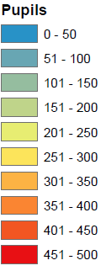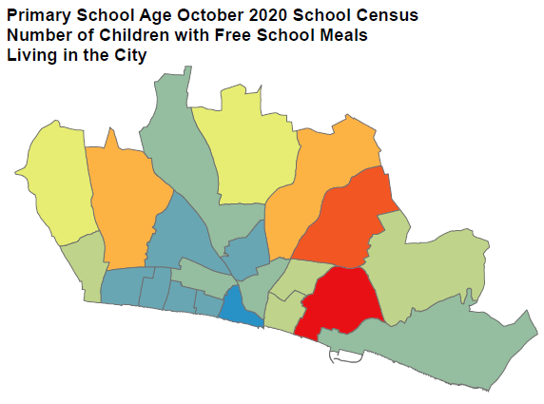

* Includes 3845 pupils at state-funded schools in Brighton & Hove, including special schools. Primary school age is National Curriculum years of Reception, 1, 2, 3, 4, 5 and 6.

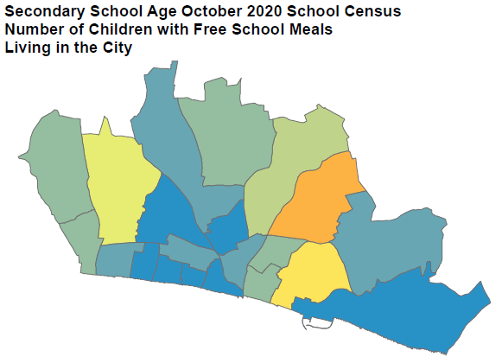

* Includes 2314 pupils at state-funded schools in Brighton & Hove, including special schools. Secondary school age is National Curriculum years of 7, 8, 9, 10 and 11.

**Wards in Brighton & Hove**

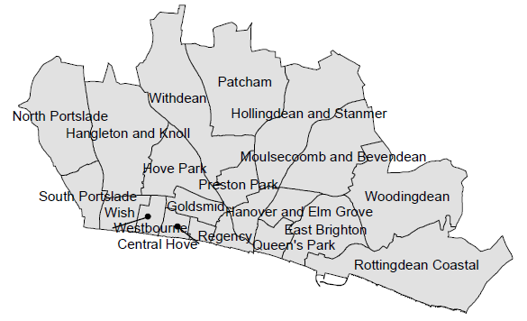

**Appendix 2**

**Ofsted**

Holidays clubs may need to register with Ofsted and there are benefits associated with doing so; however, it is not a prerequisite for providers participating in the HAF programme.

Guidance on Ofsted registration exemption is set out [here](https://www.gov.uk/guidance/childminders-and-childcare-providers-register-with-ofsted/registration-exemptions)

1. Excluding bank holidays
2. See link to school food standards below
3. As above
4. Details on Ofsted registration are in Appendix 2. It is the responsibility of applicants to check that they are compliant with Ofsted registration requirements
5. Please see section 3 HAF programme requirements on pages 2 to 3 above for information about meeting items 13 to 16 below