**Hexton Gate access instructions**

There are two gates to the reserve, one referred to as Hexton Covers on the side of the reserve nearest to Barton Le Clay. This entrance gate is off of Hexton Road on the way to Lilley. Here is a link to a google map location <https://goo.gl/maps/E9VdByMxGsUiA17X9>  or the what three words is marmalade.inhaled.guarded. and this is the gate you go through (see photo below)…

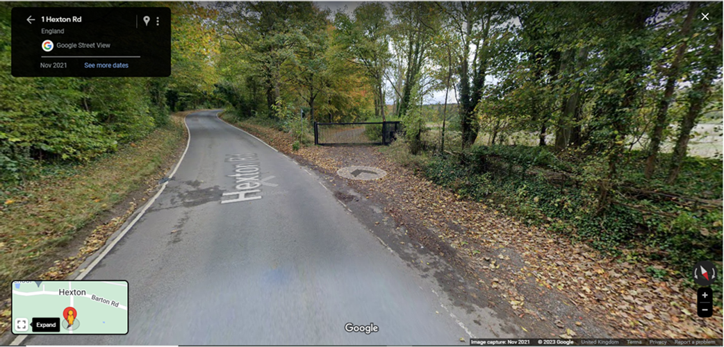

The second gate to the site is called the Meg gate and this is on the Pegston side of the site. This entrance gate is off the Barton Road, here’s a google map link to the gate… <https://goo.gl/maps/r8WrtLFS6fYxwrMQ9> and a photo of what it looks like…

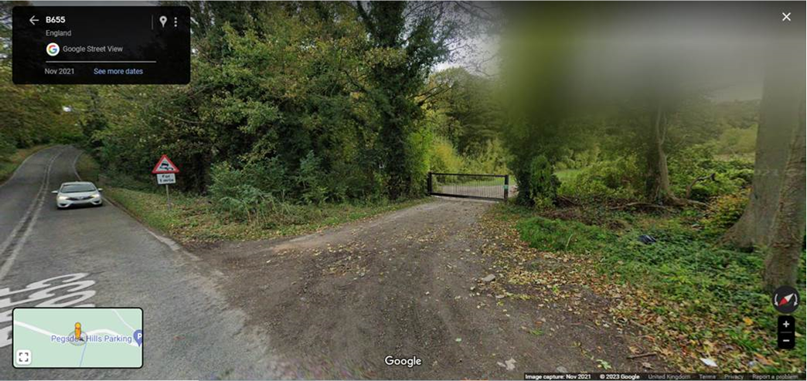

**do note** the gate is not on a sensor and will close after a set amount of time whether or not a car is in the way!