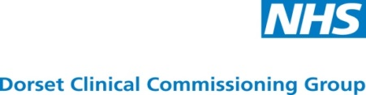

Dermatology Model of Care
Expressions of Interest for Market Engagement meeting

NHS Dorset Clinical Commissioning Group (CCG) wish to engage with prospective providers who are interested in working with the CCG to design the future service model and discuss potential provider structures for its future Dermatology Model of Care .
The market engagement meeting will take place on Wednesday 8th February 2017 at Kinson Community Centre, Millhams Park , Bournemouth BH10 7LH. Refreshments will be available from 1:00pm the event will finish by 4:00pm. There will be a presentation followed by discussion, questions and answer sessions and group working.
If you are interested in attending this meeting or are unable to attend but would like information sent to you please express your interest by completing and returning this form to procurement.bp@dorsetccg.nhs.uk putting Dermatology in the Subject field by no later than 3rd February 2017. Upon receipt of a completed form the CCG will send the provider a draft of the model of care. Attendance at the Market Engagement Meeting will be limited to two individuals from each representative organisation. Please provide name and role of attendees.
Contact name:
Organisation name:
Organisation address
Contact number:
Contact email address
Attendee 1:
Name and position
Attendee 2:
Name and position

I can /cannot attend the Market Engagement Meeting on 8th February 2017
*delete as appropriate

