Wye NNR
Fishponds Bank (Compartment 14) Fence Replacement 2024.

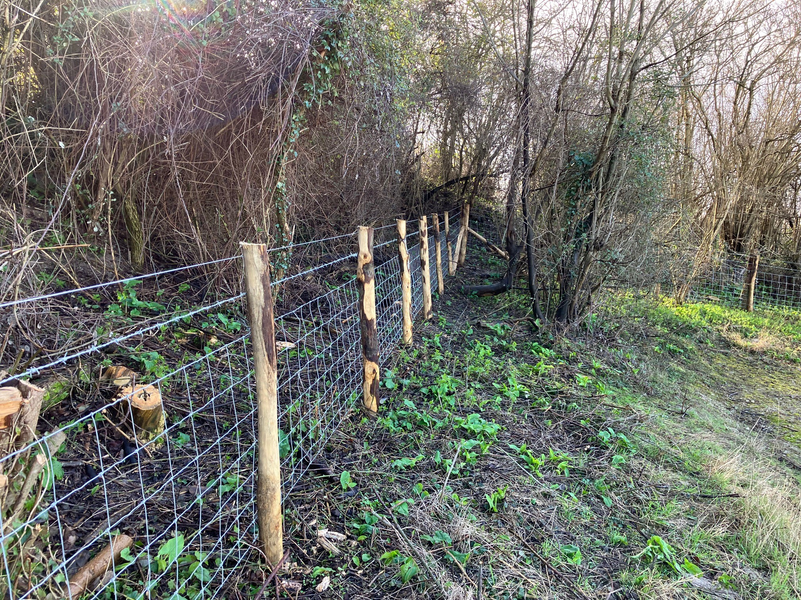

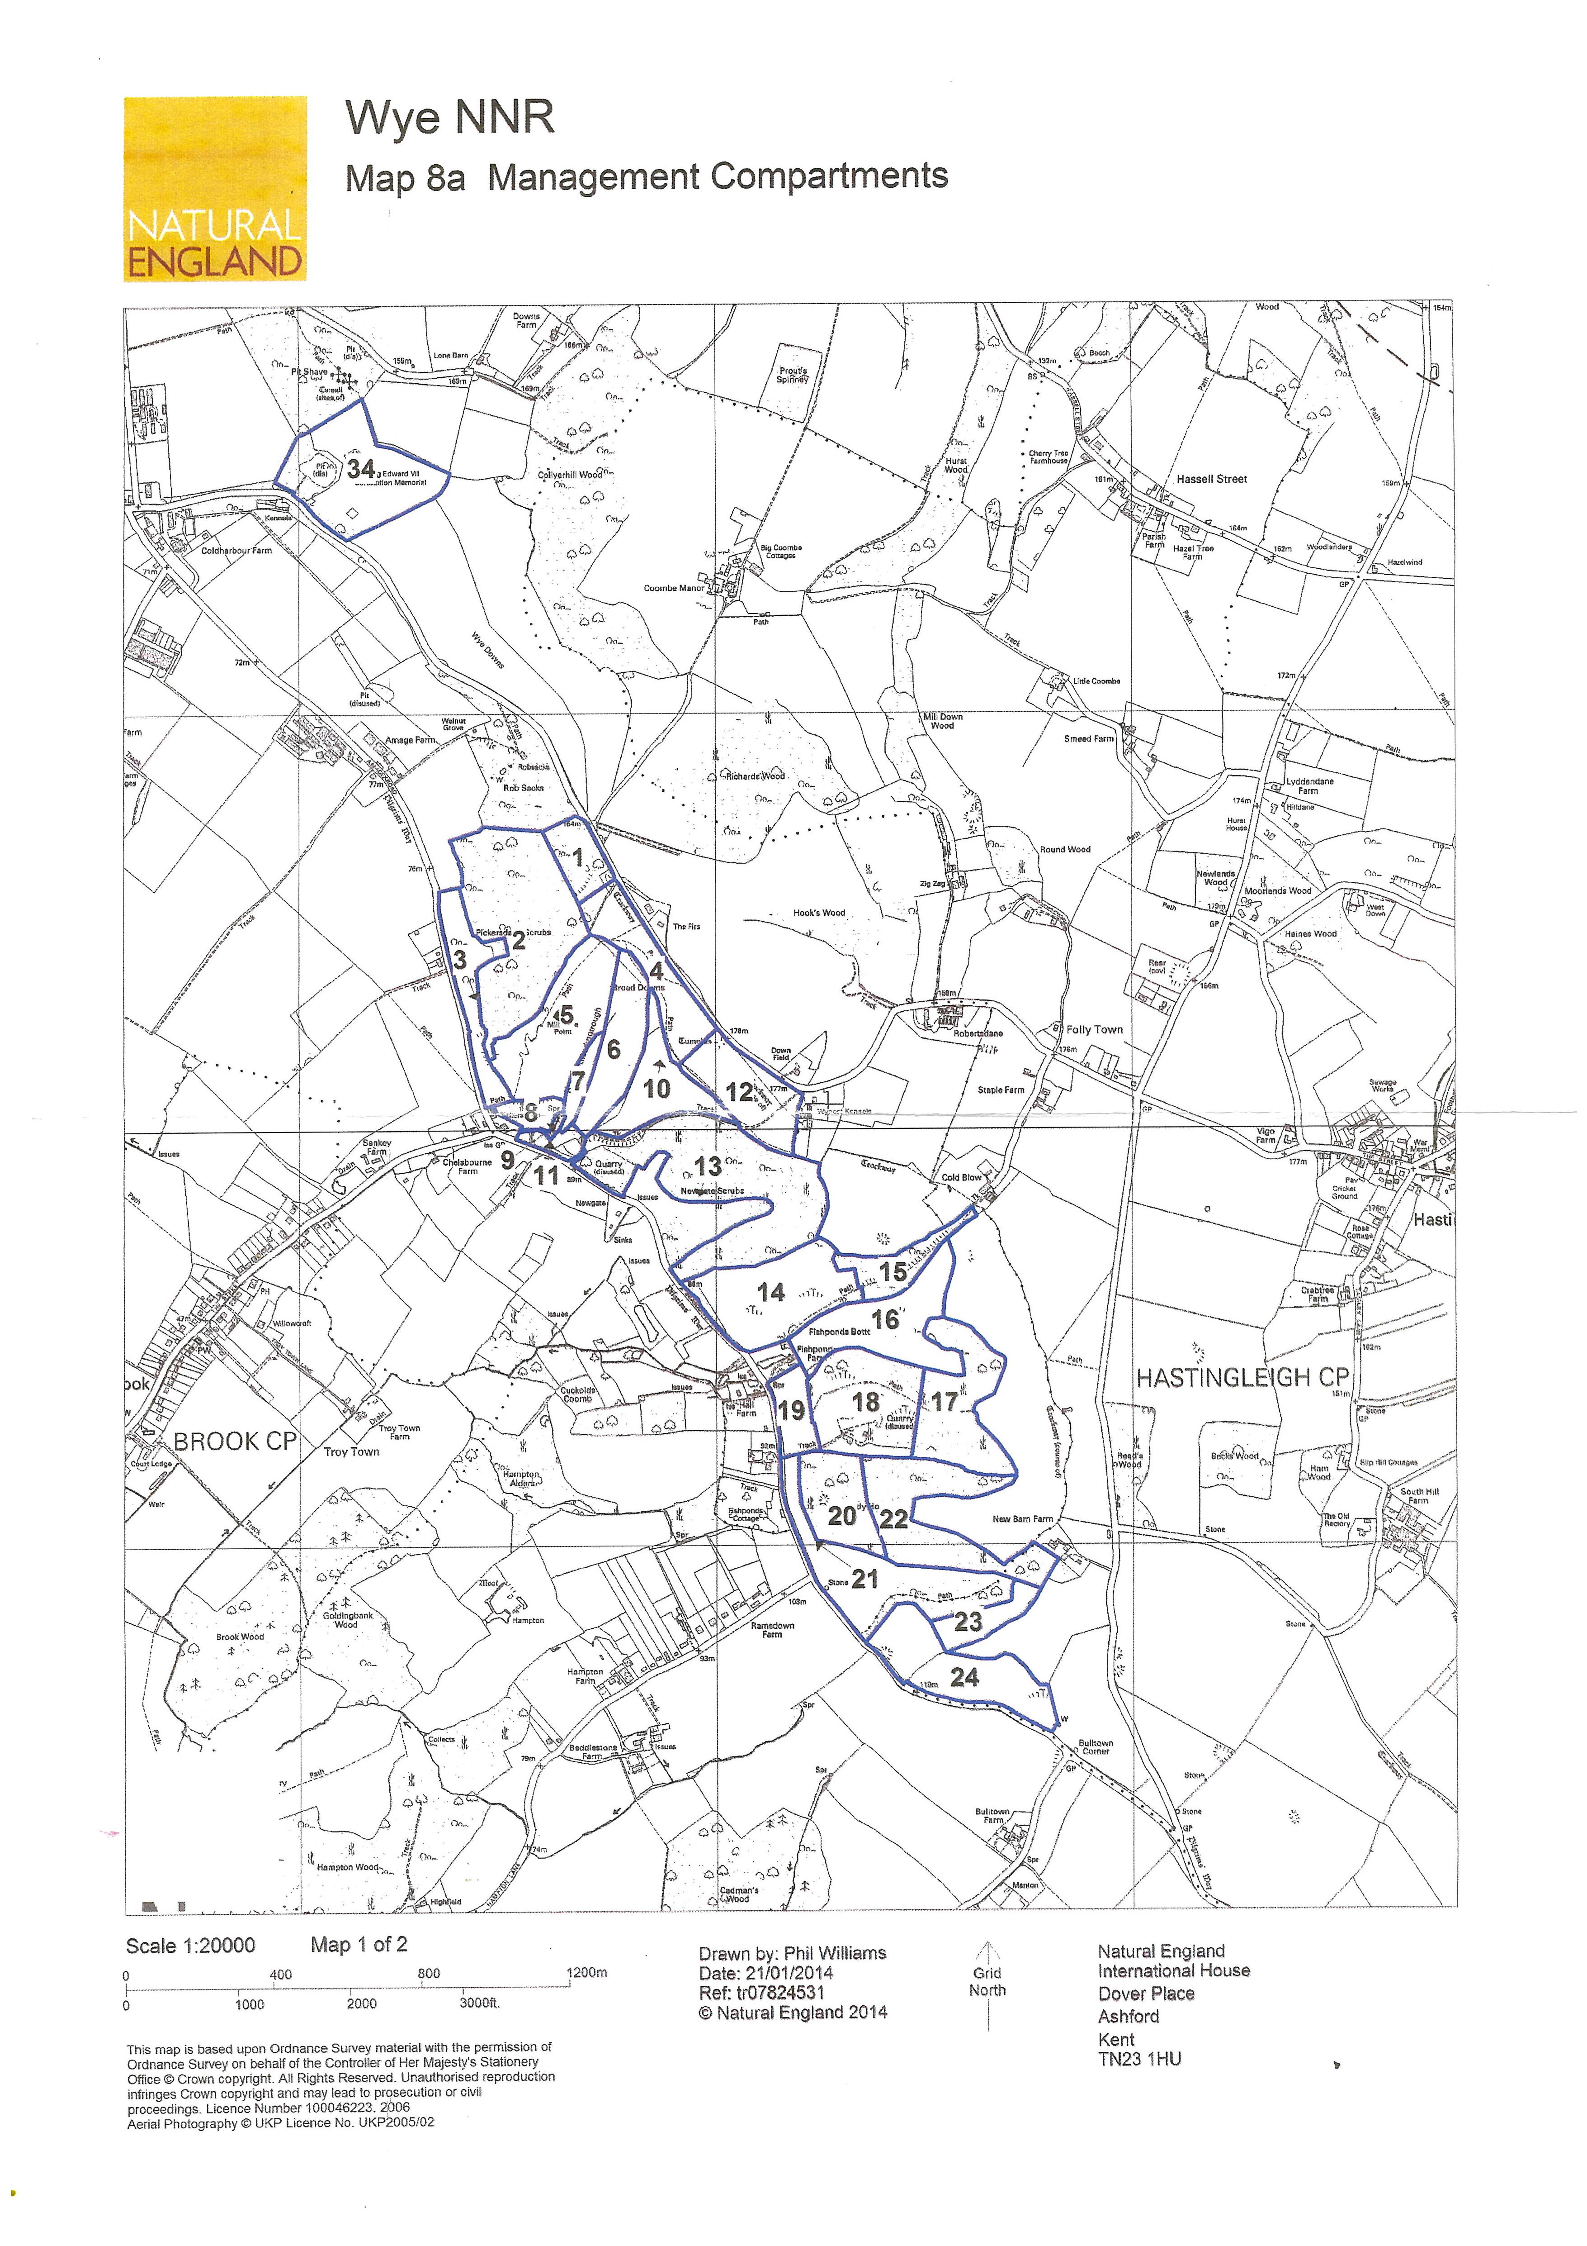

Background:

Natural England advises the Government on nature conservation issues and promotes, directly and through others, the conservation of the wildlife and natural features of England within the wider setting of the United Kingdom and its international responsibilities.

Natural England’s estate of NNRs (National Nature Reserves) includes the finest examples of wildlife and geology in England and provides outstanding opportunities for people to experience the natural world. These areas form a vitally important resource and are a means of increasing public awareness about nature and its part in the landscape.

Wye NNR is about 145 Hectares of Chalk Grassland and Woodland on mainly the steep sided scarp slope of the North Downs above Wye. It is 5 miles East of Ashford.
The open grassland is grazed by sheep and cattle and the woodland is mainly Hazel with Ash and Oak Standards. The site is well known for its Orchid colonies, particularly the Late Spider Orchid (Orphrys fuciflora) and its invertebrate assemblage. The Butterflies of note include the Chalkhill Blue, Adonis Blue, Duke of Burgandy. Also the very rare Black-veined Moth can be found in good numbers over large areas of the site.

Wye is Designated as a SSSI for the following features.
- Broadleaf and Yew woodland W8 and W10.
- Breeding Bird Assmeblage.
- Invertebrate assemblage.
- Lowland Calcareous Grassland and Orchid Rich site.

It is also designated as an SAC for being an orchid rich site. As a GCR for the quaternary geology, and sits within the protected North Downs National Landscape area.

Summary of Project

To keep Wye NNR in favourable condition it needs to be grazed by livestock. This keeps the sward at the optimum length and allows for the herbage and orchids to thrive. For grazing to be successful it needs dependable fences surrounding each compartment and the boundary of the site.
Since the management plan review in 2020, there have been annual fencing replacements on the most in-need sections.
This year we are looking for quotes to fence the boundary of compartment 14 (Fishponds Bank / The Mountain).

Specifics of work to be undertaken

In places the scrub and trees will need to be cut back, this will be done either on a separate contract or by Natural England staff. However the extent of the works will be on advice of the fencing contractor and their needs.

The Successful Contractor must remove and dispose of current fence, then replace with stock fencing as specified below.

- F27, F28 – Northern and western boundary fences. Estimated length - 550 metres. This fence is bounded at each end by a 12ft field which will both remain in situ.

- F29 – Eastern and Southern Boundary. This fence drops down a steep scarp slope and then along a flatter part of the field. Estimated length - 400 metres

See attached map for locations:

The materials and method that are to be used are described as follows:

Peeled chestnut full round fence posts:
Strainers - round, minimum 150mm (6") dia., 2.45m (8 ft) long
Struts - round, 75-100mm (3-4") dia., 2.45m (8 feet) long
Intermediates – full rounds, minimum 75-100mm (3-4") dia., 1.65m (5.5ft) long.

Where slope or dips in the ground merit longer posts to maintain fence height/strength, intermediates 1.8m (6ft) or longer should be used.

Wire:
All wire must conform to British Standard Specification.
Stock netting - C8/80/15
barbed wire.
Plain wire.

Methods (ref TCV Fencing Handbook)

C8/80/15 and strands of barbed wire.

Approximately 1/3 of strainer length to be below ground and approximately 0.5 metre of stakes to be embedded in the ground. Cutting tops off posts to mask the fact that they are not deep enough in the ground is not acceptable. Struts to be morticed into strainers. Anchor stakes are necessary where struts bed into any ground softer than the chalk bedrock. Soil around strainers to be replaced and rammed. Concreting strainers in is not acceptable. Turf should be replaced as far as possible when ramming is complete.

Strainers to be placed at 50 metre intervals, with the C8/80/15 strained and tied off at each strainer. Bottom line of the C8/80/15 to follow the ground surface, as far as possible. Extra strainers are to be used at significant bends (horizontal or vertical) in the line. Gate posts and old strainers are not to be used to strain the fence. All new strainers to be used.

Intermediates should be at approximately 2 to 3 metre intervals and should not be under strain from irregularities in the line of the fence.

One line of barbed approximately 100mm (4") above the C8/80/15. Then a line of plain wire approximately 100mm (4") above the barbed wire. Lines to be evenly spaced.

All wood offcuts, litter, and Off-cuts of wire (No matter how small) and all other metal fragments, including staples, used or otherwise, must be cleared from the site for the sake of visitor safety and animal welfare.

The field to be fenced is very steep in places and difficult to access. A tracked machine will be needed to work on this project.

Timing – All Fencing work must take place before the middle of March 2025. This deadline is non-negotiable as the funding is only for this financial year.

Machinery to be used with utmost care to the site. Do not access site in wet conditions. Always use field edges to move machinery around , avoid all damage to the chalk grassland.

Bio-Security - While the risk of spread of alien species and pathogens from the site is low it is expected that the successful contractor will follow industry best practice regarding biosecurity and must not move machinery or equipment to and from site without taking appropriate measures.

Access:

Wye NNR has 2 car parks at the Northwest side – The Coach Park and the main Car park. These are both found off Coldharbour lane, Hatingleigh, Wye, Nr Ashford, Kent TN25 5HE.

However, the access to the work site is found on the western side of the site. The access gate to compartment 14 is off a bridleway and is off a narrow lane (Brabourne Road). There is a yard area for storage of materials and machinery 200m up the same road.

The access gate to compartment 14 is at W3W///kitchen.novelists.joins

The field is steep and is unsuitable even for a 4wd vehicle, especially in wet weather. A more purpose built tracked vehicle will be required.

See maps attached

Conditions of contract:

The successful contractor must be willing and able to comply with all of Natural England’s Health & Safety requirements. Particularly:
- Lone working will not be permitted;
- Appropriate protective equipment must be worn when using powered tools or equipment
- Appropriate certification must be held for use of equipment
- Care must be taken to avoid hazards to public safety and warning signs must be erected around working area

The successful contractor is required to carry out an independent risk assessment and to indemnify Natural England against all claims by third parties arising out of the operations of the contractor.

Contractor to provide the following information before commencement of work:-.
- a copy of your health and safety policy
- copies of all relevant risk assessments
- a copy of the task method statement
- copies of relevant certification
- a copy of your employer's liability insurance certificate
- a copy of your public liability insurance certificate.

A record of information exchange is to be kept and signed by both parties before work commences. Copy attached for reference.

Contract management:

The contract will be managed by the reserve management team. This consists of

- Piers Griffin (Reserve Manager) 07881037704 – piers.griffin@naturalengland.org.uk
- Rob Carver (Senior Reserves Manager) 07469036829 rob.carver@naturalengland.org.uk
Regular contact in person, and via phone and email will be maintained with the appointed contractor to ensure the outputs are achieved, within the decided timescale, in a safe manner. Likewise, the contractor is expected to maintain contact with the Project Manager throughout the duration of the work.

Evaluation criteria
Successful candidates will be selected based on previous experience, as well as the value of the quote submitted and estimated timescales. Please provide evidence of this in particular relation to nature conservation work and woodland management experience.

