**Ministry of Defence**

**DEFFORM 711 – NOTIFICATION OF INTELLECTUAL PROPERTY RIGHTS (IPR) RESTRICTIONS**

# DEFFORM 711 - PART A – Notification of IPR Restrictions

**This document has been redacted in its entirety.**

|  |  |  |  |  |
| --- | --- | --- | --- | --- |
| 1. ITT / Contract Number | | 704656450 |  |  |
|  |  |  |  |  |

Please continue on additional sheets where necessary.

# DEFFORM 711 - PART B – System / Product Breakdown Structure (PBS)

The Contractor should insert their PBS here. For Software, please provide a Modular Breakdown Structure.

**DEFFORM 711 (Edn 11/22)**

|  |  |
| --- | --- |
| REDACTED | |
|  |  |

REDACTED

**DEFFORM 711 (Edn 11/22)**

## Completion Notes Part A

If any information / technical data that is deliverable or delivered under the relevant Contract conditions is, or may be, subject to any IPR restrictions (or any other type of restriction which may include export restrictions) affecting the Authority’s ability to use or disclose the information / technical data in accordance with the conditions of any resulting Contract, then the Contractor must identify this restricted information / technical data in this Part A. Otherwise, the Authority shall treat such information in accordance with the same rights under the Contract it would enjoy should no restrictions exist.

For example, any of the following must be disclosed:

1. any restriction on the provision of information / technical data to the Authority; any restriction on disclosure or the use of information by, or on behalf of, the Authority; any obligations to make payments in respect of IPR, and any patent or registered design (or application for either) or other IPR (including unregistered design right) owned or controlled by you or a third party;
2. any allegation made against the Contractor, whether by claim or otherwise, of an infringement of IPR (whether a patent, registered design, unregistered design right, copyright or otherwise) or of a breach of confidence, which relates to the performance of the Contract or subsequent use by or for the Authority of any Contract deliverables;
3. the nature of any allegation referred to under sub-paragraph (b) above, including any request or obligation to make payments in respect of the IPR of any confidential information and / or;
4. any action the Contractor needs to take, or the Authority is requested to take, to deal with the consequences of any allegation referred to under sub-paragraph (b) above.

|  |  |
| --- | --- |
| Block 1 | Enter the associated Invitation to Tender (ITT) or Contract number as appropriate. |
| Block 2 | No action – This sequential numbering is to assist isolation and discussion of any line item |
| Block 3 | Identify a unique reference number for the information / technical data (i.e. a Contractor’s document or file reference number) including any dates and version numbers. Documents may only be grouped and listed as a single entry where they relate to the same Article and where the restrictions and IPR owner are the same. |
| Block 4 | Identify the Article(s) associated with the information / technical data by entering a unique identification number / label for the Article(s). This may range from platform level down to sub-system level. This is to enable the Authority to quickly identify the approximate technical boundary to any user rights limitation (e.g. The RADAR or Defensive Aid Sub-System etc). This identification shall be at the lowest level of replaceability of the Article(s) or part of it to which the restrictions apply (i.e. if the restrictions apply to a sub-system the parent system should not be used to identify the restriction boundary). Any entry without a unique identifier shall be treated as a nil entry.  NOTE: The Authority does not accept any IPR restrictions in respect of the physical Articles themselves. Block 4 is solely to provide an applied picture to any technical data stated under Block 3 as having IPR restrictions. |
| Block 5 | This is a freeform narrative field to allow a short explanation justifying why this information / technical data has limited rights applying to it. |

**DEFFORM 711 (Edn 11/22)**

|  |  |
| --- | --- |
| Block 6 | Identify who is the owner of the IPR in the information / technical data (i.e. copyright, design right etc). If it is a sub-contractor or supplier, please identify this also. |

## Part B

If neither hardware nor software is proposed to be designed, developed or delivered as part of the Contract, Part B should be marked “NIL RETURN”.

Otherwise, the Contractor must include a System / Product Breakdown Structure (PBS) in a format which is consistent with ISO 21511 and / or the configuration requirements of DEFSTAN 05-057, unless an alternative format better represents your design configuration. For software, a modular breakdown structure must be provided. For reasons of clarity, it is acceptable to provide several levels of breakdown if this assists in organising the configuration of the Articles.

Details provided under Part B shall not imply any restriction of use over the Contract Articles, nor any restriction on associated technical data to be delivered under the Contract. Any restrictions of such technical data must be identified within Part A.

Against each unique item within the PBS / module breakdown, one of the following categories shall be recorded:

1. (PVF) - Private Venture Funded - where the article existed prior to the proposed Contract and its design was created through funding otherwise than from His Majesty’s Government (HMG).
2. (PAF) - Previous Authority Funded (inc. HMG Funded) - where the article existed prior to the proposed Contract and its design was created through Previous Authority Funding.
3. (CAF) - Contract Authority Funded (inc. HMG Funded) - where the article did not exist prior to the Contract and its design will be created through Contract Authority Funding under this Contract.
4. (DNM) Design Not Mature - where the article / design configuration is not yet fixed.

In combination with one of categories (a) to (d) above, the Contractor shall further identify where an item has, or will have, foreign export control applying to it, through use of the further following category:

1. (FEX) Foreign Export Controlled

Notes:

1. During the term of the Contract the Contractor may transition any items identified as category (d) above into category (b) or (c). Transitions from category (d) into category (a) may only be made with the express written agreement of the Authority’s Senior Commercial Officer, and by following the amendment process set out in the Contract.
2. It is acceptable to specify the highest level of structure to which the category (a), (b) or (c) applies (i.e. there is no need to specify each sub-system / componentry if the entirety of the parent system was for example, Private Venture Funded). See guidance examples overleaf.
3. For the avoidance of doubt, where a parent system did not exist prior to the Contract yet makes use of Private Venture Funded Articles, it must be identified as (CAF). The Private Venture Funded sub-components / sub-systems can be identified as PVF.
4. Where items are identified as category (b), the Contractor should provide the number(s) of the previous Contract(s) under which the design was created and the Previous Authority Funding was applied.

**HMG MLI: 704656450**

**SCHEDULE 10**

**DEFFORM 711 (Edn 11/22)**

**HMG MLI: 704656450**

**SCHEDULE 10**

**DEFFORM 711 (Edn 11/22)**

## Example PBS

A theoretical pictorial example is given below but it is to be noted that the configuration may equally be dealt with in a hierarchal tabularised format.

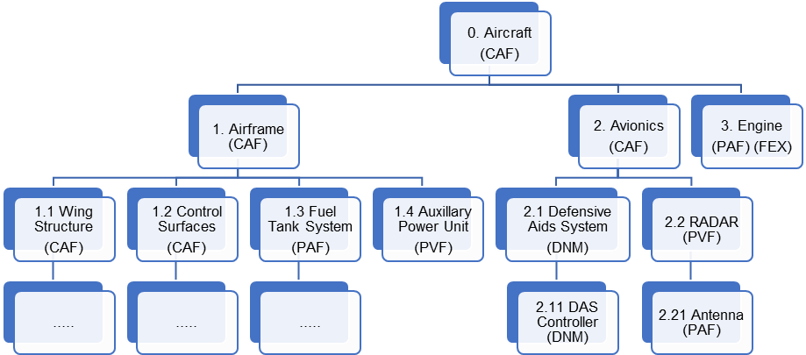

The diagram above indicates a highly simplified and hypothetical Contract scenario dealing with the procurement of a new air asset.

1. The proposed new aircraft would be considered Contract Authority Funded (CAF) at its top level.
2. Items denoted as Private Venture Funded (PVF) would generally indicate that it and all of its sub-components have been funded by sources other than HMG. In this instance there is no need to proceed down the product breakdown structure any further (see 1.4), except unusually where a generally PVF regarded item has incorporated a Previous Authority Funded (PAF) item (see 2.21).
3. The proposed design is making use of a PAF engine. iv. This engine has Foreign Export Control (FEX) applying to items within it.
4. The Defensive Aids System at 2.1 is covered as part of the Contract but the exact configuration and design has not yet been fixed “Design Not Mature” (DNM).
5. It is not feasible for a parent PVF system to make use of a CAF item; the parent system configuration would not have existed prior to the Contract.