- INTRODUCTION

  - This document provides an overview of the methodology which will be adopted by the Authority and its Agent to evaluate Potential Provider responses to each question set out within the e-Sourcing event. It also sets out the marking scheme which will apply.

  - The following information has been provided in relation to each question (where applicable);

    - Weighting – highlights the relative importance of the question

    - Guidance – sets out information for the Potential Providers to consider

    - Marking Scheme – details the marks available to evaluators during evaluation

  - The defined terms used in the ITT document shall apply to this document.

- OVERVIEW

  - The e-Sourcing event is broken down into the following Questionnaires:
Questionnaire Reference | Questionnaire Title
1 | KEY PARTICIPATION REQUIREMENTS
2 | CONFLICTS OF INTEREST
3 | INFORMATION ONLY
4 | QUALITY – PROJECT SPECIFIC EXPERIENCE
5 | QUALITY - METHODOLOGY
6 | PRICE
7 | STAGE TWO - PRESENTATIONS

  - Quality Evaluation Process

    - The evaluation of each response to the Quality/Service Delivery Questionnaire(s) will be conducted and consensus checked in accordance with the Consensus Marking Procedure set out in paragraph 2.3 below.

    - Each response to questions within the Quality/Service Delivery Questionnaire(s) will be marked in accordance with the table below:

Mark | Comment
0 | Failed to provide confidence that the proposal will meet the requirements. An unacceptable response with serious reservations.
25 | A Poor response with reservations. The response lacks convincing detail with risk that the proposal will not be successful in meeting all the requirements.
50 | Meets the requirements – the response generally meets the requirements, but lacks sufficient detail to warrant a higher mark.
75 | A Good response that meets the requirements with good supporting evidence. Demonstrates good understanding.
100 | An Excellent comprehensive response that meets the requirements. Indicates an excellent response with detailed supporting evidence and no weaknesses resulting in a high level of confidence.

    - Each mark achieved will be multiplied by the corresponding weighting to provide an overall question score.

    - When the score for each question has been determined they will be added together to provide an overall score for the Quality Evaluation (“Quality Score”).

  - Consensus Marking Procedure

    - Tenders that are scored and require evaluation will be evaluated in accordance with the procedure described in this paragraph.

    - The Consensus Marking Procedure is a two-step process, comprising of:

      - Independent evaluation; and
      - Group consensus marking.

    - During the independent evaluation process, each evaluator will separately (i.e. without conferring with other evaluators) scrutinise the quality of answers given by Potential Providers in their Tender. Each evaluator will then allocate a mark for the answer in accordance with the Marking Scheme applicable to that question.

    - The Agent will review the marks allocated by the individual evaluators before facilitating a group consensus marking meeting.

    - During the meeting, the evaluators will discuss the independent marks until they reach a consensus regarding the marks that should be attributed to each Potential Providers’ answer to the questions.
    - Once all quality responses have been evaluated in accordance with Section 8 of the Invitation to Tender the individual scores attributed to each response will be added together to provide a ‘Quality Score’.

  - Price Evaluation Process

    - Prices submitted by Potential Providers’ in the Price Schedule will be recorded and evaluated in accordance with the following process.

    - Potential Providers’ are required to provide a completed pricing schedule against the ‘Price’ Questionnaire within the e-Sourcing event.

    - Prices offered will be evaluated against the range of prices submitted by all Potential Providers for that item.

    - The Potential Provider with the lowest price the requirement shall be awarded the Maximum Score Available. The remaining Potential Providers shall be awarded a percentage of the Maximum Score Available equal to their price, relative to the lowest price submitted.

    - The calculation used is the following:

    - = Lowest Price Tendered x Maximum Score Available
Tender price

Potential Provider | Price Submitted | Score Calculation | Maximum Score Available | Score Awarded
Potential Provider A | £1,000 | £1,000/£1,000 *100 | 100 | 100
Potential Provider B | £2,000 | £1,000/£2,000 *100 | 100 | 50
Potential Provider C | £2,500 | £1,000/£2,500 *100 | 100 | 40

  - Final score
    - The Quality Score achieved at stage one (1) will be added to the Price Score to determine a ranking for each Potential Provider (“Stage One Score”).
    - The highest ranked Potential Providers, who achieve the minimum acceptable Quality Score and are within 15% of the first ranked Potential Provider at stage one (1) will be invited to participate in stage two (2).
    - The Quality/Price Score at stage one (1) will be combined with the Quality Score at stage two (2) to determine the final score for each Potential Provider (“Final Score”).
- EVALUATION CRITERIA

  - A summary of all the questions contained within the e-Sourcing event, along with; the minimum acceptable score, maximum score available and weighting (where applicable) are set out below:

  - Questionnaires 1 and 2 contain ‘Pass/Fail’ questions and act as a doorway for progression to the following stages of the evaluation. Potential Providers are strongly advised to read and understand the specific guidance provided before responding to these questionnaires.

  - Questionnaire 3 is for information only. Although this questionnaire does not form part of the evaluation process, Potential Providers are advised to complete it in full as any omissions could affect the award process.

  - The Authority and its Agent reserve the right to challenge any information provided in response to Questionnaire 3 and request further information in support of any statements made therein.

QUESTIONNAIRE 1 – KEY PARTICIPATION REQUIREMENTS
GUIDANCE | The following questions are ‘Pass/Fail’ questions. If Potential Providers are unwilling or unable to answer “Yes”, their submission will be deemed non-compliant and shall be rejected.Potential Providers should confirm their answer by selecting the appropriate option from the drop down menu.
Question Number | Question | Max Score | Weighting (%)
1.1 | Have you read, understood and agree with Appendix A, Terms of Participation? By answering “Yes”, you are confirming your ‘Declaration of Compliance’ at Annex 1 of Appendix A, Terms of Participation. | Pass/Fail | N/A
1.2 | Have you read, understood and accepted the Invitation to Tender and all associated appendices, specifically Appendix B, Statement of Requirement? | Pass/Fail | N/A
1.3 | Do you agree, without caveats or limitations, that in the event that you are successful the Crown Commercial Service’s Terms and Conditions within Appendix C, will govern the provision of this contract? | Pass/Fail | N/A
1.4 | Do you confirm your Organisation’s e-Sourcing suite profile is complete and accurate at the time of Tendering and that any amendments made following acceptance of this event will be notified to the buyer in writing. | Pass/Fail | N/A
1.5 | Can you confirm that a suitable number staff required to deliver this requirement currently hold or are willing to obtain CTC clearance before commencing work? | Pass/Fail | N/A
QUESTIONNAIRE 2 – CONFLICTS OF INTEREST
GUIDANCE | Question 2.1 is a ‘Yes/No’ question and will dictate whether or not question 2.2 needs to be answered.  Question 2.2 is a Pass / Fail question. Potential Providers are required to provide details of how the identified conflict will be mitigated. The Contracting Authority will review the mitigation in line with the perceived conflict of interest, to determine what level of risk this poses to them. Therefore if Potential Providers cannot or are unwilling to suitably demonstrate that they have suitable safeguards to mitigate any risk then their Tender will be deemed non-compliant and will be rejected.
Question Number | Question | Max Score | Weighting (%)
2.1 | Please confirm whether you have any potential, actual or perceived conflicts of interest that may by relevant to this requirement. | None | N/A
2.2 | We require that any potential, actual or perceived conflicts of interest in respect of this ITT are identified in writing and that companies outline what safeguards would be put in place to mitigate the risk of actual or perceived conflicts arising during the delivery of these services. | Pass/Fail | N/A

QUESTIONNAIRE 3 – INFORMATION ONLY
GUIDANCE | The following questions are for information only and do not form part of the evaluation. Information provided in response to these questions may be used in preparation of any Contract Award and any ommissions may delay completion of this Tender exercise.
Question Number | Question | Max Score | Weighting (%)
3.1 | Please provide the name, office address, telephone number and email address for your organisations Tender point of contract. | None | N/A
3.2 | Please confirm whether your organisation is an SME as defined within EU recommendation 2003/361 | None | N/A
3.3 | Please provide details of any sub-contractors you propose to use in order to meet your obligations should you be awarded a Contract. Your response must include their;  - Trading Name(s)  - Registered Address(es) and contact details  - Goods/Services to be provided | None | N/A
3.4 | If you are the Lead contact for a Group of Economic Operators, please provide details of all the members of the Group. Your response must include their;  - Trading Names(s)  - Registered address(es)  - Dunns Number(s)  - Role/responsibility within the Group | None | N/A

  - The following Quality/Service Delivery Questionnaires are designed to test Potential Providers’ ability to deliver the requirement as set out in Appendix B, Statement of Requirements. Potential Providers MUST answer all Quality/Service Delivery questions.

  - Potential Providers must achieve the minimum acceptable Quality Score, as described, for each of the questions below. Only those responses which achieve the minimum acceptable Quality Score will be included in the Price Evaluation Process.

  - Where only one (1) submission is received which does not meet the minimum acceptable Quality Score, the Authority reserves the right to enter into dialogue and seek assurances regarding the delivery of the requirement.

  - Potential Providers must provide attachments against each question as specified in the below point. Question text fields must be populated with detailed references to relevant attachments or sections within their attachments.

  - Suppliers should set out their response in the following format:

    - Attachment 1 – Questions 1 and 3 in PDF format attached at questionnaire 1.
    - Attachment 2 – Questions 2,4 and 5 in PDF format attached at questionnaire 4.
    - Attachment 3 – Questions 6 (Appendix E – Price Table) in an Excel file attached at question level 6.1.

  - Attachment file name should be as follows; CCDE17A02 – Attachment X – QX-X –
Supplier Name.

  - Potential Providers’ responses must clearly demonstrate how they propose to meet the requirements set out in the question and address each element in the order they are asked.

  - Potential Providers’ responses should be limited to, and focused on each of the component parts of the question posed. They should refrain from making generalised statements and providing information not relevant to the topic.

  - Whilst there will be no marks given to layout, spelling, punctuation and grammar, it will assist evaluators if attention is paid to these areas including identifying key sections within responses.

  - Potential providers will be marked in accordance with the marking scheme at Section 2.

  - The page limit on all attachments is set at 20 A4 Sides. Attachments maybe submitted in Microsoft Word, Excel. PDF format and be in Arial font size 11.

QUESTIONNAIRE 4 – QUALITY – PROJECT SPECIFIC EXPERIENCE |  |  | Weighting – 25 %
All Potential Providers MUST answer ALL the following questions
Question Number | Question | Minimum Acceptable Score | Maximum Available Score | Weighting %
4.1 | Please provide details of those individuals that will make up your team; their relevant skills and experience, and indicate why this would make them suitable for conducting this review.  Your response should indicate your experience with reducing bullying, harassment and discrimination through embedding conflict resolution across complex organisations. | 50 | 100 | 40%
4.2 | Please provide a Resource Plan outlining how you propose to structure your team, including any sub contractors that you may use. | 50 | 100 | 30%
4.3 | When operating in complex enviroments, what have been your biggest challenges, and lessons learned? Please detail how these experiences would be brought to the project and add value. | 50 | 100 | 30%

QUESTIONNAIRE 5 – QUALITY - METHODOLOGY |  |  | Weighting – 30 %
All Potential Providers MUST answer ALL the following questions
Question Number | Question | Minimum Acceptable Score | Maximum Available Score | Weighting %
5.1 | Please provide a Project Plan that demonstrates how you will meet the requirements within the given deadlines. | 50 | 100 | 25%
5.2 | Please explain your methodology which will help us to reduce bullying, harassment and discrimination? | 50 | 100 | 25%
5.3 | What do you consider to be the key risks that we face in embedding conflict resolution within the organisation? How do you propose to mitigate these risks? | 50 | 100 | 25%
5.4 | Please detail how you would work alongside the IE Diversity Network to deliver the specified requirements of a early intervention scheme. | 50 | 100 | 25%

QUESTIONNAIRE 6 – PRICE |  | Weighting – 30 %
GUIDANCE | Potential Providers must upload the price schedule at the question level (6.1) specifically on the e-Sourcing event.  Prices should be submitted in pounds Sterling inclusive of any expenses but exclusive of VAT.  Potential Providers will be marked in accordance with the marking scheme at Section 2.  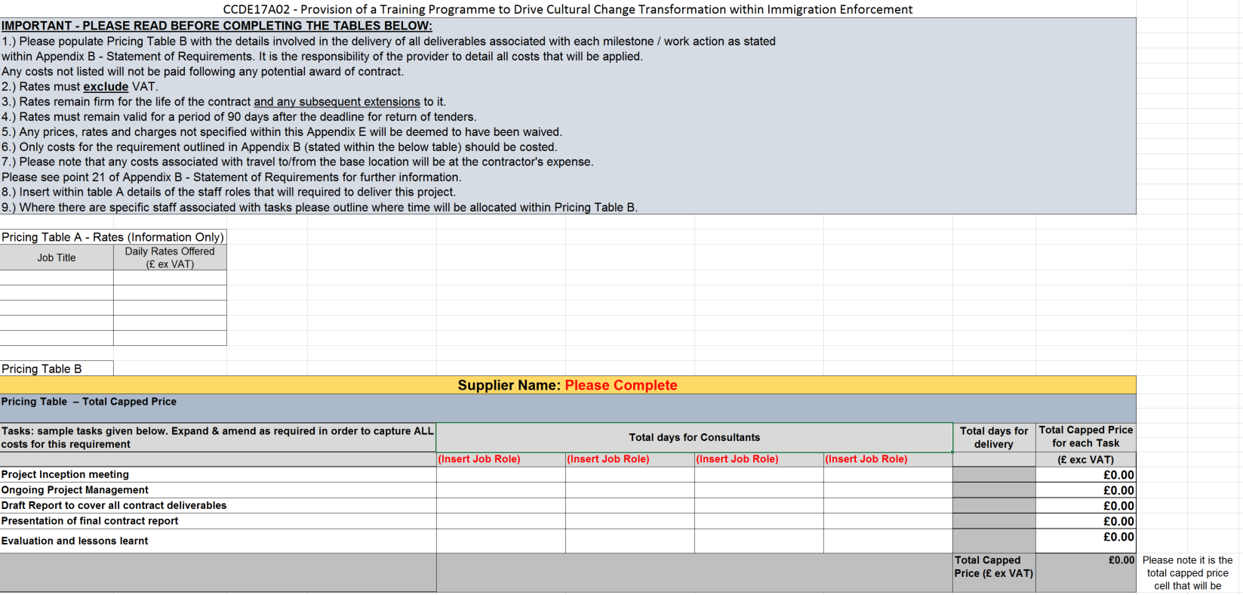
Question Number | Question | Max Score
6.1 | Please confirm, by selecting ‘YES’ that you have attached a completed Price Schedule to the response to this question. In so doing, you are also confirming that prices offered are inclusive of any expenses, exclusive of VAT and firm for a period of 90 days following the Deadline for Submission. | 100

- STAGE TWO

QUESTIONNAIRE 7 – PRESENTATION |  |  | Weighting – 15%
GUIDANCE | The technical proposal and price tables will be evaluated. All the suppliers capable (within 15%) of winning the competition after the initial evaluation will be invited to a presentation/interview.
Question Number | Question | Max Score |  | Weighting (%)
7.1 | The presentation will take the format of a 45 minute formal presentation of your team’s approach to supporting the requirement, including detail of where and how you see your team adding value to the project. The key member’s specific to this piece of work will be required to attend the presentation. | 100 |  | 100

