Medical Technologies Innovation Facility – BEZ (Boots Enterprise Zone), Nottingham
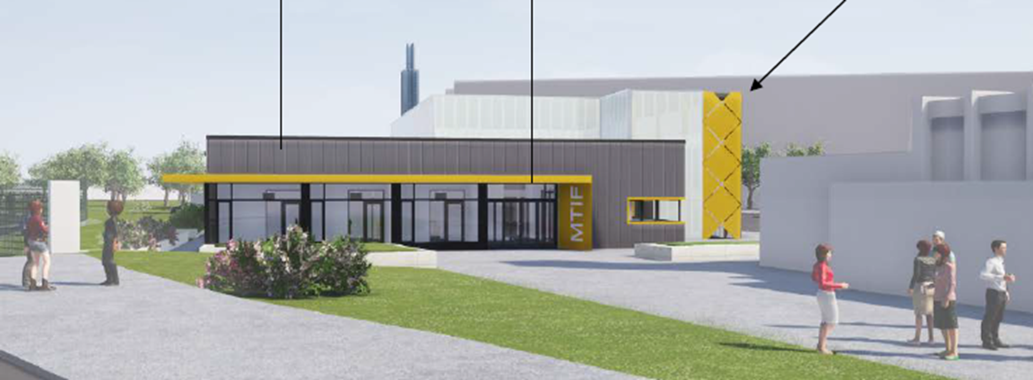
BEZ – 1000M2
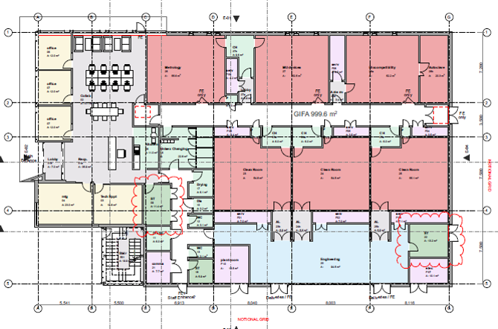

MTIF is a subsidiary company of NTU
3 ISO Class 6 Clean Rooms
Multi user Devices Lab
Metrology Lab
Biocompatability Lab
Autoclave Room

Construction start date – July 2019, Completion date July 2020
Project value approx £8m Nett, (Construction approx 5.5m NETT)
The project will also deliver a “Very Good” BREEAM rating & EPC A

PROCUREMENT

It is anticipated that the building contract will be let on a single stage fixed price Design and Build form of contract, e.g. JCT Design and Build or similar. Further information and confirmation of novation approach and contract type will be provided at the tender stage.

The tendering process will follow the procedures laid down in The Public Contracts Regulations 2015.

Nottingham Trent University is following the Competitive with Negotiation procedure in accordance with the legislation.

