

Buyer: The Secretary of State for the Home Department acting through Border Force

statement of requirements

CPV SPEEDWELL - MAINTENANCE AND SAFETY EQUIPMENT RECERTIFICATION

March 2024

Project_817

Contents
Definitions 4
Part 1: General 7
1.0 Background 7
Part 2: Insurance 8
2.0 Insurance 8
Part 3: Objectives, Location and Constraints 9
3.0 Objectives 9
4.0 Location 9
5.0 Constraints 9
Part 4: Provision of Services 11
6.0 General Provision 11
7.0 Project Management 12
8.0 Warranty 13
Part 5: Emergent Work 15
9.0 Emergent Work 15
Part 6: Trials, Certification and Acceptance 16
10.0 Trials 16
11.0 Certification 16
12.0 Project Completion 17
Part 7: Charges and Payment 18
13.0 Charges and Payment 18
Annex A: General Requirements of Work 20
Annex B: Inspection, Testing and Certification of Safety Equipment 21
Annex C: Vessel Maintenance Tasks 22
Annex D: Modifications and Defect Rectification 23
Annex E: General Arrangements 29
Annex F: Vessel Details 31
Annex G: Emergent Work Individual Item Proforma 32
Annex H: Emergent Work item Record Spreadsheet 33
Annex I: Handover Certificate 34
Annex J: Acceptance Certificate 35
Annex K: Project Completion Certificate 36
Annex L: Reimbursable Expenses 37
Annex M: Carbon Centre Disc Assembly & Operation M034-0003-EN 38
Annex N: Jet Anodes 521 39
Annex O: CPV Anodes, Cathode Protection and Bonding 40
Annex P: MDKBL Cummins Onan Service 41
Annex Q: 9m GRP Patrol Boat Tech 110416. CPV Paint Scheme 42
Annex R: CPV SOP 08 – Inventory 43

For more information on how HM Government classifies its information to ensure it is appropriately protected and your role in that protection, please visit:
https://www.gov.uk/government/publications/government-security-classifications

Definitions
Phrase | Definition
Acceptance | The issuing of an acceptance certificate to the Supplier, signed by the BFOO on behalf of the Buyer following the re-floating of the Vessel following the lifting out from the water.
After Service | A single phone number for the Supplier giving access to a point of contact able to give user-friendly assistance to persons experiencing technical problems with any part or operation of the Vessel.
Berth | A suitable berth with at least 1m below the keel at ALL states of the tide  Complete with access by gangway/brow (refer to the appropriate MGN).
Border Force (BF) | Buyer
Border Force Overseeing Officer (BFOO) | Buyer representative responsible for the overseeing of the project and the monitoring of the agreement at the point of delivery.
Cardinal Date Plan (CDP) | A plan provided by the Supplier mapping out the significant dates for a project.
Coastal Patrol Vessel (CPV) | The Vessel.
Collar | RHIB Collars (also known as RHIB Tubes or Sponson) are the inflatable section of a Rigid Hull Inflatable OR A polyurethane coated closed cell foam cored buoyant Collar offering similar properties.
Defect Rectification | Work undertaken to resolve any kind of defect identified and listed in the work package at Annex D.
Driveline | The CPV Driveline is the engines, water jets and drive shafts, and components used to connect these together.
Emergent work  (EW) | Any work that emerges from the specified Planned Maintenance, which is notified to the Supplier in this Statement of Requirements. Any repairs which are required as a direct result of defects/damage found with during this package of works.
Major Defect | Any defect or fault which reduces the performance of the Vessel, so it is unable to perform its duties rendering the Vessel inoperable or unseaworthy.
MCA | Maritime and Coastguard Agency
Minor Defect | Any defect or fault which reduces the performance of the Vessel while allowing it to be safely operated for its duties and remain seaworthy.
Original Equipment Manufacturer (OEM) | The original manufacturer of a piece of equipment.
Project Progress Meeting (PPM) | A formal Progress Meeting to be conducted between the BFOO and the PM weekly for the duration of the contract at a date and time to be agreed as part of contract mobilisation and following award.
Project Completion | Formal notification by the BFOO, on behalf of the Buyer, to the Supplier that the project is completed to a satisfactory standard. The Supplier will be issued a Project Completion Confirmation.
Project Conclusion Meeting (PCM) | The mandated close-down meeting between Supplier and BFOO.
Project Initiation Meeting (PIM) | The initial, mandated, meeting between Supplier and BFOO.
Planned Maintenance | The package of works as detailed in the Statement of Requirements.
Project Manager (PM) | A member of the Supplier’s personnel who is responsible for the overall planning and execution of a project.
Progress Report | A formal report that is emailed to the BFOO, either on request or as scheduled, giving details of progress against the agreed CDP
Rectification Plan | A plan to rectify a specified defect, giving dates and reasons for relevant actions to effect full rectification of the defect.
Safe Working Load (SWL) | The maximum load a piece of equipment can safely operate under.
SOP 08 | Standard Operating Procedure - Certification sheet of all safety equipment on board.
SQEP | Suitably Qualified and Experienced Personnel.  SQEP - Qualification  Qualifications that are current, in date, valid, appropriate to the requirements and issued by a recognised professional body, relevant to the work being undertaken. The minimum level we would expect to be obtained is UK NVQ Level 3, or equivalent.  SQEP - Experience  Having gained knowledge or skill in a particular field over time where we would expect appropriate experience over the last 3 years in the professional trade area concerned.  SQEP - Currency  Any appropriate qualification must be valid for at least 6 months from date of Vessel acceptance.
Vessel | CPV Speedwell
Warranty | A guarantee, issued to the Buyer by the Supplier, promising to repair or replace an item or rectify a service level, if necessary, and within a specified period.
WHO | World Health Organisation
Working Location | The area in which the Vessel is operational
Work in Way | This is additional work that is required before the repairs/maintenance works are started. This should be allowed for in the bid.
Work in Wake | This is work involved due to preparation and after the repairs/maintenance works are done, must be included in duration, and pricewise in the Quotation.
Yacht Designers & Surveyors Association (YDSA) | The UK’s professional association for yacht surveyors and designers.

Part 1: General

1.0 Background
1.1 The Buyer currently operates a fleet of eleven sea going patrol craft operating in both UK National and International waters. This consists of five Cutters and six Coastal Patrol Vessels (CPV).

1.2 The six CPVs are equipped and certified to comply with Maritime Coastguard Agency (MCA) MGN 280 (M) Small Vessels in Commercial Use for Sport or Pleasure, Workboats and Pilot Boats – Alternative Construction Standards, Category 2, for service in waters up to 60 nautical miles from a safe haven.

  - The primary roles of the CPVs are: -

1.3.1 To provide a mobile, flexible seaborne force capable of maintaining an effective deterrent against illegal immigration, smuggling and other breaches of the law administered by Border Force both within and outside the territorial waters of the UK.

1.3.2 To increase maritime intelligence, undertake surveillance and improve international liaison in combating illegal immigration, the smuggling of drugs and movement of instruments of terrorism by sea;

    - To intercept suspect Vessels in territorial and international waters; and

1.3.4 To provide mutual assistance to EC countries, the Channel Isles, the Isle of Man and other partners on the UK border.

1.4 In addition to these primary responsibilities, Border Force also undertake tasks on behalf of the Ministry of Defence, Maritime and Coastguard Authority, National Crime Agency, Police and UK Fisheries Agencies.

1.5 The CPVs were originally built by Delta MP as Autonomous Rescue & Recovery Craft (“ARRC”), for use as Search & Rescue (SAR) assets for operation in the North Sea and were recommissioned by Border Force in 2017/18.

1.6 The CPVs are built from a Fibre Reinforced Plastic (FRP) sandwich construction with hybrid buoyant foam / air filled Collar and an enclosed wheelhouse and mission space.

Part 2: Insurance

2.0 Insurance
2.1 The Supplier is to provide written confirmation and self-certify whether they already have, or can commit to obtain, prior to the commencement of the contract, the levels of insurance cover indicated below:
2.1.1 minimum Employer’s (Compulsory) Liability Insurance = £5,000,000.00
2.1.2 Public Liability Insurance = £1,000,000.00
2.1.3 Professional Indemnity Insurance = £1,000,000.00

2.2 The limit of liability, as expressed in 2.1, is to be for each and every accident or series of accidents arising from the same event.

2.3 The Supplier’s insurance policy is to cover all employees of the Supplier or any entities sub-contracted by the Supplier, or by the Buyer, during the life of this contract and in the undertaking of this requirement.

2.4 The insurance certificate is to be submitted to the Buyer in .pdf format after contract award.

Part 3: Objectives, Location and Constraints

3.0 Objectives
3.1 The objective of this specification is to provide the requirements for;

3.1.1 the maintenance of equipment and machinery;

3.1.2 the recertification of all safety equipment;

3.1.3 the rectification of specified defects; and, if applicable

3.1.4 conduct modifications to the fabric of the Vessel as authorised by the BFOO.

Location
  - Due to the operational Working Location of the CPV this requirement is to be undertaken inside the following geographical parameters;

4.1.1 The South coast of England between Plymouth and Ramsgate.

Constraints
  - All specified work must be completed by the Supplier.
5.2 All quotations are to be submitted in currency GBP. The ￼ and zero rated for VAT. Quotes and invoices should therefore not include VAT.
5.3 All work must be completed in accordance with this Statement of Requirements and must be compliant to all applicable industry standards or Flag State regulations and in accordance with all applicable laws.

5.4 All new parts and equipment fitted are to be supportable for a period of five years following installation. If applicable, these items are to be presented to the BFOO at the PCM.

5.5 All new equipment shall be provided with relevant operator & maintenance documentation, and any applicable certification.

5.6 For the purposes of this requirement, the working week is Monday to Friday and consists of five (5) working days.

5.7 For the purposes of this requirement, the working day is to be no less than any eight (8) hours period between 07:00am and 18:00pm

5.8 The Buyer expects the duration of this requirement to be no longer than 15 working days.

5.9 The start date for this requirement is to be no later than; 18 March 2024.

5.10 The expiry date for this requirement is to be no later than; 5 April 2024.
5.11 The Supplier shall have the facility to accept the Vessel, remove it from the water and house it in a weatherproof building throughout the full Contract period.
5.12 The Supplier shall have the facility to accept the Vessel, no later than the start date, and provide suitable and secure storage of the Vessel until work commences

Part 4: Provision of Services

General Provision
6.1 The Buyer will appoint a BFOO for the duration of this requirement who shall be entitled to inspect any work or to have it inspected by their duly authorised representative at any point during the lifetime of this contract.
6.2 The Buyer may be engaging with OEM manufacturers under separate commercial arrangements. The Supplier is to afford access for the Buyer/OEM to execute these arrangements, as instructed by the BFOO. If the buyer requires assistance from the Supplier to enable these arrangements to be executed, this will be under the EW process.
6.3 The Supplier shall submit a draft CDP (in days) covering the completion of all planned work as part of the formal quotation for this work package, in an accessible Microsoft Office document format (.doc, .pdf or .xlsx), for approval by the Buyer. Once agreed by the Buyer, this will form the final CDP to be followed during the lifetime of the contract (including dates for PIM, PCM and weekly meetings).
6.3.1 The CDP will be evaluated and contribute 5% to the total evaluation score.
6.3.2 The CDP shall, in addition to § 6.3:
6.3.2.1 Clearly show the Critical Path, with key milestones.
6.3.2.2 List all Major Headings in Annexes A, B, C, and D of the Bidding. Tool
6.3.2.3 List all work in chronological order with relationships clearly shown and logically scheduled across all annexes.
6.3.2.4 Include start and finish dates for all work.
6.3.2.5 Be presented in a reasonable, understandable, and readily readable electronic format.
6.4 During the contract period and during normal working hours, the BFOO and Buyer appointed contractors will be afforded access to all premises of the yard or its supplier’s premises where any parts are being fitted, removed, manufactured, repaired, or serviced.
6.5 The Supplier is to ensure that all tasks are completed by suitably qualified and experienced personnel (SQEP) in relation to the equipment being worked upon. The Supplier may be asked to prove the qualifications of any employees or contractors by the BFOO at any time.
6.6 Where a higher level of qualification is expected, this will be communicated with the Statement of Requirements as part of the Work Item.
6.7 If you have any doubts about your qualification, experience and currency meeting these requirements, please seek confirmation from the Buyer during the clarification period.
6.8 The Buyer reserves the right to evaluate the qualifications, experience, and currency of bids at any point prior to contract award for technical compliance. Your bid may not be accepted if it is not deemed to meet the SQEP criteria.
6.9 All bunk space soft furnishings, including mattresses are to be removed to a secure clean and dry environment for the duration of this requirement, or covered to adequately protect them from becoming soiled in any way.
6.10 The Supplier is responsible for returning any soft furnishings, including mattresses, which may have become soiled during the conduct of § 6.9 to a clean and usable state at their expense.
6.11 At the commencement of the MSER Period the Vessel will be formally handed over into the custody of the Supplier using the Handover certificate (Annex I).
6.11.1 By accepting the Vessel into their custody, the Supplier understands and acknowledges that they are liable to all risks associated, whether known, unknown, identified or implied, whilst the Vessel is in the water, whilst being lifted or ashore until the acceptance certificate (Annex J) is signed.
6.11.2 Any work carried out on the sponson or weather sensitive work should take place in a weatherproof building out of the water.
6.12 On completion of the MSER period the acceptance certificate (Annex J) will be signed by the Supplier and Buyer representatives indicating the Vessel is now in the custody of the Buyer.

7.0 Project Management
7.1 The Supplier must schedule, attend and minute PIM with the BFOO prior to any works being undertaken on the Vessel. The BFOO may request this meeting to be held not less than one week before the contract start date and at the Supplier’s premises.
7.2 During the meeting, as stated in § 7.1, the BFOO and the Supplier will confirm the following;
7.2.1 the Emergent Work process;
7.2.2 berthing arrangements;
7.2.3 any Health and Safety arrangements pertinent to the Supplier’s premises including the Suppliers Covid health protection measures;
7.2.4 Border Force crew accommodation / office arrangements;
7.2.5 any OEM manufacturers that are expected to work on the Vessel during the Supplier’s CDP period; and
7.2.6 the proposed date of the PCM.
7.3 During the course of the Supplier’s CDP period the Supplier is to provide interim reports to the BFOO within twenty-four hours of the identification of any deviation from the submitted CDP. Any cost implications are to be dealt with in accordance with the EW process.
7.4 The Supplier must schedule and attend a weekly Project Progress Meeting (PPM) with the BFOO. This meeting is required to be minuted and will be in addition to the brief daily meetings. The PPM agenda must include;
7.4.1 a briefing on project progress on a task-by-task level, as per the CDP;
7.4.2 all approved EW and costs;
7.4.3 all rejected EW and costs;
7.4.3 any sub-contractors’ issues, both from the Supplier and the Buyer; and
7.4.4 any technical issues.
7.5 As part of the CDP the Supplier must schedule and attend a Project Conclusion Meeting (PCM) and confirm the following.
7.5.1 all specified work items contained in Annex’s A, B, C, and D in addition to all authorised EW tasks, have been completed to the satisfaction of the BFOO.
7.5.2 any variations to the specified requirements, as agreed by the BFOO, during the Supplier’s CDP period, have been agreed in accordance with § 7.3.
7.5.3 all Emergent Work Individual Item Proformas have been signed and agreed by the BFOO and the Supplier in accordance with § 9.0;
7.5.4 the Supplier agrees to supply the BFOO with SOP 08 as per Annex R and Annex B, § 2.0 (of the bidding tool);
7.5.5 the Supplier and the BFOO agree a project total cost.
7.5.6 The meeting minutes are to be recorded by the Supplier and emailed to the BFOO.
7.6 Following the PCM, and to the satisfaction of the BFOO, formal notification of Completion will be given to the Supplier and a Project Completion Certificate issued in accordance with § 12.0.

8.0 Warranty
8.1 The Supplier shall provide an After Service for reporting faults and obtaining technical advice, covering the hours between 08:00 and 16:30, Monday to Friday.

8.2 Response times for the service outlined in § 8.1 shall allow for all faults to be logged, given a reference number and Rectification Plan agreed between all parties within a maximum of two (2) working days of the fault being logged.

8.3 The Supplier shall provide warranty repairs in the event that any of the supplied or repaired parts develops a fault during the parts warranty period as detailed in § 8.6 and § 8.7.

8.4 All Work carried out by the Supplier during the period of this contract shall be covered by a one-year Warranty commencing from the date of acceptance back into the custody of the Buyer.

85 All new parts supplied or fitted during the period of this contract shall be covered by a one-year warranty or such other provided warranty if it is longer than the minimum one year commencing from the date of acceptance back in to the custody of the Buyer.

8.6 In the event that a Warranty Major Defect is notified to the Supplier that will render the CPV non-operational. The Supplier shall provide services to ensure the CPV is restored to full working condition within forty-eight hours (inclusive of weekends and evenings), calculated from the date and time on which the Buyer agrees the Supplier personnel can gain access to the CPV. In the event a Major Defect cannot be rectified within the assigned period, a Rectification Plan must be agreed with the Buyer within forty-eight hours of identification of the potential failure.

8.6 In the event that a Warranty Minor Defect is notified to the Supplier, other than those that will render the CPV non-operational, the Supplier shall provide services to ensure the CPV is restored to full working condition, as quickly as possible, and in any event, within ten working days, calculated from the date and time on which the Buyer agrees the Supplier personnel can gain access to the CPV. In the event a Minor Defect cannot be rectified within the assigned period, a Rectification Plan must be agreed with the Buyer within forty-eight hours of identification of the potential failure.

Part 5: Emergent Work

9.0 Emergent Work
9.1 The Supplier will not be renumerated for any EW that is not approved by way of a completed and signed Emergent Work Individual Item Proforma (Annex G).

9.2 All identified EW proposals are to be submitted to the BFOO on the attached Emergent Work Individual Item Proforma prior to the commencement of any work for authorisation by the BFOO.

9.3 The PM for the Supplier is to inform the BFOO if any of the Suppliers employees or contractors have been approached by either; the Vessel commander, the Vessel’s crew, or any member of the Buyer’s staff to undertake work not specified in this Statement of Requirements or as part of previously authorised EW task.

9.4 The Supplier is to confirm that they understand the Vessel Commander is unable to commission or authorise work tasks at the PIM.

9.5 All costs and any time delays to the completion date are to be articulated to the BFOO with the EW proposal.

9.6 If the work is deemed appropriate, the BFOO will authorise the EW on behalf of the Buyer and provide formal acknowledgement of acceptance of the proposal including costs and completion timeframe to the Supplier.

9.7 Any proposals or work that has been undertaken by the Supplier, or a sub-contractor of the Supplier, and that are found to have not been authorised by the BFOO in accordance with § 9.0, upon final invoice submission, will be strictly at the expense of the Supplier and will not be remunerated by the Buyer.

9.8 The Supplier are to record the cumulative EW costs on the attached spreadsheet (Annex H), or in a similar format, which will be cross checked and analysed at the Weekly progress meeting.
9.9 The Supplier will email all authorised Emergent Works Individual Item Proformas along with the overall Emergent Work Item Record Spreadsheet (Annex H), to the BFOO one working day prior to PCM.

9.10 The Supplier must, therefore, liaise with the BFOO for every item of EW that requires consideration before the Supplier commences work.

Part 6: Trials, Certification and Acceptance

10.0 Trials
10.1 Because of the specialist nature of the Vessel, the Buyer will provide a minimum of three (3) crew members familiar with the navigational controls and engineering systems of the CPV during any trials.

10.2 On completion of all work and once the Supplier has satisfied themselves that the CPV is in a seaworthy condition; the seaworthiness of the Vessel will be demonstrated to the Buyer.

10.3 Where propulsion work has been undertaken, trials shall include propulsion and manoeuvring trials measured against original trials data for comparison. This data will be supplied by the Buyer.

10.1 On completion of all work and once the Supplier has satisfied themselves that the Vessel is seaworthy, the seaworthiness will be demonstrated to the Buyer who will provide a Project Completion Certificate (provided at Annex K) and confirm the hand back of the Vessel into the Buyer’s custody and responsibility. Where propulsion work has been undertaken, this shall include propulsion and manoeuvring trials measured against original trials data for comparison and include OEM service engineer alongside the Supplier’s own mechanical and electrical service engineers.

10.2 Any trials required shall be to prove that the executed work has been carried out satisfactorily and that the various systems can be checked and confirmed as fully and effectively re-commissioned. Other than fuel, all costs related to the operations of test and trials will be the responsibility of the Supplier.

10.3 Where the Buyer have engaged separate OEM(s), under $ 6.2, these service engineer costs for attendance at Basin Trials will be funded by the Buyer.

10.4 Because of the specialist nature of the Vessel, the Buyer will provide a minimum of five (5) crew members familiar with the navigational, controls and engineering systems of the Vessel during the Sea trials.

11.0 Certification
11.1 All certification and survey reports (including the list of survey reports as required for regulatory compliance, or requested by the Buyer, shall be supplied in hard copy enclosed in clear plastic envelopes within a four-ring ring binder, complete with index. An electronic copy of all certificates and survey reports shall also be forwarded by e-mail to the Buyer in an accessible Microsoft Office format.

12.0 Project Completion
12.1 Once approved by the BFOO, formal notification of Project Completion will be given to the Supplier by the issuing of a Project Completion Certificate (Annex K).

12.2 The Project Completion Certificate will only be issued to the Supplier after:

12.2.1 successful completion of all specified items as stated in this requirement;

12.2.2 the Supplier has formally presented all certificates to the BFOO during the PCM in accordance with § 11; and

12.2.3 upon successful completion of any applicable trials required in response to the work undertaken.

12.3 The issuing of a Project Completion Certificate to the Supplier by the Buyer, or a duly authorised representative of the Buyer, does in no way affect the warranty requirements as specified in this requirement nor the statutory right of the Buyer.

12.4 Failure, by the Supplier, to complete all specified items and authorised EW tasks may result in a delay in the issuing of the Project Completion confirmation and a delay in payment for services rendered

Part 7: Charges and Payment

13.0 Charges and Payment
13.1 All invoices are to be submitted in currency GBP. The Vessel is a qualifying ship under VAT Notice 744C and zero rated for VAT. Invoices should therefore not include VAT.
13.2 All invoice correspondence is to be as per instructions on the Buyer-issued Purchase Order (PO) document only.

13.3 The Supplier will receive one (1) PO number for this requirement. It may be amended by the Buyer from time to time.

13.4 Upon issue of a PO by the Buyer, and following approval from the BFOO, the Supplier can submit an invoice(s) to the email address provided in accordance with the line-items on the PO document ensuring that all mandatory data is on the Invoice.

13.5 On completion, the Supplier shall provide the Buyer with a completed schedule confirming the individual cost breakdown for each item of specified work and emerging work for approval. Following BFOO approval and agreement of this schedule the Supplier will invoice the Buyer for 100% of the total amount.

13.6 The Supplier is to acknowledge that all travel and subsistence costs related to warranty defect repairs shall be recharged at the Home Office reimbursable travel and subsistence rates as stipulated in Annex L. Any additional costs outside those stated in Annex L are strictly at the expense of the Supplier..

13.7 The Supplier is to ensure that every item of specified work has been completed in line with this Statement of Requirements or they have a formal acknowledgement from the BFOO allowing for non-completion.

13.8 The Supplier is to ensure that all EW tasks are approved by the BFOO, serialised appropriately, and signed off and recorded in the EW spreadsheet (Annex H).

13.9 Failure, by the Supplier, to include EW that is compliant with the instructions set out at § 9.0, will result in the Buyer being unable to accept them for remuneration. If non-compliant tasks, either specified or emergent, are invoiced for payment, these costs will be rejected by the Buyer, and they will be at the expense of the Supplier.

13.10 The Buyer reserves the right to withhold payment from the Supplier, in part or in full, should any, specified or otherwise, condition as expressed in the Statement of Requirements, not be successfully met by the Supplier and to the satisfaction of the BFOO.

13.11 Please ensure that any Work in Way or Work in Wake completed is included in the bid.

Annex A: General Requirements of Work
Please see C - CPV Speedwell - MSER - Bidding Tool - v1.0

Annex B: Inspection, Testing and Certification of Safety Equipment
Please see C - CPV Speedwell - MSER - Bidding Tool - v1.0

Annex C: Vessel Maintenance Tasks
Please see C - CPV Speedwell - MSER - Bidding Tool - v1.0

Annex D: Modifications and Defect Rectification
Defect 1 – Figure 1: Repair damaged/de-laminating areas of hull (see red arrow).
Figure 1
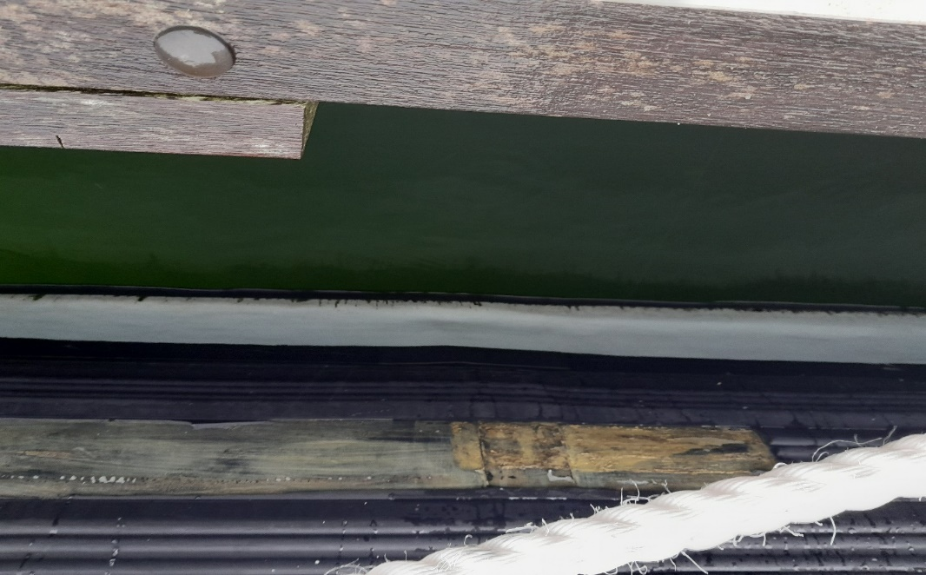

Defect 2 – Figure 2 & 3: All Wheelhouse and Engine Room roof penetrations to be inspected and leak tested. Any failed seals to be cleaned out and renewed using an approved sealant.

Figure 2 Figure 3
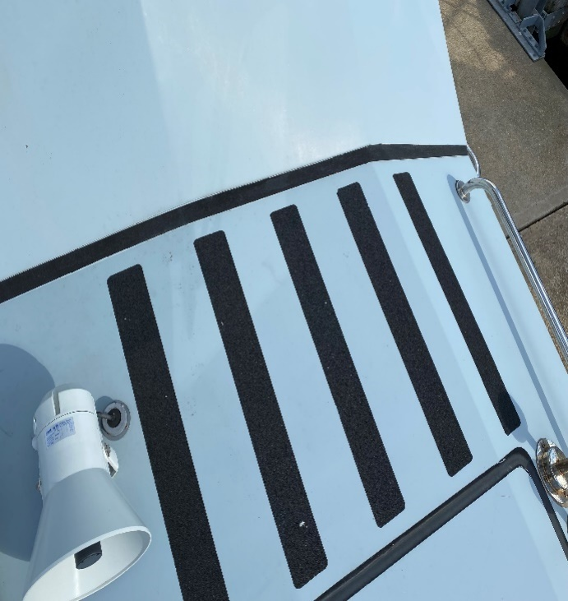
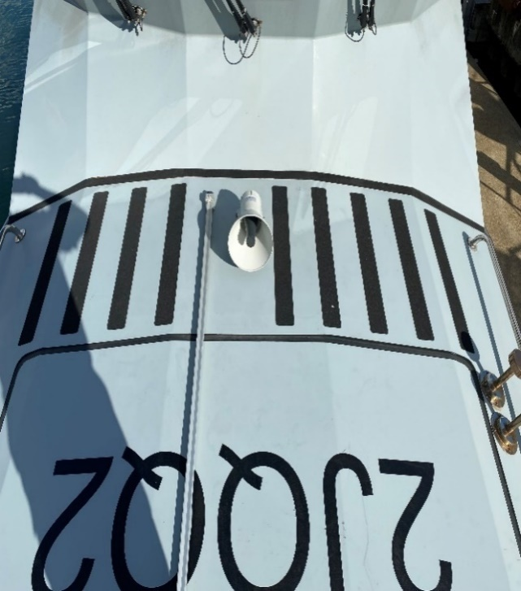

Defect 3 – Figure 4: Remove, clean, prepare and replace deck non-slip on both jet space hatches with an approved paint.
Figure 4
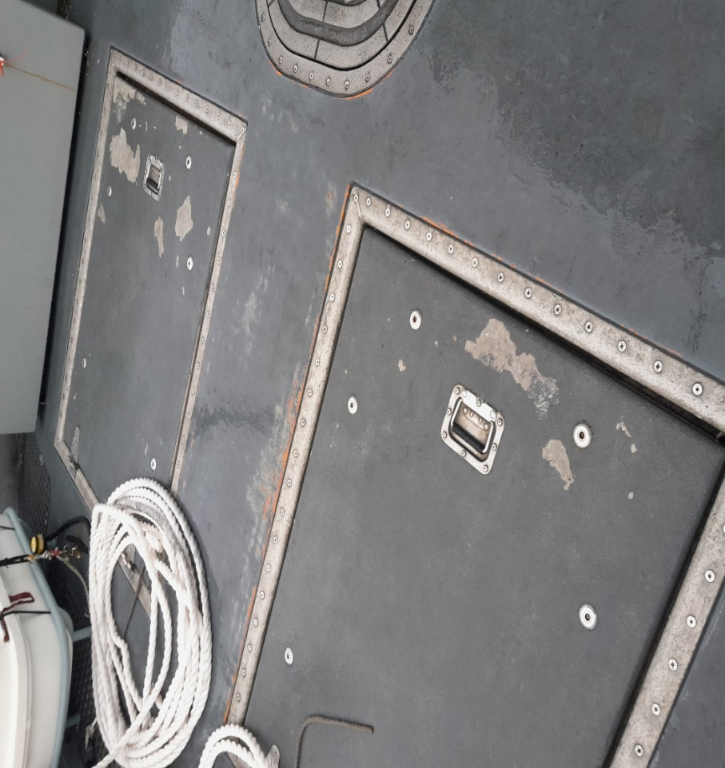
Defect 4 – Figure 5: Repair/replace damaged Port main Engine fuel filter bracket.
Figure 5
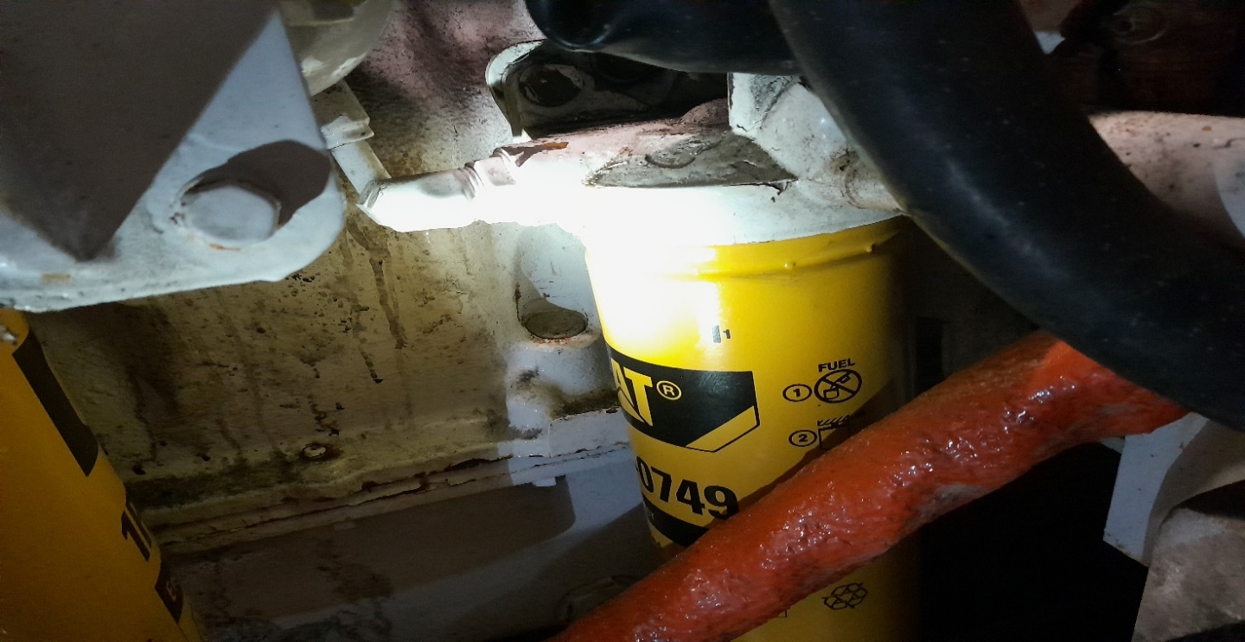
Defect 6 – Figure 6 & 7: Remove, inspect, clean & pressure test both Main Engine Gearbox Oil Coolers.
Figure 6
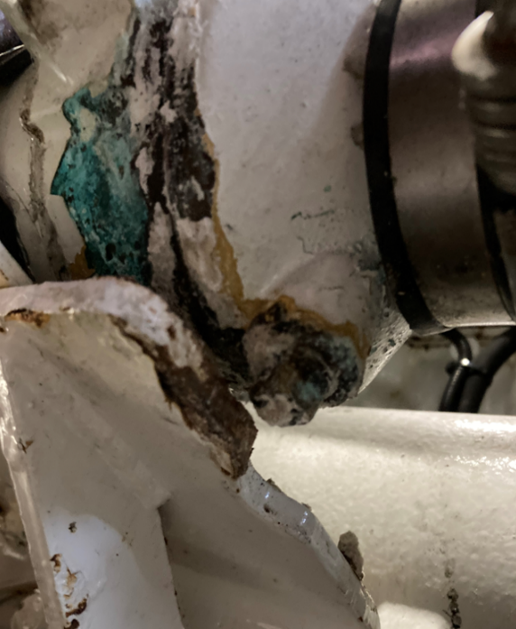
Figure 7
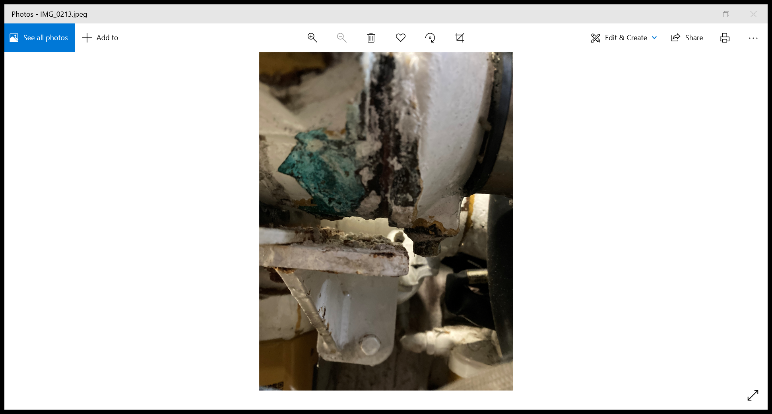

Defect 7 – Figure 8: Replace Port aft section (approx. 1 mtr) of rubbing band.
Figure 8
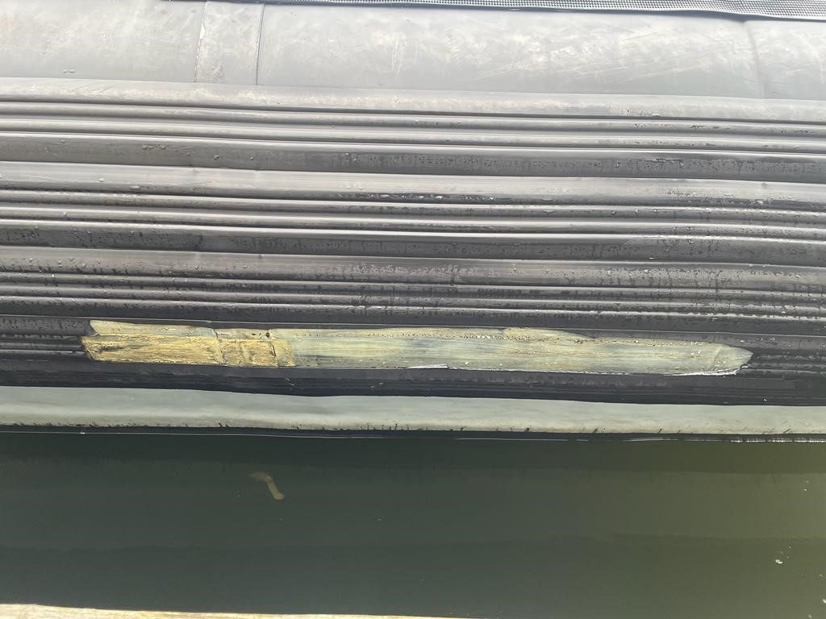
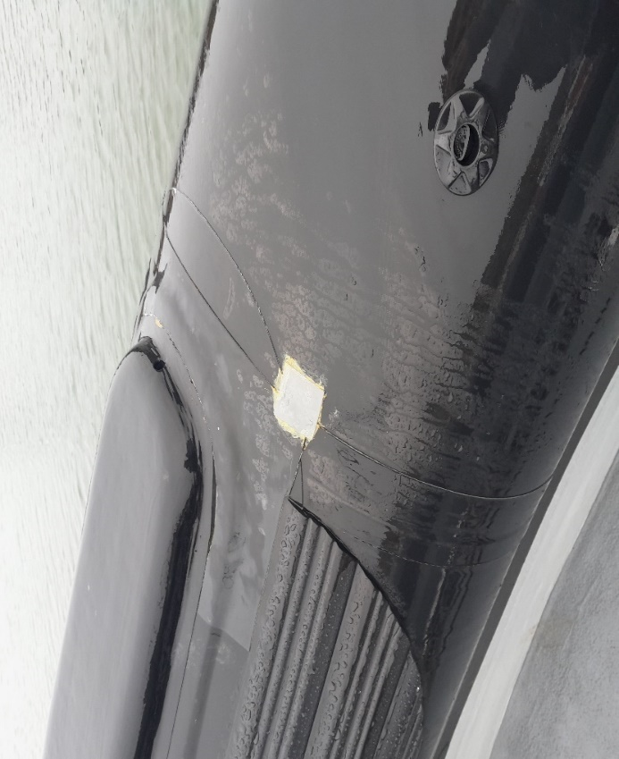
Defect 8 – Figure 9: Complete permanent repair of STBD sponson upper rubbing strake.
Figure 9

Defect 10 - Figure 10: Manufacture and fit a protective access door to all wheelhouse fuse/breaker panels.
Figure 10
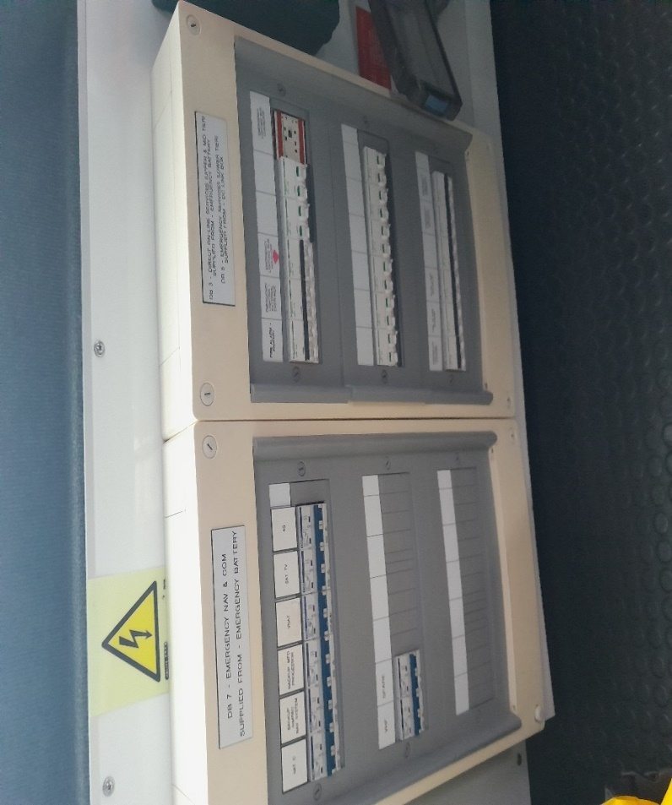
Modification 14 – Figure 11: Fit supplied fresh water filler Perspex cover.
Figure 11
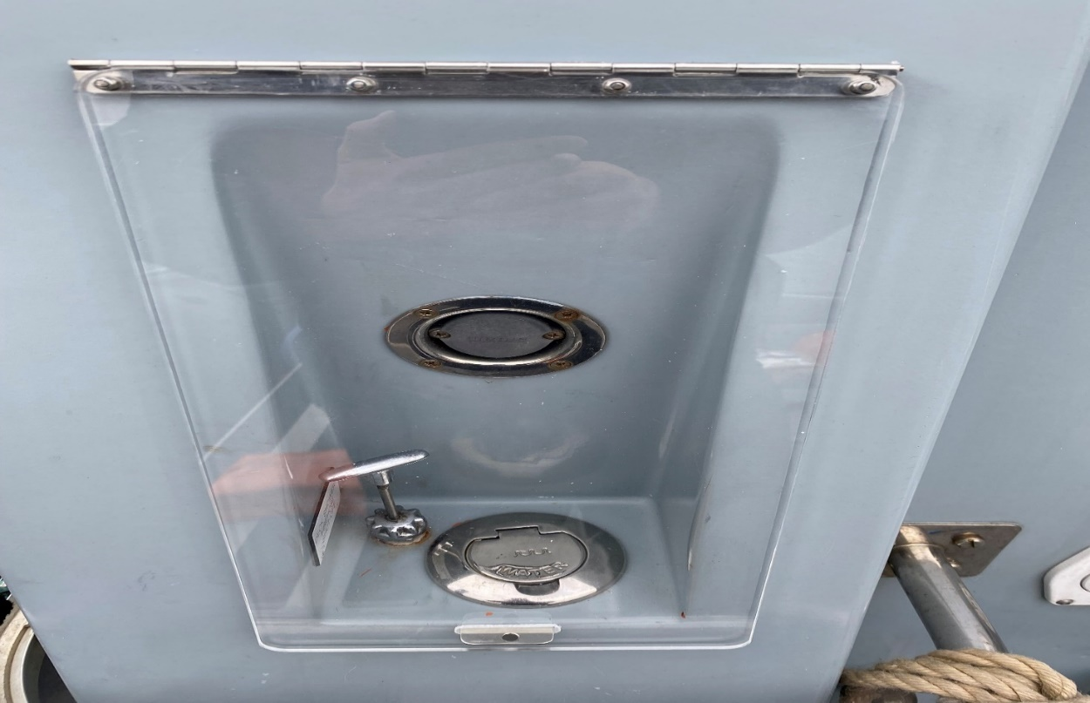
Modification 15 – Figure 12: Fit supplied fuel filling hatch locking bar.
Figure 12
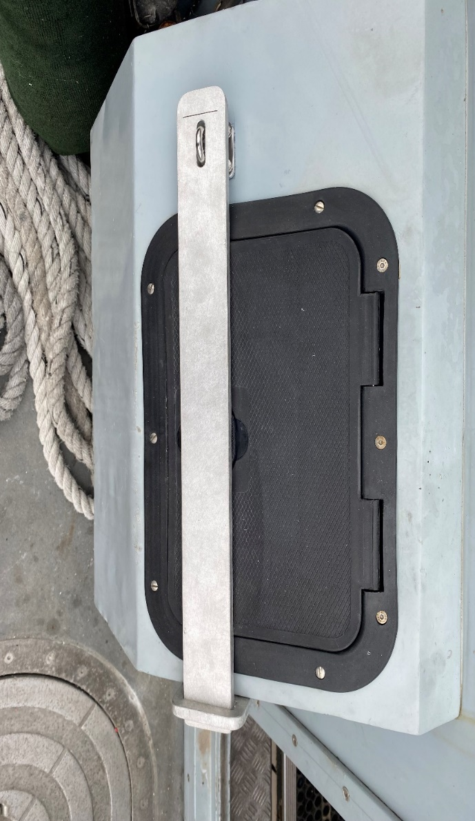
Modification 16 – Figure 13: Modify jet hatch lock (1 per hatch) and supply 2 x modified allen keys.
Figure 13
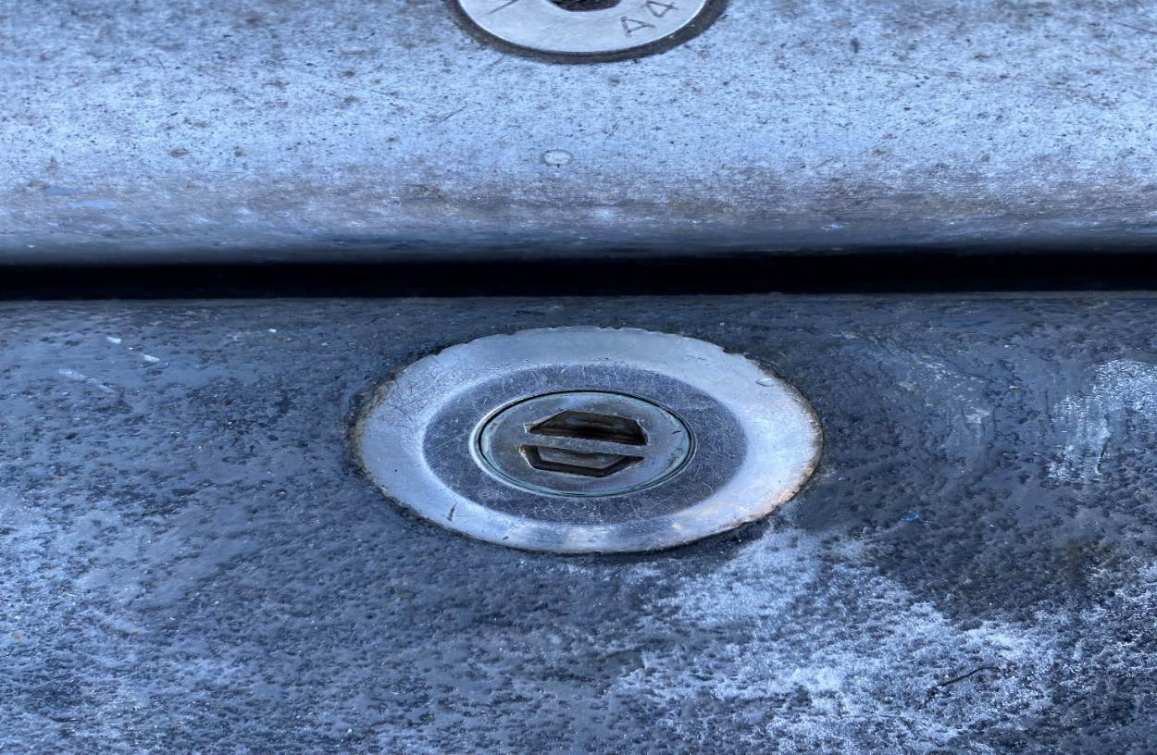

Annex E: General Arrangements
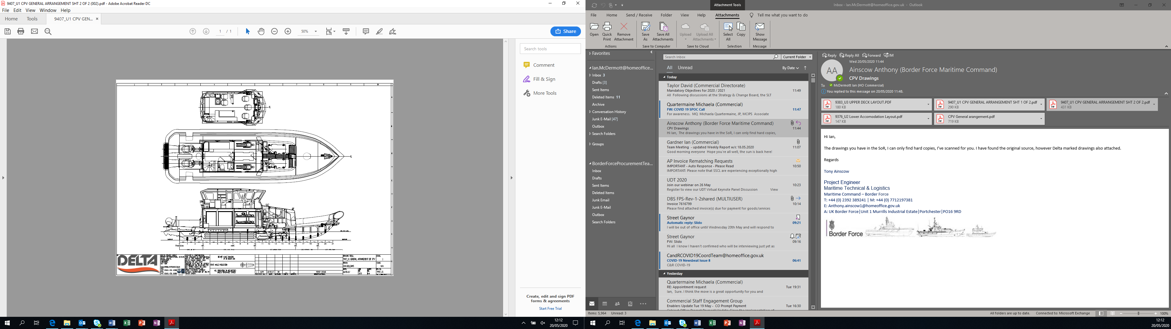

Annex F: Vessel Details
 | Name | MMSI | Callsign
 | CPV EAGLE | 235118128 | 2JQP8
 | CPV NIMROD | 235118129 | 2JQP9
 | CPV ALERT | 235118131 | 2JQQ2
 | CPV ACTIVE | 235118132 | 2JQQ3
 | CPV HUNTER | 235118133 | 2JQQ4
 | CPV SPEEDWELL | 235118134 | 2JQQ5
Length overall (LOA) | 18.80 m including the Collar, waterjet and its guard
Length Rigid Hull | 16.75 m
Length waterline (LWL) | 15.49 m
Beam Overall | 5.60 m
Beam Moulded Hull | 5.22 m
Draught aft full load | 0.96 m
Ht Overall USK to mast | 7.42 m (approx.)
Displacement | c31.1 tonne
Construction | FRP (fibre reinforced plastic)
Main Engines | Twin Caterpillar C18 Marine diesel engines rated output 876 bhp / 644 kW @ 2,200 rpm each. (Total 1,752 bhp / 1,288 kW) Emergency rating 1,000 bhp (747 kW) @ 2,300 rpm
Gearbox | ZF 550 reduction ratio 1.5:1
Propulsion | Twin Hamilton HM 521A Waterjets
Speeds | 28 knots Cruising  34 knots emergency sprint speed in suitable seas
Manoeuvrability | Manoeuvrability at all speeds is good
Range / Endurance | (See Section 11: Fuel, Speed, Range.)
Fuel | Design fuel load 3,424 litres. Max Fuel capacity 3,750 litres.
Fuel Consumption | At Max rated power 195.6 litres / hour
Fresh water | 270 litres
Black Water | 71 litres
Accommodation | 4 berths FOC
Domestic Arrgts | Small Galley, Combined shower and heads (Wheelhouse deck IOC Main Deck FOC)
Crew Seating | 5 Wheelhouse seats
Mission Space | IOC. An open compartment accessed from the main deck level provides non-formatted mission space to accommodate up to 23 persons in addition to the crew. FOC separate compartment containing 4 x Bunk accommodation in Fwd. section of mission space.

Annex G: Emergent Work Individual Item Proforma
Emergent Work (EW) Individual Item Proforma |  |  |  | 
EMERGENT WORK ITEM No: C
Description
Signed, BFOO: |  | Date:
PART I: By Supplier
The above item is accepted as a genuine Emergent work item.
Our Firm Price is*  Our Realistic Estimate is* | £
Signed: | Position:
Signed: | Dated:
TIME PENALTY (if any) ..................................................................... The completion date of the contract* will/will not be affected by this item.
PART II: By Border Force Overseeing Officer
It is agreed that this is a genuine emergent work item and Buyer is given for the work to be undertaken.
The Above Firm Price/Realistic Estimate* of £ |  |  | ACCEPTED |  | REJECTED
Signed: |  |  | Date:
Notes:
*- Delete as required

All interactions pertaining to Emergent Work are to be carried out strictly in accordance with § 9.0.

Annex H: Emergent Work item Record Spreadsheet
CPV SPEEDWELL |  | 
Supplier:
Contract Number: | C
MTL Project Lead:
BFOO:
EMERGENT WORK NUMBER | JOB DESCRIPTION |  | %  COMP
C

Annex I: Handover Certificate
CPV SPEEDWELL
This Handover Certificate is to be duly signed by a representative of the Buyer and the Supplier for the aforenamed Vessel at commencement of the Maintenance and Safety Equipment Recertification Period.
Immediately upon signing this Handover Certificate, the Supplier accepts responsibility for the safe custody of CPV SPEEDWELL until they are issued with a Buyer -signed Acceptance Certificate.
Statement of Condition issued by (BFOO):

CPV SPEEDWELL is in a safe and stable condition. All systems have been shut down, (except those as listed below, commensurate with the systems as required by the Supplier).

Tank Contents
Fuel |  |  | litres
Fresh water |  |  | litres
Black Water Tank |  |  | litres
Systems Still Operational
Signed: |  | Signed:
For and on Behalf of the Supplier: |  | For and on Behalf of the Buyer:
Name: |  | Name:
Position / Capacity: |  | Position / Capacity

Annex J: Acceptance Certificate
Acceptance Certificate |  | 
PART I: to be completed by Supplier
CPV SPEEDWELL

CPV SPEEDWELL has completed her Planned and agreed Emergent Work tasks associated with contract C to the satisfaction of the BFOO and is in a seaworthy condition ready to undertake sea trials, and is this day offered for acceptance by Border Force.
Signed: | For and on Behalf of the Supplier:
Print Name: | Date:
PART II: to be completed by The Buyer
I attended the acceptance of CPV SPEEDWELL and have satisfied myself that all systems, machinery, and equipment are working satisfactorily. I have inspected the CPV and consider she is in a condition suitable for return to theBuyerAut hority and is hereby accepted.
By Vessel Commander:
Signed: | Print Name / Post:
By Border Force Overseeing Officer:
Signed: | Border Force Overseeing Officer
Print Name: | Date:
PART III: Notes
Distribution
Original - Retained by the Supplier
Copies to - Border Force Overseeing Officer

Annex K: Project Completion Certificate
Project Completion Certificate |  | 
PART I: to be completed by Supplier
CPV SPEEDWELL

CPV SPEEDWELL, having completed contract C to the satisfaction of the Buyer and having successfully completed any applicable trials and provided all documentation required under this requirement, Contract Number C is this day offered as completed to Border Force.
Signed: | For and on Behalf of the Supplier:
Print Name: | Date:
PART II: to be completed by The Buyer
By Vessel Commander:
I attended the Project Completion Meeting of CPV SPEEDWELL and have satisfied myself that all systems, machinery, and equipment are working satisfactorily. I have inspected the CPV and consider she is in a condition suitable for return to operational service.
Signed: | Print Name / Post:
By Border Force Overseeing Officer:
CPV SPEEDWELL, having completed contract C to the satisfaction of the Buyer and having completed all appropriate trials and received all documentation required under the Contract is hereby accepted at.…......... hours.
Signed: | Border Force Overseeing Officer
Print Name: | Date:
PART III: Warranty
The issuing of a Project Completion Certificate to the Supplier by the Buyer, or a duly authorised representative of the Buyer, does in no way affect the warranty requirements as specified in this requirement nor the statutory rights of the Buyer.
Distribution
Original - Retained by the Supplier
Copies to - Border Force Overseeing Officer

Annex L: Reimbursable Expenses
The Supplier may claim the following Reimbursable Expenses at the rates set out below:
1. Travel
Standard rate of allowance for private cars
Initial 10,000 miles |  | 45p per mile
Additional miles over the initial 10,000 |  | 25p per mile
2. Hotel rates
London |  | £150 per night
All other locations other than London |  | £100 per night

Annex M: Carbon Centre Disc Assembly & Operation M034-0003-EN

Annex N: Jet Anodes 521

Annex O: CPV Anodes, Cathode Protection and Bonding

Annex P: MDKBL Cummins Onan Service

Annex Q: 9m GRP Patrol Boat Tech 110416. CPV Paint Scheme

Annex R: CPV SOP 08 – Inventory


© Crown copyright 2020
This publication is available at https://www.gov.uk/contracts-finder

Check UK Qualifications or Check Overseas Qualifications
Ships, trains, aircraft and associated services (VAT Notice 744C) - GOV.UK (www.gov.uk)
Ships, trains, aircraft and associated services (VAT Notice 744C) - GOV.UK (www.gov.uk)

